实验报告
姓名： 郑智瑄 专业： 电子科学与技术 学号： 3230103913
课程名称： 数字系统 任课老师： 李宇波
实验名称： lab7 实验日期： 2024/4/22
1 实验目的和要求
1.1 实验目的
验证EC-1的设计。
1.2 实验要求
对于EC-1微处理器，在Verilog模块中分别实现数据路径电路和FSM电路，使用顶部模块连接在一起，并在Basys3板中实现。注意，你需要把编译后的汇编代码，即ROM中的二进制可执行代码放入数据路径电路中，以便在微处理器中运行程序。将板内开关连接到输入引脚，并将输出引脚连接到LED。
2 实验原理
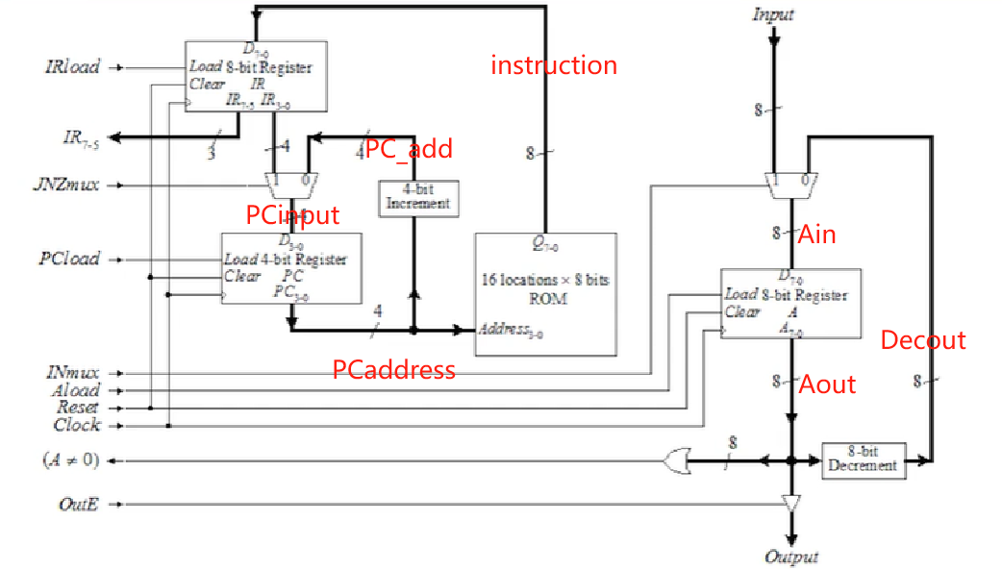
图2-1 datapath
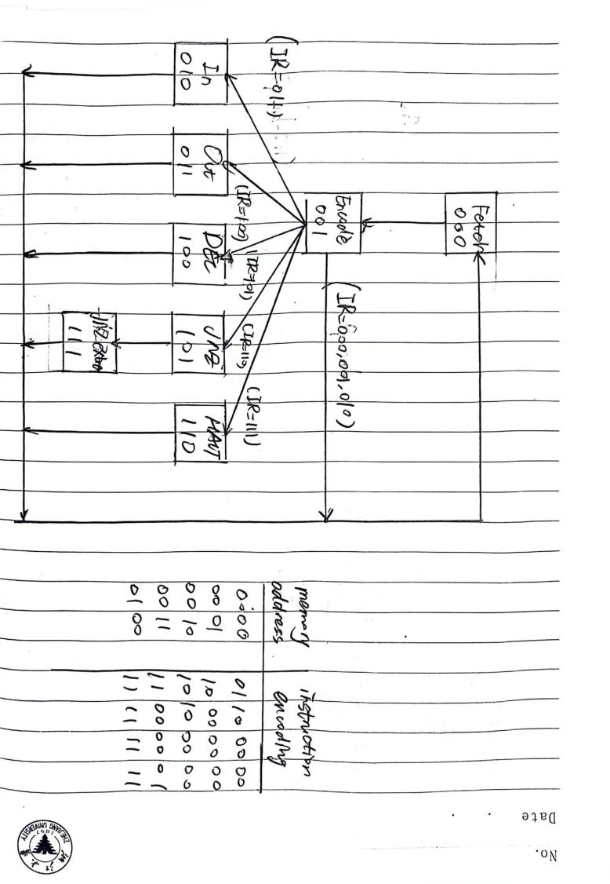
图2-2 FSM与ROM
3 实验内容
1、写出datapath段代码
- 写出FSM段代码
- 写出顶端top代码
- 写出对top段代码仿真top_tb
- 仔细认真的debug
4 实验结果和分析
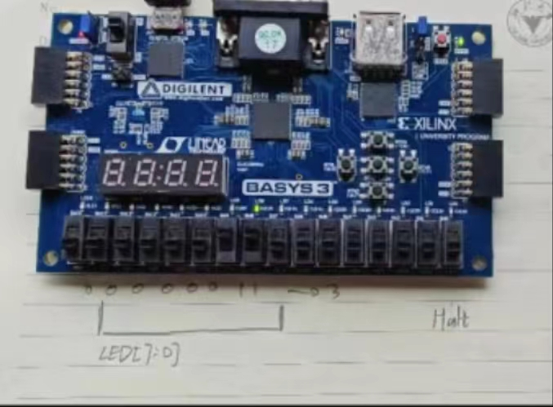
图4-1 验收结果截图
5 实验结论
- 厘清状态机的状态个数，尽量多用自己写的东西或者自己复写过的东西
- Debug的时候要多方面考虑，综合思考
6 源代码与分析
此处附上top;datapath;FSM;clk_div;tb五段代码

（1）top代码
module EC1(
input [7:0] A,
input clk, reset,
output [7:0] led,
output HALT
);
wire clk_2s;
//1_0000_0000 2s 2500_0000 0.5s
clk_div #(.N( 2500_0000)) divl(.clk(clk),.reset(reset),.clk_div(clk_2s));
wire IRload,JNZmux,PCload,INmux,Aload,OutE;
wire AnotZero;
wire [2:0] IR_OpWord;
Datapath d1(.clk(clk_2s),.reset(reset),.IRload(IRload),.JNZmux(JNZmux),.PCload(PCload),.INmux(INmux),.Aload(Aload),.OutE(OutE),
.INPUT(A),.AnotZero(AnotZero),.OUTPUT(led),.IR_OpWord(IR_OpWord));
Control c1(.clk(clk_2s),.reset(reset),.IR_OpWord(IR_OpWord),.AnotZero(AnotZero),
.IRload(IRload),.JNZmux(JNZmux),.PCload(PCload),.INmux(INmux),.Aload(Aload),.OutE(OutE),.HALT(HALT));
endmodule

（2）datapath代码
module Datapath(
input reset,clk, IRload,JNZmux,PCload, INmux,Aload,OutE,
input [7:0] INPUT,
output AnotZero,
output [7:0] OUTPUT,
output [7:5] IR_OpWord
);

//描述A累加器
wire [7:0] Decout,Ain,Aout;
mux2to1 #(.N(8)) Amux(.mux(INmux),.ina(INPUT),.inb(Decout),.out(Ain));
Register #(.N(8)) Areg(.clk(clk),.load(Aload),.clear(reset),.loaddata(Ain),.outdata(Aout));
Decrement #(.N(8)) Adec(.DecInput(Aout),.DecOutput(Decout));
Outputgate #(.N(8)) AOutput(.E(OutE),.I(Aout),.O(OUTPUT));

assign AnotZero=Aout[7]|Aout[6]|Aout[5]|Aout[4]|Aout[3]|Aout[2]|Aout[1]|Aout[0];

//描述指令ROM
wire [3:0] PCaddress;
wire [7:0] instruction;
InstructionROM ROM(.clk(clk),.reset(reset),.address(PCaddress),.q(instruction));
//描述指令寄存器
wire [7:0] reg_instruction;
Register #(.N(8)) IRReg(.clk(clk),.load(IRload),.clear(reset),.loaddata(instruction),.outdata(reg_instruction));
//JNZmux
wire [3:0] PCinput,PC_add;
mux2to1 #(.N(4)) PCmux(.mux(JNZmux),.ina(reg_instruction[3:0]),.inb(PC_add),.out(PCinput));
//Increment
Increment #(.N(4)) PCinc(.IncInput(PCaddress),.IncOutput(PC_add));
//描述PC寄存器
Register #(.N(4)) PCReg(.clk(clk),.load(PCload),.clear(reset),.loaddata(PCinput),.outdata(PCaddress));
assign IR_OpWord[7:5]=reg_instruction[7:5];
endmodule

module mux2to1
#( parameter N = 8 )
(
input mux,
input [N-1:0] ina,inb,
output reg [N-1:0] out
);
always @(*) begin
if(mux)
out <= ina;
else
out <= inb;
end
endmodule

module Register
#( parameter N = 8 )
(
input clk,load,clear,
input [N-1:0] loaddata,
output reg [N-1:0] outdata
);
always @(posedge clk or posedge clear) begin
if(clear)
outdata <= 0;
else if(load)
outdata <= loaddata;
end
endmodule

module Decrement
#( parameter N = 8 )
(
input [N-1:0] DecInput,
output [N-1:0] DecOutput
);
assign DecOutput=DecInput-1;
endmodule

module Increment
#( parameter N = 8 )
(
input [N-1:0] IncInput,
output [N-1:0] IncOutput
);
assign IncOutput=IncInput+1;
endmodule

module InstructionROM
(
input clk,reset,
input [3:0] address,
output reg [7:0] q
);
always @(posedge clk) begin
case (address)
4'b0000: q <= 8'b011_00000;//IN A
4'b0001: q <= 8'b100_00000;//OUT A
4'b0010: q <= 8'b101_00000;//DEC A
4'b0011: q <= 8'b110_00001;//JNZ loop
4'b0100: q <= 8'b111_11111;//HALT
endcase
end
endmodule

module Outputgate
#( parameter N = 8)
(
input E,
input [N-1:0] I,
output reg [N-1:0] O
);
always @(*) begin
if(E)
O = I;
else
O = 'bz;
end
Endmodule

（3）FSM代码
module Control (
input clk,reset,AnotZero,
input [2:0]IR_OpWord,
output reg IRload,JNZmux,PCload,INmux,Aload,OutE,HALT);
//state definition
parameter s_fetch = 0;
parameter s_encode = 1;
parameter s_in = 2;
parameter s_out = 3;
parameter s_dec = 4;
parameter s_jnz = 5;
parameter s_halt = 6;
parameter s_jnz_extra = 7;
reg [2:0] state,next_state;
//次态逻辑
always @(*)begin
if (reset)
next_state = s_fetch;
else case(state)
s_fetch:next_state = s_encode;
s_encode:
if (IR_OpWord == 3)
next_state = s_in;
else if (IR_OpWord == 4)
next_state = s_out;
else if (IR_OpWord == 5)
next_state = s_dec;
else if (IR_OpWord == 6)
next_state = s_jnz;
else if (IR_OpWord == 7)
next_state = s_halt;
else
next_state = s_fetch;
s_in:next_state = s_fetch;
s_out:next_state = s_fetch;
s_dec:next_state = s_fetch;
s_jnz:next_state = s_jnz_extra;
s_halt:next_state = s_halt;
s_jnz_extra:next_state = s_fetch;
default:next_state = s_fetch;
endcase
end
//现态逻辑
always @(posedge clk or posedge reset)begin
if(reset) state=s_jnz_extra;
else state = next_state;
end
//输出逻辑
always @(*)begin
case(state)
s_fetch:begin
IRload = 1;
JNZmux = 0;
PCload = 1;
//INmux = 0;
Aload = 0;
OutE = 0;
HALT = 0;
end
s_encode:begin
IRload = 0;
//JNZmux = 0;
PCload = 0;
//INmux = 0;
Aload = 0;
OutE = 0;
HALT = 0;
end
s_in:begin
IRload = 0;
//JNZmux = 0;
PCload = 0;
INmux = 1;
Aload = 1;
OutE = 0;
HALT = 0;
end
s_out:begin
IRload = 0;
//JNZmux = 0;
PCload = 0;
//INmux = 1;
Aload = 0;
OutE = 1;
HALT = 0;
end
s_dec:begin
IRload = 0;
//JNZmux = 0;
PCload = 0;
INmux = 0;
Aload = 1;
OutE = 0;
HALT = 0;
end
s_jnz:begin
IRload = 0;
JNZmux = 1;
case (AnotZero)
1:PCload = 1;
0:PCload = 0;
endcase
//INmux = 1;
Aload = 0;
OutE = 0;
HALT = 0;
end
s_halt:begin
IRload = 0;
//JNZmux = 0;
PCload = 0;
//INmux = 0;
Aload = 0;
OutE = 0;
HALT = 1;
end
s_jnz_extra:begin
IRload = 0;
//JNZmux = 0;
PCload = 0;
//INmux = 0;
Aload = 0;
OutE = 0;
HALT = 0;
end
default:begin
IRload = 0;
JNZmux = 0;
PCload = 0;
INmux = 0;
Aload = 0;
OutE = 0;
HALT = 0;
end
Endcase
（4）分频器代码
module clk_div
#(
parameter N=1_0000_0000
)
(
input clk,reset,
output reg clk_div
);
//synthesis: 2s:100000000
//tb:1000000
reg [28:0] count;
//2_6843_5456
always @(posedge clk or posedge reset) begin
if(reset) begin clk_div<=0;count<=0; end
else if(count<N) count<=count+1;
else if(count==N) begin count=0;clk_div=~clk_div; end
end
endmodule

（5）仿真测试代码
module EC1_tb();
reg [7:0] A;
reg clk, reset;
wire [7:0] led;
wire HALT;
EC1 d1(.A(A),.clk(clk),.reset(reset),.led(led),.HALT(HALT));
initial
begin
A=8'b00000010;
clk=0;
reset=1;
#100
reset=0;
#5000
A=8'b00000011;
reset=1;
#100
reset=0;
end
always begin
#5
clk=~clk;
end
endmodule

