

基于ADXL345加速度传感器和
FPGA的人体运动状态检测系统

课程名称： | 数字系统
姓 名： | 沙梓博
学 院： | 信息与电子工程学院
专 业： | 电子科学与技术
学 号： | 3220103764
指导教师： | 李宇波
小组编号： | 第十二组
组员： | 丁婕妮 沙梓博
贡献占比： | 50%，50%

2023 年07月15日

- 设计背景
随着亚运会的日子不断接近，在主办场地杭州，人们身边也逐渐掀起一股运动的风潮，见此我们想要试着制作一款运动状态检测器，可以判断人物究竟处于哪一种运动状态下，并进行计时。
这款人体运动状态检测系统主要分割为三个具体功能：1、判断运动状态；2、进行运动计时；3、分析运动效果。
与我们平时所用的运动app相比，那些软件的功能大多只是测试运动的时间及距离，需要手动选择运动状态，记录相应时间，而并没有实时监测某一时刻下速度区间（代表其运动状态），而我们的系统则可以将任意运动状态对应的时间区间检测出来，判断其对应运动状态，并进行相应的计时。也可由此进行运动的后续分析，看看是否进行了有效的锻炼。
在选题的过程中，经过讨论与查找资料，我们选择了加速度传感器作为这一项目的核心，原理是利用加速度传感器来测定人运动的速度，从而确定人的运动状态。之后通过搜索和比较选择了以ADXL345加速度传感器为主体进行测定，还有就是必需的basys3开发板作为装置主体部分。在进行模块的具体拆分时，考虑到状态图和具体功能实现，将具体工作拆分为传感器模块、信号处理模块、状态转换模块、计时模块、显示模块进行编写。
在整个制作过程中的主要难点，就在于传感器模块的相关处理，如何利用，连接，接受信号，如何处理信号转换成我们所需要的信号，都需要我们自己在过程中查找资料一一尝试。

- 具体模块
- 计时模块
通过加法器和寄存器实现了计时的控制，通过控制寄存器的使能端来控制计时器的运行与暂停，其代码如下所示
（1）代码结构
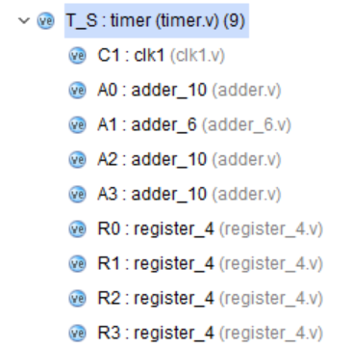
（2）主模块代码
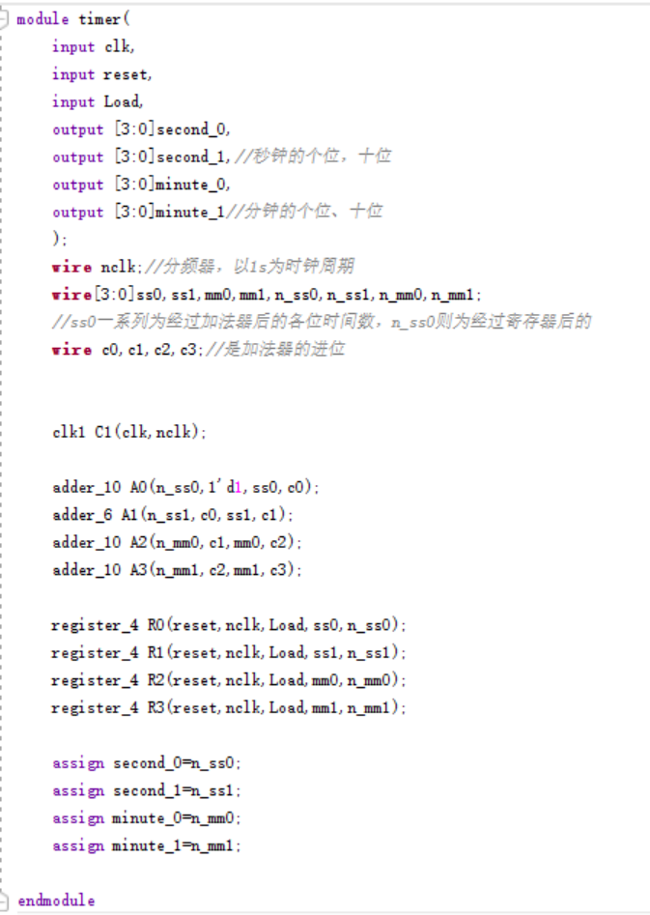
（3）子模块代码
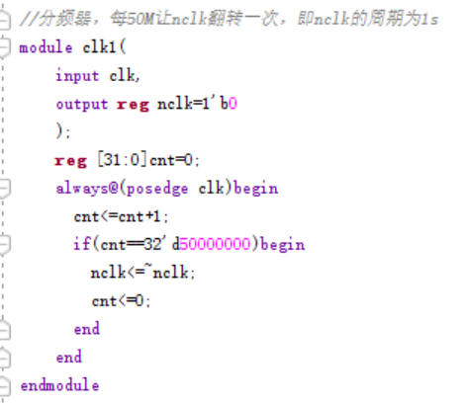
分频器
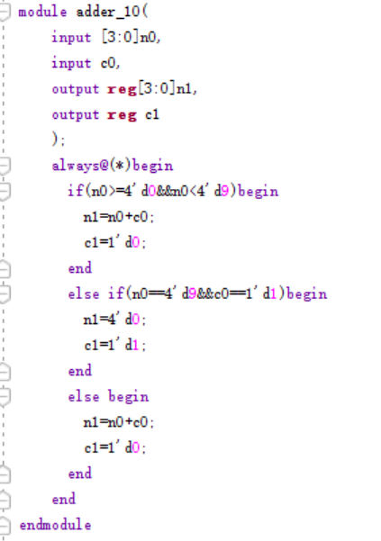
十进制加法器
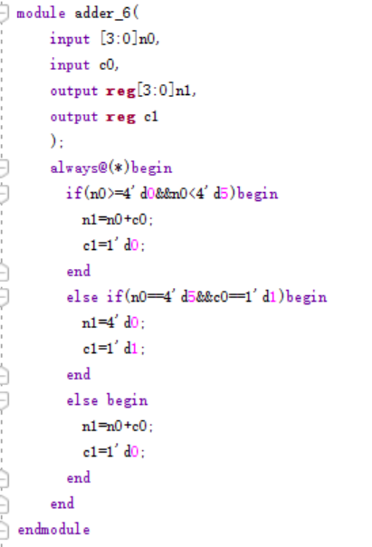
六进制加法器
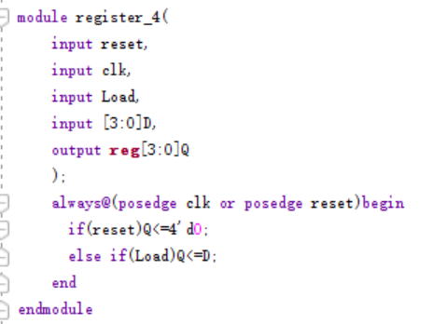
寄存器
- 显示模块
七段数码管的数字显示在之前课堂上的实验便已经做过，由于其显示随着时间变化而变化，所以先通过输入的各位数字确定七段数码管究竟如何显示，再确定哪一位数码管显示哪一位数字，2.5ms闪动一次，成功实现时间的显示，其代码如下：
- 代码结构
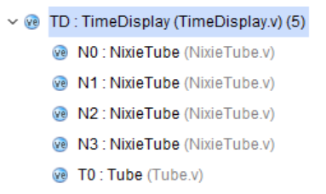
- 主模块代码
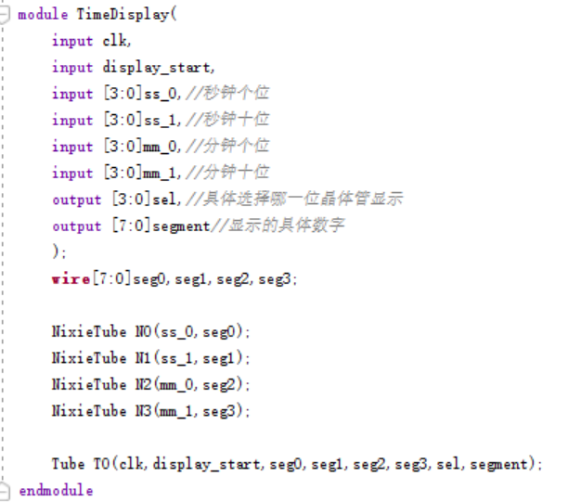
- 子模块代码
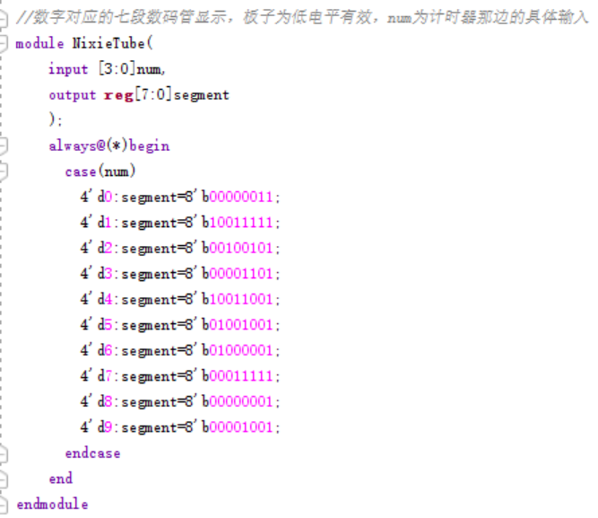
晶体管具体显示
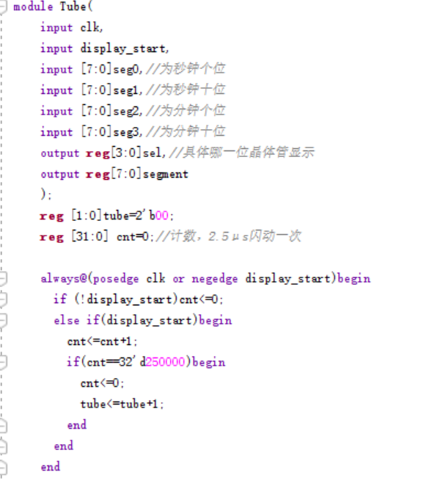
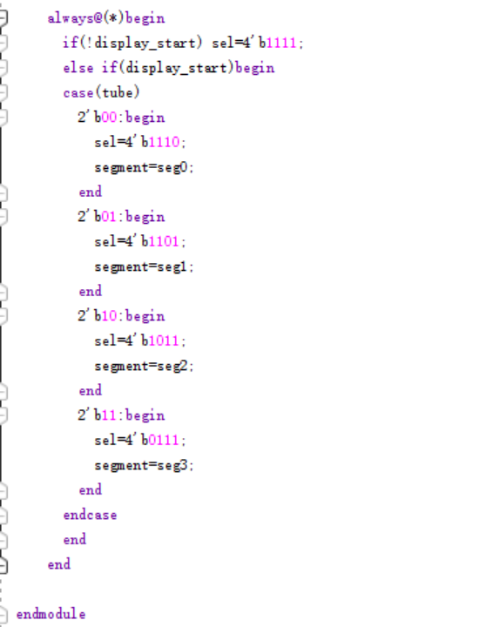
晶体管闪动显示
- 状态转换模块
根据最初设想的具体功能，我们通过信号处理模块传输过来的信号以及按钮控制来进行状态转换，且计时模块与显示模块的状态转换互不关联，因此我们将两者的状态图分开，各自设计状态转换模块。其状态图及代码如下：
- 状态图
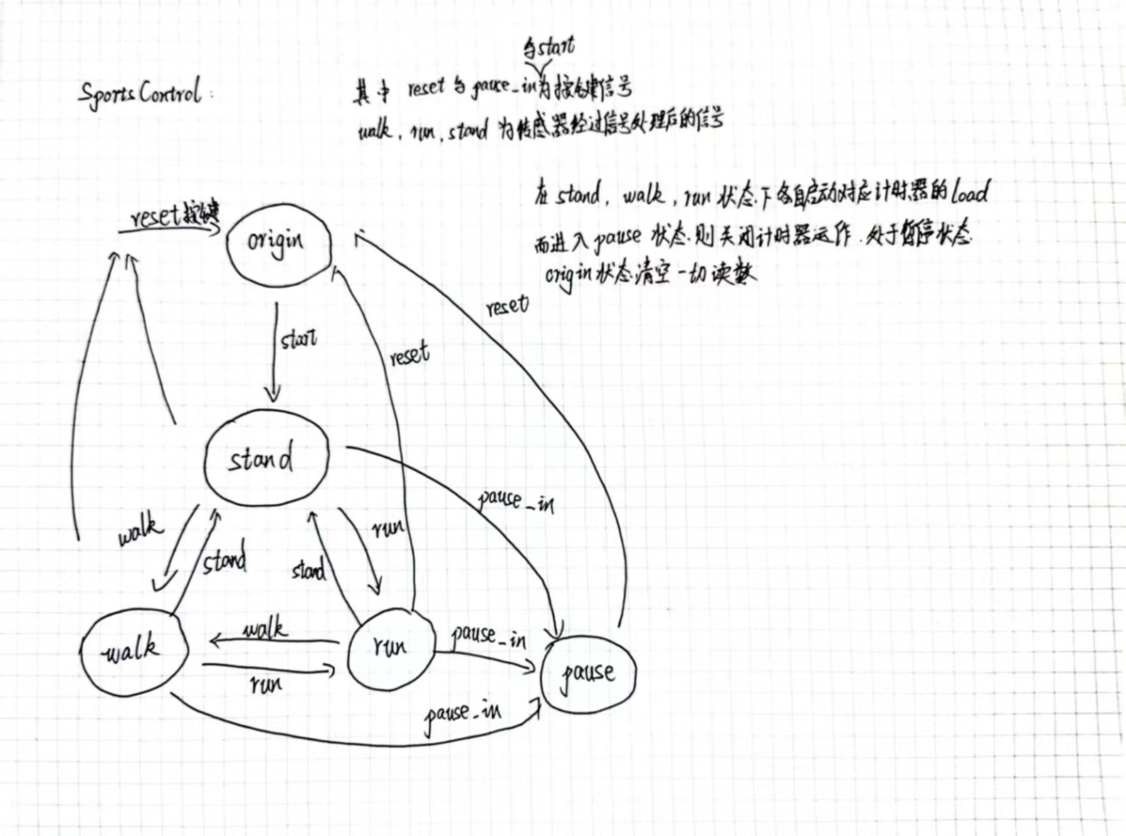
运动状态转换
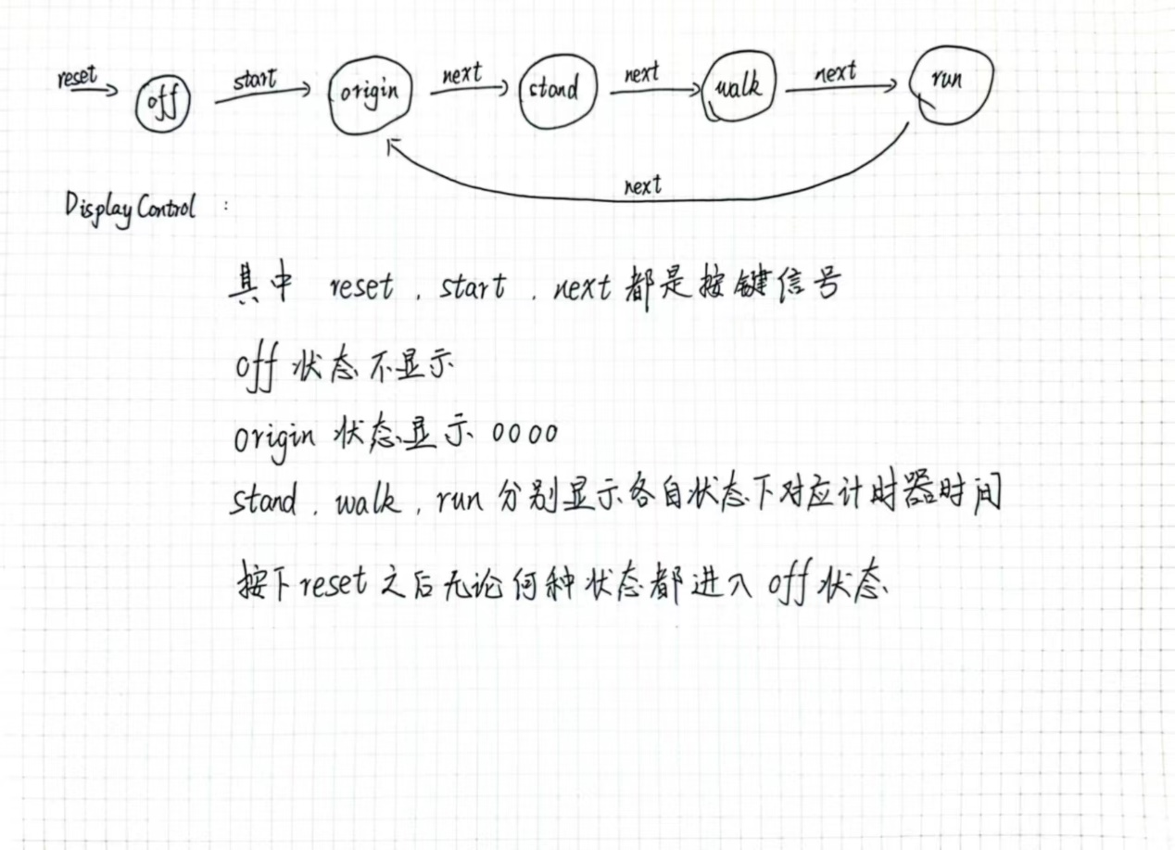
显示状态转换
- 代码结构
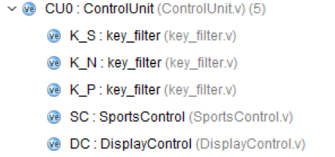
- 主模块代码
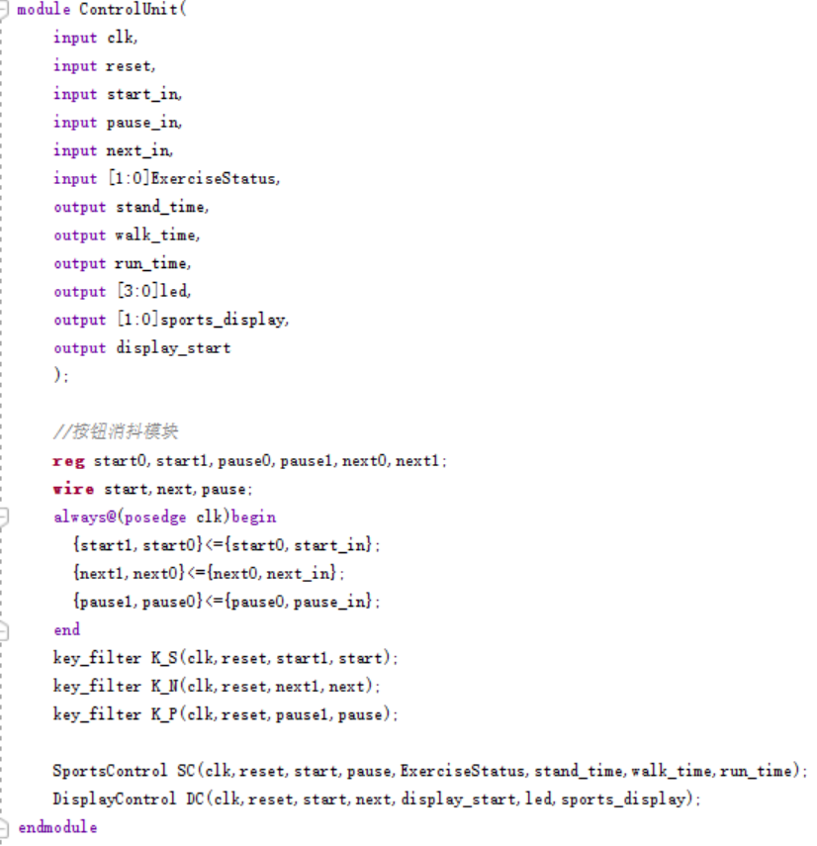
- 子模块代码
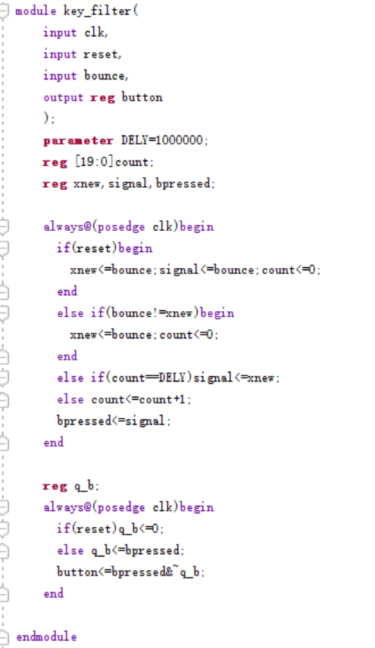
按键消抖模块
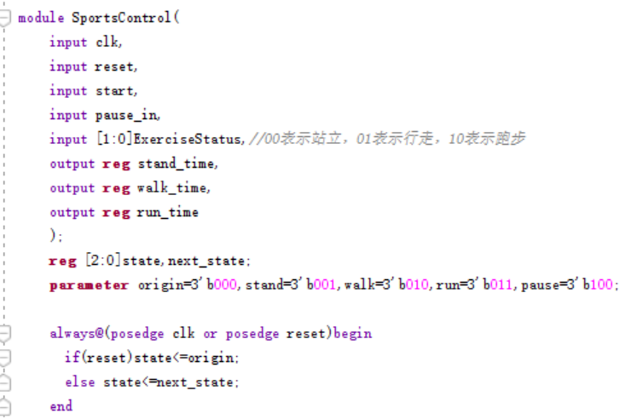

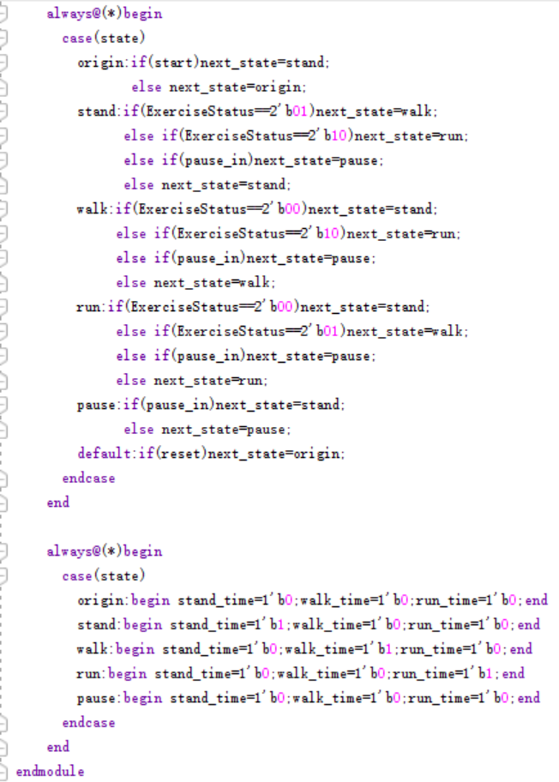
运动状态转换模块
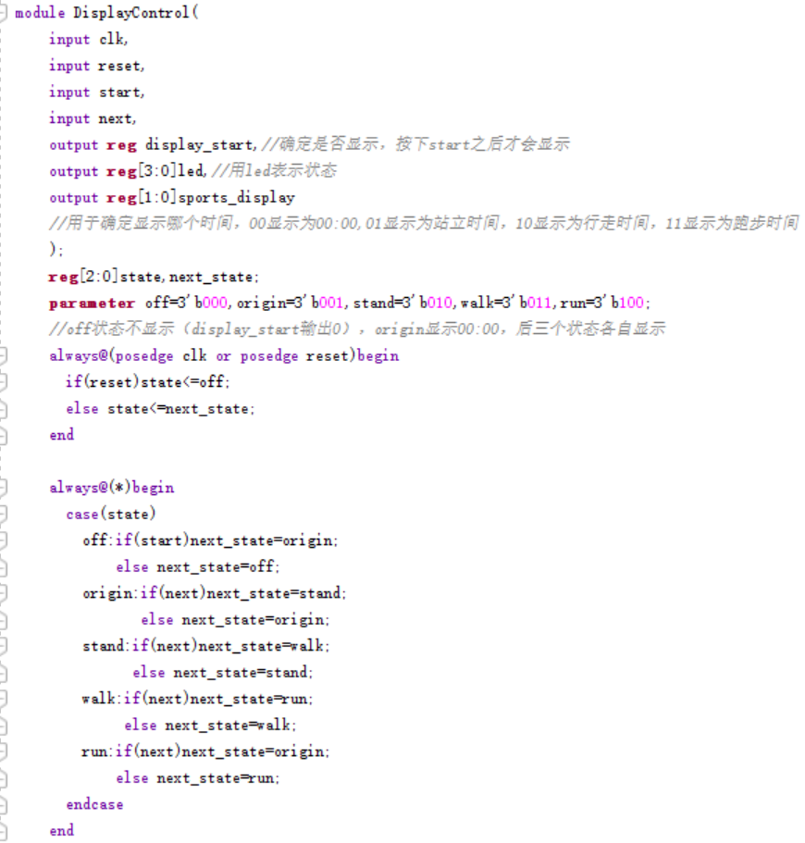
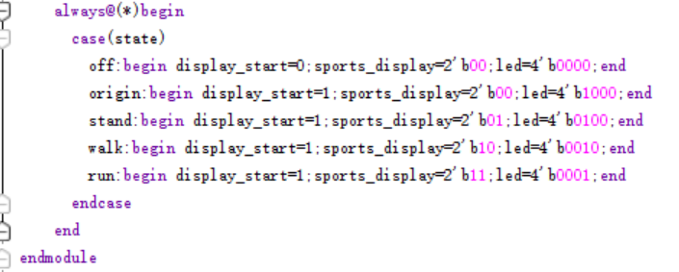
显示状态转换模块
- 传感器模块
module ADXL345(
ACC_XL_READ,
ACC_XH_READ,
ACC_YL_READ,
ACC_YH_READ,
ACC_ZL_READ,
ACC_ZH_READ,
datastart,
Clk,
Rst_n,
ADXL345_SDO, //input
ADXL345_CSB, //output
ADXL345_SDI,
ADXL345_SCK
);
output reg[7:0]ACC_XL_READ
output reg[7:0]ACC_XH_READ
output reg[7:0]ACC_YL_READ
output reg[7:0]ACC_YH_READ
output reg[7:0]ACC_ZL_READ
output reg[7:0]ACC_ZH_READ
output reg datastart;
input Clk; //systerm clk(50MHz)
input Rst_n; //global reset
input ADXL345_SDO; //ADXL345 data output

output reg ADXL345_CSB; //ADXL345 chip select,active low
output reg ADXL345_SDI; //ADXL345 data input
output reg ADXL345_SCK; //ADXL345 serial clock

reg[5:0]Div_cnt;
reg Start;

parameter ADXL345_Start=1; //ADXL345_Start signal

//divide clock to 1MHz
always@(posedge Clk or negedge Rst_n)
begin
if(!Rst_n)
Div_cnt<=6'd0;
else if(Start)begin
if(Div_cnt==6'd9)
Div_cnt<=6'd0;
else
Div_cnt<=Div_cnt+1'b1;
end
else
Div_cnt<=6'd0;
end

always@(posedge Clk or negedge Rst_n)
begin
if(!Rst_n)
ADXL345_SCK<=1'b1;
else if(Div_cnt==6'd0)
ADXL345_SCK<=1'b1;
else if(Div_cnt==6'd5)
ADXL345_SCK<=1'b0;
end

reg[2:0]clk_state;

//-----------------//
always@(posedge Clk or negedge Rst_n)
begin
if(!Rst_n)
clk_state<=3'd0;
else if(Div_cnt==6'd8)
clk_state<=3'd1;
else if(Div_cnt==6'd5)
clk_state<=3'd2;
else if(Div_cnt==6'd9)
clk_state<=3'd3;
else if(Div_cnt==6'd1)
clk_state<=3'd4;
else
clk_state<=3'd0;
end

`define clk_high (clk_state==3'd1) //clock high
`define clk_neg (clk_state==3'd2) //clock falling edge
`define clk_pos (clk_state==3'd3) //clock rising edge
`define clk_cs0 (clk_state==3'd4) //clock control cs
//-----------------//

//control ADXL345280 Timing state machine
localparam
IDLE =6'd1,
DATA_FORMAT =6'd2,
BW_RATE =6'd3,
POWER_CTL =6'd4,
INT_ENABLE =6'd5,
CONVENTION0 =6'd6,
RD_T =6'd7,
RD_R =6'd8,
CONVENTION1 =6'd9,
CONVENTION2 =6'd10,
CONVENTION3 =6'd11;

parameter DATA_FORMAT_v =16'b0011_0001_0000_1011; //register address 0x31,value set the 0x0B
parameter BW_RATE_v =16'b0010_1100_0000_1110; //register address 0x2C,value set the 0x08 1600Hz
parameter POWER_CTL_v =16'b0010_1101_0000_1000; //register address 0x2D,value set the 0x08
parameter INT_ENABLE_v =16'b0010_1110_1000_0000; //register address 0x2E,value set the 0x80
parameter rd_addr = 8'hF2 ;
// parameter rd_addr = 8'h80 ;

//define register
reg [4:0] cstate;
reg [6:0] num;
reg [7:0] cs_num;

//------------------//

always@(posedge Clk or negedge Rst_n)
begin
datastart=1'b0;
if(!Rst_n)
begin
ADXL345_CSB <=1'b1;
ADXL345_SDI <=1'b1;
Start <=1'b0;
cstate <=IDLE;
num <=7'b0;

ACC_XL_READ <= 8'd0;
ACC_XH_READ <= 8'd0;
ACC_YL_READ <= 8'd0;
ACC_YH_READ <= 8'd0;
ACC_ZL_READ <= 8'd0;
ACC_ZH_READ <= 8'd0;
end
else
begin
case(cstate)
IDLE:
begin
if(ADXL345_Start)
begin
cstate<=DATA_FORMAT;
Start<=1'b1;
ADXL345_CSB<=1'b0;
end
else
cstate<=IDLE;
end

DATA_FORMAT:
begin
if(`clk_high)
begin
num<=num+1'b1;
case(num)
7'd0 :ADXL345_SDI<=DATA_FORMAT_v[15];
7'd1 :ADXL345_SDI<=DATA_FORMAT_v[14];
7'd2 :ADXL345_SDI<=DATA_FORMAT_v[13];
7'd3 :ADXL345_SDI<=DATA_FORMAT_v[12];
7'd4 :ADXL345_SDI<=DATA_FORMAT_v[11];
7'd5 :ADXL345_SDI<=DATA_FORMAT_v[10];
7'd6 :ADXL345_SDI<=DATA_FORMAT_v[9];
7'd7 :ADXL345_SDI<=DATA_FORMAT_v[8];
7'd8 :ADXL345_SDI<=DATA_FORMAT_v[7];
7'd9 :ADXL345_SDI<=DATA_FORMAT_v[6];
7'd10 :ADXL345_SDI<=DATA_FORMAT_v[5];
7'd11 :ADXL345_SDI<=DATA_FORMAT_v[4];
7'd12 :ADXL345_SDI<=DATA_FORMAT_v[3];
7'd13 :ADXL345_SDI<=DATA_FORMAT_v[2];
7'd14 :ADXL345_SDI<=DATA_FORMAT_v[1];
7'd15 :ADXL345_SDI<=DATA_FORMAT_v[0];
default: ;
endcase
end
else if(`clk_cs0)
begin
if(num==7'd16)
begin
num<=7'd0;
ADXL345_CSB <=1'b1;
Start <=1'b0;
cstate<=CONVENTION1;
end
end
else
cstate<=DATA_FORMAT;
end

CONVENTION1 :
begin
if(cs_num==8'd31)
begin
cs_num <= 8'd0;
Start <=1'b1;
ADXL345_CSB <=1'b0;
cstate <=BW_RATE;
end
else
begin
cs_num<=cs_num+1'b1;
cstate <=CONVENTION1;
end
end

BW_RATE:
begin
if(`clk_high)
begin
num<=num+1'b1;
case(num)
7'd0 :ADXL345_SDI<=BW_RATE_v[15];
7'd1 :ADXL345_SDI<=BW_RATE_v[14];
7'd2 :ADXL345_SDI<=BW_RATE_v[13];
7'd3 :ADXL345_SDI<=BW_RATE_v[12];
7'd4 :ADXL345_SDI<=BW_RATE_v[11];
7'd5 :ADXL345_SDI<=BW_RATE_v[10];
7'd6 :ADXL345_SDI<=BW_RATE_v[9];
7'd7 :ADXL345_SDI<=BW_RATE_v[8];
7'd8 :ADXL345_SDI<=BW_RATE_v[7];
7'd9 :ADXL345_SDI<=BW_RATE_v[6];
7'd10 :ADXL345_SDI<=BW_RATE_v[5];
7'd11 :ADXL345_SDI<=BW_RATE_v[4];
7'd12 :ADXL345_SDI<=BW_RATE_v[3];
7'd13 :ADXL345_SDI<=BW_RATE_v[2];
7'd14 :ADXL345_SDI<=BW_RATE_v[1];
7'd15 :ADXL345_SDI<=BW_RATE_v[0];
default: ;
endcase
end
else if(`clk_cs0)
begin
if(num==7'd16)
begin
num<=7'd0;
ADXL345_CSB <=1'b1;
Start <=1'b0;
cstate<=CONVENTION2;
end
end
else
cstate<=BW_RATE;
end

CONVENTION2 :
begin
if(cs_num==8'd31)
begin
cs_num <= 8'd0;
Start <=1'b1;
ADXL345_CSB <=1'b0;
cstate <=POWER_CTL;
end
else
begin
cs_num<=cs_num+1'b1;
cstate <=CONVENTION2;
end
end

POWER_CTL:
begin
if(`clk_high)
begin
num<=num+1'b1;
case(num)
7'd0 :ADXL345_SDI<=POWER_CTL_v[15];
7'd1 :ADXL345_SDI<=POWER_CTL_v[14];
7'd2 :ADXL345_SDI<=POWER_CTL_v[13];
7'd3 :ADXL345_SDI<=POWER_CTL_v[12];
7'd4 :ADXL345_SDI<=POWER_CTL_v[11];
7'd5 :ADXL345_SDI<=POWER_CTL_v[10];
7'd6 :ADXL345_SDI<=POWER_CTL_v[9];
7'd7 :ADXL345_SDI<=POWER_CTL_v[8];
7'd8 :ADXL345_SDI<=POWER_CTL_v[7];
7'd9 :ADXL345_SDI<=POWER_CTL_v[6];
7'd10 :ADXL345_SDI<=POWER_CTL_v[5];
7'd11 :ADXL345_SDI<=POWER_CTL_v[4];
7'd12 :ADXL345_SDI<=POWER_CTL_v[3];
7'd13 :ADXL345_SDI<=POWER_CTL_v[2];
7'd14 :ADXL345_SDI<=POWER_CTL_v[1];
7'd15 :ADXL345_SDI<=POWER_CTL_v[0];
default: ;
endcase
end
else if(`clk_cs0)
begin
if(num==7'd16)
begin
num<=7'd0;
ADXL345_CSB <=1'b1;
Start <=1'b0;
cstate<=CONVENTION3;
end
end
else
cstate<=POWER_CTL;
end

CONVENTION3 :
begin
if(cs_num==8'd31)
begin
cs_num <= 8'd0;
Start <=1'b1;
ADXL345_CSB <=1'b0;
cstate <=INT_ENABLE;
end
else
begin
cs_num<=cs_num+1'b1;
cstate <=CONVENTION3;
end
end

INT_ENABLE:
begin
if(`clk_high)
begin
num<=num+1'b1;
case(num)
7'd0 :ADXL345_SDI<=INT_ENABLE_v[15];
7'd1 :ADXL345_SDI<=INT_ENABLE_v[14];
7'd2 :ADXL345_SDI<=INT_ENABLE_v[13];
7'd3 :ADXL345_SDI<=INT_ENABLE_v[12];
7'd4 :ADXL345_SDI<=INT_ENABLE_v[11];
7'd5 :ADXL345_SDI<=INT_ENABLE_v[10];
7'd6 :ADXL345_SDI<=INT_ENABLE_v[9];
7'd7 :ADXL345_SDI<=INT_ENABLE_v[8];
7'd8 :ADXL345_SDI<=INT_ENABLE_v[7];
7'd9 :ADXL345_SDI<=INT_ENABLE_v[6];
7'd10 :ADXL345_SDI<=INT_ENABLE_v[5];
7'd11 :ADXL345_SDI<=INT_ENABLE_v[4];
7'd12 :ADXL345_SDI<=INT_ENABLE_v[3];
7'd13 :ADXL345_SDI<=INT_ENABLE_v[2];
7'd14 :ADXL345_SDI<=INT_ENABLE_v[1];
7'd15 :ADXL345_SDI<=INT_ENABLE_v[0];
default: ;
endcase
end
else if(`clk_cs0)
begin
if(num==7'd16)
begin
num <=7'd0;
ADXL345_CSB <=1'b1;
Start <=1'b0;
cstate <=CONVENTION0;
end
end
else
cstate<=INT_ENABLE;
end

CONVENTION0 :
begin
if(cs_num==8'd31)
begin
cs_num <= 8'd0;
Start <=1'b1;
ADXL345_CSB <=1'b0;
cstate <=RD_T;
end
else
begin
cs_num<=cs_num+1'b1;
cstate <=CONVENTION0;
end
end

RD_T :
begin
if(`clk_high)
begin
num<=num+1'b1;
case(num)
7'd0 :ADXL345_SDI<=rd_addr[7];
7'd1 :ADXL345_SDI<=rd_addr[6];
7'd2 :ADXL345_SDI<=rd_addr[5];
7'd3 :ADXL345_SDI<=rd_addr[4];
7'd4 :ADXL345_SDI<=rd_addr[3];
7'd5 :ADXL345_SDI<=rd_addr[2];
7'd6 :ADXL345_SDI<=rd_addr[1];
7'd7 :ADXL345_SDI<=rd_addr[0];
default: ;
endcase
end
else if(`clk_cs0)
begin
if(num==7'd8)
begin
num<=7'd0;
cstate<=RD_R;
end
end
else
cstate<=RD_T;
end

RD_R:
begin
if(`clk_neg)
begin
num<=num+1'b1;
case(num)
7'd0 :ACC_XH_READ[7]<=ADXL345_SDO;
7'd1 :ACC_XH_READ[6]<=ADXL345_SDO;
7'd2 :ACC_XH_READ[5]<=ADXL345_SDO;
7'd3 :ACC_XH_READ[4]<=ADXL345_SDO;
7'd4 :ACC_XH_READ[3]<=ADXL345_SDO;
7'd5 :ACC_XH_READ[2]<=ADXL345_SDO;
7'd6 :ACC_XH_READ[1] <=ADXL345_SDO;
7'd7 :ACC_XH_READ[0] <=ADXL345_SDO;
7'd8 :ACC_XL_READ[7] <=ADXL345_SDO;
7'd9 :ACC_XL_READ[6] <=ADXL345_SDO;
7'd10 :ACC_XL_READ[5] <=ADXL345_SDO;
7'd11 :ACC_XL_READ[4] <=ADXL345_SDO;
7'd12 :ACC_XL_READ[3] <=ADXL345_SDO;
7'd13 :ACC_XL_READ[2] <=ADXL345_SDO;
7'd14 :ACC_XL_READ[1] <=ADXL345_SDO;
7'd15 :ACC_XL_READ[0] <=ADXL345_SDO;
7'd16 :ACC_YH_READ[7]<=ADXL345_SDO;
7'd17 :ACC_YH_READ[6]<=ADXL345_SDO;
7'd18 :ACC_YH_READ[5]<=ADXL345_SDO;
7'd19 :ACC_YH_READ[4]<=ADXL345_SDO;
7'd20 :ACC_YH_READ[3]<=ADXL345_SDO;
7'd21 :ACC_YH_READ[2]<=ADXL345_SDO;
7'd22 :ACC_YH_READ[1] <=ADXL345_SDO;
7'd23 :ACC_YH_READ[0] <=ADXL345_SDO;
7'd24 :ACC_YL_READ[7] <=ADXL345_SDO;
7'd25 :ACC_YL_READ[6] <=ADXL345_SDO;
7'd26 :ACC_YL_READ[5] <=ADXL345_SDO;
7'd27 :ACC_YL_READ[4] <=ADXL345_SDO;
7'd28 :ACC_YL_READ[3] <=ADXL345_SDO;
7'd29 :ACC_YL_READ[2] <=ADXL345_SDO;
7'd30 :ACC_YL_READ[1] <=ADXL345_SDO;
7'd31 :ACC_YL_READ[0] <=ADXL345_SDO;
7'd32 :ACC_ZH_READ[7]<=ADXL345_SDO;
7'd33 :ACC_ZH_READ[6]<=ADXL345_SDO;
7'd34 :ACC_ZH_READ[5]<=ADXL345_SDO;
7'd35 :ACC_ZH_READ[4]<=ADXL345_SDO;
7'd36 :ACC_ZH_READ[3]<=ADXL345_SDO;
7'd37 :ACC_ZH_READ[2]<=ADXL345_SDO;
7'd38 :ACC_ZH_READ[1] <=ADXL345_SDO;
7'd39 :ACC_ZH_READ[0] <=ADXL345_SDO;
7'd40 :ACC_ZL_READ[7] <=ADXL345_SDO;
7'd41 :ACC_ZL_READ[6] <=ADXL345_SDO;
7'd42 :ACC_ZL_READ[5] <=ADXL345_SDO;
7'd43 :ACC_ZL_READ[4] <=ADXL345_SDO;
7'd44 :ACC_ZL_READ[3] <=ADXL345_SDO;
7'd45 :ACC_ZL_READ[2] <=ADXL345_SDO;
7'd46 :ACC_ZL_READ[1] <=ADXL345_SDO;
7'd47 :ACC_ZL_READ[0] <=ADXL345_SDO;
default: ;
endcase
end
if(`clk_cs0)
begin
if(num==7'd48)
begin
num <=7'd0;
ADXL345_CSB <=1'b1;
Start <=1'b0;
cstate <=CONVENTION0;
datastart<=1'b1;
end
end
else
cstate<=RD_R;
end
default:cstate<=IDLE;
endcase
end
end
endmodule
- 信号转换模块
module a_v_shift(
input [7:0] ACC_XL_READ,
input clk,
input rst,
output reg[7:0]v
);
//单位:0.2m/s
always@(posedge clk)begin
if(rst==1)
v<=8'b00000000;
else if (ACC_XL_READ>0&&ACC_XL_READ<1)
v<=v+8'd1;
else if (ACC_XL_READ>1&&ACC_XL_READ<2)
v<=v+8'd2;
else if (ACC_XL_READ>2&&ACC_XL_READ<3)
v<=v+8'd3;
else if (ACC_XL_READ>3&&ACC_XL_READ<4)
v<=v+8'd4;
else if (ACC_XL_READ>4&&ACC_XL_READ<5)
v<=v+8'd5;
else if (ACC_XL_READ>5&&ACC_XL_READ<6)
v<=v+8'd6;
else if (ACC_XL_READ>6&&ACC_XL_READ<7)
v<=v+8'd7;
else if (ACC_XL_READ>7&&ACC_XL_READ<8)
v<=v+8'd8;
else if (ACC_XL_READ>8&&ACC_XL_READ<9)
v<=v+8'd9;
else if (ACC_XL_READ>9&&ACC_XL_READ<10)
v<=v+8'd10;

if(v>8'd30)
v<=9;
end

endmodule

- 总体代码
`timescale 1ns / 1ps
module ALL_IN_ALL(
input Clk,
input Rst_n,
output [7:0]segment,
input ADXL345_SDO,
output ADXL345_CSB, //ADXL345 chip select,active low
output ADXL345_SDI, //ADXL345 data input
output ADXL345_SCK //ADXL345 serial clock
);
wire [7:0]ACC_XL_READ,ACC_XH_READ,ACC_YL_READ,ACC_YH_READ,ACC_ZL_READ,ACC_ZH_READ;
wire datastart,nclk,locked;

clk_wiz_0 clk1(nclk,Rst_n,locked,Clk);

ADXL345 adxl(
ACC_XL_READ,
ACC_XH_READ,ACC_YL_READ,ACC_YH_READ,ACC_ZL_READ,ACC_ZH_READ,
datastart,
nclk,
Rst_n,
ADXL345_SDO, //input
ADXL345_CSB, //output
ADXL345_SDI,
ADXL345_SCK
);
Nixie_test nixie(Clk,datastart,ACC_XL_READ,segment);
endmodule
由于传感器模块暂未完成，所以这一模块暂时空缺，而为了实验其他模块是否能正常运行，直接拟定了一个运动信号。
（1）代码结构
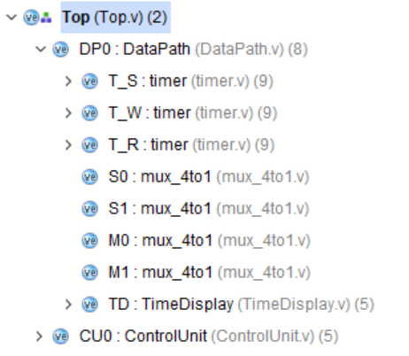
（2）主模块代码
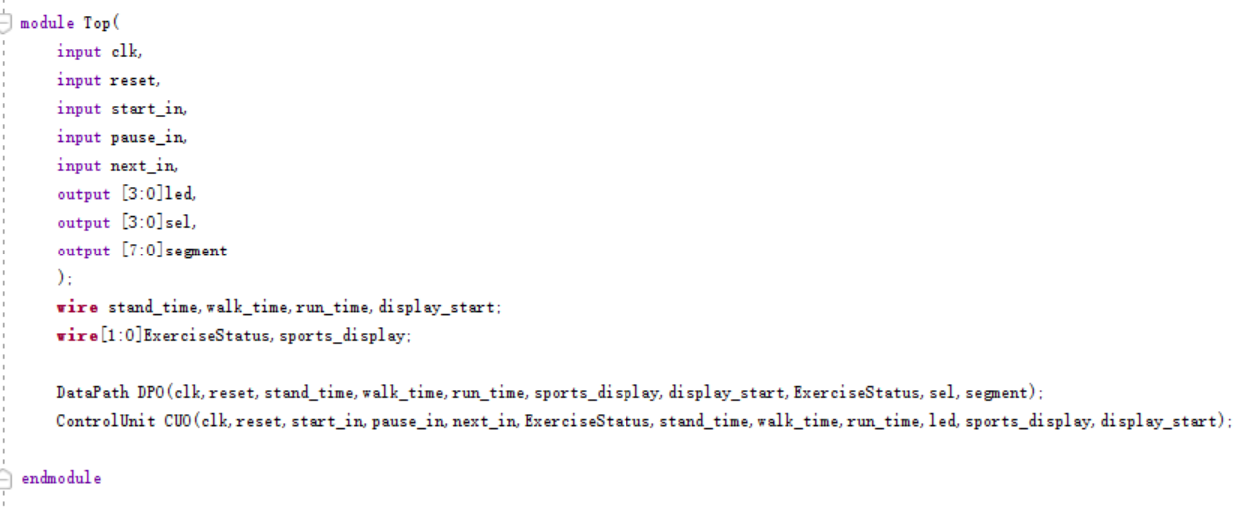
（3）子模块代码（DataPath）
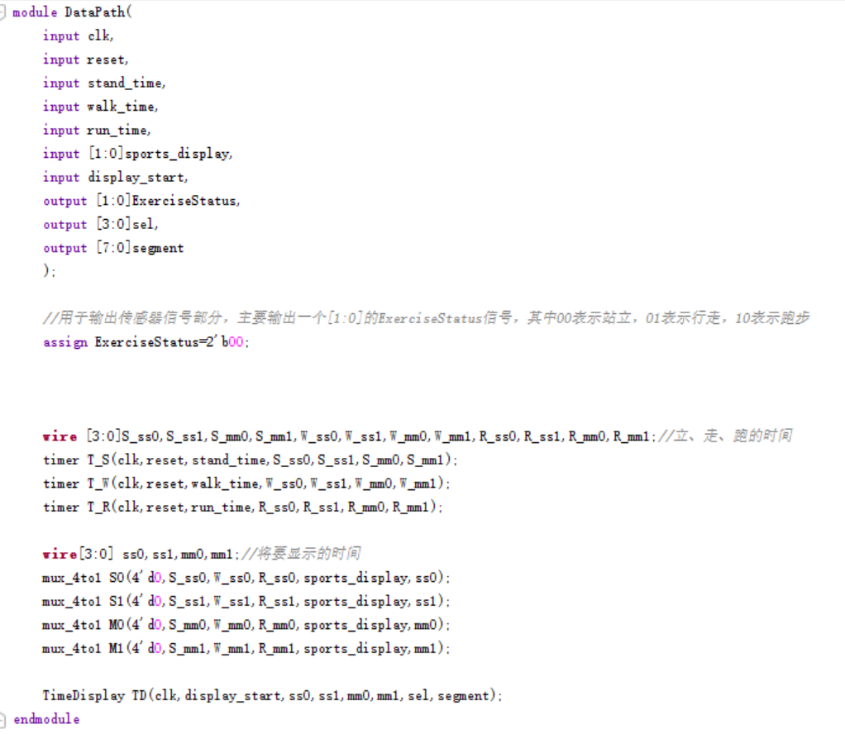
数据通路
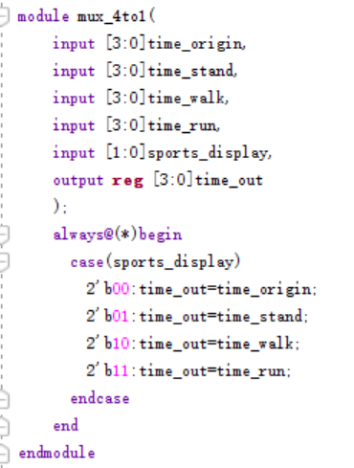
数据选择器
- 仿真实现
在代码编写过程中，对几个模块分别进行了仿真，发现它们都能够正常运行，具体仿真及代码如下图所示：
- 计时器模块仿真
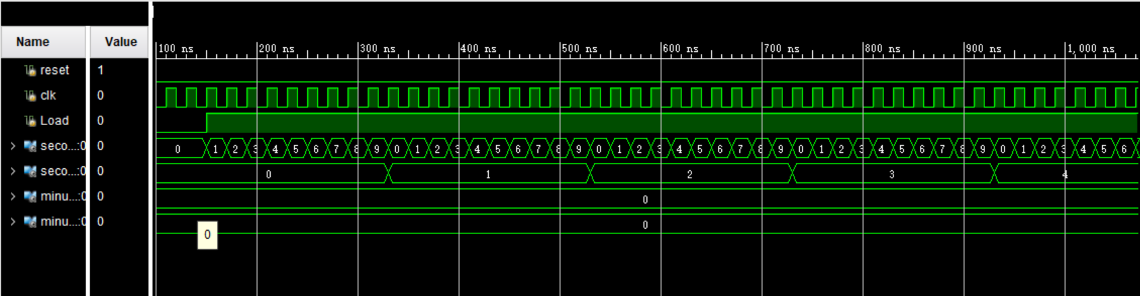
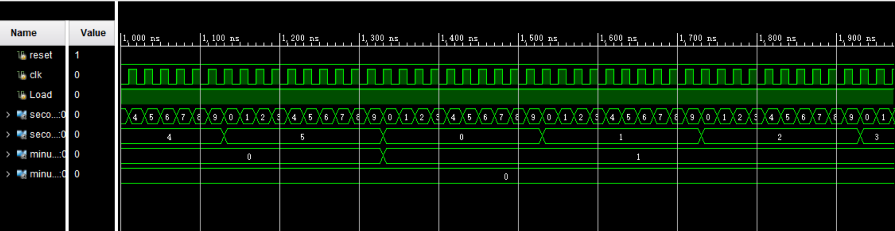
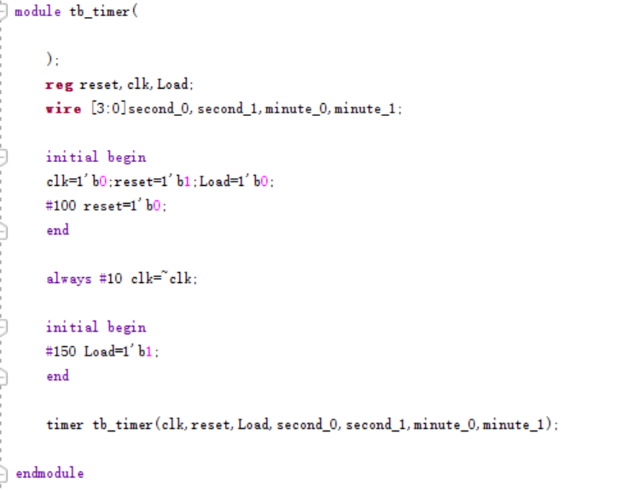
- 显示模块仿真
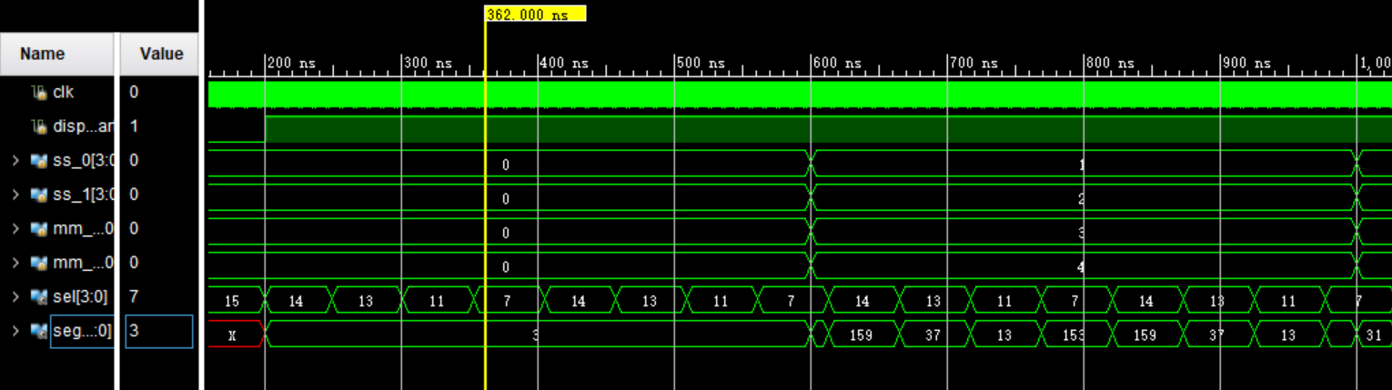
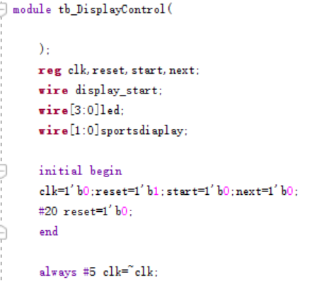
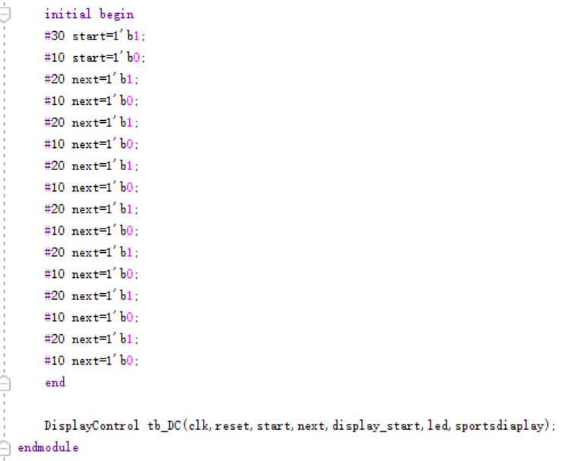

- 功能实现
由于传感器模块，所以最终实验之时直接拟定了一个站立信号，能够为此计时，并通过按钮显示各个状态下的计时，这一功能成功实现。
