

**BAKERY SHOPPING**

**Software Requirement Specification**

– Hanoi, May 2022 –

**Table of Contents**

**I. Overview** 3

1. Introduction 3

2. System Functions 4

3. Common Requirements 5

**II. Functional Requirements** 6

**1. Customer** 6

a. My Orders 6

b. Order Information 6

**2.** **Sales** 7

a.Sales Dashboard 7

b.Orders List 7

c.Order Details 8

**3****.** **Marketing** 8

a.MKT Dashboard 9

b.Posts List 9

c.Post Details 10

d.Sliders List 10

e.Slider Details 11

f.Products List 11

g.Product Details 12

h.Customers List 12

i.Customer Details 12

k.Feedbacks List 13

l.Feedback Details 14

**4****.** **Admin** 14

a.Admin Dashboard 15

b.Users List 15

c.User Details 16

d.Settings List 16

e.Setting Details 16

**5. Public** 17

a.Home Page 17

b.Blogs List 17

c.Blog Details 18

d.Products List 18

e.Product Details 19

f.Cart Details 19

g.Cart Contact 20

h.Cart Completion 20

i.Feedback 21

# I. Overview

## 1. Introduction

The Bakery Shopping System is a new software system that replaces the current manual and phone processes for ordering and selecting custom cakes in the shop. The system is expected to evolve through multiple issuances, eventually connecting to an Internet ordering service for everyone, a restaurant, an event, and a credit and debit card authorization service.

## 

## 

## 

## 2. System Functions

#### a. Screen Flow

Admin

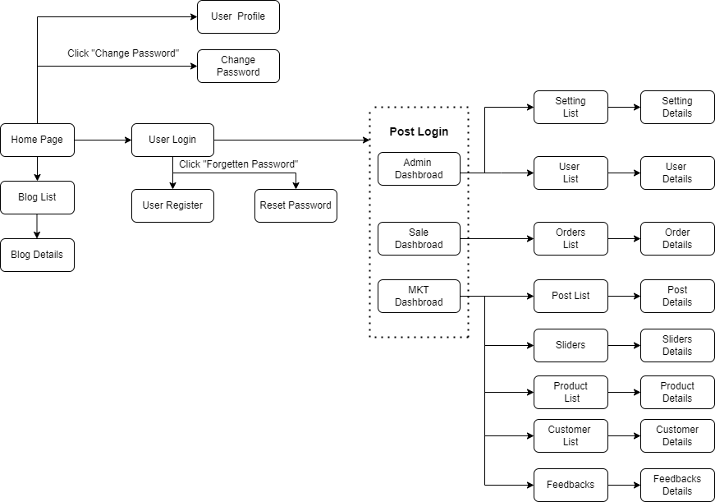

User

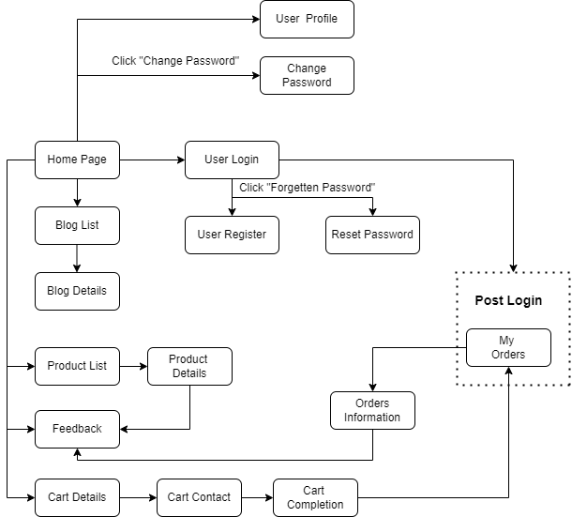

#### b. Screen Details

*[Provide the descriptions for the screens in the Screens Flow above]*

|  |  |  |  |
| --- | --- | --- | --- |
| **#** | **Function/Screen** | **Feature** | **Function/Screen Details** |
| 1 | Home Page | Public | Show sliders, hot posts, featured products + the sider with the latest posts, static contacts/links  - Shown slider information includes its image and title; the user is redirected to the slider's backlink on his/her clicking  - Shown post information includes its thumbnail, title, brief-info; the user is redirected to the post's details on his/her clicking  - Shown product information includes its thumbnail, title, brief information; the user is redirected to the product's details on his/her clicking |
| 2 | Blogs List | Public | Show the posts paginatedly (sorted by updated date, paginated) + the sider with the post search box, post categories, the latest posts, and static contacts/links; Shown post information includes its thumbnail, title, brief-info; the user is redirected to the post's details on his/her clicking |
| 3 | Blog Details | Public | Show post details (including title, author, updated date, category, and post details) + the sider with the post search box, post categories, static contacts/links |
| 4 | Products List | Public | Show the products paginatedly (sorted by updated date) + the sider with the product search box, product categories, the latest products, and static contacts/links;  - Shown product information includes its thumbnail, title, brief information, original price, and sale price;  - The user is redirected to the product's details on his/her clicking on the product  - The user can choose to add the product to the cart or to feedback on the product by clicking the product's Buy & Feedback buttons responsively |
| 5 | Product Details | Public | Show product details (including title, category, images, original price, sale price, and product details) + the sider with the product search box, product categories, the latest products, and static contacts/links |
| 6 | Cart Details | Public | Show the cart details with list of the user's chosen products (including Id, title, price, quantity, total cost) and the total order price + the sider with the product search box, product categories, the latest products, and static contacts/links; The user can  - Change the quantity of each product: the total cost is automatically adjusted  - Choose to delete/remove product by clicking on the deleting icon  - Click the Choose More Product button to go to Products List page  - Click the Check Out button to go to the Cart Contact page  Please notes: the user's chosen products from the last browsing session are remained in his/her cart until s/he submit the cart. However, the product prices are updated with the latest prices in the system |
| 7 | Cart Contact | Public | Show the list of user chosen product (including id, title, price, quantity, total cost), the total order price and the receiver information (including full-name, gender, email, mobile, address, notes) for user to edit/input + the sider with the product search box, product categories, the latest products, and static contacts/links  - In case the user has logged in, the receiver information would be filled with the user's information  - The user can click the Change button to come back to the Cart Details page for changing the choosing products, click the Submit button to submit the order before redirecting user to the Card Completion or Error page (due to technical error or any out-of-stock product) |
| 8 | Cart Completion | Public | This page show the cart completion notes + the sider with the product search box, product categories, the latest products, and static contacts/links; Before this page is shown:  - The Order status is changed to submitted;  - The product's available quantities are updated accordingly  - The submitted order is assigned automatically to the active salers rotatedly  - If the receiver information (name, email, mobile, gender) is new or changed (checking via the email0, the latest receiver information is stored in the system as latest & historical system contact information (for the marketing's reference later)  - The customer/user would be received the order confirmation & payment guides via his/her email. Those information is shown on the page also. The payment information (banking account,...) are taken from the system configuration file |
| 9 | Feedback | Public | On receiving the bought products successfully, the receiver would receive a confirmation email with the guides to feedback on each of the received product; Beside, the user/receive could also give the feedback (on a specific product or general feedback) via the website; The user also call this screen from the system menu on the header;  The feedback information includes contact information (full name, gender, email, mobile), rated star, the attached images and the contact's free-format feedback  The page sider is also shown with the product search box, product categories, static contacts/links; |
| 10 | User Login | Common | This is a pop-up screen which allows the user to enter email & password to login; on this page, there are also options for user to register new information or reset the password for the case s/he forget it |
| 11 | User Register | Common | This is a pop-up screen which allows the user to register himself/herself to the system by inputing following information: full name, gender, email, mobile, and address; User then need to verify by clicking the link sent via email to him/her before being able to access the system |
| 12 | Reset Password | Common | The user to input his/her email to receive the reset password link. This link is sent to the user's email for his/her password resetting.  - On clicking the link, the user is redirected to the password resetting page in which s/he input new password (twice) for the system access  - Note that the link is only available for a specific time duration as configured in the system config file. |
| 13 | Change Password | Common | This is a pop-up screen which allows the user to change his/her password by inputting his current password as well as new password (twice) |
| 14 | User Profile | Common | This is a pop-up screen which allows the user to edit his/her profile information, including the registered ones & the avatar image. Please note that s/he is not allowed to change the email |
| 15 | User Authorization | Common | Implementation of authorization mechanism in the system, including the specify the role of logged-in user, his/her authorized page links (building the displayed menu items (in the front end) and preventing unauthorized access via enter the links directly) |
| 16 | My Orders | Customer | Show the list of user's orders paginatedly + the sider with the product search box, product categories, the latest products, and static contacts/links  - Each order include below information: id, ordered date, product (first product name & number of other products if any), total cost, status;  - On clicking the link under the order id, user would be redirected to the Order Information page |
| 17 | Order Information | Customer | Show the order details, including the information as below + the sider with the product search box, product categories, the latest products, and static contacts/links  - The order id, order date, total cost, status  - The receiver information: full name, gendar, email, mobile  - This list of ordered products, each product include following information & the links/buttons that allow the user to re-buy or feedback: thumbnail, name, category, unit price, quantity, total cost  For the submitted orders, the user can choose to update (redirect the user to the Cart Details page for that) or cancel the order |
| 18 | MKT Dashboard | Marketing | Show statistics of posts, products, customers, feedbacks & the trend of new customers by day for the last 7 days (the start date & end date can be adjustable) |
| 19 | Posts List | Marketing | Show the paginated list of posts (include posts' id, thumbnail, title, category, author, featured, and status information):  - The user can filter the post by category, author, status or search by title  - Sortable by title, category, author, featured, or status  - From each post, the user can choose to hide, show, view, edit it  - The page also have the button/link that allows the user to add new post |
| 20 | Post Details | Marketing | Show detailed post information (thumbnail, category, title, brief information, description, flag to turn the featurning on/off, status), from that allow the user to input, view or edit them |
| 21 | Sliders List | Marketing | Show the paginated list of sliders (including sliders' id, title, image, backlink, status)  - The user can filter the sliders by the status + search by title or backlink  - For each slider, the user can choose to hide, show, edit it |
| 22 | Slider Details | Marketing | Show detailed slider information (image, title, backlink, status, notes) |
| 23 | Products List | Marketing | Show the paginated list of products (include products' id, thumbnail, title, category, list price, sale price, featured, and status information):  - The user can filter the product by category, status or search by title, brief info  - Sortable by title, category, list price, sale price, featured, or status  - From each product, the user can choose to hide, show, view, edit it  - The page also have the button/link that allows the user to add new product |
| 24 | Product Details | Marketing | Show detailed product information (thumbnail, category, title, brief information, attached images, description, quantity, list price, sale price, flag to turn the featurning on/off, status), from that allow the user to input, view or edit them |
| 25 | Customers List | Marketing | Show the list of customers / contacts paginatedly (include contacts' id, full name, gender, email, mobile, status):  - The user can filter the customers by status + search by full name, email, mobile  - Sortable by full name, email, mobile, status  - From each customer, the user can choose to add new, view or edit it |
| 26 | Customer Details | Marketing | Show detailed customer/contact information (full name, gender, email, mobile, address, status), from that allow the user to input, view or edit them (excep for the status which is generated automatically - contact, potential or customer)  Besides, the screen also shows the list of customer/contact changes history in the form of a table which includes following columns: email, full-name, gender, mobile, address, updated by, updated date |
| 27 | Feedbacks List | Marketing | Show the list of feedbacks paginatedly (include feedbacks' contact full name, product name, rated star, status):  - The user can filter the feedbacks by status, product, rated star + search by full name, feedback content  - Sortable by full name, product name, rated star, status  - From each feedback, the user can choose to view or change it's status |
| 28 | Feedback Details | Marketing | Show the feedback details (contact full name, email, mobile, product, rated star, feedback, images status) from that allow the user to change its status |
| 29 | Sale Dashboard | Sale | Show the trend of success/total orders, and the revenues trends by day for the last 7 days for all or a specific sale person (the start date, end date, sale, order status can be adjustable) |
| 30 | Orders List | Sale | Show the list of orders paginatedly  - The list can be shorted by the order date, customer name, total cost, status  - Each order include below information: id, ordered date, customer name, product (first product name & number of other products if any), total cost, status;  - Allow the users to filter the order by the order date (from, to), sale name, status  - Allow the user to search the orders by order id, customer name  - On clicking the link under the order id, user would be redirected to the Order Details page |
| 31 | Order Details | Sale | Show the order details, including the following information:  - Basic order information: order id, customer full name, email, mobile, order date, total cost, sale name, status  - The receiver information: full name, gendar, email, mobile, address  - This list of ordered products, each product include following information: thumbnail, name, category, unit price, quantity, total cost  Sale Manager & the assigned Sale can change the order status & the sale notes  Sale Manager can assign the order to other sale |
| 32 | Admin Dashboard | Admin | Show statistics of new orders (success, cancelled, submitted), revenues (total, by product categories), customers (newly registered, newly bought), feedbacks (average star: total, by product categories) & the trend of order counts (success, all) by day for the last 7 days (the start date & end date can be adjustable) |
| 33 | Users List | Admin | Show the paginated list of registered users (include users' id, full name, gender, email, mobile, role, status):  - The admin can filter the users by gender, role, status  - Allow the admin to seach users by full name, email, mobile  - The list is sortable by id, fullname, gender, email, mobile, role, status  - From each user, the admin can choose to view or edit it  - The page also have the button/link that allows the admin to add new user |
| 34 | User Details | Admin | Show detailed user information (avatar, full name, gender, email, mobile, role, address, status), from that allow the user to add new, view or edit user information  - After adding, new generated login password would be email to the new user  - The admin can only edit/update the role and status of the user |
| 35 | Settings List | Admin | Show the paginated list of settings (include settings' id, type, value, order, status):  - The admin can filter the setting by type, status  - Allow the admin to seach settings by value  - The list is sortable by id, type, value, order, status  - From each setting, the admin can choose to view, activate/deactivate, or edit it  - The page also have the button/link that allows the admin to add new setting |
| 36 | Setting Details | Admin | Show detailed user information (type, value, order, description, status), from that allow the user to add new, view or edit setting information |

#### c. User Authorization

|  |  |  |  |  |  |
| --- | --- | --- | --- | --- | --- |
| **Screen** | **Guest** | **Customer** | **Marketing** | **Sale** | **Admin** |
| Query All Data |  |  |  |  | x |
| Query Own Data |  | x | x | x | x |
| Query Managed Data |  |  |  |  | x |
| Add New Data |  |  |  | x | x |
| Update All Data |  |  |  |  | x |
| Update Own Data |  | x | x | x | x |
| Update Managed Data |  |  |  | x | x |
| Delete Data |  |  |  |  | x |
| Login with Admin |  |  | x | x | x |
| Dashboard |  | x | x | x | x |
| Home | x | x |  |  | x |
| Products List | x | x | x | x | x |
| Blogs List | x | x | x | x | x |
| My Registrations | x |  |  |  |  |
| Cart | x | x |  | x |  |
| Posts List | x |  | x |  | x |
| Sliders List | x |  | x |  | x |
| New Products |  |  | x |  | x |
| Products Details |  | x |  | x | x |
| Customer List |  |  | x |  | x |
| Customer Details |  |  | x |  | x |
| Order List |  | x |  | x | x |
| Feedback |  | x | x |  | x |
| Registrations List |  |  |  | x | x |
| Registration Details |  |  |  | x | x |

In which:

• **Guest:** unregistered users

• **Customer:** they are registered users who are actual customers or potential customers

• **Marketing:** the marketing members of the organization

• **Sale:** the sale members of the organization

• **Admin:** the organization leader/manager, acts as the system administrator

## 

## 3. Common Requirements

|  |  |  |
| --- | --- | --- |
| **#** | **Feature** | **Description** |
| 1 | User Login | This is a pop-up screen which allows the user to enter email & password to login; on this page, there are also options for user to register new information or reset the password for the case s/he forget it. |
| 2 | User Register | This is a pop-up screen which allows the user to register himself/herself to the system by inputing following information: full name, gender, email, mobile, and address; User then need to verify by clicking the link sent via email to him/her before being able to access the system. |
| 3 | Reset Password | The user to input his/her email to receive the reset password link. This link is sent to the user's email for his/her password resetting.  - On clicking the link, the user is redirected to the password resetting page in which s/he input new password (twice) for the system access  - Note that the link is only available for a specific time duration as configured in the system config file. |
| 4 | User Authorization | Implementation of authorization mechanism in the system, including the specify the role of logged-in user, his/her authorized page links (building the displayed menu items (in the front end) and preventing unauthorized access via enter the links directly). |
| 5 | User Profile | This is a pop-up screen which allows the user to edit his/her profile information, including the registered ones & the avatar image. Please note that s/he is not allowed to change the email. |
| 6 | Change Password | This is a pop-up screen which allows the user to change his/her password by inputting his current password as well as new password (twice). |

# II. Functional Requirements

**1. Customer**

1. My Orders:

b. Order Information:

**2.** **Sales**

a. Sales Dashboard:

b. Orders List:

c. Order Details:

**3****.** **Marketing**

1. MKT Dashboard:
2. Posts List:
3. Post Details:
4. Sliders List:
5. Slider Details:
6. Products List:
7. Product Details:
8. Customers List:
9. Customer Details:

k. Feedbacks List:

l. Feedback Details:

**4****.** **Admin**

1. Admin Dashboard:

b. Users List:

c. User Details:

d. Settings List:

e. Setting Details:

**5. Public**

a. Home Page:

b. Blogs List:

c. Blog Details:

d. Products List:

e. Product Details:

f .Cart Details:

g. Cart Contact:

h. Cart Completion:

i. Feedback: