**Example II: Poisson Solver**

The Poisson problem is expressed by the following equations:  in the interior,  on the boundary. To simplify the discussion, we use the unit square as the domain. To find an approximate solution to this problem, we define a 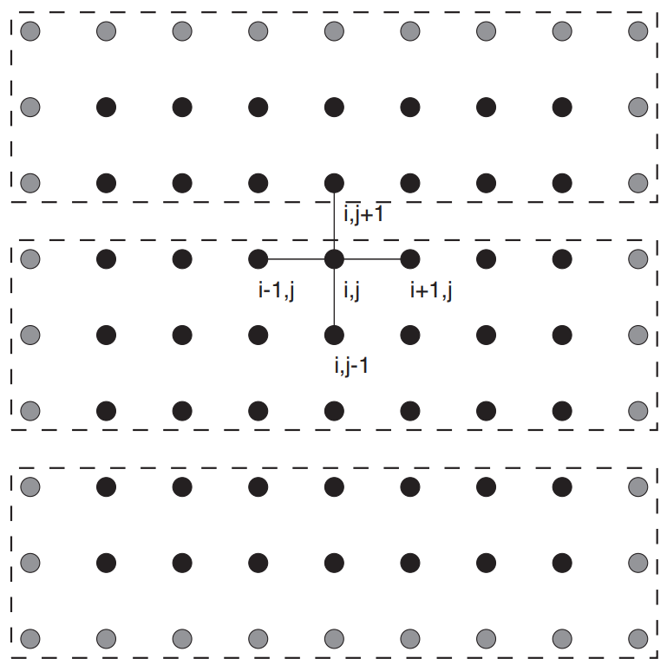grid consisting of the points (*xi*, *yj*), given by

 and 

We approximate the governing equation with a second-order finite difference scheme

, where 

We adopt the Jacobi iteration, which repeats updating the following equation until the solution is reached

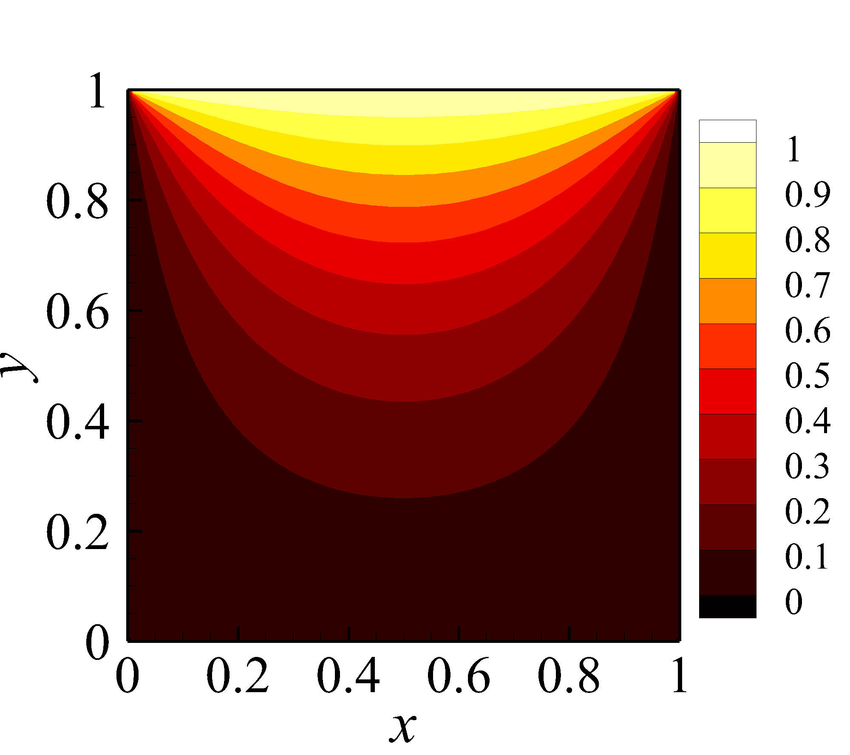

A special case of the Poisson equation is *f* = 0, which leads to the Laplace equation. The Laplace equation describes many transport processes, such as heat conduction. In the simulation, the domain is [0, 1] × [0, 1]. We set the initial condition as *u* = 0, and the boundary conditions as , .