**Example I: Calculate Pi**

We compute the value of  by numerical integration. Since



we will integrate the function .

We allocate a Fortran array *X(1:n)* to store , suggesting that there are *n*-1 intervals. Because we numerically integrate the function from 0 to 1, the length of each interval is 1/(*n*-1). Each element in the X array represents the value

*X*(*i*) = (*i*-1)/(*n*-1)

Using the trapezoidal rule, we can compute the integration as



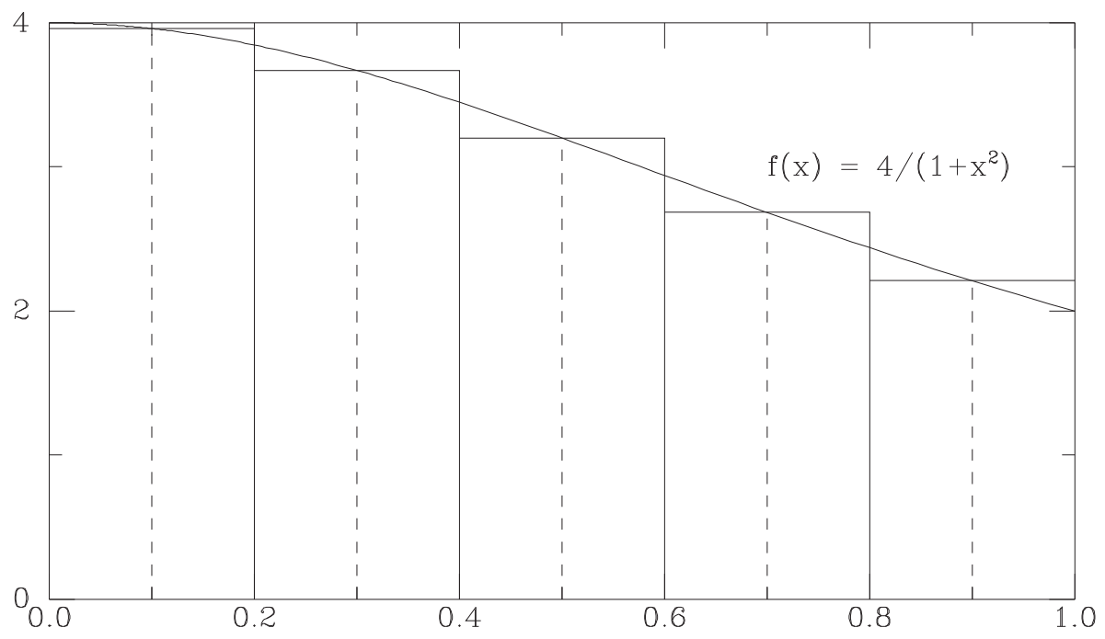 Or we can simply use the function value at X(*i*+0.5) and the interval length 1/(*n*-1) to calculate the summation, which gives .

Here, we allocate an array *Xcenter(1:n-1)* to store , and each element is represented as

*Xcenter*(*i*) = (*i*-0.5)/(*n*-1)

NOTE: The above two formulas are equivalent because in the trapezoidal rule we have 