Michael Kester

7/8/15

CSC 130/E41A

Final Project – Bank Account

**Pseudocode**

Create bank account class

Create constructor (account name, account number, account balance)

Create withdraw method (withdraw amount)

if account balance > withdraw amount

account balance = account balance – withdraw method

Output confirmation

else

Output insufficient funds

Create deposit method (deposit amount)

account balance = account balance + deposit amount

Output confirmation

Create inquiry method

Output current account balance

Create ToString method

account string = [formatting]

[formatting]

Name: account name

Balance: account balance

Account Number: account number

Create numAccounts method

Outputs number of accounts constructed

Create main (BankAccountTest)

Create random numbers via Math.random

Create new bank account using constructor with account name “Mike”, random account number, initial balance of $500

Output Mike’s account information using ToString method

Deposit $500 using deposit method

Call inquiry method for Mike

Create new bank account using constructor with account name “Susan”, random account number, initial balance of $100

Output Susan’s account information using ToString method

Withdraw $50 using withdraw method

Call inquiry method for Susan

Attempt to withdraw additional $70 (should get insufficient funds message)

Call inquiry method again for Susan

Output total number of accounts constructed using numAccounts method

**Screenshots**

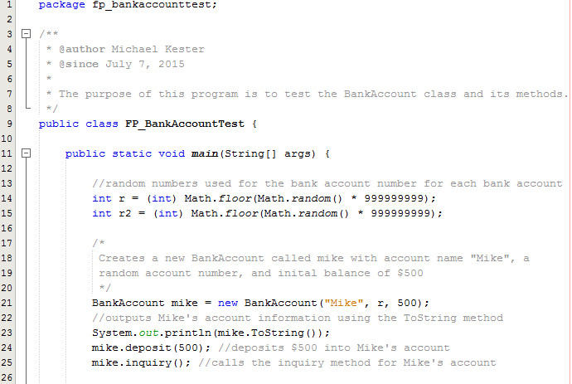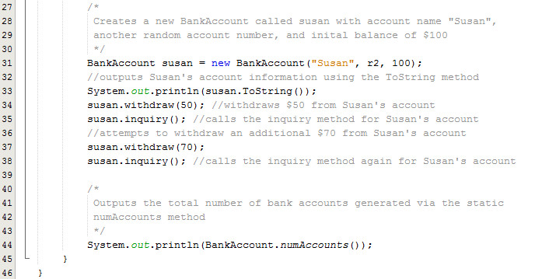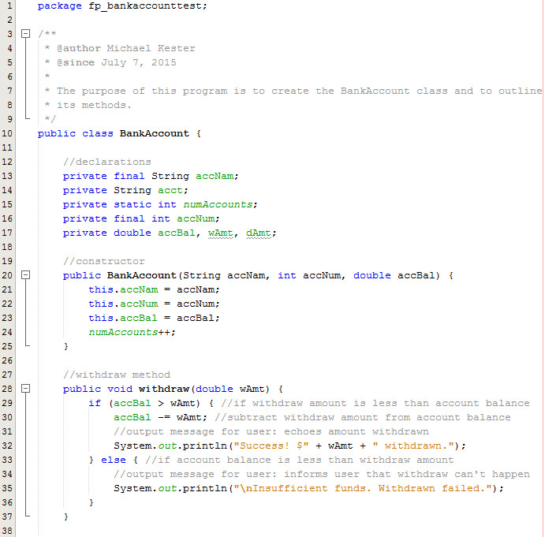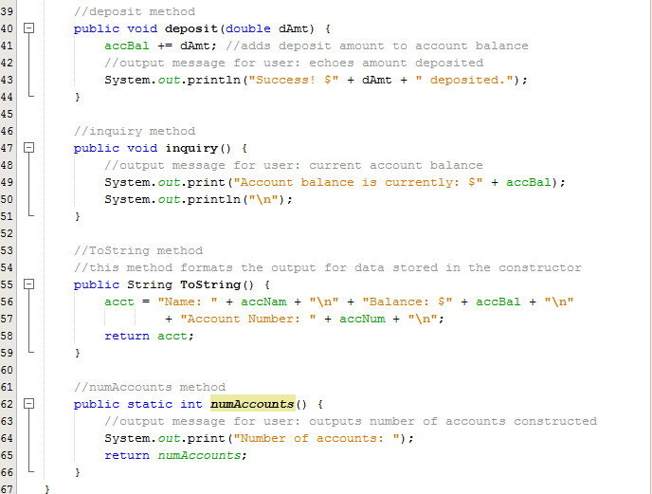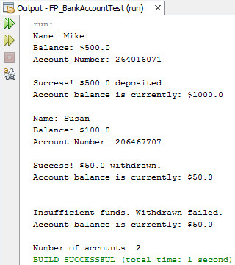

**UML Diagram**

