网狐棋牌机器人添加说明
- 先申请个账号为 zhou2848 的用户 密码随便
- 用网狐机器人账号生成器（又叫网狐压力测试生成器）生成一些账号。界面如下：
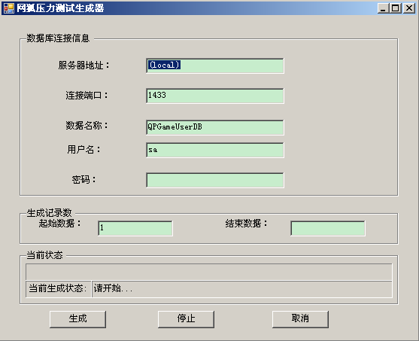
注：服务器地址、用户名、密码做相应修改；生成记录数：例生成50个，起始数据为1。结束数据为50。

- 让后执行如下脚本（一定要在相应的数据库执行）

Sql 2005添加机器人脚本

------------------------------------------------------------------------------------------------------------------------------------

delete from AndroidUserInfo
go

declare @KindID int
declare @ServerID int
declare @charts int

set @KindID = 103
set @ServerID = 5001
set @charts=256

insert into AndroidUserInfo(UserID,KindID,ServerID)
select top(@charts) UserID,@KindID,@ServerID
from QPGameUserDBLink.QPGameUserDB.dbo.AccountsInfo
where userid not in (
select UserID
from AndroidUserInfo
)
order by UserID desc

sql 2000添加机器人脚本

----------------------------------------------------------------------------------------------------------------------------------
delete from AndroidUserInfo
go

declare @KindID int
declare @ServerID int
declare @charts int

set @KindID = 100
set @ServerID = 6100
set @charts=50

insert into AndroidUserInfo(UserID,KindID,ServerID)
select top 50 UserID,@KindID,@ServerID
from QPGameUserDBLink.QPGameUserDB.dbo.AccountsInfo
where userid not in (
select UserID
from AndroidUserInfo
)

and userid>15
order by UserID desc
------------------------------------------------------------------------------------------------------------------------------------

注意：其中红色部分是需要改动的
@KindID后为游戏的KINDID。例如斗地主就是 100
@ServerID后为房间标识
@charts为添加机器人的个数

