360.\*

2018-06-04 Release:

* Application HoloGraph

App -> Files -> Users/Devices -> Devices/Users

App -> Users -> Files/Devices -> Devices/Files

App -> Devices -> Files/Users -> Users/Files

* Before - No data alert for HoloGraph (all four holographs)

Update - There should be an alert show up when HoloGraph has no data.

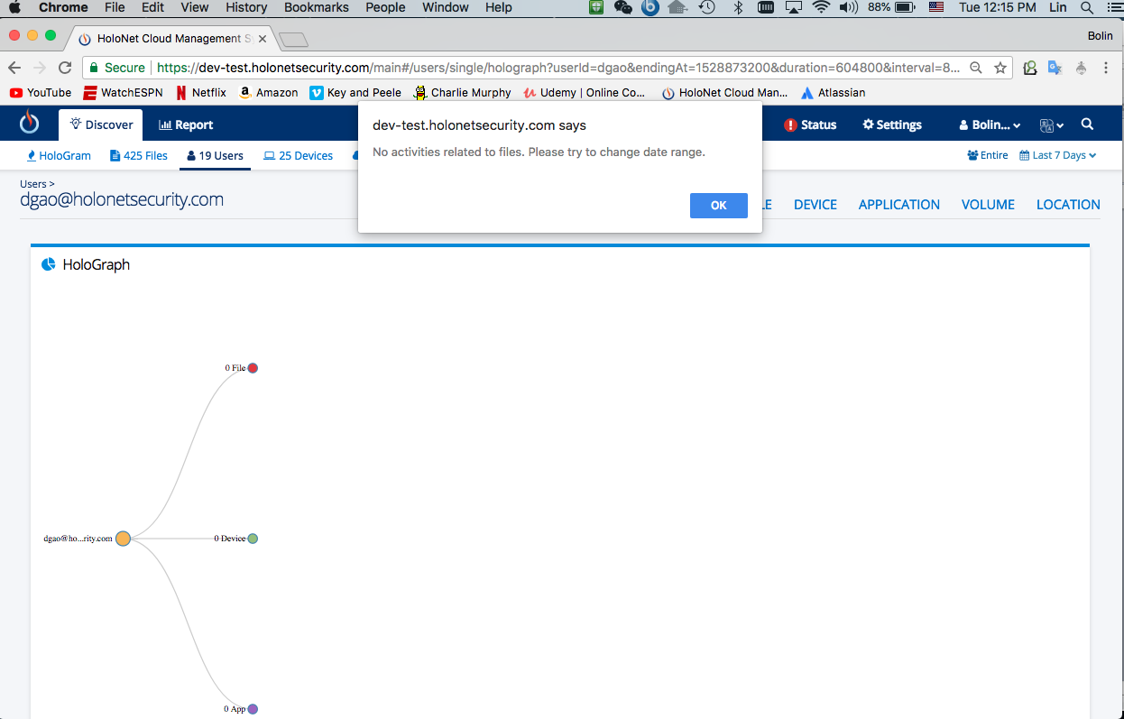

* Files Summary – File Access Count History click event added

New window shows up for file details that contain all the files activities in that specific time slot.