Commit Roaster Project Proposal
AI-Project-1 | Python CLI + Dify + OpenRouter | Target: Windows 11 | October 2026
Goal. A Python command-line tool that reads the last 20 commit messages from any local Git repo and has an LLM roast them. The prompt and model choice live in a Dify app connected to OpenRouter, so you can change the persona or swap models (Claude, GPT, Llama and others) in Dify without changing code. The script only ever needs one secret: the Dify app key.
PIPELINE
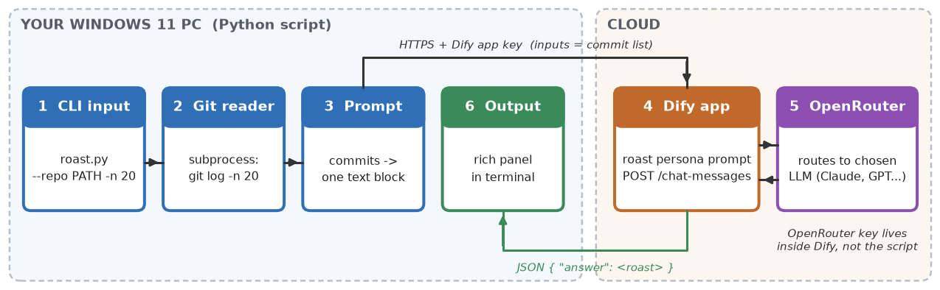
KEY LAYERS AND TECHNOLOGY STACK
Layer | Responsibility | Recommended | Alternative
1 Input (CLI) | Parse --repo, -n (default 20), --tone | argparse (stdlib) | Typer
2 Data (Git reader) | Run git log; split hash / author / age / subject | Git for Windows + subprocess | GitPython
3 Prompt builder | Number commits, trim long ones, cap ~4k chars | Plain Python f-strings | Jinja2 templates
4 Orchestration | Hold the roast persona prompt + rules; call the model | Dify Cloud Chat app, called with requests | Self-hosted Dify (Docker Desktop + WSL2)
5 Model gateway | Route to an LLM, metering and billing | OpenRouter (key stored in Dify) | Call OpenRouter directly (OpenAI-style API)
6 Presentation | Show the roast; friendly errors | rich (panels, colour) | plain print()
X Config / secrets | Dify URL + app key, defaults | python-dotenv + .env (git-ignored) | Windows user env vars
PSEUDOCODE AND SETUP
def main():  args = parse_args() # --repo . -n 20  load_dotenv() # DIFY_API_KEY, DIFY_BASE_URL  log = run(['git', '-C', args.repo, 'log', f'-n{args.n}',  '--pretty=format:%h%x1f%an%x1f%ar%x1f%s'])  commits = [ln.split('\x1f') for ln in log.splitlines()]  text = '\n'.join(f'{i}. [{h}] {msg} ({who}, {age})'  for i, (h, who, age, msg) in enumerate(commits, 1))  r = requests.post(f'{BASE}/chat-messages',  headers={'Authorization': f'Bearer {KEY}'},  json={'query': text, 'inputs': {},  'response_mode': 'blocking', 'user': 'cli'},  timeout=60)  r.raise_for_status()  print(Panel(r.json()['answer'], title='Commit Roast')) | Windows 11 dev environment  - One script: setup\setup_windows.ps1 records PC specs, installs Python 3.12, Git and VS Code (winget), builds .venv and creates .env.  - OpenRouter: create an API key and set a credit limit. Free models work for testing.  - Dify Cloud: Settings, Model Providers, OpenRouter, paste the key. Create a Chat app with the roast persona prompt (savage but no slurs or personal attacks). Copy its app- key into .env.  - Repo: github.com/xucaleb6335/AI-Project-1 (private).  Milestones  - M1 Environment set up and accounts connected (done when the Dify app answers a test message)  - M2 Git reader and prompt builder  - M3 Dify call, output, error handling  - M4 Extra options (--tone, --author) and tests
RISKS AND GUARDRAILS
- Secrets: .env is git-ignored and the OpenRouter key never leaves Dify. Cost: set an OpenRouter credit limit; 20 commits is about 1-2k tokens per run.
- Edge cases: not a Git repo or empty history gives a clear error; very long messages are trimmed. Tone: the persona targets the commit messages, never the people who wrote them.

