实验目的： 掌握所有点对之间的最短路径的常用算法

实验内容：编程实现Dijkstra算法和Bellman-Ford算法

Python code

Dijkstra and bellman-Ford:
import logging as l
import math
inf = math.inf
l.basicConfig(level=l.INFO)
class Edge():
def __init__(self, start, end, weight):
self.start = start
self.end = end
self.weight = weight
class Node():
def __init__(self, sign):
# self.number = number
self.sign = sign
# for initial nodes(vertex) of the graph
self.distance = math.inf
# set the node's precursor:
self.precursor = None
def initialize_source_node(self):
self.distance = 0
return self
class G():
# the source node :
s_node = None
def __init__(self, edges, nodes):
self.edges = edges
self.nodes = nodes
# def generate_nodes(self):
# # get the nodes number(you can custom the number regularity,there use the default simple number system)
# self.nodes = [Node(chr(sign)) for sign in range(ord('A'), ord('E')+1)]
def print_nodes(self):
for node in self.nodes:
# l.debug(f'{node.sign,node.distance}')
print(f'{node.sign, node.distance}')
def print_nodes_ford(self):
self.print_nodes()
def print_nodes_dijkstra(self, nodes_ite):
for node in nodes_ite:
# l.debug(f'{node.sign,node.distance}')
print(f'{node.sign, node.distance}')
def get_weight(self, u, v):
for edge in self.edges:
if edge.start == u and edge.end == v:
return edge.weight
return math.inf
def relax(self, edge):
u = edge.start
v = edge.end
l.debug(f'self.weight(u, v):{self.get_weight(u, v)}')
new_distance = u.distance + self.get_weight(u, v)
# debug
l.debug(f'{edge.start.sign, edge.end.sign}')
l.debug(f'new_distance:{new_distance}')
if v.distance > new_distance:
v.distance = new_distance
v.precursor = u
# def initialize_single_source(G, source_node):
# # for node in G.nodes:
# # node.distance=0
# # node.precursor=None
# source_node.distance = 0

#bellman_ford()
def bellman_ford(self, s):
G.s_node = s.initialize_source_node()
# l.info(f'G.s_node:{G.s_node.sign}')
for i in range(len(self.nodes) - 1):
for edge in self.edges:
self.relax(edge)
l.debug(f'{edge.end.distance}')
return self

# dijkstra()
def dijkstra(self, source_node):
G.s_node = source_node.initialize_source_node()
S = [] # the S is the set which contain the solved points
# Q={}
Q = self.nodes[:]
# for node in self.nodes:
# # Q[node.sign]=node.distance
# Q.append([node.sign,])
while len(Q) > 0:
node_u = min(Q, key=lambda item: item.distance)
S.append(node_u)
# print("len=",len(Q))
Q.remove(node_u)
for edge in self.edges:
if edge.start.sign == node_u.sign:
self.relax(edge)
# print("there...")
return S
# def print_dijkstra(self):
# print_nodes(self.dijkstra())
def print_ford_result(self):
# self.bellman_ford(s)
if not self.is_exist_shortest():
print("there is a negative circle.")
else:
for node in self.nodes:
# print()''' '''
print(f'from source node to node:{node.sign},the minimal distance is:{node.distance}')
def is_exist_shortest(self):
for edge in self.edges:
if edge.end.distance > edge.start.distance + edge.weight:
return False
return True
def print_precursor(self, node):
if node.sign == G.s_node.sign:
print(G.s_node.sign, end=" ")
# return
else:
if node.precursor == None:
print(G.s_node.sign, "->", node.sign,
"(the node is not accessible)", end=" ")
else:
self.print_precursor(node.precursor)
print(node.sign, end=" ")
def print_path(self):
for node in self.nodes:
# print(node.sign)
self.print_precursor(node)
print()
def print_nodes(nodes_ite):
for node in nodes_ite:
# l.debug(f'{node.sign,node.distance}')
print(f'{node.sign, node.distance}')
def get_node_instance(sign):
for node in nodes:
if node.sign == sign:
return node
# throw exception
return None
# get the edges parameters to instantiate the edge nodes ,put the edges to the list edges;
def generate_directed_edges():
# the node instances constructed by the strings
while (True):
line = input("input node:(,,)")
if line == "0":
break
edge_param = line.split(",")
start, end, weight = edge_param[0], edge_param[1], int(edge_param[2])
start_node = get_node_instance(start)
end_node = get_node_instance(end)
# print(end_node.sign)
edges.append(Edge(start_node, end_node, weight))
return edges
def generate_nodes():
# get the nodes number(you can custom the number regularity,there use the default simple number system)
nodes = [Node(chr(sign)) for sign in range(ord('1'), ord('6') + 1)]
return nodes
'''debug the edges is right: '''
def print_edges():
for edge in edges:
# print(edge.start.sign,edge.end.sign,edge.weight)
l.info((edge.start.sign, edge.end.sign, edge.weight))
nodes = []
nodes = generate_nodes()
edges = []
edges = generate_directed_edges()
G = G(edges, nodes)
# G.print_nodes()
source_node = input("input the source node you want:(from 'A'~'E')\n")
# source_node="A"
source_node = get_node_instance(source_node)
result = G.dijkstra(source_node)
print("solved by dijkstra:")
G.print_nodes_dijkstra(result)
print("solved by bellman_ford:")
G.bellman_ford(source_node)
G.print_nodes_ford()
G.print_ford_result()
G.print_path()
'''
the dijkstra only solve the data without negative weights in edges of the Graph
''' test data 2:
1,2,10
2,1,10
1,5,45
5,1,45
1,4,30
4,1,30
4,6,20
6,4,20
2,3,50
3,2,50
2,5,40
5,2,40
2,6,25
6,2,25
3,5,35
5,3,35
3,6,15
6,3,15
5,6,55
6,5,55
0
'''

实验要求：以下图作为输入，进行测试上述算法，比较二者的性能。

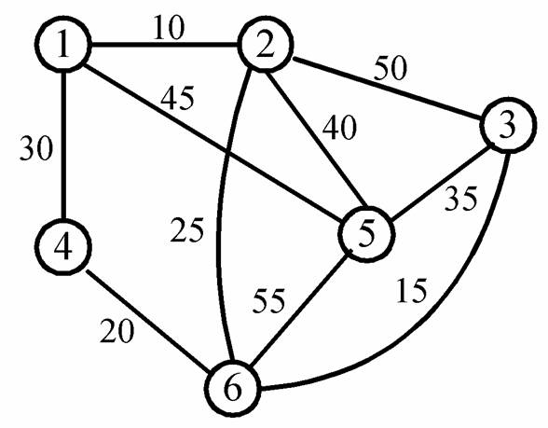

运行结果:
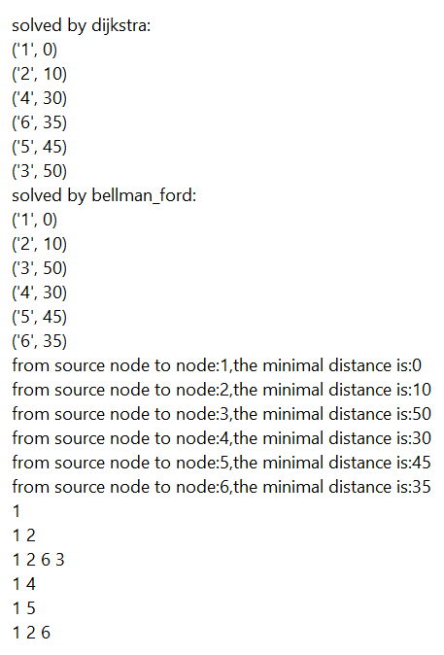

性能比较:

Dijkstra效率更高

