
FPT-aptech computer education
eProject Document
National Level Paper Presentation
fat2-c0808l-s4-g2
Group Member | Nguyễn Việt Hùng (vn.040/200807/0124)  Trịnh Nam Phong (vn.041/200808/0064)  Nguyễn Văn Vinh (vn.041/200809/0135)
Instructor | Đỗ Quốc Bình
Batch | C0808L
Semester | 4

- Hanoi, 08/2011 -

Contents
1. Introduction 7
2. Problem Definition 7
2.1. Problem Abstraction 7
2.2. The Current System 7
2.3. The Proposed System 8
2.4. Boundaries of the System 10
2.5. System requirement 10
2.6. Development Environment 11
3. Requirements and Business Flow 11
3.1. Customer Requirement Specification 11
3.1.1. User subcribe 11
3.1.2. User enroll on online system 11
3.1.3. Employee create enrollment for user 12
3.1.4. Payment 12
3.2. Data flow diagram 13
3.2.1. DFD Level 0: Context diagram 13
3.2.2. DFD Level 1: Website process 14
3.3. Use Case Diagram 18
3.3.1. System Use Case 18
3.4. Use Case Specification 18
3.4.1. Register 18
3.4.2. Login 20
3.4.3. Update account information 21
3.4.4. Subcribe 22
3.4.5. Unsubcribe 24
3.4.6. Enroll 25
3.4.7. Unenroll 26
3.4.8. Manage payment 27
3.4.9. Manage event 29
3.4.10. Active enrollment 30
3.4.11. Create enrollment for guest 31
3.4.12. Manage account 32
4. Design 34
4.1. System Architecture 34
4.2. Class Diagram 35
4.3. Package Diagram 36
4.4. Active Diagram 37
4.4.1. Subcribe 37
4.4.2. Unsubcribe 38
4.4.3. Enroll 39
4.4.4. Unenroll 39
4.4.5. Accept payment 40
4.4.6. Active enrollment 41
4.5. Sequence Diagram 41
4.6. State Diagram 44
4.7. Entity Relationship Diagram 44
4.8. Database Design 45
4.9. Table details 46
4.9.1. Event 46
4.9.2. Category 46
4.9.3. Person 47
4.9.4. Enrollment 47
4.9.5. Comment 48
4.9.6. Subcriber category 48
5. Management and Project Planning 48
5.1. Management Approach 48
5.2. Project Plan 48
6. Checklists 50
6.1. Check List of Validation 50
6.2. Submission Checklist 50
7. Screenshots 50
7.1. Manager’s pages 51
7.2. User’s pages 56
8. Coding Convention 58
8.1. Naming Convention 58
8.2. Documentation 59
8.3. Java Comments 59
8.4. Standards For Member Functions 60
8.4.1. Naming member functions 60
8.4.2. Naming Accessor Member Functions 60
8.4.3. Member Function Visibility 61
8.4.4. Documenting Member Functions 61
8.5. Techniques for Writing Clean Code 63
8.6. Standards for Fields (Attributes / Properties) 63
8.6.1. Naming Fields 63
8.6.2. Naming Components 64
8.6.3. Naming Constants 64
8.6.4. Field Visibility 64
8.6.5. Documenting a Field 65
8.6.6. Usage of Accesors 65
8.7. Standards for Local Variables 67
8.7.1. Naming Local Variables 67
8.7.2. Declaring and Documenting Local Variables 68
8.8. Standards for Parameters (Arguments) to Member Functions 68
8.8.1. Naming Parameters 68
8.8.2. Documenting Parameters 69
8.9. Standards for Classes, Interfaces, Packages, and Compilation Units 69
8.9.1. Class Visibility 69
8.9.2. Naming classes 69
8.9.3. Documenting a Class 69
8.9.4. Ordering Member Functions and Fields 70
8.10. Standards for Interfaces 70
8.10.1. Naming Interfaces 70
8.10.2. Documenting Interfaces 70
8.11. Standards for Packages 70
8.11.1. Documenting a Package 70
8.12. Standards for Compilation Unit (Source code file) 71
8.12.1. Naming a Compilation Unit 71
8.12.2. Beginning Comments 71
8.12.3. Declaration 71
8.12.4. Indentation 72
8.12.5. Line Length 72
8.12.6. Wrapping Lines 72
8.12.7. Declaration 75
8.12.8. Initialization 75
8.12.9. Placement 75
8.12.10. Class and Interface Declarations 76
8.12.11. Statements 77
8.13. Naming Conventions Summary 83

Figure list
Figure 1. DFD Context diagram 13
Figure 2. DFD Website process 14
Figure 3. DFD Event management 15
Figure 4. DFD Enrollment management 16
Figure 5. DFD User management 17
Figure 6. System use case 18
Figure 7. 3-tiers Architechture 34
Figure 8. DAO Classes 35
Figure 9. BO Classes 35
Figure 10. Package Diagram 36
Figure 11. Active diagram for subcribe use case 37
Figure 12. Active diagram for unsubcribe use case 38
Figure 13. Active diagram for enroll use case 39
Figure 14. Active diagram for unenroll use case 39
Figure 15. Active diagram for accept payment use case 40
Figure 16. Active diagram for active enrollment use case 41
Figure 17. Add new Employee 41
Figure 18. Add new enrollment for event 42
Figure 19. Enroll for event 42
Figure 20. Cancel event enrollment 42
Figure 21. Payment 42
Figure 22, Register for customer 43
Figure 23. Subcribe 43
Figure 24. ER Diagram 44
Figure 25. Database diagram 45
Figure 26. Event table details 46
Figure 27. Category table details 46
Figure 28. Person table details 47
Figure 29. EnrollEvent table details 47
Figure 30. Comment table details 48
Figure 31. EmailReceiverEventCategory details 48

Introduction
KSC Technology and Sciences is the educational university which runs the classes for the categories like Engineering, Pharmaceutical sciences, Literature, etc. It is one of the famous universities in the country. They generally conduct Paper Presentations at state level and national level. They also conduct seminars, Techno-Feat, etc. so as to entertain the students in the technical back grounds.

Problem Definition

Problem Abstraction
KSC Technology and Sciences want to provide a facility where the participants can register themselves online and as well the invitation can be displayed directly online itself in the specific portal. Once they are registered online they can send the details of the payment along with the print out of the enrollment along with the signature of the participant and for the paper presentation, the hard copy of the paper presentation will be sent along with it.

The Current System
Each time when KSC Technology and Sciences conduct seminars, symposiums, or paper presentation, etc. they used to send the invitations for the participation of the students of other colleges, etc. so that the knowledge of the student can be enhanced and at the same time, the students who does not belong to this university can also have the opportunity in participating in these activities.
While sending the invitations to the other colleges, universities, they quote some registration fees for the gate pass and also they will provide the details like the topics for which seminars or paper presentations or symposiums or techno-feats are conducted. For the seminars and the Techno-feats they also provide the names of the speakers who are conducting or providing this. Along with the invitation they also send the format of enrollment, which is to be filled and sent back to the address as mentioned in the invitation for participating in the activities.
In general to participate in these activities, the students who do not belong to this university send their requests by filling in the enrollment form as per the format sent and send it along with the payment through courier or directly dropping it at the address in personal. In case of the Paper presentations, along with the courier, they also used to submit both the soft copy and the hard copy, so that they can reach the mentioned address before the end date of the participation. After sending these copies, they used to verify and then finalize which students are to be participated in this paper presentation. The selection is purely based on the technology (like mostly they prefer the new implementations in the technology, etc.).

The Proposed System
They want that the following steps to be incorporated in the website.
- There should be a logo indicating the brand of the institute on all the web pages. (Note: the logo can be of any institution or it can be designed by your own as well)
- On the home page of the website the details of the upcoming activities, and the winners of the recent activity conducted is to be displayed. Also the details of the participants like how many are registered for the recent or for the latest activity conducted can be displayed on the home page.
- The user can also create the account with the website, with his/her personal mail id. So that if any activity is going to be launched a mail will be marked to the mail id that is mentioned during the time of registration with the site.
- When a user tries to access the link of the activity like symposium, seminar, techno-feat, etc. he/she should be able to view the details like
- Date and time of conducting
- The procedure for applying for the participation
- The fees details
- Payment options
- Eligibility criteria
- Speakers name or guest’s name
- Topics on which the activity is performed
- Prize details if any
- Address for sending the enrollments for the participation
- Terms and conditions, etc.
- The navigation bar should include the following
- Home Page
- Login Page
- Enrollment or enroll Page
- Update/Edit Page
- Subscribe Page (through this one can create the account) and unsubscribe
- Page (through this one can deactivate the account created)
- About Us Page
- Contact Information Page
- Through Login page, users and admin can login.
- Through the Enroll page one can enroll or apply for symposiums, seminars, Techno-Feat, etc.
- Through Un-Enroll for an event (symposiums/seminars/Techno-Feat)
- Through Subscribe Page one can subscribe for the mailing lists and create the account with the site.
- Through Unsubscribe Page one can subscribe for the mailing lists.
- Through Update page that is available after login one can Manage Personal Information
- It should also include the About Us and Contact information.
- The payment options to be included are
- Payment through Demand Draft
- Payment through Cheque
- Payment by cash
- The enrollment can be done in both the ways
- Online enrollment
Note: The payment can be sent through the courier or dropped at the address. Once the payment is cleared, then only the enrollment will be activated.
- Taking the print out of the enrollment and filling it up and sending it through courier to the address mentioned.

Boundaries of the System
The enrollment can be done in both the ways
- Online enrollment
Note: The payment can be sent through the courier or dropped at the address. Once the payment is cleared, then only the enrollment will be activated.
- Taking the print out of the enrollment and filling it up and sending it through courier to the address mentioned.

System requirement
- Java virtual machine
- Apache Tomcat server

Development Environment
- OS:
Microsoft Windows 7.
- DBMS:
Microsoft SQL Server 2005.
- IDE:
Netbeans 6.9.
- Tool:
Microsoft Visio 2007.
Microsoft Word 2007.
Visual Paradigm 7.1

Requirements and Business Flow

Customer Requirement Specification

User subcribe

Input
Require loged in.
Select subcribe on menu bar.
Select categories of event that you prefer and want to get news.

Process
Add UserID and CategoryID to table EmailRecieverEventCategory.

Output
User will receiver email for each news.

User enroll on online system

Input
User ID (User must loged in)
Event ID (user can search by event info)

Process
Add user ID and event info to database (table EnrollEvent)

Output
Details of enrollment with printing support.

Employee create enrollment for user

Input
Case 1: Users go to the university to register directly. The employee creates enrollment for them.
Case 2: Users send the enrollment (hard copy) to the university. The employee creates the enrollment for them.

Process
Employee enter user info to create enrollment form. When he enter email, program check the existence of this email. If this email isn’t existed, new user will create and user info is send to this email, otherwise, the user info has this email auto fill to this form.

Output
The enrollment for user

Payment

Input
Enrollment info.

Process
The employee searches the enrollment by enrollment info and changes payment status.

Output
The status of enrollment is paid. (IsPayment field on EnrollEvent = true)

Data flow diagram

DFD Level 0: Context diagram
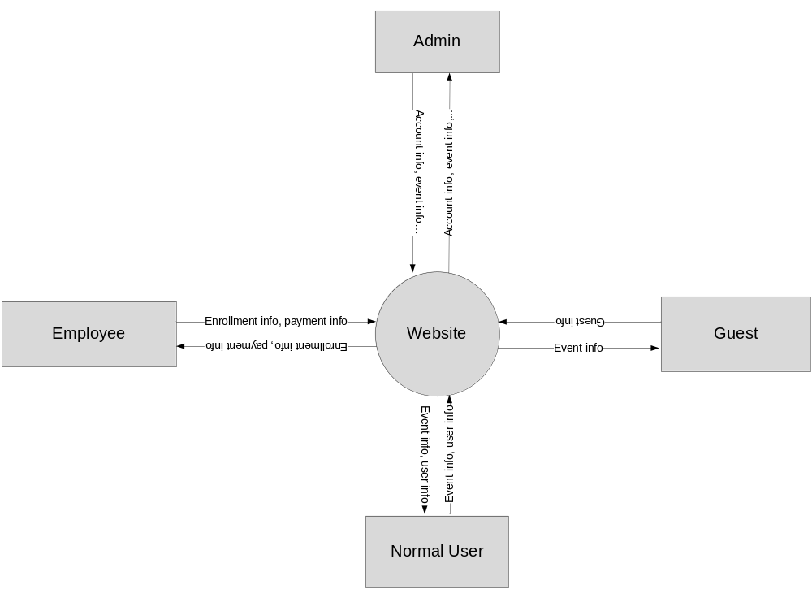
Figure 1. DFD Context diagram

DFD Level 1: Website process
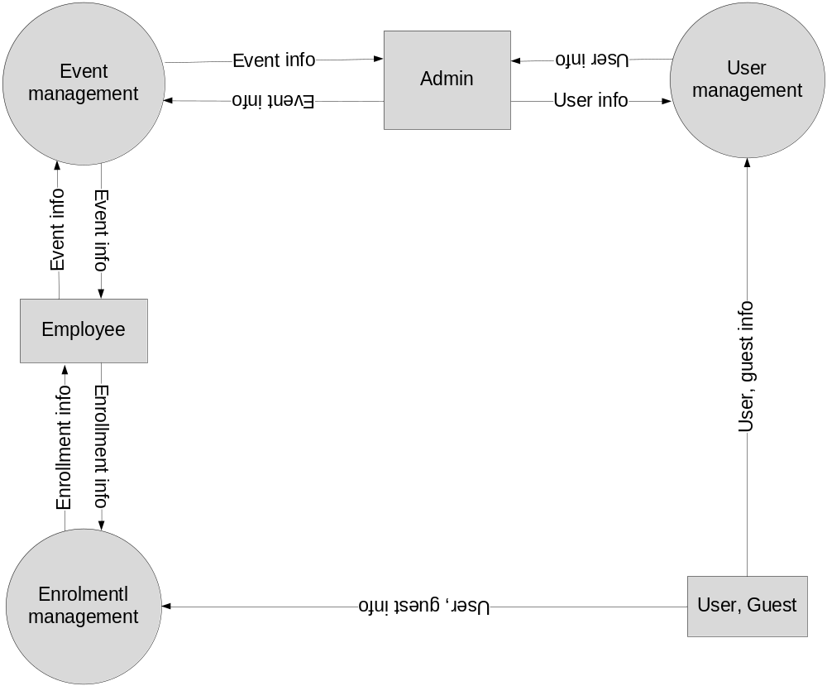
Figure 2. DFD Website process

DFD Level 1.1: Event management
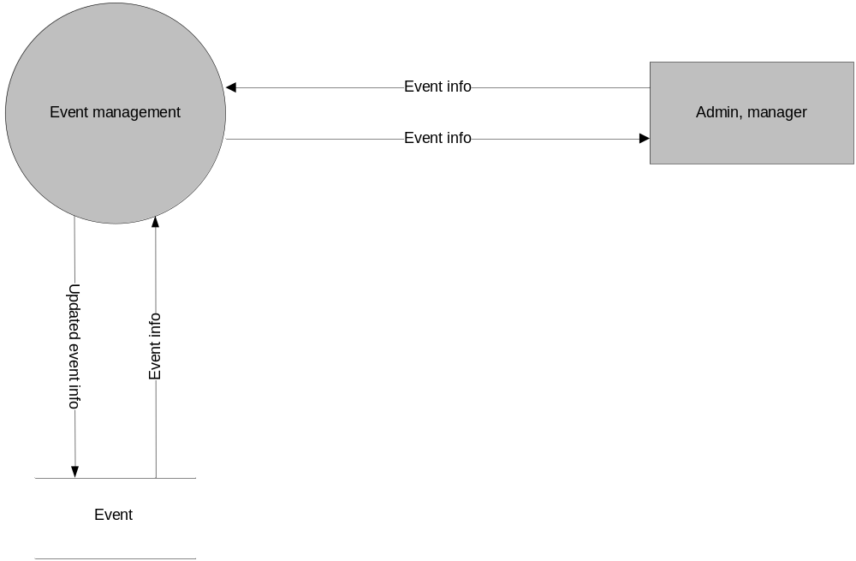
Figure 3. DFD Event management

DFD Level 1.2: Enrollment management
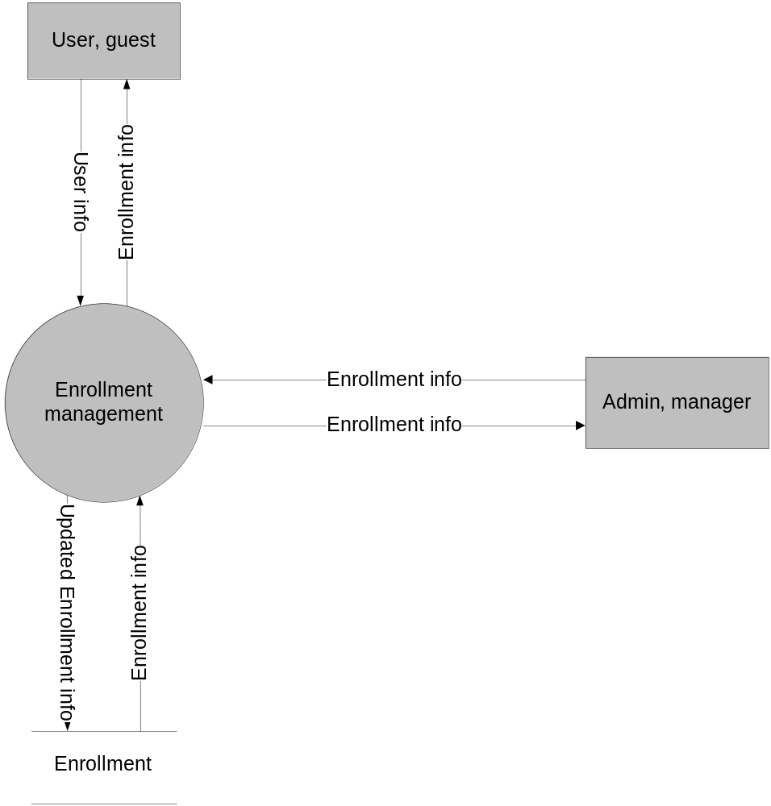
Figure 4. DFD Enrollment management

DFD Level 1.3: User management
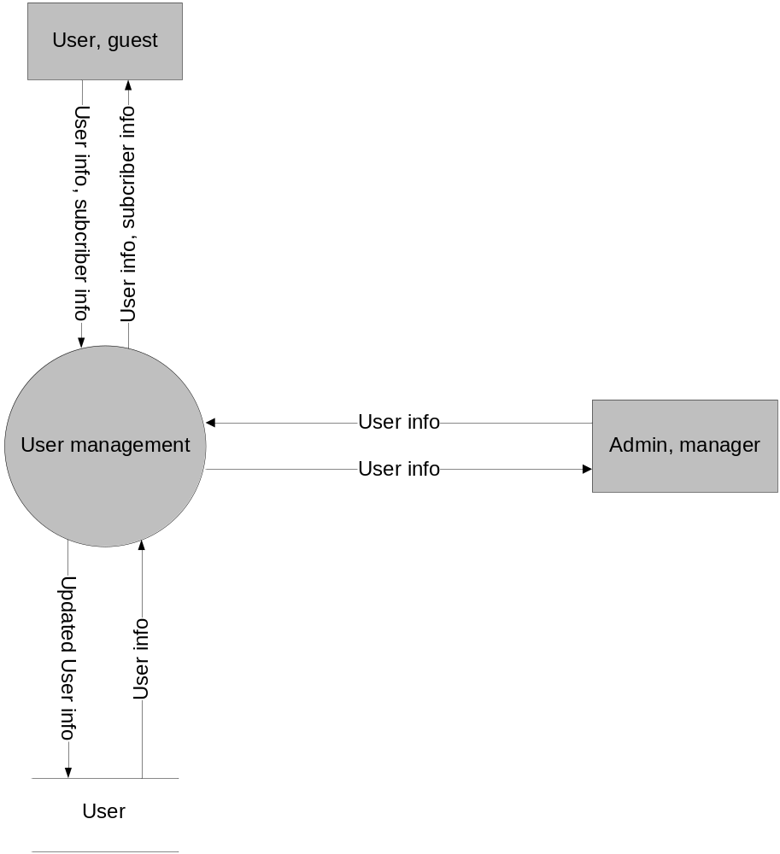
Figure 5. DFD User management

Use Case Diagram

System Use Case
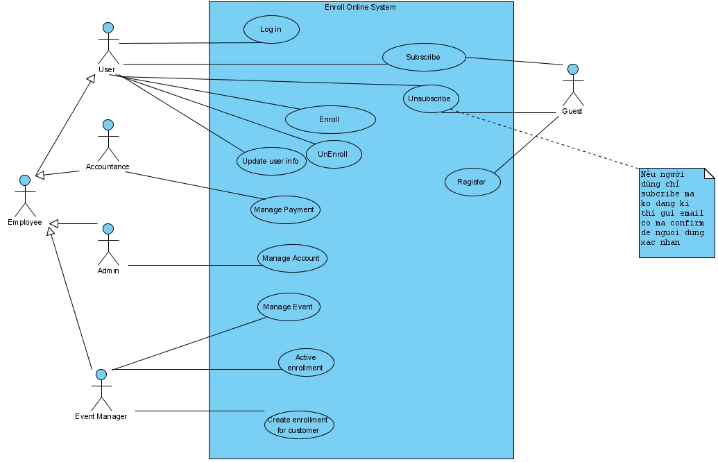
Figure 6. System use case

Use Case Specification

Register
USE CASE SPECIFICATION

Use-case No. | UC001 | Use-case Version |  | <1.0>
Use-case Name | Register
Author | VinhNV
Date | 10-Aug-2011 | Priority | Low
Actor:
Guest
Summary:
Guest enter required info to get website account.
Goal:
Create account in database for guest
Triggers
Check existence of email
Preconditions:
All required info is not empty
Post Conditions:
No
Main Success Scenario:
User enters all required info and submit.
New account will be created in database.
The successful message is display.
Notifier email is send to this email.
Alternative Scenario:
If email is existed in database, the error message will appears on the website with the link to the recover password page.
Exceptions:
No
Relationships:
No
Business Rules:
No

Login
USE CASE SPECIFICATION

Use-case No. | UC002 | Use-case Version |  | <1.0>
Use-case Name | Login
Author | PhongTN
Date | 10-Aug-2011 | Priority | Low
Actor:
User
Summary:
Goal:
Authenticate users
Triggers
No
Preconditions:
User hasn’t loged in.
Post Conditions:
No
Main Success Scenario:
User enters email and password.
There is an account in database has the same email and password.
User loged in successfully.
Alternative Scenario:
If there isn’t account has this email and password, error message will appear on website with the link to the recover password page.
Exceptions:
No
Relationships:
Is condition for next use cases.
Business Rules:
No

Update account information
USE CASE SPECIFICATION

Use-case No. | UC003 | Use-case Version |  | <1.0>
Use-case Name | Update account information
Author | HungNV
Date | 10-Aug-2011 | Priority | Low
Actor:
User
Summary:
User enter new information and submit.

Goal:
New information is store in database.
Triggers
User must fill the required info.
Preconditions:
User has loged in.
Post Conditions:
No
Main Success Scenario:
User choose the fields, enter new information and submit.
New informarion will be saved in database.
Alternative Scenario:
User click cancel, website redirect to home page.
Exceptions:
No
Relationships:
Require log in use case
Business Rules:
No

Subcribe
USE CASE SPECIFICATION

Use-case No. | UC004 | Use-case Version |  | <1.0>
Use-case Name | Subcribe
Author | VinhNV
Date | 10-Aug-2011 | Priority | Hight
Actor:
User
Summary:
Case 1: User loged in and chooses subcribe page.
Goal:
Add user or guest to mailling list
Triggers
No
Preconditions:
No
Post Conditions:
No
Main Success Scenario:
UserID and CategoryID is added toEmailRecieverEventCategory table
And user will receives email for each changes of prefered category.
Alternative Scenario:
No
Exceptions:
No
Relationships:
No
Business Rules:
No

Unsubcribe
USE CASE SPECIFICATION

Use-case No. | UC005 | Use-case Version |  | <1.0>
Use-case Name | Unsubcribe
Author | PhongTN
Date | 10-Aug-2011 | Priority | Hight
Actor:
User
Summary:
Goal:
Remove user or guest from mailling list
Triggers
No
Preconditions:
User sebcribed.
Post Conditions:
No
Main Success Scenario:
User ID is removed from EmailRecieverEventCategory table.
Alternative Scenario:
No
Exceptions:
No
Relationships:
No
Business Rules:
No

Enroll
USE CASE SPECIFICATION

Use-case No. | UC006 | Use-case Version |  | <1.0>
Use-case Name | Enroll
Author | HungNV
Date | 10-Aug-2011 | Priority | Hight
Actor:
User
Summary:
Goal:
Add user or guest to list of event’s participants
Triggers
No
Preconditions:
User has loged in.
Post Conditions:
No
Main Success Scenario:
User chooses event and submit.
The enroll info will be appear on website with printing support.
Alternative Scenario:
No
Exceptions:
No
Relationships:
Require loged in use case
Business Rules:
No

Unenroll
USE CASE SPECIFICATION

Use-case No. | UC007 | Use-case Version |  | <1.0>
Use-case Name | Unenroll
Author | VinhNV
Date | 10-Aug-2011 | Priority | Hight
Actor:
User
Summary:
Goal:
Remove user or guest from list of event’s participants
Triggers
No
Preconditions:
No
Post Conditions:
No
Main Success Scenario:
The enrollment’s status is set to unenroll
Alternative Scenario:
No
Exceptions:
No
Relationships:
Require login use case.
Business Rules:
No

Manage payment
USE CASE SPECIFICATION

Use-case No. | UC008 | Use-case Version |  | <1.0>
Use-case Name | Accept payment
Author | HungNV
Date | 10-Aug-2011 | Priority | Hight
Actor:
Accountant
Summary:
Goal:
Accept payment
Triggers
No
Preconditions:
User has enrolled
Post Conditions:
No
Main Success Scenario:
Accoutant searches the enrollment by enroll information and get the fee of enrollment.
After user paid for enrollment, accoutant changes enrollment status.
Alternative Scenario:
No
Exceptions:
No
Relationships:
Requied loged in and is employee
Business Rules:
No

Manage event
USE CASE SPECIFICATION

Use-case No. | UC009 | Use-case Version |  | <1.0>
Use-case Name | Manage event
Author | HungNV
Date | 10-Aug-2011 | Priority | Hight
Actor:
Event manager
Summary:
Goal:
Create, remove, update event.
Triggers
No
Preconditions:
No
Post Conditions:
No
Main Success Scenario:
Enter information and submit, the result message will appears.
Alternative Scenario:
No
Exceptions:
No
Relationships:
No
Business Rules:
No

Active enrollment
USE CASE SPECIFICATION

Use-case No. | UC010 | Use-case Version |  | <1.0>
Use-case Name | Active enrollment
Author | HungNV
Date | 10-Aug-2011 | Priority | Hight
Actor:
Event manager
Summary:
Goal:
Accept particition enrollment.
Triggers
No
Preconditions:
Enrollment must be paid.
Post Conditions:
No
Main Success Scenario:
Enrollment is active
Alternative Scenario:
No
Exceptions:
No
Relationships:
Require loged in
Business Rules:
No

Create enrollment for guest
USE CASE SPECIFICATION

Use-case No. | UC011 | Use-case Version |  | <1.0>
Use-case Name | Create enrollment for guest
Author | HungNV
Date | 10-Aug-2011 | Priority | Hight
Actor:
Event manager
Summary:
Goal:
Create enrollment for participant
Triggers
No
Preconditions:
User goes to university and meets the employee to enroll an event or send a enrollment through courier, express delivery.
Post Conditions:
No
Main Success Scenario:
Employee enter user info to create enrollment form. When he enter email, program check the existence of this email. If this email isn’t existed, new user will create and user info is send to this email, otherwise, the user info has this email auto fill to this form.
Alternative Scenario:
No
Exceptions:
No
Relationships:
No
Business Rules:
No

Manage account
USE CASE SPECIFICATION

Use-case No. | UC012 | Use-case Version |  | <1.0>
Use-case Name | Manage account
Author | HungNV
Date | 10-Aug-2011 | Priority | Low
Actor:
Admin
Summary:
Goal:
Admin can create, active, deactive user account.
Triggers
No
Preconditions:
No
Post Conditions:
No
Main Success Scenario:
Admin can create, active, deactive user account.
Alternative Scenario:
No
Exceptions:
No
Relationships:
No
Business Rules:
No

Design

System Architecture
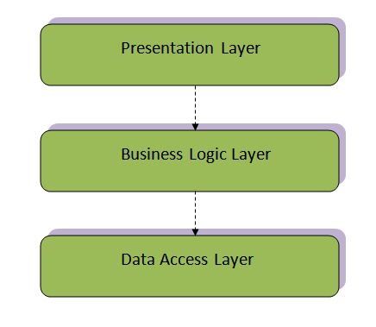
Figure 7. 3-tiers Architechture
Data Access Layer:
This tier consists of Database Servers. Here information is stored and retrieved. This tier keeps data neutral and independent from enrollment servers or business logic. Giving data its own tier also improves scalability and performance.
Business Logic Layer:
The logic tier is pulled out from the presentation tier and, as its layer, it controls an enrollment’s functionality by performing detailed processing.
Presentation Layer
This is the topmost level of the enrollment. The presentation tier displays information related to such services as browsing merchandise, purchasing, and shopping cart contents. It communicates with other tiers by outputting results to the browser/client tier and all other tiers in the network.

Class Diagram
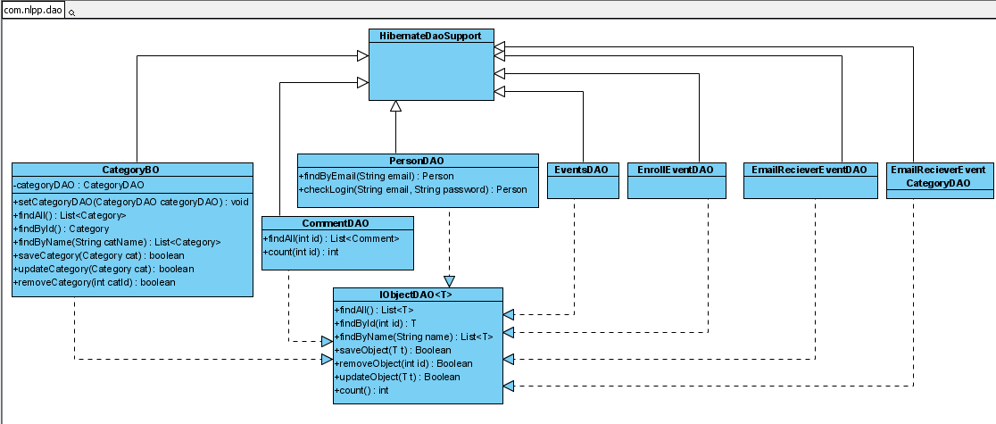
Figure 8. DAO Classes
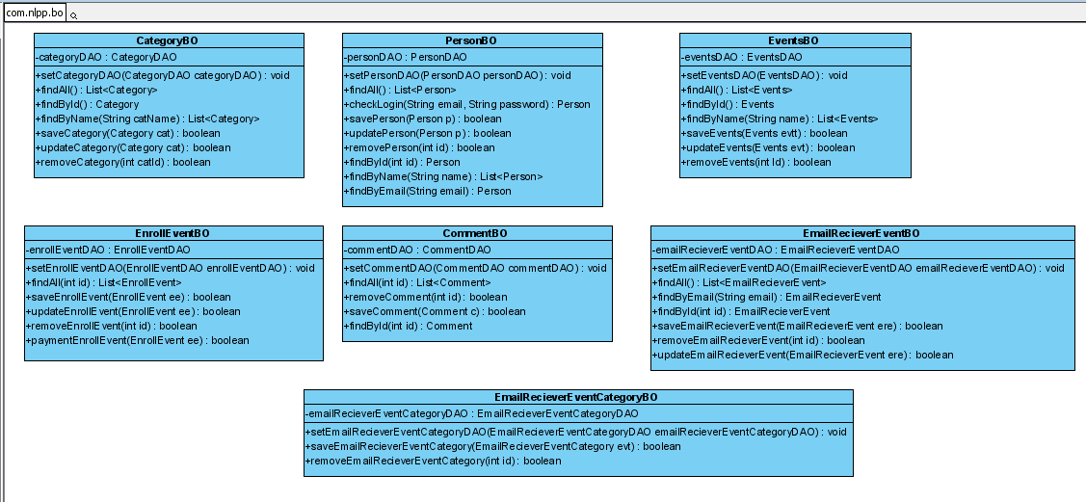
Figure 9. BO Classes

Package Diagram
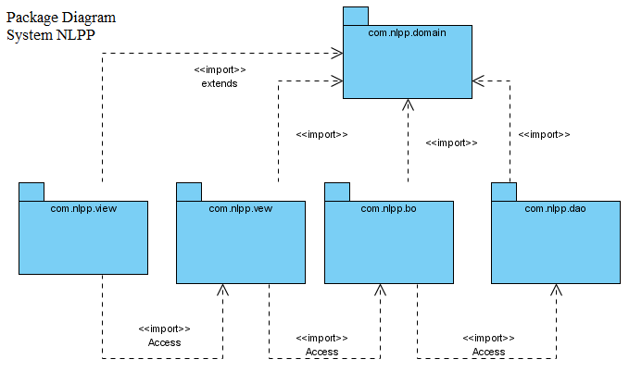
Figure 10. Package Diagram

Active Diagram

Subcribe
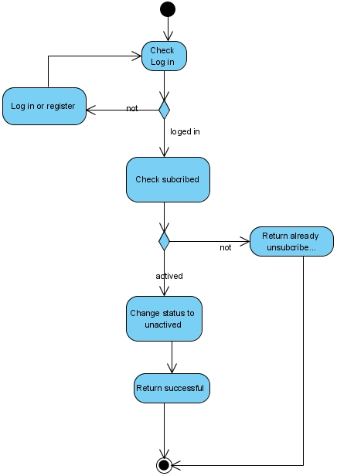
Figure 11. Active diagram for subcribe use case

Unsubcribe
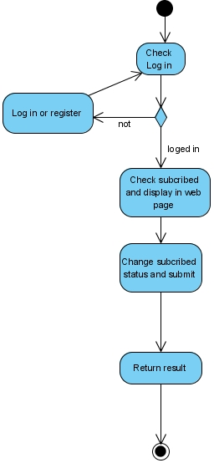
Figure 12. Active diagram for unsubcribe use case

Enroll
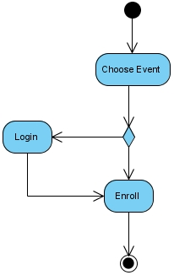
Figure 13. Active diagram for enroll use case

Unenroll
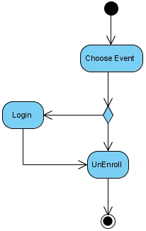
Figure 14. Active diagram for unenroll use case

Accept payment
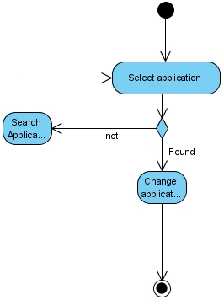
Figure 15. Active diagram for accept payment use case

Active enrollment
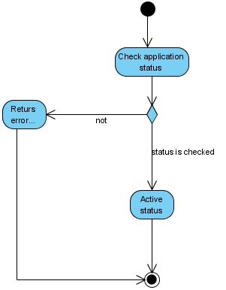
Figure 16. Active diagram for active enrollment use case

Sequence Diagram
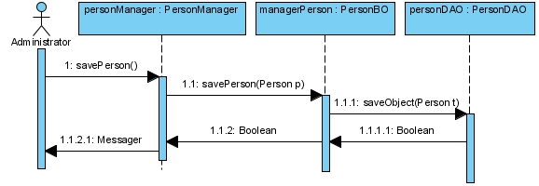
Figure 17. Add new Employee
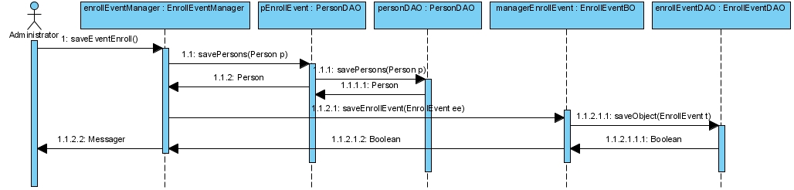
Figure 18. Add new enrollment for event
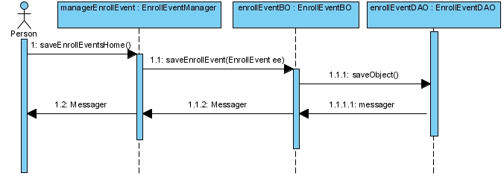
Figure 19. Enroll for event
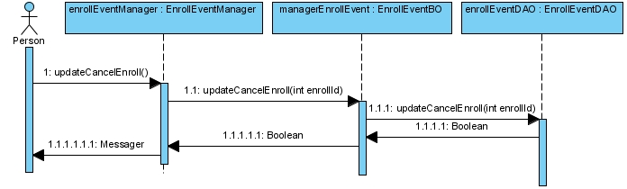
Figure 20. Cancel event enrollment
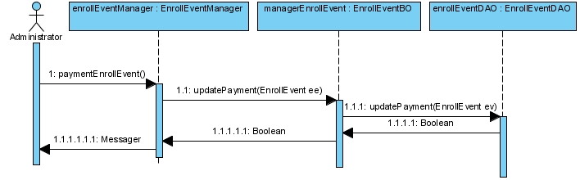
Figure 21. Payment
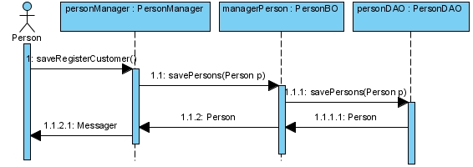
Figure 22, Register for customer
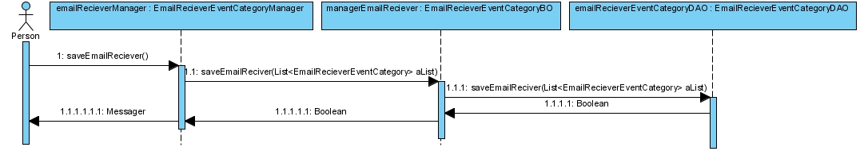
Figure 23. Subcribe

State Diagram

Entity Relationship Diagram
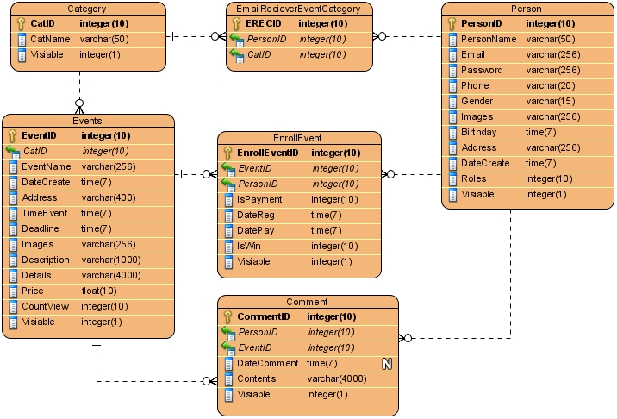
Figure 24. ER Diagram

Database Design
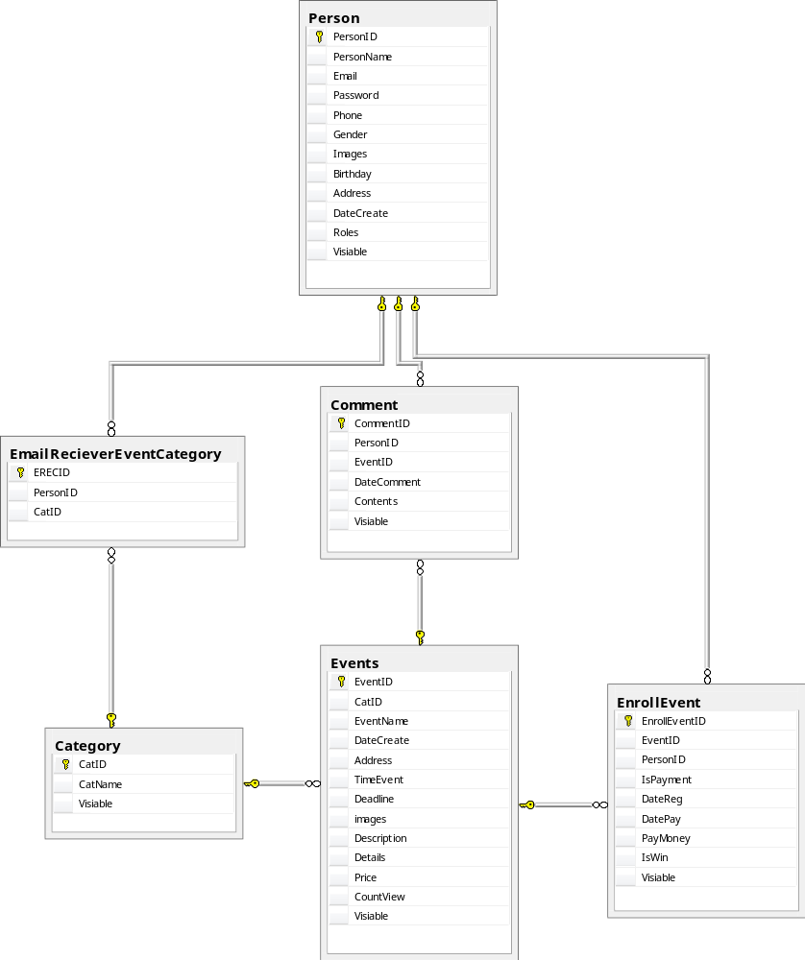
Figure 25. Database diagram

Table details

Event
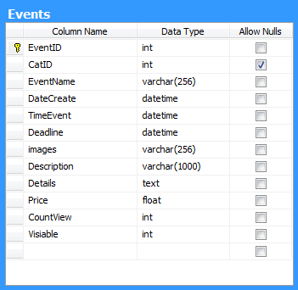
Figure 26. Event table details

Category
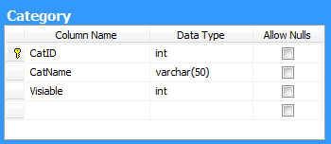
Figure 27. Category table details

Person
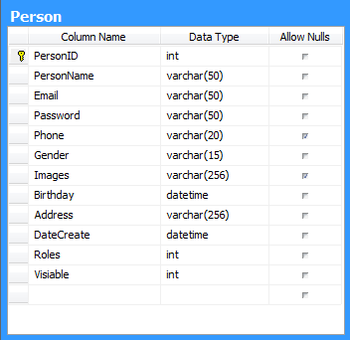
Figure 28. Person table details

Enrollment
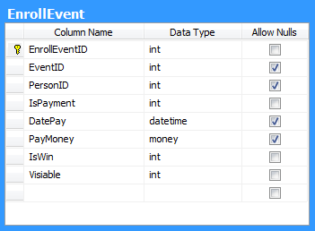
Figure 29. EnrollEvent table details

Comment
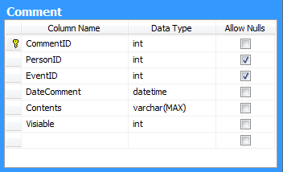
Figure 30. Comment table details

Subcriber category
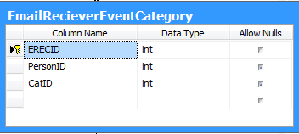
Figure 31. EmailReceiverEventCategory details

Management and Project Planning

Management Approach

Project Plan
Project Plan
No | Tasks | Members | Start | End | Days | Priority
1 | System analysis | HungNV (Lead) | 8-Aug-11 | 13-Aug-11 | 6 | Hight
1.1 | Requirements analysis | All | 8-Aug-11 | 9-Aug-11 | 2 | Hight
1.2 | Plan | VinhNV, HungNV | 10-Aug-11 | 10-Aug-11 | 1 | Hight
1.3 | Bussiness analysis | HungNV, PhongTN | 11-Aug-11 | 13-Aug-11 | 3 | Hight
2 | Document | HungNV (Lead) | 14-Aug-11 | 23-Aug-11 | 10 | Hight
2.1 | Diagram | HungNV, VinhNV | 14-Aug-11 | 20-Aug-11 | 7 | Hight
2.2 | Document content | HungNV, PhongTN | 21-Aug-11 | 23-Aug-11 | 3 | Normal
3 | Development | VinhNV (Lead) | 14-Aug-11 | 2-Sep-11 | 20
3.1 | Frameword Demo | VinhNV | 14-Aug-11 | 15-Aug-11 | 2 | Normal
3.2 | Database | VinhNV, HungNV | 16-Aug-11 | 17-Aug-11 | 2 | Hight
3.3 | Account module | VinhNV | 18-Aug-11 | 21-Aug-11 | 4 | Normal
3.4 | Adminitration module | VinhNV | 22-Aug-11 | 24-Aug-11 | 3 | Normal
3.5 | Event manage module | PhongTN | 24-Aug-11 | 26-Aug-11 | 3 | Hight
3.6 | Payment module | HungNV | 24-Aug-11 | 26-Aug-11 | 3 | Hight
3.7 | Enroll module | VinhNV | 25-Aug-11 | 31-Aug-11 | 7 | Hight
3.8 | Subcribe module | HungNV, PhongTN | 27-Aug-11 | 31-Aug-11 | 5 | Hight
3.9 | Combine module | All | 1-Sep-11 | 2-Sep-11 | 2 | Hight
4 | Interface Designing | PhongTN (Lead) | 14-Aug-11 | 23-Aug-11 | 10 | Normal
4.1 | Template design | PhongTN | 13-Jan-11 | 19-Jan-11 | 7 | Hight
4.2 | Others | PhongTN | 20-Jan-11 | 22-Jan-11 | 3 | Normal
5 | Test | PhongTN (Lead) | 3-Sep-11 | 7-Sep-11 | 5 | Normal
5.1 | Enroll module test | All | 3-Sep-11 | 3-Sep-11 | 1 | Normal
5.2 | Subcribe module test | All | 4-Sep-11 | 4-Sep-11 | 1 | Normal
5.3 | Payment test | All | 5-Sep-11 | 5-Sep-11 | 1 | Normal
5.4 | Event manage test | All | 6-Sep-11 | 6-Sep-11 | 1 | Normal
5.5 | Project Test | All | 7-Sep-11 | 7-Sep-11 | 1 | Normal

Checklists

Check List of Validation

Submission Checklist

Screenshots

Screenshots 1. Home page

Manager’s pages
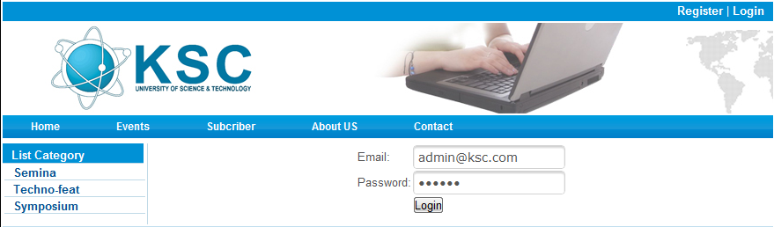
Screenshots 2. Login
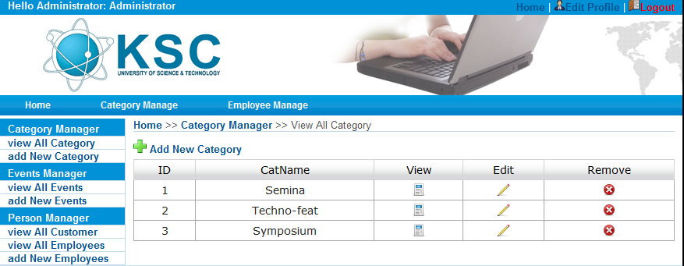
Screenshots 3. Category Management
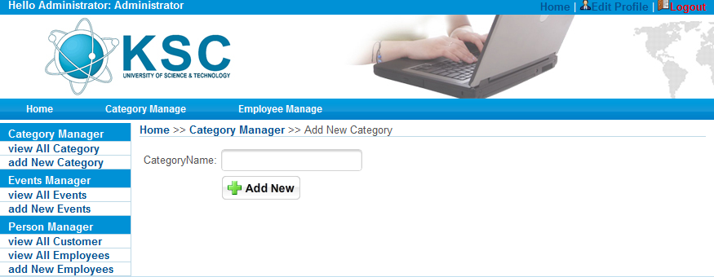
Screenshots 4. Add new category
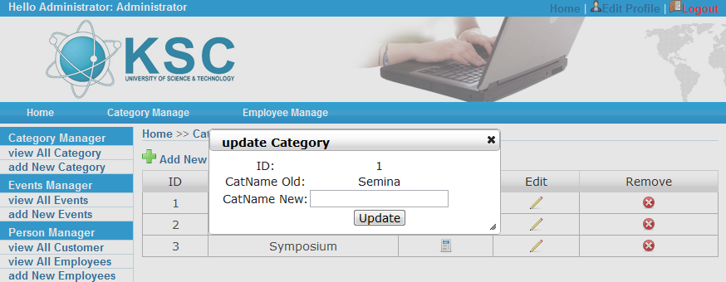
Screenshots 5. Edit category
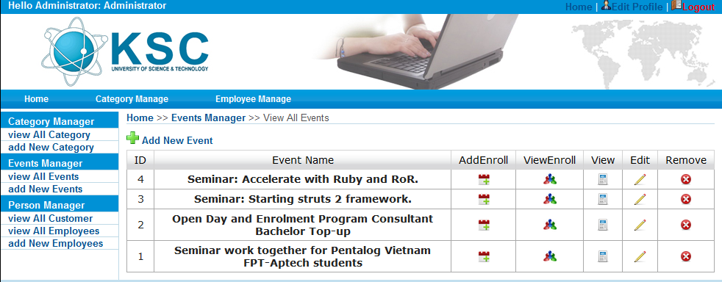
Screenshots 6. Event manager
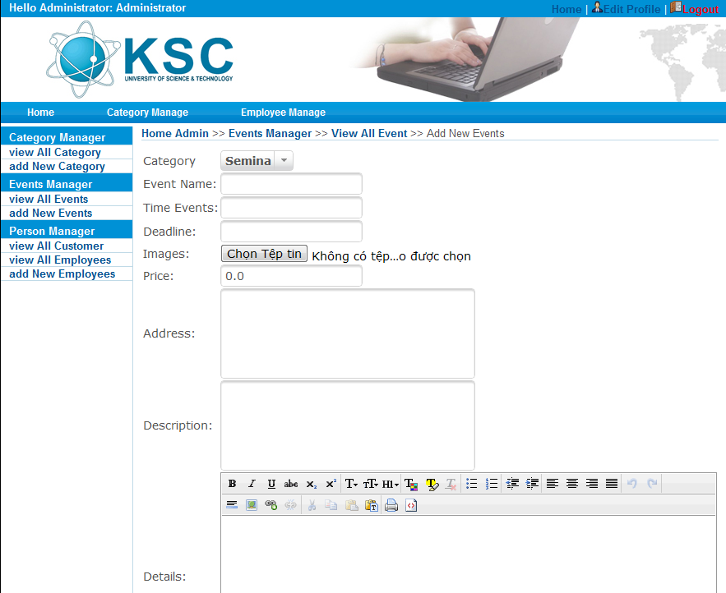
Screenshots 7. Add new event
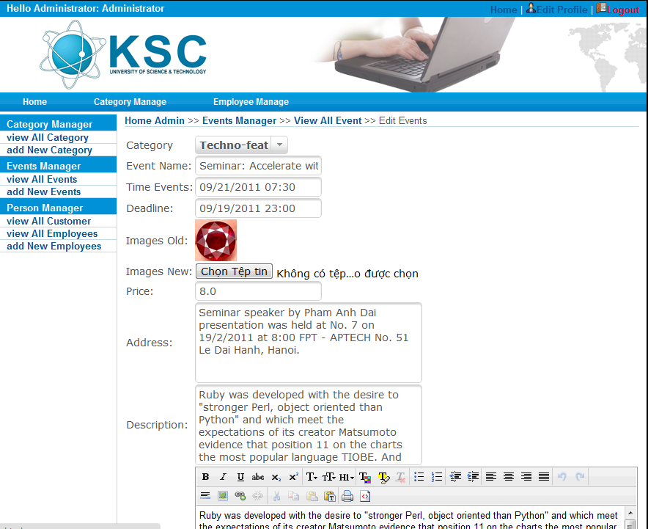
Screenshots 8. Edit event
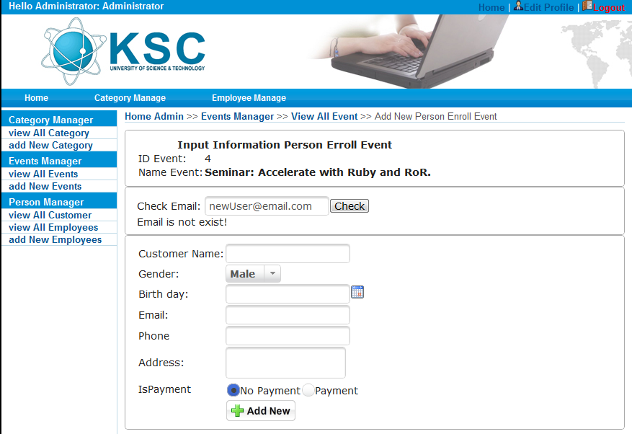
Screenshots 9. Manager add enrollment for user

User’s pages

Screenshots 10. All event list

Screenshots 11. Event in one category
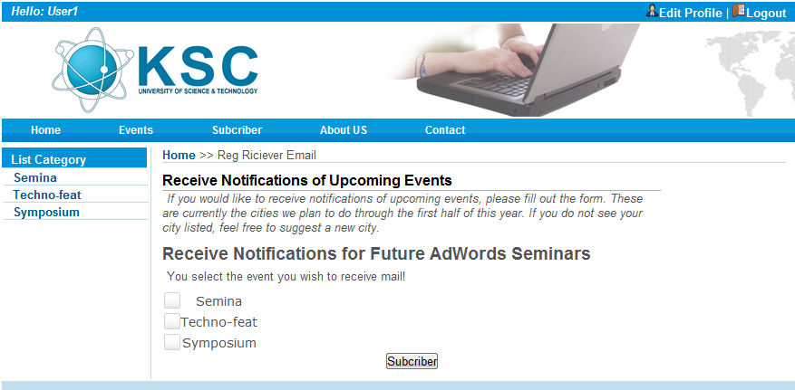
Screenshots 12. Subcribe for event category
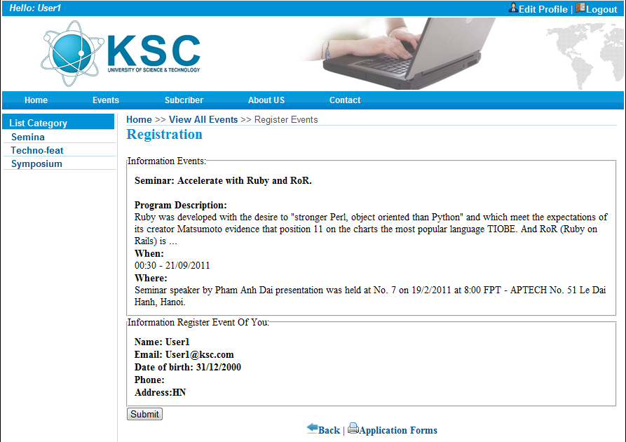
Screenshots 13. Enroll for event
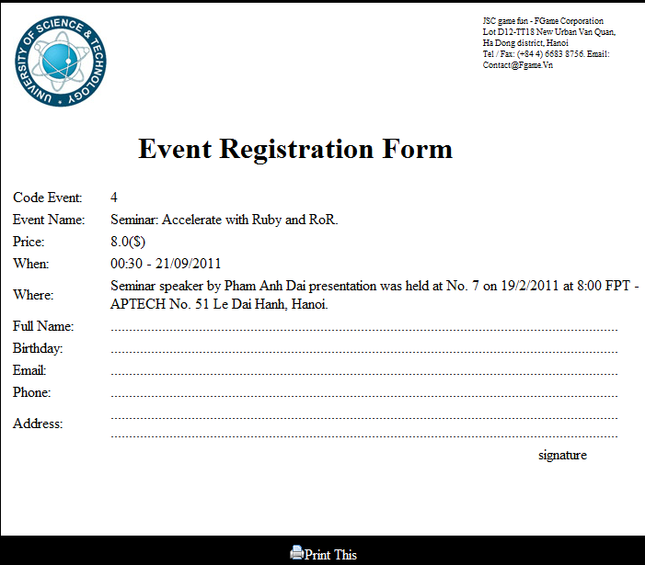
Screenshots 14. Page for printing enrollment

Coding Convention
A project requirement may vary from the standards mentioned in this document. When going against the standards, projects should make sure to document it.

Naming Convention
- Use full English descriptors that accurately describe the variable/field/class/interface.
For example, use names like firstName, grandTotal, or CorporateCustomer.
- Use terminology applicable to the domain
If the users of the system refer to their clients as Customer, then use the term Customer for the class, not client.
- Use mixed case to make names readable

- Use abbreviations sparingly, but if you do so then use then intelligently and document it
For example, to use a short form for the word “number”, choose one of nbr, no or num.
- Avoid long names (<15 characters is a good tradeoff)
- Avoid names that are similar or differ only in case

Documentation
- Comments should add to the clarity of code.
- Avoid decoration, i.e., do not use banner-like comments
- Document why something is being done, not just what.

Java Comments
Comment Type | Usage | Example
Documentation  Starts with /** and ends with */ | Used before declarations of interfaces, classes, member functions, and fields to document them. | /**  * Customer – a person or  * organization  */
C style  Starts with /* and ends with */ | Used to document out lines of code that are no longer applicable. It is helpful in debugging. | /*  This code was commented out by Ashish Sarin  */
Single line  Starts with // and go until the end of the line | Used internally within member functions to document business logic, sections of code, and declarations of temporary variables. | // If the amount is greater  // than 10 multiply by 100

Standards For Member Functions

Naming member functions
Member functions should be named using a full English description, using mixed case with the first letter of any non-initial word capitalized. The first word of the member function should be a verb.
Examples
openAccount()
printMailingList()
save()
delete()
This results in member functions whose purpose can be determined just by looking at its name.

Naming Accessor Member Functions
Getters: member functions that return the value of a field / attribute / property of an object.
Use prefix “get” to the name of the field / attribute / property if the field in not boolean
Use prefix “is” to the name of the field / attribute / property if the field is Boolean
A viable alternative is to use the prefix ‘has’ or ‘can’ instead of ‘is’ for boolean getters.
Examples
getFirstName()
isPersistent()
Setters: member functions that modify the values of a field.
Use prefix ‘set’ to the name of the field.
Examples
setFirstName()
Constructors: member functions that perform any necessary initialization when an object is created. Constructors are always given the same name as their class.
Examples
Customer()
SavingsAccount()

Member Function Visibility
A good design requires minimum coupling between the classes. The general rule is to be as restrictive as possible when setting the visibility of a member function. If member function doesn’t have to be public then make it protected, and if it doesn’t have to be protected than make it private.

Documenting Member Functions
Member Function Header
Member function documentation should include the following:
What and why the member function does what it does
What member function must be passed as parameters
What a member function returns
Known bugs
Any exception that a member function throws
Visibility decisions (if questionable by other developers)
How a member function changes the object – it is to helps a developer to understand how a member function invocation will affect the target object.
Include a history of any code changes
Examples of how to invoke the member function if appropriate.
Applicable pre conditions and post conditions under which the function will work properly. These are the assumptions made during writing of the function.
All concurrency issues should be addressed.
- Explanation of why keeping a function synchronized must be documented.
When a member function updates a field/attribute/property, of a class that implements the Runnable interface, is not synchronized then it should be documented why it is unsynchronized.
If a member function is overloaded or overridden or synchronization changed, it should also be documented.
Note: It’s not necessary to document all the factors described above for each and every member function because not all factors are applicable to every member function.
Internal Documentation: Comments within the member functions
Use C style comments to document out lines of unneeded code.
Use single-line comments for business logic.
Internally following should be documented:
Control Structures This includes comparison statements and loops
Why, as well as what, the code does
Local variables
Difficult or complex code
The processing order If there are statements in the code that must be executed in a defined order
Document the closing braces If there are many control structures one inside another

Techniques for Writing Clean Code
Document the code Already discussed above
Paragraph/Indent the code: Any code between the { and } should be properly indented
Paragraph and punctuate multi-line statements
Example
Line 1 BankAccount newPersonalAccount = AccountFactory
Line 2 createBankAccountFor(currentCustomer, startDate,
Line 3 initialDeposit, branch)
Lines 2 & 3 have been indented by one unit (horizontal tab)
Use white space
A few blank lines or spaces can help make the code more readable.
Single blank lines to separate logical groups of code, such as control structures
Two blank lines to separate member function definitions
Specify the order of Operations: Use extra parenthesis to increase the readability of the code using AND and OR comparisons. This facilitates in identifying the exact order of operations in the code
Write short, single command lines Code should do one operation per line So only one statement should be there per line

Standards for Fields (Attributes / Properties)

Naming Fields
Use a Full English Descriptor for Field Names
Fields that are collections, such as arrays or vectors, should be given names that are plural to indicate that they represent multiple values.
Examples
firstName
orderItems
If the name of the field begins with an acronym then the acronym should be completely in lower case
Example
sqlDatabase

Naming Components
Use full English descriptor postfixed by the widget type. This makes it easy for a developer to identify the purpose of the components as well as its type.
Example
okButton
customerList
fileMenu
newFileMenuItem

Naming Constants
In Java, constants, values that do not change, are typically implemented as static final fields of classes. The convention is to use full English words, all in upper case, with underscores between the words
Example
MINIMUM_BALANCE
MAX_VALUE
DEFAULT_START_DATE

Field Visibility
Fields should not be declared public for reasons of encapsulation. All fields should be declared private and accessor methods should be used to access / modify the field value. This results in less coupling between classes as the protected / public / package access of field can result in direct access of the field from other classes

Documenting a Field
Document the following:
It’s description
Document all applicable invariants Invariants of a field are the conditions that are always true about it. By documenting the restrictions on the values of a field one can understand important business rules, making it easier to understand how the code works / how the code is supposed to work
Examples For fields that have complex business rules associated with them one should provide several example values so as to make them easier to understand
Concurrency issues
Visibility decisions If a field is declared anything but private then it should be documented why it has not been declared private.

Usage of Accesors
Accessors can be used for more than just getting and setting the values of instance fields. Accesors should be used for following purpose also:
Initialize the values of fields Use lazy initialization where fields are initialized by their getter member functions.
Example
/**
* Answer the branch number, which is the leftmost four digits of the full account
* number. Account numbers are in the format BBBBAAAAAA.
*/
protected int getBranchNumber()
{
if(branchNumber == 0)
{
// The default branch number is 1000, which is the
// main branch in downtown Bedrock
setBranchNumber(1000);
}
return branchNumber;
}
Note:
This approach is advantageous for objects that have fields that aren’t regularly accessed
Whenever lazy initialization is used in a getter function the programmer should document what is the type of default value, what the default value as in the example above.
Access constant values Commonly constant values are declared as static final fields. This approach makes sense for “constants” that are stable.
If the constants can change because of some changes in the business rules as the business matures then it is better to use getter member functions for constants.
By using accesors for constants programmer can decrease the chance of bugs and at the same time increase the maintainability of the system.
Access Collections The main purpose of accesors is to encapsulate the access to fields so as to reduce the coupling within the code. Collections, such as arrays and vectors, being more complex than single value fields have more than just standard getter and setter member function implemented for them. Because the business rule may require to add and remove to and from collections, accessor member functions need to be included to do so.
Example
Member function type | Naming Convention | Example
Getter for the collection | getCollection() | getOrderItems()
Setter for the collection | setCollection() | setOrderItems()
Insert an object into the collection | insertObject() | insertOrderItems()
Delete an object from the collection | deleteObject() | deleteOrderItems()
Create and add a new object into the collection | newObject() | newOrderItem()

Note
The advantage of this approach is that the collection is fully encapsulated, allowing programmer to later replace it with another structure
It is common to that the getter member functions be public and the setter be protected
Always Initialize Static Fields because one can’t assume that instances of a class will be created before a static field is accessed

Standards for Local Variables

Naming Local Variables
Use full English descriptors with the first letter of any non-initial word in uppercase.
Naming Streams
When there is a single input and/or output stream being opened, used, and then closed within a member function the convention is to use in and out for the names of these streams, respectively.
Naming Loop Counters
A common way is to use words like loopCounters or simply counter because it helps facilitate the search for the counters in the program.
i, j, k can also be used as loop counters but the disadvantage is that search for i ,j and k in the code will result in many hits.
Naming Exception Objects
The use of letter e for a generic exception

Declaring and Documenting Local Variables
Declare one local variable per line of code
Document local variable with an endline comment
Declare local variables immediately before their use
Use local variable for one operation only. Whenever a local variable is used for more than one reason, it effectively decreases its cohesion, making it difficult to understand. It also increases the chances of introducing bugs into the code from unexpected side effects of previous values of a local variable from earlier in the code.
Note
Reusing local variables is more efficient because less memory needs to be allocated, but reusing local variables decreases the maintainability of code and makes it more fragile

Standards for Parameters (Arguments) to Member Functions

Naming Parameters
Parameters should be named following the exact same conventions as for local variable
Name parameters the same as their corresponding fields (if any)
Example
If Account has an attribute called balance and you needed to pass a parameter representing a new value for it the parameter would be called balance The field would be referred to as this.balance in the code and the parameter would be referred as balance

Documenting Parameters
Parameters to a member function are documented in the header documentation for the member function using the javadoc @param tag. It should describe:
What it should be used for
Any restrictions or preconditions
Examples If it is not completely obvious what a parameter should be, then it should provide one or more examples in the documentation
Note
Use interface as a parameter to the member function then the object itself.

Standards for Classes, Interfaces, Packages, and Compilation Units
Standards for Classes

Class Visibility
Use package visibility for classes internal to a component
Use public visibility for the façade of components

Naming classes
Use full English descriptor starting with the first letter capitalized using mixed case for the rest of the name

Documenting a Class
The purpose of the class
Known bugs
The development/maintenance history of the class
Document applicable variants
The concurrency strategy Any class that implements the interface Runnable should
have its concurrency strategy fully described

Ordering Member Functions and Fields
The order should be:
Constructors
private fields
public member functions
protected member functions
private member functions
finalize()

Standards for Interfaces

Naming Interfaces
Name interfaces using mixed case with the first letter of each word capitalized.
Prefix the letter “I” or “Ifc” to the interface name

Documenting Interfaces
The Purpose
How it should and shouldn’t be used

Standards for Packages
Local packages names begin with an identifier that is not all upper case
Global package names begin with the reversed Internet domain name for the organization
Package names should be singular

Documenting a Package
The rationale for the package
The classes in the packages

Standards for Compilation Unit (Source code file)

Naming a Compilation Unit
A compilation unit should be given the name of the primary class or interface that is declared within it. Use the same name of the class for the file name, using the same case.

Beginning Comments
/**
* Classname
*
* Version information
*
* Date
*
* Copyright notice
*/

Declaration
Class/interface documentation comment (/**...*/) | See Documentation standard for class / interfaces
Class or interface statement
Class/interface implementation comment (/*...*/), if necessary | This comment should contain any class-wide or interface-wide information that wasn't appropriate for the class/interface documentation comment.
Class (static) variables | First the public class variables, then the protected, then package level (no access modifier), and then the private.
Instance variables | First public, then protected, then package level (no access modifier), and then private.
Methods | These methods should be grouped by functionality rather than by scope or accessibility. For example, a private class method can be in between two public instance methods. The goal is to make reading and understanding the code easier.

Indentation
Four spaces should be used as the unit of indentation. The exact construction of the indentation (spaces vs. tabs) is unspecified. Tabs must be set exactly every 8 spaces (not 4).

Line Length
Avoid lines longer than 80 characters, since they're not handled well by many terminals and tools.
Note: Examples for use in documentation should have a shorter line length-generally no more than 70 characters.

Wrapping Lines
When an expression will not fit on a single line, break it according to these general principles:
Break after a comma.
Break before an operator.
Prefer higher-level breaks to lower-level breaks.
Align the new line with the beginning of the expression at the same level on the previous line.
If the above rules lead to confusing code or to code that's squished up against the right margin, just indent 8 spaces instead.
Here are some examples of breaking method calls:
someMethod(longExpression1, longExpression2, longExpression3,
longExpression4, longExpression5);
var = someMethod1(longExpression1,
someMethod2(longExpression2,
longExpression3));
Following are two examples of breaking an arithmetic expression. The first is preferred, since the break occurs outside the parenthesized expression, which is at a higher level.
longName1 = longName2 * (longName3 + longName4 - longName5)
+ 4 * longname6; // PREFER
longName1 = longName2 * (longName3 + longName4
- longName5) + 4 * longname6; // AVOID
Following are two examples of indenting method declarations. The first is the conventional case. The second would shift the second and third lines to the far right if it used conventional indentation, so instead it indents only 8 spaces.
//CONVENTIONAL INDENTATION
someMethod(int anArg, Object anotherArg, String yetAnotherArg,
Object andStillAnother) {
...
}
//INDENT 8 SPACES TO AVOID VERY DEEP INDENTS
private static synchronized horkingLongMethodName(int anArg,
Object anotherArg, String yetAnotherArg,
Object andStillAnother) {
...
}
Line wrapping for if statements should generally use the 8-space rule, since conventional (4 space) indentation makes seeing the body difficult. For example:
//DON'T USE THIS INDENTATION
if ((condition1 && condition2)
|| (condition3 && condition4)
||!(condition5 && condition6)) { //BAD WRAPS
doSomethingAboutIt(); //MAKE THIS LINE EASY TO MISS
}
//USE THIS INDENTATION INSTEAD
if ((condition1 && condition2)
|| (condition3 && condition4)
||!(condition5 && condition6)) {
doSomethingAboutIt();
}
//OR USE THIS
if ((condition1 && condition2) || (condition3 && condition4)
||!(condition5 && condition6)) {
doSomethingAboutIt();
}
Here are three acceptable ways to format ternary expressions:
alpha = (aLongBooleanExpression) ? beta : gamma;
alpha = (aLongBooleanExpression) ? beta
: gamma;
alpha = (aLongBooleanExpression)
? beta
: gamma;

Declaration
One declaration per line is recommended since it encourages commenting. In other words,
int level; // indentation level
int size; // size of table
is preferred over
int level, size;
Do not put different types on the same line. Example:
int foo, fooarray[]; //WRONG!
Note: The examples above use one space between the type and the identifier. Another acceptable alternative is to use tabs, e.g.:
int level; // indentation level
int size; // size of table
Object currentEntry; // currently selected table entry

Initialization
Try to initialize local variables where they're declared. The only reason not to initialize a variable where it's declared is if the initial value depends on some computation occurring first.

Placement
Put declarations only at the beginning of blocks. (A block is any code surrounded by curly braces "{" and "}".) Don't wait to declare variables until their first use; it can confuse the unwary programmer and hamper code portability within the scope.
void myMethod() {
int int1 = 0; // beginning of method block
if (condition) {
int int2 = 0; // beginning of "if" block
...
}
}
The one exception to the rule is indexes of for loops, which in Java can be declared in the for statement:
for (int i = 0; i < maxLoops; i++) { ... }
Avoid local declarations that hide declarations at higher levels. For example, do not declare the same variable name in an inner block:
int count;
...
myMethod() {
if (condition) {
int count = 0; // AVOID!
...
}
...
}

Class and Interface Declarations
When coding Java classes and interfaces, the following formatting rules should be followed:
No space between a method name and the parenthesis "(" starting its parameter list
Open brace "{" appears at the end of the same line as the declaration statement
Closing brace "}" starts a line by itself indented to match its corresponding opening statement, except when it is a null statement the "}" should appear immediately after the "{"
class Sample extends Object {
int ivar1;
int ivar2;
Sample(int i, int j) {
ivar1 = i;
ivar2 = j;
}
int emptyMethod() {}
...
}
A blank line separates methods

Statements
Simple Statements
Each line should contain at most one statement.
Example:
argv++; // Correct
argc--; // Correct
argv++; argc--; // AVOID!
Compound Statements
Compound statements are statements that contain lists of statements enclosed in braces "{ statements }". See the following sections for examples.
The enclosed statements should be indented one more level than the compound statement.
The opening brace should be at the end of the line that begins the compound statement; the closing brace should begin a line and be indented to the beginning of the compound statement.
Braces are used around all statements, even single statements, when they are part of a control structure, such as a if-else or for statement. This makes it easier to add statements without accidentally introducing bugs due to forgetting to add braces.
return Statements
A return statement with a value should not use parentheses unless they make the return value more obvious in some way.
Example:
return;
return myDisk.size();
return (size ? size : defaultSize);
if, if-else, if else-if else Statements
The if-else class of statements should have the following form:
if (condition) {
statements;
}
if (condition) {
statements;
} else {
statements;
}
if (condition) {
statements;
} else if (condition) {
statements;
} else {
statements;
}
Note: if statements always use braces {}. Avoid the following error-prone form:
if (condition) //AVOID! THIS OMITS THE BRACES {}!
statement;
for Statements
A for statement should have the following form:
for (initialization; condition; update) {
statements;
}
An empty for statement (one in which all the work is done in the initialization, condition, and update clauses) should have the following form:
for (initialization; condition; update);
When using the comma operator in the initialization or update clause of a for statement, avoid the complexity of using more than three variables. If needed, use separate statements before the for loop (for the initialization clause) or at the end of the loop (for the update clause).
while Statements
A while statement should have the following form:
while (condition) {
statements;
}
An empty while statement should have the following form:
while (condition);
do-while Statements
A do-while statement should have the following form:
do {
statements;
} while (condition);
switch Statements
A switch statement should have the following form:
switch (condition) {
case ABC:
statements;
/* falls through */
case DEF:
statements;
break;
case XYZ:
statements;
break;
default:
statements;
break;
}
Every time a case falls through (doesn't include a break statement), add a comment where the break statement would normally be. This is shown in the preceding code example with the /* falls through */ comment.
Every switch statement should include a default case. The break in the default case is redundant, but it prevents a fall-through error if later another case is added.
try-catch Statements
A try-catch statement should have the following format:
try {
statements;
} catch (ExceptionClass e) {
statements;
}
A try-catch statement may also be followed by finally, which executes regardless of whether or not the try block has completed successfully.
try {
statements;
} catch (ExceptionClass e) {
statements;
} finally {
statements;
}
Blank Lines
Blank lines improve readability by setting off sections of code that are logically related.
Two blank lines should always be used in the following circumstances:
Between sections of a source file
Between class and interface definitions
One blank line should always be used in the following circumstances:
Between methods
Between the local variables in a method and its first statement
Before a block or single-line comment
Between logical sections inside a method to improve readability
Blank Spaces
Blank spaces should be used in the following circumstances:
A keyword followed by a parenthesis should be separated by a space. Example:
while (true) {
...
}
Note that a blank space should not be used between a method name and its opening parenthesis. This helps to distinguish keywords from method calls.
A blank space should appear after commas in argument lists.
All binary operators except . should be separated from their operands by spaces. Blank spaces should never separate unary operators such as unary minus, increment ("++"), and decrement ("--") from their operands.
Example:
a += c + d;
a = (a + b) / (c * d);
while (d++ = s++) {
n++;
}
printSize("size is " + foo + "\n");
The expressions in a for statement should be separated by blank spaces. Example:
for (expr1; expr2; expr3)
Casts should be followed by a blank space. Examples:
myMethod((byte) aNum, (Object) x);
myMethod((int) (cp + 5), ((int) (i + 3)) + 1);

Naming Conventions Summary
Identifier Type | Rules for Naming | Examples
Packages | The prefix of a unique package name is always written in all-lowercase ASCII letters and should be one of the top-level domain names, currently com, edu, gov, mil, net, org, or one of the English two-letter codes identifying countries as specified in ISO Standard 3166, 1981.  Subsequent components of the package name vary according to an organization's own internal naming conventions. Such conventions might specify that certain directory name components be division, department, project, machine, or login names. | com.sun.eng  com.apple.quicktime.v2  edu.cmu.cs.bovik.cheese
Classes | Class names should be nouns, in mixed case with the first letter of each internal word capitalized. Try to keep your class names simple and descriptive. Use whole words-avoid acronyms and abbreviations (unless the abbreviation is much more widely used than the long form, such as URL or HTML). | class Raster;  class ImageSprite;
Interfaces | Interface names should be capitalized like class names. | interface RasterDelegate;  interface Storing;
Methods | Methods should be verbs, in mixed case with the first letter lowercase, with the first letter of each internal word capitalized. | run();  runFast();  getBackground();
Variables | Except for variables, all instance, class, and class constants are in mixed case with a lowercase first letter. Internal words start with capital letters. Variable names should not start with underscore _ or dollar sign $ characters, even though both are allowed.  Variable names should be short yet meaningful. The choice of a variable name should be mnemonic- that is, designed to indicate to the casual observer the intent of its use. One-character variable names should be avoided except for temporary "throwaway" variables. Common names for temporary variables are i, j, k, m, and n for integers; c, d, and e for characters. | int i;  char c;  float myWidth;
Constants | The names of variables declared class constants and of ANSI constants should be all uppercase with words separated by underscores ("_"). (ANSI constants should be avoided, for ease of debugging.) | static final int MIN_WIDTH = 4;  static final int MAX_WIDTH = 999;  static final int GET_THE_CPU = 1;

Java Coding Standards
Java Coding Standards

