
FPT-aptech computer education
eProject Document
National Level Paper Presentation
FAT3-C0812L-S4-G2
Group Member | Nguyen Luu Hung - C00164 - 3417  Dao Trong Thanh - C00160 - 3333  Nguyen The Anh - C00117 – 3356  Le Tien Anh – C00177 – 6191
Instructor | Duong Le Vinh
Batch | C0812L
Semester | 4

- Hanoi, 4/2012 -

Table of Contents
1 Introduction 3
2 Problem Definition 3
2.1 Problem Abstraction 3
2.2 The Current System 3
2.3 The Proposed System 4
2.4 Boundaries of the System 5
2.5 Development Environment 5
2.5.1 Hardware Requirements: 5
2.5.2 Software Requirements: 5
3 Requirements and Business Flow 6
3.1 Customer Requirement Specification 6
3.2 Activity Diagram 6
3.2.1 Register 6
3.2.2 Update Personal Information 7
3.2.3 Enroll 8
3.2.4 Invite for participating 9
3.2.5 Manage Activities 10
3.2.6 Confirm enrollment request 11
3.3 Use Case Diagram 12
3.4 Use Case Specification 12
4 Design 22
4.1 System Architecture 22
4.2 Class Diagram 22
4.3 Class Diagram Explanation 23
4.4 Entity Relationship Diagram 23
4.5 Database Design 24
5 System Prototype 25
6 Management and Project Planning 26
6.1 Management Approach 26
6.2 Project Plan 26
6.3 Task Sheet 26
7 Checklists 27
7.1 Check List of Validation 27
7.2 Submission Checklist 27
8 Screenshots 27
9 Coding Convention 27
9.1 Naming Convention 27
9.2 Documentation 27
9.3 Java Comments 27
9.4 Standards For Member Functions 28
9.4.1 Naming member functions 28
9.4.2 Naming Accessor Member Functions 28
9.4.3 Member Function Visibility 29
9.4.4 Documenting Member Functions 29
9.5 Techniques for Writing Clean Code 29
9.6 Standards for Fields (Attributes / Properties) 30
9.6.1 Naming Fields 30
9.6.2 Naming Components 30
9.6.3 Naming Constants 30
9.6.4 Field Visibility 31
9.6.5 Documenting a Field 31
9.6.6 Usage of Accesors 31
9.7 Standards for Local Variables 32
9.7.1 Naming Local Variables 32
9.7.2 Declaring and Documenting Local Variables 33
9.8 Standards for Parameters (Arguments) to Member Functions 33
9.8.1 Naming Parameters 33
9.8.2 Documenting Parameters 33
9.9 Standards for Classes, Interfaces, Packages, and Compilation Units 33
9.9.1 Class Visibility 33
9.9.2 Naming classes 33
9.9.3 Documenting a Class 34
9.9.4 Ordering Member Functions and Fields 34
9.10 Standards for Interfaces 34
9.10.1 Naming Interfaces 34
9.10.2 Documenting Interfaces 34
9.10.3 Standards for Packages 34
9.10.4 Documenting a Package 34
9.11 Standards for Compilation Unit (Source code file) 34
9.11.1 Naming a Compilation Unit 34
9.11.2 Beginning Comments 34
9.11.3 Declaration 35
9.11.4 Indentation 35
9.11.5 Line Length 35
9.11.6 Wrapping Lines 35
9.11.7 Declaration 37
9.11.8 Initialization 37
9.11.9 Placement 37
9.11.10 Class and Interface Declarations 38
9.11.11 Statements 38
9.12 Naming Conventions Summary 41

Introduction
KSC Technology and Sciences is the educational university which runs the classes for the categories like Engineering, Pharmaceutical sciences, Literature, etc. It is one of the famous universities in the country. They generally conduct Paper Presentations at state level and national level. They also conduct seminars, Techno-Feat, etc. so as to entertain the students in the technical back grounds.
Our project is developed a complete web-based solution for KSC Technology and Sciences.

Problem Definition

Problem Abstraction
KSC Technology and Sciences want to provide a facility where the participants can register themselves online and as well the invitation can be displayed directly online itself in the specific portal. Once they are registered online they can send the details of the payment along with the print out of the enrollment along with the signature of the participant and for the paper presentation, the hard copy of the paper presentation will be sent along with it.

The Current System
Each time when they conduct seminars, symposiums, or paper presentation, etc. they used to send the invitations for the participation of the students of other colleges, etc. so that the knowledge of the student can be enhanced and at the same time, the students who does not belong to this university can also have the opportunity in participating in these activities.

While sending the invitations to the other colleges, universities, they quote some registration fees for the gate pass and also they will provide the details like the topics for which seminars or paper presentations or symposiums or techno-feats are conducted. For the seminars and the Techno-feats they also provide the names of the speakers who are conducting or providing this. Along with the invitation they also send the format of application, which is to be filled and sent back to the address as mentioned in the invitation for participating in the activities.

In general to participate in these activities, the students who do not belong to this university send their requests by filling in the application form as per the format sent and send it along with the payment through courier or directly dropping it at the address in personal. In case of the Paper presentations, along with the courier, they also used to submit both the soft copy and the hard copy, so that they can reach the mentioned address before the end date of the participation. After sending these copies, they used to verify and then finalize which students are to be participated in this paper presentation. The selection is purely based on the technology (like mostly they prefer the new implementations in the technology, etc.).

The Proposed System
Our web-based solution provides a facility where the participants can register themselves online and as well the invitation can be displayed directly online itself in the specific portal. Once they are registered online they can send the details of the payment along with the print out of the application along with the signature of the participant and for the paper presentation, the hard copy of the paper presentation will be sent along with it.

- There should be a logo indicating the brand of the institute on all the web pages. (Note: the logo can be of any institution or it can be designed by your own as well)
- On the home page of the website the details of the upcoming activities, and the winners of the recent activity conducted is to be displayed. Also the details of the participants like how many are registered for the recent or for the latest activity conducted can be displayed on the home page.
- The user can also create the account with the website, with his/her personal mail id. So that if any activity is going to be launched a mail will be marked to the mail id that is mentioned during the time of registration with the site.
- When a user tries to access the link of the activity like symposium, seminar, techno-feat, etc. he/she should be able to view the details like
  - Date and time of conducting
  - The procedure for applying for the participation
  - The fees details
  - Payment options
  - Eligibility criteria
  - Speakers name or guest’s name
  - Topics on which the activity is performed
  - Prize details if any
  - Address for sending the applications for the participation
  - Terms and conditions, etc.
- The navigation bar should include the following
- Home Page
- Login Page
- Application or enroll Page
- Update/Edit Page
- Subscribe Page (through this one can create the account) and unsubscribe
- Page (through this one can deactivate the account created)
- About Us Page
- Contact Information Page
- Through Login page, users and admin can login.
- Through the Enroll page one can enroll or apply for symposiums, seminars, Techno-Feat, etc.
- Through Un-Enroll for an event (symposiums/seminars/Techno-Feat)
- Through Subscribe Page one can subscribe for the mailing lists and create the account with the site.
- Through Unsubscribe Page one can subscribe for the mailing lists.
- Through Update page that is available after login one can Manage Personal Information
- It should also include the About Us and Contact information.
- The payment options to be included are
- Payment through Demand Draft
- Payment through Cheque
- Payment by cash
- The application can be done in both the ways
- Online application
Note: The payment can be sent through the courier or dropped at the address. Once the payment is cleared, then only the enrollment will be activated.
- Taking the print out of the application and filling it up and sending it through courier to the address mentioned.

Boundaries of the System
- KSC Technology and Sciences generally conduct Paper Presentations at state level and national level.
- They conduct seminars, Techno-Feat, etc. so as to entertain the students in the technical back grounds

Development Environment

Hardware Requirements:
• 256 MB of Ram or higher
• Pentium IV CPU 2.0 GHz or higher

Software Requirements:
• Java Virtual Machine
• Netbean IDE 6.9.1 or higher
• SQL Server 2005 or higher
• Apache Tomcat Server 6.0

Requirements and Business Flow

Customer Requirement Specification
- User can register.
- User can login.
- User can update personal information.
- Admin can invite user for participating an activity.
- User can enroll for activity.
- Admin can manage activities.
- Admin can confirm enrollment request of a specific activity.

Activity Diagram

Register
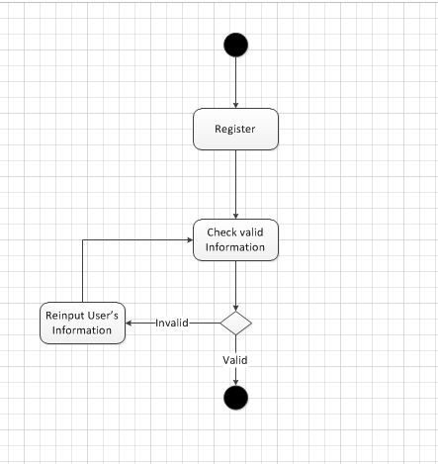

Update Personal Information
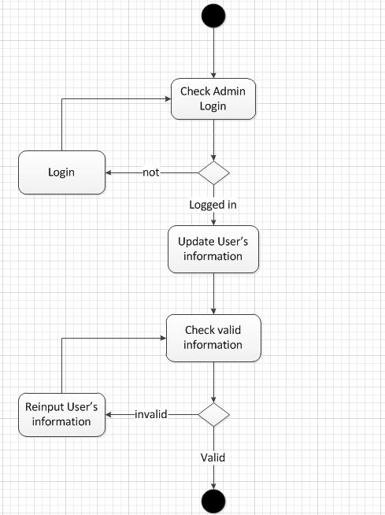

Enroll
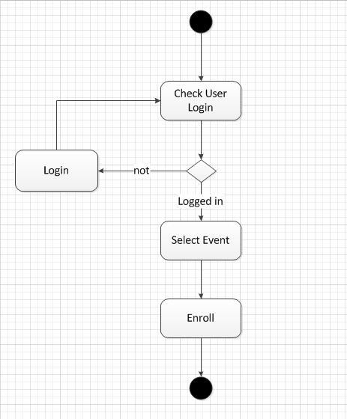

Invite for participating
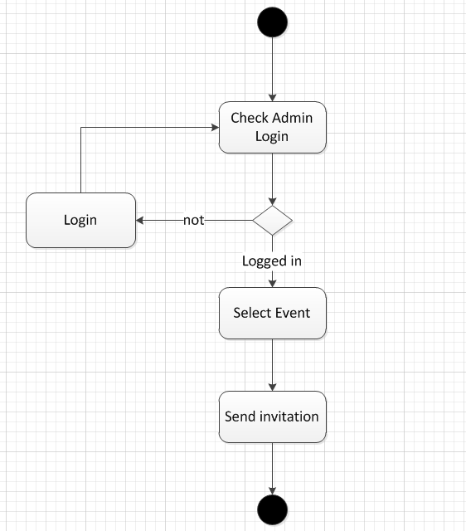

Manage Activities
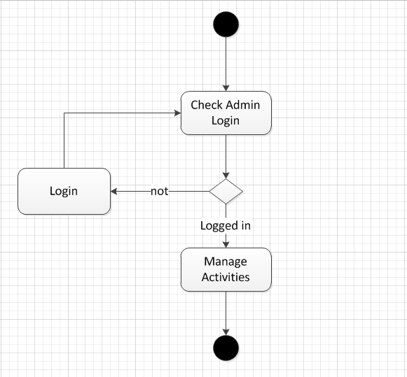

Confirm enrollment request

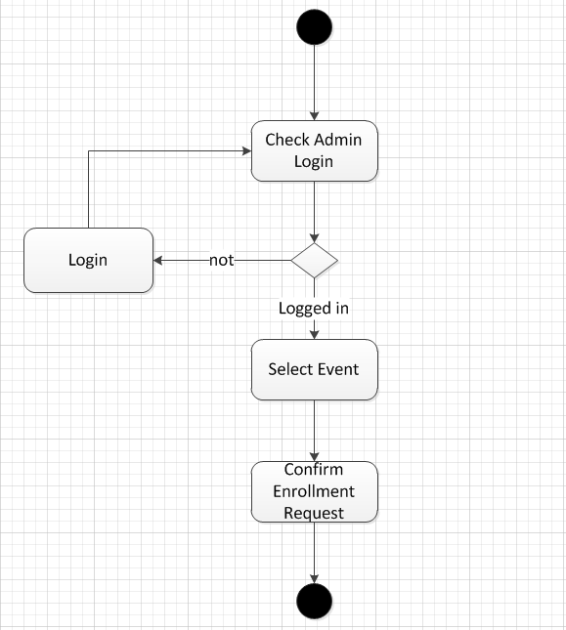

Use Case Diagram
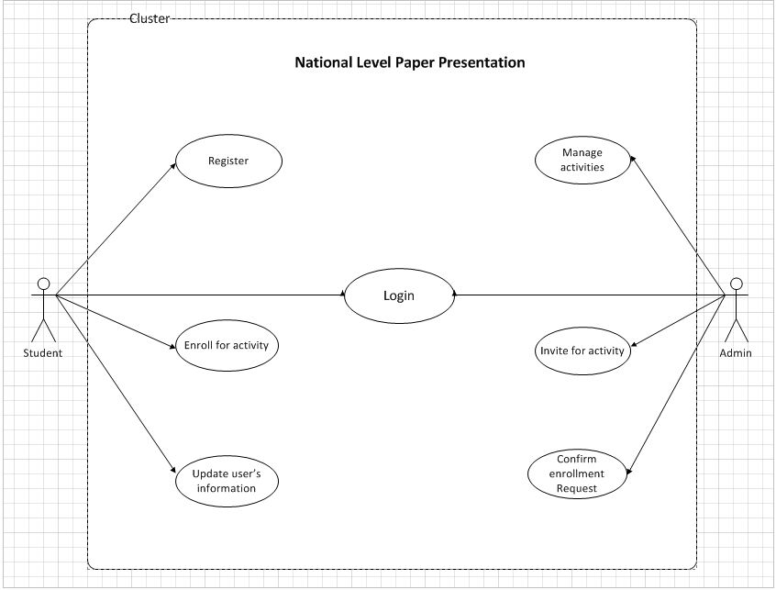

Use Case Specification

- User can register.
- User can login.
- User can update personal information.
- Admin can invite user for participating an activity.
- User can enroll for activity.
- Admin can manage activities.
- Admin can confirm enrollment request of a specific activity.

USE CASE SPECIFICATION

Use-case No. | UC001 | Use-case Version |  | 1.0
Use-case Name | Register
Author | Dao Trong Thanh
Date | 8/4/2012 | Priority | High
Actor:
Student
Summary:
Describe how a student sends a request for registration.
Goal:
To obtain an account of the system.
Triggers

Preconditions:

Post Conditions:
A new user is created in database.
Main Success Scenario:
- User enter register page.
- Input registration’s information which is included:
- User ID
- Password
- Fullname
- Gender
- Images
- Address
- Phone
- Email
- Date of birth
- Click “Register” button.
- System validates the information.
  - The information is missing or invalid.
  - An error message is displayed.
  - Go back to step 2.
- Information is valid.
- A new user is created in database.
- A message is displayed to user.
- Use Case ends successfully.
Exceptions:
- If the user inputs incorrect information 5 times continuously.
  - The system locks the login function of user for 5 minutes.
  - Use case is terminated.
Business Rules:

USE CASE SPECIFICATION

Use-case No. | UC002 | Use-case Version |  | 1.0
Use-case Name | Login
Author | Dao Trong Thanh
Date | 8/4/2012 | Priority | High
Actor:
Student
Admin

Summary:
Describe how a user login to the site.
Goal:
To login to the system.
Preconditions:
User must be existed and is active.
Post Conditions:
User login successfully.
Main Success Scenario:
- User enter login page.
- Input Username and password.
- Click “Login” button.
- System validates the login’s information.
4.1. The information is missing or incorrect.
4.2. An error message is displayed.
4.3. Go back to step 2.
- Information is correct.
- User logins successfully.
- Use Case ends successfully.
Alternative Scenario:

Exceptions:
- If the user inputs incorrect information 5 times continuously.
  - The system locks login’s function of user for 5 minutes.
  - Use case is terminated.

Business Rules:

USE CASE SPECIFICATION

Use-case No. | UC003 | Use-case Version |  | 1.0
Use-case Name | Enroll for
Author | Dao Trong Thanh
Date | 8/4/2012 | Priority | High
Actor:
Student
Admin

Summary:
Describe how a user modifies his/her personal information.
Goal:
User’s information is modified.
Preconditions:
User must login.
Post Conditions:
Information is updated.
Main Success Scenario:
- User enter user’s information page.
- Update information.
- Password
- Full name
- Gender
- Date of Birth
- Address
- Phone
- Email
- Click “Update” button
- Information is updated
- Use case ends successfully.

Alternative Scenario:

Exceptions:

Business Rules:

USE CASE SPECIFICATION

Use-case No. | UC004 | Use-case Version |  | 1.0
Use-case Name | Send activity’s invitation
Author | Dao Trong Thanh
Date | 8/4/2012 | Priority | High
Actor:
Admin

Summary:
Describe how admin send an invitation to user.
Goal:
Users are invited to an activity.
Preconditions:
Admin must login.
Post Conditions:

Main Success Scenario:
- Admin enter activity page.
- Click on an activity to select
- Select users to invite
- Click “Send invitation” button
- Use case ends successfully.

Alternative Scenario:

Exceptions:

Business Rules:

USE CASE SPECIFICATION

Use-case No. | UC005 | Use-case Version |  | 1.0
Use-case Name | Enroll for an activity
Author | Dao Trong Thanh
Date | 8/4/2012 | Priority | High
Actor:
Student

Summary:
Describe how student send a request for participating an activity.
Goal:
A request of participating is sent to admin .
Preconditions:
Student must login.
Post Conditions:

Main Success Scenario:
- User enter activity page.
- Click on an activity to select
- Click “Enroll” button
- Use case ends successfully.

Alternative Scenario:

Exceptions:

Business Rules:

USE CASE SPECIFICATION

Use-case No. | UC006 | Use-case Version |  | 1.0
Use-case Name | Manage activities
Author | Dao Trong Thanh
Date | 8/4/2012 | Priority | High
Actor:
Admin

Summary:
Describe how admin manage (create, update, confirm enrollment request) activities.
Goal:
Create new activity or update activity’s information.
Preconditions:
Admin must login.
Post Conditions:
Activity is managed in database.
Main Success Scenario:
- Admin enter “Manage activity” page.
- Manage Activity
2.1. Create an activity (UC0006_1).
2.2. Update an activity’s information (UC0006_2).
2.3. Confirm an activity’s enrollment request (UC0006_3).
- Activity is managed
- Use case ends successfully.

Alternative Scenario:

Exceptions:

Business Rules:

USE CASE SPECIFICATION

Use-case No. | UC006_1 | Use-case Version |  | 1.0
Use-case Name | Create new activity
Author | Dao Trong Thanh
Date | 8/4/2012 | Priority | High
Actor:
Admin

Summary:
Describe how admin create a new activity.
Goal:
A new activity is created in database.
Preconditions:
Admin must login.
Post Conditions:
Activity is created in database.
Main Success Scenario:
- Admin enter “Manage activity” page.
- Click “New Activity” button
- Input Activity’s information
- Category.
- Activity’s Name.
- Address.
- Time.
- Deadline.
- Image.
- Description.
- Detail.
- Price
- Click “Create” button.
- A new activity is created in database.
- Use case ends successfully.

Alternative Scenario:

Exceptions:

Business Rules:

USE CASE SPECIFICATION

Use-case No. | UC006_2 | Use-case Version |  | 1.0
Use-case Name | Update activity’s information
Author | Dao Trong Thanh
Date | 8/4/2012 | Priority | High
Actor:
Admin

Summary:
Describe how admin modifies activity’s information.
Goal:
Activity’s information is updated in database.
Preconditions:
Admin must login.
Post Conditions:
Activity is updated in database.
Main Success Scenario:
- Admin enter “Manage activity” page.
- Click on an activity to select
- Input Activity’s information
- Category.
- Activity’s Name.
- Address.
- Time.
- Deadline.
- Image.
- Description.
- Detail.
- Price
- Click “Update” button.
- Activity’s information is updated in database.
- Use case ends successfully.

Alternative Scenario:

Exceptions:

Business Rules:

USE CASE SPECIFICATION

Use-case No. | UC006_3 | Use-case Version |  | 1.0
Use-case Name | Confirm enrollment request
Author | Dao Trong Thanh
Date | 8/4/2012 | Priority | High
Actor:
Admin

Summary:
Describe how admin confirm an activity’s enrollment request.
Goal:
Enrollment request is confirmed.
Preconditions:
Admin must login.
Post Conditions:
Activity’s enrollment is updated in database.
Main Success Scenario:
- Admin enter “Manage activity” page.
- Click on an activity to select
- Click “Enrollment” button
- Select student’s enrollment request in list
4.1. Click “Accept” to accept users’ requests.
4.2. Click “Deny” to reject users’ requests.
- An announcement is send to users.
- Use case ends successfully.

Alternative Scenario:

Exceptions:

Business Rules:

Design

System Architecture
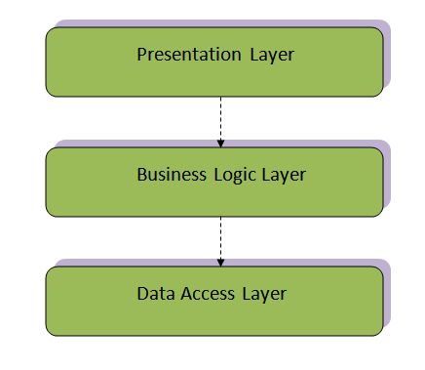
3-Tiers Architecture

Class Diagram
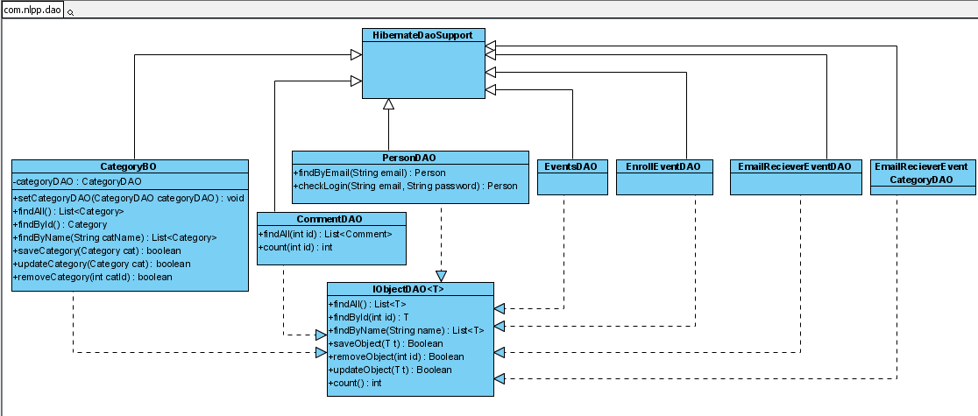
DAO Classes
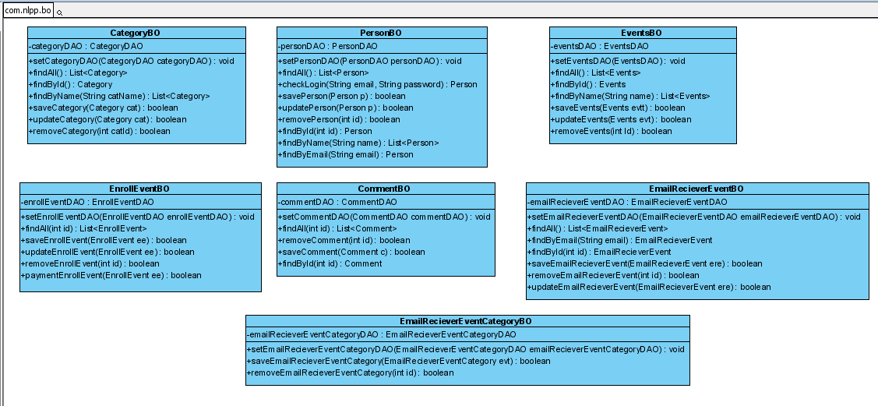
BO Classes

Class Diagram Explanation

Entity Relationship Diagram
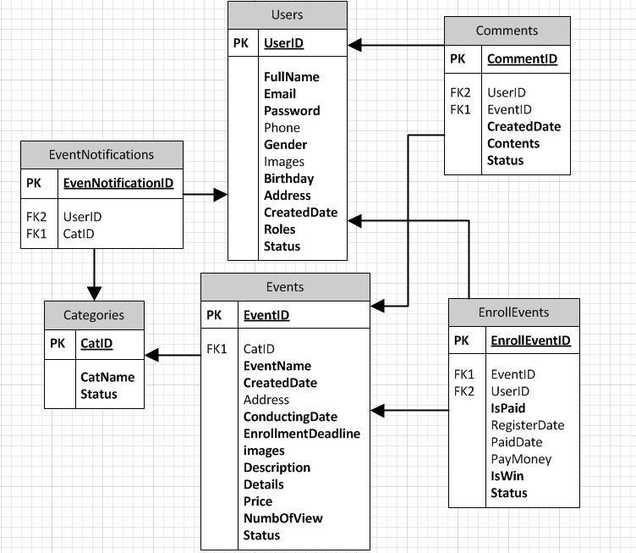

Database Design

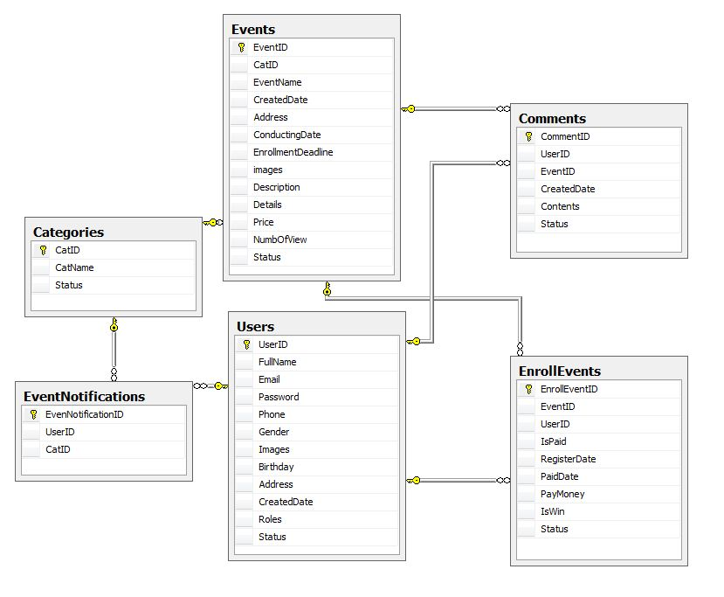

Screenshots
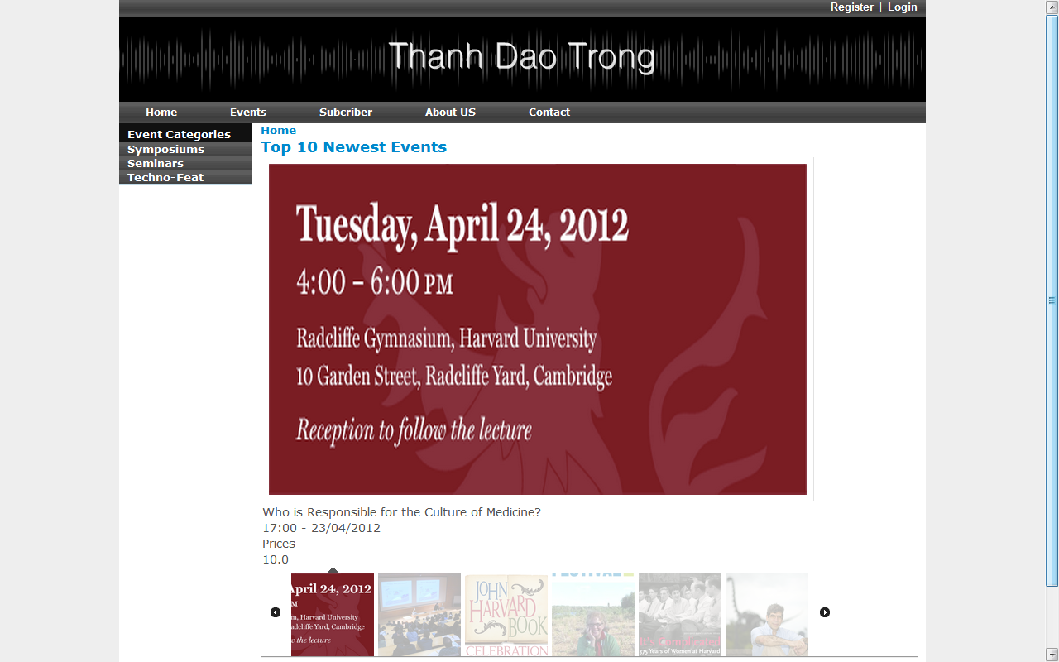
Screen Shot 1- User Home Page

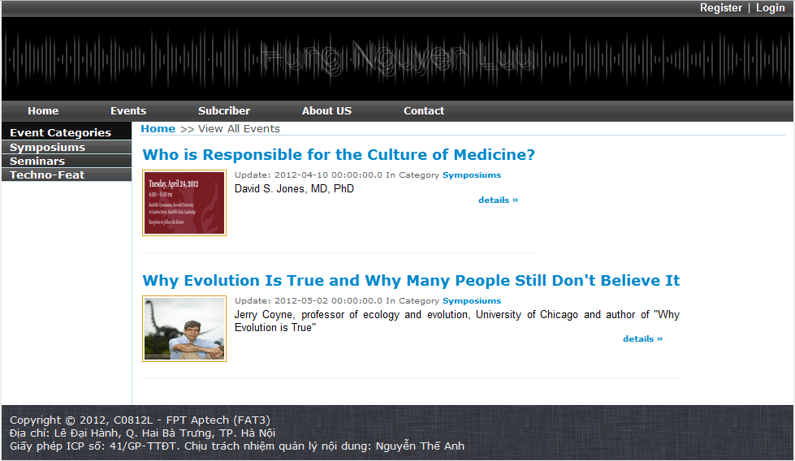
Screen Shot 2 – Event Page

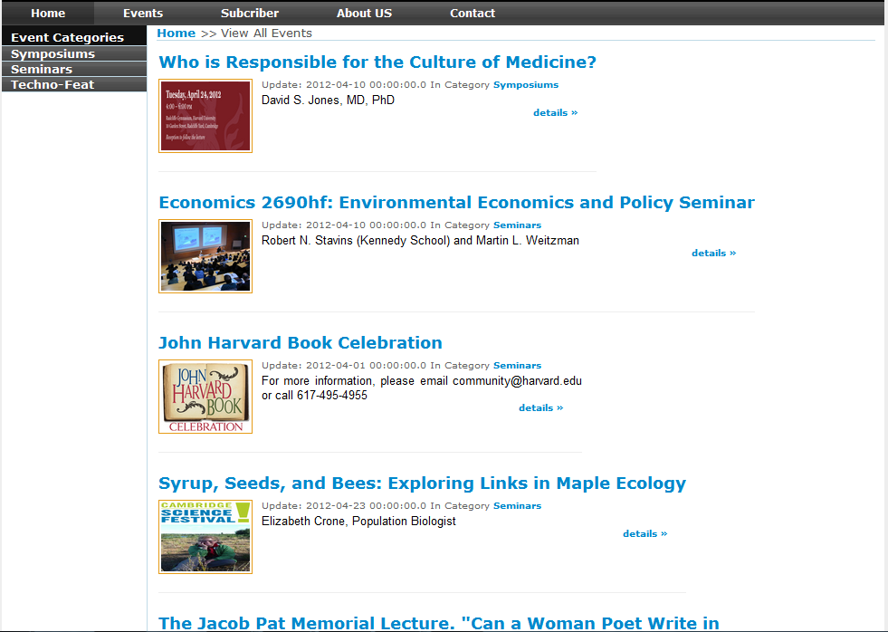
Screen Shot 3 - Subscriber Page

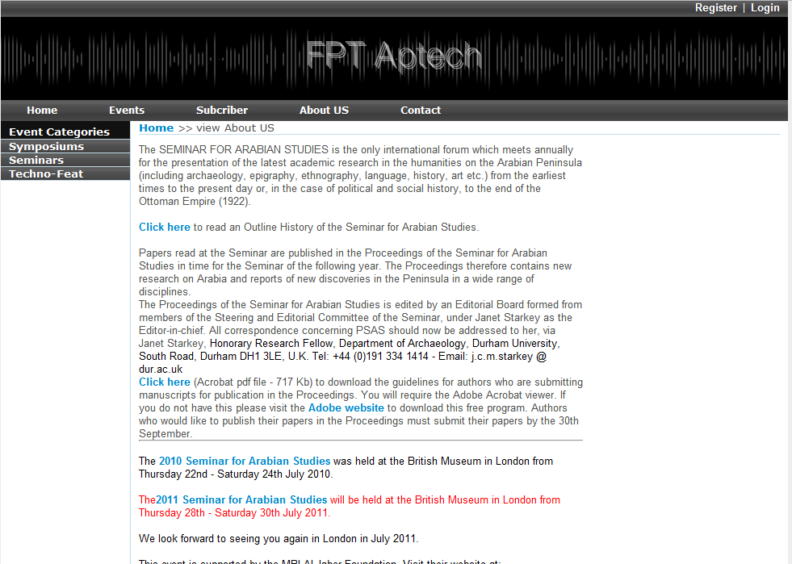
Screen Shot 4 – About Us Page

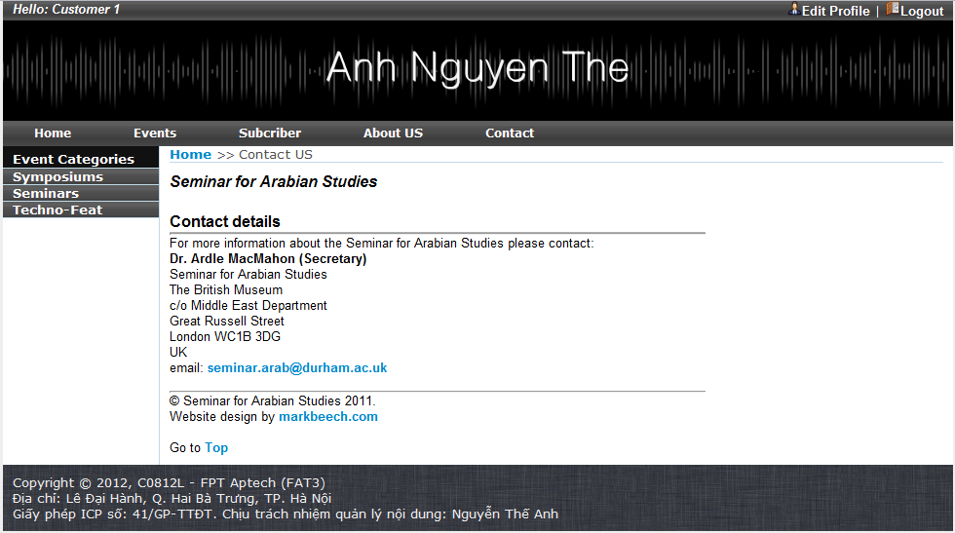
Screen Shot 5 – Contact Page

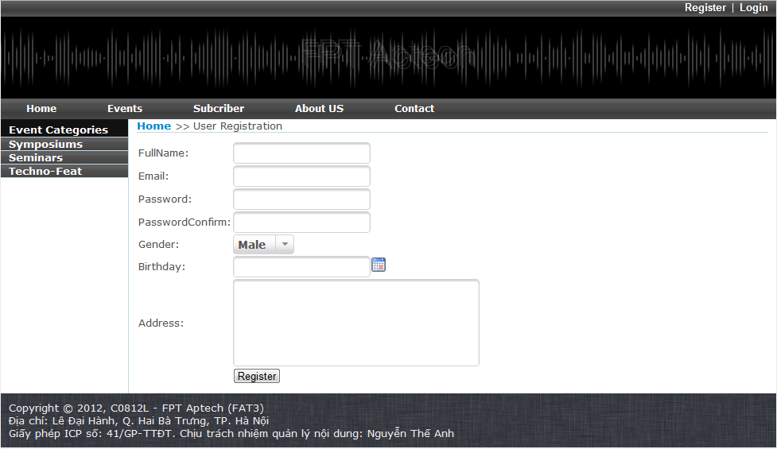
Screen Shot 6 – Register Page

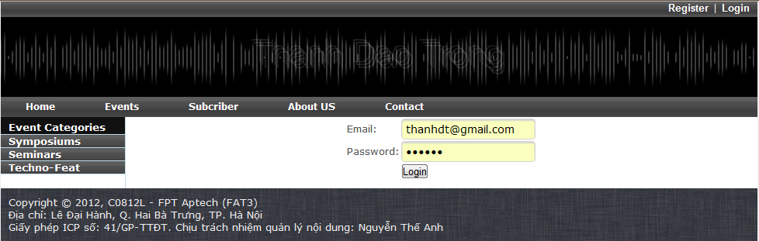
Screen Shot 7 – Login Page

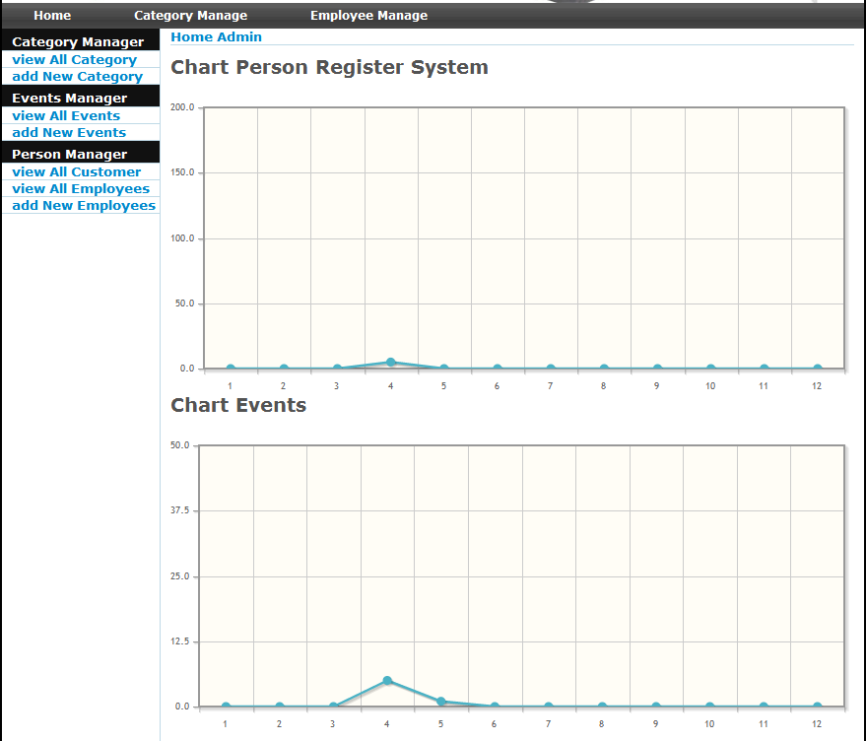
Screen Shot 8 – Admin Home Page

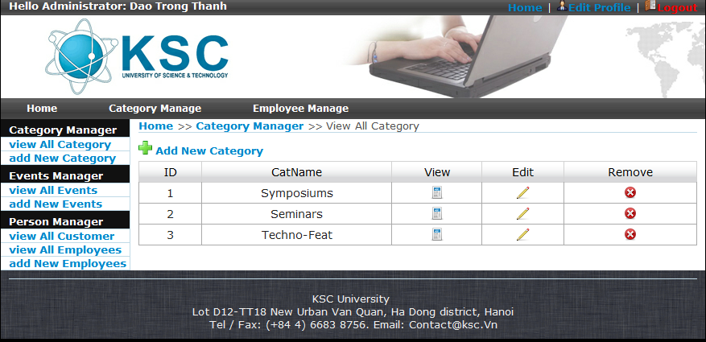
Screen Shot 9 – Category Management Page

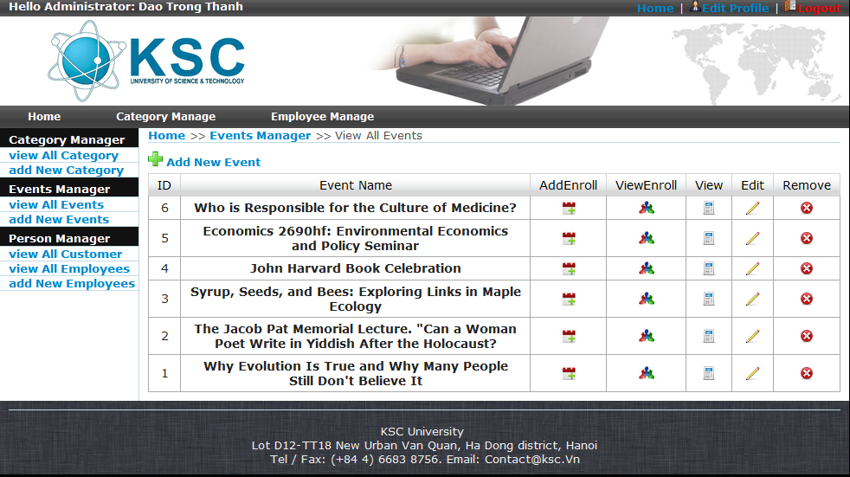
Screen Shot 10 – Event Management Page

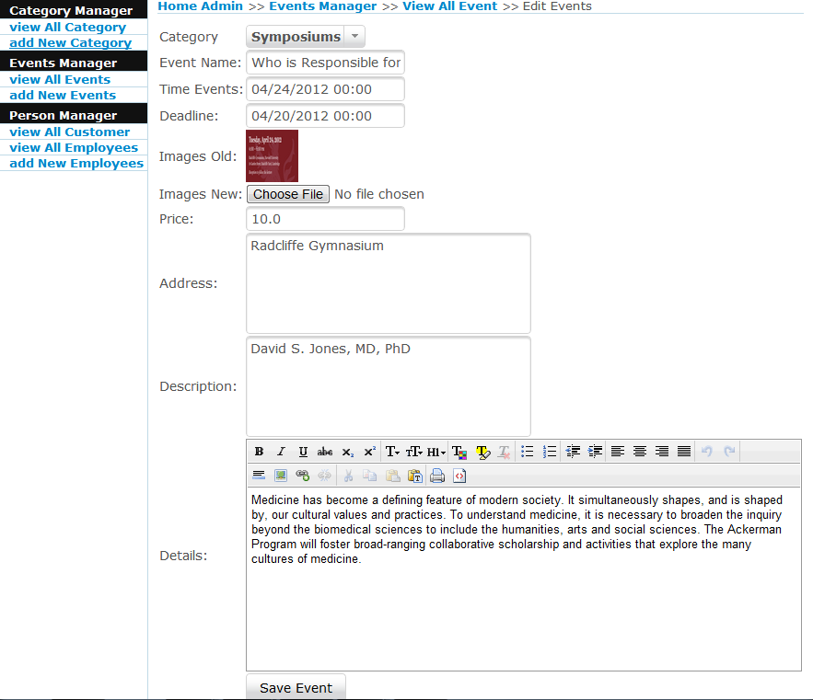
Screen Shot 11 – Event Information Page

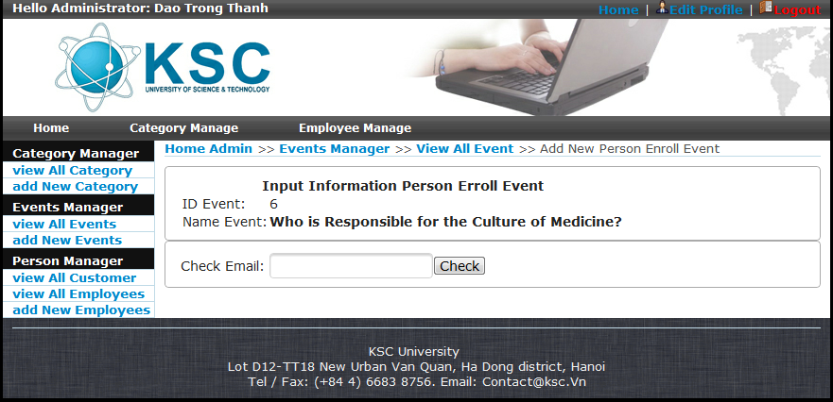
Screen Shot 12 – Event Invitation Page

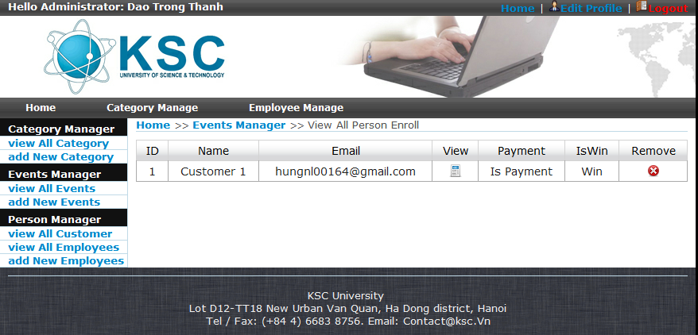
Screen Shot 13 – Event Enrollment Request Page

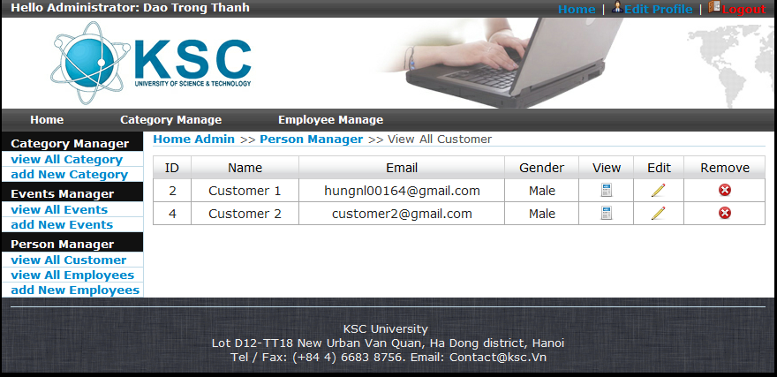
Screen Shot 14 – Customer Management Page

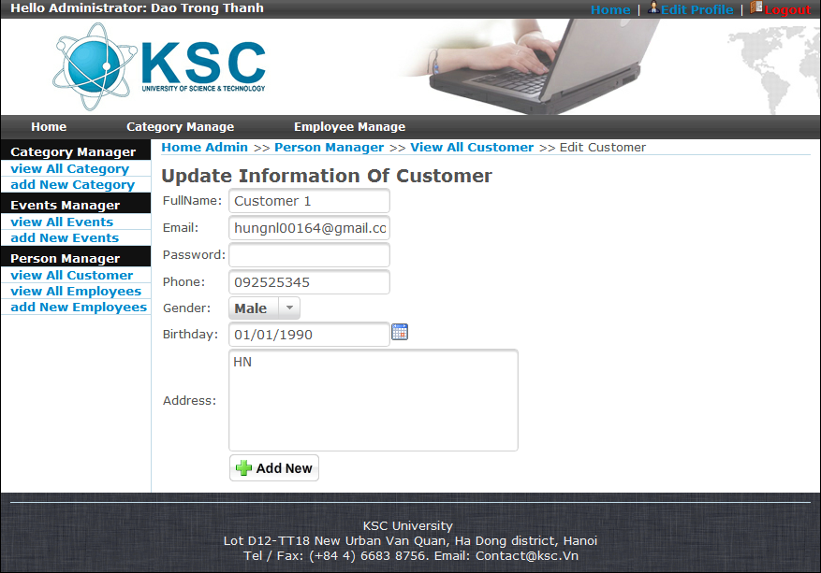
Screen Shot 15 – Customer Information Page

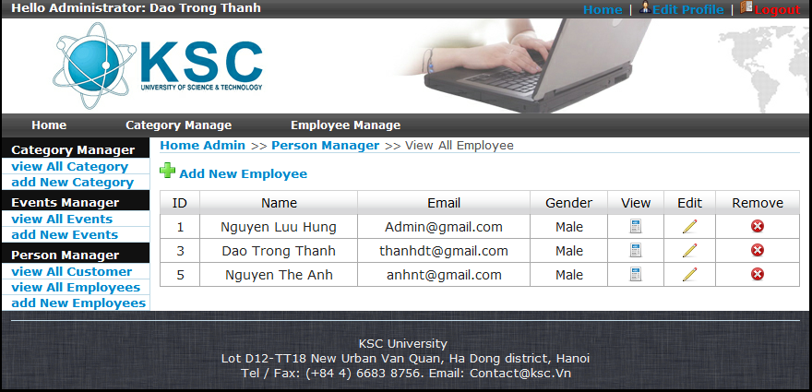
Screen Shot 16 – Employee Management Page

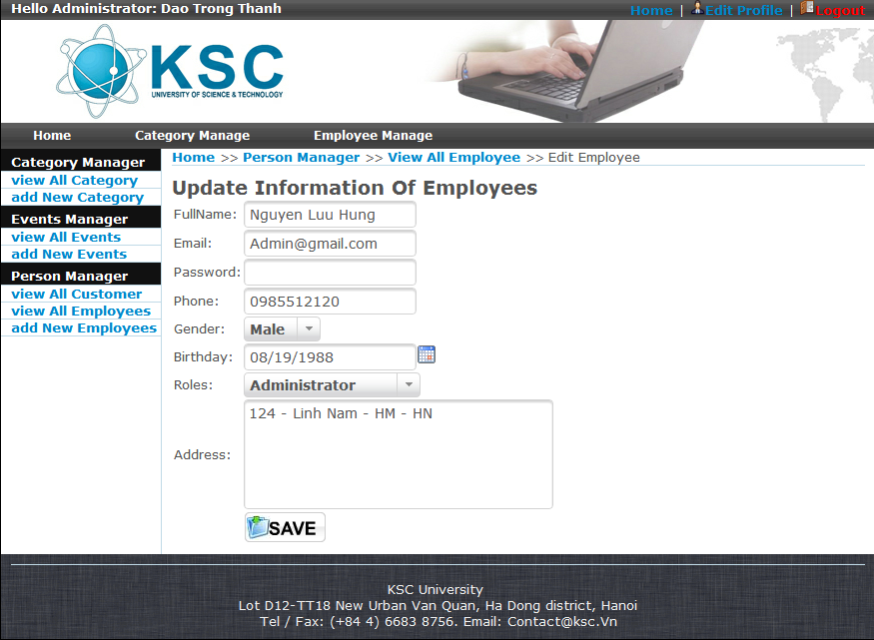
Screen Shot 17 – Employee Information Page

