K-means Algorithm analysis of Depression dataset

Abstract:
This report presents several algorithms analyses of a depression dataset such as KMeans algorithm. The dataset includes features such as age, smoking status, family history of depression, and substance abuse history. After preprocessing to deal with missing values and normalize data, we applied KMeans clustering with three clusters. The clustering results revealed many interesting information. More importantly, the result reveals demographic and behavioral traits associated with mental health risks. Based on the analysis I present later; the analysis also emphasizes the importance of clustering techniques in mental health research.

Introduction
Depression is a common disease worldwide. The Patients who suffer from depression are characterized by persistent low mood, loss of interest, lack of energy. An article on World Health Organization describes the prevalence of depression:” An estimated 3.8% of the population experience depression, including 5% of adults (4% among men and 6% among women), and 5.7% of adults older than 60 years. Approximately 280 million people in the world have depression.”
In recent years, with the growing
prominence of mental health issues, depression has attracted increasing attention in academic and medical fields. According to report from the Harvard university, the author the author illustrates how complex the causes of depression are:” It's often said that depression results from a chemical imbalance, but that figure of speech doesn't capture how complex the disease is. Research suggests that depression doesn't spring from simply having too much or too little of certain brain chemicals. Rather, there are many possible causes of depression, including faulty mood regulation by the brain, genetic vulnerability, and stressful life events.”In this situation, we can see that the occurrence of depression is not only related to genetic factors but is also closely linked to environmental and sociocultural influences. So, it is necessary for people to Understand the underlying factors contributing to depression, because it is essential for effective prevention and intervention strategies.

This study applies the K-Means clustering algorithm to a depression dataset. K-means Clustering is an unsupervised machine learning technique which enables the identification of hidden patterns in complex datasets. By grouping individuals with similar characteristics, we plan to uncover hidden patterns that could inform mental health strategies. The focus of this report is on exploring the relationship between demographic, medical, and behavioral factors in the context of depression.

Dataset description

The depression dataset was taken from

Kaggle. We can clearly see the dataset used in this analysis focuses on depression-related factors. It contains over 0.4 million entries with multiple features that capture demographic, medical, and behavioral attributes. Each entry represents an individual and provides data about their basic information, health conditions, disease history and lifestyle.
Apart from that, we can also see other characteristics of this dataset by coding process.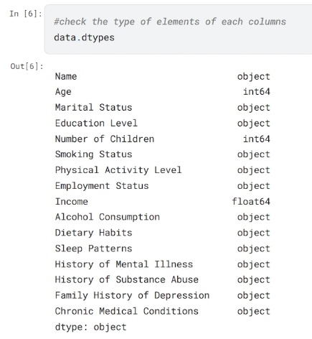 From the graph above, it shows that this dataset includes both categorical and binary features. Besides, it seems that this dataset is quite big. In this situation, perhaps we should only take a portion of this dataset for certain steps, which might save time.

Data preprocessing
Since we have a general understanding of the basic information about this dataset, we can now start preprocessing it. First, 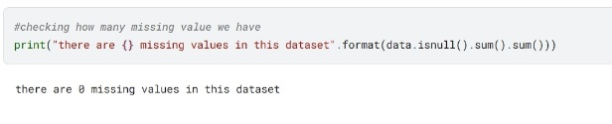we can see that there is not any missing value in this dataset, so we do not have to deal with them. Secondly, it seems we need to normalize certain columns because the features in the dataset have inconsistent scales. The differences in magnitudes may cause the model to focus more on features with larger values during optimization. However, removing these columns might be
a better idea. we plan to keep only the age and columns that can be binary, as this approach simplifies computation (binary features have a small range of values, 0 or 1, it makes distance calculations straightforward and efficient).So, I have decided to select the following columns as our experimental dataset: 'Chronic Medical Conditions,' 'Smoking Status,' 'Family History of Depression,' 'History of Substance Abuse,' and 'Age'." We all know that the K-Means clustering model only supports numerical data, so next, we will binarize four of the columns by converting 'yes' and 'no' into '0' and '1.' Then, we will discretize the 'Age' column by using the 'qcut' command to divide it into four equal parts.

Finally, we have done the preprocessing part. In the next step, we will input the processed data into the algorithm model and review the results.

K-means algorithm
The Wikipedia explains the K-means algorithm as follows:” k-means clustering is a method of vector quantization, originally from signal processing, that aims to partition n observations into k clusters in which each observation belongs to the cluster with the nearest mean (cluster centers or cluster centroid), serving as a prototype of the cluster.” In general. K-means is a distance-based clustering method that finds a grouping scheme by assigning data points to clusters and iteratively optimizing the centroids' positions which aim to maximize similarity within clusters and differences between
clusters.

Just like other algorithms, the K-means has its own advantages and limitations. First, K-means is computationally efficient which makes it suitable for dealing with large-scale datasets. Besides, the result of K-means clustering is very straightforward, it provides a clear partition of data into distinct clusters. Except that, the result of k-means can be put into many uses such as image compression and behavior analysis. However, we cannot ignore some limitations of k-means algorithm. One of the biggest disadvantages is that this algorithm is too sensitive to noise. Maximum and minimum values can significantly distort the computation of cluster centroids which will affect the clustering results. Moreover, K-means required users give it k value (number of clusters) at first. If the k value is not appropriate, the results may be suboptimal.
Fortunately, we have many methods to address these two issues. For the problem of K-means being sensitive to noise, we have already addressed it during the data preprocessing stage by using discretization and segmenting the dataset. As for the issue of finding an appropriate k for K-means, we can solve it using two methods: one is by plotting the SSE curve, and the other is by using the silhouette coefficient to determine the optimal value.

Analysis of K-means algorithm result
First, let's look at the SSE method. When we use SSE to generate the ELBOW curve, we can determine the optimal value of k based on the inflection point. We then use this parameter in
the K-means model for clustering to obtain the results. 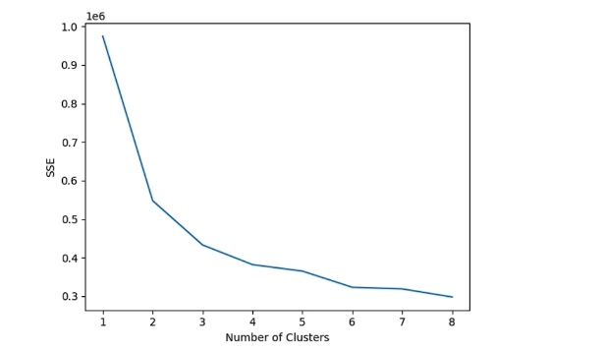According to our plot, the optimal inflection point should be at k=3. After the K-means clustering process is finished, each sample is assigned a Cluster ID. The samples are then grouped by Cluster ID, and the mean of each feature is calculated so that we can review the results. 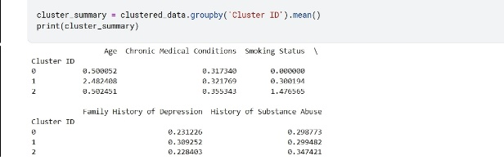Based on the results we obtained, we see that for users with a Cluster ID of 0, the average Age value is 1.2 which indicates that this cluster primarily consists of middle-aged individuals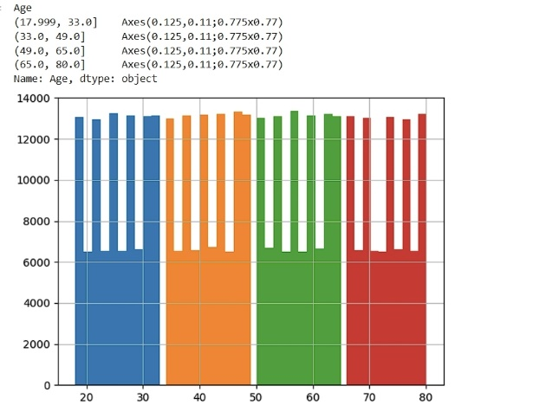 (assuming Age=1 represents middle-aged people). The average value for Family History of Depression is 0.9, suggesting that most individuals in this cluster have a family history of depression. Members of this cluster may belong to a middle-age demographic, and their family history of depression potentially makes them a target group for early intervention. For users whose Cluster ID is 1, we can observe a clear distinction from the previous group. Based on the average values we obtained, users with a Cluster ID of 1 exhibit relatively balanced characteristics, potentially representing individuals with better overall health and no significant single risk factor. We can see that this group has an average Chronic Medical Conditions value of 0.4, indicating a lower incidence of chronic
diseases. The average values for Smoking Status and Substance Abuse are also relatively low. Additionally, the Age values are evenly distributed which shows that this group is not skewed toward a specific age range. For the final group of users, we can also observe distinctive characteristics. For users with a Cluster ID of 2, the average Age value is 3.1 which indicates that this group mainly consists of older individuals. The average values for Smoking Status and Substance Abuse are 1.8 and 0.7 respectively, showing higher rates of smoking and substance abuse. In other words, they are older individuals with a history of smoking and substance abuse, which may imply that members of this cluster could face higher mental health risks, particularly those related to substance and tobacco abuse.

After identifying the optimal K value using the SSE method, we can follow the same steps by plotting the silhouette coefficient chart. However, when calculating the silhouette coefficient, the process was not successful. The primary reason was the large size of the dataset (over 420,000 entries), which resulted in excessively long computation times. Therefore, it was necessary to take certain measures with the original dataset. First, I used PCA for dimensionality reduction which attempts to reduce the original 5 features to two dimensions. However, the results were still not ideal. Consequently, I had to extract only a portion of the dataset (20,000 entries) as a sample for calculating the silhouette coefficient. As a result, it works.
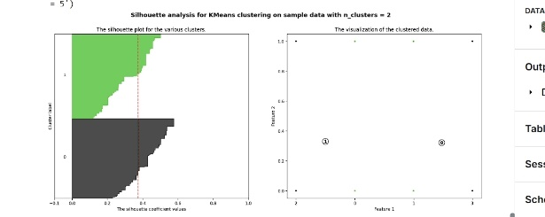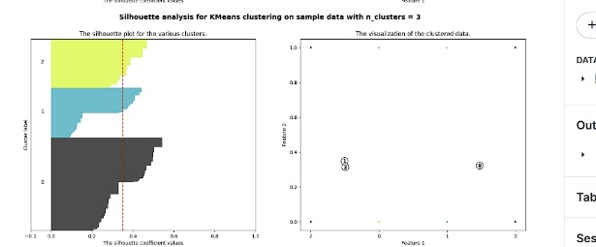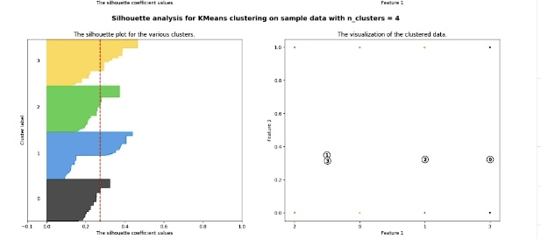

From the graphic we got, we can clearly see the computation results of the silhouette coefficient program. When the number of clusters is 2, the overall silhouette coefficient is relatively high, with an average value of approximately 0.4 or above. The silhouette coefficients of the two clusters are consistent, and most data points have positive silhouette coefficients. Therefore, we can conclude that the clustering performance is better when clusters = 2. On the other hand, as the number of clusters increases, the silhouette coefficient gradually decreases, and some negative values appear which indicate that certain data points were incorrectly assigned. This suggests that the quality of the clusters is progressively declining. Therefore, our conclusion is that clusters = 2 is a reasonable choice, as it has a relatively high silhouette coefficient, with good separation between clusters and strong internal consistency within each cluster.

Conclusion
According to the analysis result, the clustering process divided the dataset into three different groups. The characteristics of the three segmented groups are very distinct. They are younger individuals with a family history of depression, mixed age group with lower rates of chronic medical conditions and older individuals who have habit of smoking and substance abuse. We can take corresponding actions based on the characteristics of each group, such as providing older users with more lifestyle recommendations.

World Health Organization (31 March 2023),” Depressive disorder (depression)”, available: https://www.who.int/news-room/factsheets/detail/depression
Harvard Health Publishing (January 10, 2022),” What causes depression?”, available: https://www.health.harvard.edu/mind-and-mood/what-causes-depression
wikipedia ,“k-means clustering”,available: https://en.wikipedia.org/wiki/K-means_clustering

