Figure 1: Overall System Architecture Diagram
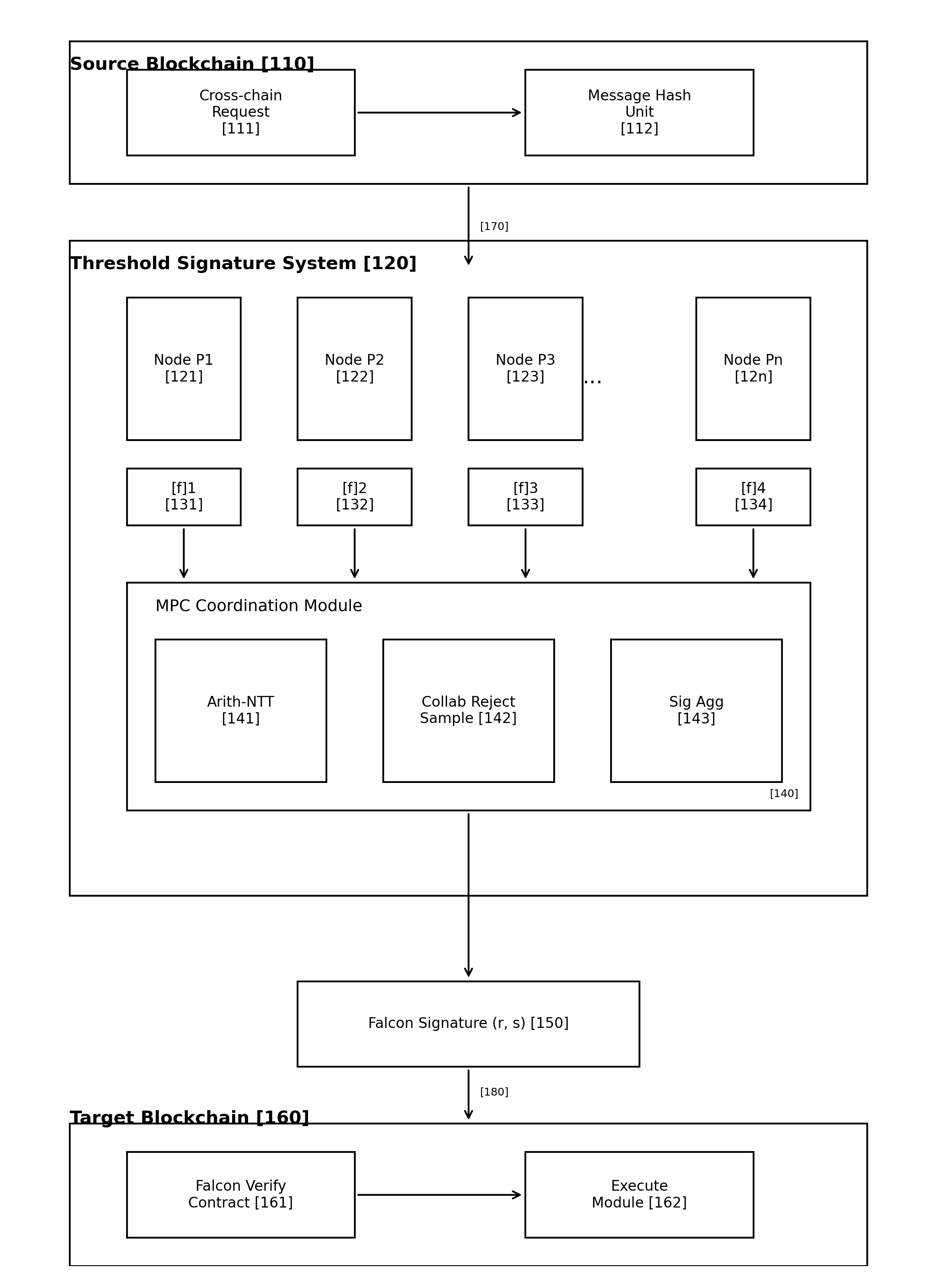

图1：系统整体架构图
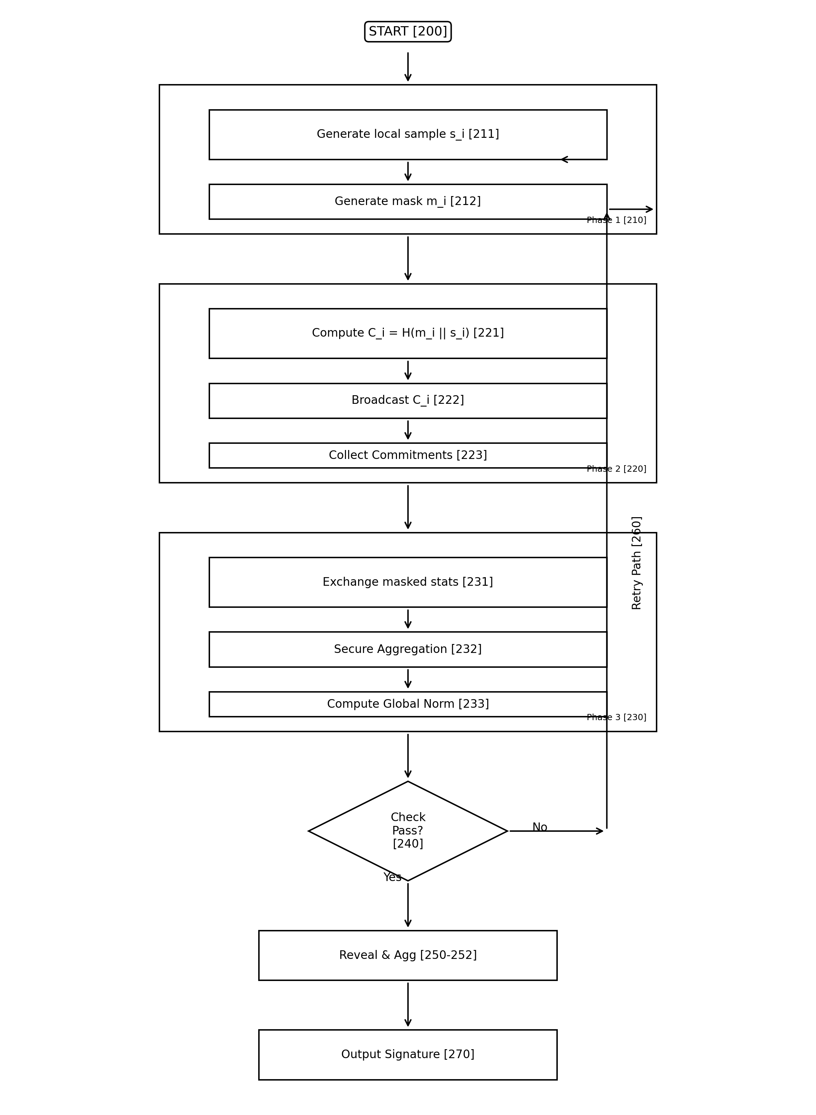
### Description / 描述
Shows the complete threshold Falcon signature system architecture with source chain, signature system, and target chain interaction.
### Reference Numerals / 附图标记
### Layout Specification / 布局规格
```
+----------------------------------------------------------+
+----------------------------------------------------------+
```
### Arrow Specifications / 箭头规格
- All arrows: 0.5mm line width, solid arrowhead
- Vertical data flow arrows: Downward direction
- Horizontal process arrows: Left to right
- Dashed lines for internal communication within modules

Figure 2: Collaborative Rejection Sampling Flowchart
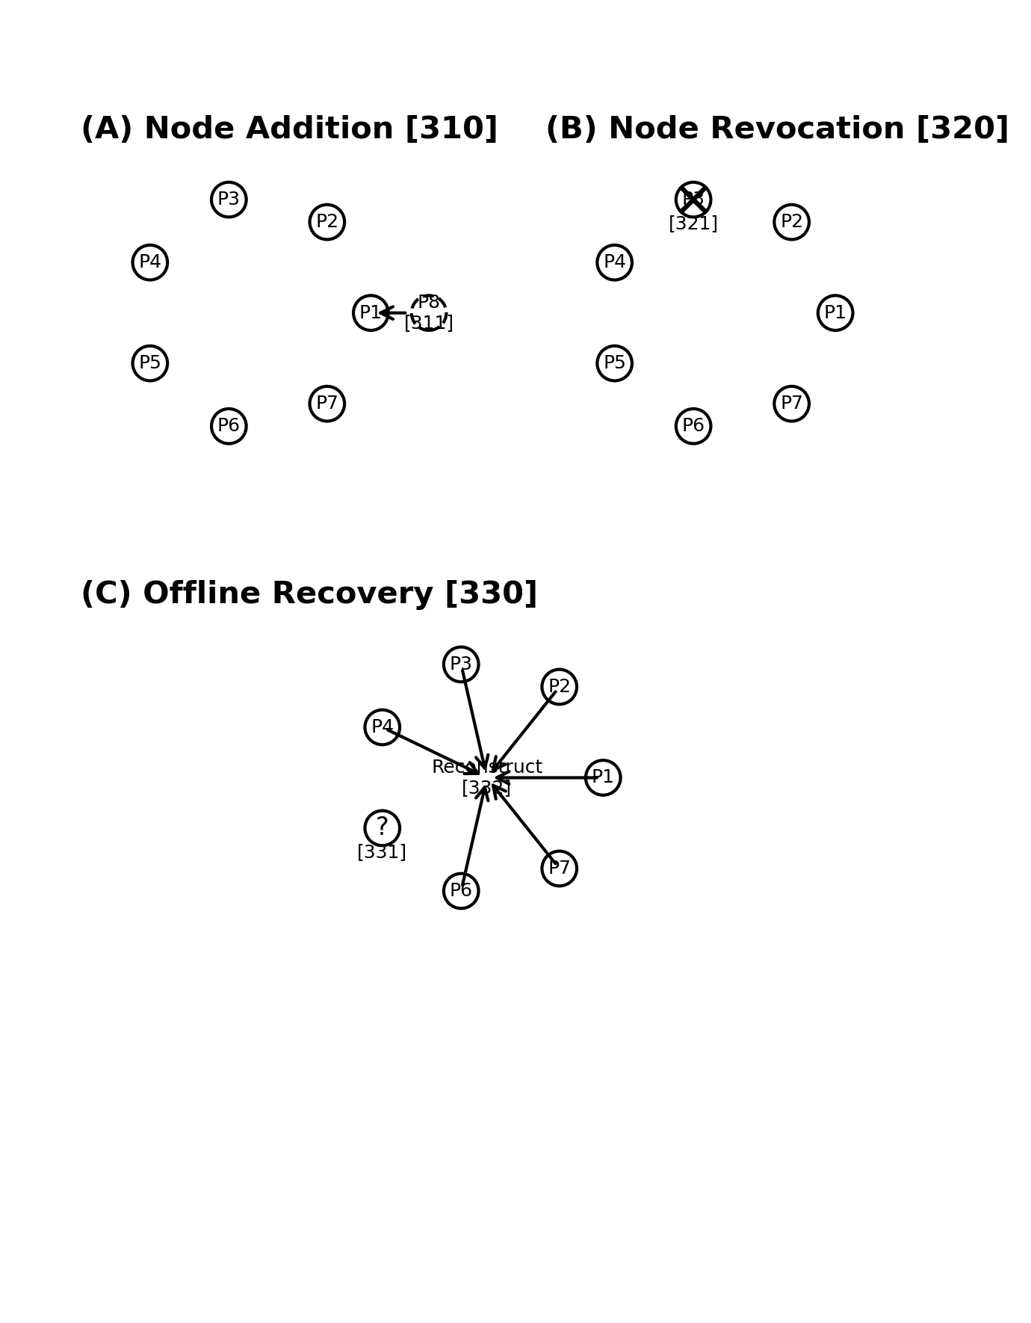

图2：协同纠偏采样流程图
[图片文件未找到]
### Description / 描述
Flowchart showing the three-phase protocol: Commitment, Pre-check Verification, and Conditional Reveal.
### Reference Numerals / 附图标记
### Layout Specification / 布局规格
```
+----------------------------------------------------------+
+----------------------------------------------------------+
```
### Flowchart Symbol Standards / 流程图符号标准
- Oval/Ellipse: Start/End terminals (200, 280)
- Rectangle: Process steps (211, 212, 221-223, 231-233, 251, 252, 261, 262)
- Diamond: Decision point (240)
- Rectangle with double border: Phase groupings (210, 220, 230, 250)
- Arrows: 0.5mm width, solid arrowhead

Figure 3: Dynamic Node Management Diagram
[图片文件未找到]

图3：动态节点管理示意图
[图片文件未找到]
### Description / 描述
Three sub-diagrams showing: (A) Node Addition, (B) Node Revocation, (C) Offline Node Recovery
### Reference Numerals / 附图标记
### Layout Specification / 布局规格
```
+----------------------------------------------------------+
+----------------------------------------------------------+
```
### Visual Element Standards / 视觉元素标准
- Active Node: Solid border rectangle
- Revoked Node: Rectangle with X overlay
- Offline Node: Rectangle with ? overlay
- New Node: Dashed border rectangle (before integration)
- Process Box: Rounded rectangle with gray fill (10%)
- Arrows: Indicate data/share flow direction
- Separator Lines: Double line (═) between scenarios
## Production Instructions / 制作说明
### For Professional Illustrators / 给专业制图人员
1. Software Recommendations / 软件建议:
- Adobe Illustrator (preferred)
- Microsoft Visio
- Draw.io (free alternative)
- AutoCAD LT
2. File Deliverables / 交付文件:
- Source file (AI, VSDX, or DWG)
- PDF export (vector, not rasterized)
- PNG export at 300 DPI
- TIFF export at 300 DPI (for USPTO)
3. Color Mode / 颜色模式:
- Grayscale only
- No fills darker than 20% gray
- All text and lines must be pure black (#000000)
4. Text Handling / 文字处理:
- Convert all text to outlines/curves for final submission
- Maintain editable version separately
5. Reference Numeral Placement / 标记放置:
- Place numerals adjacent to elements, not overlapping
- Use leader lines (thin, 0.25mm) when necessary
- Consistent numeral size throughout (10pt minimum)
## Estimated Production Time / 预计制作时间
## Approval Checklist / 审批清单
- [ ] Figure 1 draft reviewed
- [ ] Figure 2 draft reviewed
- [ ] Figure 3 draft reviewed
- [ ] All reference numerals match specification text
- [ ] Resolution meets patent office requirements
- [ ] Chinese and English versions consistent
- [ ] Final files exported in required formats
*Document Version: 1.0*
*Created: December 2025*
*Last Updated: December 2025*

