## Mnist对输入求梯度

|  |  |  |  |  |  |  |  |
| --- | --- | --- | --- | --- | --- | --- | --- |
| 样本数量 | 迭代轮数 | Minibatch | 500loss | 500acc | 10000loss | 10000acc |  |
| 500 | 150 | 50 | 0.69 | 0.76 | 0.19 | 0.92 |  |

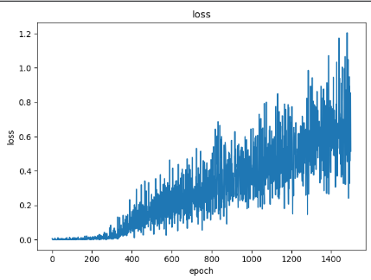

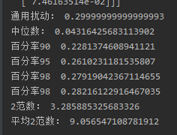

Cifar-10求梯度

|  |  |  |  |  |  |  |  |
| --- | --- | --- | --- | --- | --- | --- | --- |
| 样本数量 | 迭代轮数 | Minibatch | 样本loss | 样本acc | 10000loss | 10000acc |  |
| 1000 | 13 | 100 | 18.6 | 0.14（打乱0.6） | 18.13 | 0.15（打乱0.50） |  |

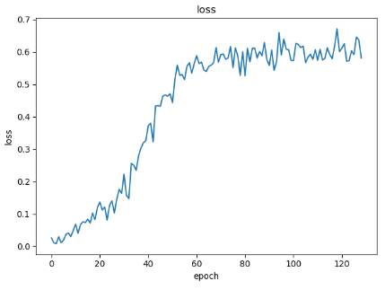

|  |  |  |  |  |  |  |  |
| --- | --- | --- | --- | --- | --- | --- | --- |
| 样本数量 | 迭代轮数 | Minibatch | 样本loss | 样本acc | 10000loss | 10000acc |  |
| 100 | 60 | 25 | 18.2 | 0.24（打乱0.64） | 13 | 0.23（打乱0.71） |  |

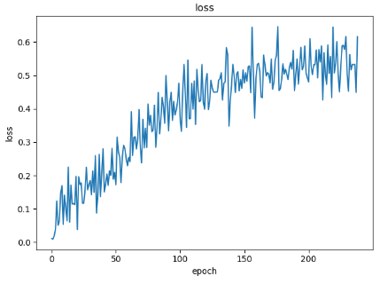

|  |  |  |  |  |  |  |  |
| --- | --- | --- | --- | --- | --- | --- | --- |
| 样本数量 | 迭代轮数 | Minibatch | 样本loss | 样本acc | 10000loss | 10000acc |  |
| 2000 | 20 | 200 | 28 | 0.12（打乱0.58） | 13 | 0.128（打乱0.51） |  |

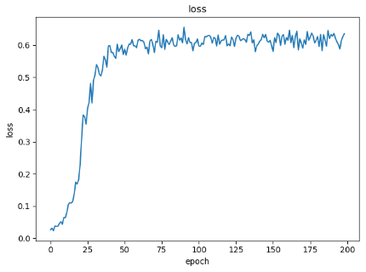

现在是9/21号。一部分用来做实验，进行百纳话