画圆（方法一）：

import matplotlib.pyplot as plt
import numpy as np
x = np.linspace(-1,1,3000)
y = np.linspace(-1,1,3000)
points_x=[]
points_y=[]
for x1 in x:
for y1 in y:
if np.abs(x1**2 + y1**2 - 1) <= 1e-4:
points_x.append(x1)
points_y.append(y1)
plt.scatter(points_x,points_y)
plt.axis("equal")
plt.show()
input()

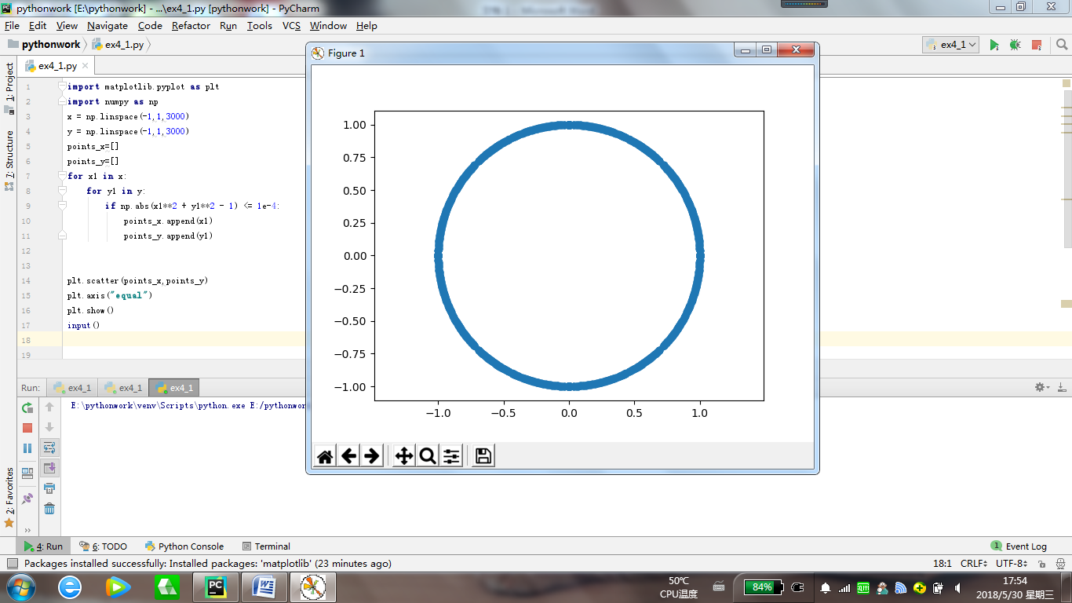
画圆（方法二）：

import matplotlib.pyplot as plt
import numpy as np
x = np.linspace(-1, 1, 3000)
y1 = np.linspace(-1, 1, 3000)
y1 = np.sqrt(1 - x**2)
y2 = -y1
plt.plot(x,y1,'g')
plt.plot(x,y2,'g')
plt.axis('equal')
plt.show()
input()

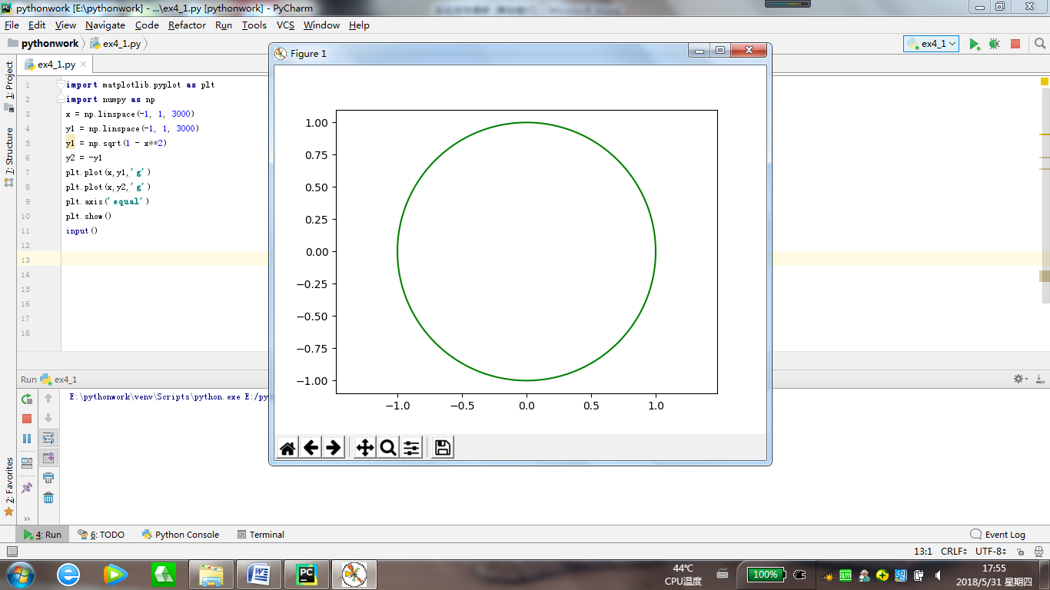
方波绘制：
import matplotlib.pyplot as plt
import numpy as np
t = np.linspace(0, 2*np.pi, 30000)
f = np.linspace(0, 2*np.pi, 30000)
N = 666
k = 1
f = 4*np.sin(t) / np.pi
while k <= N:
f = f + 4*np.sin((2*k - 1)*t) / (2*k - 1)*np.pi
k = k + 1
plt.plot(t,f)
plt.show()
input()

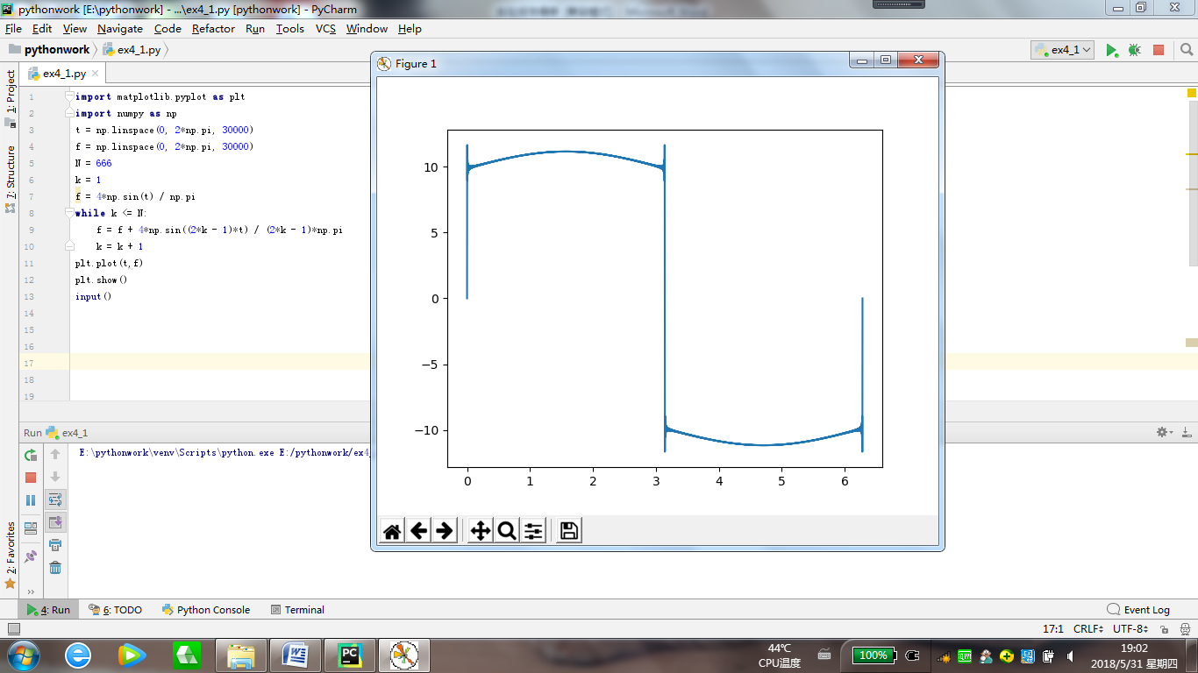

解方程：
import numpy as np
from numpy.linalg import inv
a = np.array([[1,0.5,5],[2.3,2,3],[4,1,1.7]])
b = np.array([[1],[2],[3]])
a1 = inv(a)
x = np.matmul(a1,b)
print(x)
input()

