计算机程序设计实验报告（第14周）

最好大学排名：
#e23.1CrawUnivRanking.py
import requests
from bs4 import BeautifulSoup
allUniv = []
def getHTMLText(url):
try:
r = requests.get(url, timeout=30)
r.raise_for_status()
r.encoding = 'utf-8'
return r.text
except:
return ""
def fillUnivList(soup):
data = soup.find_all('tr')
for tr in data:
ltd = tr.find_all('td')
if len(ltd)==0:
continue
singleUniv = []
for td in ltd:
singleUniv.append(td.string)
allUniv.append(singleUniv)
def printUnivList(num):
print("{:^4}{:^10}{:^5}{:^8}{:^10}".format("排名","学校名称","省市",”总分”"培养规模"))
for i in range(num):
u=allUniv[i]
print("{:^4}{:^10}{:^5}{:^8}{:^10}".format(u[0],u[1],u[2],u[3],u[6]))
def main():
url = 'http://www.zuihaodaxue.cn/zuihaodaxuepaiming2016.html'
html = getHTMLText(url)
soup = BeautifulSoup(html, "html.parser")
fillUnivList(soup)
printUnivList(20)
main()
input()

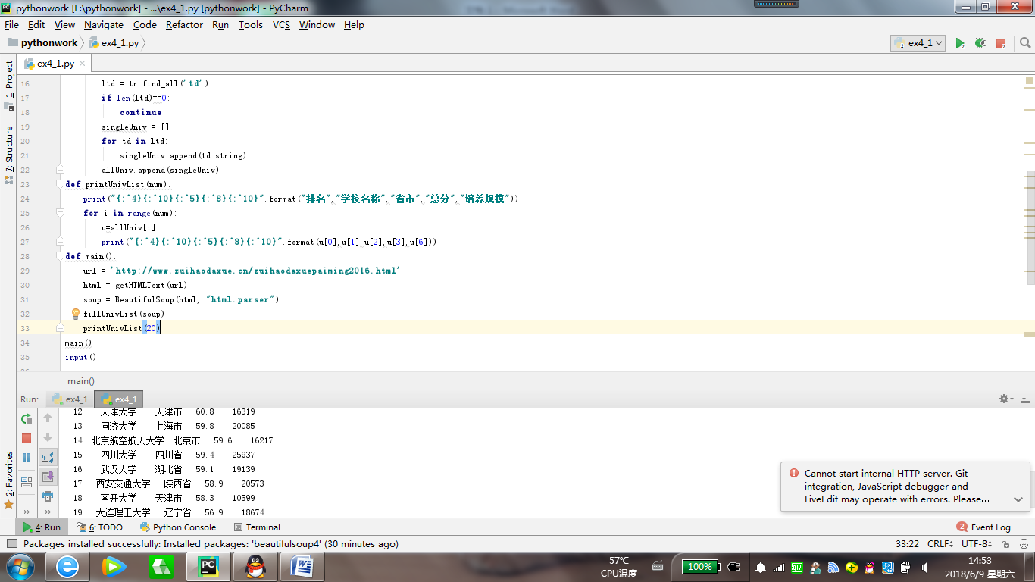

江西省大学排名：
#e23.1CrawUnivRanking.py
import requests
from bs4 import BeautifulSoup
allUniv = []
def getHTMLText(url):
try:
r = requests.get(url, timeout=30)
r.raise_for_status()
r.encoding = 'utf-8'
return r.text
except:
return ""
def fillUnivList(soup):
data = soup.find_all('tr')
for tr in data:
ltd = tr.find_all('td')
if len(ltd)==0:
continue
singleUniv = []
for td in ltd:
singleUniv.append(td.string)
allUniv.append(singleUniv)
def printUnivList(province):
print("{:^4}{:^10}{:^5}{:^8}{:^10}".format("排名","学校名称","省市","总分","培养规模"))
for u in allUniv:
if province in u[2]:
print("{:^4}{:^10}{:^5}{:^8}{:^10}".format(u[0],u[1],u[2],u[3],u[6]))
def main(p):
url = 'http://www.zuihaodaxue.cn/zuihaodaxuepaiming2018.html'
html = getHTMLText(url)
soup = BeautifulSoup(html, "html.parser")
fillUnivList(soup)
printUnivList(p)
main('江西')
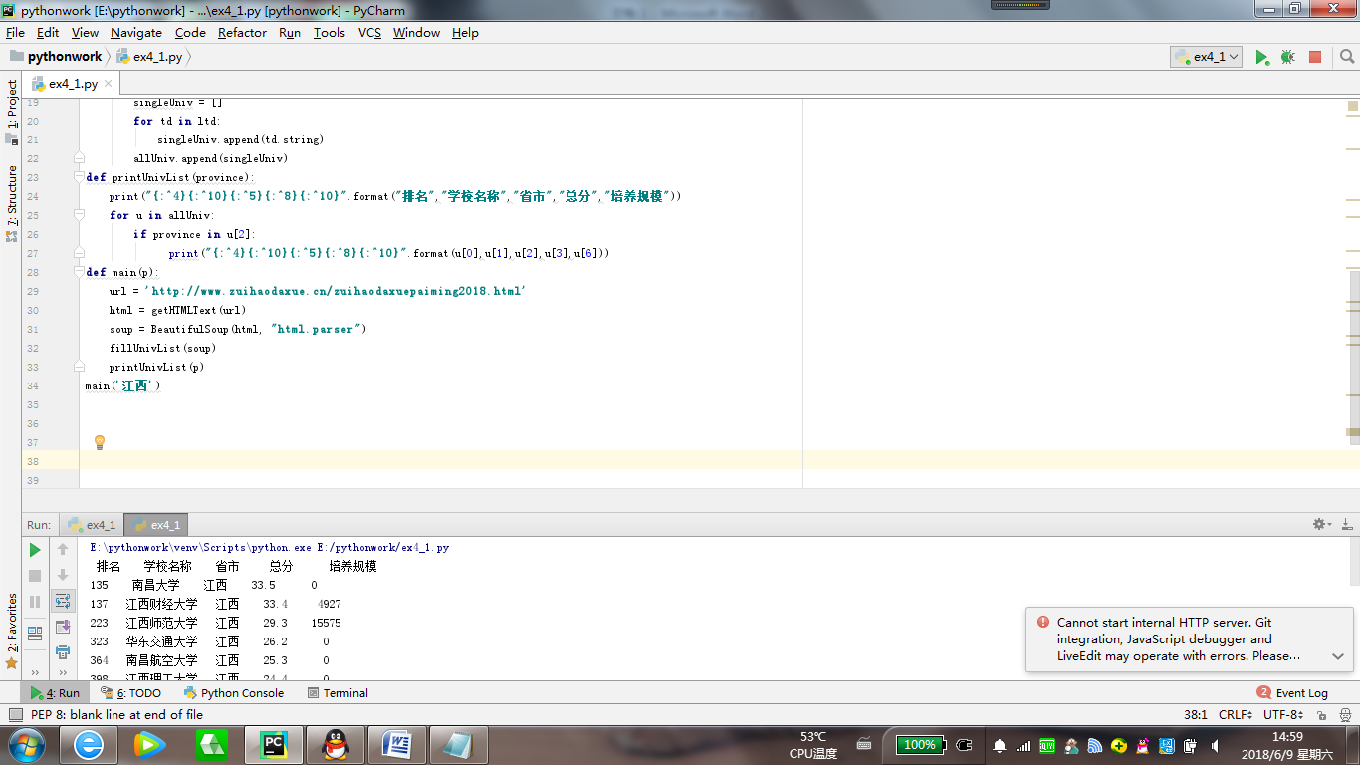

美国大学排名：

import requests
import re
from bs4 import BeautifulSoup
allUniv = []
def getHTMLText(url):
send_headers = {
"User-Agent": "Mozilla/5.0 (Windows NT 10.0; Win64; x64) AppleWebKit/537.36 (KHTML, like Gecko) Chrome/61.0.3163.100 Safari/537.36",
"Connection": "keep-alive",
"Accept": "text/html,application/xhtml+xml,application/xml;q=0.9,image/webp,image/apng,*/*;q=0.8",
"Accept-Language": "zh-CN,zh;q=0.8"}
try:
r = requests.get(url, headers=send_headers)
r.raise_for_status()
print(r.status_code)
r.encoding = 'utf-8'
return r.text
except:
return ""
def fillUnivList(soup):
data = soup.find_all('div', {'class': re.compile('shadow-dark')})
for div in data:
singleUniv = []
# 排名
div1 = div.find('div', {'style': 'margin-left: 2.5rem;'})
rank = div1.get_text().strip()
# 学校名称
singleUniv.append(rank.split(' ')[0])
div2 = div.find('h3')
# City
singleUniv.append(div2.get_text().strip())
address = div.find('div', {'class': re.compile('block-normal')})
singleUniv.append(address.string)
lstrong = div.find_all('strong')
singleUniv.append(lstrong[0].string) # 学费
singleUniv.append(lstrong[1].string) # 培养规模
allUniv.append(singleUniv)
def printUnivList():
print("{:<6}{:<20}{:<10}{:<10}{:<10}".format("排名", "学校名称", "City", "学费", "培养规模"))
for u in allUniv:
print("{:<6}{:<20}{:<10}{:<10}{:<10}".format(u[0], u[1], u[2], u[3], u[4]))
def main():
url = 'https://www.usnews.com/best-colleges/rankings/national-universities'
html = getHTMLText(url)
soup = BeautifulSoup(html, 'html.parser')
fillUnivList(soup)
printUnivList()
main()
input()

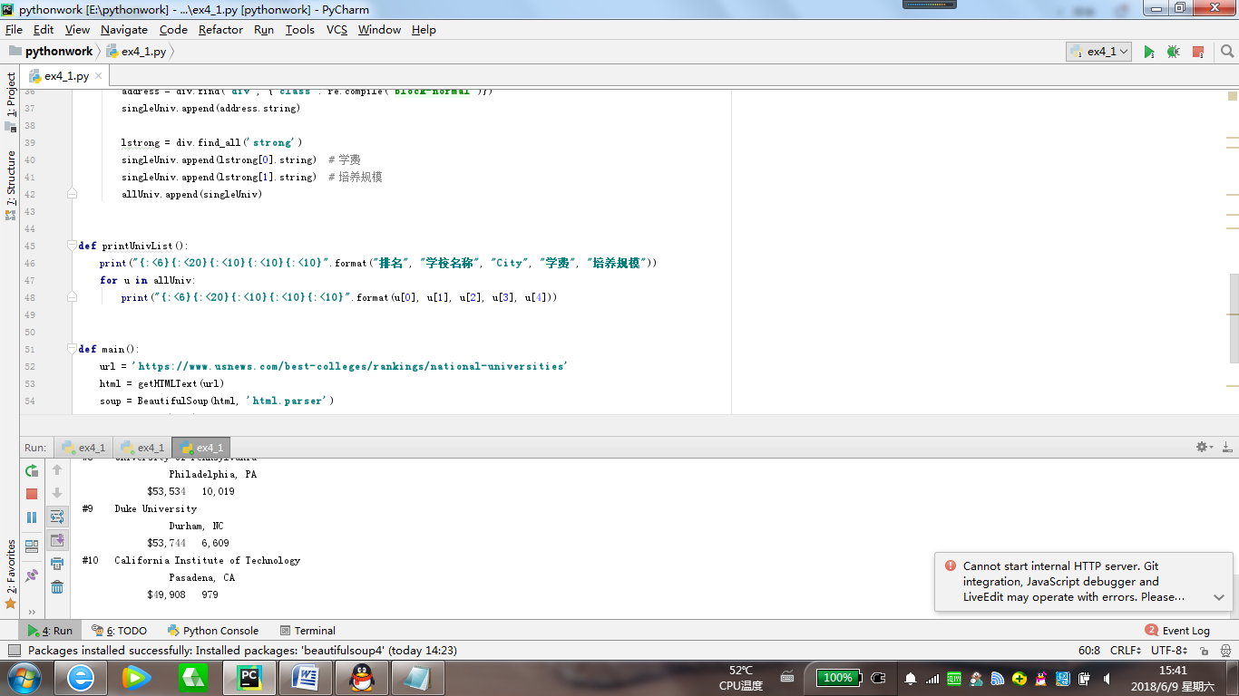

下载百度图片：

import requests
import re
def getHTMLText(url,coding='gbk'):
try:
r = requests.get(url,timeout=30)
print(r)
r.raise_for_status()
r.encoding = coding
return r.text
except:
return ""
def downloadImageFile(imgUrl, destUrl, fname=''):
local_filename = imgUrl.split('/')[-1]
print('Download Image File={}'.format(local_filename))
try:
r = requests.get(imgUrl, stream=True)
r.raise_for_status()
if len(fname) == 0:
fname = local_filename
print('fname={}'.format(fname))
with open(destUrl + "/" + fname, 'wb') as f:
for chunk in r.iter_content(chunk_size=1024):
if chunk:
f.write(chunk)
f.flush()
f.close()
return r.status_code
except:
return r.status_code
def getImg(html):
imgre = re.compile('"objURL":"(.*?)"')
imglist = re.findall(imgre,html)
return imglist
def download(urls,path):
index = 1
for url in urls:
print("Download Image from page:{}".format(url))
status = downloadImageFile(url,path,str(index)+".jpg")
try:
if str(status)[0] == '4':
print("未下载成功{}".format(url))
continue
except Exception as e:
print("未下载成功{}".format(url))
index += 1
page = 'https://image.baidu.com/search/index?tn=baiduimage&word=蔡徐坤'
html= getHTMLText(page,'utf-8')
download(getImg(html),'e:\\117060400125')
input()



