解方程：

import numpy as np
A = np.array([[1, 0.5, 5], [2.3, 2, 3], [4, 1, 1.7]], dtype=int)
print(A)
B = np.array([1, 2, 3], dtype=int)
print(B)
b = B.transpose()
print(b)
from numpy.linalg import inv
A1 = inv(A)
print(A1)
X = np.multiply(b, A1)
print(X)
input()

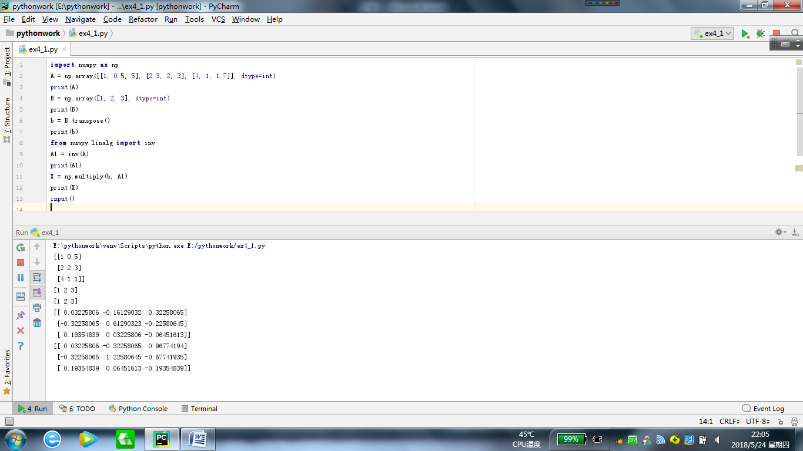

自画像的手绘效果：
from PIL import Image
import numpy as np
vec_el = np.pi/2.2
vec_az = np.pi/4
depth = 10
im = Image.open(".\myself.jpg").convert("L")
a = np.asarray(im).astype("float")
grad = np.gradient(a)
grad_x, grad_y = grad
grad_x = grad_x*depth/100.
grad_y = grad_y*depth/100.
dx = np.cos(vec_el)*np.cos(vec_az)
dy= np.cos(vec_el)*np.sin(vec_az)
dz = np.sin(vec_el)
A = np.sqrt(grad_x**2 + grad_y**2 + 1.)
uni_x = grad_x/A
uni_y = grad_y/A
uni_z = 1./A
a2 = 255*(dx*uni_x + dy*uni_y + dz*uni_z)
a2 = a2.clip(0, 255)
im2 = Image.fromarray(a2.astype('uint8'))
im2.save('.\myself.jpg')
input()

