**部署到 Cloudflare Pages**

再次无比感谢 Cloudflare 对技术的探索，让我可以实现这个项目。

[#](https://web.archive.org/web/20230519151611/https:/edgetunnel.114567.xyz/guide/cf-pages.html#fork-edgetunnel-%E6%9C%AC%E9%A1%B9%E7%9B%AE)**Fork edgetunnel 本项目**

<https://github.com/xuebaiyo/edgetunnel/>

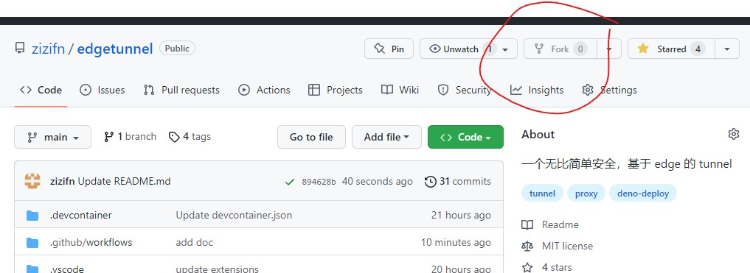

[#](https://web.archive.org/web/20230519151611/https:/edgetunnel.114567.xyz/guide/cf-pages.html#%E6%B3%A8%E5%86%8C-cloudflare-%E8%B4%A6%E6%88%B7)**注册 Cloudflare 账户**

https://www.cloudflare.com/

[#](https://web.archive.org/web/20230519151611/https:/edgetunnel.114567.xyz/guide/cf-pages.html#%E8%AE%BF%E9%97%AE-https-dash-cloudflare-com)**访问 https://dash.cloudflare.com/**

[#](https://web.archive.org/web/20230519151611/https:/edgetunnel.114567.xyz/guide/cf-pages.html#%E5%88%9B%E5%BB%BA-cloudflare-pages)**创建 Cloudflare Pages**

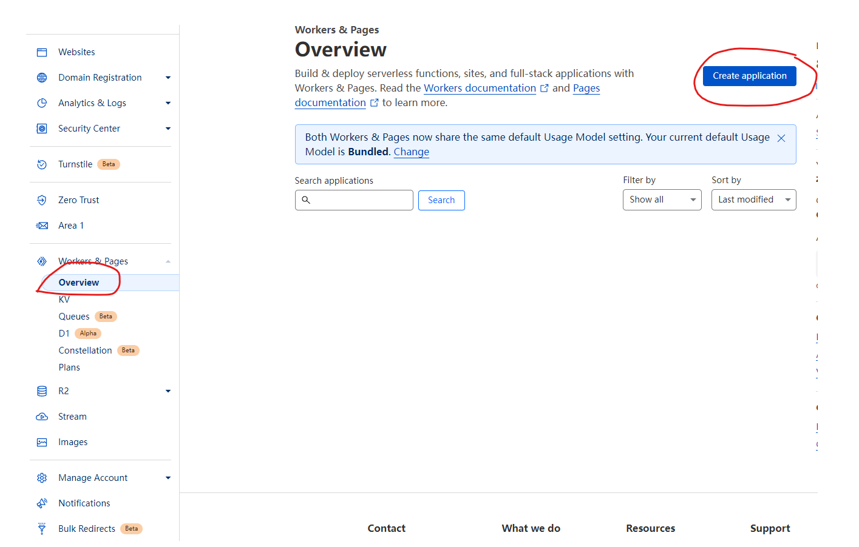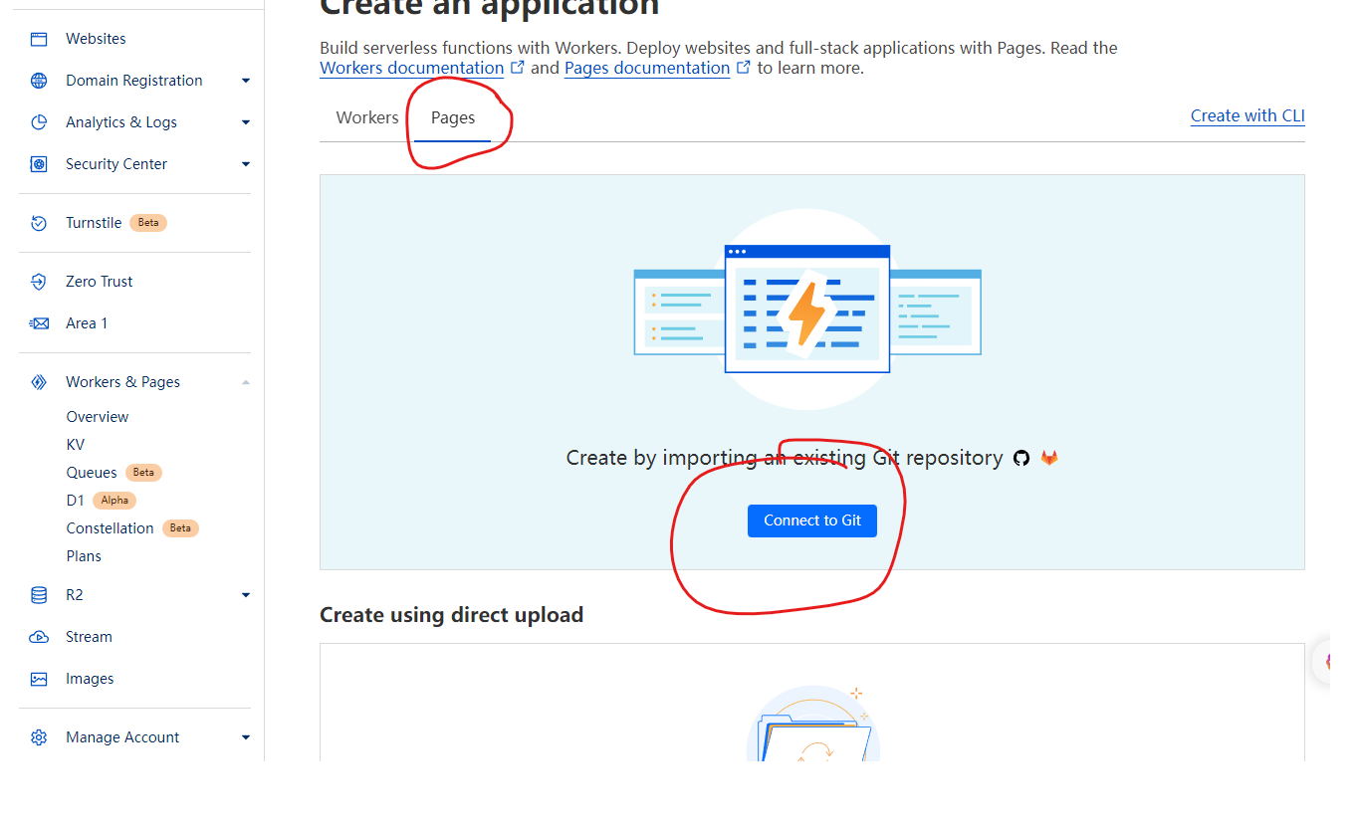

[#](https://web.archive.org/web/20230519151611/https:/edgetunnel.114567.xyz/guide/cf-pages.html#%E8%BF%9E%E6%8E%A5-github-%E8%B4%A6%E6%88%B7-%E5%92%8C-repo)**连接 GITHUB 账户 和 repo**

连接 GITHUB 账户， 并且要选择你 fork 的 repo。

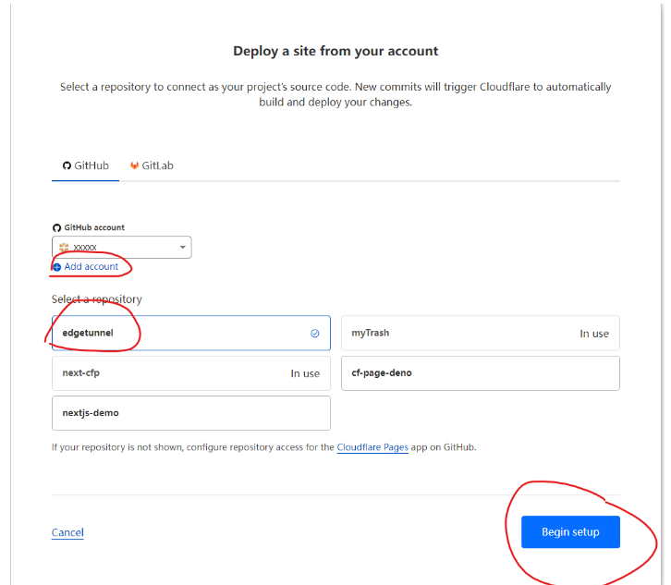[#](https://web.archive.org/web/20230519151611/https:/edgetunnel.114567.xyz/guide/cf-pages.html#%E5%A1%AB%E5%86%99-pages-build-%E4%BF%A1%E6%81%AF)**填写 Pages build 信息**

请自己生成一个 UUID

|  |  |
| --- | --- |
| 选项 | 值 |
| Build Command | npm run cf-page-vless |
| Build Directory | dist/apps/cf-page-vless |
| 环境变量 | 值 |
| UUID | b7625108-80fb-4544-a1f2-aa40c931aa52 |
| NODE_VERSION | 18 |

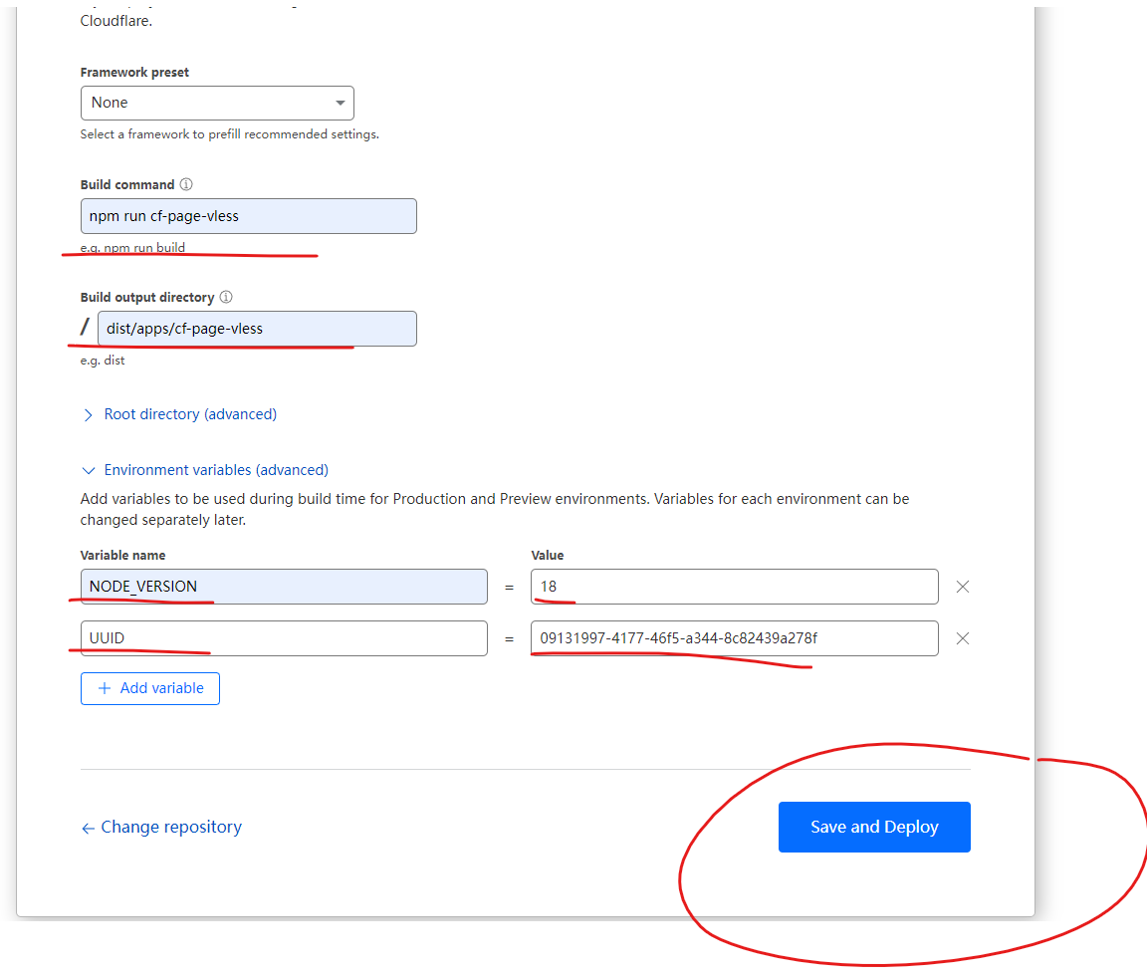

[#](https://web.archive.org/web/20230519151611/https:/edgetunnel.114567.xyz/guide/cf-pages.html#%E9%83%A8%E7%BD%B2%E6%88%90%E5%8A%9F%E8%AE%BF%E9%97%AE-pages-url)**部署成功访问 Pages URL**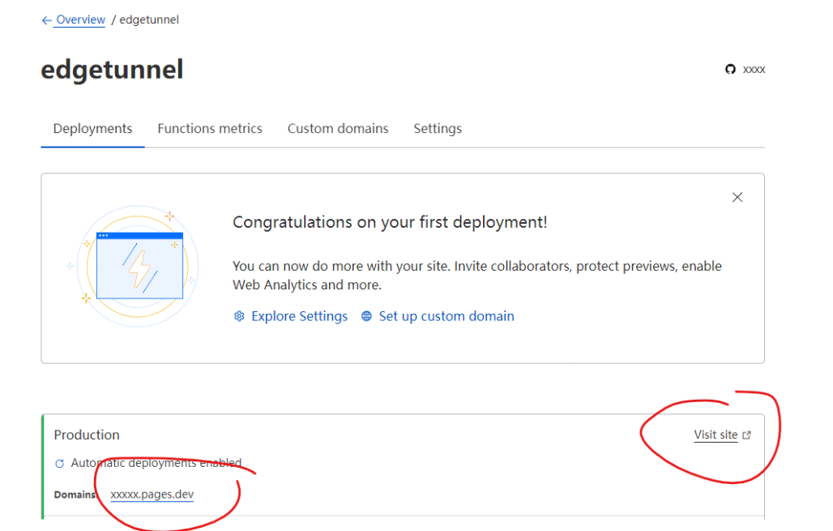

**WARNING**

**页面的账户和密码，就是之前设置的 UUID**

访问 Pages 项目地址，并且点击分享 Vless，扫码导入配置。

[#](https://web.archive.org/web/20230519151611/https:/edgetunnel.114567.xyz/guide/cf-pages.html#%E4%BF%AE%E6%94%B9-cloudflare-pages-%E7%9A%84%E8%AE%BE%E7%BD%AE-%E5%8F%AF%E9%80%89%E4%BD%86%E6%98%AF%E6%8E%A8%E8%8D%90%E8%AE%BE%E7%BD%AE)**修改 Cloudflare Pages 的设置 (可选但是推荐设置)**

如果忘记 UUID 或者想修改配置，可以在 Pages 的设置里面修改。

[#](https://web.archive.org/web/20230519151611/https:/edgetunnel.114567.xyz/guide/cf-pages.html#%E8%87%AA%E5%AE%9A%E4%B9%89%E5%9F%9F%E5%90%8D)**自定义域名** 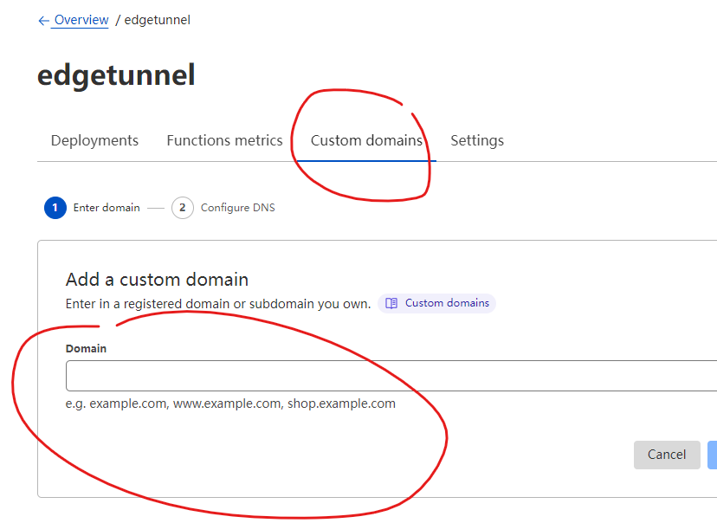

[#](https://web.archive.org/web/20230519151611/https:/edgetunnel.114567.xyz/guide/cf-pages.html#cloudflare-tos)**Cloudflare TOS**

按照我对 Cloudflare TOS 理解。Cloudflare Pages 是可以运行代理软件的。

https://www.cloudflare.com/supplemental-terms/

Unlike most Cloudflare products, the Developer Platform can be used to host content. Content stored on the Developer Platform (whether in conjunction with a Cloudflare storage offering or not) that we determine in our sole judgment to be illegal, harmful, or in violation of Section 5 of the Cloudflare Developer Platforms Supplemental Terms may be blocked or removed, and use of the Developer Platform for storage of such illegal or harmful content may result in suspension or termination of Cloudflare Services. While we generally try to provide notice of such action, we reserve the right to take action without notice as appropriate. For these purposes, illegal or harmful content includes but is not limited to: (a) content containing, promoting, or facilitating child sexual abuse material or human trafficking; (b) content that infringes on another person’s intellectual property rights or is otherwise unlawful; (c) content that discloses sensitive personal information, incites or exploits violence, or is intended to defraud the public; and (d) content that seeks to distribute malware, facilitate phishing, or otherwise constitutes technical abuse.

按照我对协议理解，Cloudflare Worker 是可以运行代理软件的。

# 部署到 Cloudflare Worker

**本方式不推荐**，我不保证一直工作。除非你有特色需求和你知道自己在做什么，否则请采用 Cloudflare Pages

## [#](https://web.archive.org/web/20230519151832/https:/edgetunnel.114567.xyz/guide/cf-worker.html#cloudflare-worker-%E4%BB%A3%E7%A0%81)Cloudflare Worker 代码

https://raw.githubusercontent.com/xuebaiyo/edgetunnel/main/libs/cf-worker-vless/cf-worker-vless-dev.js

## [#](https://web.archive.org/web/20230519151832/https:/edgetunnel.114567.xyz/guide/cf-worker.html#%E4%BF%AE%E6%94%B9-uuid)修改 UUID

**WARNING**

只有 UUID 是强制，其他参数无所谓。WS PATH 随便填写。

