1Lal et al. - 2017 - Three-level learning for improving cross-project l
categorize features in terms
of domains (if, method_bi, and other), types (boolean, numerical,
and textual), and classes (positive and negative).

Fifth, we convert all the
terms to their Tf-Idf (term frequency-inverse document frequency)
representation. Tf-idf is a numerical statistic that is used to identify
importance of a word in a given document in a collection of corpus
(Manning et al., 2008). Eq. (1) presents the formula for Tf-idf
weight computation. In Eq. (1), Term Frequency (TF t,d ) presents fre-
quency of a word t in a document d, N is the total number of doc-
uments in the corpus and Document Frequency (DF t ) represents
frequency of a term t in the corpus.

在本工作中，我们提出了一个新颖的三层，基于机器学习的跨项目IF块日志预测模型（CLIF）。在第一个层次上，CLIF使用文本挖掘方法将文本特征转换为数值文本特征（参见第3节，以获得关于将文本特征转换为数值文本特征的详细信息）。在第二层，CLIF将数字文本特征与数字和布尔特征相结合，并训练机器学习分类器。在第三层，CLIF学习用于中频块测井预测的有效判决阈值边界。CLIF搜索有效阈值边界，该阈值边界最大化在训练数据中实现的日志F度量(LF)(即，F1分数，并参考4.3节以获得细节)，以解决类别不平衡的挑战。在本文中，我们使用两个文本挖掘分类器（Naive Bayesian（NB）和Bayesian Network（BN））将文本特征转换为数值文本特征。我们使用BN和NB文本挖掘分类，因为它们在我们的初步调查中提供了良好的结果（参见5.1节）。CLIF将这两个文本挖掘分类器与八个机器学习分类器（Adaboost（ADA）、ADTree（ADT）、BN、J48、Logistic回归（LOG）、NB、随机森林（RF）和支持向量机（SVM））组合以产生16个CLIF分类器，即八个CLIF NB和CLIF BN分类器。

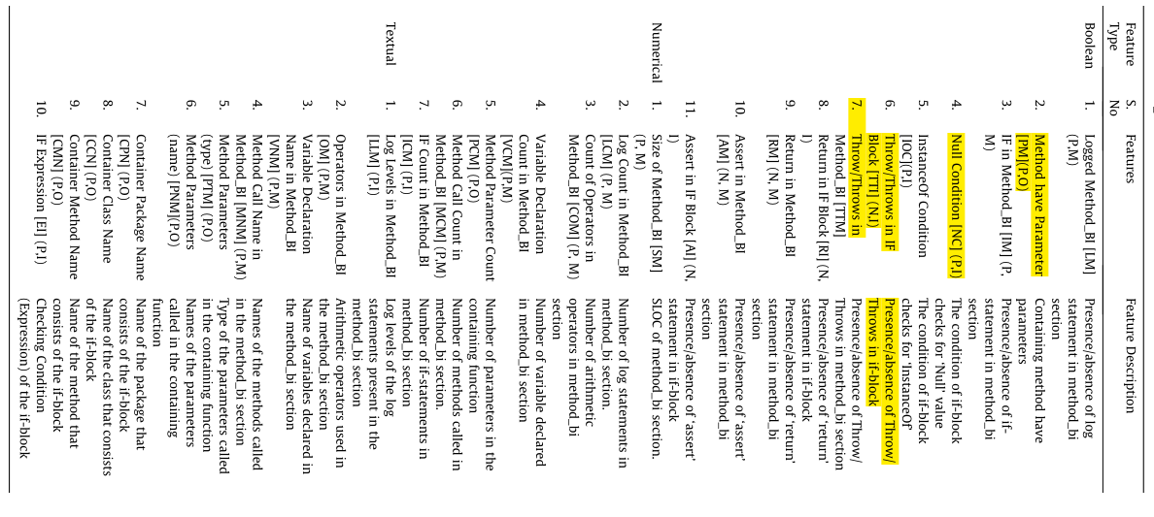

ECLogger: Cross-Project Catch-Block Logging
Prediction Using Ensemble of Classifiers
其它同上
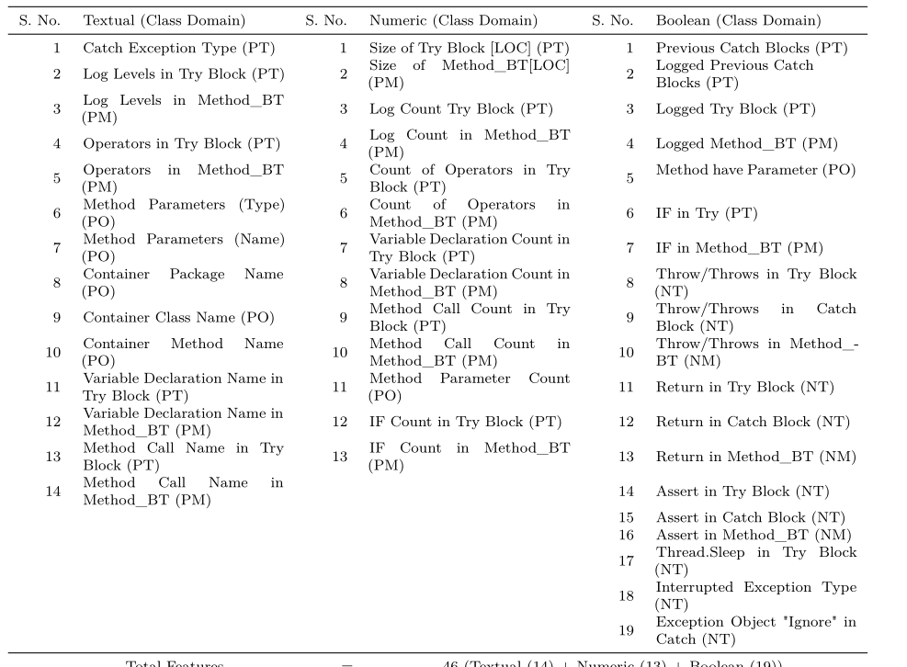

Examining the Stability of Logging Statements
We use metrics that measure the context, the content and the
developers of the logging statements to train the random forest
classifier.

Correlation analysis is necessary to remove the highly cor-
related metrics from our dataset [21].

