Microsoft.SQL.Server.2008.R2.Unleashed
目录
Chapter 1 Security and User Administration 6
1.1 Managing Principals 6
1.1.1 Logins 6
1.1.2 SQL Server Security: Users 7
1.1.3 User/Schema Separation 8
1.1.4 Roles 8
1.1.5 Application roles 12
1.2 Managing Securables 12
1.3 Managing permission 12
1.4 Managing SQL Server Logins 13
1.5 Managing SQL Server users 14
1.6 Managing Database Roles 14
1.7 Managing SQL Server Permissions 14
1.8 The Execution Context 15
1.8.1 Explict context switching 15
1.8.2 Implicit Context Switching 16
Chapter 2 Database Backup and Restore 17
2.1 Developing a Backup and Restore Plan 17
2.2 Types of Backups 17
2.2.1 Full Database Backups 17
2.2.2 Differential database backups 17
2.2.3 Partial Backups 18
2.3.4 Differential partial backups 18
2.3.5 File and filegroup backups 18
2.3.6 Copy-Only backups 18
2.3.7 Transaction log backups 18
2.3 Recovery models 18
2.3.1 Full recovery 18
2.3.2 Bulk-Logged recovery 19
2.3.3 Simple recovery 19
2.4 Backup Devices 19
2.4.1 Disk devices 19
2.4.2 Tape Devices 19
2.4.3 Network devices 19
2.4.4 Creating and Dropping Backup Devices 19
2.5 Backing up a database 20
2.5.1 Creating database backups with T-SQL 20
2.6 Backing up the transaction log 21
2.6.1 Creating transaction log backups with T-SQL 21
2.7 Backup scenarios 22
2.7.1 Full database backups only 22
2.7.2 Full database backups with transaction log backups 22
2.7.3 Differential backups 22
2.7.4 Partial backups 23
2.7.5 File/Filegroup backup 24
2.7.6 Mirrored backups 25
2.7.7 Copy-only backups 25
2.7.8 Compressed backups 25
2.7.9 System database backups 25
2.8 Restoring databases and transaction logs 26
2.8.1 Database restore with T-SQL 26
2.8.2 Transaction log restore with T-SQL 27
2.8.3 Restore information 27
2.8.4 Backup and restore system tables 28
2.9 Restore scenrios 29
2.9.1 restoring to a different database 29
2.9.2 Restoring a snapshot 29
2.9.3 Restoring a transaction log 30
2.9.4 Restoring to the point of failure 30
2.9.5 Restoring to a point in time 31
2.9.6 Online restore 31
Chapter 3 Database Mail 33
3.1 Setting up database mail 33
3.1.1 Creating mail profiles and accounts 33
3.1.2 Using T-SQL to update and delete mail objects 34
3.1.3 Setting system-wide mail settings 34
3.2 sending and receiving with database mail 34
3.3 Using SQL Server Agent Mail 34
3.3.1 Job mail notifications 35
3.3.2 Alert mail notifications 36
Chapter 4 The Key T-SQL Scripts 38
Chapter 5 replication 41
5.1 Replication scenarios 42
5.1.1 The central publisher replication model 42
5.1.2 The central publisher with remote distributor replication model 43
5.1.3 The publishing subscriber replication model 44
5.1.4 The central subscriber replication model 45
5.1.5 The multiple publishers with multiple subscribers replication model 46
5.1.6 The updating subscriber replication model 47
5.1.7 The peer-to-peer replication model 48
5.2 Replication agents 49
5.3 Planning for SQL Server data replication 49
5.3.1 Autonomy, Timing and Latency of Data 50
5.3.2 Methods of data distribution 50
5.4 SQL Server replication types 51
5.4.1 Snapshot replication 51
5.4.2 Transactional replication 51
5.4.3 Merge replication 52
5.5 Basing the replication design on user requirements 53
5.5.1 User requirements 53
5.5.2 Data characteristics 53
5.6 Setting up replication 53
Chapter 6 Creating and Managing Indexes 55
6.1 Types of indexes 55
6.1.1 Clustered indexes 55
6.1.2 Non-clustered indexes 55
6.2 Creating/Managing/Dropping Indexes with T-SQL 56
6.3 Online indexing operations 58
6.4 Indexes on views 58
Chapter 7 Data Structures 60
7.1 Database Files and Filegroups 60
7.1.1 Primary data file 60
7.1.2 Secondary Data Files 60
7.1.3 The log file 60
7.1.4 File management 61
7.1.5 Using Filegroups 61
7.1.6 FILESTREAM filegroups 62
7.2 Database Pages 64
7.2.1 Data Pages 64
7.2.2 Row-Overflow pages 66
7.2.3 LOB data pages 67
7.2.1 Index pages 67
7.3 Space Allocation Structures 68
7.3.1 Extents 68
7.3.2 Global and Shared Global Allocation Map Pages 68
7.3.3 Page free space pages 69
7.3.4 Differential Changed Map Pages 69
7.3.5 Bulk Changed Map Pages 69
7.4 Data compression 69
Chapter 8 Indexes and Performance 71
8.1 Understanding table/index structures 71
8.1.1 Heap tables 71
8.1.2 Clustered tables 72
8.1.3 Clustered indexes 73
8.1.4 Non-clustered indexes 74
8.2 Index statistics 75
8.2.1 Evaluating index usefulness 75
8.2.2 Identifying missing/unused indexes 75
8.3 Index design guidelines 77
8.3.2 Clustered index indications 77
8.3.3 Non-clustered index indications 78
8.3.4 Index covering 78
8.3.5 Included columns 78
8.3.6 Filtered Indexes and Statistics 79
Chapter 9 Understanding Query Optimization 81
9.1 Row Estimation and Index Selection 81
9.1.1 Evaluating SARG and Join Selectivity 81
9.1.2 Estimating Access Path Cost 81
9.1.3 Using multiple indexes 83
9.2 Join selection 85
9.2.1 Join Processing Strategies 85
9.2.2 Determining the Optimal Join Order 87
9.2.3 Subquery processing 87

Chapter 1 Security and User Administration

1.1 Managing Principals
The principals at the Windows level are Windows users or groups. The principals at the SQL Server level include SQL Server logins and server roles. The principals scoped at the database level include database users, data roles, and application roles.
No. | Scope | Principals
1 | Windows | Windows users or groups
2 | SQL Server | SQL Server logins and server roles
3 | Database | Database users, data roles, and application roles

1.1.1 Logins
- select left(name,25) AS name,
- [type],
- type_desc
- from sys.server_principals
- WHERE type in ('U', 'G', 'S', 'R')
- order by 3,1

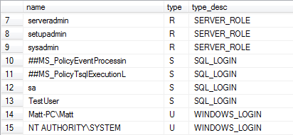
The rows that have a type_desc value of SQL_LOGIN, WINDOWS_GROUP, or WINDOWS_LOGIN are all logins established on the SQL Server instance. A login with a type_desc of SQL_LOGIN represents a login created with SQL Server authentication. Logins with a type_desc of WINDOWS_GROUP or WINDOWS_LOGIN are Windows groups or individual Windows users granted logins to SQL Server. The other entries with type_desc of SERVER_ROLE are fixed server roles discussed later in this chapter.

- SA account
The SA account is a SQL_LOGIN assigned to the sysadmin fixed server role. The SA account and members of the sysadmin fixed server role have permission to perform any activity within SQL Server.
- NT AUTHORITY/SYSTEM
The NT AUTHORITY\SYSTEM login is an account related to the local system account under which SQL Server services can run. It is also added as a member of the sysadmin fixed server role and has full administrative privileges in SQL Server.

1.1.2 SQL Server Security: Users
Database users are principals scoped at the database level. Database users establish a link between logins (which are stored at the server level) and users (which are stored at the database level).
- --check for orphaned users
- EXEC sp_change_users_login 'Report'
- --add a new login named 'Chris' and tie the orphaned database user to the newly created login
- EXEC sp_change_users_login 'Auto_Fix', 'Chris', NULL, 'pw'

- --all the users in a database
- SELECT left(u.name,25) AS [Name],
- [type],
- left(type_desc,15) as type_desc
- FROM sys.database_principals AS u
- WHERE u.type in ('U', 'S', 'G')
- ORDER BY 1

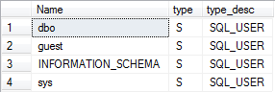

- The dbo user
- The dbo user is the database owner and cannot be deleted from the database.
- Members of the sysadmin server role are mapped to the dbo user in each database, which allows them to administer all databases.
- When an object is referenced without a schema name, SQL Server first looks for the object in the default schema for the user that is connected. If the object is not in the user’s default schema, the object is retrieved from the dbo schema.
- The guest user
This account allows users that do not have a user account in the database to access the database.
- --grant and revoke CONNECT permission to the target database
- GRANT CONNECT TO GUEST
- REVOKE CONNECT FROM guest

- The INFORMATION_SCHEMA User
The INFORMATION_SCHEMA user owns all the information schema views installed in each database.
- The sys user
The sys account gives users access to system objects such as system tables, system views, extended stored procedures, and other objects that are part of the system catalog. The sys user owns these objects.

- Find all objects owned by a given user
- --Find all objects owned by a given user
- SELECT name,
- object_id,
- schema_id,
- type_desc
- FROM sys.all_objects
- WHERE OBJECTPROPERTYEX(object_id, N'OwnerId') = USER_ID(N'dbo')
- ORDER BY 1

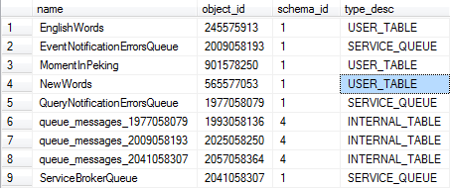

1.1.3 User/Schema Separation
The important point to remember is that owners and schemas are different from one another in SQL Server 2008. This has the distinct advantage of allowing object ownership to change without affecting the code that references the object. The reason is that database code that references an object uses the schema name instead of the object owner.
- --references an object uses the schema name instead of the object owner
- select * from region
- select * from sales.region
- select * from AdventureWorks2008.Sales.Region

1.1.4 Roles
Roles are similar to the groups used in administering networks. Permissions are applied to a role, and then members are added to the role.

- Fixed server roles
- Fixed server roles are scoped at the server level, which means that the permissions for these roles are oriented toward server-level securables.
- Logins (not users) are assigned to these roles.
- A single login can be assigned to one or more of these fixed server roles.

- select left(name,25) AS name,
[type],
type_desc
- from sys.server_principals
- WHERE type = 'R'
- order by 3,1

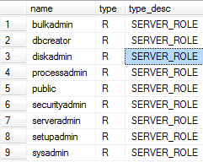
--Check server roles by SSMS
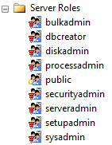

- Finxed database roles
SQL Server provides fixed roles that define a common set of permissions at the database level. These fixed database roles are assigned to database users.

- SELECT left(u.name,25) AS [Name],
- [type],
- left(type_desc,15) as type_desc
- FROM sys.database_principals AS u
- WHERE u.type = 'R'
- ORDER BY 1

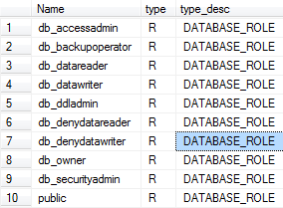
--Check Database roles by SSMS
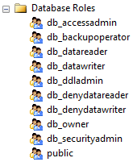

- The public role
- The permissions for this role can be altered. Every user in a database is automatically made a member of the public role .
- The public role is similar in function to the guest user that is installed by default in each database. the permissions granted to the guest user are used by any login that does not have a user account in the database. In this case, the login is allowed to enter the database via the guest account. In the case of the public role, the login has been added as a user of the database and in turn picks up any permissions that have been granted to the public role.
- --to view the permission associated with public role
- SELECT top 5 g.name,
object_name(major_id) as 'Object',
permission_name
- from sys.database_permissions p
- join sys.database_principals g on p.grantee_principal_id = g.principal_id and g.name = 'public'
- order by 1,2

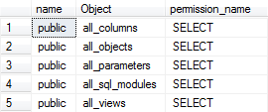

- User-defined roles
- --The following statements must be run by an administrator to add a login and database user with no explicit permissions granted
- CREATE LOGIN [TestUser] WITH PASSWORD=N'123456',
- DEFAULT_DATABASE=[master], CHECK_EXPIRATION=OFF, CHECK_POLICY=OFF
- GO
- USE [FlowerCavern20160513102144]
- GO
- CREATE USER [TestUser] FOR LOGIN [TestUser]
- go
- --the following statement fails when executed by the TestUser which has no explicit permissions defined in the AdventureWorks2008 database
- select top 5 * from dbo.EnglishWords
- UPDATE dbo.EnglishWords SET difficult = 0.1
- WHERE word = 'a'
- --The following statement is run by an administrator to:
- --1)add a new TestDbRole with permission to UPDATE
- --2)grant UPDATE permission on the Person.person table
- --3)add the TestUser to the TestDbRole database role
- USE [FlowerCavern20160513102144]
- GO
- --1)
- CREATE ROLE [TestDbRole] AUTHORIZATION [dbo]
- --2)
- GRANT UPDATE ON dbo.EnglishWords TO [TestDbRole]
- GRANT SELECT ON dbo.EnglishWords TO [TestDbRole]
- --3)
- EXEC sp_addrolemember N'TestDbRole', N'TestUser'
- --the following statements now succeed when executed
- --by the TestUser because the role that it
- --was added to has SELECT and UPDATE permission
- --on that table
- select top 5 * from dbo.EnglishWords
- UPDATE dbo.EnglishWords SET difficult = 0.1
- WHERE word = 'a'
- --the following select fails because 'testdbrole'
- --does not permit SELECT on any table but person.person
- select * from dbo.MomentInPeking
- --The following statement is run by an administrator
- --to add the TestDbRole database role to the db_datareader
- --fixed-database role
- EXEC sp_addrolemember N'db_datareader', N'TestDbRole'
- GO
- --Finally, the testuser can update the Person.person table
- -- and select from any other table in the database
- select * from dbo.MomentInPeking

1.1.5 Application roles
- --Create an application role
- --(see the section 'Managing Database Roles,' later in this chapter),
- --You set the role to the sales application role (with the password PassW0rd) as follows:
- EXEC sp_setapprole 'sales', '123456'
- --You can also encrypt the password:
- EXEC sp_setapprole 'sales', {ENCRYPT N '123456'}, 'odbc'

1.2 Managing Securables
Server | Database | Schema
Logins | User | Table
Endpoints | Role | View
Databases | Application role | Function
 | Assembly | Procedure
 | Message Type | Queue
 | Route | Type
 | Service | Synonym
 | Remote Service Binding | Aggregate
 | Fulltext Catalog | XML Schema Collection
 |  | Certificate
 | Asymmetric Key
 | Symmetric Key
 | Contract
 | Schema

1.3 Managing permission
- The hierarchy exists between GRANT, REVOKE, and DENY
- A GRANT of a permission removes any REVOKE or DENY on a securable.
- DENY and REVOKE remove any GRANT permission on a securable.
- REVOKE removes any GRANT or DENY permission on a securable.
- Permissions denied at a higher scope in the security model override grants on that permission at a lower scope.
- Permissions granted at a higher scope in the security model are overridden by a DENY permission at a lower level.
- SELECT class_desc,
- permission_name,
- parent_class_desc
- FROM sys.fn_builtin_permissions(default)
- order by 1,2

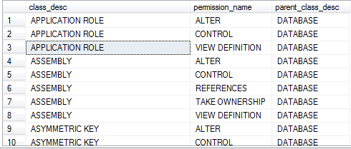

1.4 Managing SQL Server Logins
- --control access to SQL Server
- USE [master]
- DENY CONNECT SQL TO [TestUser]
- GRANT CONNECT SQL TO [TestUser]

- --languages available in the server and related options
- SELECT * FROM SYS.SYSLANGUAGES

- Using T-SQL to manage logins
- --
- CREATE LOGIN [Laura] WITH PASSWORD=N'mypassw0rd$'
- MUST_CHANGE, CHECK_EXPIRATION=ON
- --
- ALTER LOGIN [Laura] WITH
- DEFAULT_DATABASE=[master],
- DEFAULT_LANGUAGE=[British],
- PASSWORD=N'123456'
- --
- DROP LOGIN [Laura]

1.5 Managing SQL Server users
- Using T-SQL to manage users
- --change the owner of one schema
- CREATE USER [Laura]
- CREATE SCHEMA Laura
- ALTER AUTHORIZATION ON SCHEMA::[Laura] TO [Laura]

- CREATE SCHEMA LauraG
- CREATE LOGIN LauraG WITH PASSWORD='123456'
- CREATE USER LauraG FOR LOGIN LauraG
- WITH DEFAULT_SCHEMA = Laura
- ALTER AUTHORIZATION ON SCHEMA::[LauraG] TO [LauraG]
- ALTER USER LauraG WITH NAME = Laura
- DROP SCHEMA LauraG
- DROP USER Laura
- DROP LOGIN LauraG

1.6 Managing Database Roles
- Using T-SQL to manage database roles
- CREATE LOGIN [Chris] WITH PASSWORD='123456'
- CREATE USER [Chris] FOR LOGIN [Chris]
- CREATE ROLE [DevDbRole]
- CREATE ROLE [TestDbRole]
- EXEC sp_addrolemember N'DevDbRole', N'Chris'
- EXEC sp_addrolemember N'DevDbRole', N'TestDbRole'
- EXEC sp_droprolemember N'DevDbRole', N'TestDbRole'
- DROP ROLE [TestDbRole]

1.7 Managing SQL Server Permissions
- Using T-SQL to manage permissions
- --Grant permissions to create a table to a user named Chris
- GRANT CREATE TABLE TO Chris
- --Grant ALL permissions on a table to a database role named DevDbRole
- GRANT ALL ON dbo.EnglishWords TO DevDbRole
- --DENY UPDATE permission on the Customer table to user named Chris
- DENY UPDATE ON OBJECT::dbo.EnglishWords TO Chris
- --REVOKE UPDATE permissions on the Customer table to user named Chris.
- REVOKE UPDATE ON OBJECT::dbo.EnglishWords TO Chris

1.8 The Execution Context
By default, the execution context is set to the principal connected to the server or database.
you can change the execution context so that permissions are checked for a principal (users or logins ) other than that to which you are connected.

Explict context switching

- --Assume that you are connected as an administrator (DBO)
- --and want to prevent members of the Public role from
- --selecting from the Sales.Customer table
- DENY SELECT ON dbo.EnglishWords TO Public
- --We can check that user Laura cannot select from the Sales.Customer table using the EXECUTE --AS statement
- EXECUTE AS USER = 'Chris'
- SELECT TOP 1 * FROM dbo.EnglishWords
- --Revert to the previous execution context.
- REVERT

As an administrator, you can grant IMPERSONATE to a login or user to enable that user to execute as that user.
- --Chris grants the right to Laura to impersonate him
- GRANT IMPERSONATE ON LOGIN::[chris] TO [TestUser]
- GO
- --Laura can then connect with her login and use
- --the EXECUTE AS command to run commands that
- --normally only Chris has permission to run
- EXECUTE AS Login = 'Chris'
- SELECT USER_NAME()
- REVERT
- SELECT USER_NAME()

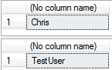

Implicit Context Switching
- CREATE PROCEDURE dbo.usp_TestExecutionContext
- WITH EXECUTE AS 'chris'
- AS
- BEGIN
- SELECT USER_NAME() as 'User'
- END
- GO
- --Set the user to someone other than chris to test the implicit EXECUTE AS
- SETUSER 'DBO'
- EXEC usp_TestExecutionContext

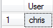

Chapter 2 Database Backup and Restore

Developing a Backup and Restore Plan
Question :
- How much data loss is acceptable?
- What is the nature of the database?
- How often does the data in the database change?
- What is the acceptable recovery time in the event a database must be restored from previous backups?
- Is there a maintenance window for the application/database?
- What is the size of the database(s) you need to back up?
- What media is available for backup, and where is the media located?
- What is the budget for database backup and recovery?

2.2 Types of Backups
- Full database backups
- Differential database backups
- Partial backups
- Differential partial backups
- File and filegroup backups
- Copy-only backups
- Transaction log backups

2.2.1 Full Database Backups
A full database backup is an all-inclusive backup that captures an entire database in one operation. As with many other backups, SQL Server allows for updates to the database while a full backup is running.
A full database backup is often used in conjunction with other backup types;

2.2.2 Differential database backups
Differential database backups capture changes to any data extent that happened since the last full database backup. When the differential database backup is executed, only those extents that have had pages modified are written to the backup.
Differential database backups can save backup space and improve the overall speed of recovery. When the number of database changes since the last backup is relatively small, you achieve the best results. there are many rows that are changed but those rows are all clustered on a limited number of data pages then the differencial backup will not be that large.

2.2.3 Partial Backups
Partial backups provide a means for eliminating read-only data from a backup.

2.3.4 Differential partial backups
Differential partial backups work like differential database backups but are focused on the same type of data as partial backups. The extents that have changed in filegroups that are not read-only are captured in this type of backup.

2.3.5 File and filegroup backups
File and filegroup backups are targeted at databases that contain more than one filegroup.
File and filegroup backups are often used for larger databases where the creation time for a full database backup takes too long or the resulting backup is too large.
The main disadvantage of this type of backup is the increase in administrative overhead.

2.3.6 Copy-Only backups
Copy-only backups do not affect the restore chain. They are useful in situations in which you simply want to get a copy of the database for testing purposes or things of this nature.

2.3.7 Transaction log backups
Transaction log backups capture records written to the transaction log file(s) defined for a database. The full and bulk-logged recovery models are the only models that support transaction log backups.

2.3 Recovery models
Each database has a recovery model that determines how transactions will be written to the transaction log.
- Full recovery
- Bulk-logged
- Simple

- ALTER DATABASE [FlowerCavern20160513102144]
- SET RECOVERY BULK_LOGGED WITH NO_WAIT

2.3.1 Full recovery
If a full database backup is available, along with the transaction log backups that occurred after the full database backup, you can recover to the point of the last transaction log backup. In addition, if your current transaction log is available, you can restore up to the point of the last committed transaction in the transaction log.
This recovery model is the most comprehensive, but in some respects, it is the most expensive. It is expensive in terms of the transaction log space needed to capture all the database operations.
You need to ensure that you have regularly scheduled backups of the transaction log if you have set your database to full recovery. The transaction log backups allow you to recover from a media failure and also remove the inactive portion of the transaction log so that it does not need to grow.

2.3.2 Bulk-Logged recovery
With full recovery mode, SQL Server writes every row to the transaction log that is inserted with BCP or BULK INSERT. Bulklogged recovery keeps track of the extents that have been modified by a bulk load operation but does not write each row to the transaction log.
The log backups are large because SQL Server copies all the data extents that have been affected by bulk load operations since the last backup of the transaction log.
For example, consider a table occupying 1GB of space that is truncated each week and reloaded with a bulk insert. The bulk insert operation goes relatively fast because the rows are not being written to the transaction log, but the backup of the transaction log is much larger.
The other downside to bulk-logged recovery is that with it, you may sacrifice the ability to restore to the most recent point in time. If transactions have occurred in a database since the last backup, and no bulk insert operations have occurred, you can recover those pending transactions as long as the media containing the transaction log is still available.

2.3.3 Simple recovery
you cannot back up the transaction log that captures changes to your database.

2.4 Backup Devices

2.4.1 Disk devices
A disk device is generally stored in a folder on a local hard drive. This should not be the same hard drive where your data is stored!

2.4.2 Tape Devices

2.4.3 Network devices
Keep in mind that backups performed on a network share should be done on a dedicated or high-speed network connection.

2.4.4 Creating and Dropping Backup Devices
- --Local Disk
- EXEC sp_addumpdevice 'disk', 'diskdev2',
- 'E:\20160323_DBBACKUPS\diskdev2.bak'
- EXEC master.dbo.sp_dropdevice @logicalname = N'diskdev1'
- GO
- --Network Disk
- EXEC sp_addumpdevice 'disk', 'networkdev1',
- '\\myserver\myshare\AdventureWorks2008.bak'
- --Tape
- EXEC sp_addumpdevice 'tape', 'tapedev1', '\\.\tape0'

2.5 Backing up a database

2.5.1 Creating database backups with T-SQL
- BACKUP DATABASE { database_name | @database_name_var }
- TO < backup_device > [ ,...n ]
- [ [ MIRROR TO < backup_device > [ ,...n ] ] [ ...next-mirror ] ]
- [ WITH
- [ BLOCKSIZE = { blocksize | @blocksize_variable } ]
- [ [ , ] { CHECKSUM | NO_CHECKSUM } ]
- [ [ , ] COMPRESSION | NO_COMPRESSION]
- [ [ , ] COPY_ONLY ]
- [ [ , ] { STOP_ON_ERROR | CONTINUE_AFTER_ERROR } ]
- [ [ , ] DESCRIPTION = { 'text' | @text_variable } ]
- [ [ , ] DIFFERENTIAL ]
- [ [ , ] EXPIREDATE = { date | @date_var } | RETAINDAYS = { days | @days_var } ]
- [ [ , ] PASSWORD = { password | @password_variable } ]
- [ [ , ] { FORMAT | NOFORMAT } ]
- [ [ , ] { INIT | NOINIT } ]
- [ [ , ] { NOSKIP | SKIP } ]
- [ [ , ] MEDIADESCRIPTION = { 'text' | @text_variable } ]
- [ [ , ] MEDIANAME = { media_name | @media_name_variable } ]
- [ [ , ] MEDIAPASSWORD = { mediapassword | @mediapassword_variable } ]
- [ [ , ] NAME = { backup_set_name | @backup_set_name_var } ]
- [ [ , ] { NOREWIND | REWIND } ]
- [ [ , ] { NOUNLOAD | UNLOAD } ]
- [ [ , ] RESTART ]
- [ [ , ] STATS [ = percentage] ]
- ]
- DECLARE @PATH VARCHAR(255)
- SELECT @PATH='E:\20160323_DBBACKUPS\FlowerCavern'+CONVERT(VARCHAR(64), GETDATE(), 112)+REPLACE(CONVERT(VARCHAR(64), GETDATE(), 8), ':', '')+'.bak'
- BACKUP DATABASE FlowerCavern20160513102144
- TO DISK=@PATH
- GO
- --
- EXEC sp_addumpdevice 'disk', 'diskdev2',
- 'E:\20160323_DBBACKUPS\diskdev2.bak'
- BACKUP DATABASE FlowerCavern20160513102144
- TO diskdev2
- GO

2.6 Backing up the transaction log
First, the transaction log backups can be used in case of a media failure to restore work completed in the database. The second reason for backing up the transaction log is to keep the size of the log manageable.

2.6.1 Creating transaction log backups with T-SQL
- BACKUP LOG { database_name | @database_name_var }
- TO < backup_device > [ ,...n ]
- [ [ MIRROR TO < backup_device > [ ,...n ] ] [ ...next-mirror ] ]
- [ WITH
- ....
- [ [ , ] NO_TRUNCATE ]
- [ [ , ] { NORECOVERY | STANDBY = undo_file_name } ]

- The NO_TRUNCATE option
- Under normal circumstances, the BACKUP LOG command not only writes to the transaction log, but also signals a checkpoint for the database to flush any dirty buffers from memory to the database files.This behavior becomes a problem when the media containing the database is unavailable and you must capture the current contents of a log to a backup file for recovery. You run BACKUP LOG with the NO_TRUNCATE option, and the log is backed up, but the checkpoint is not run because the log is not actually cleared.

- The NORECOVERY | STANDBY= undo_file_name Options
- The NORECOVERY option causes the tail of the log to be backed up and leaves the database in a RESTORING state, which allows additional transaction logs to be applied, if necessary.
- The STANDBY option also backs up the tail of the log, but it leaves the database in a readonly/standby state. The read-only state allows inquiry on the database and allows additional transaction logs to be applied to the database as well.This STANDBY option produces the same results as executing BACKUP LOG WITH NORECOVERY followed by a RESTORE WITH STANDBY command.

2.7 Backup scenarios

2.7.1 Full database backups only
- --Full Database Backup to a single disk device
- BACKUP DATABASE [FlowerCavern20160513102144]
- TO DISK = N'E:\20160323_DBBACKUPS\FlowerCavern.bak'
- WITH NOFORMAT, INIT, NAME = N'FlowerCavern-Full Database Backup',
- SKIP, NOREWIND, NOUNLOAD, STATS = 10

2.7.2 Full database backups with transaction log backups
- --First need to change the recovery model from simple to full
- --so that the tlogs are available for backup
- ALTER DATABASE [FlowerCavern20160513102144]
- SET RECOVERY FULL WITH NO_WAIT

- /*
- A Full database backup must be taken after the recovery mode has been changed in order to set a base for future tlog backups. If the full backup is not taken then tlog backups will fail.
- The Following full backup utilizes two devices on the same drive. Often times multiple devices are backed up to different drives. Backing up to different drives can speed up the overall backup time and help when you are running low on space on a drive where your backups are written.
- */
- BACKUP DATABASE [FlowerCavern20160513102144]
- TO DISK = N'E:\20160323_DBBACKUPS\AdventureWorks2008_Full_Dev1.bak',
DISK = N'E:\20160323_DBBACKUPS\AdventureWorks2008_Full_Dev2.bak'
- WITH NOFORMAT, NOINIT, SKIP, NOREWIND, NOUNLOAD, STATS = 10

- --Transaction log backups can be taken now that a base has been established
- --The following tlog backup is written to a single file
- BACKUP LOG [FlowerCavern20160513102144]
- TO DISK = N'E:\20160323_DBBACKUPS\AdventureWorks2008_FirstAfterFull.trn'
- WITH NOFORMAT, INIT, NAME = N'FlowerCavern20160513102144-Transaction Log Backup',
- SKIP, NOREWIND, NOUNLOAD, STATS = 10, CHECKSUM

2.7.3 Differential backups
Differential backups can be used to reduce the amount of time required to restore a database and can be particularly useful in environments where the amount of data that changes is limited.
It is important to remember that differential backups are cumulative and contain all changes since the last differential base（full backup）.
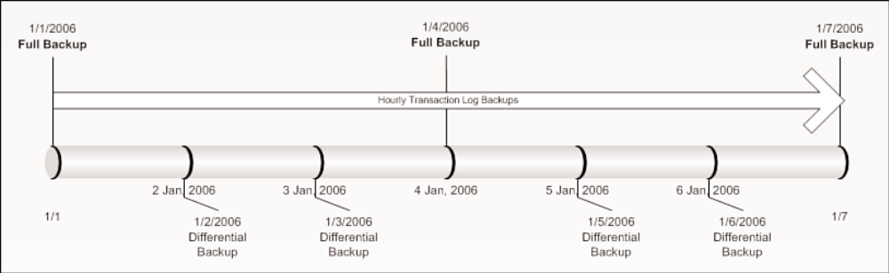
- For example, in the backup plan shown in Figure 14.5, if a media failure occurred in the middle of the day on January 3, the differential backup that would be used is the one taken at the beginning of the day on January 3; the differential backup that occurred on January 2 would not be needed. The full backup from January 1, the differential from January 3, and any transaction log backups that had occurred since the differential on January 3 would be used to restore the database.
- BACKUP DATABASE [FlowerCavern20160513102144]
- TO DISK = N'E:\20160323_DBBACKUPS\AdventureWorks2008_Diff2.bak'
- WITH DIFFERENTIAL , NOFORMAT, INIT,
- NAME = N'FlowerCavern-Differential Database Backup',
- SKIP, NOREWIND, NOUNLOAD, STATS = 10

2.7.4 Partial backups
Partial backups are useful when read-only files or filegroups are part of a database. The partial backup by default excludes any read-only filegroups and backs up only the read/write data that could have changed.
- --Need to add a read only filegroup first to demonstrate
- ALTER DATABASE FlowerCavern20160513102144
- ADD FILEGROUP ReadOnlyFG1
- GO
- Add a file to the Filegroup
- ALTER DATABASE FlowerCavern20160513102144
- ADD FILE
- (
NAME = FlowerCavern20160513102144_ReadOnlyData,
FILENAME = 'E:\20160311_MSSQLDATA\FlowerCavern20160513102144_ReadOnlyData.ndf',
SIZE = 5MB,
MAXSIZE = 100MB,
FILEGROWTH = 5MB
- ) TO FILEGROUP ReadOnlyFG1
- go
- --Create a table on the ReadOnly filegroup
- CREATE TABLE FlowerCavern20160513102144.dbo.MyReadOnlyTable
- (
FirstName varchar(50),
LastName varchar(50),
EMailAddress char(1000)
- )
- ON ReadOnlyFG1
- --Insert some data into the new read only Filegroup
- insert FlowerCavern20160513102144.dbo.MyReadOnlyTable
- select 'LastName', 'FirstName', 'xxx'
- --Make the filegroup readonly
- ALTER DATABASE [FlowerCavern20160513102144]
- MODIFY FILEGROUP [ReadOnlyFG1] READONLY

- --Need to backup the readonly filegroup that was created
- --or it will be included in the partial backup
- BACKUP DATABASE [FlowerCavern20160513102144]
- FILEGROUP = N'ReadOnlyFG1'
- TO DISK = N'E:\20160323_DBBACKUPS\FlowerCavern20160513102144_ReadOnlyFG.bak'
- WITH NOFORMAT, NOINIT, NAME = N'FlowerCavern20160513102144-Full Filegroup Backup',
- SKIP, NOREWIND, NOUNLOAD, STATS = 10
- --Create the Partial Database Backup
- --It will not contain the data from readonly filegroup
- --The partial database backup can be restored without affecting
- --the data in the readonly filegroup
- BACKUP DATABASE [FlowerCavern20160513102144] READ_WRITE_FILEGROUPS
- TO DISK = N'E:\20160323_DBBACKUPS\FlowerCavern20160513102144_Partial.bak'
- WITH NOFORMAT, INIT, NAME = N'FlowerCavern20160513102144-Partial Database Backup',
- SKIP, NOREWIND, NOUNLOAD, STATS = 10
- --It is possible to backup the readonly filegroup(s) as well
- --by listing the readonly filegroups in the backup command as shown in the
- --following backup command
- BACKUP DATABASE [FlowerCavern20160513102144] FILEGROUP = 'ReadOnlyFG1',
- READ_WRITE_FILEGROUPS
- TO DISK = N'E:\20160323_DBBACKUPS\FlowerCavern20160513102144_Partial_WithReadOnly.bak'
- WITH NOFORMAT, INIT, NAME = N'FlowerCavern20160513102144-Partial Database Backup',
- SKIP, NOREWIND, NOUNLOAD, STATS = 10

2.7.5 File/Filegroup backup
A SQL Server database, by default, has only two files: the data file (with the file extension .mdf) and the log file (with the extension .ldf). You can add additional files and filegroups that contain these files to extend the database beyond the original two files.
With very large databases, performing a full backup that contains all the database files can take too much time. In such a case, the individual files or filegroups can be backed up separately, enabling you to spread out the backup.
- BACKUP DATABASE [FlowerCavern20160513102144] FILE = 'FlowerCavern20160513102144_ReadOnlyData'
- TO DISK = N'E:\20160323_DBBACKUPS\FlowerCavern20160513102144_ReadOnlyData.bak'
- WITH NOFORMAT, INIT, NAME = N'FlowerCavern20160513102144-Readonly File Backup',
- SKIP, NOREWIND, NOUNLOAD, STATS = 10

2.7.6 Mirrored backups
- BACKUP DATABASE [FlowerCavern20160513102144]
- TO disk = 'E:\20160323_DBBACKUPS\AdventureWorks2008_Mirror1a.bak',
disk = 'E:\20160323_DBBACKUPS\AdventureWorks2008_Mirror1b.bak'
- MIRROR TO disk = 'E:\20160323_DBBACKUPS\AdventureWorks2008_Mirror2a.bak',
disk = 'E:\20160323_DBBACKUPS\AdventureWorks2008_Mirror2b.bak'
- WITH FORMAT,
- MEDIANAME = 'AdventureWorks2008MirrorSet'

2.7.7 Copy-only backups
The copy-only backup allows you to make a database or log backup without identifying the backup as one that should be included in a restore sequence. Contrast this with a full database backup: If a full database backup is taken, the information related to this backup is captured in the system tables.
- BACKUP DATABASE [FlowerCavern20160513102144]
- TO DISK = N'E:\20160323_DBBACKUPS\AdventureWorks2008_COPY.bak'
- WITH COPY_ONLY

2.7.8 Compressed backups
- BACKUP DATABASE [FlowerCavern20160513102144]
- TO DISK = N'E:\20160323_DBBACKUPS\AdventureWorks2008_compressed.bak'
- WITH NOFORMAT, NOINIT,
- NAME = N'AdventureWorks2008-Full Database Backup',
- SKIP, NOREWIND, NOUNLOAD, COMPRESSION, STATS = 10

2.7.9 System database backups
The msdb database contains information about backups and scheduled jobs. The master database contains information about all the user databases stored on the server. This information can change over time.

2.8 Restoring databases and transaction logs
Basic options for restore
- Restore an entire database.
- Perform a partial restore.
- Restore a file or page from a backup.
- Restore a transaction log.
- Restore a database to a point in time by using a database snapshot.

2.8.1 Database restore with T-SQL
- --To Restore an Entire Database from a Full database backup (a Complete Restore):
- RESTORE DATABASE { database_name | @database_name_var }
- [ FROM <backup_device> [ ,...n ] ]
- [ WITH
- [ { CHECKSUM | NO_CHECKSUM } ]
- [ [ , ] { CONTINUE_AFTER_ERROR | STOP_ON_ERROR } ]
- [ [ , ] ENABLE_BROKER ]
- [ [ , ] ERROR_BROKER_CONVERSATIONS ]
- [ [ , ] FILE = { file_number | @file_number } ]
- [ [ , ] KEEP_REPLICATION ]
- [ [ , ] MEDIANAME = { media_name | @media_name_variable } ]
- [ [ , ] MEDIAPASSWORD = { mediapassword |
- @mediapassword_variable } ]
- [ [ , ] MOVE 'logical_file_name' TO 'operating_system_file_name' ]
- [ ,...n ]
- [ [ , ] NEW_BROKER ]
- [ [ , ] PARTIAL ]
- [ [ , ] PASSWORD = { password | @password_variable } ]
- [ [ , ] { RECOVERY | NORECOVERY | STANDBY =
- {standby_file_name | @standby_file_name_var }
- } ]
- [ [ , ] REPLACE ]
- [ [ , ] RESTART ]
- [ [ , ] RESTRICTED_USER ]
- [ [ , ] { REWIND | NOREWIND } ]
- [ [ , ] STATS [ = percentage ] ]
- [ [ , ] { STOPAT = { date_time | @date_time_var }
- | STOPATMARK = { 'mark_name' | 'lsn:lsn_number' }
- [ AFTER datetime ]
- | STOPBEFOREMARK = { 'mark_name' | 'lsn:lsn_number' }
- [ AFTER datetime ]
- } ]
- [ [ , ] { UNLOAD | NOUNLOAD } ]
- ]

- RESTORE DATABASE [AdventureWorks2008_FullRecovery]
- FROM DISK = N'E:\20160323_DBBACKUPS\DB20160429222009.bak'
- WITH FILE = 1, NOUNLOAD, REPLACE, STATS = 10

2.8.2 Transaction log restore with T-SQL
With the RECOVERY option, any uncommitted transactions are rolled back, and the database is made available for use.
When the NORECOVERY option is specified, the database is completely unavailable after the restore and is left in a restoring state.
With the STANDBY option, the database is left in a read-only state that allows some database access. standby_file_name must be specified with the STANDBY option. The standby file contains uncommitted transactions rolled back to place the database in a consistent state for read operations.
- --***
- BACKUP DATABASE [FlowerCavern20160513102144]
- TO DISK = 'E:\20160323_DBBACKUPS\Test\FlowerCavern_FullBackupD.bak'
- BACKUP LOG [FlowerCavern20160513102144]
- TO DISK= 'E:\20160323_DBBACKUPS\Test\FlowerCavern_FullBackupL.bak'
- --
- RESTORE FILELISTONLY
- FROM DISK = 'E:\20160323_DBBACKUPS\Test\FlowerCavern_FullBackupD.bak'
- --
- DROP DATABASE [FlowerCavernTest1]
- RESTORE DATABASE [FlowerCavernTest1]
- FROM DISK = N'E:\20160323_DBBACKUPS\Test\FlowerCavern_FullBackupD.bak'
- WITH FILE = 1,
- MOVE 'FlowerCavernD' TO 'E:\20160323_DBBACKUPS\Test\DataFiles\FlowerCavernD.ndf',
- MOVE 'FlowerCavern20160513102144_ReadOnlyData' TO 'E:\20160323_DBBACKUPS\Test\DataFiles\FlowerCavernD_ReadOnlyData.ndf',
- MOVE 'FlowerCavernL' TO 'E:\20160323_DBBACKUPS\Test\DataFiles\FlowerCavernL.ldf',
- NOUNLOAD, STATS = 10, NORECOVERY
- --
- RESTORE LOG [FlowerCavernTest1]
- FROM DISK = N'E:\20160323_DBBACKUPS\Test\FlowerCavern_FullBackupL.bak'
- WITH FILE = 1, NOUNLOAD, STATS = 10, NORECOVERY

2.8.3 Restore information
- BACKUP DATABASE [FlowerCavern20160513102144]
- TO DISK = 'E:\20160323_DBBACKUPS\Test\FlowerCavern_FullBackupD.bak'
- WITH NOFORMAT, INIT, NAME = N'FlowerCavern-Full Database Backup',
SKIP, NOREWIND, NOUNLOAD, STATS = 10
- RESTORE FILELISTONLY
- FROM DISK = 'E:\20160323_DBBACKUPS\Test\FlowerCavern_FullBackupD.bak'

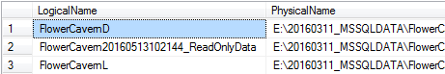
- RESTORE HEADERONLY
- FROM DISK = 'E:\20160323_DBBACKUPS\Test\FlowerCavern_FullBackupD.bak'

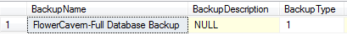
- RESTORE VERIFYONLY
- FROM DISK = 'E:\20160323_DBBACKUPS\Test\FlowerCavern_FullBackupD.bak'

2.8.4 Backup and restore system tables
Msdb system table | Description
backupfile | Contains one row for each data or log file of a database.
backupfilegroup | Contains one row for each filegroup in a database at the time of backup.
backupmediafamily | Contains a row for each media family.
backupmediaset | Contains one row for each backup media set.
backupset | Contains a row for each backup set.
logmarkhistory | Contains one row for each marked transaction that has been committed.
restorefile | Contains one row for each restored file. These include files restored indirectly, by filegroup name.
restorefilegroup | Contains one row for each restored filegroup.
restorehistory | Contains one row for each restore operation.
suspect_pages | Contains one row per page that failed with an 824 error (with a limit of 1,000 rows).
sysopentapes | Contains one row for each currently open tape device.

- --retrieves restore information for the FlowerCavernTest1 database:
- select destination_database_name 'database',
h.restore_date, restore_type,
cast((backup_size/1024)/1024 as numeric(8,0)) 'backup_size MB',
f.physical_device_name
- from msdb..restorehistory h (NOLOCK)
- LEFT JOIN msdb..backupset b (NOLOCK) ON h.backup_set_id = b.backup_set_id
- LEFT JOIN msdb..backupmediafamily f (NOLOCK) ON b.media_set_id = f.media_set_id
- where h.restore_date > getdate() - 5
- and UPPER(h.destination_database_name) = 'FlowerCavernTest1'
- order by UPPER(h.destination_database_name),
h.restore_date desc

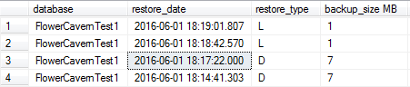

2.9 Restore scenrios

2.9.1 restoring to a different database
A restore of a database backup taken from another server can cause problems after the restore completes. The problems are caused by broken relationships between the database users captured in the backup file and the associated logins on the server to which the backup is restored.The unique ID from the login is stored with each database user in order to identify the login that the user is associated with.
- RESTORE DATABASE [FlowerCavernTest1]
- FROM DISK = N'E:\20160323_DBBACKUPS\Test\FlowerCavern_FullBackupD.bak'
- WITH FILE = 1,
- MOVE 'FlowerCavernD' TO 'E:\20160323_DBBACKUPS\Test\DataFiles\FlowerCavernD.ndf',
- MOVE 'FlowerCavern20160513102144_ReadOnlyData' TO 'E:\20160323_DBBACKUPS\Test\DataFiles\FlowerCavernD_ReadOnlyData.ndf',
- MOVE 'FlowerCavernL' TO 'E:\20160323_DBBACKUPS\Test\DataFiles\FlowerCavernL.ldf',
- NOUNLOAD, STATS = 10

- SELECT * FROM SYS.SERVER_PRINCIPALS
- DROP LOGIN TestUser
- GO
- EXEC sp_change_users_login 'report'
- GO
- EXEC sp_change_users_login 'AUTO_FIX', 'TestUser', NULL, '123456'
- CREATE LOGIN TestUser1 WITH PASSWORD='123456'
- DROP LOGIN TestUser1
- EXEC sp_change_users_login 'UPDATE_ONE', 'TestUser', 'TestUser1'

2.9.2 Restoring a snapshot
The snapshot is created as another read-only database linked to the original database from which the snapshot was taken. As changes are made to the original database, the database engine uses a copy-onwrite method to keep the snapshot consistent.After a snapshot is taken, you can revert back to the snapshot at a later time and restore the original database to the state it was in when the snapshot was taken.
- RESTORE DATABASE { database_name | @database_name_var }
- FROM DATABASE_SNAPSHOT database_snapshot_name

2.9.3 Restoring a transaction log

2.9.4 Restoring to the point of failure
It is hoped the disk that experienced a failure is not the same disk that houses your backups.
The backup components that you need to restore to the point of failure include the following:
- A backup of the tail of the transaction log
- A full database backup or file/filegroup backup to establish a base
- The full sequence of transaction log backups created since the full database backup

- --Backing Up the Tail of the Transaction Log
- --This type of backup is possible only if the transaction log file is accessible and was not on the disk that had the failure.
- BACKUP LOG [FlowerCavern20160513102144]
- TO DISK = N'E:\20160323_DBBACKUPS\Test\FlowerCavern_Tail.trn'
- WITH NO_TRUNCATE

- --This restore, which is based on a full database backup or a file/filegroup backup, overwrites the existing database.
- RESTORE DATABASE [FlowerCavernTest1]
- FROM DISK = N'E:\20160323_DBBACKUPS\Test\FlowerCavern_FullBackupD.bak'
- WITH FILE = 1,
- MOVE 'FlowerCavernD' TO 'E:\20160323_DBBACKUPS\Test\DataFiles\FlowerCavernD.ndf',
- MOVE 'FlowerCavern20160513102144_ReadOnlyData' TO 'E:\20160323_DBBACKUPS\Test\DataFiles\FlowerCavernD_ReadOnlyData.ndf',
- MOVE 'FlowerCavernL' TO 'E:\20160323_DBBACKUPS\Test\DataFiles\FlowerCavernL.ldf',
- NORECOVERY, NOUNLOAD, REPLACE, STATS = 10
- /*
- Restoring the Transaction Log Backup
- These backups include all the transaction log backups since the last full backup plus the tail of the log you backed up after the media failure. If differential backups were taken since the last full backup, you can apply the last differential backup and apply only those transaction log backups that have occurred since the last differential backup.
- */
- RESTORE LOG [FlowerCavernTest1]
- FROM DISK = N'E:\20160323_DBBACKUPS\Test\FlowerCavern_FullBackupL.bak'
- WITH FILE = 1, NORECOVERY, NOUNLOAD, STATS = 10
- GO
- RESTORE LOG [FlowerCavernTest1]
- FROM DISK = N'E:\20160323_DBBACKUPS\Test\FlowerCavern_FullBackupL02.bak'
- WITH FILE = 1, NORECOVERY, NOUNLOAD, STATS = 10
- GO
- RESTORE LOG [FlowerCavernTest1]
- FROM DISK = N'E:\20160323_DBBACKUPS\Test\FlowerCavern_Tail.trn'
- WITH FILE = 3, NOUNLOAD, STATS = 10
- GO

2.9.5 Restoring to a point in time
A point-in-time restore can be done using one of the following:
- A specific date/time within the transaction log backup
- A specific transaction name inserted in the log
- An LSN

2.9.6 Online restore
They allow a filegroup, file, or specific page within a file to be restored while the rest of the database is online. The file or filegroup that is being restored to must be offline during the duration of the online restore.
- --The following example demonstrates how to take a read-only file offline:
- ALTER DATABASE FlowerCavern20160513102144
- MODIFY FILE
- (
NAME = 'FlowerCavern20160513102144_ReadOnlyData', OFFLINE
- )

- RESTORE DATABASE [FlowerCavern20160513102144]
- FILE = N'FlowerCavern20160513102144_ReadOnlyData'
- FROM DISK = N'E:\20160323_DBBACKUPS\FlowerCavern20160513102144_ReadOnlyData.bak'
- WITH FILE = 1, NOUNLOAD, STATS = 10, RECOVERY

Chapter 3 Database Mail

3.1 Setting up database mail
- --Configure the Database Mail XPs configuration option
- use Master
- GO
- sp_configure 'show advanced options', 1;
- GO
- RECONFIGURE;
- GO
- sp_configure 'Database Mail XPs', 1;
- GO
- RECONFIGURE
- GO
- --you stop the SQL Server Agent service enable Service Broker in msdb because Database Mail relies on it as part of its implementation.
- USE master
- GO
- ALTER DATABASE msdb SET ENABLE_BROKER
- --
- Use Master
- GO
- SELECT is_broker_enabled
- FROM sys.databases
- WHERE name = 'msdb'

3.1.1 Creating mail profiles and accounts

- --The first script creates the new profile:
- EXEC msdb.dbo.sysmail_add_profile_sp
- @profile_name = 'Default SQL 2012 Profile',
- @description = 'Used for test-purpose emailing.'
- --The second script creates the new SMTP account:
- EXEC msdb.dbo.sysmail_add_account_sp
- @account_name = 'TestMailAcct1',
- @description = 'The test SMTP Account.',
- @email_address = 'xuechengeng@163.com',
- @display_name = 'SQL test Mail Account 1',
- @mailserver_name = 'smtp.163.com' ;
- --The third script associates this new account with the new profile:
- EXEC msdb.dbo.sysmail_add_profileaccount_sp
- @profile_name = 'Default SQL 2012 Profile',
- @account_name = 'TestMailAcct1',
- @sequence_number =1;
- --To set profile security
- exec msdb.dbo.sysmail_add_principalprofile_sp
- @profile_name = 'Default SQL 2012 Profile',
- @principal_name = 'public',
- @is_default = 1 ;

3.1.2 Using T-SQL to update and delete mail objects
- --For example, to delete a profile, you execute this:
- exec msdb.dbo.sysmail_delete_profile_sp @profile_name='Default SQL 2012 Profile'
- --To update a profile's security,
- exec msdb.dbo.sysmail_update_principalprofile_sp
- @profile_name = 'Default SQL 2012 Profile',
- @principal_name = 'public',
- @is_default = 0;

3.1.3 Setting system-wide mail settings
- exec msdb.dbo.sysmail_configure_sp 'AccountRetryDelay', 1200

3.2 sending and receiving with database mail
- exec msdb.dbo.sp_send_dbmail
- @profile_name='Default SQL 2008 Profile',
- @body='Testing...',
- @subject='A Test',
- @recipients='2780393506@qq.com'
- go

3.3 Using SQL Server Agent Mail

3.3.1 Job mail notifications
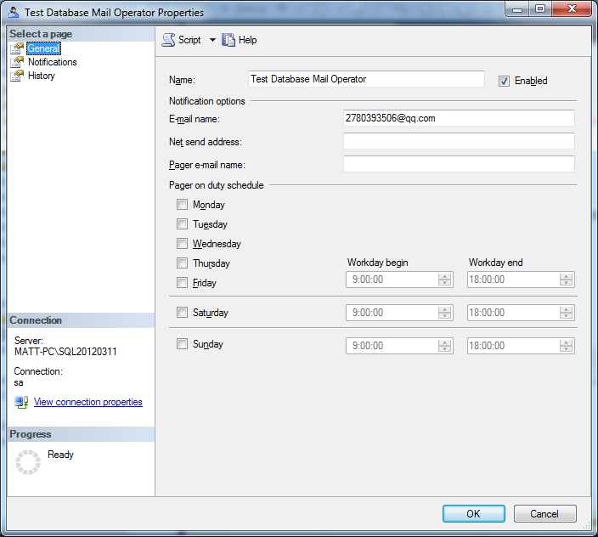
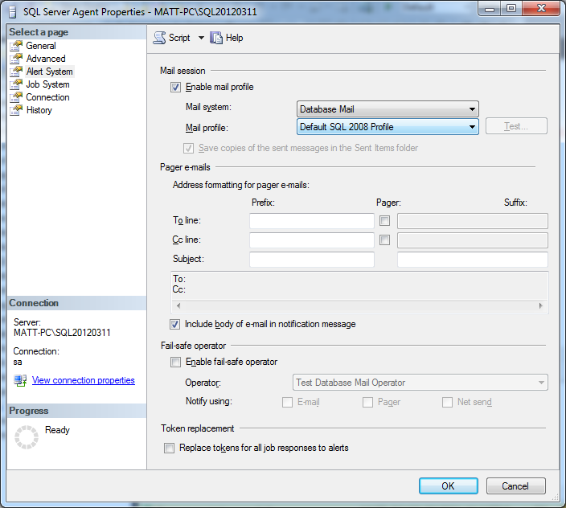
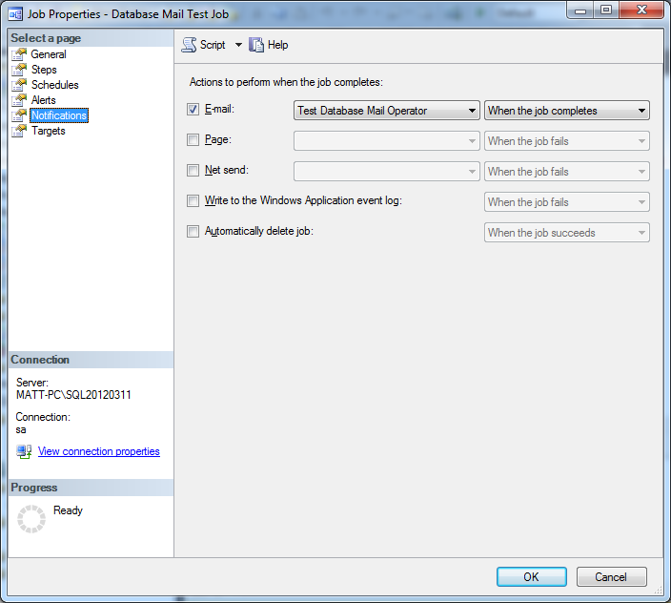

3.3.2 Alert mail notifications
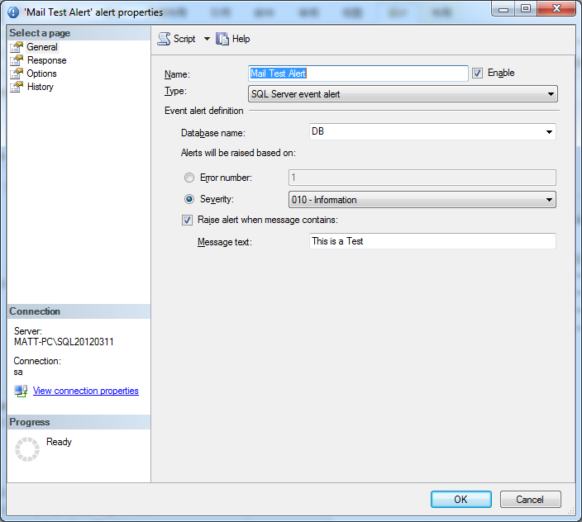
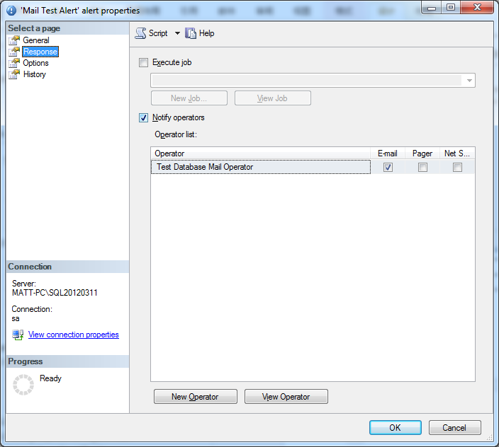
- RAISERROR('This is an alert mail test', 10, 1) WITH LOG
- go

Chapter 4 The Key T-SQL Scripts

- --Recurse query the info in different levels

;WITH CTE01 AS
(
SELECT VGUID, OGUID AS [PGUID], PDESCCHS AS [ODESCCHS]
FROM CSPOSI_1
WHERE VGUID='403DC96F-DB21-44D7-8300-00F3E30AC9CA'
UNION ALL
SELECT A.VGUID, A.PGUID, A.ODESCCHS
FROM CSORGA_1 AS A
INNER JOIN CTE01 AS B ON A.VGUID=B.PGUID
)
SELECT * FROM CTE01
- --SELECT VGUID, * FROM CSPOSI_1
- --check database process

- SELECT *
- FROM SYS.SYSPROCESSES
- WHERE DBID=DB_ID('LandaV9')
- DBCC INPUTBUFFER(51)

- --landa报表打开字段乱序问题

- delete from csreportfield where RPTid in (select rptid from csrpt_1 where rptdatasource='USP_Emplyee_Class')
- delete from csreportsetup where reportid in (select rptid from csrpt_1 where rptdatasource='USP_Emplyee_Class')

- --Change the status of a database

- ALTER DATABASE DB20160312 SET READ_WRITE
- RESTORE DATABASE DB20160312 WITH RECOVERY

- --添加本地计算机用户为数据库管理员
- sp_addsrvrolemember 'LANDASOFT-AP\Tiny.Cui', 'sysadmin'
- SELECT *
- FROM SYS.SERVER_PRINCIPALS
- --CREATE FUNCTION

- IF OBJECT_ID('getonlydate', 'FN') IS NOT NULL DROP FUNCTION getonlydate
- GO
- CREATE FUNCTION getonlydate ()
- RETURNS datetime
- AS
- BEGIN
RETURN (select convert(datetime, convert(date, getdate())))
- END
- GO

- --UNPIVOT
- SELECT * FROM CSEMPL_12
- SELECT DAYNUM,
DAYVALUE
- FROM CSEMPL_12
- UNPIVOT
- (
DAYVALUE FOR DAYNUM IN
(
D1,
D2,
D3,
D4,
D5,
D6,
D7,
D8,
D9,
D10,
D11,
D12,
D13,
D14,
D15,
D16,
D17,
D18,
D19,
D20,
D21,
D22,
D23,
D24,
D25,
D26,
D27,
D28,
D29,
D30,
D31
)
- )T
- WHERE YEARMONTH='1605'

Chapter 5 replication
data that is inserted, updated, or deleted in one location (stored) is automatically distributed (forwarded) to one or more locations.
- Offloading
You might need to deliver data to different locations to eliminate network traffic and unnecessary load on a single server.
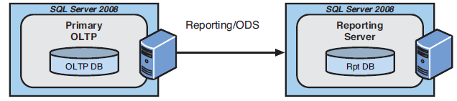
- Enabling
You might need to enable a group of users with a copy of data or a subset of data (vertically or horizontally) for their private use.
- Partitioning
You might need to move data off a single server onto several other servers to provide for high availability and decentralization of data (or partitioning of data).
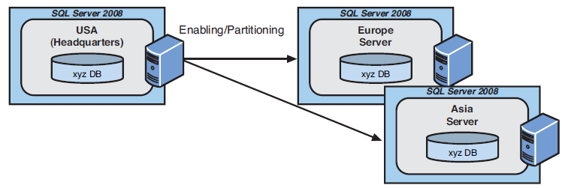
- Regionalization
You might have regional ownership of data (for example, regional customers and their orders). In this case, it is possible to set up data replication to replicate data bidirectionally from two or more publishers of the same data.
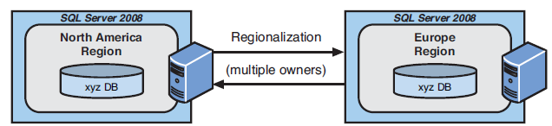
- Failover
You could be replicating all data on a server to another server (that is, a failover server) so that if the primary server crashes, users can switch to the failover server quickly and continue to work with little downtime or data loss.
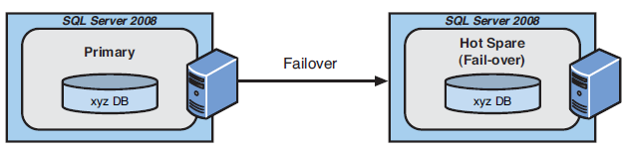

5.1 Replication scenarios
- Central publisher
- Central publisher with a remote distributor
- Publishing subscriber
- Central subscriber
- Multiple publishers with multiple subscribers
- Updating subscribers
- Peer-to-peer

5.1.1 The central publisher replication model
In this scenario, one SQL Server performs the function of both publisher and distributor. The publisher/distributor can have any number of subscribers.
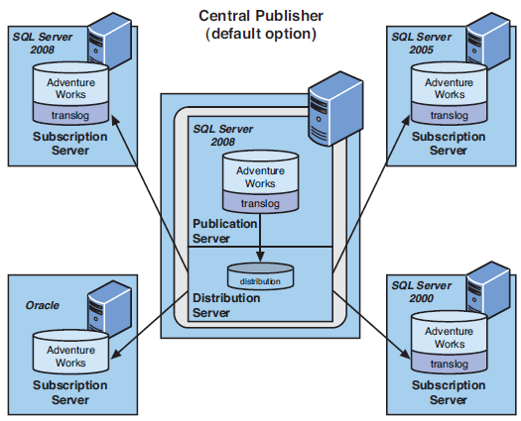
- The central publisher scenario can be used in the following situations:
- Creation of a copy of a database for ad hoc queries and report generation (classic use)
- However, it’s important to consider the following for this replication model:
- If your OLTP server’s activity is substantial and affects greater than 10% of your total data per day, this scenario is not for you. Other scenarios or configurations will better fit your needs.
- If your OLTP server is maximized on CPU, memory, and disk utilization, you should also consider another data replication scenario because this one is not for you either.

5.1.2 The central publisher with remote distributor replication model
This model is similar to the central publisher scenario and would be used in the same general situations. This is highly desirable when you need to free the publishing server from having to perform the distribution task from a CPU, disk, and memory point of view. This is also the best scenario from which to expand the number of publishers and subscribers. The publisher and distributor must be connected to each other via a reliable, high-speed data link.
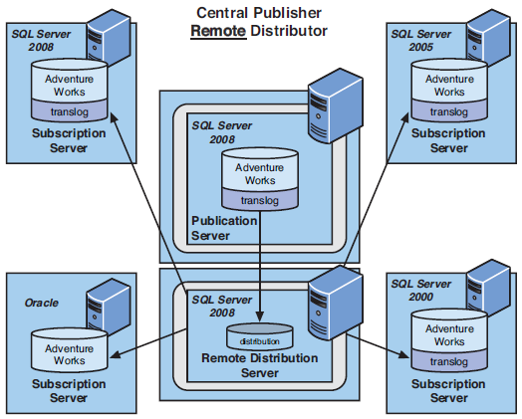

5.1.3 The publishing subscriber replication model

the publication server also has to act as a distribution server to one subscriber. This subscriber, in turn, immediately publishes the data to any number of other subscribers. This scenario is best used when a slow or expensive network link exists between the original publishing server and all the other potential subscribers.
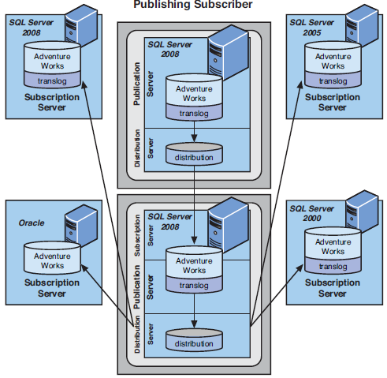

5.1.4 The central subscriber replication model
several publishers replicate data to a single, central subscriber. Basically, this supports the concept of consolidating data at a central site. An example of this might be consolidating all new orders from regional sales offices to company headquarters.
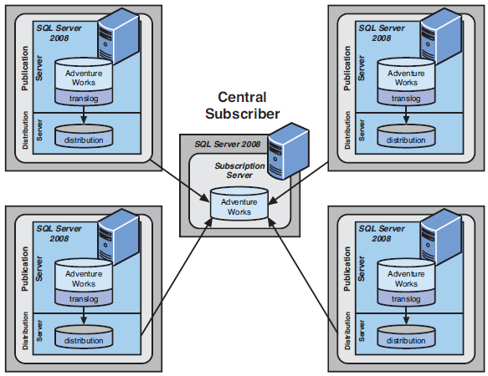

5.1.5 The multiple publishers with multiple subscribers replication model
Each server publishes a particular set of rows (for example, the customer rows in a customer’s own territory) that pertain to it—usually via filtering on something that identifies that site to the data rows it owns—and subscribes to the rows that all the other servers are publishing. The result is that each server has all the data at all times and can make changes to its data only.
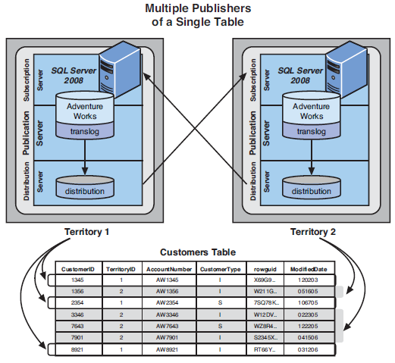

5.1.6 The updating subscriber replication model
this model allows the subscriber to update data in a table to which it subscribes and have those updates automatically made back to the publisher through either immediate or queued updates.
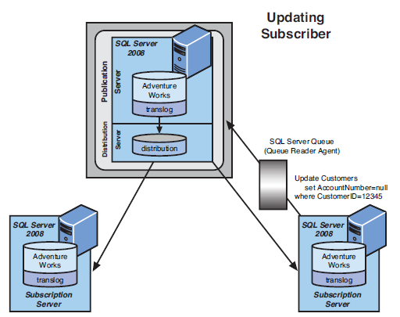

5.1.7 The peer-to-peer replication model
the peer-to-peer replication model can provide a simpler way for all nodes to have the same data and also gives them the capability to update this data independently. Each peer is equal in level. Peers do not subscribe to each other’s data; they share each other’s data. you might decide to prohibit updates to the other nodes’ data by putting into place some type of stored procedure or view restrictions that allow the loca node to update only its own local data.
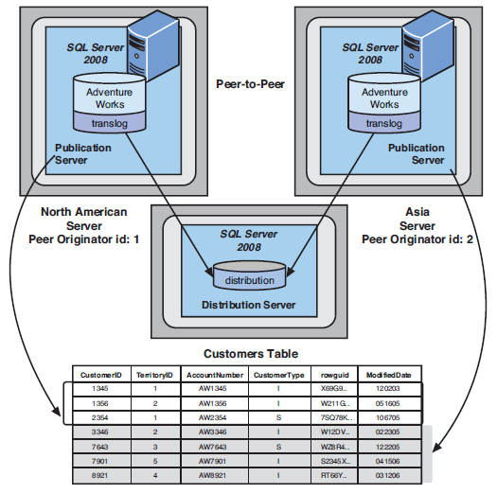

5.2 Replication agents
Here are the main replication agent categories:
Snapshot Agent
Log Reader Agent
Distribution Agent
Merge Agent (for updating subscribers)
History Cleanup Agent
Distribution Cleanup Agent
Expired Subscription Cleanup Agent
Reinitialize Subscriptions Having Data Validation Failures Agent
Replication Monitoring Refresher for Distribution Agent
Replication Agent Cleanup Agent

5.3 Planning for SQL Server data replication

5.3.1 Autonomy, Timing and Latency of Data
- immediate transactional consistency
SQL Server implements immediate transactional consistency data distribution in the form of two-phase commit processing. A two-phase commit, sometimes known as 2PC, ensures that transactions are committed on all servers, or the transaction is rolled back on all servers. One of the main drawbacks of immediate transactional consistency is that it requires a high-speed LAN to work. This type of solution might not be feasible for large environments with many servers because occasional network outages can occur.
- Latent transactional consistency
Latent transactional consistency is implemented in SQL Server via data replication. The result is “real-enough-time” data.
- autonomy
A site with complete autonomy can continue to function without being connected to any other site. A site with no autonomy cannot function without being connected to all other sites. For example, applications that utilize two-phase commits rely on all other sites being able to immediately accept changes sent to them. In the event that any one site is unavailable, no transactions on any server can be committed. In contrast, sites using merge replication can be completely disconnected from all other sites and continue to work effectively, not guaranteeing data consistency.

5.3.2 Methods of data distribution
- Distributed transactions
Distributed transactions ensure that all sites have the same data at all times. You pay a certain amount of overhead cost to maintain this consistency. (We do not discuss this nondata replication method here.)
- Transactional replication with updating subscribers
Users can change data at the local location, and those changes are applied to the source database at the same time. The changes are then eventually replicated to other sites. This type of data distribution combines replication and distributed transactions because data is changed at both the local site and source database.
- Peer-to-peer replication
A variation on the Transactional replication with updating subscribers theme is peer-to-peer replication, which is essentially full transactional replication between two (or more) sites, but is publisher-to-publisher (not update subscriber). There is no hierarchy—publisher (parent) and subscriber (child).
- Transactional replication
With transactional replication, data is changed only at the source location and is sent out to the subscribers. Because data is changed at only a single location, conflicts cannot occur.
- Snapshot replication with updating subscribers
This method is much like transactional replication with updating subscribers; users can change data at the local location, and those changes are applied to the source database at the same time. The entire changed publication is then replicated to all subscribers. This type of replication provides higher autonomy than transactional replication.
- Snapshot replication
A complete copy of the publication is sent out to all subscribers. This includes both changed and unchanged data.
- Merge replication
All sites make changes to local data independently and then update the publisher. It is possible for conflicts to occur, but they can be resolved.

5.4 SQL Server replication types

5.4.1 Snapshot replication
Snapshot replication makes an image of all the tables in a publication at a single moment in time and then moves that entire image to the subscribers. Snapshot replication is the easiest form of replication to set up and is used primarily with smaller tables for which subscribers do not have to perform updates.

- The primary agents used for snapshot replication are the snapshot agent and distribution agent.
- The snapshot agent creates files that contain the schema of the publication and the data. The files are temporarily stored in the snapshot folder of the distribution server, and then the distribution jobs are recorded in the distribution database.
- The distribution agent is responsible for moving the schema and data from the distributor to the subscribers.

5.4.2 Transactional replication
Transactional replication is the process of capturing transactions from the transaction log of the published database and applying them to the subscription databases. No direct reading of tables is required except during initial snapshot, and only the minimal amount of traffic is generated over the network.

- The primary agents used for transactional replication are the snapshot agent, log agent, and distribution agent:
- The snapshot agent creates files that contain the schema of the publication and the data. The files are stored in the snapshot folder of the distribution server, and the distribution jobs are recorded in the distribution database.
- The log reader agent monitors the transaction log of the database that it is set up to service. Each database published has its own log reader agent set up for replication, and it will copy the transactions from the transaction log of that published database into the distribution database.
- The distribution agent is responsible for moving the schema and data from the distributor to the subscribers for the initial synchronization and then moving all the subsequent transactions from the published database to each subscriber as they come in. These transactions are stored in the distribution database for a certain length of time and are eventually purged.

5.4.3 Merge replication
Merge replication involves getting the publisher and all subscribers initialized and then allowing data to be changed at all sites involved in the merge replication at the publisher and at all subscribers. All these changes to the data are subsequently merged at certain intervals so that, again, all copies of the database have identical data. Occasionally, data conflicts have to be resolved.

- The primary agents used for merge replication are the snapshot agent and merge agent:
- The snapshot agent creates files that contain the schema of the publication and the data. The files are stored in the snapshot folder of the distribution server, and the distribution jobs are recorded in the distribution database. This is essentially the same behavior as with all other types of replication methods.
- The merge agent takes the initial snapshot and applies it to all the subscribers. It then reconciles all changes made on all the servers, based on the rules you configure.

- Preparing for merge replication
- If the table already contains a column with the ROWGUIDCOL property, SQL Server automatically uses that column for the row identifier. If not, SQL Server adds a column called rowguid to the table. SQL Server also places an index on this rowguid column.
- Next, SQL Server adds triggers to the table to track changes that occur to the data in the table and record them in the merge system tables.
- Finally, SQL Server adds new system tables to the database that contains the replicated tables. The MSMerge_contents and MSMerge_tombstone tables track the updates, inserts, and deletes. These tables rely on rowguid to track which rows have actually been changed.
- The merge agent is responsible for moving changed data from the site where it was changed to all other sites in the replication scenario. When the data reaches the other sites, the data is merged with existing data according to rules you have defined. The merge agent identifies conflicts using the MSMerge_contents table.

5.5 Basing the replication design on user requirements

5.5.1 User requirements
As mentioned earlier, business requirements drive your replication configuration and method.
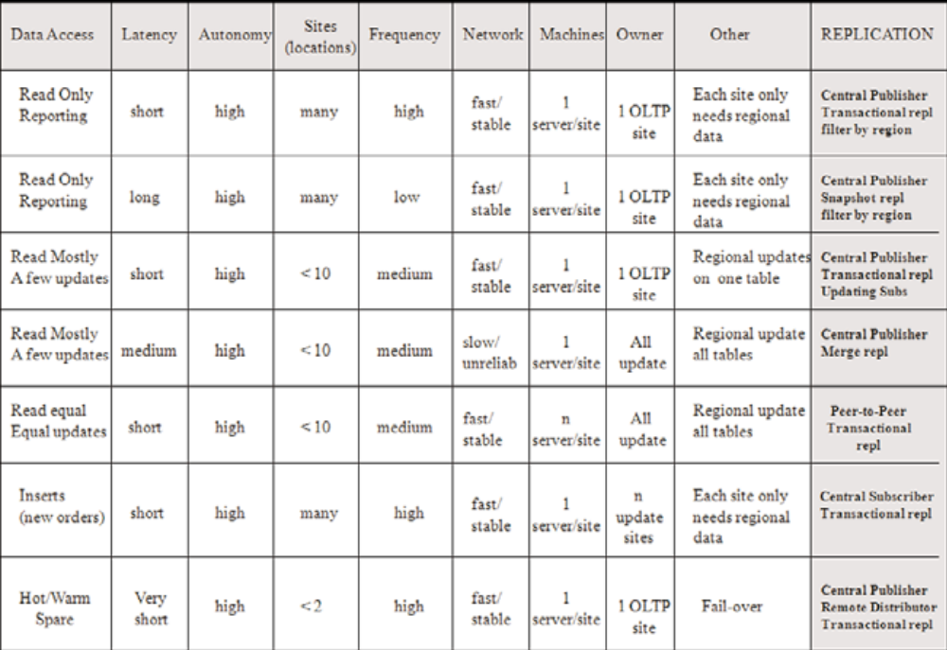

5.5.2 Data characteristics
You need to analyze the underlying data types and characteristics thoroughly. Issues such as collation or character set and data sorting come into play. Sometimes, using the Unicode data types at all sites is best for consistency.
- Following is a general list of issues to watch out for in this regard:
- Collation consistency across all nodes of replication.
- Time stamp column data in replication. It might not be what you think.
- identity, uniqueidentifier, and guid column behavior with data replication.
- text or image data types to heterogeneous subscribers.
- Missing or unsupported data types because of prior versions of SQL Server or heterogeneous subscribers as part of the replication configuration.
- Maximum row size limitations between merge replication and transactional replication.

5.6 Setting up replication

Chapter 6 Creating and Managing Indexes

6.1 Types of indexes

6.1.1 Clustered indexes
- Clustered indexes sort and store the data rows for a table, based on the columns defined in the index. A clustered index is structured as a balanced tree (B-tree).
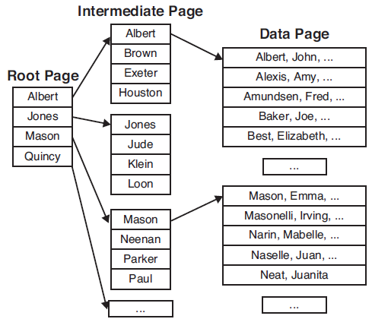

- There can be only one clustered index per table. The selection of columns for a clustered index should be driven by the way the data is most commonly accessed in the table.
- Those that are often accessed sequentially
- Those that contain a large number of distinct values
- Those that are used in range queries that use operators such as BETWEEN, >, >=, <, or <= in the WHERE clause
- Those that are frequently used by queries to join or group the result set
- The queries that are run most often or that must have the best performance.

6.1.2 Non-clustered indexes
- A non-clustered index is independent of the physical sort order of the data rows in the table. With non-clustered indexes, you may have to jump around to many different non-sequential pages to find all the references. A non-clustered index is also structured as a B-tree.
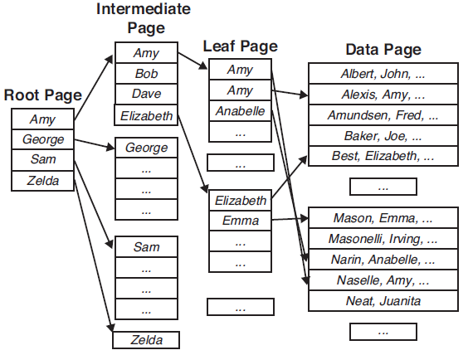
The main difference between a nonclustered index and clustered index is that the leaf row of a nonclustered index is independent of the data rows in the table. The leaf level of a nonclustered index contains a row for every data row in the table, along with a pointer to locate the data row. This pointer is either the clustered index key for the data row, if the table has a clustered index on it, or the data page ID and row ID of the data row if the table is stored as a heap structure (that is, if the table has no clustered index defined on it).

- You should choose your non-clustered indexes with the book index example in mind. You should consider using non-clustered indexes for the following:
- Queries that do not return large result sets
- Columns that are frequently used in the WHERE clause that return exact matches
- Columns that have many distinct values (that is, high cardinality)
- All columns referenced in a critical query (a special non-clustered index called a covering index that eliminates the need to go to the underlying data pages)

6.2 Creating/Managing/Dropping Indexes with T-SQL
- --Create index syntax
- CREATE [ UNIQUE ] [ CLUSTERED | NONCLUSTERED ] INDEX index_name
- ON <object> ( column [ ASC | DESC ] [ ,...n ] )
- [ INCLUDE ( column_name [ ,...n ] ) ]
- [ WHERE <filter_predicate> ]
- [ WITH ( <relational_index_option> [ ,...n ] ) ]
- --The NONCLUSTERED and ASC keywords are not necessary because they are the defaults. Because the UNIQUE keyword is not specified, duplicates are allowed in the index
- CREATE NONCLUSTERED INDEX [NC_Person_LastName]
- ON [Person].[Person]
- (
- [LastName] ASC
- )
- --Unique indexes are also defined on a table whenever you define a unique or primary key constraint on a table.
- CREATE UNIQUE NONCLUSTERED INDEX [AK_CreditCard_CardNumber]
- ON [Sales].[CreditCard]
- (
- [CardNumber] ASC
- )

- --Alter Index syntax
- ALTER INDEX {index_name | ALL}
- ON [{database_name.[schema_name]. | schema_name.}]
- {table_or_view_name}
- { REBUILD [WITH(<rebuild_index_option>[,...n])]
- | REORGANIZE [ WITH( LOB_COMPACTION = {ON | OFF})]
- | DISABLE
- | SET (<set_index_option>[,...n]) }
- --The specified index is dropped and re-created, removing all fragmentation from the index pages. If it is run on a clustered index, the data pages of the table are defragmented as well.
- ALTER INDEX [PK_Product_ProductID] ON [Production].[Product] REBUILD
- --During the REORGANIZE operation, the leaf-level pages of the index are physically reordered to match the logical order of the index keys. The indexes are not dropped.
- --The REORGANIZE operation can generate a large number of transactions during its execution. Several options are available for mitigating the growth of the log during these operations, such as setting the recovery model on the database to BULK-LOGGED.
- ALTER INDEX [PK_Product_ProductID] ON [Production].[Product]
- REORGANIZE WITH ( LOB_COMPACTION = ON )
- --When the DISABLE option is used on an index, the index is no longer available for retrieving data from a table. If a clustered index is disabled, the entire table is made unavailable.
- ALTER INDEX [AK_Product_Name] ON [Production].[Product] DISABLE
- --After an index is disabled, you can re-enable it only by re-creating the index. You can accomplish this using the ALTER INDEX REBUILD command or CREATE INDEX WITH DROP_EXISTING command.
- select is_disabled,
- object_name(object_id) as [TableName],
- *
- from sys.indexes
- --If you drop a clustered index on a table, SQL Server needs to rebuild all the remaining nonclustered indexes on the table.
- DROP INDEX [IX_WorkOrder_ScrapReasonID] ON [Production].[WorkOrder]

6.3 Online indexing operations
- ALTER INDEX [PK_Product_ProductID] ON [Production].[Product]
- REBUILD WITH ( ONLINE = ON)

- During online index operations, the following three phases occur:
- Preparation—Concurrent activity is temporarily suspended while a snapshot of the source index structure is taken and written as an empty structure to the target.
- Building—The source index structures are scanned, sorted, merged, and inserted into the target. User SELECT statements are satisfied via the source. Insertions, updates, and deletions to the affected table are written to both the source and target.
- Final—Concurrent activity is temporarily suspended while the source is replaced by the newly created structures (target).

- When considering online indexing, you need to account for the following:
- Disk space—Generally, the disk space requirements for online operations are the same as those for offline operations. The exception to this is online index operations on clustered indexes.
- Performance—Online index operations are generally slower and take more system resources than offline operations.
- Transaction log—Online index operations are fully logged.

6.4 Indexes on views
The indexed view is no longer virtual because it requires maintenance as rows are added to, deleted from, or modified in the tables referenced by the view. The first index created on a view must be a unique clustered index.
- --The SCHEMABINDING clause and database schema qualifier (dbo) for each table are necessary in the view definition to be able to make the view valid for index creation.
- CREATE VIEW titleview
- WITH SCHEMABINDING AS
- select title, au_ord, au_lname, price, ytd_sales, pub_id
- from dbo.authors, dbo.titles, dbo.titleauthor
- where authors.au_id = titleauthor.au_id
- AND titles.title_id = titleauthor.title_id
- --
- CREATE UNIQUE CLUSTERED INDEX [AK_vw_Employee] ON [dbo].[vw_Employee]
- ( [JobTitle] ASC, [LoginID] ASC)

Chapter 7 Data Structures

7.1 Database Files and Filegroups
Each database file has the following set of properties:
- A logical filename—This name is used for internal reference to the file.
- A physical filename—This name is the actual physical pathname of the file.
- An initial size—If no size is specified for primary data file, its initial size, by default, is the minimum size required to hold the contents of the model database.
- An optional maximum size—A maximum file size limit can be specified.
- A file growth increment—This amount is specified in megabytes or as a percentage.

- SELECT * FROM sys.database_files
- SELECT * FROM sys.master_files

7.1.1 Primary data file
Every database has only one primary database file. The file can, of course, be created on a RAID partition to help spread I/O. However, if you need finer control over placement of your tables across disks or disk arrays, or if you want to be able to back up only a portion of your database via filegroups, you can create additional, secondary data files for a database.

7.1.2 Secondary Data Files
A database can have any number of secondary files. You can put a secondary file in the default filegroup or in another filegroup defined for the database. Secondary data files have the file extension .ndf by default.
Following are some situations in which the use of secondary database files might be beneficial:
- You want to perform a partial backup.
- You want more control over placement of database objects. This could help you spread I/O by placing your most active tables or indexes on separate filegroups defined on separate disks or disk arrays.
- Creating multiple files on a single disk provides no real performance benefit but could help in recovery if you have a 90GB database in a single file.

7.1.3 The log file
Each database must have at least one log file. A database can have several log files. A log file cannot be part of a filegroup.

7.1.4 File management
- CREATE DATABASE Customer ON
- (
- NAME='Customer_Data',
- FILENAME='E:\FileTree\DBFiles\Customer_Data1.mdf',
- SIZE=50,
- MAXSIZE=100,
- FILEGROWTH=10
- ),
- (
- NAME='Customer_Data2',
- FILENAME='E:\FileTree\DBFiles\Customer_Data2.ndf',
- SIZE=100,
- FILEGROWTH=20
- )
- LOG ON
- (
- NAME='Customer_Log',
- FILENAME='E:\FileTree\DBFiles\Customer_Log.ldf',
- SIZE=50,
- FILEGROWTH=20%
- )
- GO

7.1.5 Using Filegroups
In addition to the primary filegroup, you can add one or more filegroups to the database, and a filegroup can contain one or more files. When you create a table or index, you can map it to a specific filegroup, thus controlling the placement of data. If you have a table that itself needs to be spread across multiple disk arrays for performance reasons, you can place multiple files in a filegroup, each of which resides on a different disk, and create the table on that filegroup.
- CREATE DATABASE Customer
- ON
- (
- NAME='Customer_Data',
- FILENAME='E:\FileTree\DBFiles\Customer_Data1.mdf',
- SIZE=50,
- MAXSIZE=100,
- FILEGROWTH=10
- )
- LOG ON
- (
- NAME='Customer_Log',
- FILENAME='E:\FileTree\DBFiles\Customer_Log.ldf',
- SIZE=50,
- FILEGROWTH=20%
- )
- GO
- ALTER DATABASE Customer
- ADD FILEGROUP Cust_table
- GO
- ALTER DATABASE Customer
- ADD FILE
- (
- NAME='Customer_Data2',
- FILENAME='E:\FileTree\DBFiles\Customer_Data2.ndf',
- SIZE=100,
- FILEGROWTH=20
- )
- TO FILEGROUP Cust_Table
- GO
- USE Customer
- CREATE TABLE customer_info
- (
- cust_no INT,
- cust_address NCHAR(200),
- info NVARCHAR(3000)
- )
- ON Cust_Table
- GO
- --
- SELECT * FROM sys.filegroups
- SELECT convert(varchar(30), sf.name) as filename,
- size/128 as size_in_MB,
- convert(varchar(30), sfg.name) as filegroupname
- FROM sys.database_files sf
- INNER JOIN sys.filegroups sfg ON sf.data_space_id = sfg.data_space_id
- GO

7.1.6 FILESTREAM filegroups
FILESTREAM storage helps to solve the issues with using unstructured data by integrating the SQL Server Database Engine with the NTFS file system for storing the unstructured data, such as documents and images, on the file system with the database storing a pointer to the data. Although the actual data resides outside the database in the NTFS file system, you can still use Transact-SQL (T-SQL) statements to insert, update, query, and back up FILESTREAM data, while maintaining transactional consistency between the unstructured data and corresponding structured data with same level of security.
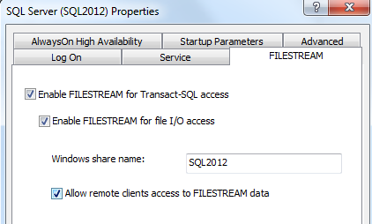
- EXEC sp_configure filestream_access_level, 2
- RECONFIGURE

- ALTER DATABASE Customer
- ADD FILEGROUP Cust_FSGroup CONTAINS FILESTREAM
- ALTER DATABASE Customer
- ADD FILE
- (
- NAME=custinfo_FS,
- FILENAME = 'E:\FileTree\DBFiles\custinfo_FS'
- )
- to FILEGROUP Cust_FSGroup
- GO

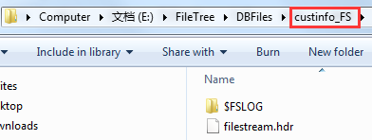
- CREATE TABLE [dbo].[customer_info]
- (
- [ID] [uniqueidentifier] ROWGUIDCOL PRIMARY KEY CLUSTERED,
- [cust_no] [int] NULL,
- [cust_address] [nchar](200) NULL,
- [info] [nvarchar](3000) NULL,
- [Photo] [VARBINARY](MAX) FILESTREAM
- ) ON [Cust_table] FILESTREAM_ON [Cust_FSGroup]
- GO

7.2 Database Pages
The page size is the same for all page types: 8KB, or 8,192 bytes. The pages are arranged in two basic types of storage structures: linked data pages and index trees. Databases are divided into logical 8KB pages. Within each file allocated to a database, the pages are numbered contiguously from 0 to n. Pages in a database are uniquely referenced by specifying the database ID, the file ID for the file the page resides in, and the page number within the file.
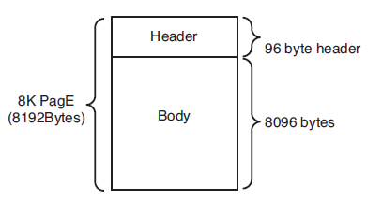
All pages, regardless of type, have a similar layout.

7.2.1 Data Pages
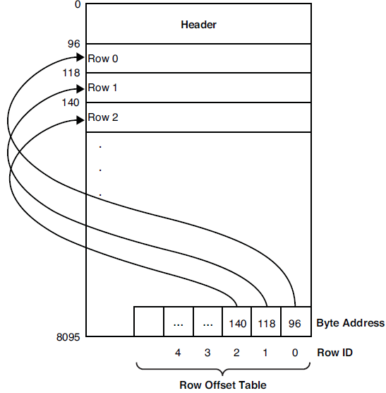
- --(96)header
- SELECT 96
- --(8192)Total bytes
- SELECT 8*1024
- --(8096)Total bytes - header bytes
- SELECT 8*1024-96
- --(8060)Total bytes - header bytes - 36 bytes(logging information)
- --maximum in-row data row size
- SELECT 8*1024-96-36

- The Data Rows
For a table that has all fixed-length, non-nullable columns, the size of the row and the number of rows that can be stored on a page are always the same. If the table has any variable or nullable fields, the number of rows stored on the page depends on the size of each row. Because each data row also incurs some overhead bytes in addition to the actual data, the maximum amount of actual data that can be stored in a single row on a page is slightly less than 8,060 bytes.
If the table contains variable-length or nullable columns, you can create a table for which the minimum row size is less than 8,060 bytes, but the data rows could conceivably exceed 8,060 bytes. SQL Server allows the table to be created. If you then try to insert a row that exceeds 8,060 bytes of data and overhead, the data that exceeds the 8,060-byte limit for in-row data is stored in a row-overflow page.
- --If you attempt to create a table with a minimum row size including data and row overhead that exceeds 8,060 bytes, you receive an error message
- CREATE TABLE customer_info2
- (
- cust_no INT,
- cust_address NCHAR(25),
- info NCHAR(4000)
- )
- go

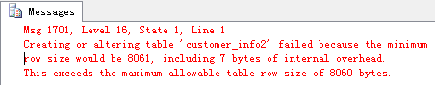

- The Structure of Data Rows
The data for all fixed-length data fields in a table is stored at the beginning of the row. All variable-length data columns are stored after the fixedlength data. Seven bytes of overhead is the minimum for any data row
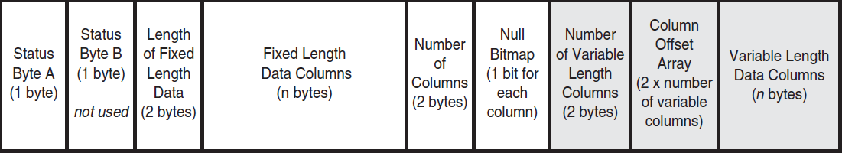

- The row offset table
The location of a row within a page is identified by the row offset table, which is located at the end of the page. Each entry in the row offset table is 2 bytes in size, so for each row in a table, an additional 2 bytes of space is added in from the end of the page for the row offset entry. The row offset table keeps track of the logical order of rows on a data page. If a table has a clustered index defined on it, the data rows are stored in clustered index order. However, they may not be physically stored in clustered key order on the page itself. Instead, the row offset array indicates the logical clustered key order of the data rows. For example, row offset slot 0 refers to the first row in the clustered index key order, slot 1 refers to the second row, slot 2 refers to the third row, and so on. The physical location of the rows on the page may be in any order, depending on when rows on the page were inserted or deleted.

7.2.2 Row-Overflow pages
While the maximum in-row size is 8,060 bytes per row, SQL Server 2008 allows actual rows to exceed this size for tables that contain varchar, nvarchar, varbinary, sql_variant, or common language runtime (CLR) user-defined type columns. Although the length of each one of these columns must still fall within the limit of 8,000 bytes, the combined width of the row can exceed the 8,060-byte limit. SQL Server moves the record column with the largest width to another page in the ROW_OVERFLOW_DATA allocation unit, while maintaining a 24-byte pointer to the row-overflow page on the original page.
Moving large records to another page occurs dynamically as records are lengthened based on update operations. Update operations that shorten records may cause records to be moved back to the original page in the IN_ROW_DATA allocation unit.

- --(8092)Total bytes per page
- SELECT 8*1024
- --(192)pointer to the original Data Row page type
- SELECT 24*8
- --(8000)the maximum bytes for use per Row-Overflow page type
- SELECT (8*1024)-(24*8)

If there are likely to be frequent queries on many rows of row-overflow data, you should consider normalizing the table so that some columns are moved to another table, reducing the overall row size so that the rows fit within 8,060 bytes. The data can then be recombined in a query using an asynchronous JOIN operation.

7.2.3 LOB data pages
If you want to store large amounts of text or binary data, you can use the text, ntext, and image data types, as well as the varchar(max), nvarchar(max), and varbinary(max) data types. The LOB values are not stored as part of the data row, but as a collection of pages on their own. For each LOB column, the data page contains a 16-byte pointer, which points to the location of the initial page of the LOB data. A row with several LOB columns has one pointer for each column.

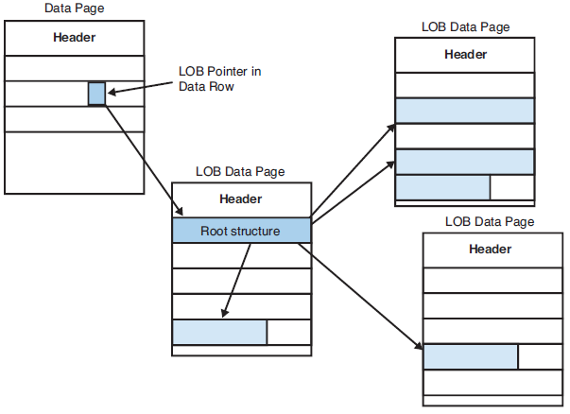

- Storing LOB Data in the Data Row
You should keep in mind that just because this option is enabled it doesn’t always mean that the LOB data will be stored in the row. All other data columns that are not LOB take priority over LOB data for storage in the data row.
- exec sp_tableoption customer_info, 'text in row', 512
- GO

- Storage of MAX data
An alternative to the text and image data types in SQL Server 2008 is the option of defining variable-length data using the MAX specifier. If the actual length is less than 8,000 bytes, SQL Server treats it as if it were one of the regular variable-length data types, including using row-overflow pages if necessary. If the MAX column exceeds 8,000 bytes, it is stored like LOB data.

7.2.1 Index pages
The actual information stored in an index page
- A leaf-level clustered index page is the data page itself; you’ve already seen its structure. The information stored on other index pages is as follows:
- Clustered indexes, nonleaf pages—Each index row contains the index key and a pointer (the fileId and a page address) to a page in the index tree at the next lower level.
- Nonclustered index, nonleaf pages—Each index row contains the index key and a page-down pointer (the file ID and a page address) to a page in the index tree at the next lower level. For nonunique indexes, the nonleaf row also contains the row locator information for the corresponding data row.
- Nonclustered index, leaf pages—Rows on this level contain an index key and a reference to a data row. For heap tables, this is the Row ID; for clustered tables, this is the clustered key for the corresponding data row.

7.3 Space Allocation Structures

7.3.1 Extents
When a table or index is created, it is initially allocated a page on a mixed extent. If no mixed extents are available in the database, a new mixed extent is allocated. A mixed extent can be shared by up to eight objects (each page in the extent can be assigned to a different table or index).
As the table grows to at least eight pages in size, all future allocations to the table are done as uniform extents.
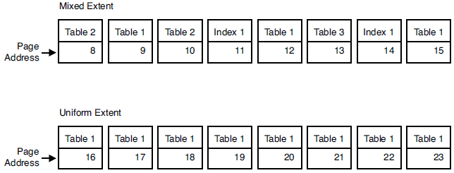

7.3.2 Global and Shared Global Allocation Map Pages
SQL Server uses two special types of pages to record which extents have been allocated to tables or indexes and whether it is a mixed or uniform extent:
- Global allocation map (GAM)—Nearly 8,000 bytes (64,000 bits) are available in a GAM page after the header and other overhead bytes are taken into account. Therefore, a single GAM covers approximately 64,000 extents, or 4GB (64,000 * 64KB) of data.
- Shared global allocation map (SGAM)—The SGAM keeps track of mixed extents that have free space available. An SGAM has a structure similar to a GAM, with each bit representing an extent.
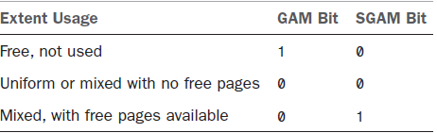
SQL Server is able to easily locate GAM pages in a database because the first GAM page is located at the third page in the file (page number 2). There is another GAM every 511,230 pages after the first GAM. The fourth page (page number 3) in each database file is the SGAM page, and there is another SGAM each 511,230 pages after the first SGAM.

7.3.3 Page free space pages
A page free space (PFS) page records whether each page is allocated and the amount of free space available on the page. The first PFS page in a file is located at page number 1, the second PFS page is located at page 8088, and each additional PFS page is located every 8,088 pages after that. SQL Server uses PFS pages to find free pages on extents and to find pages with space available on extents when a new row needs to be added to a table or index.
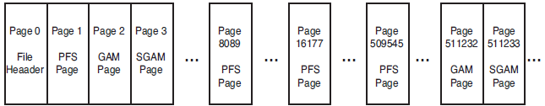

7.3.4 Differential Changed Map Pages
This page keeps track of which extents in a file have been modified since the last full database backup. Using the DCM, SQL Server can quickly tell which extents need to be backed up by examining the bits on the DCM pages for each data file in the database. When a full backup is performed for the database, all the bits are set back to 0.

7.3.5 Bulk Changed Map Pages
In BULK_LOGGED recovery mode, SQL Server logs only the fact that the operation occurred and doesn’t log the actual data changes. The operation is still fully recoverable because SQL Server keeps track of what extents were actually modified by the bulk operation in the BCM page. All the bits on the BCM page are reset to 0 whenever a full database backup or log backup occurs.

7.4 Data compression
Data compression helps to reduce both storage and memory requirements as the data is compressed both on disk and when brought into the SQL Server data cache.
- ALTER TABLE customer_info REBUILD WITH (DATA_COMPRESSION=ROW)
- ALTER TABLE customer_info REBUILD WITH (DATA_COMPRESSION=PAGE)

Chapter 8 Indexes and Performance

8.1 Understanding table/index structures
A table is contained in one or more partitions. The partitions can be placed in one or more filegroups in the database. The table is treated as a single logical entity when queries or updates are performed on the data.
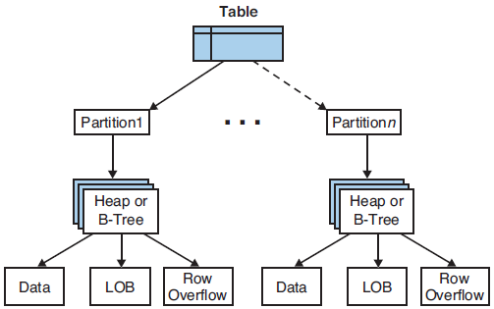
- SELECT convert(varchar(15), o.name) AS table_name,
- p.index_id as indid,
- convert(varchar(30), i.name) AS index_name ,
- convert(varchar(18), au.type_desc) AS allocation_type,
- au.data_pages as d_pgs,
- partition_number as ptn
- FROM sys.allocation_units AS au
- JOIN sys.partitions AS p ON au.container_id = p.partition_id
- JOIN sys.objects AS o ON p.object_id = o.object_id
- JOIN sys.indexes AS i ON p.index_id = i.index_id AND i.object_id = p.object_id
- WHERE o.name = N'customer_info'
- ORDER BY o.name, p.index_id;

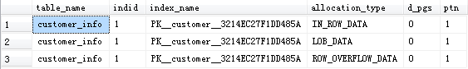

8.1.1 Heap tables
The data pages and rows in the heap are not sorted in any specific order and are not linked. The IAM page registers which extents are used by the table. SQL Server can then simply scan the allocated extents referenced by the IAM page, in physical order.
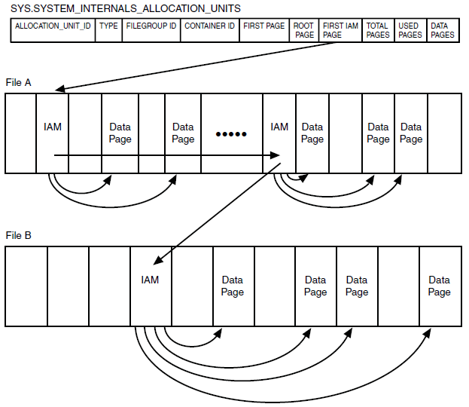
- select p.partition_number as ptn,
- type_desc,
- filegroup_id,
- first_iam_page
- from sys.system_internals_allocation_units i
- inner join sys.partitions p
- on p.hobt_id = i.container_id
- where p.object_id = OBJECT_ID('customer_info')
- go

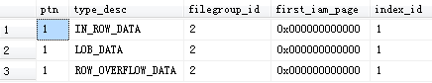

8.1.2 Clustered tables
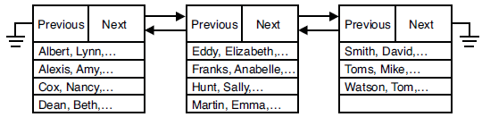

8.1.3 Clustered indexes
Indexes are used to speed up access to the data; they are also the mechanism used to enforce the uniqueness of key values.
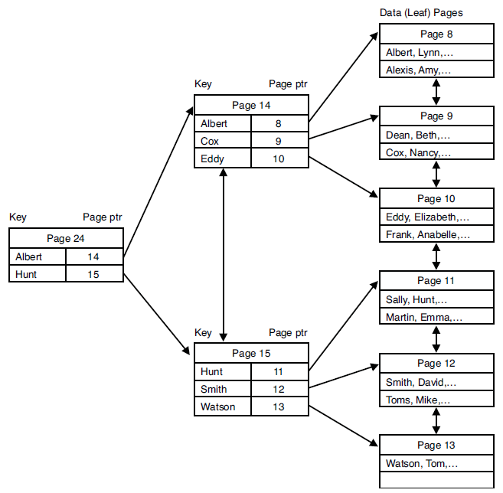

8.1.4 Non-clustered indexes
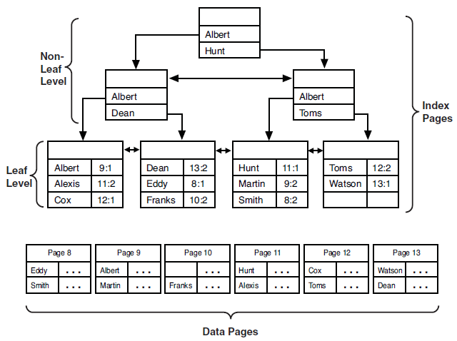
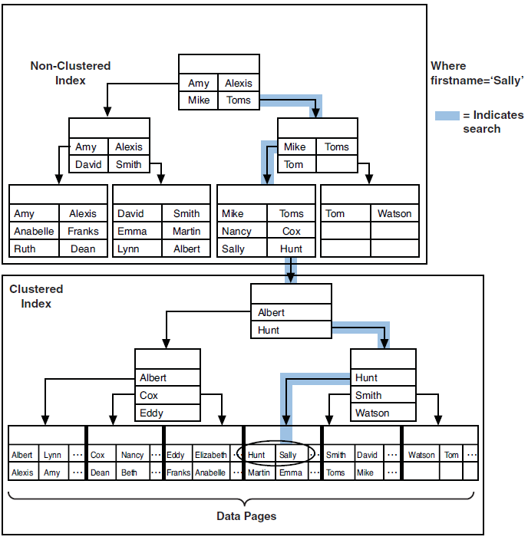

8.2 Index statistics
SQL Server does not use an index for the more efficient row locator lookup if at least the first column of the index is not included in a valid search argument (SARG) or join clause.
- create index nc1_stores on customer_info (ID, cust_no, cust_address)

Although both seeks and scans use an index, the index scan is still more expensive in terms of I/O than an index seek but slightly less expensive than a table scan,

8.2.1 Evaluating index usefulness
Selectivity ratio = Number of unique index values / Number of rows in table

If the selectivity ratio is high—that is, if a large number of rows can be uniquely identified by the key—the index is highly selective and useful to the Query Optimizer. If the selectivity ratio for a nonclustered index key is less than 0.85 , the Query Optimizer generally chooses a table scan to process the query rather than a nonclustered index.
- select count(distinct DCNAMECHS) as '# unique',
- count(*) as '# rows',
- str(count(distinct DCNAMECHS) / cast (count(*) as real),4,2) as 'selectivity'
- from CSEMPL_1
- go
- –-Calculate the selectivity of one column
- select RESADD,
- count(*) as numrows,
- count(*)/b.totalrows * 100 as percentage
- from CSEMPL_1 a,
- (
- select convert(numeric(6,2), count(*)) as totalrows
- from CSEMPL_1
- ) as b
- group by RESADD, b.totalrows
- having count(*) >= 1
- order by 2 desc
- go

- --Index statistics
- DBCC SHOW_STATISTICS (CSEMPL_1, CSEMPL_1_DCNO)

8.2.2 Identifying missing/unused indexes
- SELECT
- mig.index_group_handle as handle,
- convert(varchar(30), statement) AS table_name,
- convert(varchar(12), column_name) AS Column_name,
- convert(varchar(10), column_usage) as ColumnUsage,
- avg_user_impact as avg_impact
- FROM sys.dm_db_missing_index_details AS mid
- CROSS APPLY sys.dm_db_missing_index_columns (mid.index_handle)
- INNER JOIN sys.dm_db_missing_index_groups AS mig
- ON mig.index_handle = mid.index_handle
- inner join sys.dm_db_missing_index_group_stats AS migs
- ON migs.group_handle = mig.index_group_handle
- where mid.object_id = object_id('CSEMPL_1')
- --and last_user_seek between '2010-02-21 22:30' and '2010-02-21 22:40'
- ORDER BY mig.index_group_handle, mig.index_handle, column_id;
- GO

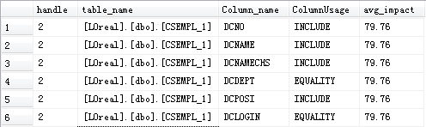
- --
- SELECT convert(varchar(12), OBJECT_SCHEMA_NAME(I.OBJECT_ID)) AS SchemaName,
- convert(varchar(20), OBJECT_NAME(I.OBJECT_ID)) AS ObjectName,
- convert(varchar(30), I.NAME) AS IndexName
- FROM sys.indexes I
- WHERE -- only get indexes for user created tables
- OBJECTPROPERTY(I.OBJECT_ID, 'IsUserTable') = 1
- ignore heaps
- and I.index_id > 0
- find all indexes that exist but are NOT used
- AND NOT EXISTS (
- SELECT index_id
- FROM sys.dm_db_index_usage_stats
- WHERE OBJECT_ID = I.OBJECT_ID
- AND I.index_id = index_id
- AND database_id = DB_ID())
- ORDER BY SchemaName, ObjectName, IndexName

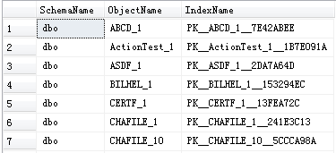

8.3 Index design guidelines
- For composite indexes, try to keep the more selective columns leftmost in the index.
- Be sure to index columns used in joins.
- Tailor your indexes for your most critical queries and transactions.
- Avoid indexes on columns that have poor selectivity.
- Choose your clustered and nonclustered indexes carefully.

8.3.2 Clustered index indications
Searching for rows via a clustered index is almost always faster than searching for rows via a nonclustered index a clustered index contains only pointers to pages rather than pointers to individual data rows; searching for duplicate values or for a range of clustered key values is faster;
In most applications, the primary key column on a table is almost always retrieved in single-row lookups. For single-row lookups, a nonclustered index usually costs you only a few more I/Os than a similar clustered index. However, if you have to perform a range retrieval, such as a lookup on last name, will you notice a difference between scanning 10% of the table versus having to find the rows using a full table scan? You might want to consider creating your primary key as a unique nonclustered index and choosing another candidate for your clustered index.

- Potential candidates for clustered indexes:
- Columns with a number of duplicate values searched frequently
- Columns often specified in the ORDER BY clause
- Columns often searched for within a range of values
- Columns, other than the primary key, frequently used in join clauses
- Keep your clustered indexes on relatively static columns to minimize the re-sorting of data rows when an indexed column is updated.
- You should also avoid creating clustered indexes on wide keys that are made up of several columns, Because the nonclustered index entries contain the clustering key in addition to the key columns defined for that nonclustered index,

8.3.3 Non-clustered index indications
You typically want to define indexes on columns that are more selective (that is, columns with low density values)
- Potential candidates for non-clustered indexes:
- Columns referenced in SARGs or join clauses that have a relatively high selectivity
- Columns referenced in both the WHERE clause and the ORDER BY clause. When the data rows are retrieved using a nonclustered index, they are retrieved in nonclustered index key order.

8.3.4 Index covering
Index covering is a situation in which all the information required by the query in the SELECT and WHERE clauses can be found entirely within the nonclustered index itself. Because the leaf pages in a nonclustered index are linked together, the leaf level of the index can be scanned just like the data pages in a table. Because the leaf index rows are typically much smaller than the data rows, a nonclustered index that covers a query will be faster than a clustered index on the same columns because fewer pages would need to be read.

- In the following example, a nonclustered index on the au_lname and au_fname columns of the authors table would cover the query

- Select au_lname, au_fname
- From authors
- Where au_lname like 'M%'
- Go
- select count(au_lname) from authors where au_lname like 'M%'
- select count(*) from authors where au_lname like 'M%'
- select count(*) from authors
- --For the last query, SQL Server chooses the smallest nonclustered index—that is, the one with the smallest number of leaf pages.

- Assume that the authors table has a clustered index on au_lname and au_fname and a nonclustered primary key defined on au_id. Each row in the nonclustered index on au_id would contain the clustered key values for au_lname and au_fname for its corresponding data row.

- select au_lname, au_fname
- from authors
- where au_id like '123%'

8.3.5 Included columns
Included columns allow you to add nonkey columns to the leaf level of a nonclustered index for the purpose of index covering.
- CREATE INDEX NC_titles_price on titles (price) INCLUDE (royalty)

8.3.6 Filtered Indexes and Statistics
- Following are some of the situations in which filtered indexes can be useful:
- When a column contains mostly NULL values, but your queries search only for rows where data values are NOT NULL.
- When a column contains a large number of duplicate values, but your queries typically ignore those values and search only for the more unique values.
- When you want to enforce uniqueness on a subset of values
- When queries retrieve only a particular range of data values and you want to index these values but not the entire table.

- create index ord_date_filt on CSEMPL_1 (HIRDAT)
- where HIRDAT >= '2014-11-13 00:00:00.000'
- SELECT * FROM CSEMPL_1 WHERE HIRDAT='2015-10-13 00:00:00.000'

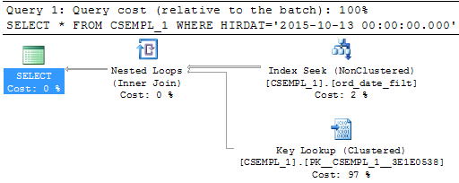
- SELECT * FROM CSEMPL_1 WHERE HIRDAT='2011-10-13 00:00:00.000'

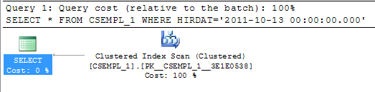
- SELECT HIRDAT FROM CSEMPL_1 WHERE HIRDAT='2015-10-13 00:00:00.000'

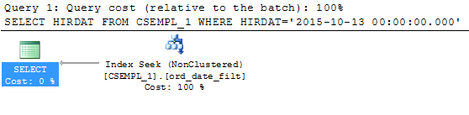

Chapter 9 Understanding Query Optimization
- Optimization Steps
- Query analysis
- Row estimation and index selection
- Join selection
- Execution plan selection

9.1 Row Estimation and Index Selection

9.1.1 Evaluating SARG and Join Selectivity
More often than not, an inequality SARG will result in a table or clustered index scan. You should try to avoid using inequality SARGs whenever possible.
- --This query gets the correct result set but ends up having to do so with a full table or index scan
- select distinct stor_id
- from sales
- where datepart(month, ord_date) = 6
- --you could create a computed column on the function and index it as follows: the Query Optimizer can use the index on the computed column to accurately estimate the number of matching rows and possibly use the nonclustered index to find the matching rows and avoid a table scan,
- alter table sales add ord_month as datepart(month, ord_date)
- create index nc_sales_ordmonth on sales(ord_month)

9.1.2 Estimating Access Path Cost
- Clustered index cost

- --For a unique clustered index and an equality operator, the logical I/O cost estimate is one data page plus the number of index levels that need to be traversed to access the data page.
- SELECT * FROM CSEMPL_1 WHERE VGUID='3A91351A-D45A-4064-A500-004A09E66CA7'

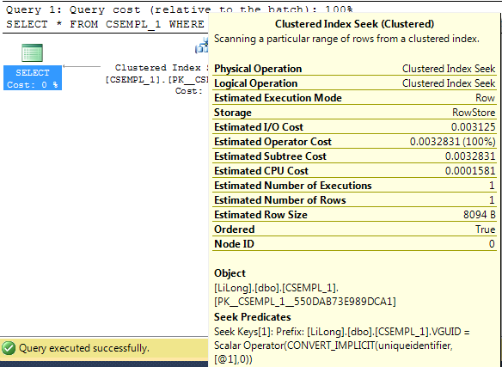

- Non-clustered index cost
- --For a heap table, the nonclustered row bookmark is the page and row pointer (the row ID [RID]) to the actual data row.
- DROP INDEX IndexClustered_CSEMPL_1_Test_DCOPSI ON CSEMPL_1_Test
- SP_HELP CSEMPL_1_Test
- CREATE NONCLUSTERED INDEX IndexNonClustered_CSEMPL_1_Test_DCOPSI ON CSEMPL_1_Test(DCPOSI)
- SELECT * FROM CSEMPL_1_Test WHERE DCPOSI='AA64E5F6-6981-45CE-AE71-0DC1093FBFAE'

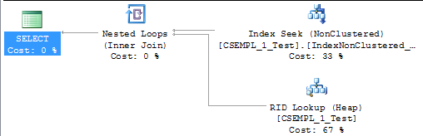
- --If the table is clustered, the row bookmark is the clustered key for the data row.
- CREATE CLUSTERED INDEX IndexClustered_CSEMPL_1_Test_DCNO ON CSEMPL_1_Test(DCNO)
- SELECT * FROM CSEMPL_1_Test WHERE DCPOSI='AA64E5F6-6981-45CE-AE71-0DC1093FBFAE'

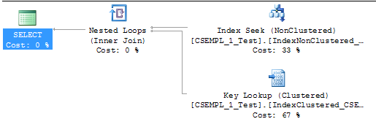

- Covering non-clustered index cost

- SELECT DCNO FROM CSEMPL_1_Test

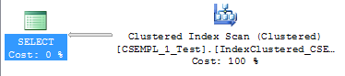
- CREATE NONCLUSTERED INDEX IndexNonClustered_CSEMPL_1_Test_DCOPSI ON CSEMPL_1_Test(DCPOSI) INCLUDE (DCNO)
- SELECT DCNO FROM CSEMPL_1_Test

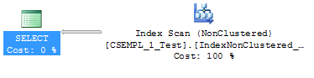

- Table scan cost

- SELECT COUNT(*) FROM CSEMPL_1_Test

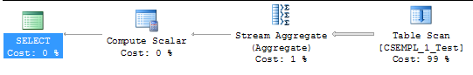

9.1.3 Using multiple indexes
- Index intersection

- --Methods of retrieve the result set
- --A table scan
- --A standard data row retrieval via the nonclustered index on DCPOSI
- --A standard data row retrieval via the nonclustered index on DCDEPT
- --The index intersection
- SELECT * INTO CSEMPL_1_Test FROM CSEMPL_1
- CREATE CLUSTERED INDEX IndexClustered_CSEMPL_1_Test_VGUID ON CSEMPL_1_Test(VGUID)
- CREATE INDEX IndexNonClustered_CSEMPL_1_Test_DCPOSI ON CSEMPL_1_Test(DCPOSI)
- CREATE INDEX IndexNonClustered_CSEMPL_1_Test_DCDEPT ON CSEMPL_1_Test(DCDEPT)
- GO
- SELECT *
- FROM CSEMPL_1_Test
- WHERE DCPOSI='7C274EF7-A486-4E79-BEB5-E88B1ABC529F'
- AND DCDEPT='8C321437-CFEE-4F82-A76C-65EC8D1230AE'
- GO

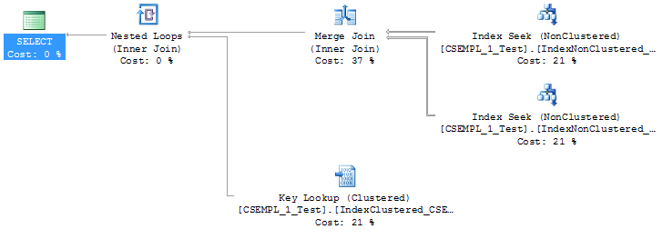
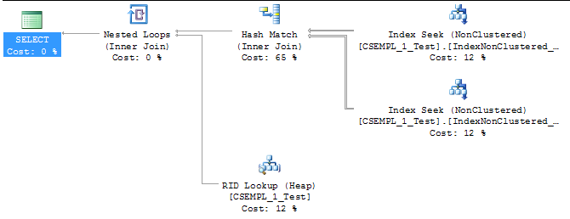

- The Index Union Strategy
- DROP INDEX IndexClustered_CSEMPL_1_Test_VGUID ON CSEMPL_1_Test
- SELECT *
- FROM CSEMPL_1_Test
- WHERE DCPOSI='7C274EF7-A486-4E79-BEB5-E88B1ABC529F'
- OR DCDEPT='8C321437-CFEE-4F82-A76C-65EC8D1230AE'
- GO

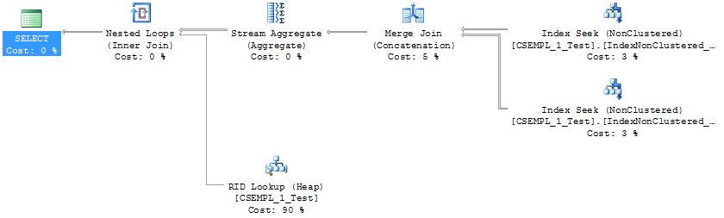

- Index joins

- SELECT DCPOSI, DCDEPT
- FROM CSEMPL_1_Test
- WHERE DCPOSI='7C274EF7-A486-4E79-BEB5-E88B1ABC529F'
- AND DCDEPT='8C321437-CFEE-4F82-A76C-65EC8D1230AE'

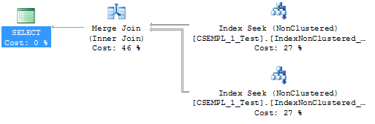

9.2 Join selection

9.2.1 Join Processing Strategies
- Nested loops joins

- SELECT B.em_No
- FROM CSEMPL_1 AS A
- INNER JOIN KQRSSZ_1 AS B ON A.DCNO=B.EM_NO
- WHERE A.DCNO='0007'

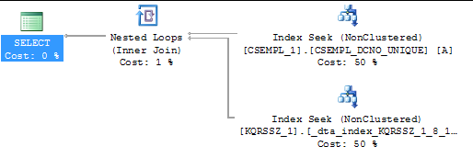

- Merge joins

- SELECT *
- FROM CSEMPL_1_Test AS A
- INNER JOIN KQRSSZ_1_Test AS B ON A.DCNO=B.EM_NO

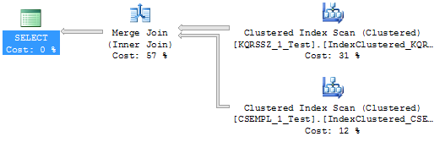

- Hash join

- SELECT *
- FROM CSEMPL_1_Test AS A
- INNER JOIN KQRSSZ_1_Test AS B ON A.DCNO=B.EM_NO
- WHERE A.DCNAME='Jenny Xue'

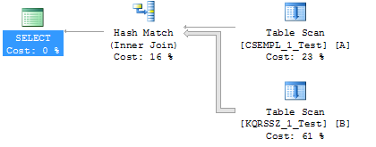

9.2.2 Determining the Optimal Join Order
- SELECT A.DCNO, A.VGUID
- FROM CSEMPL_1 AS A
- INNER JOIN CSEMPL_12 AS B ON A.VGUID=B.VGUID
- INNER JOIN KQRSSZ_1 AS C ON A.DCNO=C.em_No
- WHERE A.DCNO='10115'

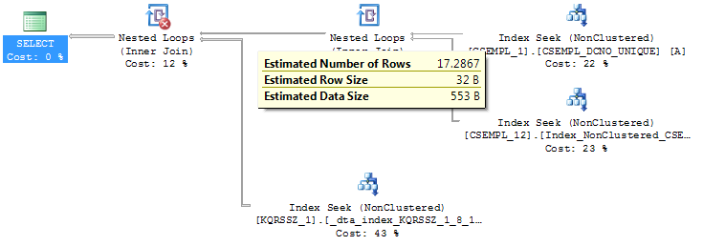

9.2.3 Subquery processing
- select A.DCNO
- from CSEMPL_1 AS A
- where exists
- (
select 1
from KQRSSZ_1 AS B
where YMONTH = '1506'
and A.DCNO=B.EM_NO
- )
- --
- select A.DCNO
- from CSEMPL_1 AS A
- where DCNO in
- (
select EM_NO
from KQRSSZ_1
where YMONTH = '1506'
- )

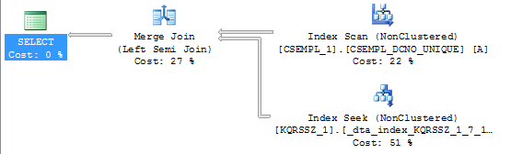
- select A.DCNO
- from CSEMPL_1 AS A
- where DCNO =
- (
- SELECT MAX(EM_NO) FROM KQRSSZ_1
- )

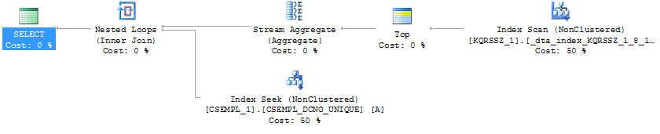
- select A.DCNO
- from CSEMPL_1 AS A
- where DCNO =
- (
SELECT MAX(DCNO) FROM CSEMPL_1
- )

