# Anatomy of an App

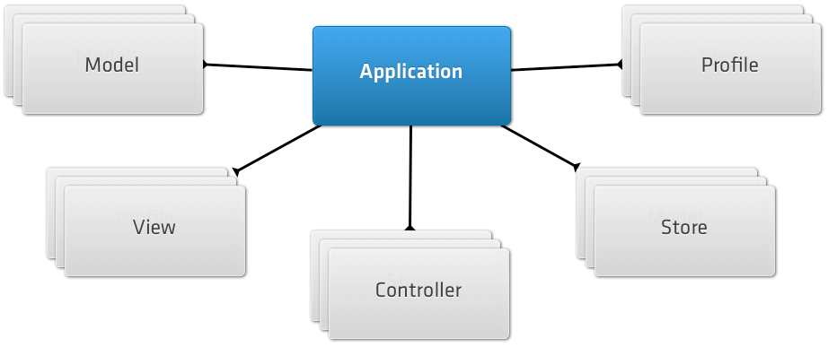

[Ext.application](http://docs.sencha.com/touch/2.3.1/#!/api/Ext-method-application)({

name: 'MyApp',

models: ['User', 'Product', 'nested.Order'],

views: ['OrderList', 'OrderDetail', 'Main'],

controllers: ['Orders'],

launch: function() {

[Ext.create](http://docs.sencha.com/touch/2.3.1/#!/api/Ext-method-create)('MyApp.view.Main');

}

});

The **name** is used to create a single global namespace for your entire app, including all of its models, views, controllers, and other classes. This keeps the entire app under a single global variable, thus minimizing the chance of other code on the same page conflicting with it

The app uses the defined models, views and controllers configurations to automatically load these classes into your app. The classes follow a simple file structure convention - models are expected to be in the app/model directory, controllers in the app/controller directory and views inside the app/view directory - for example app/model/User.js, app/controllers/Orders.js and app/view/Main.js.

Note that one of the models we previously specified is different than the others, in the sense that we specified its full class name ("MyApp.model.nested.Order").