
Functional Requirements Document
Margin Parameters

Saurabh Dubey
2/18/2011 1:32:00 PM

Contents
1. Document Change Control 3
1.1 Document history 3
1.2 Approval Form for Functional Requirements Document (FRD) 3
1.3 Functional Requirements Guidelines 4
1.4 Document References 4
2. Introduction 4
2.1 Background / Business Problem 4
2.2 Project Scope 4
2.3 Document Scope 4
2.4 Document Structure 5
2.5 Project Governance 5
2.5.1 On-Line Project RACI 5
2.5.2 BEN Project Details 5
2.5.3 Project Updates 5
2.6 User Groups Impacted 5
2.7 Assumptions 6
2.8 Dependencies and Risk 6
3. The Current vs. Future Processing Environment 6
3.1 Current State 6
3.1.1 Current State Diagram 7
3.1.2 Current State GUI 7
3.1.2.1 Credit Profile GUI 7
3.1.2.2 Discount Set GUI 8
3.1.2.3 Customized Rules Editor 9
3.2 Future State 10
3.2.1 Future State Diagram 11
4. Functional Requirements Summary 12
4.1 Margin Profile Page 12
4.1.1 Accessing the Page 12
4.1.2 Entitlements 12
4.1.3 UC 1 -Create a new Margin Profile or Modify an existing Margin Profile 12
5. User Interface Specifications 14
5.1 Asset Class Templates 14
5.1.1 Equities 14
5.1.1.1 Base Rates 15
5.1.1.2 Liquidity 17
5.1.1.3 Concentration 18
5.1.1.4 Emerging Market 19
5.1.1.5 Volatility 20
5.1.1.6 Top N 21
5.1.2 Equity Pairs 22
5.1.2.1 General 23
5.1.2.2 Sector Pairs 24
5.1.2.3 Liquidity 24
5.1.2.4 Concentration 25
5.1.2.5 Cash Buyouts Concentration 26
5.1.2.6 EM Mergers/Buyouts Concentration 26
5.1.3 Equity Options 27
5.1.3.1 Standard Methodology > Diversification Benefit 28
5.1.3.2 Standard Methodology > Low Vol Scenario 29
5.1.3.3 Standard Methodology > High Vol Scenario 30
5.1.3.4 VolArb Methodology > Liquidity Multiplier 31
5.1.3.5 VolArb Methodology > Underliers 32
5.1.3.6 VolArb Methodology > Sector Scenarios 32
5.1.3.7 VolArb Methodology > Correlation Scenarios 33
5.1.3.8 VolArb Methodology > Low Vol Single Name Scenarios 34
5.1.3.9 VolArb Methodology > Low Vol Single Name Scenarios 35
5.1.4 Convertibles 37
5.1.4.1 Base Rates 38
5.1.4.2 Liquidity 39
5.1.4.3 Concentration 39
5.1.4.4 Asset Strips 40

Document Change Control

Document history
Version | Change Description | Author | Date Released
0.1 | Initial | Saurabh Dubey | 18 Jan 2011
0.2 | Adding future BOW | Saurabh Dubey | 24 Jan 2011

Approval Form for Functional Requirements Document (FRD)
Role | Print/Type Name | Print/Type Name | Sign Off
GPF IT BA | Saurabh Dubey
GPF IT BA Peer Reviewer | Simon Connor
GPF Risk IT | Nandan K, Jilei Y, Ron F
GPF Risk | Joel Pitkin
GPF UX | Michael Quon

Functional Requirements Guidelines
- Requested Delivery Date: Equities by end of Q1 2011
- Draft or Final Version #:
- Approvals via email will be stated as such under Signed Off column in section 1.2
- Above list of people will also approve the deployment of the system into production

Document References
Documents below, related to the current initiative, have been created prior to or in conjunction with the Functional Requirements document and can be
Name | Date | Version |  | Author | Location

Introduction

Background / Business Problem
The current process to setup a credit profile of a Legal Entity, Child Account or Group of Group is quite cumbersome and involves 3 groups at times - Risk, Transition and DBX Support. The biggest areas which require an improvement is the ability to setup custom and discount sets. The process for setting up a client’s credit profile has evolved over the years into a patch work of screens and tactically focused functionality. This credit profile is used by DBX and DBX2 ROR engines to calculate the entities margin requirements.
The Primary benefit for this project is an operational efficiency in setting up a clients risk profile. It is approximated that it takes about 30 – 45 minutes to setup a profile and involve various groups.
The goal is to streamline the process by not only making the GUI more useable but to also reboot the way margin parameters are defined.

Project Scope
Primary goals of this project are:
- Improve & streamline the credit profile setup process
- Redefine the way the margin parameters for the credit profile are setup

Document Scope
The current scope of this document is limited to the identified functional requirements for
Balanced L/S, Strategy:
- Provide Risk the ability set the margin parameters for an entity.
- Provide Risk the ability to customize margin parameters for client with a Balanced L/S Strategy but still use the legacy functionality for the other products.
- Provide DBX IT the mapping requirements for Balanced L/S between the old margin parameters (Margin Tier, Margin Calculation Type, Discount Set and Custom set) and the new parameters.
- Provide Risk the ability to see which entities are mapped to the new margin parameters.
- Provide users with audit trails.
Each section in the functional requirements section has a table labeled as the Scope identifying the exact deliverable for the development teams involved.

The following are out of scope for this document:
- Other strategy’s covered in DBX
- Integration of new margin parameters with DBX ROR (Pearl)

Document Structure
This document includes the functional requirements for CDS & CDS Intermediation Phase I and it is intended for the following groups: Business users and Development Teams.

The functional requirements were gathered and documented by the BA Team.

It is to be distributed to the users for sign-off and to be used by the developers the requested functionality.

The document is structured into 3 main parts, Current Vs Future high level overview. Then it is followed by detailed functional requirements for the future state and finally non functional requirements required by the GPF Business sponsors.

The document tries to contain the functional requirements by systems involved so that development teams have a clear understanding of expected deliveries.

Project Governance
Please refer to the RACI matrix below, which depicts the members of GPF Business, IT and PDG who should be Responsible, Accountable, Consulted or Informed for each task within the different phases of this project.

A weekly meeting has been setup to review the progress and work for this project.

On-Line Project RACI
The following link provides the RACI Matrix for this project and can be used to identify key stakeholders of the Phase 1 initiatives.
https://sharepoint.de.intranet.db.com/site0095/MARS/DBX-Margin/default.aspx

BEN Project Details
A request has been made to the GPF COO team for a BEN Project setup, once done the link will be added into this section.

Project Updates
Project updates will be given to key stakeholders on a weekly basis, details will be posted on the project sharepoint site.

User Groups Impacted
The primary users impacted by this initiative are listed below:
User Group | Location | Role
GPF Risk | All (NY, London, APAC)
GPF Transition | All (NY, London, APAC)

Assumptions
The following lists the assumption used in writing the functional requirements for this project.
- Implementation of Strategy’s will be done in a phased manner
- New Margin Parameters will integrate with DBX 2 only

Dependencies and Risk
Once the BEN report has been added in all dependencies and risks will be tracked through it and a link will be placed in this section.
At the moment no major risk are present for the project.

The Current vs. Future Processing Environment

Current State
The current process to setup an entities’ (legal entity, child account or group of group) margin profile involves a four step process i.e. an entity must be assigned a margin tier, margin calculation type, discount set and customized margin rule.
- Margin Tier – This defines the base rates to be used for that entity
- Margin Calculation Type – This defines the margin methodology or rules to be used by the margin ROR engine
- Discount Set – This allows a user to further customize by strategy the rates defined by the margin tier
- Customized Margin Rule – This acts as a set of switches or instructions for the margin ROR engine and instructs the engine to process certain conditions in a certain way
These 4 steps instruct the margin engine on how to calculate the margin calculations. This profile is part of setting up the client’s credit profile and is usually setup when on-boarding a client by either transition support or risk. Modifications to the margin profile occur due to changes in the client’s credit profile.

Issues with the current process:
- Process too fragmented
- GUI quite rudimentary and cumbersome to use
- No audit capabilities
- Over complicated process

Current State Diagram
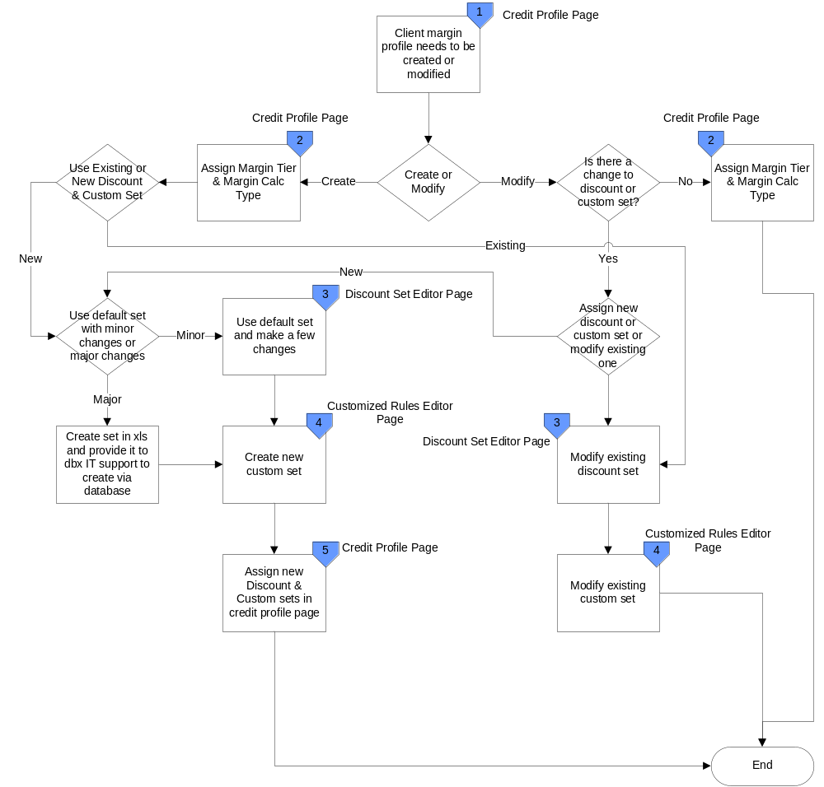

Current State GUI

Credit Profile GUI
Setting up the margin profile by going into the credit profile page, the key 4 drop downs used for the defining the margin profile are marked in the red squares.
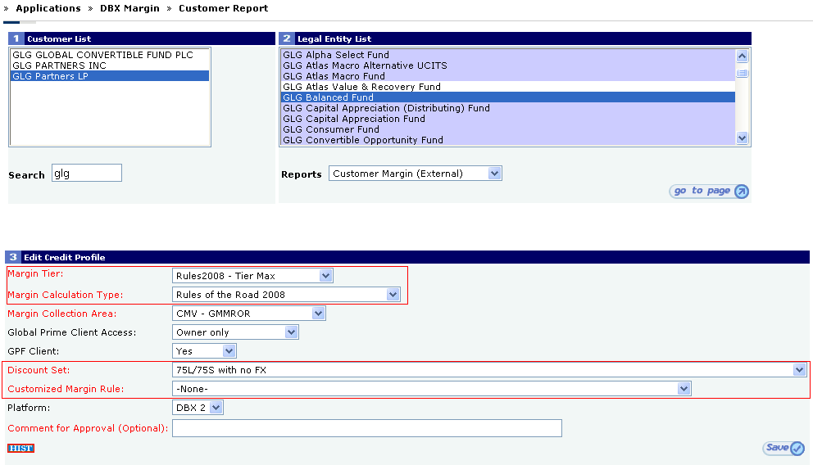

Discount Set GUI
User can either select to modify an existing discount set by selecting a choice in the edit drop down and hitting display or can create a new one by typing the name in the create box and hitting display.

Issues with this GUI:
- No way to clone an existing set
- No way to modify the name of an existing set
- No way to see which entities use a particular set
- No audit trail on who created the set

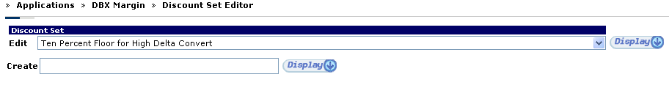
Once the display button is pressed a user will be presented the discount set form which is used to either modify existing rates or modify the default rates which the system assigns.

Issues with this GUI:
- The list gives a complete list of all strategies even the ones which aren’t used
- No validation rules for lower bounds, upper bounds and discount rates
- No way to enter comments on why certain rates were applied
- No way to add new lower and upper bounds without supports help
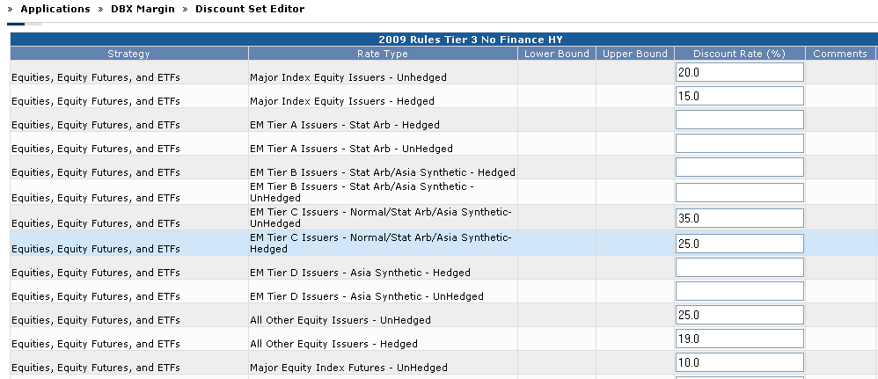

Customized Rules Editor
User can either select to modify an existing customized rules set by selecting a choice in the edit drop down and hitting display or can create a new one by typing the name in the create box and hitting display. This functionality is very similar to the way discount sets are modified and created.

Issues with this GUI:
- No way to clone an existing set
- No way to modify the name of an existing set
- No way to see which entities use a particular set
- No audit trail on who created the set

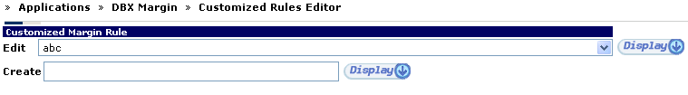
Once the display button is pressed a user will be presented the rules set form which is list of check boxes that act as flags for the margin engine to use to perform certain rules.
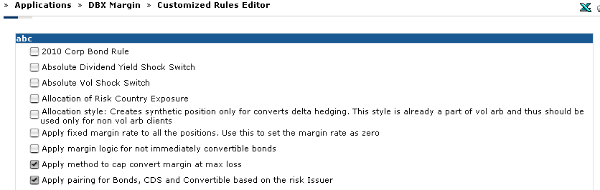

Future State
The future is envisioned to be not as cumbersome as the current, the approach is to consolidate the various screens and steps into a single screen to be termed as Margin Profile which will encompass functionality from the Credit Profile Page, Discount Set Editor & Customized Rules Editor.
A user will be able to select what strategy a client will trade in and based on that define
- Applicable Margin Tier
- What calculation methodology to use
- What rates and flags to apply
Users will also be given addition functionality to see audit trails for changes, assigned entities to a particular margin profile and the ability to enter additional bands for existing rate types. Users will also be given the ability to compare different profiles and clone existing profiles to speed up the margin profile setup process.

Future State Diagram
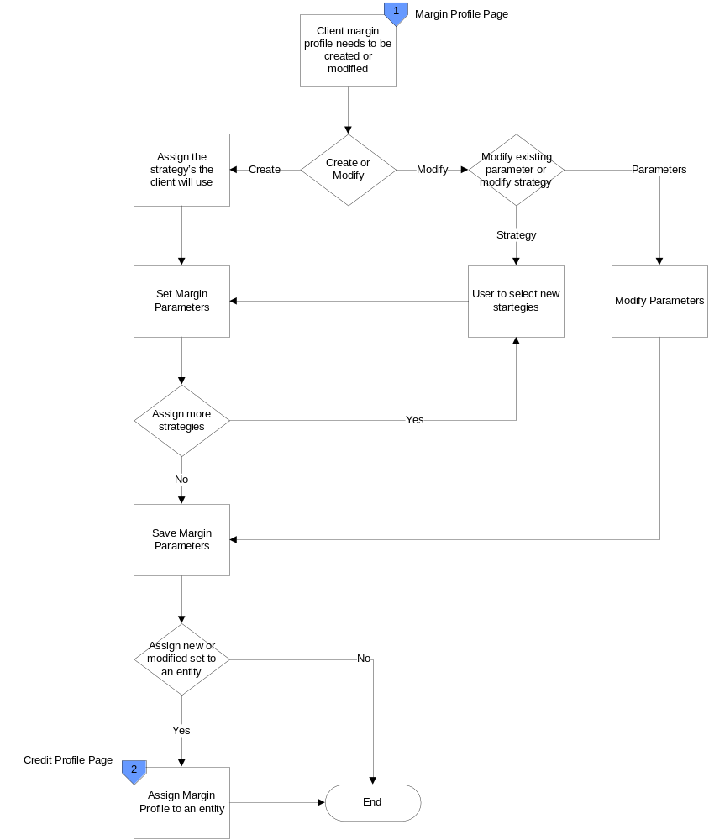

Functional Requirements Summary
The following sections outline the functional requirements of this project required by the various systems involved. This projects functional requirements are more centered on data feeds, processing logic, reporting and few UI changes to existing iProcess screens.

Margin Profile Page
The margin profile page will be the primary page will allow users to create custom profiles based on Strategy and will replace the following screens in CPORT WEB:
- Discount Set Editor
- Customized Rules Editor

Accessing the Page
- User will have a link in the DBX Margin section of the left navigation menu called Margin Profile
- User will have a link in the Edit Credit Profile Page to launch the margin profile assigned to an entity

Entitlements
- User can be either given edit access or view only access

UC 1 -Create a new Margin Profile or Modify an existing Margin Profile
Brief Description
The use case details the process for either modifying an existing margin profile or creating a new margin profile.
Actors
Risk, Transition Support
Preconditions
- User has edit access to the margin profile page.
Business Rules
- Show only the margin parameters based on the selected strategy.
- Certain choices like which calculation methodology and margin tier will always be present irrespective of which strategy is used.
References
N/A
Trigger
New client on boarding or an event at the client or market which requires risk to revise the client’s margin profile.
Frequency of use
Adhoc
Flow of events
Main Success Scenario – New Profile created or existing profile modified
Step | Description
1 | User logs into DBX and expands the DBX Margin left navigation menu item
2 | User see the link for Margin Profile Manager
3 | User selects Margin Profile Manager
4 | User is given the option to create a new profile, clone an existing one or modify an existing profile.
5 | User is shown the detailed margin parameters page.
6 | User exit’s use case.

User Interface Specifications

Asset Class Templates

Equities
Figure 5.1.1–A
1
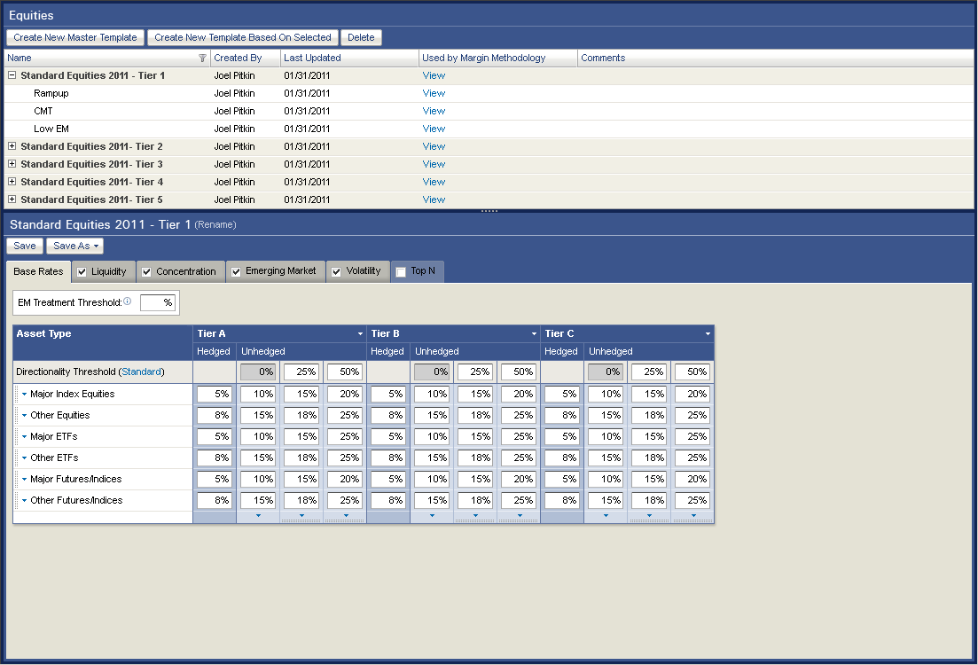
2
3
4
5
6
7
8
9
11
13
14
15
12
16
17
18
19
20
10

Table 5.1.1–A
ID | Label | Control | Functional Specification | UI Specification
 | Equities | Panel Header |  | Panel Header
 | Create New Master Template | Button
 | Create New Template Based on Selected | Button
 | Delete | Button
 | Name | DataGrid Column 1
 | Created By | DataGrid Column 2
 | Last Updated | DataGrid Column 3
 | Used by Margin Methodology | DataGrid Column 4 |  | Onclick of “View” hyperlink opened a listing of all Margin Methodologies using respective template.
 | Comments | DataGrid Column 5
 | Templates
 | Selected Template Name | Panel Header |  | Panel Header
 | Rename | Hyperlink |  | Onclick of hyperlink opens a popup allowing user to rename the template
 | Save | Button |  | Onclick saves any changes made to the template
 | Save As… | Button |  | Onclick opens a popup allowing the user to save the template as under a different name
 | Base Rates | Tab
 | Liquidity | Tab |  | Contents of this tab is disabled if checkbox is unchecked
 | Concentration | Tab |  | Contents of this tab is disabled if checkbox is unchecked
 | Emerging Market | Tab |  | Contents of this tab is disabled if checkbox is unchecked
 | Volatility | Tab |  | Contents of this tab is disabled if checkbox is unchecked
 | Top N | Tab |  | This tab is in disabled state before selection.

Base Rates

Figure 5.1.1.1–A
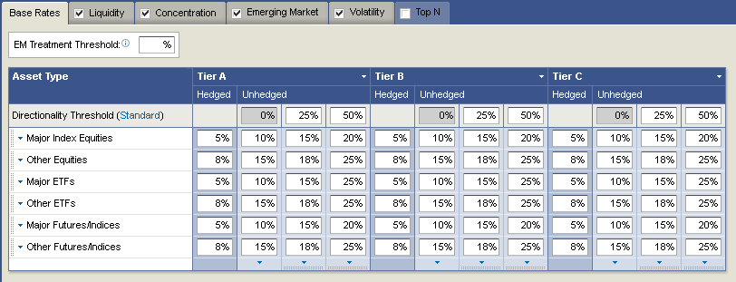
2
4
5
8
13
14
15
16
17
18
6
7
1
19
20
9
10
11
12
3
22
21

Table 5.1.1.1–A
ID | Label | Control | Functional Specification | UI Specification
 | Base Rate | Tab | Selected Tab | Page content will change depends on the Tab Selection
 | EM Treatment Threshold | Text Input
 | Info Icon | Icon |  | On click, will get related information
 | Asset Type | Header | Column Header
 | Tier A | Column Group Header
 | Tier B | Column Group Header
 | Tier C | Column Group Header
 | Hedged | DataGrid Column 1
 | Unhedged | DataGrid Column 2
 | White Arrow | Arrow |  | On clicking arrow, will appear the options like ‘Add Tier or Remove Tier’.
 | Directionality Threshold | Text Input
 | Disabled Text input | Text input |  | Disabled Text input
 | Major Index Equities | Text Input
 | Other Equities | Text Input
 | Major ETFs | Text Input
 | Other ETFs | Text Input
 | Major Futures / Indices | Text Input
 | Other Futures / Indices | Text Input
 | Arrow and Gripper dots (Horizontal) |  |  | On clicking arrow, will appear the options like ‘Add Row or Remove Row’.  Through the ‘Gripper dots’ user can change the Row order, can move up or down.
 | Arrow and Gripper dots (Vertical) |  |  | On clicking arrow, will appear the options like ‘Add Column or Remove Column’.  Through the ‘Gripper dots’ user can change the Column order, can move Left or Right.
 | Column Divider line | Line
 | Row Divider line | Line

Liquidity

Figure 5.1.1.2–A
1
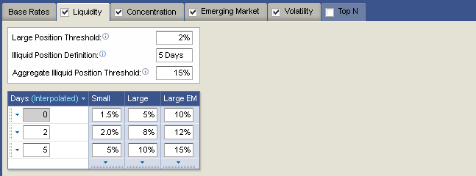
2
3
4
6
7
8
9
10
11
5

Table 5.1.1.2–A
ID | Label | Control | Functional Specification | UI Specification
 | Liquidity | Tab | Selected Tab | Page content will change depends on the Tab Selection
 | Large Position Threshold | Text Input
 | Illiquid Position Definition | Text Input
 | Aggregate Illiquid Position Threshold | Text Input
 | Info Icon | Icon |  | On click, will get related information
 | Days | DataGrid Column 1
 | Small | DataGrid Column 2
 | Large | DataGrid Column 3
 | Large EM | DataGrid Column 4
 | Disabled Text Input
 | Text Inputs | Text Inputs

Concentration
Figure 5.1.1.3–A
1
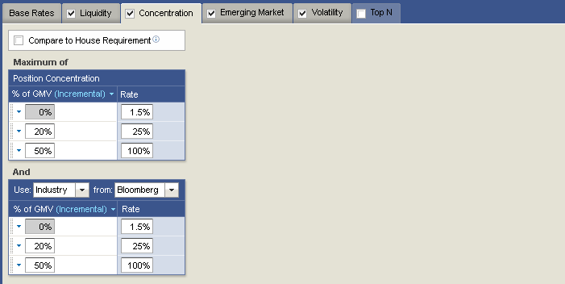
2
3
4
5
6
7
8
9
10
Table 5.1.1.3–A
ID | Label | Control | Functional Specification | UI Specification
1 | Concentration | Tab | Selected Tab | Page content will change depends on the Tab Selection
2 | Compare to House Requirement | Check Box
3 | Info Icon | Icon |  | On click, will get related information
4 | Position Concentration | Table Header
5 | % of GMV | DataGrid Column 1
6 | Rate | DataGrid Column 2
7 | Disabled Text Input | Text Input
8 | Text Inputs | Text Input
9 | Use | Combo Box |  | User can select the different field using dropdown option
10 | From | Combo Box |  | User can select various industry using dropdown option

Emerging Market
Figure 5.1.1.4–A
1
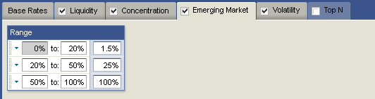
2
3
4
Table 5.1.1.4–A
ID | Label | Control | Functional Specification | UI Specification
1 | Emerging Market | Tab | Selected Tab | Page content will change depends on the Tab Selection
2 | Range | Table Header
3 | Disabled Text Input | Text Input
4 | Text Inputs | Text Inputs

Volatility

Figure 5.1.1.5–A
1
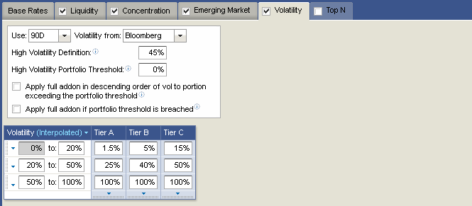
2
3
4
6
5
7
8
9
10
11
12

Table 5.1.1.5–A
ID | Label | Control | Functional Specification | UI Specification
 | Volatility | Tab | Selected Tab | Page content will change depends on the Tab Selection
 | Use - 90D | Combo Box |  | User can select the different field using dropdown option
 | From - Bloomberg | Combo Box |  | User can select various industry using dropdown option
 | High Volatility | Text Input
 | Info Icon | Icon |  | On click, will get related information
 | Apply full addon | Check Box
 | Volatility | DataGrid Column 1
 | Tier A | DataGrid Column 2
 | Tier B | DataGrid Column 3
 | Tier C | DataGrid Column 4
 | Disabled Text Input | Text Input
 | Text Inputs | Text Inputs

Top N

Figure 5.1.1.6–A
1
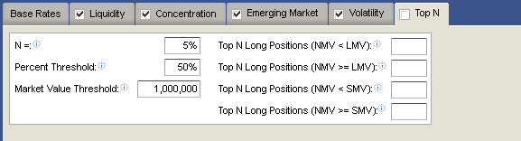
2
3
4
5
6
Table 5.1.1.6–A
ID | Label | Control | Functional Specification | UI Specification
 | Top N | Tab | Selected Tab | Page content will change depends on the Tab Selection
 | N = | Text Input
 | Percent Threshold | Text Input
 | Market Value Threshold | Text Input
 | Info Icon | Icon |  | On click, will get related information
 | Top N Long Positions (NMV < LMV) | Text Inputs

Equity Pairs
Figure 5.1.2–A
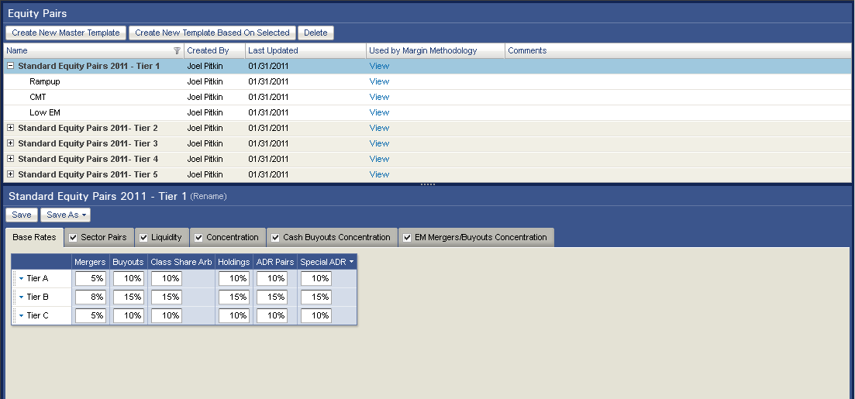
1
2
3
4
5
6
7
8
9
10
12
13
14
15
16
17
18
19
20
21
11

Table 5.1.1–B
ID | Label | Control | Functional Specification | UI Specification
 | Equity Pairs | Panel Header |  | Panel Header
 | Create New Master Template | Button
 | Create New Template Based on Selected | Button
 | Delete | Button
 | Name | DataGrid Column 1
 | Created By | DataGrid Column 2
 | Last Updated | DataGrid Column 3
 | Used by Margin Methodology | DataGrid Column 4 |  | Onclick of “View” hyperlink opened a listing of all Margin Methodologies using respective template.
 | Comments | DataGrid Column 5
 | Selected Template
 | Templates
 | Selected Template – Standard Equity Pairs | Panel Header |  | Panel Header
 | Rename | Hyperlink |  | Onclick of hyperlink opens a popup allowing user to rename the template
 | Save | Button |  | Onclick saves any changes made to the template
 | Save As… | Button |  | Onclick opens a popup allowing the user to save the template as under a different name
 | Base Rates | Tab
 | Sector Pairs | Tab |  | Contents of this tab is disabled if checkbox is unchecked
 | Liquidity | Tab |  | Contents of this tab is disabled if checkbox is unchecked
 | Concentration | Tab |  | Contents of this tab is disabled if checkbox is unchecked
 | Cash Buyouts Concentration | Tab |  | Contents of this tab is disabled if checkbox is unchecked
 | EM Mergers / Buyouts Concentration | Tab |  | Contents of this tab is disabled if checkbox is unchecked

General
Figure 5.1.2.1–A
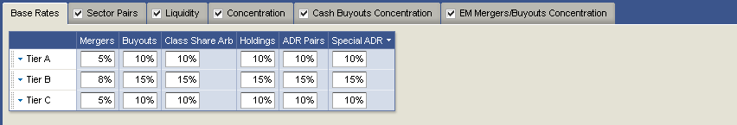
1
2
3
4
5
6
7
8
9
10

Table 5.1.2.1–A
ID | Label | Control | Functional Specification | UI Specification
 | Base Rate | Tab | Selected Tab | Page content will change depends on the Tab Selection
 | Tier A, B, C | Tier Rows
 | Mergers | Datagrid Column 2
 | Buyouts | Datagrid Column 3
 | Class Share Arb | Datagrid Column 4
 | Holdings | Datagrid Column 5
 | ADR Pairs | Datagrid Column 6
 | Special ADR | Datagrid Column 7
 | Dropdown Arrow | Arrow |  | Option selection Arrow
 | Text Inputs | Text Input

Sector Pairs
Figure 5.1.2.2–A
1
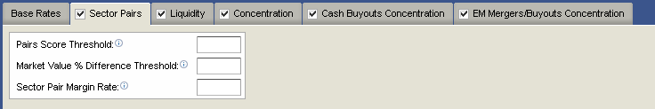
2
5
3
4

Table 5.1.3.3–A
ID | Label | Control | Functional Specification | UI Specification
 | Sector Pairs | Tab | Selected Tab | Page content will change depends on the Tab Selection
 | Pairs Score Threshold | Text Input
 | Market Value % Difference Threshold | Text Input
 | Sector Pair Margin Rate | Text Input
 | Info Icon | Icon |  | On click, will get related information

Liquidity
Figure 5.1.2.3–A
1
2
3
4
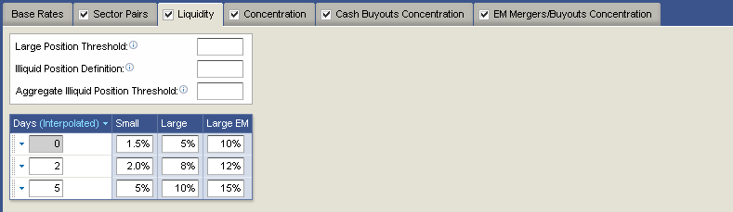
6
7
8
9
11
10
5
Table 5.1.2.3–A
ID | Label | Control | Functional Specification | UI Specification
 | Liquidity | Tab | Selected Tab | Page content will change depends on the Tab Selection
 | Large Position Threshold | Text Input
 | Illiquid Position Definition | Text Input
 | Aggregate Illiquid Position Threshold | Text Input
 | Info Icon | Icon |  | On click, will get related information
 | Days | DataGrid Column 1
 | Small | DataGrid Column 2
 | Large | DataGrid Column 3
 | Large EM | DataGrid Column 4
 | Disabled Text Input
 | Text Inputs

Concentration
Figure 5.1.2.4–A
1
2
3
4
5
6
7
8
10
9

Table 5.1.2.4–A
ID | Label | Control | Functional Specification | UI Specification
 | Concentration | Tab | Selected Tab | Page content will change depends on the Tab Selection
 | Compare to House Requirement | Check Box
 | Info Icon | Icon |  | On click, will get related information
 | Position Concentration | Content Header
 | % of GMV | DataGrid Column 1
 | Rate | DataGrid Column 2
 | Disabled Text Input
 | Text Inputs
 | Use | Combo Box |  | User can select the different field using dropdown option
 | From | Combo Box |  | User can select various industry using dropdown option

Cash Buyouts Concentration
Figure 5.1.2.5–A
1
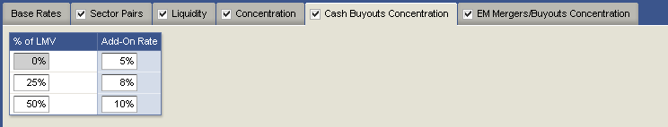
2
3
4
5
Table 5.1.2.5–A
ID | Label | Control | Functional Specification | UI Specification
 | Cash Buyouts Concentration | Tab | Selected Tab | Page content will change depends on the Tab Selection
 | % of LMV | DataGrid Column 1
 | Add-On Rate | DataGrid Column 2
 | Disabled Text Input
 | Text Inputs

EM Mergers/Buyouts Concentration
Figure 5.1.2.6–A
1
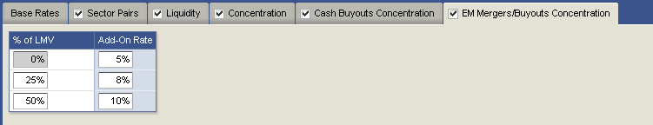
2
3
4
5
Table 5.1.2.6–A
ID | Label | Control | Functional Specification | UI Specification
 | EM Mergers / Buyouts Concentration | Tab | Selected Tab | Page content will change depends on the Tab Selection
 | % of LMV | DataGrid Column 1
 | Add-On Rate | DataGrid Column 2
 | Disabled Text Input
 | Text Inputs

Equity Options
Figure 5.1.3–A
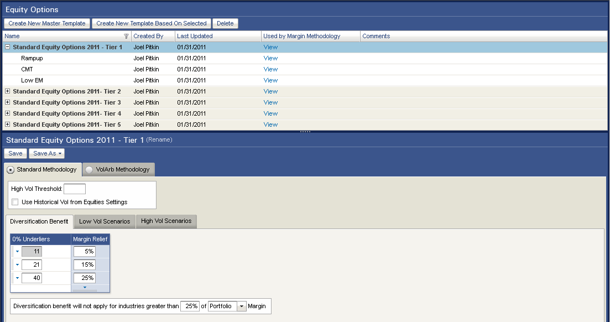
1
2
3
4
5
6
7
8
9
10
12
13
14
15
16
17
11

Table 5.1.1–C
ID | Label | Control | Functional Specification | UI Specification
 | Equity Options | Panel Header |  | Panel Header
 | Create New Master Template | Button
 | Create New Template Based on Selected | Button
 | Delete | Button
 | Name | DataGrid Column 1
 | Created By | DataGrid Column 2
 | Last Updated | DataGrid Column 3
 | Used by Margin Methodology | DataGrid Column 4 |  | Onclick of “View” hyperlink opened a listing of all Margin Methodologies using respective template.
 | Comments | DataGrid Column 5
 | Selected Template
 | Templates
 | Selected Template – Standard Equity Options | Panel Header |  | Panel Header
 | Rename | Hyperlink |  | Onclick of hyperlink opens a popup allowing user to rename the template
 | Save | Button |  | Onclick saves any changes made to the template
 | Save As… | Button |  | Onclick opens a popup allowing the user to save the template as under a different name
 | Standard Methodology | Tab | Selected Tab | Onclick of tab, respective data will show.
 | VolArb Methodology | Tab | Unselected Tab

Standard Methodology > Diversification Benefit
Figure 5.1.3.1–A
1
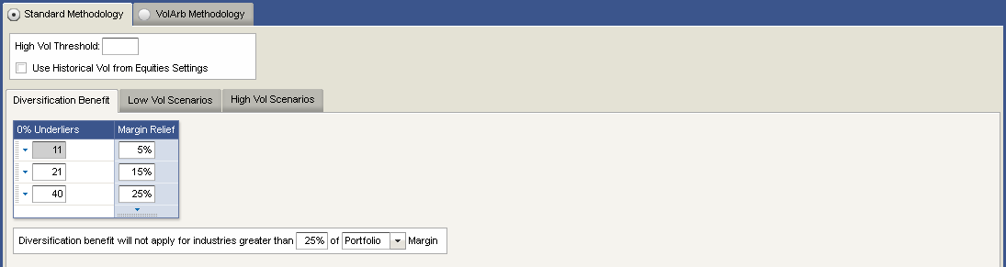
2
3
4
5
6
7
8
9
10
11
12

Table 5.1.3.1–D
 | Standard Methodology | Tab | Selected Tab | Onclick of tab, respective data will show.
 | High Vol Threshold | Text Input
 | Use Historical Vol from Equities Settings | Check Box
 | Diversification Benefit | Selected Inner Tab |  | Onclick of Inner Tab page content will change
 | Low Vol Scenarios | Inner Tab | Unselected Tab
 | High Vol Scenarios | Inner Tab | Unselected Tab
 | 0% Underliers | Data Grid Column 1
 | Margin Relief | Data Grid Column 2
 | Disabled Text Input
 | Text Inputs
 | 25% | Text Input
 | Portfolio | Combo Box |  | Through the dropdown button, user will select options

Standard Methodology > Low Vol Scenario
Figure 5.1.3.2–A
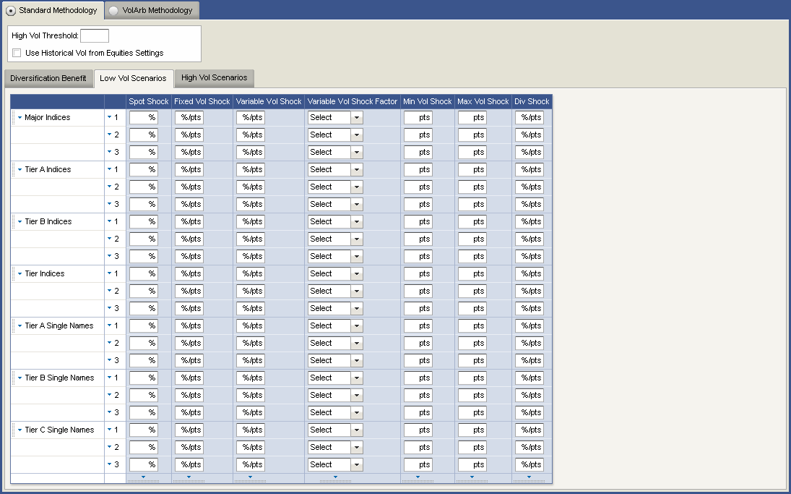
1
2
3
4
5
6
7
8
9
10
11

Table 5.1.3.2–E
 | Low Vol Scenarios | Selected Inner Tab |  | Onclick of Inner Tab page content will change
 | 1 with arrow | Arrow |  | Onclick of arrow, can have different options
 | Spot Shock | Data Grid Column 1
 | Fixed Vol Shockl | Data Grid Column 2
 | Variable Vol Shock
 | Variable Vol Shock Factor | Data Grid Column 3
 | Min Vol Shock | Data Grid Column 4
 | Max Vol Shock | Data Grid Column 5
 | Div Shock | Data Grid Column 6
 | Check Boxes
 | Select Combo Box | Combo Box |  | Onclick of dropdown button user will get different options

Standard Methodology > High Vol Scenario

Figure 5.1.3.3–A
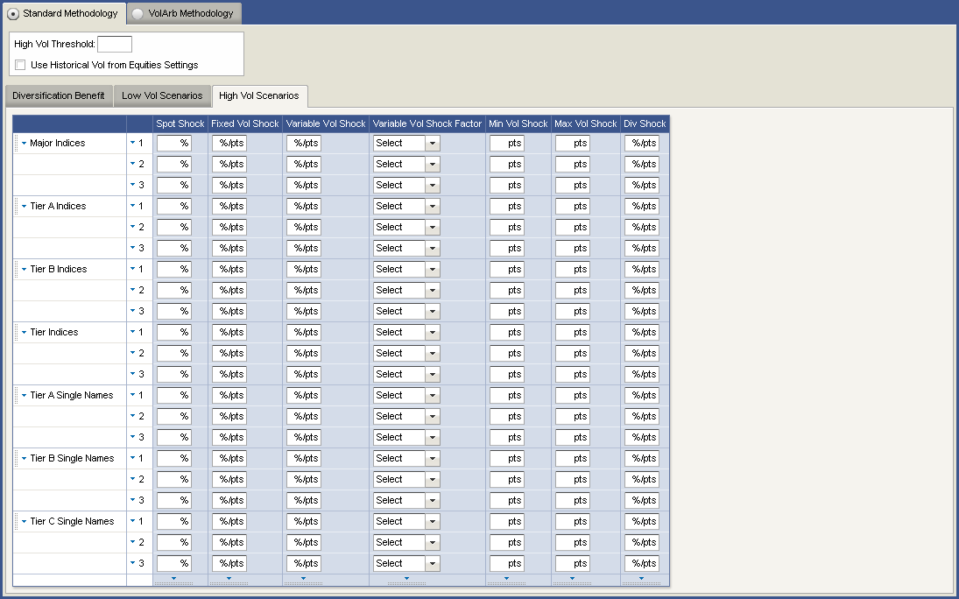
1
2
3
4
5
6
7
8
9
10
11

Table 5.1.3.3–F
 | High Vol Scenarios | Selected Inner Tab |  | Onclick of Inner Tab page content will change
 | 1 with arrow | Arrow |  | Onclick of arrow, can have different options
 | Spot Shock | Data Grid Column 1
 | Fixed Vol Shockl | Data Grid Column 2
 | Variable Vol Shock
 | Variable Vol Shock Factor | Data Grid Column 3
 | Min Vol Shock | Data Grid Column 4
 | Max Vol Shock | Data Grid Column 5
 | Div Shock | Data Grid Column 6
 | Check Boxes
 | Select Combo Box | Combo Box |  | Onclick of dropdown button user will get different options

VolArb Methodology > Liquidity Multiplier
Table 5.1.3.4–G
1
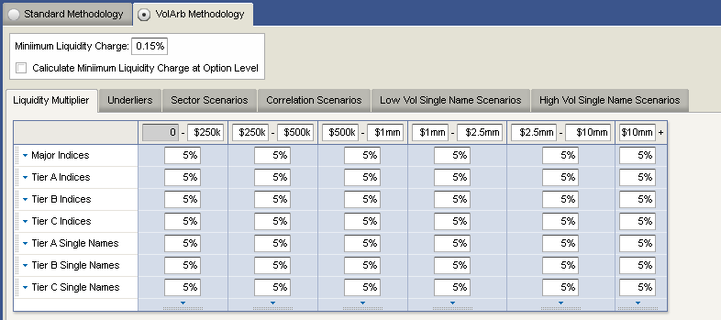
2
3
4
6
5
7
8
9
10
11
12

Table 5.1.3.4–H
 | VolArb Methodology | Tab | Selected Tab | Onclick of tab, respective data will show.
 | Minimum Liquidity Charge | Text Input
 | Calculate Minimum Liquidity Charge at Option Level | Check Box
 | Liquidity Multiplier | Selected Inner Tab |  | Onclick of Inner Tab page content will change
 | Disabled Text Input | Text Input
 | Major Indices | Text Input
 | Tier A Indices | Text Input
 | Tier B Indices | Text Input
 | Tier C Indices | Text Input
 | Tier A Single Names | Text Input
 | Tier B Single Names | Text Input
 | Tier C Single Names | Text Input

VolArb Methodology > Underliers
Table 5.1.3.5–I
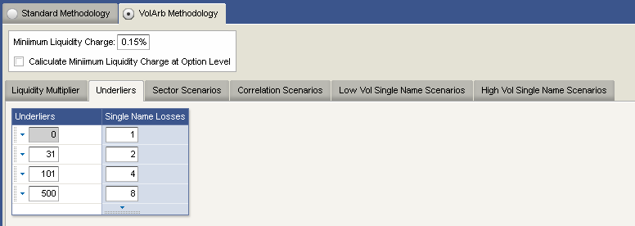
1
2
3
4
5

Table 5.1.3.5–J
 | Underliers | Selected Inner Tab |  | Onclick of Inner Tab page content will change
 | Underliers | Data Grid Column 1
 | Single Name Losses | Data Grid Column 2
 | Disabled Text Input | Text Input
 | Text Inputs | Text Inputs

VolArb Methodology > Sector Scenarios
Table 5.1.3.6–K
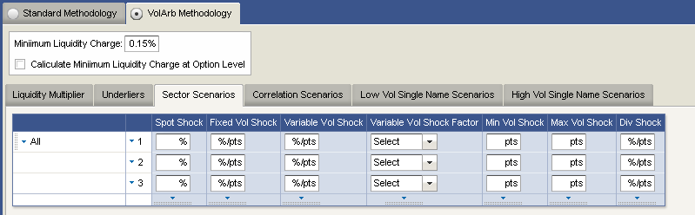
1
3
4
5
6
7
8
9
2
10
11
Table 5.1.3.6–L
 | Sector Scenarios | Selected Inner Tab |  | Onclick of Inner Tab page content will change
 | 1 with arrow | Arrow |  | Onclick of arrow, can have different options
 | Spot Shock | Data Grid Column 1
 | Fixed Vol Shockl | Data Grid Column 2
 | Variable Vol Shock
 | Variable Vol Shock Factor | Data Grid Column 3
 | Min Vol Shock | Data Grid Column 4
 | Max Vol Shock | Data Grid Column 5
 | Div Shock | Data Grid Column 6
 | Check Boxes
 | Select Combo Box | Combo Box |  | Onclick of dropdown button user will get different options

VolArb Methodology > Correlation Scenarios
Table 5.1.3.7–M
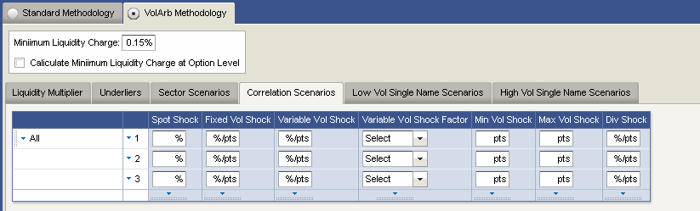
1
3
4
5
6
7
8
9
2
10
11

Table 5.1.3.7–N
 | Correlation Scenarios | Selected Inner Tab |  | Onclick of Inner Tab page content will change
 | 1 with arrow | Arrow |  | Onclick of arrow, can have different options
 | Spot Shock | Data Grid Column 1
 | Fixed Vol Shockl | Data Grid Column 2
 | Variable Vol Shock
 | Variable Vol Shock Factor | Data Grid Column 3
 | Min Vol Shock | Data Grid Column 4
 | Max Vol Shock | Data Grid Column 5
 | Div Shock | Data Grid Column 6
 | Check Boxes
 | Select Combo Box | Combo Box |  | Onclick of dropdown button user will get different options

VolArb Methodology > Low Vol Single Name Scenarios
Table 5.1.3.8–O
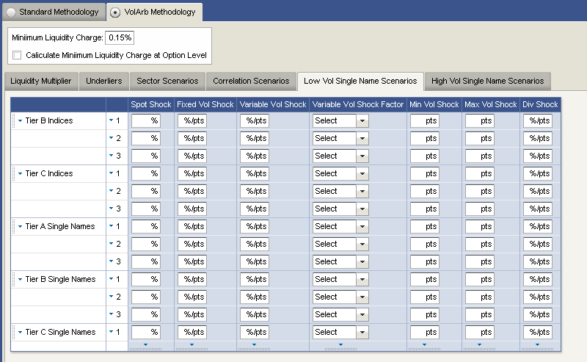
1
3
4
5
6
7
8
9
2
10
11

Table 5.1.3.8–P
 | Low Vol Single Name Scenarios | Selected Inner Tab |  | Onclick of Inner Tab page content will change
 | 1 with arrow | Arrow |  | Onclick of arrow, can have different options
 | Spot Shock | Data Grid Column 1
 | Fixed Vol Shock | Data Grid Column 2
 | Variable Vol Shock
 | Variable Vol Shock Factor | Data Grid Column 3
 | Min Vol Shock | Data Grid Column 4
 | Max Vol Shock | Data Grid Column 5
 | Div Shock | Data Grid Column 6
 | Check Boxes
 | Select Combo Box | Combo Box |  | Onclick of dropdown button user will get different options

VolArb Methodology > Low Vol Single Name Scenarios
Table 5.1.3.9–Q
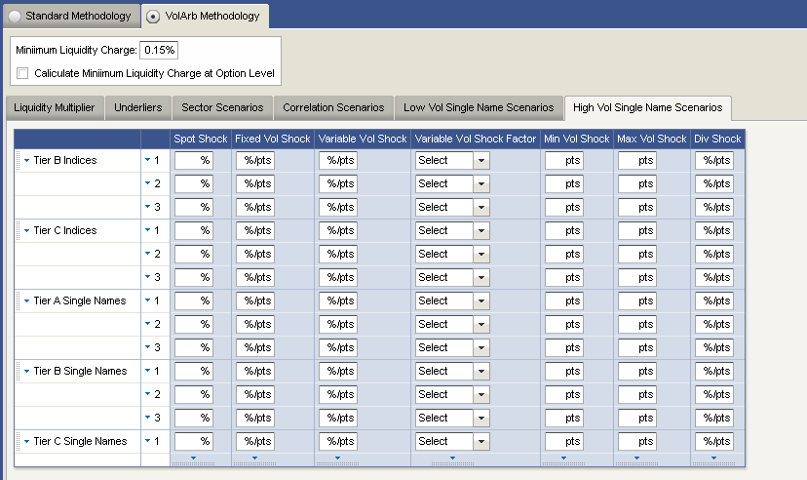
1
3
4
5
6
7
8
9
2
10
11

Table 5.1.3.9–R
 | High Vol Single Name Scenarios | Selected Inner Tab |  | Onclick of Inner Tab page content will change
 | 1 with arrow | Arrow |  | Onclick of arrow, can have different options
 | Spot Shock | Data Grid Column 1
 | Fixed Vol Shockl | Data Grid Column 2
 | Variable Vol Shock
 | Variable Vol Shock Factor | Data Grid Column 3
 | Min Vol Shock | Data Grid Column 4
 | Max Vol Shock | Data Grid Column 5
 | Div Shock | Data Grid Column 6
 | Check Boxes
 | Select Combo Box | Combo Box |  | Onclick of dropdown button user will get different options

Convertibles
Figure 5.1.4–A
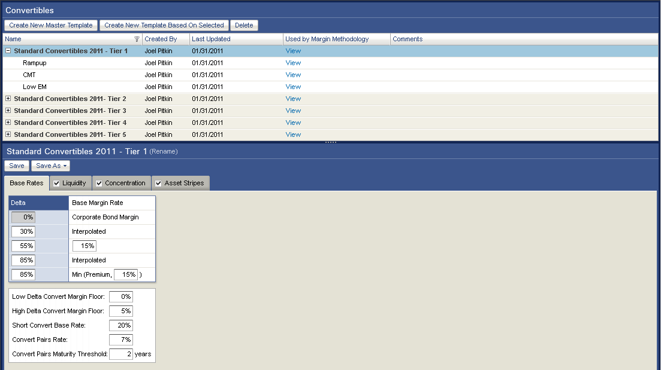
1
2
3
4
5
6
7
8
9
10
11
12
13
14
15
16
17
18
19
Table 5.1.4–S
ID | Label | Control | Functional Specification | UI Specification
 | Convertibles | Panel Header |  | Panel Header
 | Create New Master Template | Button
 | Create New Template Based on Selected | Button
 | Delete | Button
 | Name | DataGrid Column 1
 | Created By | DataGrid Column 2
 | Last Updated | DataGrid Column 3
 | Used by Margin Methodology | DataGrid Column 4 |  | Onclick of “View” hyperlink opened a listing of all Margin Methodologies using respective template.
 | Comments | DataGrid Column 5
 | Selected Template
 | Templates
 | Selected Template – Standard Convertibles | Panel Header |  | Panel Header
 | Rename | Hyperlink |  | Onclick of hyperlink opens a popup allowing user to rename the template
 | Save | Button |  | Onclick saves any changes made to the template
 | Save As… | Button |  | Onclick opens a popup allowing the user to save the template as under a different name
 | Base Rates | Tab | Selected Tab
 | Liquidity | Tab |  | Contents of this tab is disabled if checkbox is unchecked
 | Concentration | Tab |  | Contents of this tab is disabled if checkbox is unchecked
 | Asset Strips | Tab |  | Contents of this tab is disabled if checkbox is unchecked

Base Rates

Figure 5.1.4.1–A
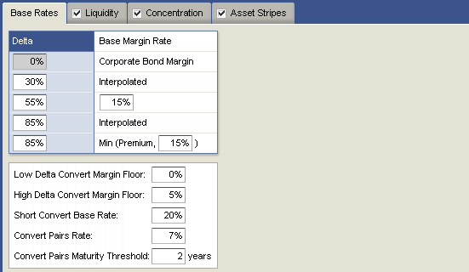
1
2
5
3
4

Table 5.1.4.1–A
ID | Label | Control | Functional Specification | UI Specification
 | Base Rates | Tab | Selected Tab | Page content will change depends on the Tab Selection
 | Delta | Datagrid Column 1
 | Disabled Text Input
 | Text Inputs
 | Text Inputs

Liquidity
Figure 5.1.4.2–A
1
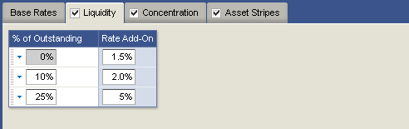
2
3
5
4

Table 5.1.5.3–A
ID | Label | Control | Functional Specification | UI Specification
 | Liquidity | Tab | Selected Tab | Page content will change depends on the Tab Selection
 | % of Outstanding | DataGrid Column 1
 | Add-On Rate | DataGrid Column 2
 | Disabled Text Input
 | Text Inputs

Concentration

Figure 5.1.4.3–A
1
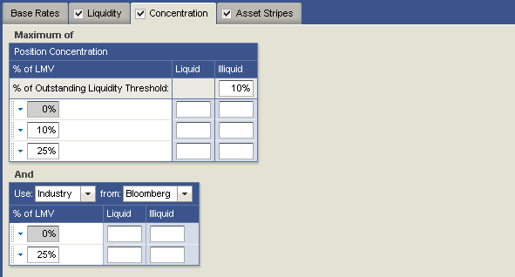
3
4
5
2
6
7
8
9

Table 5.1.4.3–A
ID | Label | Control | Functional Specification | UI Specification
 | Concentration | Tab | Selected Tab | Page content will change depends on the Tab Selection
 | Position Concentration | Content Header
 | % of GMV | DataGrid Column 1
 | Liquid | DataGrid Column 2
 | Illiquid | DataGrid Column 3
 | Disabled Text Input
 | Text Inputs
 | Use | Combo Box |  | User can select the different field using dropdown option
 | From | Combo Box |  | User can select various industry using dropdown option

Asset Strips
Figure 5.1.4.4–A
1
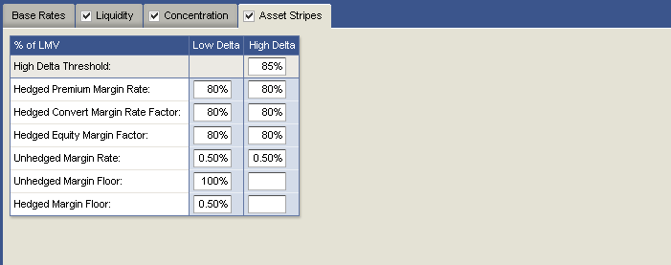
2
3
4
5
Table 5.1.5.5–A
ID | Label | Control | Functional Specification | UI Specification
 | Asset Strips | Tab | Selected Tab | Page content will change depends on the Tab Selection
 | % of LMV | Data Grid Column 1
 | Low Delta | Data Grid Column 2
 | High Delta | Data Grid Column 3
 | Text Inputs | Text Input

