Web.xml如何执行？
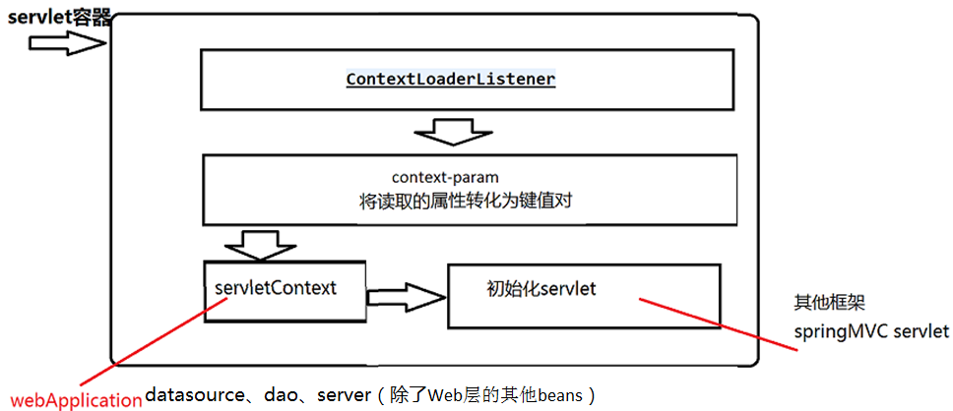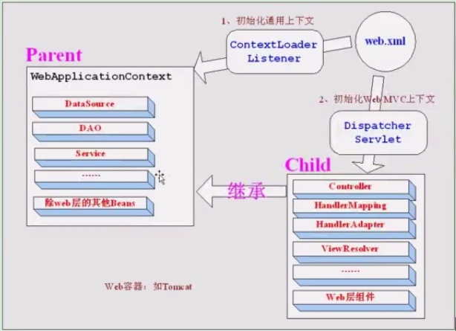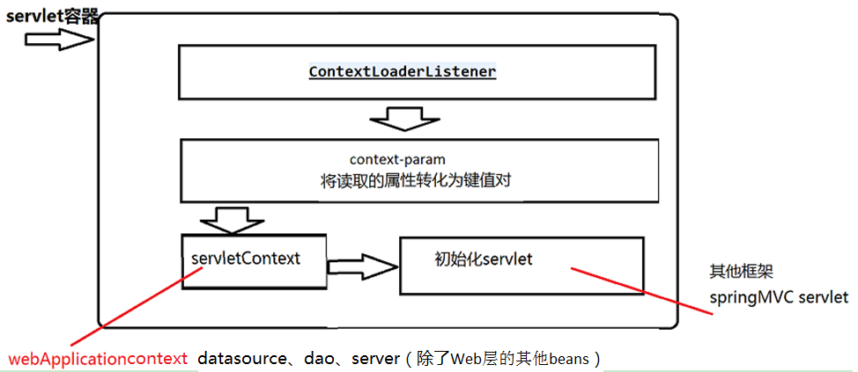
1.spring容器整套技术是如何与我们web容器（j2ee规范）的耦合
web.xml

执行顺序1.监听器 2. contextConfigLocation （根上下文，web项目共享的上下文）3.servlet
1.欢迎页
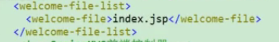
2.springMVC前端控制器
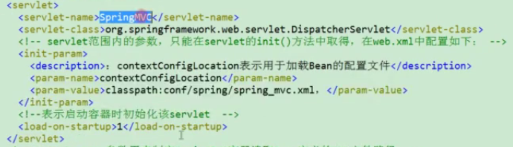
3.contextConfigLocation IOC
初始化上下文
context-param:参数用来制定SpringIOC容器读取bean定义的xml文件路径
4.监听器（生命周期开始）
5.过滤器
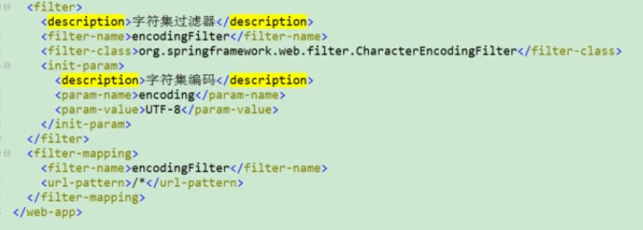

越是优秀的框架它本身对自己监听监控这种监听器必须是开始就已经监听自己的生命周期

  - 类ContextLoaderListener 继承 ContextLoader 实现 ServletContextListener（初始化/销毁）

作用：监听上下文初始化和销毁
/**
* Initialize the root web application context.
*/
@Override
public void contextInitialized(ServletContextEvent event) {
initWebApplicationContext(event.getServletContext());
}

/**
* Close the root web application context.
*/
@Override
public void contextDestroyed(ServletContextEvent event) {
closeWebApplicationContext(event.getServletContext());
ContextCleanupListener.cleanupAttributes(event.getServletContext());
}

ContextLoaderListener 是 spring 容器
提供的监听器，它是实现ServletContextListener，规范了SpringIOC容器的生命周期回调。
实际上它是交由它的父类完成这个IOC容器初始化细节。
ContextLoaderListener.java
// Store context in local instance variable, to guarantee that
// it is available on ServletContext shutdown.
//context = WebApplicationContext
if (this.context == null) {
this.context = createWebApplicationContext(servletContext);
}
if (this.context instanceof ConfigurableWebApplicationContext) {
ConfigurableWebApplicationContext cwac = (ConfigurableWebApplicationContext) this.context;
//创建根上下文是否活跃cwac上下文至少刷新一次
if (!cwac.isActive()) {
// The context has not yet been refreshed -> provide services such as
// setting the parent context, setting the application context id, etc
if (cwac.getParent() == null) {
//设置父上下文，设置应用程序id
// determine parent for root web application context, if any.
ApplicationContext parent = loadParentContext(servletContext);
cwac.setParent(parent);
}
// 进行装配和刷新WebApplicationContext容器，这个点再次进入一层
- configureAndRefreshWebApplicationContext(cwac, servletContext);
}
}
servletContext.setAttribute(WebApplicationContext.ROOT_WEB_APPLICATION_CONTEXT_ATTRIBUTE, this.context);

ClassLoader ccl = Thread.currentThread().getContextClassLoader();
if (ccl == ContextLoader.class.getClassLoader()) {
currentContext = this.context;
}
else if (ccl != null) {
currentContextPerThread.put(ccl, this.context);
}

if (logger.isDebugEnabled()) {
logger.debug("Published root WebApplicationContext as ServletContext attribute with name [" +
WebApplicationContext.ROOT_WEB_APPLICATION_CONTEXT_ATTRIBUTE + "]");
}
if (logger.isInfoEnabled()) {
long elapsedTime = System.currentTimeMillis() - startTime;
logger.info("Root WebApplicationContext: initialization completed in " + elapsedTime + " ms");
}

return this.context;
}

ContextLoader.java
//IOC容器初始化进一步细节
protected void configureAndRefreshWebApplicationContext(ConfigurableWebApplicationContext wac, ServletContext sc) {
if (ObjectUtils.identityToString(wac).equals(wac.getId())) {
// The application context id is still set to its original default value
// -> assign a more useful id based on available information
//获取ServletContext 上下文 CONTEXT_ID_PARAM
//根据配置设置更合适的CONTEXT_ID_PARAM
String idParam = sc.getInitParameter(CONTEXT_ID_PARAM);
if (idParam != null) {
wac.setId(idParam);
}
else {
// 默认id
wac.setId(ConfigurableWebApplicationContext.APPLICATION_CONTEXT_ID_PREFIX +
ObjectUtils.getDisplayString(sc.getContextPath()));
}
}
// 设置servletContext
wac.setServletContext(sc);
// 外部配置路径参数
String configLocationParam = sc.getInitParameter(CONFIG_LOCATION_PARAM);
if (configLocationParam != null) {
// 设置外部配置路径参数，到上下文中
wac.setConfigLocation(configLocationParam);
}

// The wac environment's #initPropertySources will be called in any case when the context
// is refreshed; do it eagerly here to ensure servlet property sources are in place for
// use in any post-processing or initialization that occurs below prior to #refresh
//拿取环境就是为了保证我们的外部配置属性初始化必须有环境支持
ConfigurableEnvironment env = wac.getEnvironment();
if (env instanceof ConfigurableWebEnvironment) {
//确保Servlet属性就为初始化
((ConfigurableWebEnvironment) env).initPropertySources(sc, null);
}
//选择什么类型的IOC容器初始化
customizeContext(sc, wac);
//初始化启动节点
wac.refresh();
}

总结：SpringMVC启动时是如何和servlet容器耦合？
就是讲spring上下文体系寄宿到servlet容器中，中间耦合就是web.xml

- springMVC启动自己持有的MVC上下文需要IOC容器支持，它是如何驱动IOC容器的初始化细节？
- springMVC上下文初始化以及组件和服务初始化细节

