- oracle 获取employees表自增长id原理
- 查询所有表序列获取user表序列:select * from user_suquences;

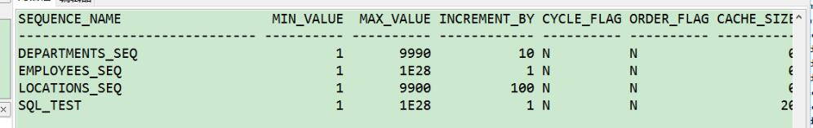
2. 获取（自增）id：select EMPLOYEES_SEQ.NEXYTVAULE from dual //返回id

