河南省肿瘤医院新冠疫情报告

每日简报(数据更新至2022年1028日)

## 累计阳性病例特征描述

截止2022-10-28河南省肿瘤医院累计报告阳性病例1792例，其中，男性969例，女性823例。阳性病例以患者或陪护为主1279例，其余依次为职工（272例）、第三方（241例）；在楼宇分布方面以 10号楼（696）为主。具体结果见表1

表1 累计至2022-10-28日阳性病例特征

| 分类 | Overall, N = 1,792 | 患陪, N = 1,279 | 第三方, N = 241 | 职工, N = 272 |
| --- | --- | --- | --- | --- |
| **性别** |  |  |  |  |
| 女 | 969 (54%) | 661 (52%) | 117 (49%) | 191 (70%) |
| 男 | 823 (46%) | 618 (48%) | 124 (51%) | 81 (30%) |
| **年龄** | 51 (38, 59) | 54 (44, 63) | 46 (27, 56) | 35 (31, 42) |
| **楼号** |  |  |  |  |
| 1号楼 | 179 (10.0%) | 3 (0.2%) | 86 (36%) | 90 (33%) |
| 2号楼 | 148 (8.3%) | 138 (11%) | 1 (0.4%) | 9 (3.3%) |
| 3号楼 | 165 (9.2%) | 139 (11%) | 3 (1.2%) | 23 (8.5%) |
| 5号楼 | 26 (1.5%) | 19 (1.5%) | 2 (0.8%) | 5 (1.8%) |
| 6号楼 | 151 (8.4%) | 140 (11%) | 0 (0%) | 11 (4.0%) |
| 8号楼 | 15 (0.8%) | 0 (0%) | 12 (5.0%) | 3 (1.1%) |
| 10号楼 | 696 (39%) | 583 (46%) | 8 (3.3%) | 105 (39%) |
| 11号楼 | 122 (6.8%) | 109 (8.5%) | 1 (0.4%) | 12 (4.4%) |
| 16号楼 | 148 (8.3%) | 138 (11%) | 0 (0%) | 10 (3.7%) |
| 其它 | 142 (7.9%) | 10 (0.8%) | 128 (53%) | 4 (1.5%) |

## 每日新增阳性病例情况

2022年10月17日至2022年10月22日期间，河南省肿瘤医院每日新增阳性病例数呈上升趋势，2022/10/22 之后呈下降趋势，见图 1。不同类别、不同楼宇的每日新增阳性病例数的变化趋势与整体相符，分别见图 2 和图 3。每日新增具体例数见表2，图**1**、图**2**以及图**3**。

表2 累计至2022-10-28日 阳性病例数

| 分类 | 10.17 | 10.18 | 10.19 | 10.20 | 10.21 | 10.22 | 10.23 | 10.24 | 10.25 | 10.26 | 10.27 | 10.28 |
| --- | --- | --- | --- | --- | --- | --- | --- | --- | --- | --- | --- | --- |
| **人员类别** |  |  |  |  |  |  |  |  |  |  |  |  |
| 患陪 | 5 | 7 | 12 | 92 | 153 | 382 | 178 | 125 | 114 | 120 | 74 | 17 |
| 第三方 | 0 | 5 | 1 | 25 | 36 | 62 | 30 | 21 | 29 | 15 | 11 | 6 |
| 职工 | 0 | 0 | 0 | 34 | 43 | 59 | 52 | 12 | 32 | 26 | 11 | 3 |
| **楼号** |  |  |  |  |  |  |  |  |  |  |  |  |
| 1号楼 | 0 | 1 | 1 | 37 | 45 | 28 | 18 | 11 | 23 | 13 | 2 | 0 |
| 2号楼 | 0 | 2 | 4 | 8 | 18 | 65 | 31 | 15 | 2 | 3 | 0 | 0 |
| 3号楼 | 2 | 0 | 1 | 8 | 13 | 38 | 12 | 19 | 17 | 19 | 30 | 6 |
| 5号楼 | 0 | 0 | 0 | 3 | 6 | 11 | 2 | 1 | 0 | 2 | 1 | 0 |
| 6号楼 | 2 | 0 | 4 | 15 | 18 | 52 | 14 | 16 | 14 | 10 | 3 | 3 |
| 8号楼 | 0 | 0 | 0 | 1 | 4 | 4 | 2 | 0 | 1 | 1 | 2 | 0 |
| 10号楼 | 0 | 5 | 3 | 51 | 54 | 169 | 116 | 60 | 95 | 94 | 42 | 7 |
| 11号楼 | 1 | 0 | 0 | 4 | 21 | 58 | 26 | 8 | 3 | 1 | 0 | 0 |
| 16号楼 | 0 | 0 | 0 | 6 | 29 | 41 | 20 | 16 | 9 | 15 | 8 | 4 |
| 其它 | 0 | 4 | 0 | 18 | 24 | 37 | 19 | 12 | 11 | 3 | 8 | 6 |

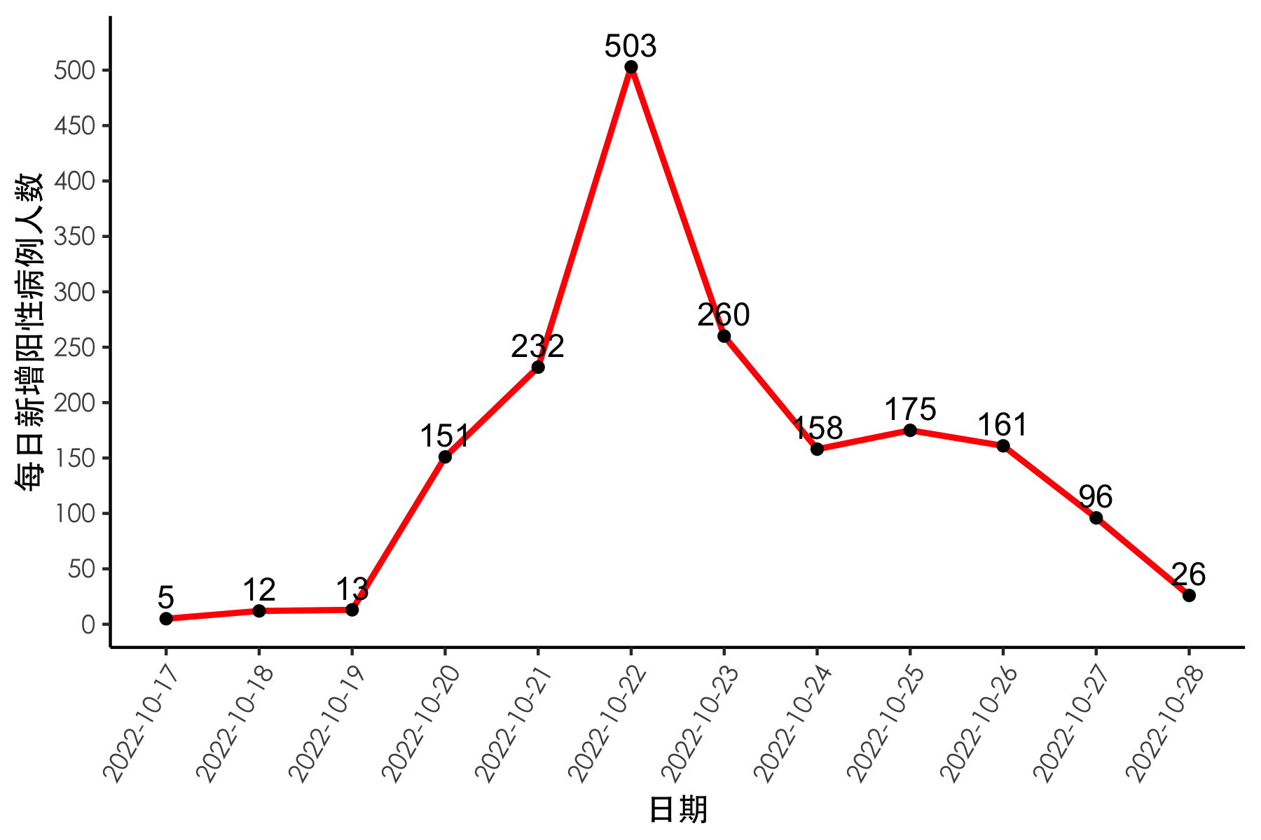

**图****1** 2022-10-17日至2022-10-28日每日新增阳性病例人数

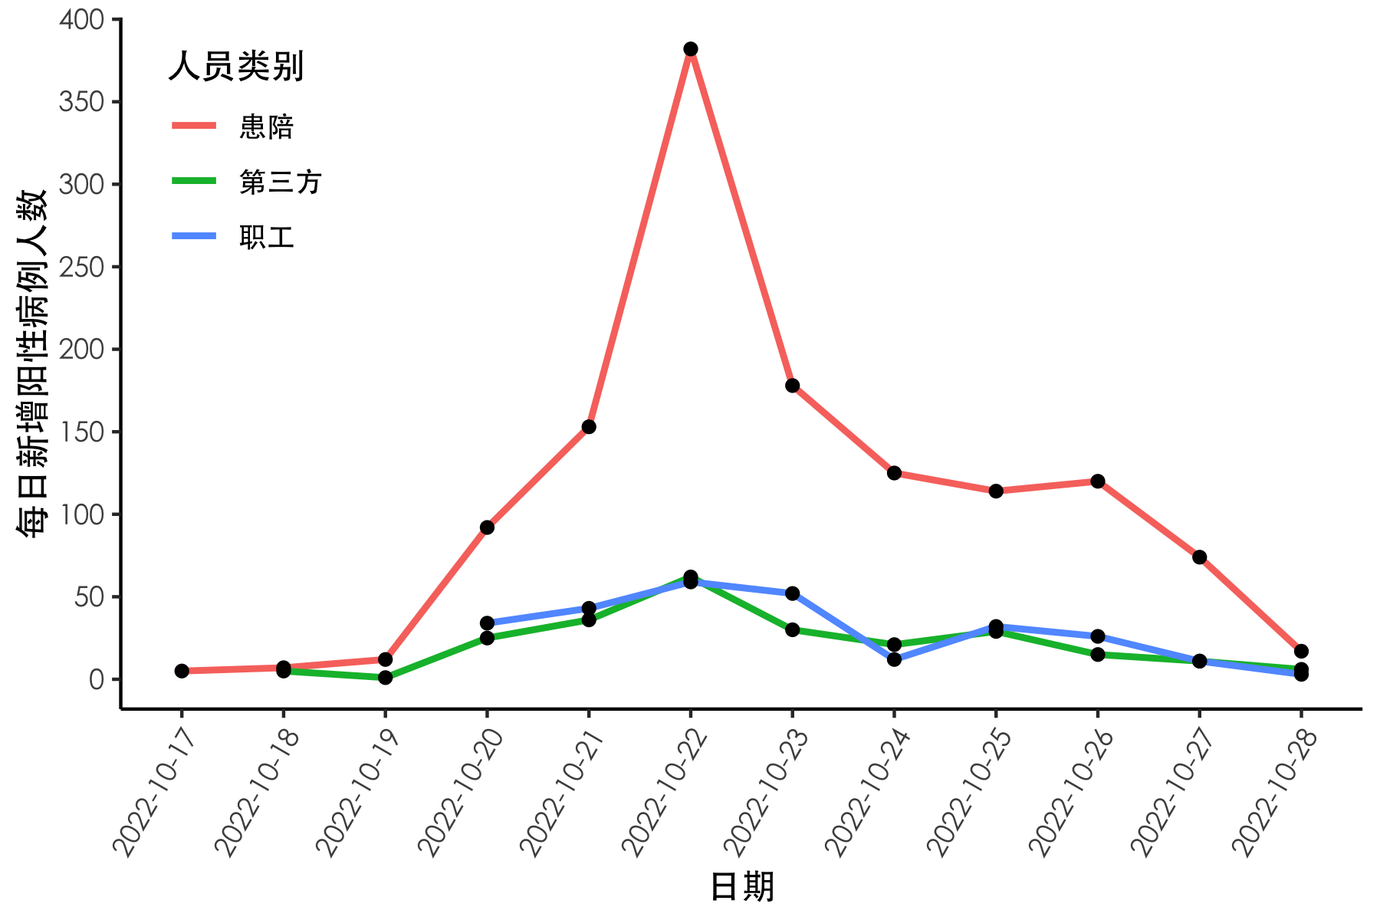

**图****2** 2022-10-17日至2022-10-28日各类人群每日新增阳性病例人数

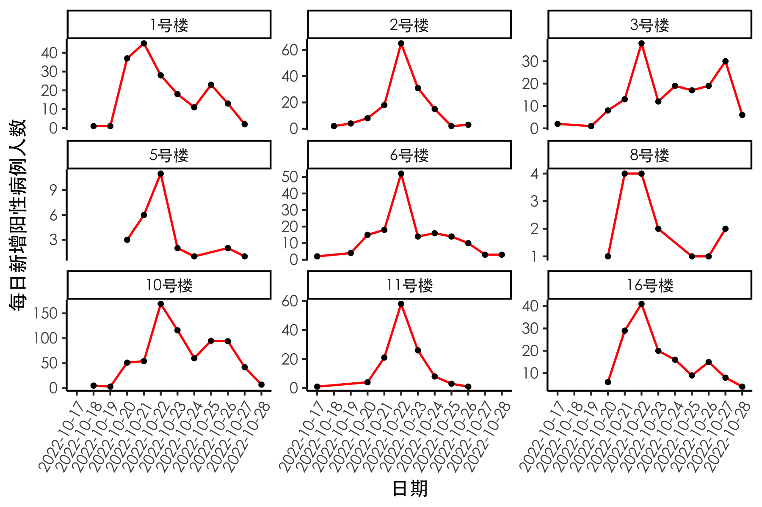

**图****3** 2022-10-17日至2022-10-28日不同楼宇每日新增阳性病例人数