# 小结

模型0为矩形法，模型1为梯形法，模型2为辛普森法，模型3为高斯—勒让德法，模型4为高斯法,模型5为区间高斯法

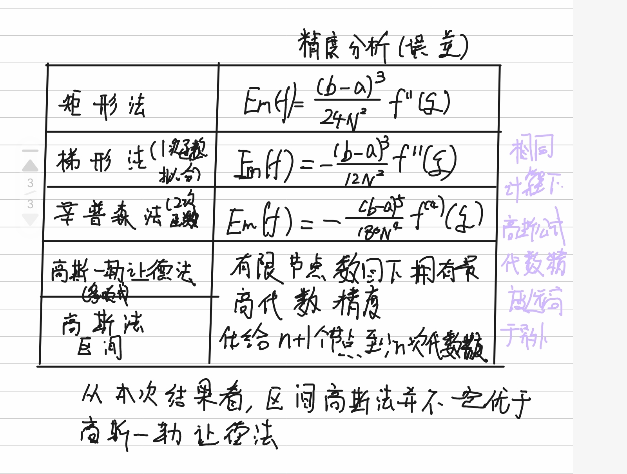

## 模型0

模型0耗时为2.820342540740967：

计算结果为10.545780183649509：

与精确值误差为：1.0334844091630657e-11

|  |  |  |
| --- | --- | --- |
| Iteration | No.of Points | Result |
| 1 | 4 | 9.818295796330048 |
| 2 | 8 | 10.364566156525633 |
| 3 | 16 | 10.500516156350898 |
| 4 | 32 | 10.53446662047393 |
| 5 | 64 | 10.542951945222335 |
| 6 | 128 | 10.545073133567156 |
| 7 | 256 | 10.545603421731373 |
| 8 | 512 | 10.545735993214887 |
| 9 | 1024 | 10.545769136050936 |
| 10 | 2048 | 10.545777421757753 |
| 11 | 4096 | 10.545779493184337 |
| 12 | 8192 | 10.545780011040975 |
| 13 | 16384 | 10.545780140505123 |
| 14 | 32768 | 10.54578017287118 |
| 15 | 65536 | 10.545780180962655 |
| 16 | 131072 | 10.545780182985482 |
| 17 | 262144 | 10.54578018349134 |
| 18 | 524288 | 10.545780183617586 |
| 19 | 1048576 | 10.545780183649509 |

## 模型1

模型1耗时为3.326080560684204：

计算结果为10.545780183680986：

与精确值误差为：2.114219910254178e-11

|  |  |  |
| --- | --- | --- |
| Iteration | No.of Points | Result |
| 1 | 4 | 11.997760173917115 |
| 2 | 8 | 10.908027985123582 |
| 3 | 16 | 10.636297070824607 |
| 4 | 32 | 10.568406613587754 |
| 5 | 64 | 10.551436617030841 |
| 6 | 128 | 10.54719428112659 |
| 7 | 256 | 10.546133707346874 |
| 8 | 512 | 10.54586856453912 |
| 9 | 1024 | 10.545802278877012 |
| 10 | 2048 | 10.54578570746395 |
| 11 | 4096 | 10.545781564610902 |
| 12 | 8192 | 10.545780528897621 |
| 13 | 16384 | 10.545780269969299 |
| 14 | 32768 | 10.54578020523718 |
| 15 | 65536 | 10.545780189054138 |
| 16 | 131072 | 10.54578018500842 |
| 17 | 262144 | 10.545780183997142 |
| 18 | 524288 | 10.54578018374399 |
| 19 | 1048576 | 10.545780183680986 |

## 模型2

模型2耗时为0.002988100051879883：

计算结果为10.545780183656298：

与精确值误差为：3.5456082514429e-12

|  |  |  |
| --- | --- | --- |
| Iteration | No.of Points | Result |
| 1 | 4 | 10.544783922192403 |
| 2 | 8 | 10.545720099391618 |
| 3 | 16 | 10.54577646117547 |
| 4 | 32 | 10.54577995151187 |
| 5 | 64 | 10.545780169158503 |
| 6 | 128 | 10.545780182753633 |
| 7 | 256 | 10.545780183603206 |
| 8 | 512 | 10.545780183656298 |

## 模型3

模型3耗时为0.0：

计算结果为10.545781046606981：

与精确值误差为：8.629471377474829e-07

|  |  |  |
| --- | --- | --- |
| Iteration | No.of Points | Result |
| 1 | 3 | 10.515863127281214 |
| 2 | 4 | 10.546659708172271 |
| 3 | 5 | 10.545765040052986 |
| 4 | 6 | 10.545781046606981 |

## 模型4

模型4耗时为0.2481086254119873：

计算结果为10.515862191005173：

与精确值误差为：0.029917992654670655

|  |  |  |
| --- | --- | --- |
| Iteration | No.of Points | Result |
| 1 | 2 | 11.07166019468161 |
| 2 | 3 | 10.515862191005173 |

## 模型5

模型5耗时为0.000993490219116211：

计算结果为10.545780711759019：

与精确值误差为：5.280991750566955e-07

|  |  |  |
| --- | --- | --- |
| Iteration | No.of Points | Result |
| 1 | 3 | 10.545767614387145 |
| 2 | 4 | 10.545778493620068 |
| 3 | 5 | 10.545780149161233 |
| 4 | 6 | 10.545780529735492 |
| 5 | 7 | 10.545780642762642 |
| 6 | 8 | 10.545780682687226 |
| 7 | 9 | 10.545780698633969 |
| 8 | 10 | 10.545780705592609 |
| 9 | 11 | 10.545780708824527 |
| 10 | 12 | 10.545780710386634 |
| 11 | 13 | 10.545780711154453 |
| 12 | 14 | 10.545780711526957 |
| 13 | 15 | 10.545780711696244 |
| 14 | 16 | 10.545780711759019 |

## 收敛图

模型0

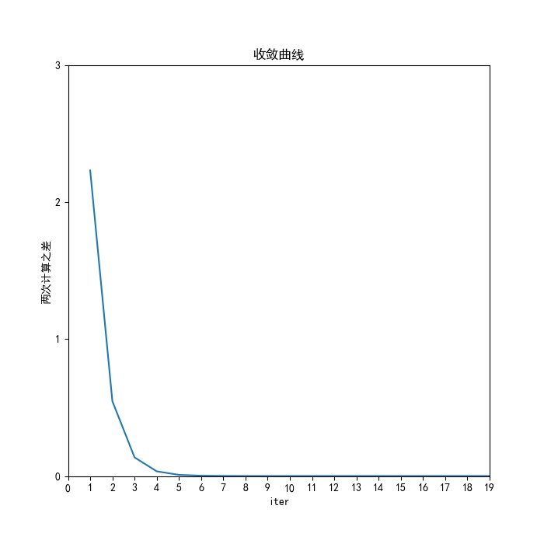

流程图

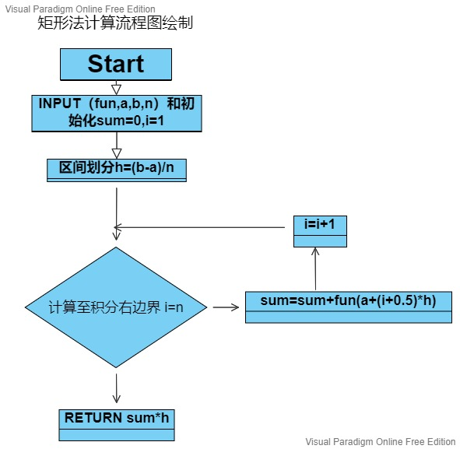

模型1

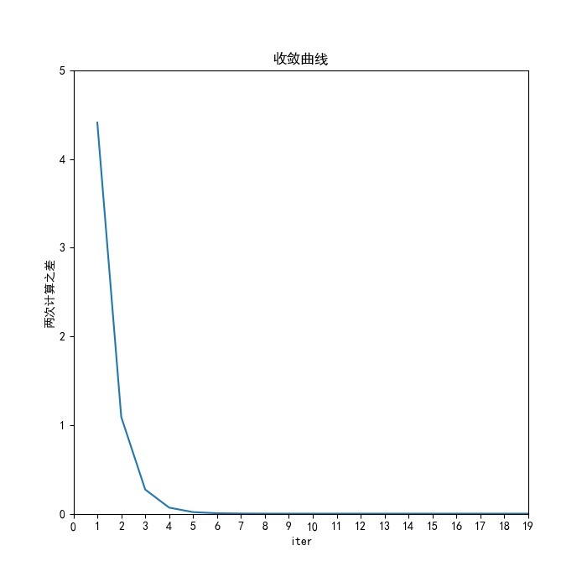

流程图

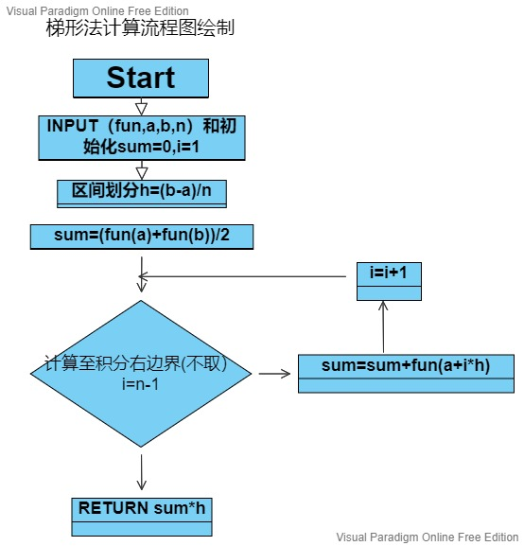

模型2

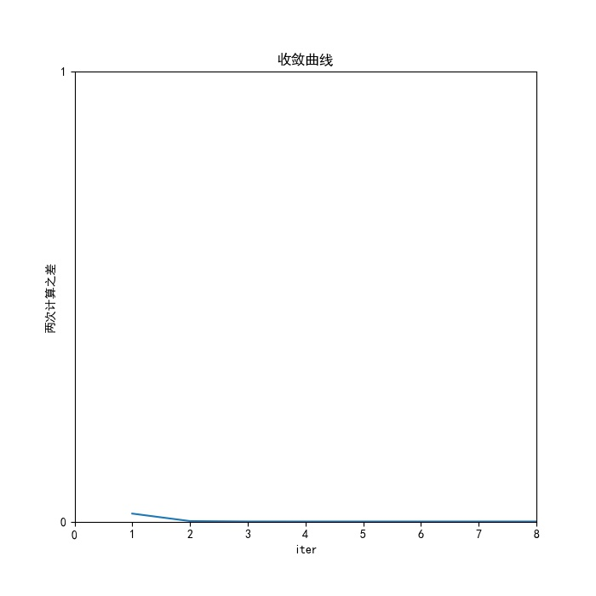

流程图

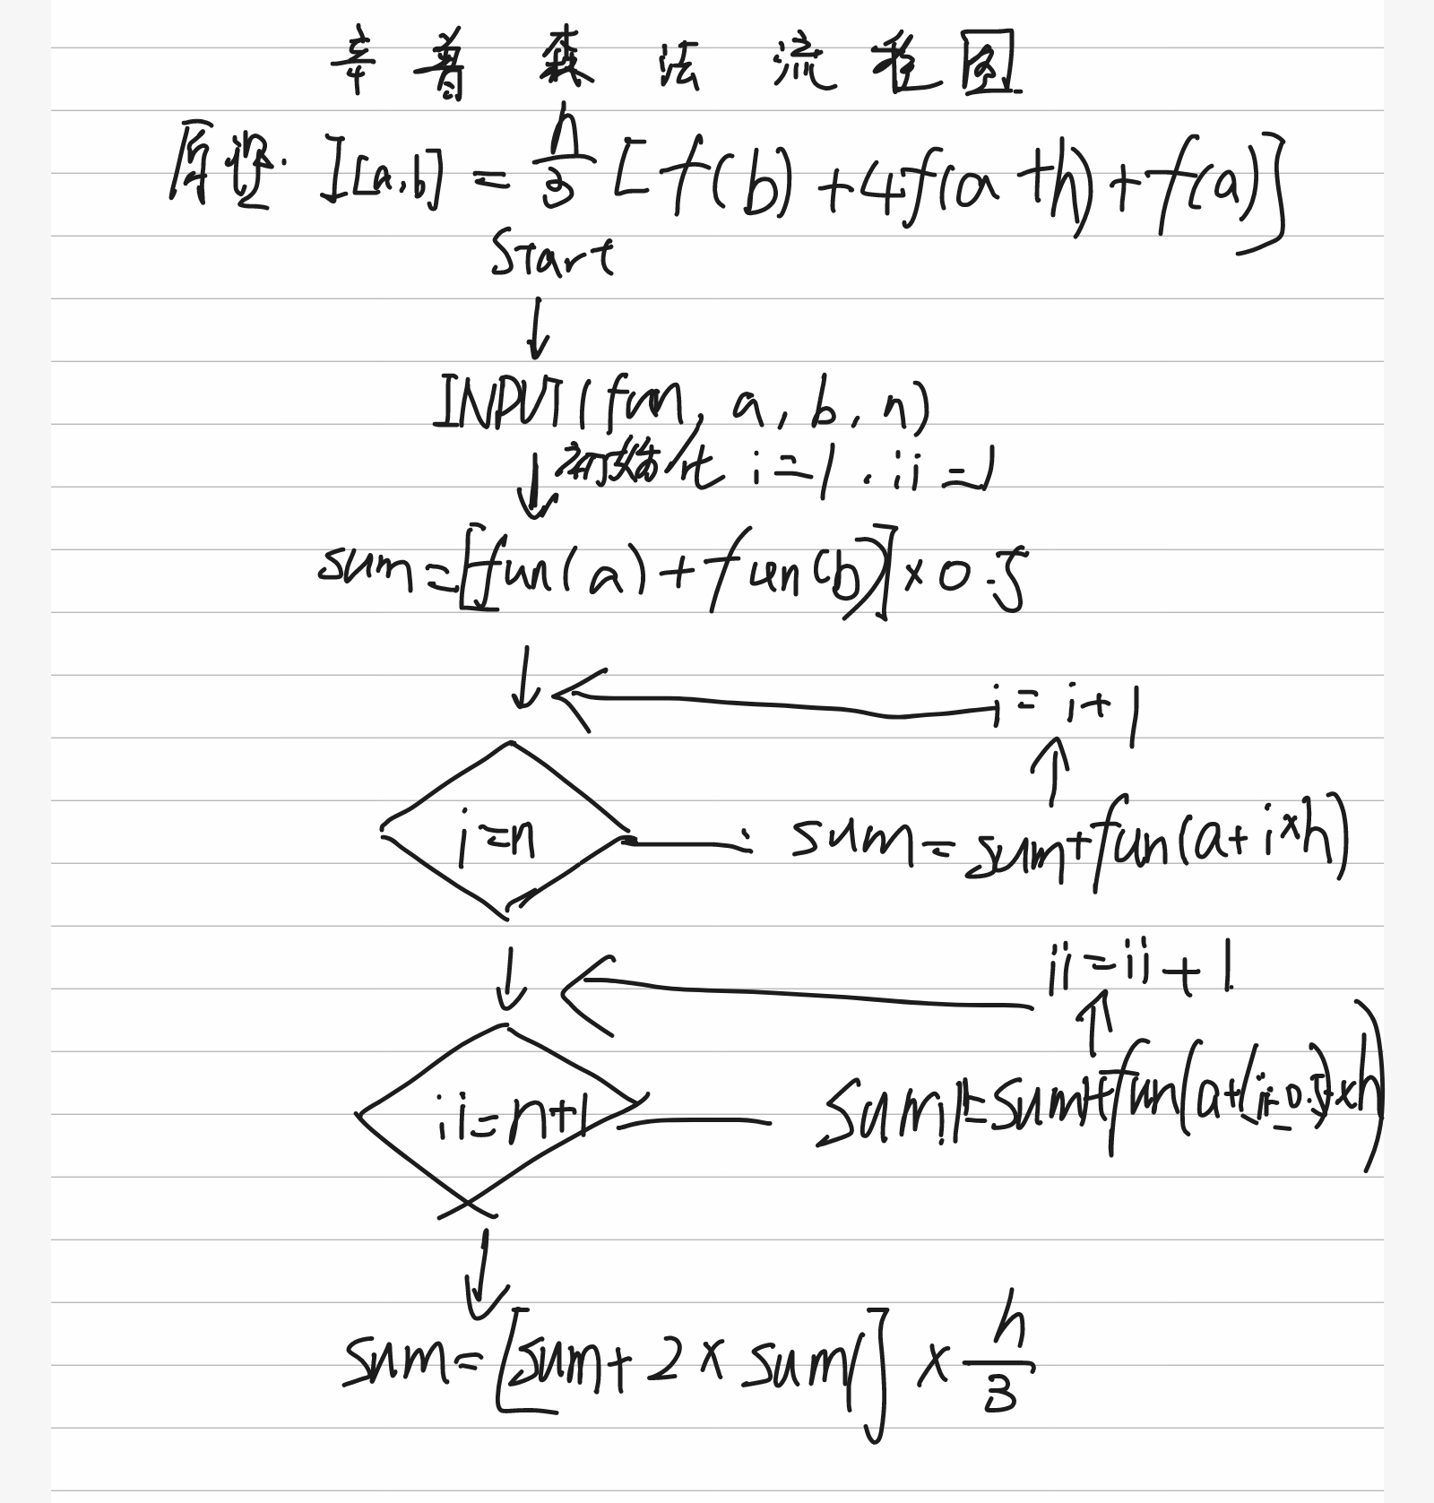

模型3

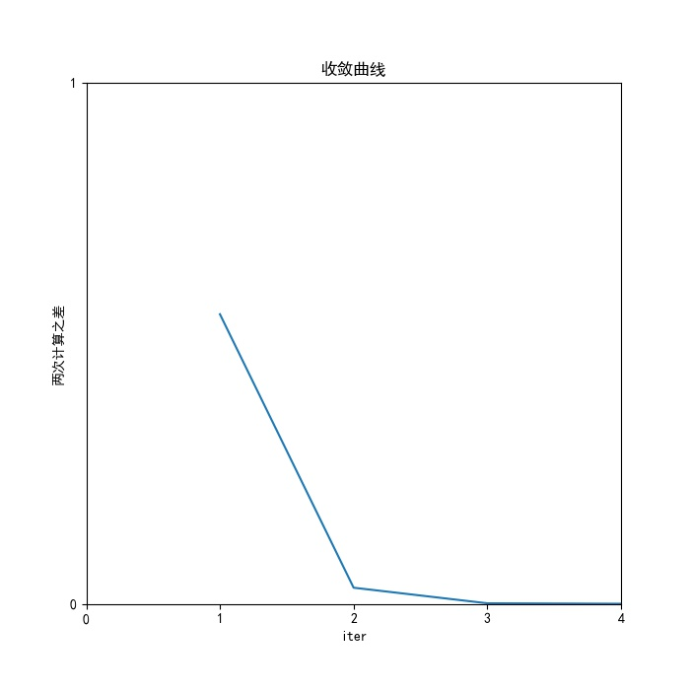

流程图

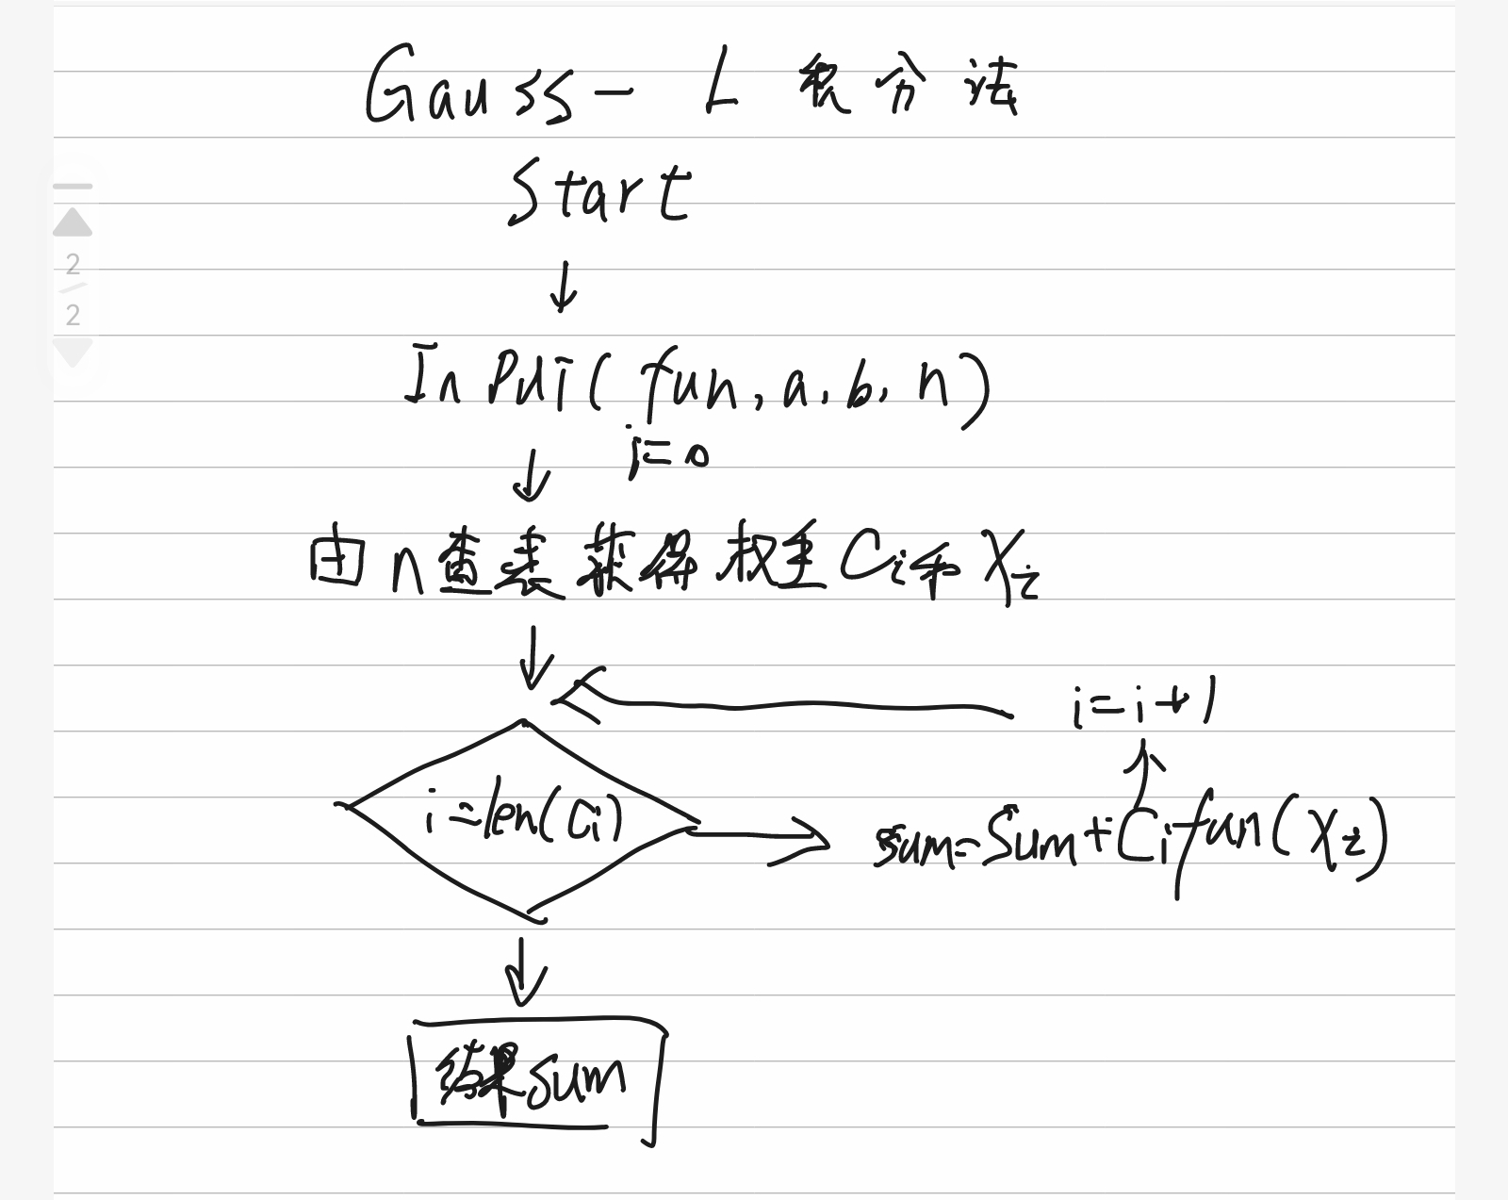

模型4

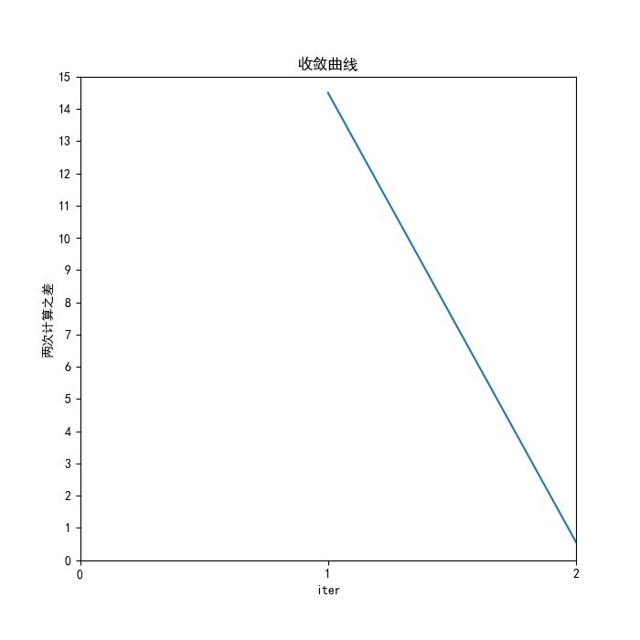

流程图

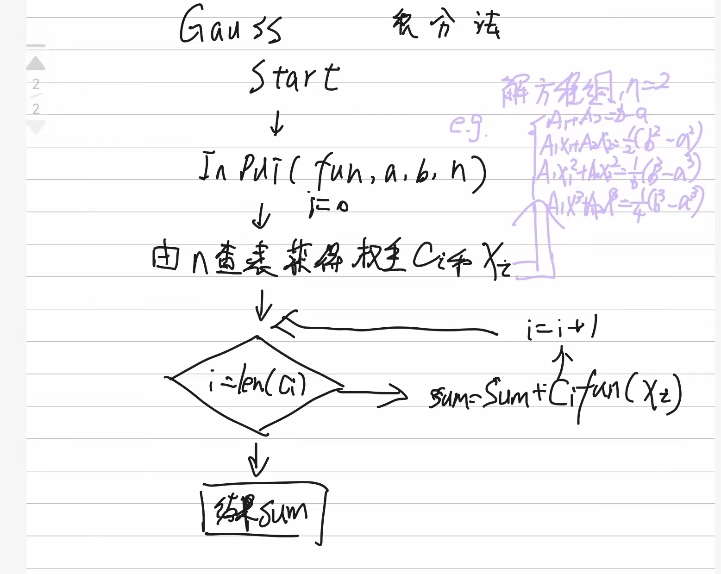

模型5

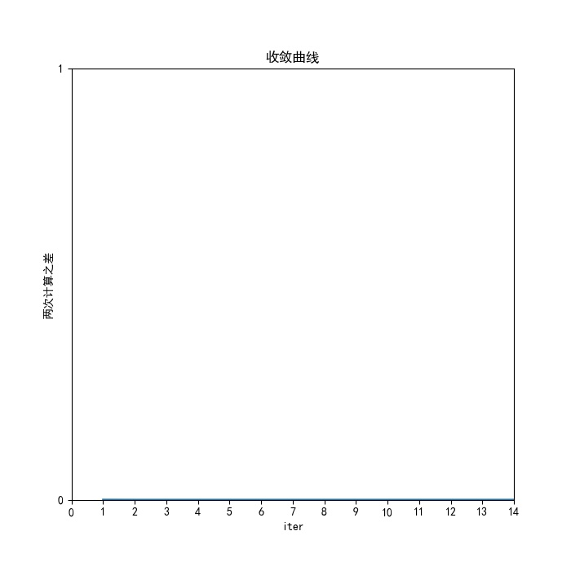

流程图

