[01] Lufeng Unit 1 (CGN)| Condenser modules lowered into position
Key words: CI MEH, condenser installation, integral module, jacking into position, modularisation
🔍Source:<IN-EN>- 陆丰核电1号机组凝汽器安装圆满收官
(FCD+19.9 months) On 23 October 2026, all three integral modules of the condenser in the conventional island of Lufeng Unit 1 were lowered into position, completing condenser installation. The complete assembly has a maximum weight of approximately 742 tonnes. The modules were assembled off site, transported as integral units and jacked into position, and their installation cleared the way for turbine generator installation and the hot functional test.
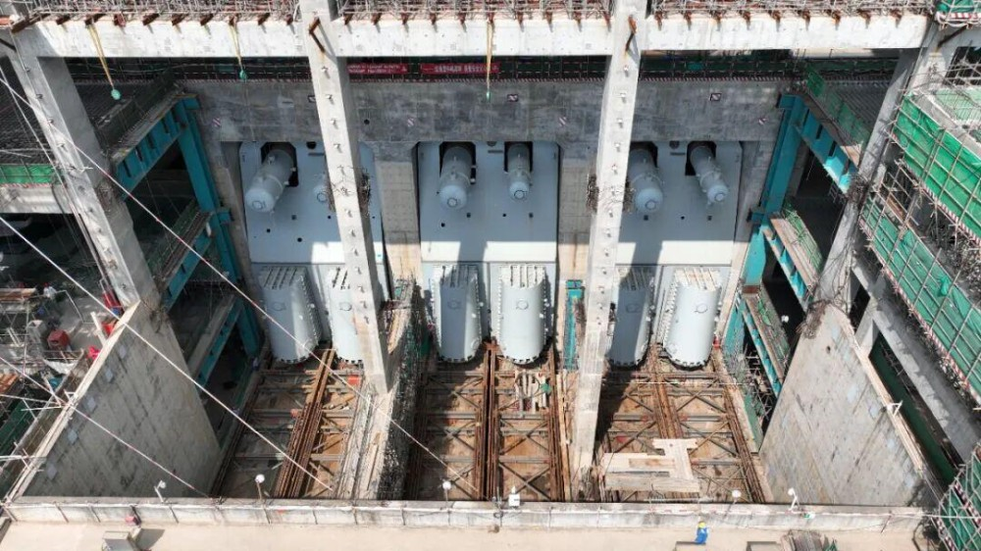
Three condenser modules in position in the conventional island at Lufeng Unit 1 (Image source: CGN).
The condenser modules are large and carry high self-weight loads, with stringent construction parameters and technical standards. The lower module, combined with its water chamber, weighs 508 tonnes, and the upper module weighs 123.6 tonnes. Working space was limited between individual modules and between the modules and the building structures, making lifting and transport complex and placing high demands on positioning accuracy.
The lower tube bundle, throat, water chamber and low-pressure heater were integrated into a single assembly, giving a modularisation rate of 97% and simplifying on-site work. Compared with the traditional method of piece-by-piece lifting and on-site fit-up and welding, which entailed heavy site welding, risks from concurrent operations and difficult positioning control, the approach shortened the critical-path duration by about two months.

