<https://www.online-banking.business.hsbc.com.cn/portalserver/logon>

IP: 111.18.3.173

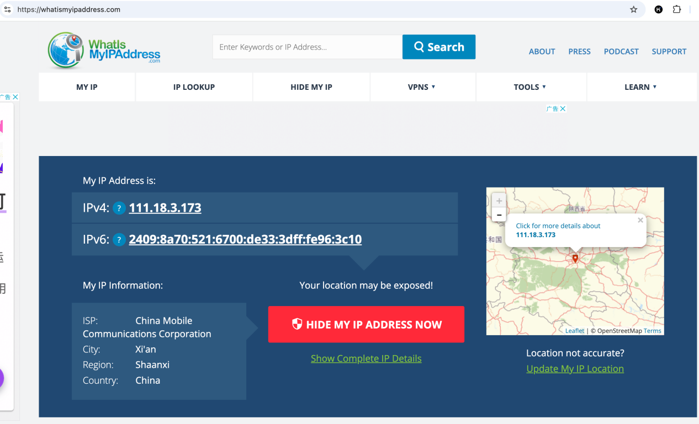

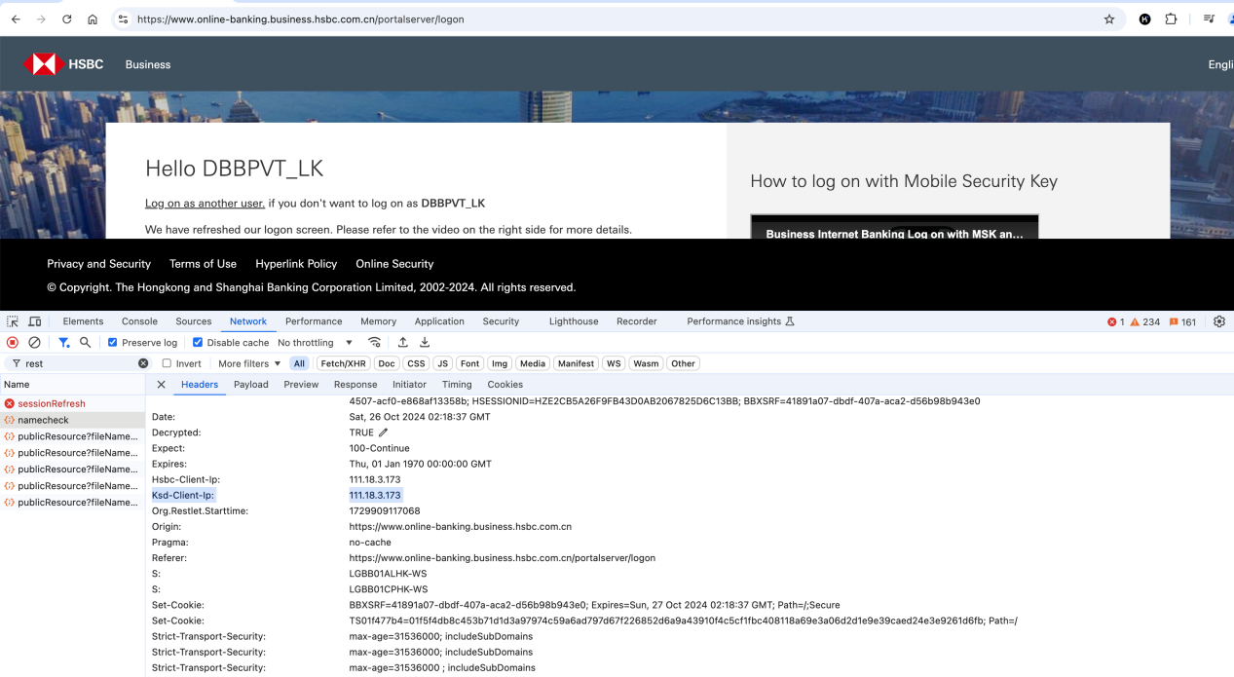

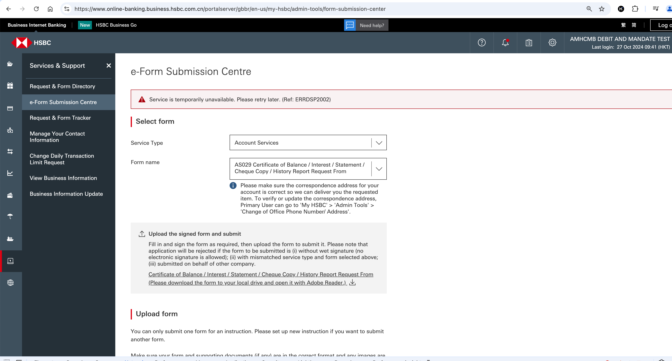

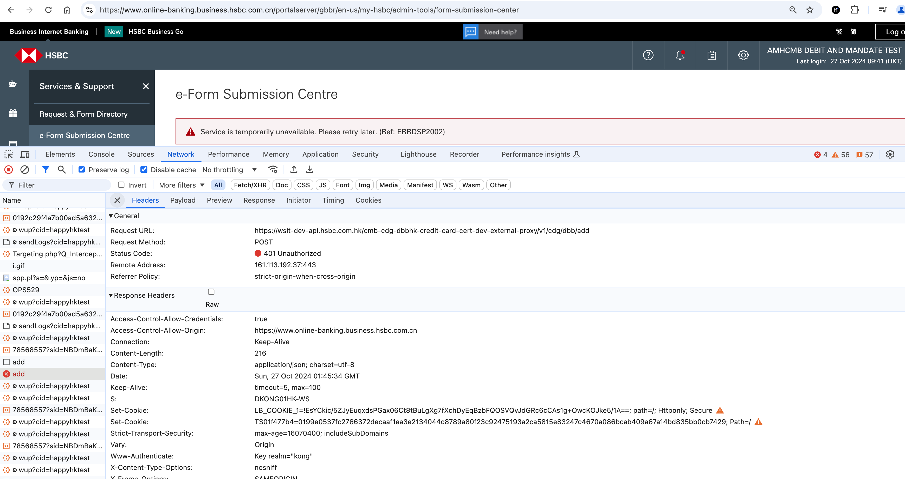

<https://wsit-dev-api.hsbc.com.hk/cmb-cdg-dbbhk-credit-card-cert-dev-external-proxy/v1/cdg/dbb/add>

{

"status": 401,

"type": "/authn-error/code/ERRDSP2002",

"errorDateTime": "2024-10-27T01:45:34Z",

"instance": "74f17fb0-909b-46f5-9425-3ccd0194de30",

"title": "Token Validation Exception",

"detail": "Token Validation Exception"

}

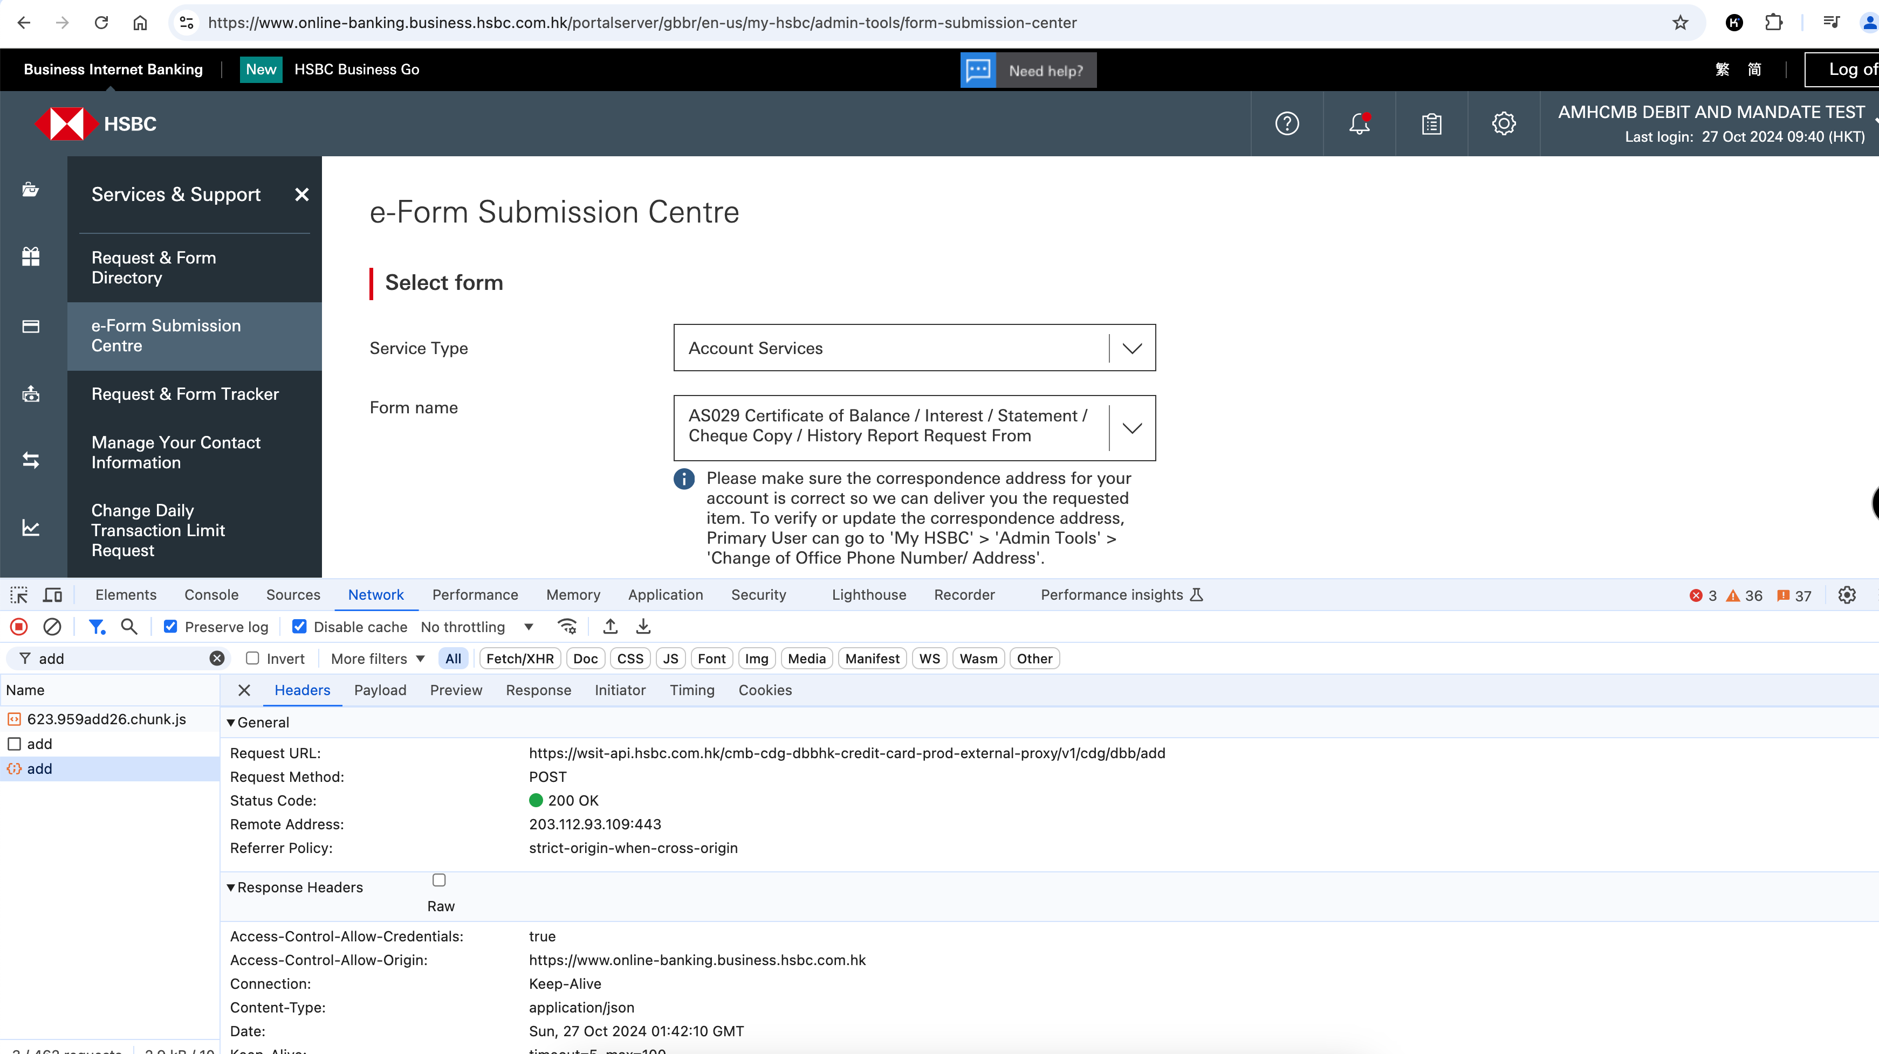

<https://wsit-api.hsbc.com.hk/cmb-cdg-dbbhk-credit-card-prod-external-proxy/v1/cdg/dbb/add>

[https://wsit-](https://wsit-dev-api.hsbc.com.hk/cmb-cdg-dbbhk-credit-card-cert-dev-external-proxy/v1/cdg/dbb/add)**[dev-](https://wsit-dev-api.hsbc.com.hk/cmb-cdg-dbbhk-credit-card-cert-dev-external-proxy/v1/cdg/dbb/add)**[api.hsbc.com.hk/cmb-cdg-dbbhk-credit-card-cert-dev-external-proxy/v1/cdg/dbb/add](https://wsit-dev-api.hsbc.com.hk/cmb-cdg-dbbhk-credit-card-cert-dev-external-proxy/v1/cdg/dbb/add)

<https://wsit-api.hsbc.com.hk/cmb-cdg-dbbhk-credit-card-prod-external-proxy/v1/cdg/dbb/add>