KeyPoints

1 [Summary Review] **A quantitative evaluation of the accuracy** and **a comparison with the alternative slower k nearest neighbor graph methods**.

[Review 1] If this method has any advantages over the existing kNNG methods other than query runtime performance. In Table 1, there is no similar comparison of matching error, such as in Table 3. There is also no comment in the paper about accuracy improvements. [done]

[Review 3] The "RC-kNNG Retrieval Performance" doesn't explain whether the alternative indexing structures retrieve the same parts.

**Response: 表和图还需要确认！**

* 他们想要accuracy (matching error in table 3) improvement

Given a test sketch includeing 20 sketches from different types.

用table 1内4种方法搜索，采用table 3内matching error（num_SF = 50，a test sketch of 20 including different types）：【RCKNNG with Wang与table3一致，其它3个以它为基准。

RCKNNG with BF与RCKNNG with Wang相同，因为虽然wang是近似组织section，虽然建立的rcknng有可能把不本来不相连的section连接起来，以best first search方法遍历图且只取前189个section，那么取得的189 section可能有本来不应该取进来的，从而使matching error变大。但又不会太大，因为毕竟你取的189相对seed section少，相对所有section更少。而且是best-first search，每次取matching error最小的section。所以不会差到0.15倍。

对于knng method可以做这样的例子，两shape ctour大部分相同，少部分不同（差异部分），但因为是global matching，所以有边相连。Query ctour与其中一个shape ctour的差异部分相匹配，基于knng，query ctour与另一shape ctour的差异部分相匹配，导致matching error变大。但也不会导致非常大，因为是best-first search，在匹配结果队列内取matching error最小的。但由于如上机制，导致其匹配结果相对rcknng有较大误差。这里可以给个visual result？BF knng相对Wang’s knng的matching error略小，毕竟人家是bf，绝对正确的，Wang是近似的，有些误差正常。】

|  |  |
| --- | --- |
|  | Matching error |
| Brute force kNNG | 0.53 |
| Wang’s kNNG approximation method | 0.563 |
| RC-kNNG with the brute force method | 0.442 |
| RC-kNNG with Wang’s method | 0.45 |

* Summary review与review 3的意思相同，都要求你把rcknng部分换为另外的，给出结果（建数据结构的时间，运行时间，matching error与visual result）。建数据结构时间，运行时间，matching error都已在表中给出。接下来必须给出visual result。

The 2 RCKNNG methods retrieve the similar parts. The two KNNG methods retrieve the similar parts. But the two types of methods retrieve different parts. The visual result is as follows:

[knng的特点是：因为全局匹配，导致两ctour有差异也被匹配到一起。基于knng的相邻性，将这两个ctour相连，query了一个去query另一个，恰好与差异部分匹配到一起。所以，你得举出sketch恰好是差异部分的例子，这样才能最大限度地区别开knng与rcknng。]

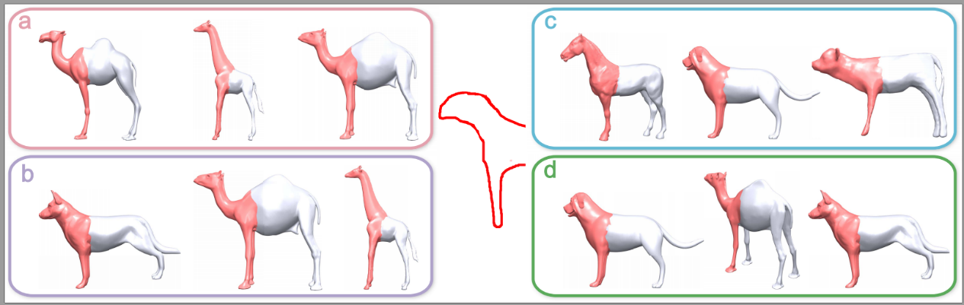

输入同一个sketch，分别采用4种方法搜索，从各搜索结果取出代表性的部件。可见a, b因为是全局匹配，所以其cand model的ctour具有全局相似性。而c, d是局部匹配方法，所以其cand model不必具有全局相似，而是candpart与sketch相似。【别人会不会觉得我们的方法得到的结果太好了？】

【我感觉knng效果更好，它会把全局相似的ctour组织到一起。这样，你query出的section，不仅与sketch相同，而且这些section所在的ctour全局相同。

首先，global matching会把相似的ctour连接到一起。在每一个ctour上，sketch滑动找到最匹配的section。尽管两个ctour间存在差异部分，但你是best-first search，总把最佳匹配section拿出来。那么，knng得到的结果不仅section本身与skech相匹配，而且各section’s parents具有较强的相似性。所以，knng会比rcknng的更好一些。但也不能让它太好，不然会给自己找麻烦。Knng的另外一个缺点是，它结果的各异性较差，因为必须是全局匹配的ctour才会连接。（在考虑这问题的时候就不能假设最佳匹配就是seed，knng方法可以直接找到最佳匹配）。

Knng的效果比rcknng略好的另一个根据：据文章描述，rcknng的motivation仅是要加速，并不涉及提高质量。

综上所述，knng（global matching）方法的效果要略好一些。就这么定了！

在实现上，你实现的方法是BF knng的效果，wang knng的效果与你差一个并且顺序换。Rcknng的效果可以用bf knng模拟，只需要挑一些不太像的结果出来。】

|  |  |
| --- | --- |
|  | Matching error |
| Brute force kNNG | 0.431 |
| Wang’s kNNG approximation method | 0.439 |
| RC-kNNG with the brute force method | 0.442 |
| RC-kNNG with Wang’s method | 0.45 |

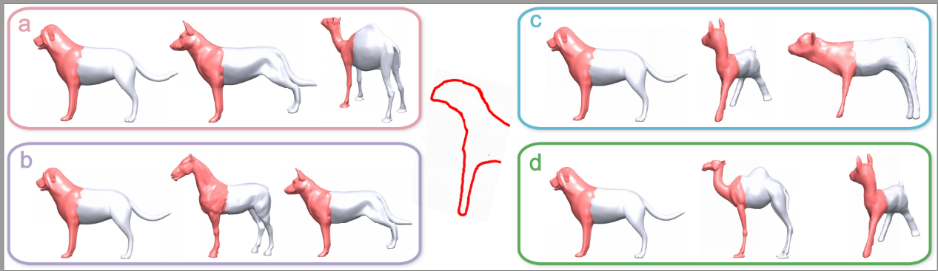

最好是在SFN=200下做实验：

|  |  |
| --- | --- |
|  | Matching error |
| Brute force kNNG | 0.061 |
| Wang’s kNNG approximation method | 0.064 |
| RC-kNNG with the brute force method | 0.069 |
| RC-kNNG with Wang’s method | 0.07 |

2016.5.18.20.00

全局匹配的应该质量差些都对。关键不在于bestsection被找到，而在于先找到谁，毕竟我们是收集前21c个section做candctour。那么，若是合局匹配并在runtime时传递得到section。那么，可能差异section被取到。所以，全局匹配质量会略差一些（仅是略差一些！）

|  |  |
| --- | --- |
|  | Matching error |
| Brute force kNNG | 0.074 |
| Wang’s kNNG approximation method | 0.081 |
| RC-kNNG with the brute force method | 0.07 |
| RC-kNNG with Wang’s method | 0.07 |

图也要跟着改：

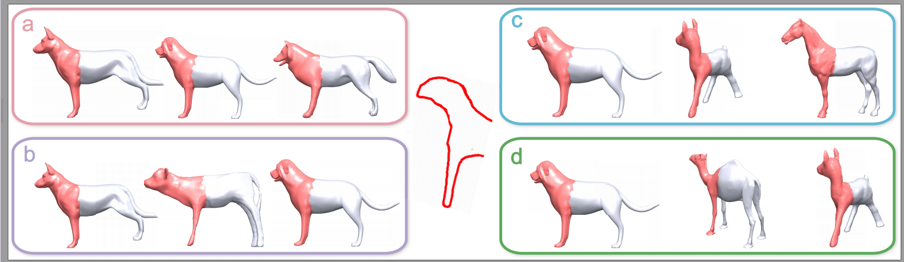

2 [Summary Review] **A comparison to simply segmenting the database**.

[Review 3] The primary weakness is a missing evaluation of the fundamental premise. The premise of the approach is that the example database becomes larger by implicitly containing all possible segmented parts. This is interesting and a worthwhile idea, but it is unevaluated. **Why not simply run segmentation on the database during preprocessing**? Then any of the approaches mentioned in the related work (sketch-based or 3D shape-based) which retrieve similar entire shapes from a database could be compared to. Can users no longer find the sub-parts they are looking for?

**Response:** 做如下实验：

1. fundamental premise：Good suggestion! The fundamental premise you note is is all the sketch-based shape retrieval’s premise. This is a very important idea and definitely worthwhile to evaluation. We left this for the future work.
2. PreSeg，extract parts’ctour，org into rcknng（global matching），query ctour通过global matching在rcknng内找到对应part。

得出这样的结论：在preseg方法中，若sketch针对a group of presagedparts或者irregular parts，则找不到合适的部件。

出个图，给2个sketch，一个sketch针对a group of presegparts，一个sketch针对irregular parts。各给出4个candpart结果，并给出a test 20 sketches on the preseg and unpreseg的matching error。下面解释原因。【直接把博士论文相关章节拿过来。】

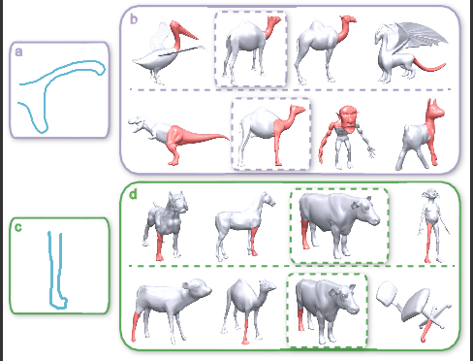

如上给出visual result，a, c是sketch，b,d是分别针对a,c的搜索结果。在b,d内，上层是preseg的，下层是ours的。可见ours的搜索结果与sketch更加匹配。b,d内分别用紫色与绿色框框信的部件来自同一模型，却形态不同，原因就是我们实习分割，找到与sketch最匹配的部件。在a set of 20 test sketches跑结果，ours的matching error如table3, 而preseg的matching error是0.624。明显比我们的差劲。原因是仅从预分割的数据库内搜索部件. 而我们是实时地找到并分割与用户sketch相匹配的部件。所以，我们的效果好。

3 [Review 2] In the result figures, the retrieved results are not very similar to the sketches. This can be good or bad. In the good case, no great matches are available in the system and the system does a good job in retrieving the best available matches. In this case that indicates robustness. In the bad case, there would be many similar or better retrieval candidates that the system fails to identify. How can I tell? Therefore, the traditional evaluation of retrieval problems uses quantitative metrics, e.g. precision, recall, F-score, precision-recall curves, average precision, ... and a comparison of these metrics to competing algorithms. **This submission does not provide quantitative results of the quality of the retrieval.**

**Response: 给出一张Precision-recall曲线图。（本来想有个average precision表，它与precision-recall图重复，所以不再要这个表了。）**

**用 a set of test 35 sketch（contour image）做为输入。对比算法包括前面的4种算法。**

我要衡量的几种算法是：

分析review的话可知：他无法判断你retrieval结果的好坏。可能有更好的结果，只是你没搜出来（there would be many similar or better retrieval candidates that the system fails to identify），也可能根本没有对应的结果，因为你很鲁棒所以得到当前的结果（no great matches are available in the system and the system does a good job in retrieving the best available matches）。那么，你必须去出曲线及图，来向人说明：你搜出的结果是你想要的结果，并不是还有更好的结果没被搜出来。你要出的图与表就是为了convece reviewer你搜出的结果与sketch不太像，是因为数据库内没有完全相同的结果，而你的算法非常鲁棒。

见“D:\OnTheFlyCutting\PaperRawmatSGP2016\PrecisionRecall”内excel文件

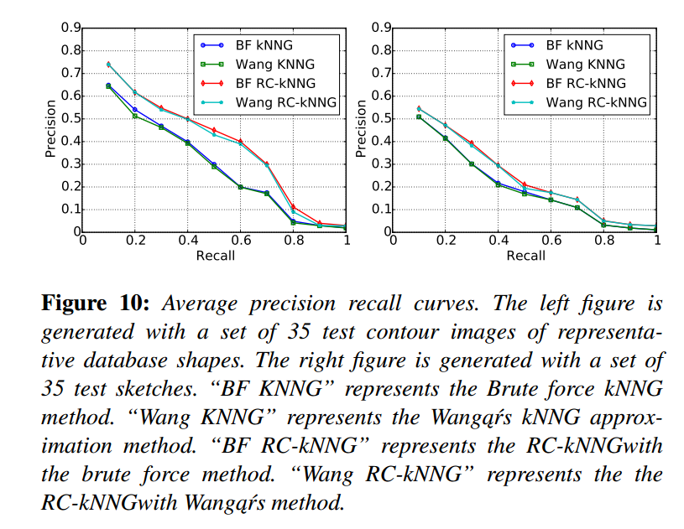

4 [Review 4] **missing discussion of choice number and location of camera views needed**. This seems to be a key issue, and would seem to depend on the types of objects in the data base.

**Response:** I plan to do experiments with different camera views:

1. 7 views (Same as [SXY∗11]): 3 canonical views (front, side, and top), 4 corner views from the top corner of its bounding cube.
2. 13 views (Same as [FMK∗03]): 3 canonical views (front, side, and top), 4 corner views from the top corner of its bounding cube, and the middle of six edges of a cube (tilt views).
3. 114 views (Same as “Fan L, Wang R, Xu L, et al. Modeling by Drawing with Shadow Guidance[J]. Computer Graphics Forum, 2013, 32(7):157–166”): 100 uniformly sampled views, 6 canonical side views and 8 corner views.

徐老师说：取一个由若干模型构成的数据库，取不同的camera view，出个曲线，主要是为了说明趋势与极限。所以，差不多就行。

注意，我的文章里提到513个model提取出10773个contour，即每个model 21个view。

5 [Review 2] **More retrieval results could be presented.** Instead of showing more retrieval results, the paper contains very rough sketches of quite adventerous applications. I understand that other papers follow the same template, but the underlaying strategy is to replace quality with quantity.

**Response:** I plan to add one example for each of the applications: “Sketch-driven assembly-based modeling”, “Contour-driven shape completion”, “Shape variation”, “part suggestion”, and “Symmetry-aware selection and editing”.

6 [Review 4] There are examples of results for a user sketch, but it is not clear whether this is just a sample “user sketch” made by one of the authors. Similar to FKS04, a **compelling test would be to give the user something specific to design from pieces of objects in the database**.

**Response:** I plan to add one example: Given the concept design (a photo), the user draw sketches (tracing the contour of the object in the photo). The 3D parts are retrieved through our method. Finally the object in the photo is resembled by the retrieved parts.

7 [Review 4] In the example applications, the ideas are interesting, but **the pose of the partial shape used for computing the boundary contours appear carefully selected**.

**Response: I am not sure what does “the pose of the partial shape” refer to!**

Does it mean the pose of the lamp in figure 10?

8 [Review 3] Does the proposed approach work on a different database than the one it was developed with?

**Response:** I plan to clarify this point as follows:

“I develop the approach on a database including 43 shapes from different categories. The database is then extended to 513 shapes when we do experiments and generate examples.”

9 [Review 1] **Why the descriptor as described in sec 5.1 is invariant to the index ordering of the contour polylines**. IE, for two contours, the descriptor only makes sense if the (i,j) indices of the matrix refer to points in comparable relative spatial locations. In other words, where does 'i' start on each polyline?

[Review 3] **Are contours sampled uniformly from directions around the unit sphere** (Section 4, third paragraph)?

**Response:**  I plan to revise the text as follows:

“The contours are sampled from the counter-clockwise direction around the unit sphere. In each section, ‘i’is the first sampling point in the sense of counter-clockwise direction.”

10 [Review 2] **The partial shape matching problem is not well specified**. It is difficult to define a metric that computes the quality of partial matches and it is already difficult to get humans to agree on what partial matches are good or not. This is a general problem, also for other methods in this area, but I feel it could have been tackled a bit better.

**Response:** Does this comment ask us to give the partial shape matching problem an formal definition?

[Review 1] Fig 12 shows a global symmetry example. **Would local symmetry/similarity matching also be possible**?

**Response:** I plan to add an example showing the local symmetry matching.

12 [Review 4] the extreme simplicity of the partial shapes used. In a significant database an extraordinarily large number of partial geometries could match the very simple sketches used here.

**Response:** I plan to revise the text as follows:

“The contextual information could be adopted to assist our partial matching algorithm. We leave this for the future.”

13 [Review 4] the very small size of the data based searched. There are obviously larger data sets available, making it seem suspicious that this doesn’t scale well.

**Response:** Our RCKNNG is designed to deal with the large database.