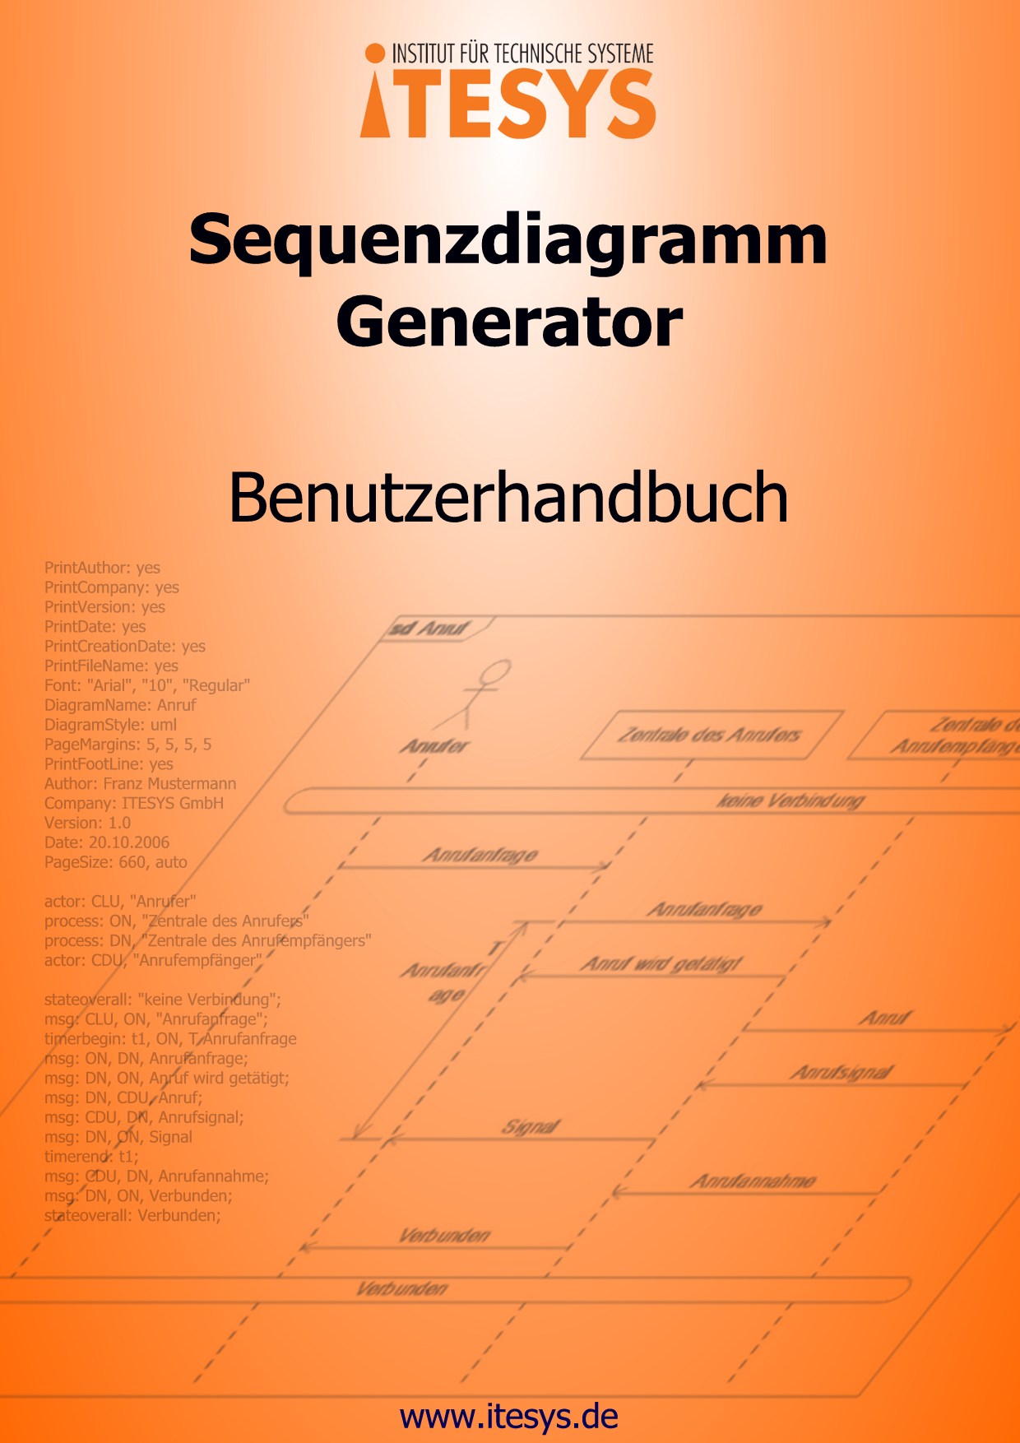

1 Introduction 3
2 Overview 5
2.1 The Text Editor 5
2.2 The Graphical Output 6
3 The User Interface 7
3.1 Main Window 7
3.2 Graphical Output (Diagram View) 10
3.3 Text Editor 11
3.4 Dialogs 15
3.4.1 Dialog Worksheet 15
3.4.2 Dialog Properties 16
3.4.3 Dialog Comment 19
3.4.4 Dialog ProcessCreate 20
3.4.5 Dialog FoundMessage 21
3.4.6 Dialog FragmentBegin 22
3.4.7 Dialog FragmentText 23
3.4.8 Dialog Instance 24
3.4.9 Dialog LineComment 25
3.4.10 Dialog LostMessage 26
3.4.11 Dialog Mark 27
3.4.12 Dialog MeasureBegin 28
3.4.13 Dialog MeasureEnd 29
3.4.14 Dialog MeasureStart 30
3.4.15 Dialog MeasureStop 31
3.4.16 Dialog Message 32
3.4.17 Dialog MessageBegin 33
3.4.18 Dialog Reference 34
3.4.19 Dialog Region 35
3.4.20 Dialog SetTimer 36
3.4.21 Dialog State 37
3.4.22 Dialog StopTimer 38
3.4.23 Dialog Task 39
3.4.24 Dialog TimeOut 40
3.4.25 Dialog TimerBegin 41
3.4.26 Dialog TimerEnd 42
4 First Steps 43
5 The Export Function 51

Introduction

Sequence diagrams make it possible to represent concrete interactions between system components in a simple and clear graphical form. The most popular formats are the “sequence diagrams” (SD), which are defined in UML2.0; and “message sequence charts” (MSC) defined in the SDL standard. In this manual we will use the term sequence diagram to refer to both variants. An introduction to MSCs can be found at the SDL Forum Society www.sdl-forum.org. SDs are defined in the “UML Superstructure Specification”, which can be downloaded from www.omg.org. Additionally almost every book UML 2.0 describes provides a description of SDs.

Sequence diagrams have a very broad application domain – from requirements to documentation and test cases. They are easy to understand and therefore an ideal basis for discussions between all project members. MSCs or SDs are often not used in projects, because it takes serious effort to draw sequence diagrams with other tools and even more effort later to keep the diagrams consistent. Avoiding this additional overhead results in incomplete documentation, which could be considered an acceptable risk in the initial project phases but is normally regretted at a later point in time. Documenting the previous phases of the project and especially the performed test cases is difficult and often impossible because the number of test cases increases as the project grows.

We have had similar experience with multiple projects and have asked ourselves how we could avoid this problem in the future. We came to the conclusion that we need a tool which allows us to easily and quickly create and edit sequence diagrams. We want to concentrate on the contents and not waste time in improving the readability of the diagrams by modifying the widths of boxes or the space between certain diagram elements. Perfectly, the sequence diagrams would be neatly drawn by the tool itself.

In our projects we very often had to work with special and system customized development and testing tools, which provide a highly customizable interface for data output. We used this as a starting point for the development of a diagram generator, which generates high quality diagrams from clearly defined and easily readable diagram description. Quite consciously we chose not to use the XML based XMI definition language because in our opinion it is way to complex to use it to manually edit sequence diagrams on a daily basis. Therefore we developed our own, more intuitive, description language. The grammar and the vocabulary of our sequence diagram descriptions are simple and readable so that it is easy to learn. The following example shows a generated sequence diagram together with its corresponding description.

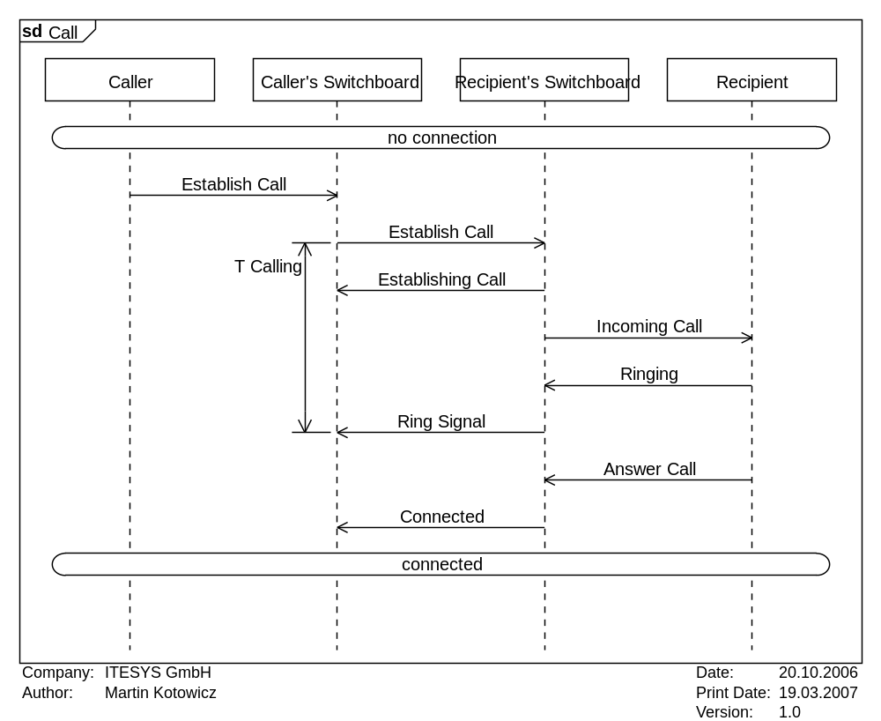 | DiagramName: Call  DiagramStyle: uml  PageMargins: 5, 5, 5, 5  PageSize: auto  actor: CLU, "Caller"  process: ON, "Caller’s Switchboard"  process: DN, "Recipient’s Switchboard"  actor: CDU, "Recipient"  stateoverall: "no connection";  msg: CLU, ON, "Establish Call";  timerbegin:T1, ON, T Calling  msg: ON, DN, Establish Call;  msg: DN, ON, Establishing Call;  msg: DN, CDU, Incoming Call;  msg: CDU, DN, Ringing;  msg: DN, ON, Ring signal  timerend: T1;  msg: CDU, DN, Answer Call;  msg: DN, ON, Connected;  stateoverall: connected;

The descriptions are plain text files which could be generated by the data output interface of many tools.

In order to make it as convenient as possible to manually create sequence diagrams we have developed a graphical interface which offers useful functionality and actively supports the user.

This kind of diagram generation proved its qualities already with the initial version of our generator in many projects in which the traditional approach would have failed due to the above mentioned reasons. Our tool can be applied for tasks like the manual creation of development documentation, which needs to be changed quite often especially in the initial project phases, and test documentation, which could be generated directly from the source code of the executed test sequences. With each project we learn something new and we constantly try to make our generator more effective, so that the future projects of our clients are not delayed or fail to fulfill the increasing requirements for the project documentation.

Overview

The central elements of the generator are the text editor and the graphical output. In the upper part of the software’s window there is a detailed menu for the functions: file management, export, and printing, edit tools and view options. The toolbar under the menu provides for fast access to the most important menu items. At the bottom of the windows there is a status line which shows important information.

The Text Editor

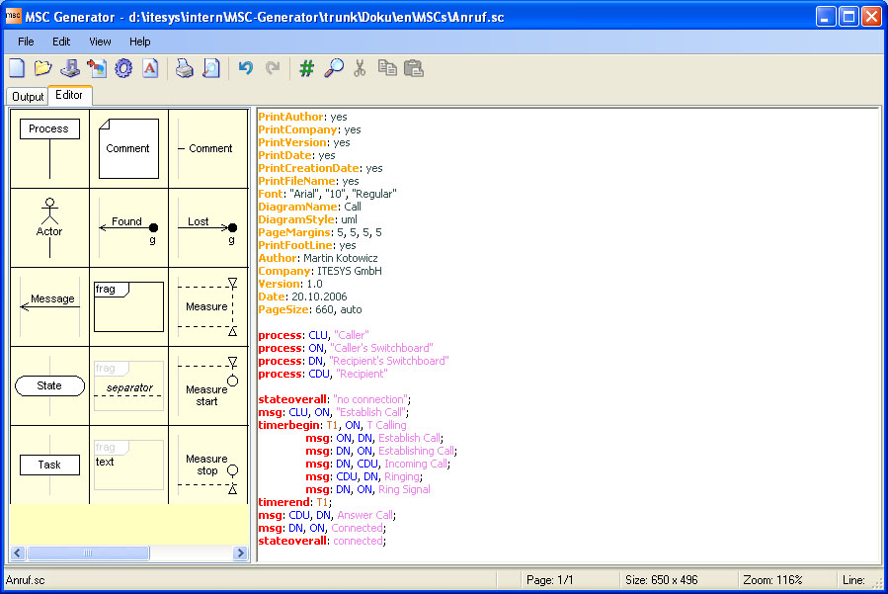

The generator’s text editor provides for a convenient way to create and edit the sequence diagrams. The user has access to a number of functions which are described in Section 3.2 of this manual. Of course it is also possible to write the sequence diagram descriptions in any text editor you like.

The Graphical Output

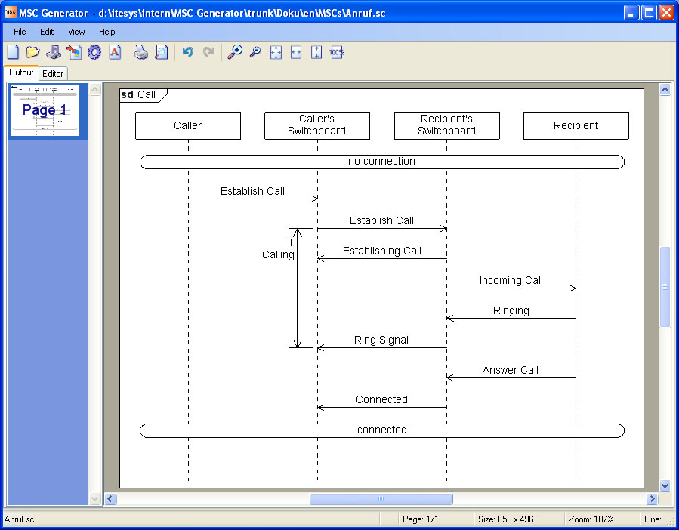

The graphical output displays the sequence diagram in graphical form. In this view the user can modify the sequence diagram and the changes will automatically be applied to the textual description. A detailed description of the graphical output is presented in Section 3.3 of this manual.

The User Interface

The software offers a graphical user interface which provides the user with easy access to all of the generator’s functionality. The user interface contains of three parts: main window, text editor and the graphical output. A number of dialogs are provided to simplify the creation and modification of diagrams. These dialogs make it possible to modify the diagram description directly in the graphical diagram output.

Main Window

The main window of the application contains the menu bar and the task bar at its top. You can switch between the text editor and the graphical output in the middle part of the main window. At the bottom of the window the status line is located.

- Menu Bar

The menu bar at the top of the main window provides the following functions:

The diagram description in the textual editor will be reset to an empty diagram. The general format properties will be reset to default values.
Loads an existing diagram description and updates the graphical output.
Saves the current diagram description in a file. If the description has not already been saved then the user is asked under which name to save the diagram description.
Saves the diagram description under a new name.
Saves the generated sequence diagram as an image file. A detailed description of the export functionality is provided in Section 5 of this manual.
Opens the printer configuration dialog.
Opens the print dialog for printing the currently opened sequence diagram.
Displays a print preview of the currently opened diagram.
Opens a dialog which enables you to modify the basic diagram and page options. A detailed description of the Properties Dialog is provided in Section 3.4 of this manual.
Exits the application.

Deletes the text selected in the text editor and copies it in the Windows clipboard.
Copies the text selected in the text editor to the Windows clipboard.
Pastes the text from the Windows clipboard at the current cursor position in the text editor.
Deletes the text select in the text editor without copying it to the Windows clipboard.
Opens the search dialog.
Searches the next occurrence of the last searched text in the text editor.
Opens the search and replace dialog.
Comments or uncomments the text lines selected in the text editor.
Selects all the text in the text editor.
Undoes the last performed action.
Redoes the last undone action.

Increases the zoom level of the diagram view with 10%.
Decreases the zoom level of the diagram view with 10%.
Rescales the diagram fits the window.
Rescales the diagram to fit the width of the window.
Rescales the diagram to fit the height of the window.
Sets the zoom level of the diagram view to a predefined zoom factor. The possible values are:
300%, 200%, 100%, 66%, 50%, 33%, 25%, 10%.

Opens the About dialog.
Opens the help file.

- Toolbar

The toolbar provides fast access to the most commonly used menu items. The toolbar buttons will be enabled or disabled depending on the currently selected view (text editor or graphical display).

The diagram description in the textual editor will be reset to an empty diagram. The general format properties will be reset to default values.
Loads an existing diagram description and updates the graphical output.
Saves the current diagram description in a file. If the description has not already been saved then the user is asked under which name to save the diagram description.
Saves the generated sequence diagram as an image file.
Opens a dialog which enables you to modify the basic diagram and page options.
Opens a dialog for selecting the font for a sequence diagram.
Opens the print dialog for printing the currently opened sequence diagram.
Displays a print preview of the currently opened diagram.
Undoes the last performed action.
Redoes the last undone action.
The following buttons are only available in the graphical diagram output:
Increases the zoom level of the diagram view with 10%.
Decreases the zoom level of the diagram view with 10%.
Rescales the diagram fits the window.
Rescales the diagram to fit the width of the window.
Rescales the diagram to fit the height of the window.
Sets the zoom level of the diagram view to 100%.
The following buttons are only available in the text editor:
Comments or uncomments the text lines selected in the text editor.
Opens the search dialog.
Deletes the text selected in the text editor and copies it in the Windows clipboard.
Copies the text selected in the text editor to the Windows clipboard.
Pastes the text from the Windows clipboard at the current cursor position in the text editor.

- Editor/Output

The central part of the main window you can switch between the views of the text editor and the graphical output. Each of these views are described in detail in the following subsections.

- Status Line

The status line shows information for the currently open diagram. The following information is presented from left to right:

The name of the diagram description file, which is currently opened and edited.
Signals whether the editor is in the overwrite mode. If this field is empty then the insert mode is selected.
Shows the number of the page displayed in the graphical output view and the total number of diagram pages.
Shows the size of the diagram displayed in the graphical output view. Page margins are not subtracted.
Show the current zoom level.
The line in the text editor where the cursor is positioned.

Graphical Output (Diagram View)

The graphical output displays the sequence diagram which was generated from the diagram description. It additionally provides dialogs over which the diagram format and its elements can be modified. Such modifications are automatically applied to the diagram description.

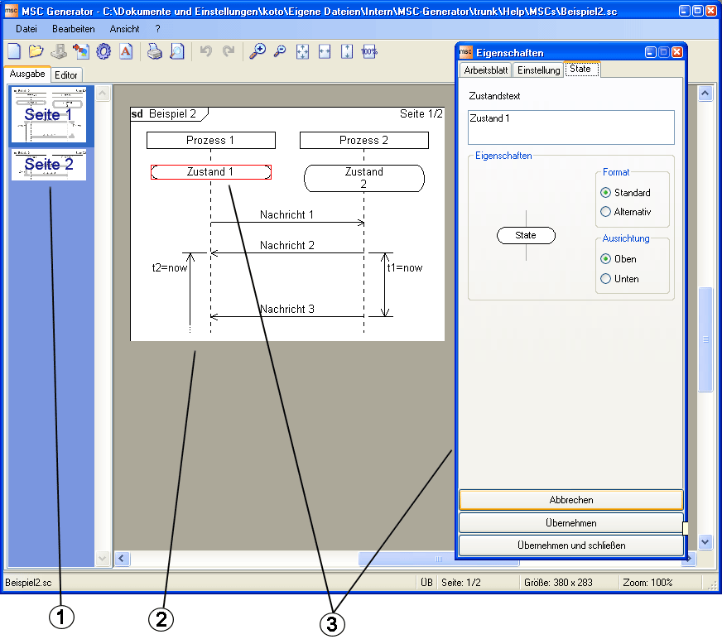

- On the left side there is a preview of the sequence diagram pages. After clicking on a page thumbnail the corresponding page will be displayed in output (the right part of the view).
- The output should the selected page of the generated sequence diagram. The footer and the page margins are excluded. The diagram can be freely moved and zoomed. You can zoom with the combination of the “Ctrl” button and the mouse wheel.
- Click on a diagram element to open the element dialog, which you can use to modify the properties of the element. The selected element will be selected with a red box. The modification will be applied and made visible to the diagram only after clicking the “Apply” or “Apply and Close” buttons of the element dialog. Detailed descriptions of the element dialogs are provided in Section 3.4.

Text Editor

The integrated text editor can be used to create and edit diagram description files. Additionally predefined command snippets are provided, which can be inserted in the diagram description just by clicking on the corresponding diagram symbol.

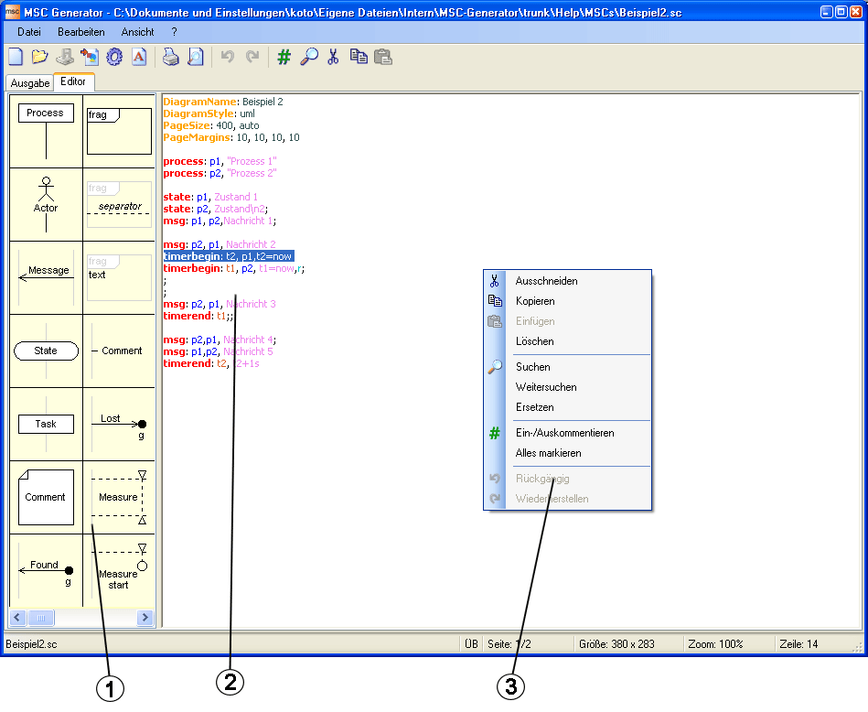

- On the left side there is a list of diagram elements, the code snippets for which can be inserted with just a mouse click at the cursor position in the diagram description. The editor can determine how exactly to apply the code snippet. For example, when selecting multiple lines the timer begin command will be inserted before the first selected line and the timer end will be inserted after the last selected line. The following diagram elements are available and can be inserted as snippets:
SDL | UML | Diagram Element
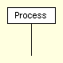 |  | Instance as a Process
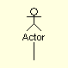 |  | Instance as an actor
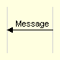 | 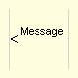 | Message
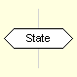 | 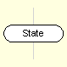 | State
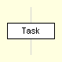 |  | Tast/Action
 |  | Comment
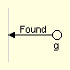 | 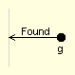 | Found message
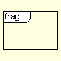 |  | Combined fragment
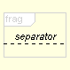 |  | Separator line for a combined fragment
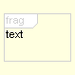 |  | Text to be display at the top left corner of a combined fragment
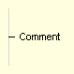 |  | Non-box comment
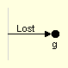 | 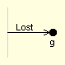 | Lost message
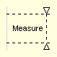 |  | Measurement
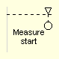 |  | Begin of a non-connected measurement
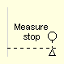 |  | End of a non-connected measurement
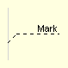 |  | Mark
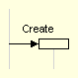 | 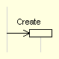 | Process creation
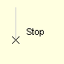 |  | Process end / Process deletion
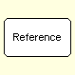 | 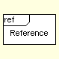 | Reference to another sequence diagram
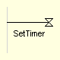 |  | Begin of a non-connected timer
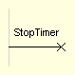 |  | Aborting of a non-connected timer
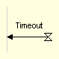 | 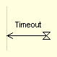 | End of a non-connected timer
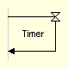 | 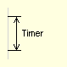 | Connected Timer
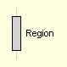 |  | Region (alternative lifeline display mode)

- The editor displays the description of the sequence diagram. Highlighting is used to improve the readability of the diagram code. The following description elements are described as follows:
- Formatting command
- Formatting parameter
- Diagram element command
- Diagram element – identifier
- Instance – identifier
- Display text
- Diagram Element – formatting parameter
- Comment, not interpreted and displayed in the generated diagram.

Detailed descriptions of all available commands and their parameters are available in the “Commands Set” manual.
- This context menu appears after a click in the editor window with the right mouse button. The context menu provides the commands most commonly used fort he creating and edition of diagram description files.

Dialogs

The dialogs make it possible to modify the diagram description from the diagram view. This holds for the diagram format and the individual diagram elements. Many diagram elements have their own dialog, which will become available after a mouse click on the corresponding diagram element in the graphical output view. In this chapter all available dialogs will be introduces and the function of their corresponding diagram elements will be described.

Dialog Worksheet

In this dialog you can change the properties of the diagram workspace. The changes will take effect in the diagram only after you click the button "Apply" or "Apply and Close". The button "Cancel" closes the dialog and you will lose all changes which have not been applied.

 | 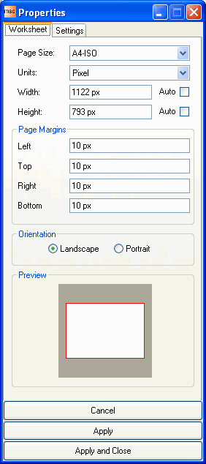
  Page Size
  Sets the size of the diagram sheet.
  Units
  Selects the units for the diagram worksheet size.
  Width
  Configures the width of the worksheet (including page margins).
  auto Width
  Configures the generator to automatically determine the width of the diagram based on the number of processes.
  Height
  Configures the height of the worksheet (including page margins).
  auto Height
  Configures the generator to automatically determine the width of the diagram based on the number of actions.
  Margins Left
  Configures the width of the left diagram margin.
  Margins Top
  Configures the height of the top diagram margin.
  Margins Right
  Configures the width of the right diagram margin.
  Margins Bottom
  Configures the height of the bottom diagram margin.
  Orientation Landscape
  Configures a horizontal paper orientation.
  Orientation Portrait
  Configures a vertical paper orientation.
  Preview
  Shows the proportion between the diagram height and width and the page margins.
  Cancel
  Closes the properties dialog without applying any changes to the diagram.
  Apply
  Applies all changes to the diagram.
  Apply and Close
  Applies all changes to the diagram and closes the properties dialog.

Dialog Properties

In this dialog you can change the properties of the diagram. The changes will take effect in the diagram only after you click the button "Apply" or "Apply and Close". The button "Cancel" closes the dialog and you will lose all changes which have not been applied.

 | 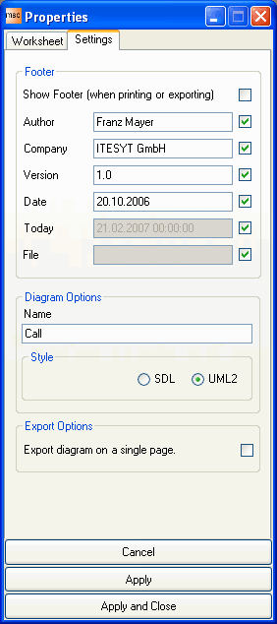
  Show Footer
  Configures whether the footer should be displayed when printing or exporting. The height of the footer is subtracted from the height of the worksheet.
  Author
  Sets the author name.
  Author Checkbox
  Determines whether the author's name will be printed in the footer when exporting or printing.
  Company
  Sets the company name.
  Company Checkbox
  Determines whether the company's name will be printed in the footer when exporting or printing.
  Version
  Sets the version of the diagram.
  Version Checkbox
  Determines whether the diagram's version will be printed in the footer when exporting or printing.
  Date
  Sets the date that should be printed in the footer.
  Date Checkbox
  Determines whether the diagram's date will be printed in the footer when exporting or printing.
  Today Checkbox
  Determines whether the current date will be printed in the footer when exporting or printing.
  File Checkbox
  Determines whether the diagram's file name will be printed in the footer when exporting or printing.
  Diagram Name
  Defines the name of the diagram. The name appears in the top left corner of the diagram. It is not necessary to specify "msc" or "sd".
  Diagram Style SDL
  Create SDL conform diagrams.
  Diagram Style UML2
  Create UML 2.0 conform diagrams.
  Export diagram on a single page
  When exporting the diagram will be created on a single page ignoring all manual or automatic page breaks.
  Cancel
  Closes the properties dialog without applying any changes to the diagram.
  Apply
  Applies all changes to the diagram.
  Apply and Close
  Applies all changes to the diagram and closes the properties dialog.

Dialog Comment

In this dialog you can modify the properties of a comment diagram element. The changes will take effect in the diagram only after you click the button "Apply" or "Apply and Close". The button "Cancel" closes the dialog and you will lose all changes which have not been applied.

 | 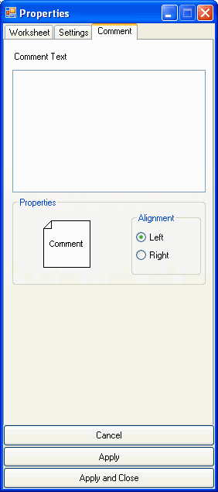
  Comment Text
  The text which should be displayed.
  Alignment Left
  The comment will be displayed to the left of the lifeline or at the left side of the diagram.
  Alignment Right
  The comment will be displayed to the right of the lifeline or at the right side of the diagram.
  Cancel
  Closes the properties dialog without applying any changes to the diagram.
  Apply
  Applies all changes to the diagram.
  Apply and Close
  Applies all changes to the diagram and closes the properties dialog.

Dialog ProcessCreate

In this dialog you can modify the properties of a create process diagram element. The changes will take effect in the diagram only after you click the button "Apply" or "Apply and Close". The button "Cancel" closes the dialog and you will lose all changes which have not been applied.

 | 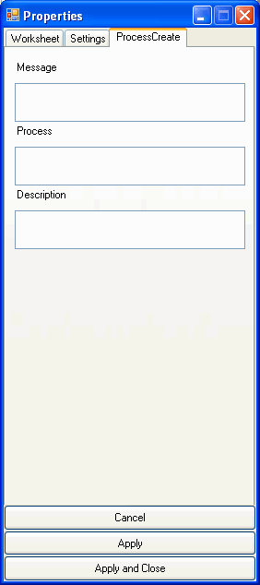
  Message
  The text that should appear as message.
  Process
  The name of the newly created process
  Description
  Description of the new process. The description will be displayed above the process.
  Cancel
  Closes the properties dialog without applying any changes to the diagram.
  Apply
  Applies all changes to the diagram.
  Apply and Close
  Applies all changes to the diagram and closes the properties dialog.

Dialog FoundMessage

In this dialog you can change the properties of the diagram element Found Message. The changes will take effect in the diagram only after you click the button "Apply" or "Apply and Close". The button "Cancel" closes the dialog and you will lose all changes which have not been applied.

 | 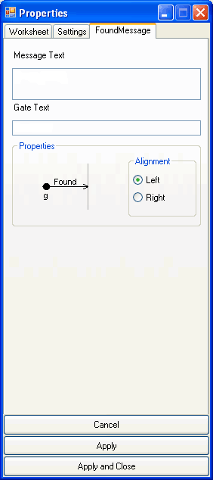
  Message Text
  The text that will be displayed in the message.
  Gate Text
  The text that will be displayed under the gate of the found message.
  Alignment Left
  The found message will be displayed to the left of the lifeline.
  Alignment Right
  The found message will be displayed to the right of the lifeline.
  Cancel
  Closes the properties dialog without applying any changes to the diagram.
  Apply
  Applies all changes to the diagram.
  Apply and Close
  Applies all changes to the diagram and closes the properties dialog.

Dialog FragmentBegin

In this dialog you can change the properties of the diagram element Combined Fragment. The changes will take effect in the diagram only after you click the button "Apply" or "Apply and Close". The button "Cancel" closes the dialog and you will lose all changes which have not been applied.

 | 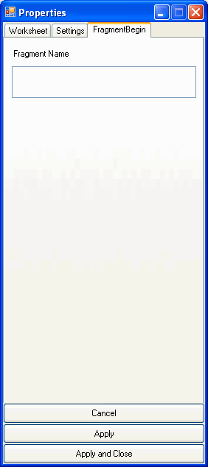
  Fragment Name
  The text that will appear as the name of the combined fragment.
  Cancel
  Closes the properties dialog without applying any changes to the diagram.
  Apply
  Applies all changes to the diagram.
  Apply and Close
  Applies all changes to the diagram and closes the properties dialog.

Dialog FragmentText

In this dialog you can change the properties of the diagram element Fragment Text in a combined fragment. The changes will take effect in the diagram only after you click the button "Apply" or "Apply and Close". The button "Cancel" closes the dialog and you will lose all changes which have not been applied.

 | 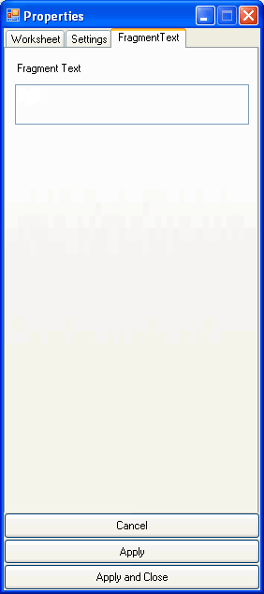
  Fragment Text
  The text that will appear on the left of the combined fragment.
  Cancel
  Closes the properties dialog without applying any changes to the diagram.
  Apply
  Applies all changes to the diagram.
  Apply and Close
  Applies all changes to the diagram and closes the properties dialog.

Dialog Instance

In this dialog you can change the properties of the diagram element instance (process/actor). The changes will take effect in the diagram only after you click the button "Apply" or "Apply and Close". The button "Cancel" closes the dialog and you will lose all changes which have not been applied.

 | 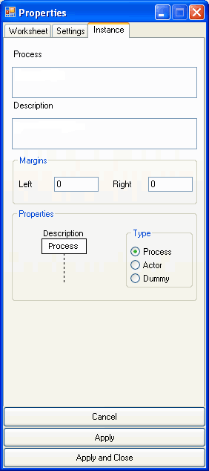
  Process
  The name of the instance. The name is only needed for the instance types process and actor. For the type dummy this field is ignored.
  Description
  The description of the instance. The description is only used for the types actor and process. This field is ignored for the type dummy.
  Margins Left
  Defines additional place to the left of the instance. The value is specified only in pixel.
  Margins Right
  Defines additional place to the right of the instance. The value is specified only in pixel.
  Type Process
  The instance will be displayed as a process.
  Type Actor
  The instance will be displayed as an actor.
  Type Dummy
  The instance will not be displayed. A dummy is simply a placeholder for a process that will be created later.
  Cancel
  Closes the properties dialog without applying any changes to the diagram.
  Apply
  Applies all changes to the diagram.
  Apply and Close
  Applies all changes to the diagram and closes the properties dialog.

Dialog LineComment

In this dialog you can change the properties of the diagram element Line Comment. The changes will take effect in the diagram only after you click the button "Apply" or "Apply and Close". The button "Cancel" closes the dialog and you will lose all changes which have not been applied.

 | 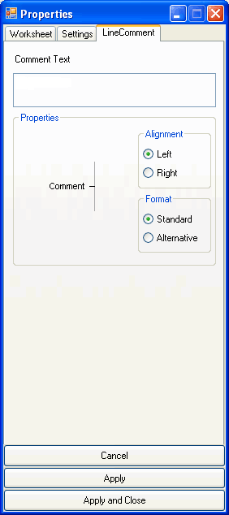
  Comment Text
  The text that should be displayed in the comment.
  Alignment Left
  The comment will be displayed to the left of the lifeline.
  Alignment Right
  The comment will be displayed to the right of the lifeline.
  Format Standard
  The comment will be displayed with a horizontal line.
  Format Alternative
  The comment will be displayed without a horizontal line.
  Cancel
  Closes the properties dialog without applying any changes to the diagram.
  Apply
  Applies all changes to the diagram.
  Apply and Close
  Applies all changes to the diagram and closes the properties dialog.

Dialog LostMessage

In this dialog you can change the properties of the diagram element Lost Message. The changes will take effect in the diagram only after you click the button "Apply" or "Apply and Close". The button "Cancel" closes the dialog and you will lose all changes which have not been applied.

 | 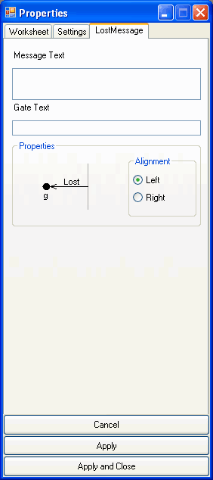
  Message Text
  The text that should appear as the lost message.
  Gate Text
  The text that should be displayed below the gate of the lost message.
  Alignment Left
  The lost message will be displayed to the left of the lifeline.
  Alignment Right
  The lost message will be displayed to the right of the lifeline.
  Cancel
  Closes the properties dialog without applying any changes to the diagram.
  Apply
  Applies all changes to the diagram.
  Apply and Close
  Applies all changes to the diagram and closes the properties dialog.

Dialog Mark

In this dialog you can change the properties of the diagram element Mark. The changes will take effect in the diagram only after you click the button "Apply" or "Apply and Close". The button "Cancel" closes the dialog and you will lose all changes which have not been applied.

 | 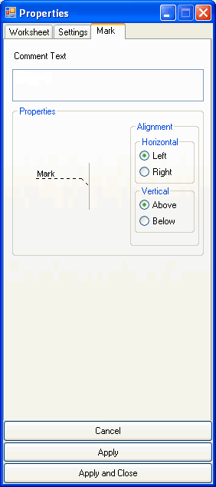
  Comment Text
  The text that will be displayed as a comment in the mark.
  Alignment Horizontal Left
  The mark will be displayed on the left side of the diagram.
  Alignment Horizontal Right
  The mark will be displayed on the right side of the diagram.
  Alignment Vertical Top
  The mark will be displayed to the top of the diagram line.
  Alignment Vertical Bottom
  The mark will be displayed to the bottom of the diagram line.
  Cancel
  Closes the properties dialog without applying any changes to the diagram.
  Apply
  Applies all changes to the diagram.
  Apply and Close
  Applies all changes to the diagram and closes the properties dialog.

Dialog MeasureBegin

In this dialog you can change the properties of the diagram element MeasureBegin. The changes will take effect in the diagram only after you click the button "Apply" or "Apply and Close". The button "Cancel" closes the dialog and you will lose all changes which have not been applied.

 | 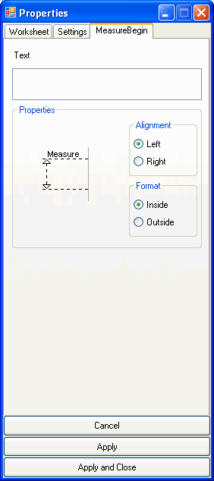
  Text
  The text that will be displayed at the measurement start point.
  Alignment Left
  The measurement will be displayed to the left of the lifeline.
  Alignment Right
  The measurement will be displayed to the right of the lifeline.
  Format Inside
  The measurement arrows will be displayed on the inside of the measurement horizontal lines.
  Format Outside
  The measurement arrows will be displayed from the outside of the measurement horizontal lines.
  Cancel
  Closes the properties dialog without applying any changes to the diagram.
  Apply
  Applies all changes to the diagram.
  Apply and Close
  Applies all changes to the diagram and closes the properties dialog.

Dialog MeasureEnd

In this dialog you can change the properties of the diagram element MeasureEnd. The changes will take effect in the diagram only after you click the button "Apply" or "Apply and Close". The button "Cancel" closes the dialog and you will lose all changes which have not been applied.

 | 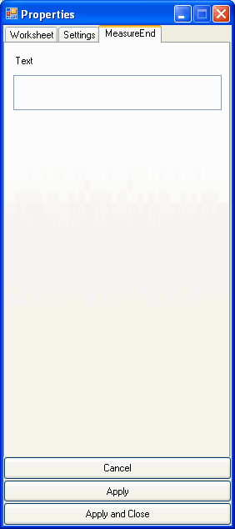
  Text
  The text that will be displayed at the measurement end point.
  Cancel
  Closes the properties dialog without applying any changes to the diagram.
  Apply
  Applies all changes to the diagram.
  Apply and Close
  Applies all changes to the diagram and closes the properties dialog.

Dialog MeasureStart

In this dialog you can change the properties of the diagram element MeasureStart. The changes will take effect in the diagram only after you click the button "Apply" or "Apply and Close". The button "Cancel" closes the dialog and you will lose all changes which have not been applied.

 | 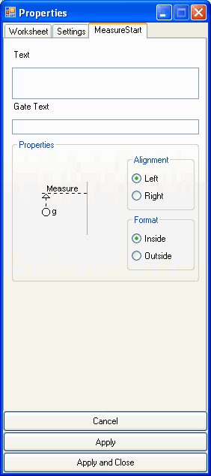
  Text
  The text that will be displayed at the measurement start point.
  Gate Text
  The text that will be displayed at the measurement gate.
  Alignment Left
  The measurement will be displayed to the left of the lifeline.
  Alignment Right
  The measurement will be displayed to the right of the lifeline.
  Format Inside
  The measurement arrows will be displayed on the inside of the measurement horizontal lines.
  Format Outside
  The measurement arrows will be displayed from the outside of the measurement horizontal lines.
  Cancel
  Closes the properties dialog without applying any changes to the diagram.
  Apply
  Applies all changes to the diagram.
  Apply and Close
  Applies all changes to the diagram and closes the properties dialog.

Dialog MeasureStop

In this dialog you can change the properties of the diagram element MeasureStop. The changes will take effect in the diagram only after you click the button "Apply" or "Apply and Close". The button "Cancel" closes the dialog and you will lose all changes which have not been applied.

 | 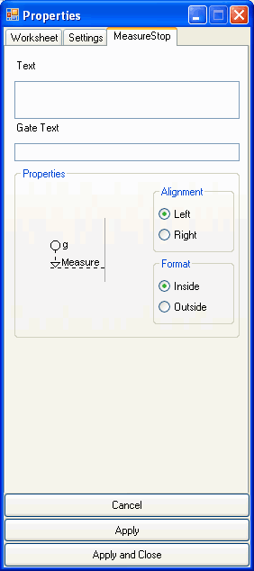
  Text
  The text that should be displayed at the measurement end point.
  Gate Text
  The text that should be displayed at the measurement end gate.
  Alignment Left
  The measurement will be displayed to the left of the lifeline.
  Alignment Right
  The measurement will be displayed to the right of the lifeline.
  Format Inside
  The measurement arrows will be displayed on the inside of the measurement horizontal lines.
  Format Outside
  The measurement arrows will be displayed from the outside of the measurement horizontal lines.
  Cancel
  Closes the properties dialog without applying any changes to the diagram.
  Apply
  Applies all changes to the diagram.
  Apply and Close
  Applies all changes to the diagram and closes the properties dialog.

Dialog Message

In this dialog you can change the properties of the diagram element Message. The changes will take effect in the diagram only after you click the button "Apply" or "Apply and Close". The button "Cancel" closes the dialog and you will lose all changes which have not been applied.

 | 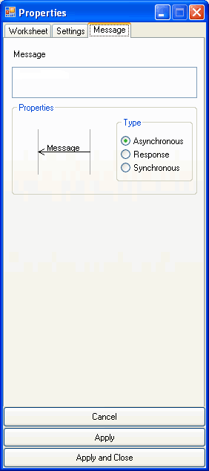
  Message
  The text that should be displayed in the message.
  Type Asynchronous
  The message will be displayed as an asynchronous message.
  Type Response
  The message will be displayed as a response message.
  Type Synchronous
  The message will be displayed as a synchronous message. This option is not available in SDL.
  Cancel
  Closes the properties dialog without applying any changes to the diagram.
  Apply
  Applies all changes to the diagram.
  Apply and Close
  Applies all changes to the diagram and closes the properties dialog.

Dialog MessageBegin

In this dialog you can change the properties of the diagram element MessageBegin. The changes will take effect in the diagram only after you click the button "Apply" or "Apply and Close". The button "Cancel" closes the dialog and you will lose all changes which have not been applied.

 | 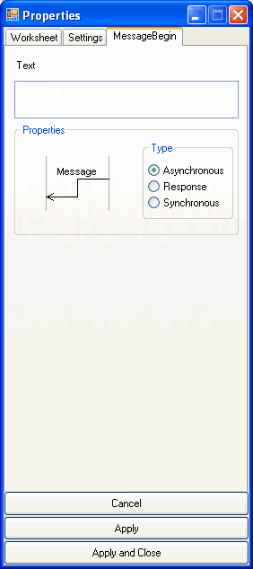
  Text
  The text that should be displayed as message.
  Type Asynchronous
  The message will be displayed as an asynchronous message.
  Type Response
  The message will be displayed as a response message.
  Type Synchronous
  The message will be displayed as a synchronous message. This option is not available in SDL.
  Cancel
  Closes the properties dialog without applying any changes to the diagram.
  Apply
  Applies all changes to the diagram.
  Apply and Close
  Applies all changes to the diagram and closes the properties dialog.

Dialog Reference

In this dialog you can change the properties of the diagram element Reference. The changes will take effect in the diagram only after you click the button "Apply" or "Apply and Close". The button "Cancel" closes the dialog and you will lose all changes which have not been applied.

 | 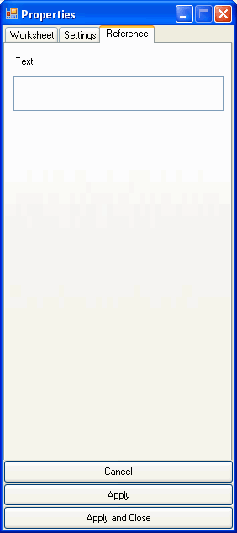
  Text
  The text that defines the referenced interaction diagram. This text will be displayed in the middle of the reference combined fragment.
  Cancel
  Closes the properties dialog without applying any changes to the diagram.
  Apply
  Applies all changes to the diagram.
  Apply and Close
  Applies all changes to the diagram and closes the properties dialog.

Dialog Region

In this dialog you can change the properties of a lifeline. The changes will take effect in the diagram only after you click the button "Apply" or "Apply and Close". The button "Cancel" closes the dialog and you will lose all changes which have not been applied.

 | 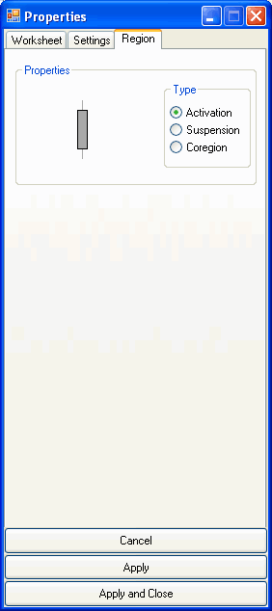
  Type Activation
  The lifeline is displayed in the activation mode.
  Type Suspension
  The lifeline will be displayed in suspension mode.
  Type Coregion
  The lifeline will be displayed in coregion mode.
  Cancel
  Closes the properties dialog without applying any changes to the diagram.
  Apply
  Applies all changes to the diagram.
  Apply and Close
  Applies all changes to the diagram and closes the properties dialog.

Dialog SetTimer

In this dialog you can change the properties of the diagram element SetTimer. The changes will take effect in the diagram only after you click the button "Apply" or "Apply and Close". The button "Cancel" closes the dialog and you will lose all changes which have not been applied.

 | 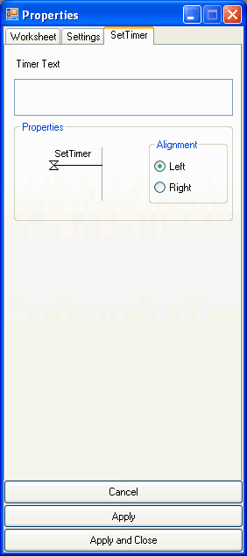
  Timer Text
  The text that should be displayed at the timer start point.
  Alignment Left
  The timer start point will be displayed to the left of the lifeline.
  Alignment Right
  The timer start point will be displayed to the right of the lifeline.
  Cancel
  Closes the properties dialog without applying any changes to the diagram.
  Apply
  Applies all changes to the diagram.
  Apply and Close
  Applies all changes to the diagram and closes the properties dialog.

Dialog State

In this dialog you can change the properties of the diagram element State. The changes will take effect in the diagram only after you click the button "Apply" or "Apply and Close". The button "Cancel" closes the dialog and you will lose all changes which have not been applied.

 | 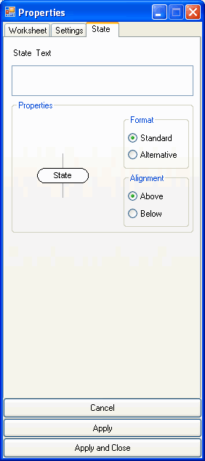
  State Text
  The text that will be displayed as state invariant.
  Format Standard
  The state invariant will be displayed in a state symbol.
  See also
  Format Alternative
  The state invariant will be displayed in curly brackets. This option is not available for the command stateoverall.
  Alignment Top
  The state invariant will be displayed at the top of the diagram line.
  Alignmnet Bottom
  The state invariants will be displayed at the bottom of the diagram line.
  Cancel
  Closes the properties dialog without applying any changes to the diagram.
  Apply
  Applies all changes to the diagram.
  Apply and Close
  Applies all changes to the diagram and closes the properties dialog.

Dialog StopTimer

In this dialog you can change the properties of the diagram element StopTimer. The changes will take effect in the diagram only after you click the button "Apply" or "Apply and Close". The button "Cancel" closes the dialog and you will lose all changes which have not been applied.

 | 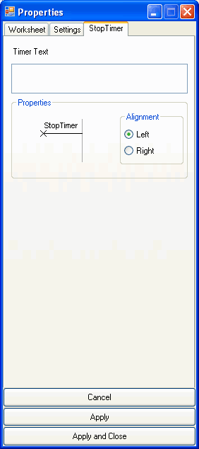
  Timer Text
  The text that should be displayed at the timer end point.
  Alignment Left
  The timer end point will be displayed to the left of the lifeline.
  Alignment Right
  The timer end point will be displayed to the left of the lifeline.
  Cancel
  Closes the properties dialog without applying any changes to the diagram.
  Apply
  Applies all changes to the diagram.
  Apply and Close
  Applies all changes to the diagram and closes the properties dialog.

Dialog Task

In this dialog you can change the properties of the diagram element Task. The changes will take effect in the diagram only after you click the button "Apply" or "Apply and Close". The button "Cancel" closes the dialog and you will lose all changes which have not been applied.

 | 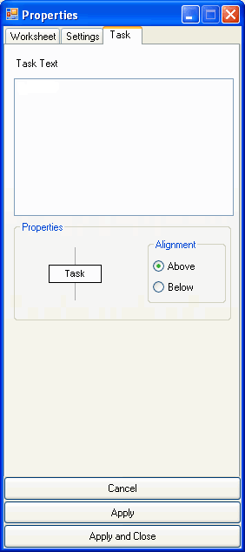
  Task Text
  The text that will be displayed in the task.
  Alignment Top
  The task will be aligned to the top of the diagram line.
  Alignment Bottom
  The task will be aligned to the bottom of the diagram line.
  Cancel
  Closes the properties dialog without applying any changes to the diagram.
  Apply
  Applies all changes to the diagram.
  Apply and Close
  Applies all changes to the diagram and closes the properties dialog.

Dialog TimeOut

In this dialog you can change the properties of the diagram element Timeout. The changes will take effect in the diagram only after you click the button "Apply" or "Apply and Close". The button "Cancel" closes the dialog and you will lose all changes which have not been applied.

 | 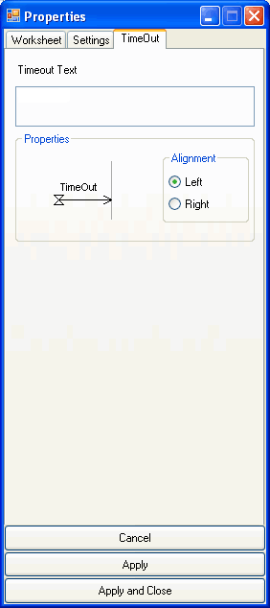
  Timeout Text
  The text that should appear above the timer end point.
  Alignment Left
  The timer end point will be displayed on the left of the lifeline.
  Alignment Right
  The timer end point will be displayed on the right of the lifeline.
  Cancel
  Closes the properties dialog without applying any changes to the diagram.
  Apply
  Applies all changes to the diagram.
  Apply and Close
  Applies all changes to the diagram and closes the properties dialog.

Dialog TimerBegin

In this dialog you can change the properties of the diagram element TimerBegin. The changes will take effect in the diagram only after you click the button "Apply" or "Apply and Close". The button "Cancel" closes the dialog and you will lose all changes which have not been applied.

 | 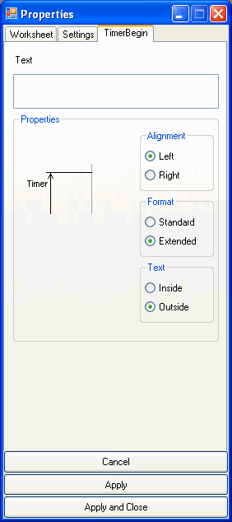
  Timer Text
  The text that will be displayed at the timer start point.
  Alignment Left
  The timer will be displayed on the left of the lifeline.
  Alignment Right
  The timer will be displayed on the right of the lifeline.
  Format Standard
  The timer will be displayed near the lifeline.
  Format Extended
  The timer will be displayed far from the lifeline.
  Text Inside
  The text will be displayed horizontally between the lifeline and the timer line. This option is only available in the extended format.
  Text Outside
  The text will be displayed horizontally outside of the timer line.
  Cancel
  Closes the properties dialog without applying any changes to the diagram.
  Apply
  Applies all changes to the diagram.
  Apply and Close
  Applies all changes to the diagram and closes the properties dialog.

Dialog TimerEnd

In this dialog you can change the properties of the diagram element TimerEnd. The changes will take effect in the diagram only after you click the button "Apply" or "Apply and Close". The button "Cancel" closes the dialog and you will lose all changes which have not been applied.

 | 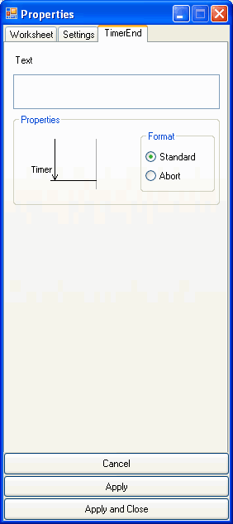
  Text
  The text that will be displayed at the timer end point.
  Format Standard
  The timer end point will represent a normal timer termination.
  Format Abort
  The timer end point will represent a timer abortion.
  Cancel
  Closes the properties dialog without applying any changes to the diagram.
  Apply
  Applies all changes to the diagram.
  Apply and Close
  Applies all changes to the diagram and closes the properties dialog.

First Steps

In this chapter we will give you a step by step tutorial with examples for the usage of our sequence generator. Detailed descriptions of all commands are available in the manual “MSC/SD-Generator Command Set”.

After starting the program click on the menu item “New”. The diagram description for a new empty diagram will be created. This default diagram description initializes the most important format settings of the diagram.

DiagramStyle: sdl
DiagramName: "New MSC"

PageSize: A4,H
PageMargins: 10,10,10,10
Font: Arial, 10, Regular
LineOffset: 20
Author: ""
Company: ""
Date: ""
Version: ""
PrintFootline: no

These settings are enough for our small example. Next, we will add two process instances to our diagram. This can be done by clicking twice on the following icon:

The following two lines will be automatically inserted to the diagram description:

process: InstanceId, ProcessName, ProcessDescription;
process: InstanceId, ProcessName, ProcessDescription;

Now we should modify the parameters of the command process. The first parameter, the one in blue, is the ID of the lifeline of this instance. This ID must be unique for each lifeline. Let us take for this example the IDs p1 und p2. We can set the names of the processes by modifying the second parameter. Let us just take Process 1 and Process 2. Since we do not need a process description we can delete the corresponding parameters. Of course, you can specify some values for all of the parameters.

After the modifications the diagram descriptions would look like this:

DiagramStyle: sdl
DiagramName: "New MSC"

PageSize: A4,H
PageMargins: 10,10,10,10
Font: Arial, 10, Regular
LineOffset: 20
Author: ""
Company: ""
Date: ""
Version: ""
PrintFootline: no

process: p1, Process 1;
process: p2, Process 2;

The first diagram elements are already inserted. Let’s have a look at the generated output.

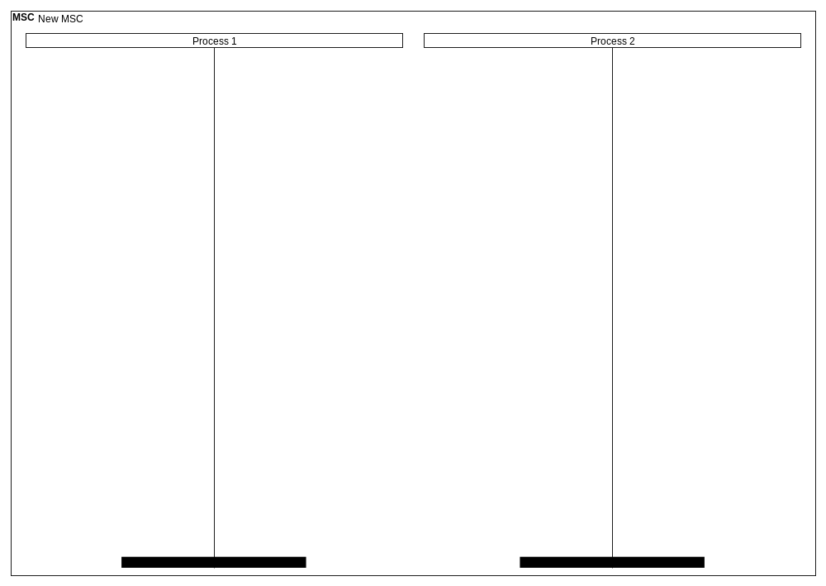

It is obvious that the diagram is bigger than necessary for this simple example. We can fix that by doing a very simple change to the diagram description. The following line defines the size of the generated diagram.

PageSize: A4,H

As we see, the sequence diagram will be drawn on an A4 paper in horizontal (landscape) orientation. If we want the size of the diagram to be proportional to the number of diagram elements, we have to replace the parameters A4,H with auto.

PageSize: auto

The new output is:

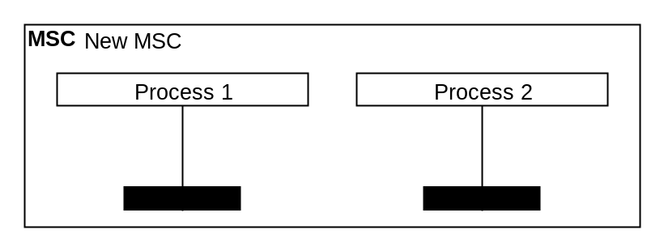

It is time to bring some life to this sequence diagram. To start with, let us add the state “Idle” to both processes. We click twice on the icon:

The following lines have been added to the diagram description:

state: InstanceId, StateText;
state: InstanceId, StateText;

Also here we do not need to change much in the parameters of the command state. The first parameters are underlined with red lines because there is no previously defined lifeline with the given ID. We change these parameters to the values we used for the previous process commands, namely p1 and p2. For state text we type our “Idle”. Notice that both lines end with a semi-colon. The semi-colon has a special meaning in the diagram description. It signals that a diagram line is finished and the next diagram element should be displayed vertically lower on next diagram line. If a description line is not ended with a semi-colon, then the next diagram element will be displayed at the same vertical position, i.e. on the same diagram line. The following images should make this clear:

state: p1, Idle;  state: p2, Idle; | state: p1, Idle  state: p2, Idle;
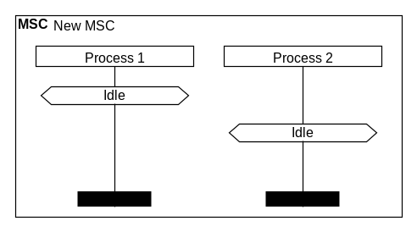 | 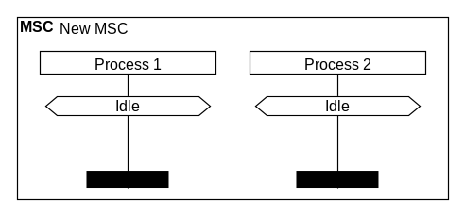

For our example we will chose the second variant.

Next, we will add a message from Process 1 to Process 2. The message will represent a function call of the function “Addition” with parameters “a” and “b”. Thus, the text of the message should be “Addition (a,b)”. The description language interprets commas as parameter separators and this means that this message text will cause an error. To avoid the problem, text that contains control characters should be written as quoted strings. Finally, we set Process 2 in the state “Calculating”. To add a message to the diagram description click on the icon:

After the modifications of the parameters we get the following line of the diagram description:

msg: p1, p2, "Addition(a,b)";

Process 2 must also go in state “Calculating”. Finally our diagram description looks like this:

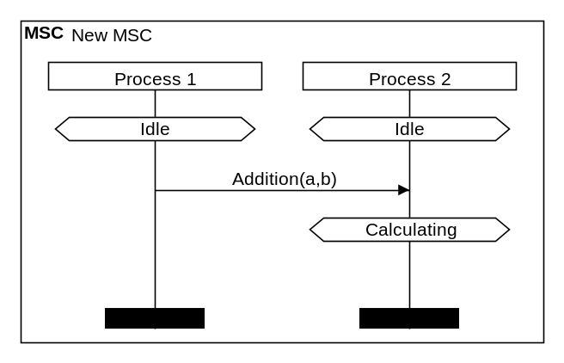 | DiagramStyle: sdl  DiagramName: "New MSC"  PageSize: auto  PageMargins: 10,10,10,10  Font: Arial, 10, Regular  LineOffset: 20  Author: ""  Company: ""  Date: ""  Version: ""  PrintFootline: no  process: p1, Process 1;  process: p2, Process 2;  state: p1, Idle;  state: p2, Idle;  msg: p1, p2, "Addition(a,b)";  state: p2, Calculating;

Now let Process 2 returns a response to Process 1 and goes back to state “Idle”. The result message should be displayed as a response message. For this purpose we use the last format parameter (displayed in Turkish blue) and it should have the value *. The result should look like this:

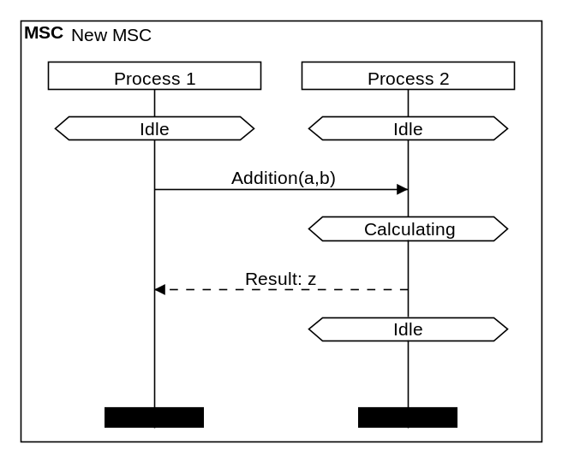 | DiagramName: "New MSC"  PageSize: auto  PageMargins: 10,10,10,10  Font: Arial, 10, Regular  LineOffset: 20  Author: ""  Company: ""  Date: ""  Version: ""  PrintFootline: no  process: p1, Process 1;  process: p2, Process 2;  state: p1, Idle  state: p2, Idle;  msg: p1, p2, "Addition(a,b)";  state: p2, Calculating;  msg: p2, p1, "Result: z",*;  state: p2, Idle;

The first sequence diagram is now ready but I would like to again point out the advantages of the text-based generator over alternative tools. Let us consider the following case: depending on the value of a variable “n” we will perform different calculations.

n<=0 | Addition(a,b);
n>0 | Addition(c,d);

This must eventually be added to the sequence diagram. With the generator this can be done quite easily. In the editor we select the lines from the addition call to the response message. Finally we click on the following icon:

This will result to the following diagram description:

(…)
state: p2, Idle;
fragmentbegin: FragmentId, FirstInstanceId, LastInstanceId, FragmentText;
msg: p1, p2, "Addition(a,b)";
state: p2, Calculating;
msg: p2, p1, "Result: z",*;
fragmentend: FragmentId;
state: p2, Idle;

Now let us modify the parameters of the fragment accordingly. The parameters displayed in brown represent the ID of the combined fragment. The two instance IDs define the first and the last lifeline over which this combined fragment should span. For fragment text we choose “alt” for alternative. After this step we should get the following diagram description and output:

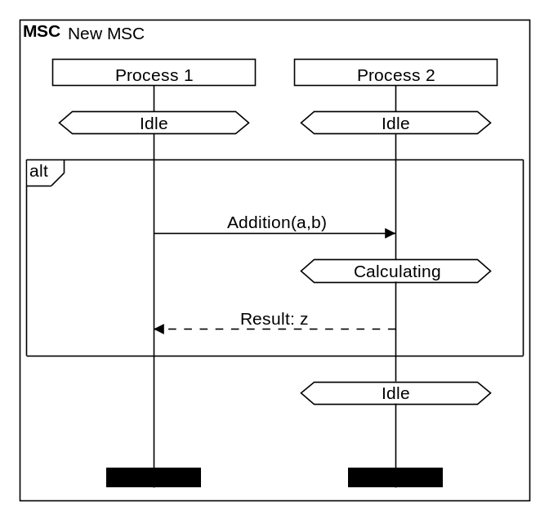 | DiagramStyle: sdl  DiagramName: "New MSC"  PageSize: auto  PageMargins: 10,10,10,10  Font: Arial, 10, Regular  LineOffset: 20  Author: ""  Company: ""  Date: ""  Version: ""  PrintFootline: no  process: p1, Process 1;  process: p2, Process 2;  state: p1, Idle  state: p2, Idle;  fragmentbegin: alt1, p1, p2, alt;  msg: p1, p2, "Addition(a,b)";  state: p2, Calculating;  msg: p2, p1, "Result: z",*;  fragmentend: alt1;  state: p2, Idle;

Now we can add a guard and a fragment separator line to the diagram. The guard will be inserted right below the command fragmentbegin and will not be ended with a semicolon. A guard text can be added by clicking on the following icon:

The fragment separator line should be added before the command fragmentend by clicking on the following icon:

After altering the default parameters of the newly inserted commands we get the following:

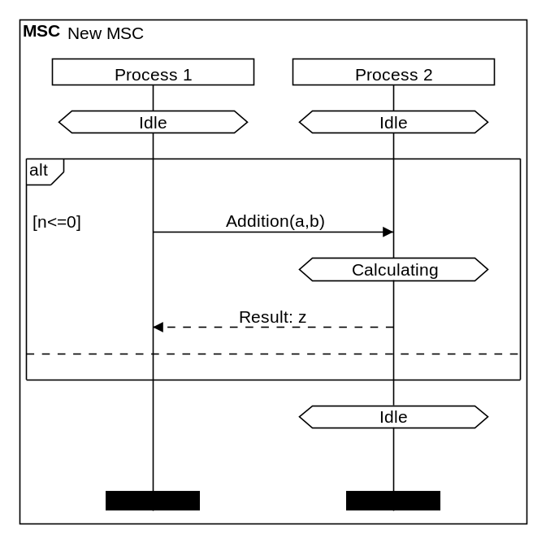 | DiagramStyle: sdl  DiagramName: "New MSC"  PageSize: auto  PageMargins: 10,10,10,10  Font: Arial, 10, Regular  LineOffset: 20  Author: ""  Company: ""  Date: ""  Version: ""  PrintFootline: no  process: p1, Process 1;  process: p2, Process 2;  state: p1, Idle  state: p2, Idle;  fragmentbegin: alt1, p1, p2, alt;  fragmenttext: alt1, [n<=0]  msg: p1, p2, "Addition(a,b)";  state: p2, Calculating;  msg: p2, p1, "Result: z",*;  fragmentseparator: alt1;  fragmentend: alt1;  state: p2, Idle;

Finally, we can copy the lines from the fragment text to the response message and paste them after the fragment separator. After modifying the parameters, in just a few steps, we have extended the diagram.

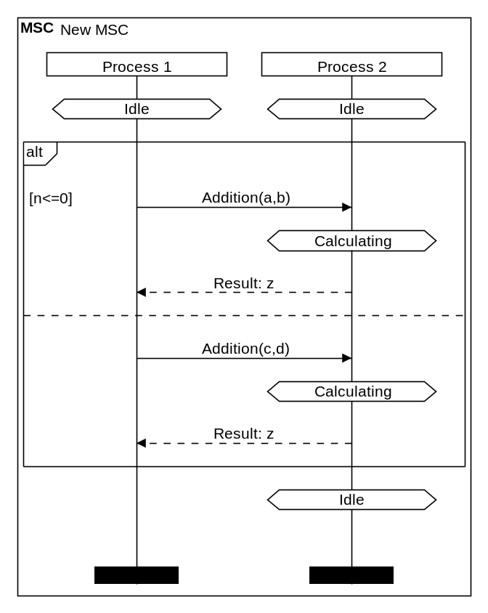 | DiagramStyle: sdl  DiagramName: "New MSC"  PageSize: auto  PageMargins: 10,10,10,10  Font: Arial, 10, Regular  LineOffset: 20  Author: ""  Company: ""  Date: ""  Version: ""  PrintFootline: no  process: p1, Process 1;  process: p2, Process 2;  state: p1, Idle  state: p2, Idle;  fragmentbegin: alt1, p1, p2, alt;  fragmenttext: alt1, [n<=0]  msg: p1, p2, "Addition(a,b)";  state: p2, Calculating;  msg: p2, p1, "Result: z",*;  fragmentseparator: alt1;  fragmenttext: alt1, [n>0]  msg: p1, p2, "Addition(c,d)";  state: p2, Calculating;  msg: p2, p1, "Result: z",*;  fragmentend: alt1;  state: p2, Idle;

If you prefer the UML format for sequence diagrams, then just change the parameter of the command DiagramStyle from sdl to uml.

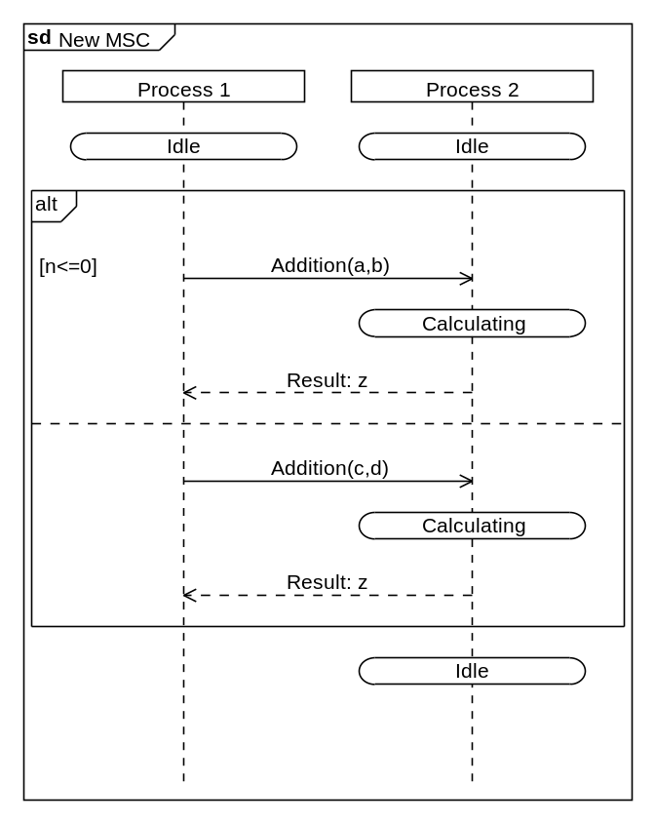 | DiagramStyle: uml  DiagramName: "New MSC"  PageSize: auto  PageMargins: 10,10,10,10  Font: Arial, 10, Regular  LineOffset: 20  Author: ""  Company: ""  Date: ""  Version: ""  PrintFootline: no  process: p1, Process 1;  process: p2, Process 2;  state: p1, Idle  state: p2, Idle;  fragmentbegin: alt1, p1, p2, alt;  fragmenttext: alt1, [n<=0]  msg: p1, p2, "Addition(a,b)";  state: p2, Calculating;  msg: p2, p1, "Result: z",*;  fragmentseparator: alt1;  fragmenttext: alt1, [n>0]  msg: p1, p2, "Addition(c,d)";  state: p2, Calculating;  msg: p2, p1, "Result: z",*;  fragmentend: alt1;  state: p2, Idle;

The Export Function

The export function makes it possible to save the generated sequence diagrams as image files. The following formats are supported:

- Bitmap (.bmp)
- Graphics Interchange Format (.gif)
- Joint Photographic Experts Group (.jpg)
- Portable Network Graphics (.png)
- Windows Metafile (.wmf)
- Enhanced Windows Metafile (.emf)

The sequence diagrams can optionally be saved under multiple files – one for each diagram page – or as a continuous diagram on a “long” page in a single file. This option can be configured in the dialog “Properties”. When exporting to multiple files (pages) all image files will be named as the user specified but suffixed with a page number.

The exported sequence diagrams have the page margins and the footer that have been configured in the diagram description.

