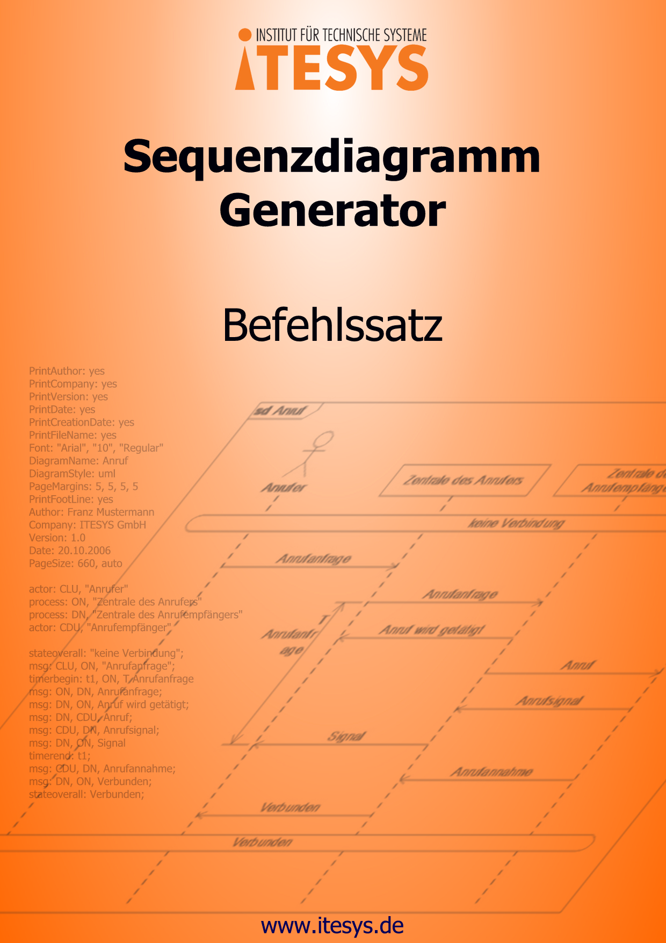

1 Formatting 4
1.1 Page Formatting 4
1.1.1 PAGESIZE 4
1.1.2 PAGEMARGINS 7
1.2 Diagram Formatting 8
1.2.1 DIAGRAMNAME 8
1.2.2 DIAGRAMSTYLE 8
1.2.3 FONT 9
1.2.4 LEFT 10
1.2.5 RIGHT 11
1.2.6 LINEOFFSET 11
1.2.7 NEXTPAGE 13
1.3 Footer 13
1.3.1 PRINTFOOTLINE 14
1.3.2 AUTHOR 14
1.3.3 PRINTAUTHOR 14
1.3.4 COMPANY 15
1.3.5 PRINTCOMPANY 15
1.3.6 PRINTFILENAME 16
1.3.7 DATE 16
1.3.8 PRINTDATE 17
1.3.9 PRINTCREATIONDATE 17
1.3.10 VERSION 18
1.3.11 PRINTVERSION 18
1.4 Color Definitions 19
1.4.1 BACKCOLOR 19
1.4.2 FILLCOLOR 20
1.4.3 TEXTCOLOR 21
2 Diagram Elements 22
2.1 Lifeline 22
2.1.1 ACTOR 22
2.1.2 PROCESS 23
2.1.3 DUMMYPROCESS 24
2.1.4 CREATE 24
2.1.5 STOP 25
2.1.6 REGIONBEGIN 25
2.1.7 REGIONEND 26
2.2 Messages 27
2.2.1 MSG 27
2.2.2 MSGBEGIN 28
2.2.3 MSGEND 30
2.2.4 FOUND 30
2.2.5 LOST 31
2.3 State Invariants 31
2.3.1 STATE 32
2.3.2 STATEOVERALL 33
2.4 Tasks 33
2.4.1 TASK 34
2.5 Comments 34
2.5.1 COMMENT 35
2.5.2 COMMENTOVERALL 36
2.5.3 LINECOMMENT 36
2.5.4 MARK 37
2.6 Timers 38
2.6.1 TIMERBEGIN 38
2.6.2 TIMEREND 40
2.6.3 SETTIMER 41
2.6.4 STOPTIMER 42
2.6.5 TIMEOUT 43
2.7 Time Measurements 44
2.7.1 MEASUREBEGIN 44
2.7.2 MEASUREEND 45
2.7.3 MEASURESTART 46
2.7.4 MEASURESTOP 47
2.8 Combined Fragments 48
2.8.1 FRAGMENTBEGIN 48
2.8.2 FRAGMENTEND 49
2.8.3 FRAGMENTSEPARATOR 49
2.8.4 FRAGMENTTEXT 50
2.9 References 50
2.9.1 REF 50
3 Control Characters 52
3.1 Text Formatting 52
3.1.1 \n – Line Break 52
3.1.2 “ – Quotation Marks 52
3.2 Diagram Formatting 53
3.2.1 ; – Diagram Line Break 53
3.2.2 { } – No Diagram Line Break 54
3.2.3 ;; – Manual Page Break 54
Appendix A 56
Color Names 56
Appendix B 59
Index 59

Formatting

The formatting of the diagram contains elements that configure the name, footer, display standard, fonts, size, etc. This chapter contains a list of the commands, which control the formatting of the diagram.

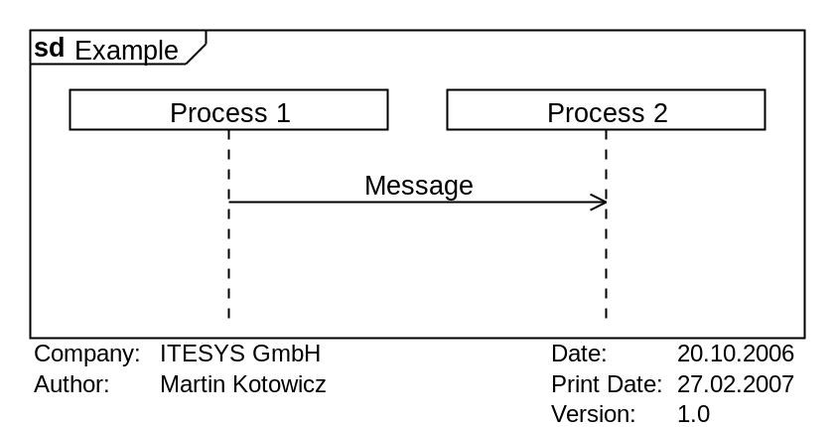 | DiagramName: Example  DiagramStyle: uml  Font: "Arial", "10", "Regular"  PrintAuthor: yes  PrintCompany: yes  PrintVersion: yes  PrintDate: yes  PrintCreationDate: yes  PrintFileName: yes  PageMargins: 5, 5, 5, 5  PrintFootLine: yes  Author: Martin Kotowicz  Company: ITESYS GmbH  Version: 1.0  Date: 20.10.2006  PageSize: 400, auto  process: p1, Process 1  process: p2, Process 2  msg: p1, p2, Message;

Page Formatting

The page formatting commands make it possible to change the properties of the display pages. Use this commands to set the page size and margins.

PAGESIZE

Use the command pagesize to set the size of the diagram. The command can be called with two sets of parameters, depending of the values you specify. It is possible to specify a page size from A0 to A5 by setting the parameter size. The orientation could be set in the parameter orientation. Alternatively, it is possible to set the height and width of the diagram using the parameter width and height. The optional parameter unit to specify the units used.

- Syntax
pagesize: size, orientation
oder
pagesize: width, height, unit

- Parameters
- size
Value | Description
A0 | The diagram has the size of a DIN A0 page  (118,9cm x 84,1cm)
A1 | The diagram has the size of a DIN A1 page  (84,1cm x 59,4cm)
A2 | The diagram has the size of a DIN A2 page  (59,4cm x 42cm)
A3 | The diagram has the size of a DIN A3 page  (42cm x 29,7cm)
A4 | The diagram has the size of a DIN A4 page  (29,7cm x 21cm)
A5 | The diagram has the size of a DIN A5 page  (21cm x 14,8cm)

- orientation (optional)
Value | Description
h | Portrait
v | Landscape

The default value for this parameter is "h".

- width
This parameter sets the width of the diagram. The unit of the value is specified by the parameter unit. Decimal numbers should be entered in quotation marks.
If the value "auto" is specified then the width is calculated automatically depending on the number of the defined processes.

- height
This parameter sets the height of the diagram. The unit of the value is specified by the parameter unit. Decimal numbers should be entered in quotation marks.
If the value "auto" is specified then the height is calculated automatically depending on the number of diagram lines.

- unit (optional)
This parameter defines the units used for the values of the parameters width and height. This parameter is ignored if the value "auto" is specified for width and height.
Value | Description
pixel | Pixel
mm | Millimeter
cm | Centimeter
inch | Inch

The default value for this parameter is "pixel".

- Example
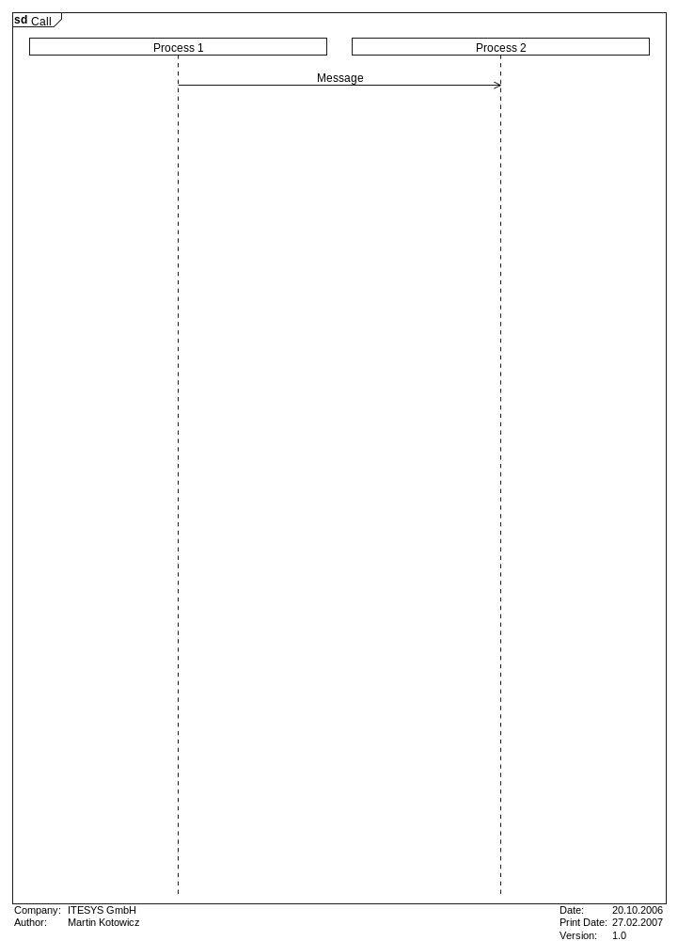 | DiagramName: Call  DiagramStyle: uml  Font: "Arial", "10", "Regular"  PrintAuthor: yes  PrintCompany: yes  PrintVersion: yes  PrintDate: yes  PrintCreationDate: yes  PrintFileName: yes  PageMargins: 5, 5, 5, 5  PrintFootLine: yes  Author: Martin Kotowicz  Company: ITESYS GmbH  Version: 1.0  Date: 20.10.2006  PageSize: A4, v  process: p1, Process 1  process: p2, Process 2  msg: p1, p2, Message

PAGEMARGINS

Use the command pagemargins to set the size of the page margins. The margins are subtracted from the page size which is defined using the command pagesize and therefore the graphical diagram area is reduced. The size of the page margins are specified by the parameters left, top, right, bottom and unit. The parameter unit is optional. In this case the default value "pixel" is used.

- Syntax
pagemargins: left, top, right, bottom, unit

- Parameters
- left
This parameter specifies the width of the left margin. The units used for this value are specified by the optional parameter unit. Decimal numbers should be entered in quotation marks.
The default value for this parameter is "10".

- top
This parameter specifies the height of the top margin. The units used for this value are specified by the optional parameter unit. Decimal numbers should be entered in quotation marks.
The default value for this parameter is "10".
- right
This parameter specifies the width of the right margin. The units used for this value are specified by the optional parameter unit. Decimal numbers should be entered in quotation marks.
The default value for this parameter is "10".

- bottom
This parameter specifies the width of the bottom margin. The units used for this value are specified by the optional parameter unit. Decimal numbers should be entered in quotation marks.
The default value for this parameter is "10".

- unit (optional)
This parameter defines the units used for the values of the parameters left, top, right and bottom.

Value | Description
pixel | Pixel
mm | Millimeter
cm | Centimeter
inch | Inch

The default value for this parameter is "pixel".

Diagram Formatting

The diagram formatting commands allow you to change the look of the generated diagram. With these commands you could change the display standard (SDL/UML) and diagram name among others.

DIAGRAMNAME

Use the command diagramname to set the name of the diagram. The name is specified by the parameter name and is displayed in the top left corner of the diagram. The prefix "sd" or "MSC" is automatically added.

- Syntax
diagramname: name

- Parameters
- name
The name of the diagram. Any alphanumeric text string is allowed.

DIAGRAMSTYLE

Use the command diagramstyle to specify the standard to be used when generating the diagram. The parameter style sets the style.

- Syntax
diagramstyle: style

- Parameters
- style
Value | Description
uml | A UML2.0 conform diagram will be generated.
sdl | A SDL conform diagram will be generated.

The default value for this parameter is "uml".

- Example
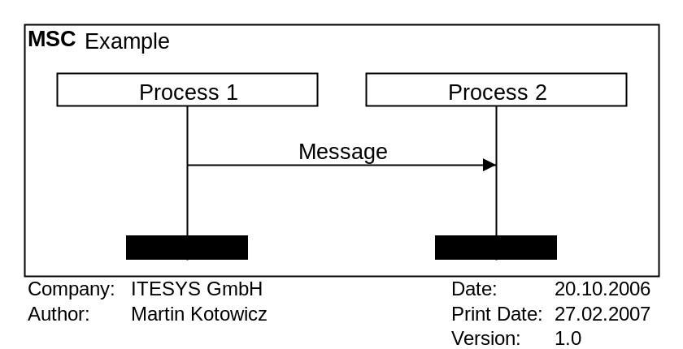 | DiagramName: Example  DiagramStyle: sdl  Font: "Arial", "10", "Regular"  PrintAuthor: yes  PrintCompany: yes  PrintVersion: yes  PrintDate: yes  PrintCreationDate: yes  PrintFileName: yes  PageMargins: 5, 5, 5, 5  PrintFootLine: yes  Author: Martin Kotowicz  Company: ITESYS GmbH  Version: 1.0  Date: 20.10.2006  PageSize: 400, auto  process: p1, Process 1  process: p2, Process 2  msg: p1, p2, Message;

FONT

Use the command font to define the font name and size to be used in the diagram. The parameters fontname, fontsize and fontstyle specify the selected font. The parameters fontsize and fontstyle are optional and if omitted, default values will be used. The specified font will be used for all texts in the diagram.

- Syntax
font: fontname, fontsize, fontstyle

- Parameters
- fontname
The value of this parameter must be the name of a font that is available in the operating system.
The default value for this parameter is "Arial".

- fontsize (optional)
This parameter defines the size of the font in pixel. Allowed are values between 6 and 20 pixel. Decimal numbers should be entered in quotation marks.
The default value for this parameter is "10".

- fontstyle (optional)
This parameter defines the font style. Multiple style values can be specified but must be separated by spaces.
Value | Description
regular | Standard
bold | Bold
italic | Italic
strikeout | Stroked our
underline | Underlined

Please note that not all fonts support all styles.
The default value for this parameter is "regular".

- Example
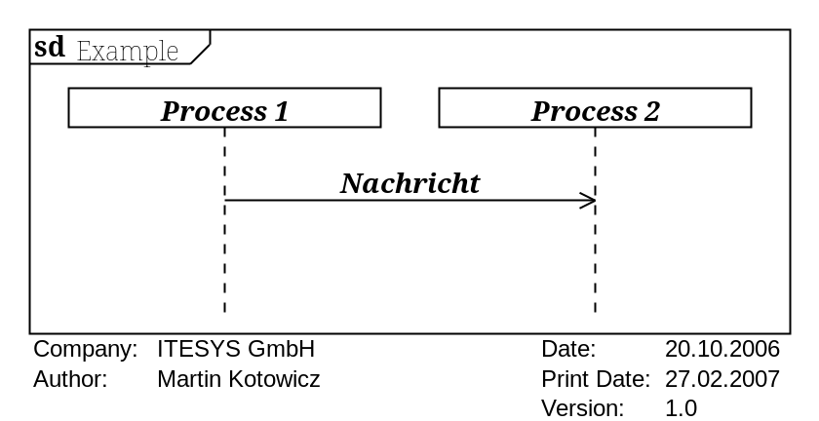 | DiagramName: Example  DiagramStyle: uml  Font: "Georgia", "10,5", "Italic Bold"  PrintAuthor: yes  PrintCompany: yes  PrintVersion: yes  PrintDate: yes  PrintCreationDate: yes  PrintFileName: yes  PageMargins: 5, 5, 5, 5  PrintFootLine: yes  Author: Martin Kotowicz  Company: ITESYS GmbH  Version: 1.0  Date: 20.10.2006  PageSize: 400, auto  process: p1, Process 1  process: p2, Process 2  msg: p1, p2, Message

LEFT

The command left can be used to reserve additional place to the left of the diagram. This place can be used for example for comments.

- Syntax
left: width

- Parameters
- width
The width of the additional space. The value is always in pixel.

- Example
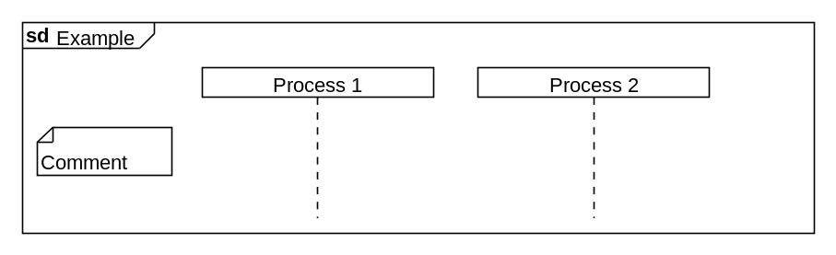 | DiagramName: Example  DiagramStyle: uml  PageSize: auto, auto  PageMargins: 10,10,10,10  Left: 100  Right: 50  process: p1, Process 1  process: p2, Process 2  comment: ENV_LEFT, Comment

RIGHT

The command right can be used to reserve additional place to the right of the diagram. This place can be used for example for comments.

- Syntax
right: width

- Parameters
- width
The width of the additional space. The value is always in pixel.

LINEOFFSET

Using the command lineoffset the height of diagram lines can be set.

- Syntax
lineoffset: height

- Parameters
- height
The height of the space between lines in the diagram. The value of this parameter must be between "1" and "100" (pixel). It is not possible to use other units.
The default value for this parameter is "20".

- Example
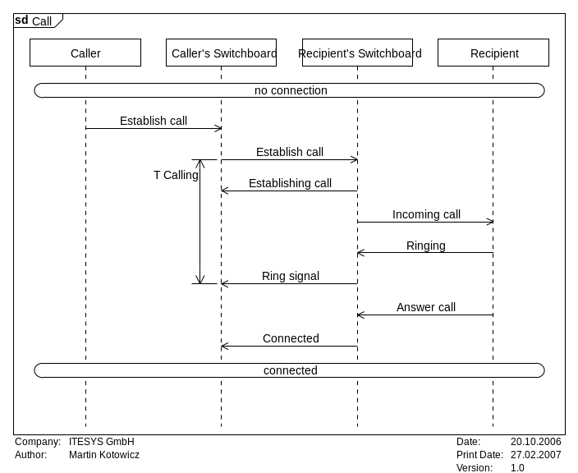 | PrintAuthor: yes  PrintCompany: yes  PrintVersion: yes  PrintDate: yes  PrintCreationDate: yes  PrintFileName: yes  Font: "Arial", "10", "Regular"  DiagramName: Call  DiagramStyle: uml  PageMargins: 5, 5, 5, 5  PrintFootLine: yes  Author: Martin Kotowicz  Company: ITESYS GmbH  Version: 1.0  Date: 20.10.2006  PageSize: 660, auto  process: CLU, "Caller"  process: ON, "Caller’s Switchboard"  process: DN, "Recipient’s Switchboard"  process: CDU, "Recipient"  stateoverall: "no connection";  msg: CLU, ON, "Establish call";  timerbegin: t1, ON, T Calling  msg: ON, DN, Establish call;  msg: DN, ON, Establishing call;  msg: DN, CDU, Incoming call;  msg: CDU, DN, Ringing;  msg: DN, ON, Ring signal  timerend: t1;  msg: CDU, DN, Answer call;  msg: DN, ON, Connected;  stateoverall: connected;
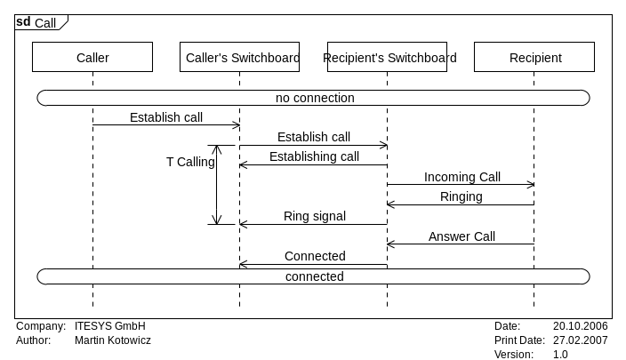 | PrintAuthor: yes  PrintCompany: yes  PrintVersion: yes  PrintDate: yes  PrintCreationDate: yes  PrintFileName: yes  Font: "Arial", "10", "Regular"  DiagramName: Anruf  DiagramStyle: uml  PageMargins: 5, 5, 5, 5  PrintFootLine: yes  Author: Martin Kotowicz  Company: ITESYS GmbH  Version: 1.0  Date: 20.10.2006  PageSize: 660, auto  Lineoffset: 5  process: CLU, "Caller"  process: ON, "Caller’s Switchboard"  process: DN, "Recipient’s Switchboard"  process: CDU, "Recipient"  stateoverall: "no connection";  msg: CLU, ON, "Establish call";  timerbegin: t1, ON, T Calling  msg: ON, DN, Establish call;  msg: DN, ON, Establishing call;  msg: DN, CDU, Incoming call;  msg: CDU, DN, Ringing;  msg: DN, ON, Ring signal  timerend: t1;  msg: CDU, DN, Answer call;  msg: DN, ON, Connected;  stateoverall: connected;

NEXTPAGE

Use the command nextpage to define a manual page break.

- Syntax
nextpage:

- Parameters

- Example
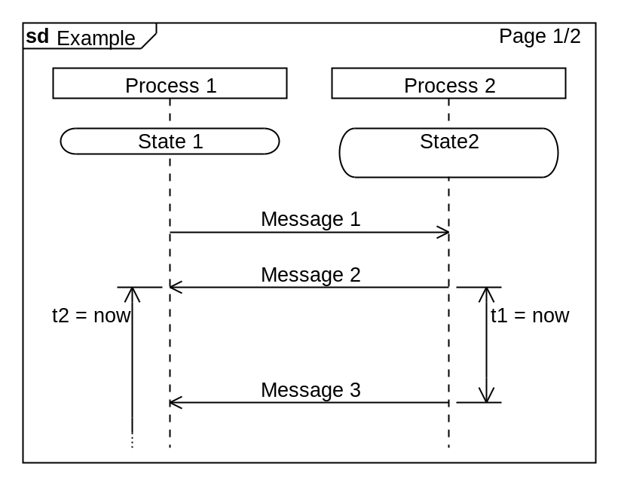  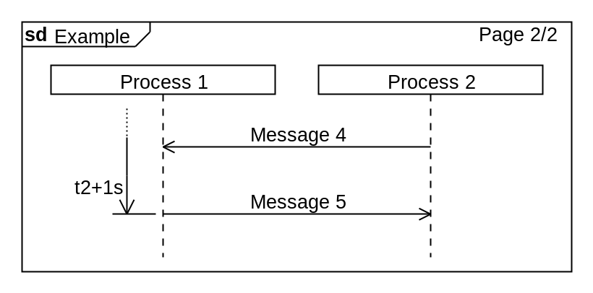 | DiagramName: Example  DiagramStyle: uml  PageSize: 400, auto  PageMargins: 10, 10, 10, 10  process: p1, "Process 1"  process: p2, "Process 2"  state: p1, State 1  state: p2, State\n2;  msg: p1, p2,Message 1;  msg: p2, p1, Message 2  timerbegin: t2, p1, t2 = now  timerbegin: t1, p2, t1 = now,r;  ;  ;  msg: p2, p1, Message 3  timerend: t1  nextpage:  msg: p2, p1,Message 4;  msg: p1, p2, Message 5  timerend: t2, t2+1s

Footer

The footer of the diagram can appear when printing or saving the diagram in a file. The footer contains additional information like for example version and creation date.

PRINTFOOTLINE

Use the command printfootline to select whether the footer of a diagram shall be displayed when printing or exporting the diagram. The parameter option enables or disables the footer.

- Syntax
printfootline: option

- Parameters
- option
Value | Description
yes | The footer will be displayed.
no | The footer will not be displayed.

The default value for the parameter is "yes".

AUTHOR

Using the command author can be used to define the name of the author. The name of the author is given by the parameter name. It is shown in the page footer when printing or exporting a diagram provided that the parameters of the commands printauthor und printfootline have the value "yes".

- Syntax
author: name

- Parameters
- name
The name of the diagram author. This parameter is allowed to have any alphanumeric value.

PRINTAUTHOR

Use the command printauthor to enable the display of the author's name defined by the command author in the footer when printing or exporting a diagram. The value of the parameter option determines whether the date will be displayed.
Important: The command printfootline determines whether the footer will be displayed at all.

- Syntax
printauthor: option

- Parameters
- option
Value | Description
yes | The author's name will be displayed.
no | The author's name will not be displayed.

The default value for the parameter is "yes".

COMPANY

Use the command company to define the name of your company. The name itself is given by the parameter name and is displayed in the footer when printing or exporting a diagram, assuming that the parameter of the commands printcompany and printfootline are set to "yes".

- Syntax
company: name

- Parameter
- name
The name of the company. This parameter can take any alphanumeric value.

PRINTCOMPANY

Use the command printcompany to enable the display of the author's company name defined by the command company in the footer when printing or exporting a diagram. The value of the parameter option determines whether the date will be displayed.
Important: The command printfootline determines whether the footer will be displayed at all.

- Syntax
printcompany: option

- Parameters
- option
Value | Description
yes | The company name will be displayed.
no | The company name will not be displayed.

The default value for the parameter is "yes".

PRINTFILENAME

Use the command printfilename to specify whether the file name of the diagram shall be displayed in the footer when exporting or printing the diagram. The value of the parameter option determines whether the date will be displayed.
Important: The command printfootline determines whether the footer will be displayed at all.

- Syntax
printfilename: option

- Parameters
- option
Value | Description
yes | The file name will be displayed.
no | The file name will be not displayed.

The default value for the parameter is "yes".

DATE

Use the command date to define the diagram date. The date is specified by the parameter date and is displayed in the footer when printing or exporting a diagram, assuming that the parameter of the commands printdate and printfootline are set to "yes".

- Syntax
date: date

- Parameters
- date
The date. This parameter can take any alphanumeric value.

PRINTDATE

Use the command printdate to enable the display of the date defined by the command date in the footer when printing or exporting a diagram. The value of the parameter option determines whether the date will be displayed.
Important: The command printfootline determines whether the footer will be displayed at all.

- Syntax
printdate: option

- Parameters
- option
Value | Description
yes | The date will be displayed.
no | The date will not be displayed.

The default value for the parameter is "yes".

PRINTCREATIONDATE

Use the command printcreationdate to specify whether the current time should be printed in the footer when exporting or printing the diagram. The value of the parameter option determines whether the date will be displayed.
Important: The command printfootline determines whether the footer will be displayed at all.

- Syntax
printcreationdate: option

- Parameters
- option
Value | Description
yes | The current date will be displayed.
no | The current date will be displayed.

The default value for the parameter is "yes".

VERSION

Use the command version to set the version number of the diagram. The version number is specified by the parameter number and is displayed in the footer when printing or exporting a diagram, assuming that the parameter of the commands printversion and printfootline are set to "yes".

- Syntax
version: number

- Parameters
- number
The version number of the diagram. This parameter can take any alphanumeric value.

PRINTVERSION

Use the command printversion to enable the display of the version number defined by the command version in the footer when printing or exporting a diagram. The value of the parameter option determines whether the date will be displayed.
Important: The command printfootline determines whether the footer will be displayed at all.

- Syntax
printversion: option

- Parameters
- option
Value | Description
yes | The version number will be displayed.
no | The version number will not be displayed.

The default value for the parameter is "yes".

Color Definitions

The background and foreground (text) colors diagram elements can easily be changed.

BACKCOLOR

Using the command backcolor it is possible to set the background color of the following diagram elements. The text background color is specified in the parameter color and is valid until the next occurrence of the command backcolor. The text background color is only applied to diagram elements which are not enclosed in a box or rectangle. For such elements the command fillcolor should be used instead.

- Syntax
backcolor: color

- Parameters
- color
The color which should be used for the background of text labels. The color must be given in HTML format, for example, "red", "darkgreen", "#FF22A0". If "none" is specified then the standard value for "white" will be used.

- Example
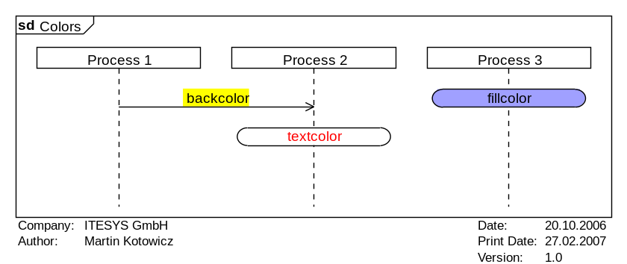 | PrintAuthor: yes  PrintCompany: yes  PrintVersion: yes  PrintDate: yes  PrintCreationDate: yes  PrintFileName: yes  Font: "Arial", "10", "Regular"  DiagramName: Colors  DiagramStyle: uml  PageMargins: 5, 5, 5, 5  PrintFootLine: yes  Author: Martin Kotowicz  Company: ITESYS GmbH  Version: 1.0  Date: 20.10.2006  PageSize: auto, auto  process: P1, "Process 1"  process: P2, "Process 2"  process: P3, "Process 3"  backcolor: yellow  fillcolor: #A0A0FF  msg: P1,P2, backcolor  state: P3, fillcolor;  backcolor: none  fillcolor:none  textcolor: red  state: P2, textcolor;

FILLCOLOR

Use the command fillcolor to the background color of all elements, which are enclosed in a box. The color is specified by the parameter color and is used until the next fillcolor command. Diagram elements that are not enclosed in a box are not influenced by this command. For such elements use the command backcolor instead.

- Syntax
fillcolor: color

- Parameters
- color
The background color to use. The color must be specified in HTML format, for example: "red", "darkgreen", "#FF22A0". If "none" is specified, then the standard value for "white" will be used.

TEXTCOLOR

Use the command textcolor to set the text color of the following text diagram elements. The color is specified by the parameter color and will be used until the next textcolor command changes it.

- Syntax
textcolor: color

- Parameters
- color
The color in which text in diagram elements will be drawn. The color must be specified in the HTML format, for example: "red", "darkgreen", "#FF22A0". If "none" is specified, then the standard value for "white" will be used.

Diagram Elements

Diagram elements are all elements displayed in a sequence diagram. For example, lifelines, messages, states, combined fragments, etc. This chapter describes the commands that create the corresponding diagram elements.

Lifeline

All lifelines must be defined by creating an instance. The appearance of the lifelines can be modified. Additionally, depending on the display mode there are two possible kinds of instances: actor and process. Process can be any classifier like for example an object or a class. In the following only the term process will be used uniformly to avoid confusion.

ACTOR

The command actor adds an actor to the diagram. An actor represents a role in the context of the system you are modeling. The actor can influence the system and can be influenced by the system. An actor could stand for a person, group of people, a sensor, another system, etc. The parameter id is used to assign a unique ID for the lifeline of the actor. The parameters name and description define the name and an optional description of the actor. By default actors and processes are equally distributed horizontally in a diagram. Sometimes it might be necessary to have more than the default space between an actor and its neighbors. The space to the left and to the right can be control with the arguments left und right.

- Syntax
actor: id, name, description, left, right

- Parameters
- id
The ID of the lifeline. Could be any alphanumeric identifier, which uniquely identifies the lifeline of the actor. This ID is not visible in the diagram.

- name
The name of the actor. Some text that defines the actor's name. The name is displayed in the diagram right below the actor symbol. If your text contains punctuation, you must put the complete text in quotes ("").

- description (optional)
The description of the actor. Some text that describes the actor. This text appears in the diagram right above the actor symbol. If your text contains punctuation, you must put the complete text in quotes ("").

- left (optional)
Additional place to the left of the actor. The value is always in pixel.

- right (optional)
Additional place to the right of the actor. The value is always in pixel.

- Example
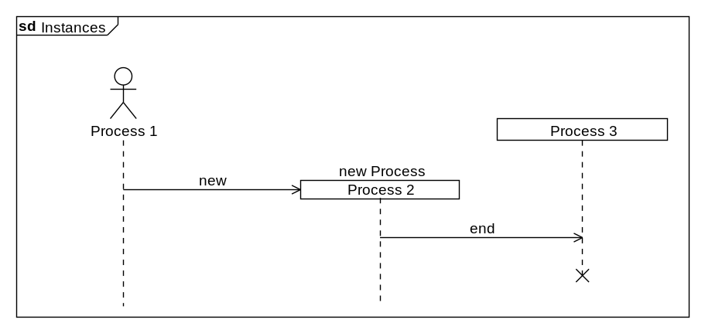 | DiagramName: Instances  DiagramStyle: uml  PageSize: auto  PageMargins: 10,10,10,10  actor: p1, Process 1  dummyprocess: p2, 50,0  process: p3, "Process 3"  create: p1, p2, new, Process 2, new Process;  msg: p2, p3, end;  stop: p3

PROCESS

The command process adds a new process (or object) to the diagram. The parameter id is used to assign a unique ID for the lifeline of the process. The parameters name and description define the name and an optional description of the process. By default actors and processes are equally distributed horizontally in a diagram. Sometimes it might be necessary to have more than the default space between an actor and its neighbors. The space to the left and to the right can be control with the arguments left und right.

- Syntax
process: id, name, description, left, right

- Parameters
- id
The ID of the lifeline. Could be any alphanumeric identifier, which uniquely identifies the lifeline of the process. This ID is not visible in the diagram.

- name
The name of the process. Some text that defines the process's name. The name is displayed in the diagram right below the process symbol. If your text contains punctuation, you must put the complete text in quotes ("").

- description (optional)
The description of the process. Some text that describes the process. This text appears in the diagram right above the process symbol. If your text contains punctuation, you must put the complete text in quotes ("").

- left (optional)
Additional place to the left of the process. The value is always in pixel.

- right (optional)
Additional place to the right of the process. The value is always in pixel.

DUMMYPROCESS

The command dummyprocess adds a placeholder for a process (or object) to the diagram. A dummy process is invisible until it is created using the command create. The parameter id is used to assign a unique ID for the lifeline of the process. The parameters name and description define the name and an optional description of the process. By default actors and processes are equally distributed horizontally in a diagram. Sometimes it might be necessary to have more than the default space between an actor and its neighbors. The space to the left and to the right can be control with the arguments left und right.

- Syntax
dummyprocess: id, left, right

- Parameters
- id
The ID of the lifeline. Could be any alphanumeric identifier, which uniquely identifies the lifeline of the process. This ID is not visible in the diagram.

- left (optional)
Additional place to the left of the process. The value is always in pixel.

- right (optional)
Additional place to the right of the process. The value is always in pixel.

CREATE

Use the command create to send a create message to a process. The lifeline of the process must be reserved in advance using the command dummyprocess.

- Syntax
create: sourceid, destinationid, message, name, description

- Parameters
- sourceid
The lifeline ID from which the create message is sent.

- destinationid
The lifeline ID, which has already been reserved using the command dummyprocess, for which a process should be created.

- message
The text that should appear as the create message text. If your text contains punctuation, you must put the complete text in quotes ("").

- name
The name of the process. Some text that defines the process's name. The name is displayed in the diagram right below the process symbol. If your text contains punctuation, you must put the complete text in quotes ("").

- description (optional)
The description of the process. Some text that describes the process. This text appears in the diagram right above the process symbol. If your text contains punctuation, you must put the complete text in quotes ("").

STOP

Use the command stop to display a stop symbol for a lifeline. The lifeline will not be drawn from this point on.

- Syntax
stop: instanceid

- Parameters
- instanceid
The ID of the lifeline for which a stop symbol should be drawn.

REGIONBEGIN

Use the command regionbegin and regionend to change the way the lifeline is displayed. The command regionbegin defines the start of the modified lifeline region. The lifeline of an instance can be displayed in activation, coregion or suspension mode.

- Syntax
regionbegin: instanceid, style

- Parameters
- instanceid
The ID of the lifeline for which the display mode should be changed.

- style
Sets the new display mode for the lifeline.

Value | Description
activation | The lifeline will be displayed in activation mode
coregion | The lifeline will be displayed in coregion mode
suspension | The lifeline will be displayed in suspension mode

- Example
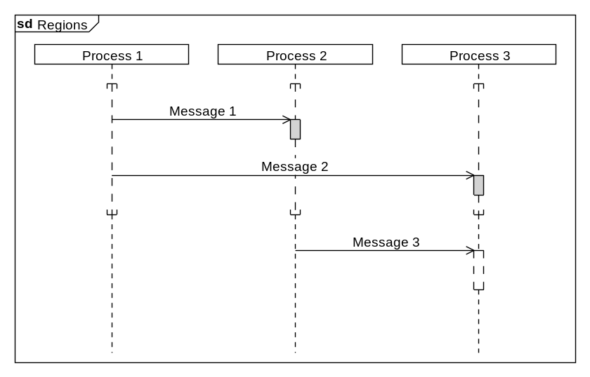 | DiagramName: Regions  DiagramStyle: uml  PageSize: auto, auto  PageMargins: 10, 10, 10, 10  process: p1, "Process 1"  process: p2, "Process 2"  process: p3, "Process 3"  regionbegin: p1, coregion  regionbegin: p2, coregion  regionbegin: p3, coregion;  msg: p1,p2, Message 1  regionbegin: p2, activation;  regionend: p2;  regionbegin: p3, activation  msg: p1,p3, Message 2;  regionend: p3;  regionend: p1  regionend: p2  regionend: p3;  msg: p2,p3, Message 3  regionbegin: p3, suspension;  ;  regionend: p3;

REGIONEND

Use the command regionbegin and regionend to change the way the lifeline is displayed. The command regionend defines the end of the modified lifeline region. The lifeline of an instance can be displayed in activation, coregion or suspension mode.

- Syntax
regionend: instanceid

- Parameters
- instanceid
The ID of the lifeline for which the display mode should be changed back to the previously set one.

Messages

Messages are, besides instances, an essential part of MSCs/SDs. Signals, Events, Commands and return values are summarized under the term messages.

MSG

Use the command msg to display a message in the diagram. A message represents communication from one actor or process to another one. There are three types of messages: asynchronous, synchronous and response messages. In SDL mode there is no difference between synchronous and asynchronous. If you want the message to span over a longer time interval (vertical offset) between sending and reception, then you use the commands msgbegin and msgend instead.

- Syntax
msg: sourceid, destinationid, message, style

- Parameters
- sourceid
The ID of the lifeline which should send the message, or one of the following constants:

Value | Description
ENV_LEFT | The message comes from the left border of the diagram.
ENV_RIGHT | The message comes from the right border of the diagram.

- destinationid
The ID of the lifeline, which should receive the message, or one of the following constants:

Value | Description
ENV_LEFT | The message comes from the left border of the diagram.
ENV_RIGHT | The message comes from the right border of the diagram.

- message
The text that should appear as the message. If your text contains punctuation, you must put the complete text in quotes ("").

- style (optional)
Sets the type of message.

Value | Description
+ | asynchronous message
! | synchronous message  (not supported in SDL diagrams)
* | response

The default value for this parameter is "+".

- Example
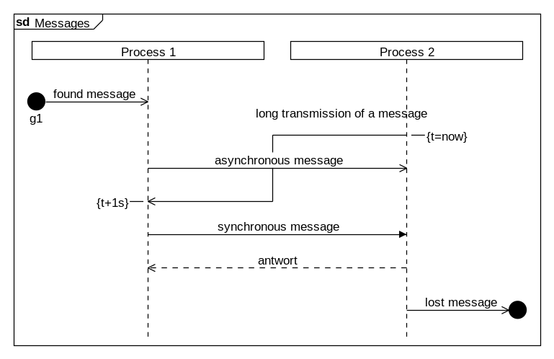 | DiagramName: Messages  DiagramStyle: uml  PageSize: 600, auto  PageMargins: 10, 10, 10, 10  process: p1, "Process 1"  process: p2, "Process 2"  found: p1, "found message","g1",l;  msgbegin: m1, p2, p1, "long transmission of a message"  linecomment: p2, "{t=now}",r;  msg: p1,p2, "asynchronous message";  msgend: m1  linecomment:p1, "{t+1s}";  msg: p1,p2, "synchronous message",!;  msg: p2, p1, "response",*;  lost: p2, "lost message", ,r

MSGBEGIN

Use the commands msgbegin and msgend if you want the message to span over a longer time interval (vertical offset) between sending and reception. A message represents communication from one actor or process to another one. There are three types of messages: asynchronous, synchronous and response messages. In SDL mode there is no difference between synchronous and asynchronous. Use the command msg if you want to display a message with no vertical offset in the diagram.

- Syntax
msgbegin: messageid, sourceid, destinationid, message, style

- Parameters
- messageid
The ID of this message. Specify this ID in the command msgend.

- sourceid
The ID of the lifeline which should send the message, or one of the following constants:

Value | Description
ENV_LEFT | The message comes from the left border of the diagram.
ENV_RIGHT | The message comes from the right border of the diagram.

- destinationid
The ID of the lifeline which should receive the message, or one of the following constants:

Value | Description
ENV_LEFT | The message comes from the left border of the diagram.
ENV_RIGHT | The message comes from the right border of the diagram.

- message
The text that should appear as the message. If your text contains punctuation, you must put the complete text in quotes ("").

- style (optional)
Sets the type of message.

Value | Description
+ | asynchronous message
! | synchronous message  (not supported in SDL diagrams)
* | response

The default value for this parameter is "+".

MSGEND

Use the commands msgbegin and msgend if you want the message to span over a longer time interval (vertical offset) between sending and reception. A message represents communication from one actor or process to another one. There are three types of messages: asynchronous, synchronous and response messages. In SDL mode there is no difference between synchronous and asynchronous. Use the command msg if you want to display a message with no vertical offset in the diagram.

- Syntax
msgend: messageid

- Parameters
- messageid
The ID of the message that should be received at this point.

FOUND

Use the command found to display a found message in the diagram. A found message is a message whose sender is either unknown or irrelevant and will therefore not be displayed on the diagram.

- Syntax
found: instanceid, message, gate, orientation

- Parameters
- instanceid
The ID of the lifeline which should receive the message.

- message
The text that should appear as the message. If your text contains punctuation, you must put the complete text in quotes ("").

- gate (optional)
The text that should be displayed below the found message. If your text contains punctuation, you must put the complete text in quotes ("").

- orientation (optional)
Sets the position of the found message in respect to the lifeline specified in the parameter instanceid.

Value | Description
l | The found message will be displayed to the left of the lifeline.
r | The found message will be displayed to the right of the lifeline.

The default value for this parameter is "l".

LOST

Use the command lost to display a lost message in the diagram. A lost message is a message whose receiver is either unknown or irrelevant, or the message is never received. Therefore the receiver will is not displayed on the diagram.

- Syntax
lost: instanceid, message, gate, orientation

- Parameter
- instanceid
The ID of the lifeline which should receive the message.

- message
The text that should appear as the message. If your text contains punctuation, you must put the complete text in quotes ("").

- gate (optional)
The text that should be displayed below the found message. If your text contains punctuation, you must put the complete text in quotes ("").

- orientation (optional)
Sets the position of the found message in respect to the lifeline specified in the parameter instanceid.

Value | Description
l | The found message will be displayed to the left of the lifeline.
r | The found message will be displayed to the right of the lifeline.

The default value for this parameter is "l".

State Invariants

The state invariants make it possible to specify the state of an instance.

STATE

Use the command state to model state invariants. The state invariants can be displayed on the lifeline of a single or multiple instances. If the state invariant should span all instances, then use the command stateoverall.

- Syntax
state: instanceid, text, style, orientation

- Parameters
- instanceid
The ID of the lifeline for which you model the state invariant. If the state invariant span over multiple instances, write a comma separated list of the IDs of all lifelines.

- text
The text that should be displayed as the state invariant. If your text contains punctuation, you must put the complete text in quotes ("").

- style (optional)
Determines the display mode of the state invariants.

Value | Description
- | The state invariant will be displayed using the state symbol
* | The state invariant will be displayed in curly brackets

The default value for this parameter is "-".

- orientation (optional)
Determines the vertical alignment of the state invariant in the diagram line.

Value | Description
t | The state invariant is top aligned
b | The state invariant is bottom aligned

The default value for this parameter is "t".

- Example
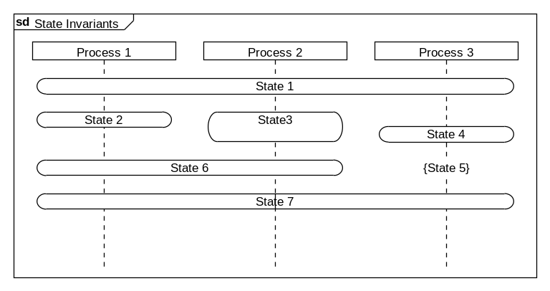 | DiagramName: State Invariants  DiagramStyle: uml  PageSize: auto, auto  PageMargins: 10, 10, 10, 10  process: p1, "Process 1"  process: p2, "Process 2"  process: p3, "Process 3"  stateoverall: State 1;  state: p1, State 2,,t  state: p2, State\n3  state: p3, State 4,-,b;  state: p3, State 5,*,b  state: "p1,p2", State 6;  state: "p1,p3", State 7;

STATEOVERALL

Use the command stateoverall to define a state invariant spanning over all diagram processes. If you to model a state invariant only for a single or multiple instances, then use the command state instead.

- Syntax
stateoverall: text, orientation

- Parameters
- text
The text that should be displayed as the state invariant. If your text contains punctuation, you must put the complete text in quotes ("").

- orientation (optional)
Determines the vertical alignment of the state invariant in the diagram line.

Value | Description
t | The state invariant is top aligned
b | The state invariant is bottom aligned

Der Standardwert für den Parameter ist "t".

Tasks

This SDL-specific diagram element allows the definitions of tasks, which certain instance performs at that given point in the sequence diagram. This element is available also in UML sequence diagrams although the UML standard does not support them.

TASK

Use the command task to model SDL specific tasks.

- Syntax
task: instanceid, text, orientation

- Parameters
- instanceid
The ID of the lifeline for which the task should be displayed.

- text
The text that should be displayed as the task. If your text contains punctuation, you must put the complete text in quotes ("").

- orientation (optional)
Determines the vertical alignment of the state invariant in the diagram line.

Value | Description
t | The state invariant is top aligned
b | The state invariant is bottom aligned

The default value for this parameter is "t".

- Example
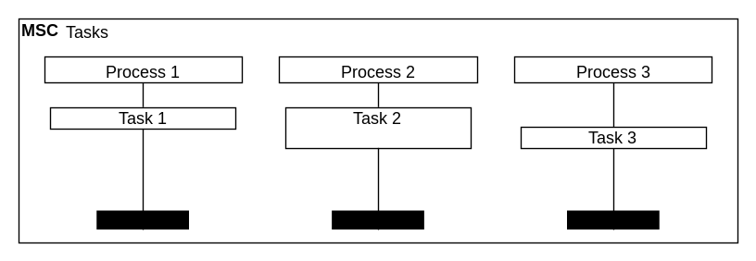 | DiagramName: Tasks  DiagramStyle: sdl  PageSize: auto, auto  PageMargins: 10, 10, 10, 10  process: p1, "Process 1"  process: p2, "Process 2"  process: p3, "Process 3"  task: p1, Task 1,t  task: p2, Task \n2  task: p3, Task 3,b;

Comments

Comments in sequence diagrams are freely defined texts, which normally provide additional information about the sequence.

COMMENT

Using the comment comment diagram comments can be added. The comments can be inserted either at the lifelines of processes or actors, or at the left or right side of the diagram. The position of the comment can be set using the parameters instanceid and orientation The text of the comment is defined by the parameter text. If a comment should be displayed over all instances, then use the command commentoverall instead.

- Syntax
comment: instanceid, text, orientation

- Parameters
- instanceid
The ID of the lifeline at which the comment should be displayed, or one of the following constants:

Value | Description
ENV_LEFT | lest side of the diagram
ENV_RIGHT | right side of the diagram

- text
The text that should be displayed as a comment. If your text contains punctuation, you must put the complete text in quotes ("").

- orientation (optional)
Sets the position of the comment relative to the lifeline selected by the parameter instanceid.

Value | Description
l | The comment will be displayed to the left of the lifeline
r | The comment will be displayed to the right of the lifeline

This parameter is ignored if the comment will be displayed at the left or right side of the diagram
The default value is for this parameter is "l".

- Example
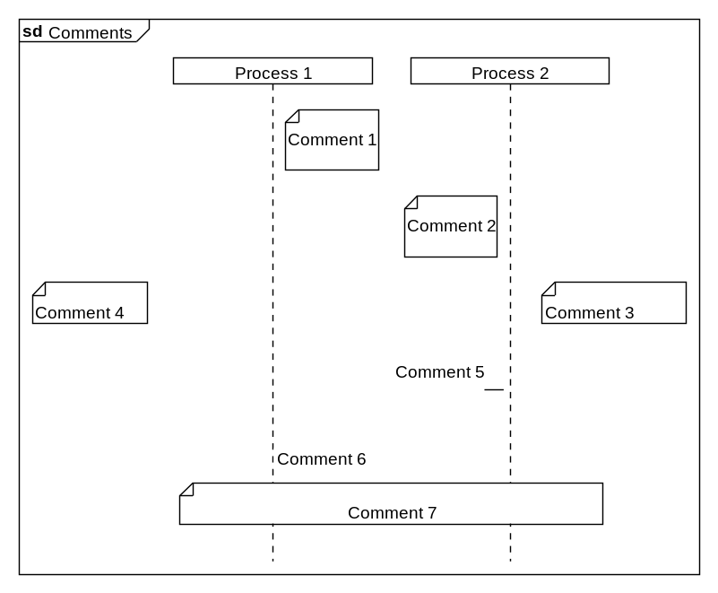 | DiagramName: Comments  DiagramStyle: uml  PageSize: auto  PageMargins: 10,10,10,10  left: 100  right: 50  process: p1, Process 1  process: p2, Process 2  comment: p1, Comment 1, r;  comment: p2, Comment 2, l;  comment: ENV_RIGHT, Comment 3  comment: ENV_LEFT, Comment 4;  linecomment: p2, Comment 5;  linecomment: p1, Comment 6, r, *;  commentoverall: Comment 7

COMMENTOVERALL

Using the command commentoverall a diagram comment can be defined, which spans over the lifelines of all processes and actors. The text of the comment can be specified in the parameter text.

- Syntax
commentoverall: text

- Parameters
- text
The text that should be displayed as a comment. If your text contains punctuation, you must put the complete text in quotes ("").

LINECOMMENT

Using the command linecomment a line diagram comment (without a comment box) can be added. The comment is attached to the lifeline of a process or an actor. To determine the position of the comment, use the parameters instanceid and orientation The comment text is specified by the parameter text. Optionally, the horizontal line that connects the comment to its corresponding lifeline can be hidden by setting the parameter format.

- Syntax
linecomment: instanceid, text, orientation, format

- Parameters
- instanceid
The ID of the lifeline at which the comment should be displayed, or one of the following constants:

- text
The text that should be displayed as a comment. If your text contains punctuation, you must put the complete text in quotes ("").

- orientation (optional)
Sets the position of the comment relative to the lifeline selected by the parameter instanceid.

Value | Description
l | The comment will be displayed to the left of the lifeline
r | The comment will be displayed to the right of the lifeline

The default value is for this parameter is "l".

- format (optional)
Determines whether the comment should be connected to its corresponding lifeline by a horizontal line.

Value | Description
* | The comment will be displayed without the horizontal line
- | The comment will be displayed with the horizontal line

The default value for this parameter is "-".

MARK

Use the command mark to display a mark in the diagram. Unlike linecomment a mark is displayed at the border of the diagram.

- Syntax
mark: instanceid, text, orientation

- Parameters
- instanceid
The ID of the lifeline with which the mark should be connected.

- text
The text that should be displayed in the mark. If your text contains punctuation, you must put the complete text in quotes ("").

- orientation (optional)
Sets the position of the mark.

Value | Description
l | The mark will be displayed at the left side of the diagram.
r | The mark will be displayed at the right side of the diagram.
t | The mark line will be displayed above the point where it is defined.
b | The mark line will be displayed below the point where it is defined.

Combinations of these values are allowed.
The default value for this parameter is "lt".

- Example
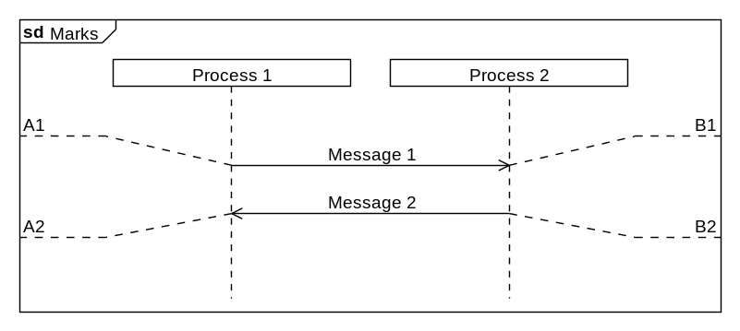 | DiagramName: Marks  DiagramStyle: uml  PageSize: 550,auto  PageMargins: 10,10,10,10  Left: 50  Right: 50  process: p1, Process 1  process: p2, Process 2  ;  msg: p1, p2, Message 1  mark: p1, A1  mark: p2, B1, r;  msg: p2, p1, Message 2  mark: p1, A2, lb  mark: p2, B2, rb;

Timers

Timer elements can be used to describe flows with specific timing. These timing constraints can be considered as either duration specification or timing requirements.

TIMERBEGIN

Use the commands timerbegin and timerend to model a time measurement. The command timerbegin defines the end of the time measurement. There is a vertical line connecting the start and end points of the time measurement. Should the time measurement be displayed without a line, use the commands settimer, stoptimer and timeout.

- Syntax
timerbegin: timerid, instanceid, text, orientation, style

- Parameters
- timerid
The ID of the time measurement. The ID is required for the command timerend in order to match it to the correct time measurement.

- instanceid
The ID of the lifeline at which the time measurement should be displayed.

- text (optional)
The text that should be displayed at the end of the time measurement. If your text contains punctuation, you must put the complete text in quotes ("").

- orientation (optional)
Sets the position of the time measurement in respect to the lifeline specified in the parameter instanceid.

Value | Description
l | The measurement will be displayed to the left of the lifeline
r | The measurement will be displayed to the right of the lifeline

Der Standardwert für den Parameter ist "l".

- style (optional)
Sets the display style of the timer.

Value | Description
n | The measurement will be displayed close to the lifeline
o | The measurement will be displayed far from the lifeline, the text is from the outside
i | The measurement will be displayed far from the lifeline, the text is from the inside

The default value for this parameter is "n".

- Example
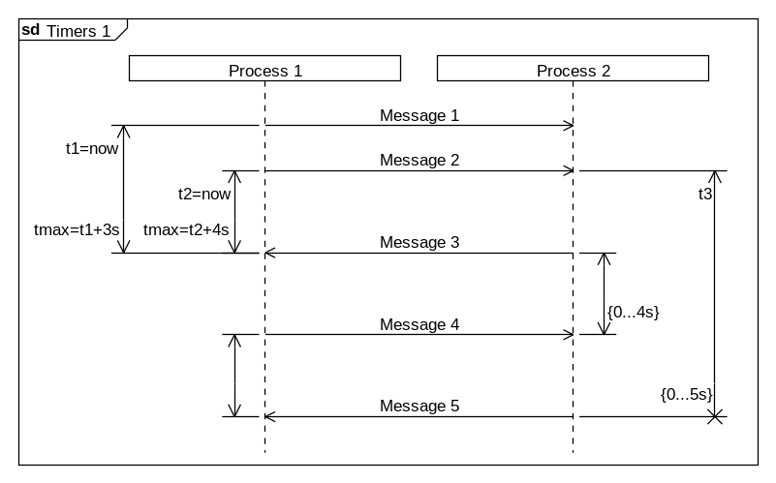 | DiagramName: Timers 1  DiagramStyle: uml  PageSize: 620, auto  PageMargins: 10, 10, 10, 10  process: p1, "Process 1",,70  process: p2, "Process 2",,0,20  timerbegin: t1, p1, t1=now,l,o  msg: p1, p2, Message 1;  timerbegin: t2, p1, t2=now,l,n  timerbegin: t3, p2,t3,r,i  msg: p1, p2, Message 2;  ;  timerbegin: t4, p2,,r,n  msg: p2, p1, Message 3  timerend: t1, tmax=t1+3s  timerend: t2, tmax=t2+4s;  ;  timerbegin: t5, p1  msg: p1, p2, Message 4  timerend: t4,{0...4s};  ;  msg: p2, p1, Message 5  timerend: t5  timerend: t3, {0...5s},*

TIMEREND

Use the commands timerbegin and timerend to model a time measurement. The command timerend defines the end of the time measurement. There is a vertical line connecting the start and end points of the time measurement. Should the time measurement be displayed without a line, use the commands settimer, stoptimer and timeout.

- Syntax
timerend: timerid, text, style

- Parameters
- timerid
The ID of the time measurement for which you define the end point.

- text (optional)
The text that should be displayed at the start of the time measurement. If your text contains punctuation, you must put the complete text in quotes ("").

- style (optional)
Sets the display mode for the time measurement end point.

Value | Description
- | The time measurement ends normally
* | The time measurement is aborted

The default value for this parameter is "-".

SETTIMER

Use the command settimer to model the beginning of a timer. There is no vertical line connecting the start and the end of the time measurement. Since the UML standard does not specify such display element the SDL representation is used. Use the command stoptimer or timeout to model the end of the time measurement.

- Syntax
settimer: instanceid, text, orientation

- Parameters
- instanceid
The ID of the lifeline at which the time measurement should be displayed.

- text (optional)
The text that should be displayed at the beginning of the time measurement. If your text contains punctuation, you must put the complete text in quotes ("").

- orientation (optional)
Sets the position of the time measurement in respect to the lifeline specified in the parameter instanceid.

Value | Description
l | The measurement will be displayed to the left of the lifeline
r | The measurement will be displayed to the right of the lifeline

The default value for this parameter is "l".

- Example
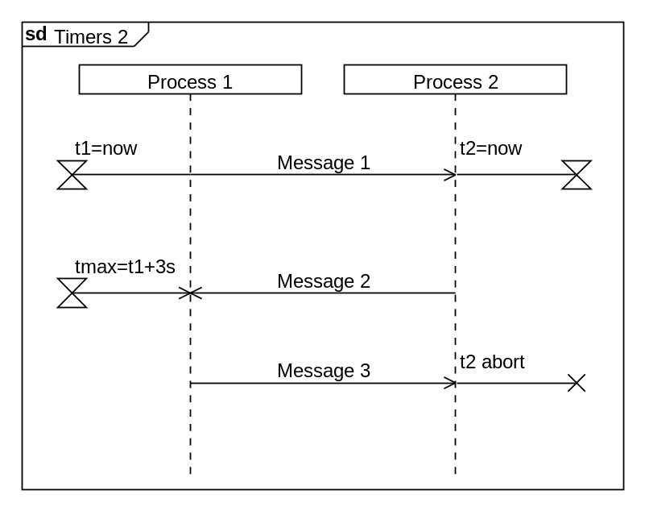 | DiagramName: Timers 2  DiagramStyle: uml  PageSize: auto, auto  PageMargins: 10, 10, 10, 10  process: p1, "Process 1",,20  process: p2, "Process 2",,0,20  settimer: p1, t1=now  settimer: p2, t2=now,r  msg: p1, p2, Message 1;  ;  msg: p2, p1, Message 2  timeout: p1, tmax=t1+3s;  ;  msg: p1, p2, Message 3  stoptimer: p2,t2 abort,r;

STOPTIMER

Use the command stoptimer to model the stopping of a timer. There is no vertical line connecting the start and the end of the time measurement. Since the UML standard does not specify such display element the SDL representation is used. Use the command settimer to model the start of the time measurement.

- Syntax
stoptimer: instanceid, text, orientation

- Parameters
- instanceid
The ID of the lifeline at which the time measurement should be displayed.

- text (optional)
The text that should be displayed at the end of the time measurement. If your text contains punctuation, you must put the complete text in quotes ("").

- orientation (optional)
Sets the position of the time measurement in respect to the lifeline specified in the parameter instanceid.

Value | Description
l | The measurement will be displayed to the left of the lifeline
r | The measurement will be displayed to the right of the lifeline

The default value for this parameter is "l".

TIMEOUT

Use the command timeout to model the stopping of a timer. There is no vertical line connecting the start and the end of the time measurement. Since the UML standard does not specify such display element the SDL representation is used. Use the command settimer to model the start of the time measurement.

- Syntax
timeout: instanceid, text, orientation

- Parameters
- instanceid
The ID of the lifeline at which the time measurement should be displayed.

- text (optional)
The text that should be displayed at the end of the time measurement. If your text contains punctuation, you must put the complete text in quotes ("").

- orientation (optional)
Sets the position of the time measurement in respect to the lifeline specified in the parameter instanceid.

Value | Description
l | The measurement will be displayed to the left of the lifeline
r | The measurement will be displayed to the right of the lifeline

The default value for this parameter is "l".

Time Measurements

This SDL specific diagram element makes it possible to specify time measurements in sequence diagrams and to store the results in variables. These variables can be used later in the sequence diagram flow to define intervals for example.

MEASUREBEGIN

Use the commands measurebegin and measureend to model a measurement. The command measurebegin defines the start of the measurement. The beginning and the end of a measurement are connected with a line on the generated diagram. It is not possible to nest multiple measurements on the same lifeline. For this purpose use the commands measurestart und measurestop which are displayed without a line connecting the start and the end.

- Syntax
measurebegin: instanceid, text, orientation, style

- Parameters
- instanceid
The ID of the lifeline on which the measurement should be displayed.

- text (optional)
The text that should be displayed at the beginning of the measurement. If your text contains punctuation, you must put the complete text in quotes ("").

- orientation (optional)
Sets the position of the measurement in respect to the lifeline specified in the parameter instanceid.

Value | Description
l | The measurement will be displayed to the left of the lifeline
r | The measurement will be displayed to the right of the lifeline

The default value for this parameter is "l".

- style (optional)
Sets the display mode for the measurement.

Value | Description
- | The measurement arrows will be displayed below the horizontal measurement lines.
* | The measurement arrows will be displayed above the horizontal measurement lines.

The default parameter for this parameter is "-".

- Example
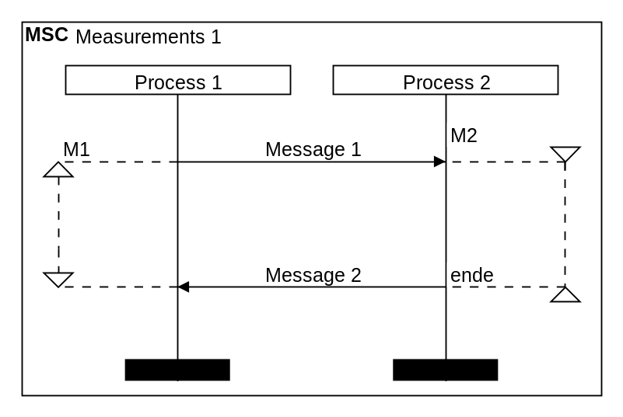 | DiagramName: Measurements 1  DiagramStyle: sdl  PageSize: auto, auto  PageMargins: 10, 10, 10, 10  left:10  right: 10  process: p1, "Process 1"  process: p2, "Process 2"  measurebegin: p1, M1  measurebegin: p2, M2, r, *  msg: p1, p2, Message 1;  ;  ;  msg: p2, p1, Message 2  measureend: p1  measureend: p2, end;

MEASUREEND

Use the commands measurebegin and measureend to model a measurement. The command measureend defines the end of the measurement. The beginning and the end of a measurement are connected with a line on the generated diagram. It is not possible to nest multiple measurements on the same lifeline. For this purpose use the commands measurestart und measurestop which are displayed without a line connecting the start and the end.

- Syntax
measureend: instanceid, text

- Parameter
- instanceid
The ID of the lifeline on which the measurement should be ended.

- text (optional)
The text that should be displayed at the end of the measurement. If your text contains punctuation, you must put the complete text in quotes ("").

MEASURESTART

Use the command measurestart to model a measurement in a diagram. The start and stop points are not connected with a line when displayed on the diagram. The end of the measurement is defined using the command measurestop.

- Syntax
measurestart: instanceid, gate, text, orientation, style

- Parameters
- instanceid
The ID of the lifeline at which the measurement should be displayed.

- gate (optional)
The text that should be displayed at the begin gate of the measurement. If your text contains punctuation, you must put the complete text in quotes ("").

- text (optional)
The text that should be displayed at the beginning of the measurement. If your text contains punctuation, you must put the complete text in quotes ("").

- orientation (optional)
Sets the position of the measurement in respect to the lifeline specified in the parameter instanceid.

Value | Description
l | The measurement will be displayed to the left of the lifeline
r | The measurement will be displayed to the right of the lifeline

The default value for this parameter is "l".

- style (optional)
Sets the display mode for the measurement.

Value | Description
- | The measurement arrows will be displayed below the horizontal measurement lines.
* | The measurement arrows will be displayed above the horizontal measurement lines.

The default parameter for this parameter is "-".

- Example
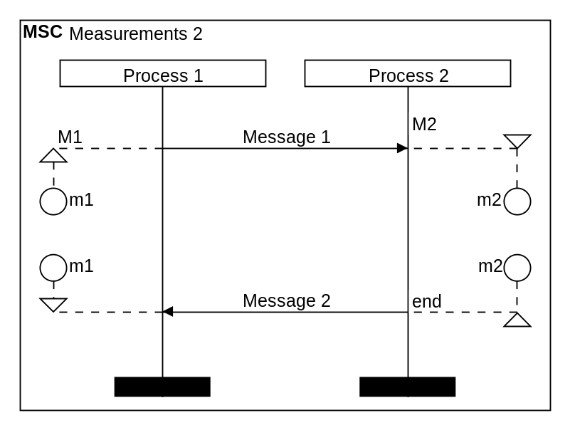 | DiagramName: Measurements 2  DiagramStyle: sdl  PageSize: auto, auto  PageMargins: 10, 10, 10, 10  left:10  right: 10  process: p1, "Process 1"  process: p2, "Process 2"  measurestart: p1, m1,M1  measurestart: p2, m2, M2,r, *  msg: p1, p2, Message 1;  ;  ;  ;  msg: p2, p1, Message 2  measurestop: p1,m1  measurestop: p2, m2, end,r,*;

MEASURESTOP

Use the command measurestop to model a measurement in a diagram. The start and stop points are not connected with a line when displayed on the diagram. The end of the measurement is defined using the command measurestart.

- Syntax
measurestop: instanceid, gate, text, orientation, style

- Parameters
- instanceid
The ID of the lifeline at which the measurement should be displayed.

- gate (optional)
The text that should be displayed at the end gate of the measurement. If your text contains punctuation, you must put the complete text in quotes ("").

- text (optional)
The text that should be displayed at the end of the measurement. If your text contains punctuation, you must put the complete text in quotes ("").

- orientation (optional)
Sets the position of the measurement in respect to the lifeline specified in the parameter instanceid.

Value | Description
l | The measurement will be displayed to the left of the lifeline
r | The measurement will be displayed to the right of the lifeline

The default value for this parameter is "l".

- style (optional)
Sets the display mode for the measurement.

Value | Description
- | The measurement arrows will be displayed below the horizontal measurement lines.
* | The measurement arrows will be displayed above the horizontal measurement lines.

The default parameter for this parameter is "-".

Combined Fragments

Combined fragments can be used within a sequence diagram to represent interaction units like alternatives and loops.

FRAGMENTBEGIN

Use the commands fragmentbegin and fragmentend to define a combined fragment. The beginning of the fragment is specified by the command fragmentbegin. A combined fragment is used to express logical components: alternatives, options, exceptions, parallel merges, loops, negations, critical regions and assertions.

- Syntax
fragmentbegin: fagmentid, firstinstanceid, lastinstanceid, text

- Parameters
- fragmentid
The ID of the new combined fragment.

- firstinstanceid
The ID of the first lifeline that should be covered by the ref combined fragment.

- lastinstanceid
The ID of the last lifeline that should be covered by the ref combined fragment.

- text
The text that describes the interaction in the combined fragment. If your text contains punctuation, you must put the complete text in quotes ("").

- Example
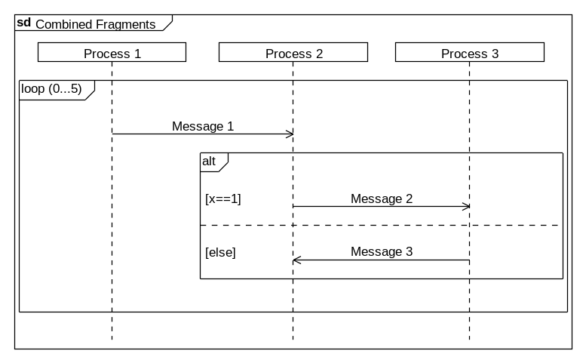 | DiagramName: Combined Fragments  DiagramStyle: uml  PageSize: auto, auto  PageMargins: 10, 10, 10, 10  process: p1, "Process 1"  process: p2, "Process 2"  process: p3, "Process 3"  fragmentbegin: i1, p1,p3, loop (0...5);  msg: p1, p2, Message 1;  fragmentbegin: i2, p2,p3,alt;  fragmenttext: i2, "[x==1]  msg: p2, p3, Message 2;  fragmentseparator: i2;  fragmenttext: i2, [else]  msg: p3, p2, Message 3;  fragmentend: i2;  fragmentend: i1

FRAGMENTEND

Use the commands fragmentbegin and fragmentend to define a combined fragment. The end of the fragment is specified by the command fragmentend. A combined fragment is used to express logical components: alternatives, options, exceptions, parallel merges, loops, negations, critical regions and assertions.

- Syntax
fragmentend: fagmentid

- Parameters
- fragmentid
The ID of the combined fragment that should be closed.

FRAGMENTSEPARATOR

Use the command fragmentseparator to insert a separator line in a combined fragment.

- Syntax
fragmentseparator: fagmentid

- Parameters
- fragmentid
The ID of the combined fragment in which a separator line should be added.

FRAGMENTTEXT

Use the command fragmenttext to write text to the left in a combined fragment.

- Syntax
fragmenttext: fagmentid, text

- Parameters
- fragmentid
The ID of the combined fragment in which a separator line should be written.

- text
The text that should appear in the combined fragment. If your text contains punctuation, you must put the complete text in quotes ("").

References

References inside a sequence diagram make it possible to refer to another sequence diagram that presents the interaction in more detail.

REF

Use the command ref to display a ref combined fragment.

- Syntax
ref: firstinstanceid, lastinstanceid, text

- Parameters
- firstinstanceid
The ID of the first lifeline that should be covered by the ref combined fragment.

- lastinstanceid
The ID of the last lifeline that should be covered by the ref combined fragment.

- text
The text that should appear as the name and parameters of the ref combined fragment. If your text contains punctuation, you must put the complete text in quotes ("").

- Example
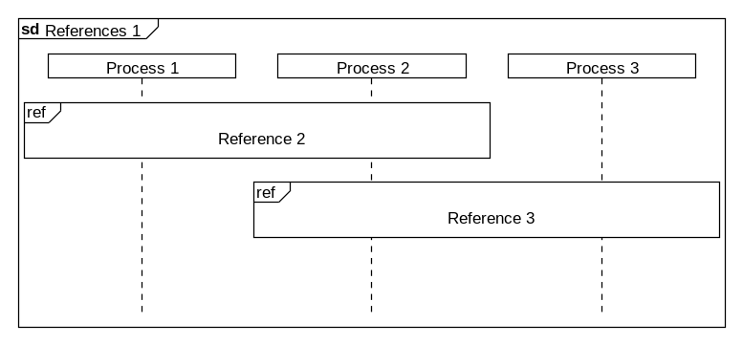 | DiagramName: References 1  DiagramStyle: uml  PageSize: auto, auto  PageMargins: 10, 10, 10, 10  process: p1, "Process 1"  process: p2, "Process 2"  process: p3, "Process 3"  ref: p1,p2, "Reference 2";  ref: p2,p3, "Reference 3";

Control Characters

Control characters play an important role for the diagram description. Among others they can control the vertical offset between diagram elements and can force a line or page break. This chapter describes the available control characters and their function.

Text Formatting

The control characters in diagram code are responsible for manual line breaks and fort he display of punctuation characters.

\n – Line Break

A parameter from type text can be broken into multiple lines using the control character "\n".

- Syntax Example
command: parameter1, parameter\n2

- Example
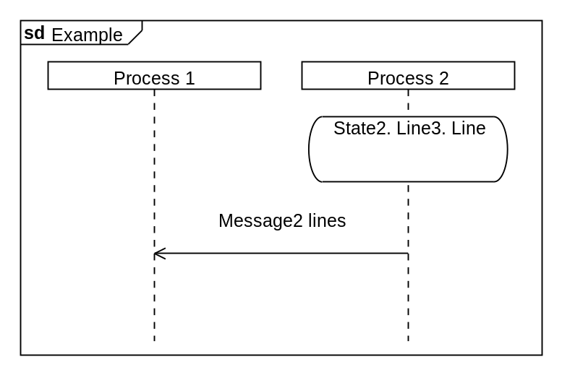 | DiagramName: Example  DiagramStyle: uml  PageSize: 400, auto  PageMargins: 10, 10, 10, 10  process: p1, "Process 1"  process: p2, "Process 2"  state: p2, State\n2. Line\n3. Line;  msg: p2, p1, Message\n2 lines;

\“ – Quotation Marks

You can type a quotation mark in a parameter from type text by using the control character "\"".

- Syntax Example
command: parameter1, \”parameter 2\”

- Example
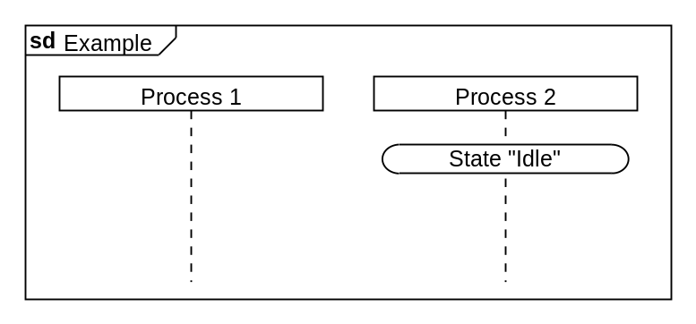 | DiagramName: Example  DiagramStyle: uml  PageSize: 400, auto  PageMargins: 10, 10, 10, 10  process: p1, "Process 1"  process: p2, "Process 2"  state: p2, State \"Idle\";

Diagram Formatting

The diagram formatting control characters are responsible fort he vertical offset between diagram elements and for manual page or line break.

; – Diagram Line Break

Use the control character semi-colon ";" at the end of a line to define the end of the diagram line as well. All diagram elements that are on the same diagram line will be displayed at the same vertical height.

- Syntax Example
command: parameter1, parameter2;

- Example
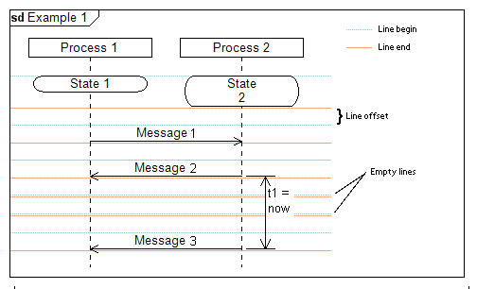 | DiagramName: Example 1  DiagramStyle: uml  PageSize: 500, auto  PageMargins: 10, 10, 10, 10  right: 150  process: p1, "Process 1"  process: p2, "Process 2"  state: p1, State 1  state: p2, State\n2;  msg: p1, p2,Message 1;  msg: p2, p1, Message 2  timerbegin: t1, p2, t1 = now,r;  ;  ;  msg: p2, p1, Message 3  timerend: t1

{ } – No Diagram Line Break

Use the curly brackets "{" and "}" to define a block, in which all diagram elements will be displayed on a single line ignoring any semi-colons in the block.

- Syntax Example
{
command1: parameter1, parameter2;
command2: parameter1, parameter2;
}

- Example
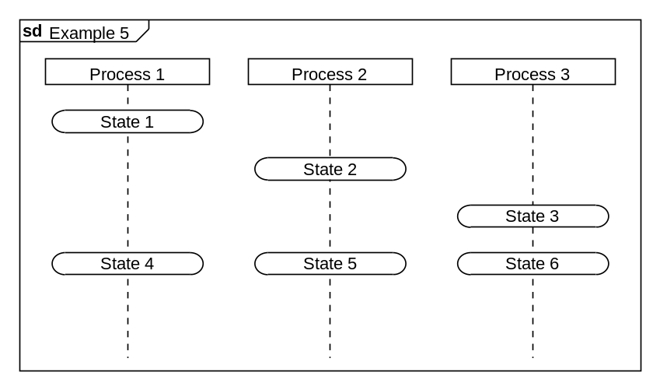 | DiagramName: Example 5  DiagramStyle: uml  PageSize: 500, auto  PageMargins: 10, 10, 10, 10  process: p1, "Process 1"  process: p2, "Process 2"  process: p3, "Process 3"  state: p1, State 1;  state: p2, State 2;  state: p3, State 3;  {  state: p1, State 4;  state: p2, State 5;  state: p3, State 6;  }

;; – Manual Page Break

Use the double semi-colon control character ";;" at the end of a line to define a manual page break.

- Syntax Example
command: parameter1, parameter2;;

- Example
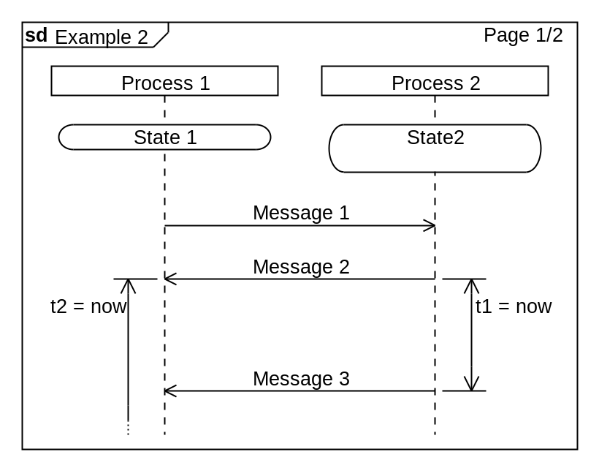  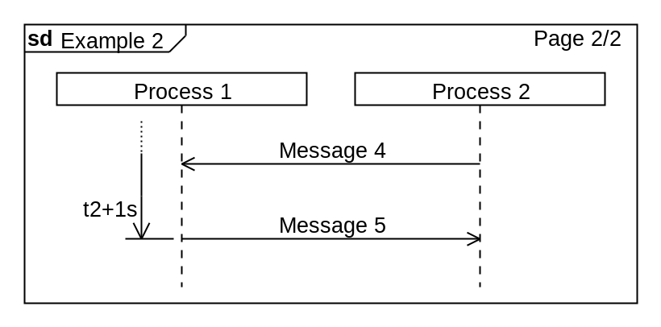 | DiagramName: Example 2  DiagramStyle: uml  PageSize: 400, auto  PageMargins: 10, 10, 10, 10  process: p1, "Process 1"  process: p2, "Process 2"  state: p1, State 1  state: p2, State\n2;  msg: p1, p2,Message 1;  msg: p2, p1, Message 2  timerbegin: t2, p1, t2 = now  timerbegin: t1, p2, t1 = now,r;  ;  ;  msg: p2, p1, Message 3  timerend: t1;;  msg: p2, p1,Message 4;  msg: p1, p2, Message 5  timerend: t2, t2+1s

Appendix A

Color Names

 | aliceblue | #f0f8ff
 | antiquewhite | #faebd7
 | aqua | #00ffff
 | aquamarine | #7fffd4
 | azure | #f0ffff
 | beige | #f5f5dc
 | bisque | #ffe4c4
 | blanchedalmond | #ffebcd
 | blue | #0000ff
 | blueviolet | #8a2be2
 | brown | #a52a2a
 | burlywood | #deb887
 | cadetblue | #5f9ea0
 | chartreuse | #7fff00
 | chocolate | #d2691e
 | coral | #ff7f50
 | cornflowerblue | #6495ed
 | cornsilk | #fff8dc
 | crimson | #dc143c
 | cyan | #00ffff
 | darkblue | #00008b
 | darkcyan | #008b8b
 | darkgoldenrod | #b8860b
 | darkgreen | #006400
 | darkkhaki | #bdb76b
 | darkmagenta | #8b008b
 | darkolivegreen | #556B2F
 | darkorange | #ff8c00
 | darkorchid | #9932cc
 | darkred | #8b0000
 | darksalmon | #e9967a
 | darkseagreen | #8fbc8f
 | darkslateblue | #483d8b
 | darkslategray | #2f4f4f
 | darkturquoise | #00ced1
 | darkviolet | #9400d3
 | deeppink | #ff1493
 | deepskyblue | #00bfff
 | dodgerblue | #1e90ff
 | firebrick | #b22222
 | floralwhite | #fffaf0
 | forestgreen | #228b22
 | fuchsia | #ff00ff
 | ghostwhite | #f8f8ff
 | gold | #ffd700
 | goldenrod | #daa520
 | green | #008000
 | greenyellow | #adff2f
 | honeydew | #f0fff0
 | hotpink | #ff69b4
 | indianred | #cd5c5c
 | indigo | #4b0082
 | ivory | #fffff0
 | khaki | #f0e68c
 | lavender | #e6e6fa
 | lavenderblush | #fff0f5
 | lawngreen | #7cfc00
 | lemonchiffon | #fffacd
 | lightblue | #add8e6
 | lightcoral | #f08080
 | lightcyan | #e0ffff
 | lightgoldenrodyellow | #fafad2
 | lightgreen | #90ee90
 | lightpink | #ffb6c1
 | lightsalmon | #ffa07a
 | lightseagreen | #20b2aa
 | lightskyblue | #87cefa
 | lightslategray | #778899
 | lightsteelblue | #b0c4de
 | lightyellow | #ffffe0
 | lime | #00ff00
 | limegreen | #32cd32
 | linen | #faf0e6
 | magenta | #ff00ff
 | maroon | #800000
 | mediumaquamarine | #66cdaa
 | mediumblue | #0000cd
 | mediumorchid | #ba55d3
 | mediumpurple | #9370db
 | mediumseagreen | #3cb371
 | mediumslateblue | #7b68ee
 | mediumspringgreen | #00fa9a
 | mediumturquoise | #48d1cc
 | mediumvioletred | #c71585
 | midnightblue | #191970
 | mintcream | #f5fffa
 | mistyrose | #ffe4e1
 | moccasin | #ffe4b5
 | navajowhite | #ffdead
 | navy | #000080
 | oldlace | #fdf5e6
 | olive | #808000
 | olivedrab | #6b8e23
 | orange | #ffa500
 | orangered | #ff4500
 | orchid | #da70d6
 | palegoldenrod | #eee8aa
 | palegreen | #98fb98
 | paleturquoise | #afeeee
 | palevioletred | #db7093
 | papayawhip | #ffefd5
 | peachpuff | #ffdab9
 | peru | #cd853f
 | pink | #ffc0cb
 | plum | #dda0dd
 | powderblue | #b0e0e6
 | purple | #800080
 | red | #ff0000
 | rosybrown | #bc8f8f
 | royalblue | #4169e1
 | saddlebrown | #8b4513
 | salmon | #fa8072
 | sandybrown | #f4a460
 | seagreen | #2e8b57
 | seashell | #fff5ee
 | sienna | #a0522d
 | skyblue | #87ceeb
 | slateblue | #6a5acd
 | slategray | #708090
 | snow | #fffafa
 | springgreen | #00ff7f
 | steelblue | #4682b4
 | tan | #d2b48c
 | teal | #008080
 | thistle | #d8bfd8
 | tomato | #ff6347
 | turquoise | #40e0d0
 | violet | #ee82ee
 | wheat | #f5deb3
 | whitesmoke | #f5f5f5
 | yellow | #ffff00
 | yellowgreen | #9acd32
 | white | #ffffff
 | gainsboro | #dcdcdc
 | lightgrey | #d3d3d3
 | silver | #c0c0c0
 | darkgray | #a9a9a9
 | gray | #808080
 | dimgray | #696969
 | black | #000000

Appendix B

Index

actor | 22
author | 15
backcolor | 19
comment | 35
commentoverall | 36
company | 16
create | 24
date | 17
diagramname | 8
diagramstyle | 8
dummyprocess | 24
fillcolor | 20
font | 9
found | 30
fragmentbegin | 49
fragmentend | 50
fragmentseparator | 51
fragmenttext | 51
left | 10
linecomment | 37
lineoffset | 11
lost | 31
mark | 38
measurebegin | 49
measureend | 46
measurestart | 47
measurestop | 48
msg | 27
msgbegin | 29
msgend | 30
nextpage | 13
pagemargins | 7
pagesize | 4
printauthor | 15
printcompany | 16
printcreationdate | 18
printdate | 17
printfilename | 16
printfootline | 14
printversion | 19
process | 23
ref | 52
regionbegin | 26
regionend | 27
right | 11
settimer | 42
state | 32
stateoverall | 33
stop | 25
stoptimer | 43
task | 34
textcolor | 21
timeout | 44
timerbegin | 39
timerend | 41
version | 18

