TO DO:
Referenz auf SDL-MSC Erläuterung,
Lizenzbedingungen,
Version aus Bild entfernen,
u.U. Abbildungen übersetzen



Introduction 3
MSC/SD Layout 4
Instances 6
Messages 9
State 11
Tätigkeiten 12
Kommentare 13
Timer 16
Abmessung 19
Bereiche 21
Kommandozeilenparameter 23

Introduction
Message Sequence Charts (MSCs) of SDL are a graphical notation similar to Sequence Diagrams (SDs) of UML. They are used to uniformly express sequences of interactions between communicating objects as standardized by ITU (International Telecommunication Union). This manual is not intended to be an introduction to MSCs or SDs, it only shows how to generate them using MSC/SD Generator. For an introduction to MSCs see ??????? and for an introduction to sequence diagrams have a look at the UML Superstructure Specification at www.omg.org or to any book about UML 2.0.

MSCs or SDs have a broad application domain. The can be used, for example to specify requirements, to specify the behavior of components, or describe test cases. MSCs or SDs are easy to understand and therefore are a perfect basis for discussion between project members.

MSCs or SDs are often not used in projects, because it takes serious effort to draw sequence diagrams with other tools. To reduce this effort, we developed the MSC/SD-Generator. With this tool and your favorite text editor, it is possible to produce high-value sequence diagrams or message sequence charts.

The generated MSCs or SDs can be exported into different file formats, for instance the vector based Windows Meta File. The required description language is designed to be clear and simple, but it also provides enough control over the layout of the diagrams.

Die following Figure shows a textual description and the MSC generated from this description.

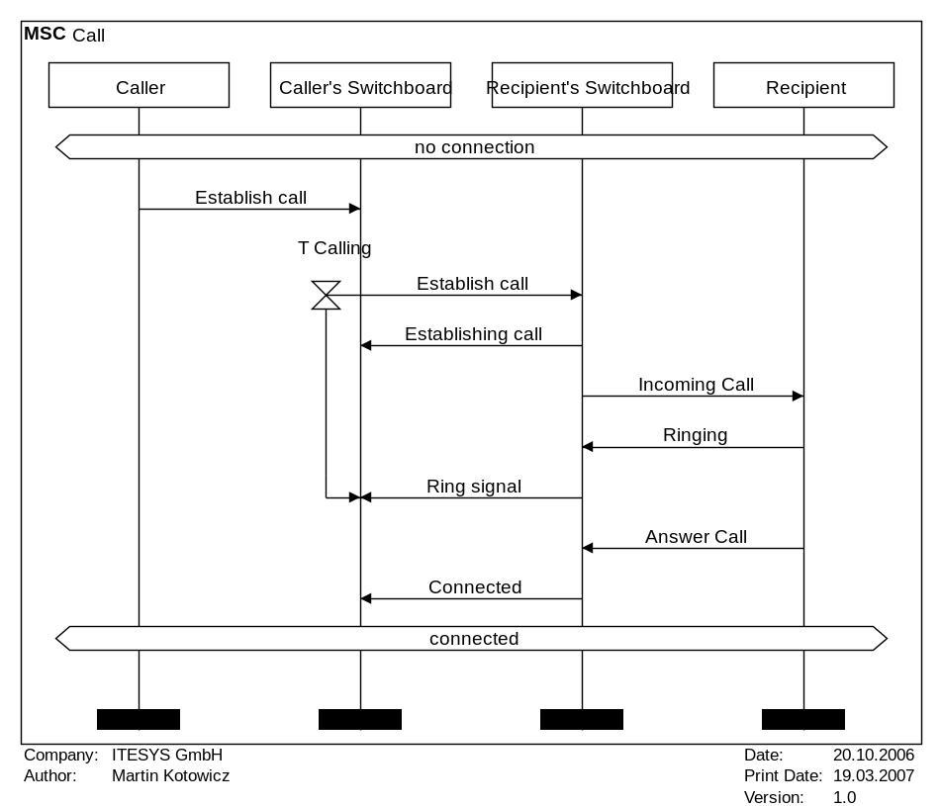 | DiagramName: Call  DiagramStyle: sdl  PageMargins: 5, 5, 5, 5  PrintFootLine: yes  Author: Martin Kotowicz  Company: ITESYS GmbH  Version: 1.0  Date: 20.10.2006  PageSize: 660, auto  process: CLU, "Caller"  process: ON, "Caller's Switchboard"  process: DN, "Recipient's Switchboard"  process: CDU, "Recipient"  stateoverall: "no connection";  msg: CLU, ON, "Establish call";  timeoutbegin: ON, T Calling  msg: ON, DN, Establish call;  msg: DN, ON, Establishing call;  msg: DN, CDU, Incoming Call;  msg: CDU, DN, Ringing;  msg: DN, ON, Ring signal  timeoutend: ON;  msg: CDU, DN, Answer Call;  msg: DN, ON, Connected;  stateoverall: connected;

The description language is defined according to the following pattern:

Commandl: param1, param2, [optParam1], [optParam2]

At the first Position, there is the command, followed by a colon and a space. Next, there are the parameters, separated by comas. The parameters in squared brackets are optional. They must be only used if necessary. The number of parameters depends on the command.

A semicolon at the end of a line ends the definition of a line in the sequence diagram and the next elements will be drawn in the next line. The height of a line depends on the maximum height of the elements in it.

MSC/SD Layout

Name of MSC/SD
The name of the MSC/SD is printed in the left upper corner of the page. It can be defined with the following command:

DiagramName: mscName

The parameter mscName represents the name of the MSC/SD. If this command is not included in the description file, the file name of the description file will be used.

MSC/SD style
The graphical representation style of the diagram can be conforming to the SDL standard or to the UML 2.0 standard. To choose the style, the following command can be used:

DiagramStyle: style

The parameter style can have the value “SDL” to choose the SDL-Style or the value “UML” to choose the UML-Style. If this command is not included in the description file, a MSC in SDL-Style is generated.

The following example shows the MSC of Page 4 as a Sequence Diagram (SD) in the UML-Style.

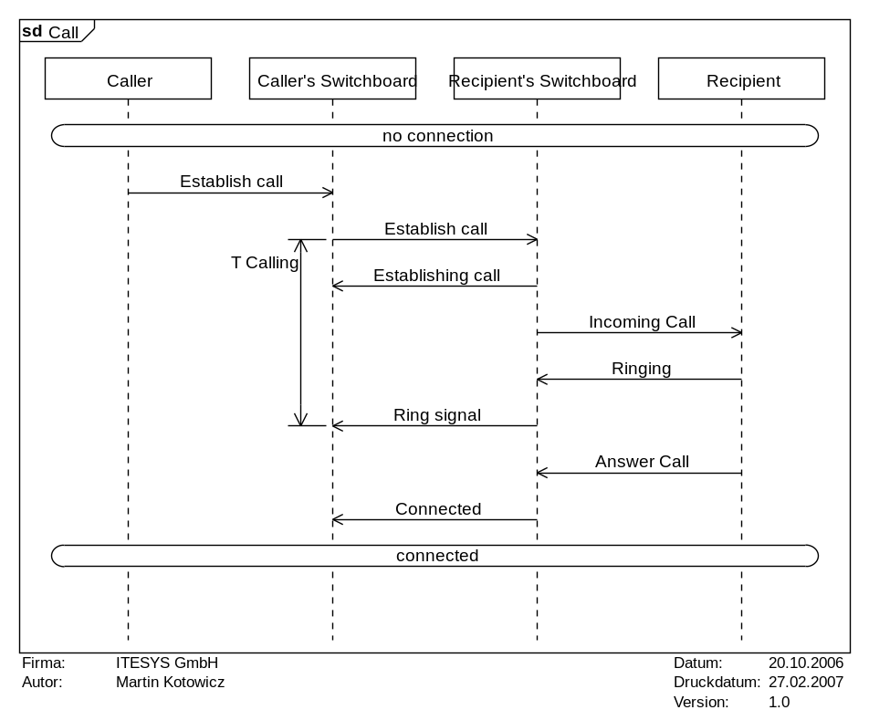 | DiagramName: Call  DiagramStyle: uml  PageMargins: 5, 5, 5, 5  PrintFootLine: yes  Author: Martin Kotowicz  Company: ITESYS GmbH  Version: 1.0  Date: 20.10.2006  PageSize: 660, auto  process: CLU, "Caller"  process: ON, "Caller's Switchboard"  process: DN, "Recipient's Switchboard"  process: CDU, "Recipient"  stateoverall: "no connection";  msg: CLU, ON, "Establish call";  timeoutbegin: ON, T Calling  msg: ON, DN, Establish call;  msg: DN, ON, Establishing call;  msg: DN, CDU, Incoming Call;  msg: CDU, DN, Ringing;  msg: DN, ON, Ring signal  timeoutend: ON;  msg: CDU, DN, Answer Call;  msg: DN, ON, Connected;  stateoverall: connected;

Size of MSC/SD
The width and height of the diagram can be changed in the user front-end of the MSC-Generator. Alternatively, it can be set in the description. The width can be preset with the following command:

mscwidth: width, [unit]

To define the height of the diagram, the following command is available:

mscheight: height, [unit]

The parameters width and height contain the desired sizes. Optionally, the unit can be set. Possible units are “MM“ (millimeter), “CM“ (centimeter,), “INCH“ and “PIXEL“. The default unit is “PIXEL“.

Margins
To set the widths of the page margins, the following commands can be used.
For size of the left margin:

mscmarginleft: size, [unit]

For size of the right margin:

mscmarginright: size, [unit]

For size of the upper margin:

mscmargintop: size, [unit]

For size of the bottom margin:

Mscmarginbottom: size [unit]

The parameter size contains the desired size of the desired margin. Optionally, the unit can be set. Possible units are „MM“ (millimeter), „CM“ (centimeter,), „INCH“ and „PIXEL“. The default unit is „PIXEL“.

Line space
The default spacing between the lines of the SD/MSC can be modified with the following command:

msclinespace: mscLinespace

The parameter mscLinespace defines the distance between two lines of the SD/MSC. The unit for this spacing is “PIXEL”. The minimal value is 10, the maximal Value is 20 and the default value is 20.

Instances

Definition
All instances must be defined, before they can be used in the MSC/SD. The MSC Generator supports two kinds of instances that are represented differently: Actors and Processes. Processes summarise all kinds of “Classifiers”, e.g. “Classes” and “Objects”.In the following description only the term “process” is used.

Instances are defined as follows:

actor: instanceID, instanceName, [instanceDescription]
process: instanceID, instanceName, [instanceDescription]

The instanceID identifizies the instance within the whole MSC/SD. It can be any alphanumeric expression being unambiguous for all instances. The name visible in the diagram is assigned with instanceName. An additional description (e.g., variables or explainations) that is displayed above of the actor or process can be added with the optional parameter instanceDescription. Thefollowing example shows the definition of two actor instances and two process instances:

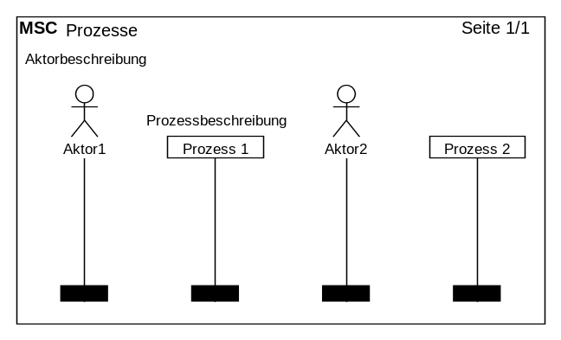 | mscname: Prozesse  actor: actor1, Aktor1, Aktorbeschreibung  process: process1, "Prozess 1", Prozessbeschreibung  actor: actor2, Aktor2  process: process2, "Prozess 2"

To create a process instance at a later point of time from another process, a dummy process (or placeholder) must be defined in the header of the MSC/SD. The dummy process can also be used to keep free same space between processes or actors.

A dummy process instance is defined as follows:

dummyprocess: instanceID

Here also an instanceID is used to identify the instance unambiguously. Name an description will be defined when the instance is created.

Create and Stop Prozesses
Processes can be stopped or created at any point of the MSC/SD. To stop a process the following command can be used:

stop: instanceID

The parameter instanceID defines the instance of the process to be stopped.

A process can be created with the following command:

create: instanceIDSource, instanceIDDestination, msgName, instanceName, [instanceDescription]

The parameter instanceIDSource defines witch process instance creates the new process. The parameter instanceIDDestination defines the instance where the new process shoud appear. The parameter msgName defines the caption of the message creating the new process. The name of the new process is given with the parameter instanceName. Optionally, a process description can be defined the the parameter instanceDescription.

The following example shows a process with the name “Prozess 1” that creates a new process “neuer Prozess” with the message “erstelle Prozess”. After that, the creating process is terminated.

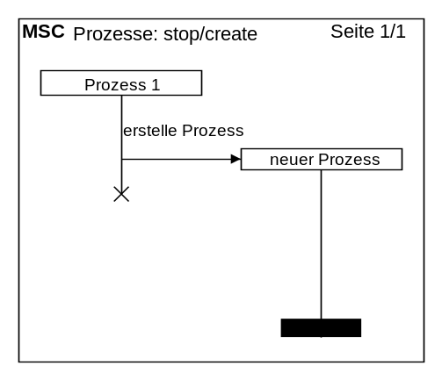 | mscname: "Prozesse: stop/create"  process: process1, "Prozess 1"  dummyprocess: process2  create: process1, process2, "erstelle Prozess", "neuer Prozess";  stop: process1;

It is possible to use the environment as the source of the creating message. In this case the parameter instanceIDSource must be “ENV_LEFT“ for a message from the left border and “ENV_RIGHT“ for a message from the right border.

Regions
Parts of the instances or the lifelines can have a different style. Such is a part is called instance region. The MSC Gererator is able to display three different kinds of regions: Activation, Suspension und Coregion. The definition of a region is done with the commands regionstart for the start of a region and regionend for the end of this region:

regionstart: instanceID, type
regionend: instanceID

The parameter instanceID defines the instance where the region starts or ends. The type of the region is defined in the parameter type. This parameter must have one of the values “activation“, “suspension“ or “coregion“. Other parameters for type are not possible.

The following example shows all types of regions in one generatet MSC:

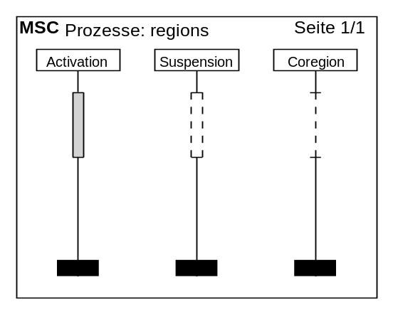 | mscname: "Prozesse: regions"  process: process1, "Activation"  process: process2, "Suspension"  process: process3, "Coregion"  regionstart: process1, activation  regionstart: process2, suspension  regionstart: process3, coregion;  ;  ;  regionend: process1  regionend: process2  regionend: process3;

Messages

Standard Messages
Messages are apart of Instances the main part of MSCs and SDs. In this documentation, Signals, Events, Commands and return values are summarized with the term message. They are defined in the MSC Generator as follows:

msg: instanceIDSource, instanceIDDestination, msgName, [style]

The parameters instanceIDSource and instanceIDDestination define the source and the destination of a message. For source and destination the defined instance IDs must be used. Alternatively, source or destination can be the environment. For messages from or to the left side of the MSC/SD the constant “ENV_LEFT“ can be used for the parameter instanceIDSource or for the parameter instanceIDDestination. For messages from or to the right side of the MSC/SD the constant “ENV_RIGHT “ can be used.The parameter msgName contains the caption of the message. Optionally, the syle of the messages can be changed with the parameter style. The parameter style may contain a star (*). In this case the line of the message will be dashed.

The following MSC shows the application of the command msg.

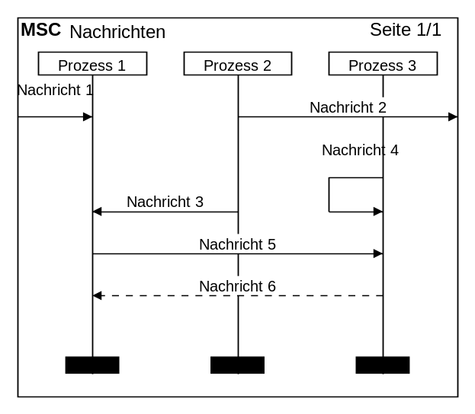 | mscname: "Nachrichten"  process: process1, "Prozess 1"  process: process2, "Prozess 2"  process: process3, "Prozess 3"  msg: ENV_LEFT, process1, "Nachricht 1"  msg: process2, ENV_RIGHT, "Nachricht 2";  msg: process2, process1, "Nachricht 3"  msg: process3, process3, "Nachricht 4";  msg: process1, process3, "Nachricht 5";  msg: process3, process1, "Nachricht 6", *

Messages can appear at different points of time for the different processes. Such a message must be defined in two steps. The starting point and the point where the message ends must be defined using the following commands:

msgbegin: msgID, instanceIDSource, instanceIDDestination, msgName, [style]
msgend: msgID

The parameter msgID must be an alphanumeric value and is used to identify the message unambiguously. The parameter must be the same for the commands msgbegin und msgend must be the same. The meaning of the other parameters of msgbegin ist the same as for the command msg.

The following example shows how to use the command and the corresponding MSC:

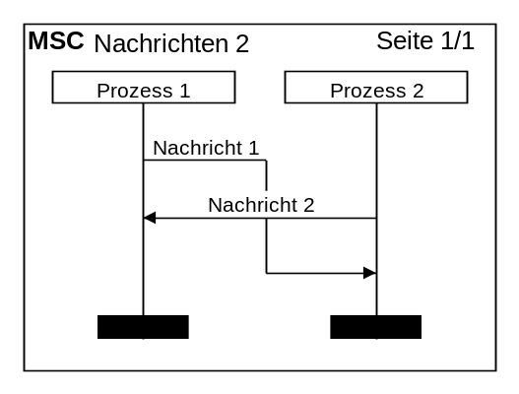 | mscname: "Nachrichten 2"  process: process1, "Prozess 1"  process: process2, "Prozess 2"  msgbegin: msg1, process1, process2, "Nachricht 1";  msg: process2, process1, "Nachricht 2";  msgend: msg1

Lost- und Found-Messages
Another kind of messages are so called “lost” and “found” messages. The can be defined woth the following commands:

found: instanceID, msgName, [gate], [placement]
lost: instanceID, msgName, [gate], [placement]

The parameter instanceID is here again the instance of the process where the message is found or lost. The parameter msgName can be used to define the caption of the lost or found message. The first optional parameter gate defines the caption of the gate. The second optional parameter placement defines if the lost or found message should be drawn left or right. The constant “r“ is used to place the message on the right-side of the process instance and the constant “l“ (default) is used to draw the lost or found message on the left-side of the instance.

The following example shows a lost and a found message:

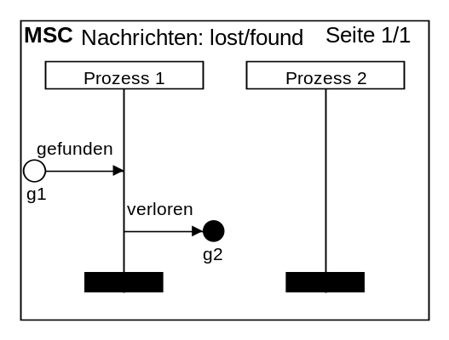 | mscname: "Nachrichten: lost/found"  process: process1, "Prozess 1"  process: process2, "Prozess 2"  found: process1, gefunden, g1;  lost: process1, verloren, g2, r

State

States of Instances
The states (or also called state invariants) can be defined with the following command:

state: instanceID*, stateName, [style]

Since states can be relevant for more than one process instance, the parameter instanceID* can contain several instances. These instances must be separates by commas („,“) and without spaces.The parameter stateName contains the caption of the state. Optionally, the parameter style can be used to change the style of the state to the notation with curly brackets. To change the style, the optional parameter style must be “*“..

The following examples shows how to use the different kinds of states in a MSC.

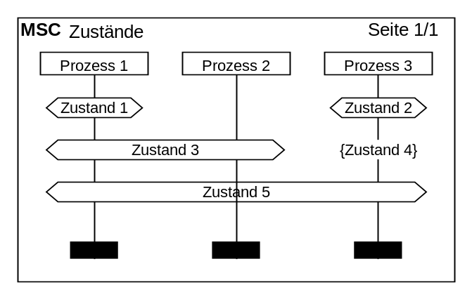 | mscname: "Zustände"  process: process1, "Prozess 1"  process: process2, "Prozess 2"  process: process3, "Prozess 3"  state: process1, "Zustand 1"  state: process3, "Zustand 2";  state: "process1,process2", "Zustand 3"  state: process3, "Zustand 4",*;  state: "process1,process3", "Zustand 5"

The UML notation is different. In the following diagram, the same sequence is shown as a SD.

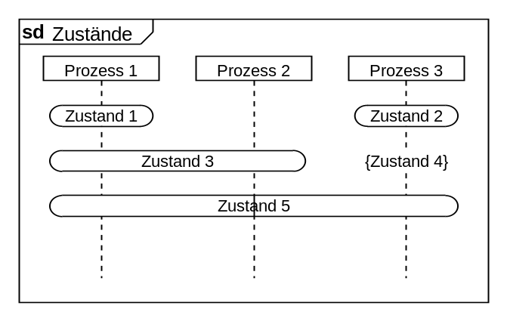 | mscname: "Zustände"  mscstyle: UML  process: process1, "Prozess 1"  process: process2, "Prozess 2"  process: process3, "Prozess 3"  state: process1, "Zustand 1"  state: process3, "Zustand 2";  state: "process1,process2", "Zustand 3"  state: process3, "Zustand 4",*;  state: "process1,process3", "Zustand 5"

The state with the caption “Zustand 5” covers the processes “Prozess 1” and “Prozess 3”. The process “Prozess 2” is not covered. Therefore, the lifeline of the process “Prozess 2” is drawn through the state “Zustand 5”.

For states being relevant for all instances, the following command can be used:

stateoverall: stateName

The parameter stateName is used for the caption of the element.

Tätigkeiten

Tasks

Tätigkeiten von Prozessen und Aktoren werden mit dem Befehl task definiert.

task: instanceID taskName

Mit dem Parameter instanceID wird bestimmt, für welche Instanz die Tätigkeit gezeichnet werden soll. Der Parameter taskName beinhaltet die Beschriftung der Tätigkeit.

Das folgende Beispiel zeigt den task-Befehl in einem generierten MSC.

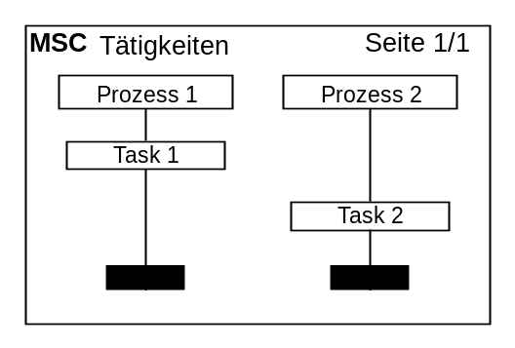 | mscname: "Tätigkeiten"  process: process1, "Prozess 1"  process: process2, "Prozess 2"  task: process1, "Task 1";  task: process2, "Task 2";

Kommentare

Einfacher Kommentar
Kommentare für Prozesse und Aktoren werden ähnlich einfach definiert wie eine Tätigkeit, sie wird nur anders im MSC dargestellt:

comment: instanceID, commentName

Der Parameter instanceID definiert auch hier wieder die Instanz, für die der Kommentar hinzugefügt werden soll. Mit dem Parameter commentName wird die Beschriftung des Kommentars angegeben.
Es besteht zusätzlich die Möglichkeit über das gesamte MSC ein Kommentar hinzuzufügen. Dies geschieht mit dem folgenden Befehl:

commentoverall: commentName

Bei diesem Befehl ist es nicht notwendig eine instanceID anzugeben, da dieser Kommentar für alle Instanzen gültig ist. Die Bedeutung des Parameters commentName ist die gleiche wie beim comment-Befehl geblieben.

Das folgende Beispiel zeigt die beiden Befehle in einem generierten MSC.

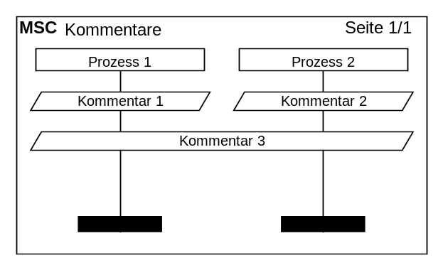 | mscname: "Kommentare"  process: process1, "Prozess 1"  process: process2, "Prozess 2"  comment: process1, "Kommentar 1"  comment: process2, "Kommentar 2";  commentoverall: "Kommentar 3";

Linienkommentar
Linienkommentare werden im Gegensatz zu den einfachen Kommentaren neben der Prozesslinie platziert. Standardmäßig werden sie mit der Prozesslinie durch eine waagerechte Linie verbunden, dieser kann aber ausgeblendet werden.

linecomment: instanceID, commentName, [placement], [style]

Der Parameter instanceID definiert die Instanz, für die der Kommentar hinzugefügt werden soll. Mit dem Parameter commentName wird die Beschriftung des Kommentars angegeben. Optional besteht die Möglichkeit über den Parameter placement die Ausrichtung des Kommentars zu bestimmen. Der Parameter placement kann die Werte „r“ für eine Ausrichtung rechts der Prozesslinie und „l“ für eine Ausrichtung links der Prozesslinie annehmen. Ist der Parameter placement nicht angegeben, so wird der Kommentar links der Prozesslinie dargestellt. Über den zweiten optionalen Parameter style kann angegeben werden, dass die waagerechte Verbindungslinie zum Prozess nicht gezeichnet werden soll. Der Parameter style kann nur den Wert „*“ annehmen.

Das folgende Beispiel zeigt den Befehl in einem MSC.

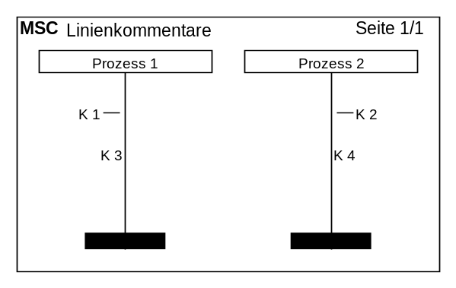 | mscname: "Linienkommentare"  process: process1, "Prozess 1"  process: process2, "Prozess 2"  linecomment: process1, "K 1"  linecomment: process2, "K 2",r;  linecomment: process1, "K 3",,*  linecomment: process2, "K 4",r,*;

Seitenkommentar
Zusätzlich zu den oben beschriebenen Kommentaren, die den Prozessen und Aktoren zugeordnet werden, besteht auch die Möglichkeit allgemeine Kommentare zu dem MSC hinzuzufügen. Diese erscheinen dann wahlweise auf der linken oder der rechten Seite des MSCs. Ein Seitenkommentar wird wie folgt definiert:

sidecomment: commentName, [placement]

Mit dem Parameter commentName wird die Beschriftung des Kommentars angegeben. Über den optionalen Parameter placement kann angegeben werden, ob der Kommentar auf der rechten oder der linken Seite des MSCs erscheinen soll. Der Parameter placement kann die Werte „r“ für die rechte und „l“ für die linke Seite annehmen. Wird der Parameter placement nicht angegeben, so wird der Kommentar auf der linken Seite dargestellt.

Das folgende Beispiel zeigt ein Seitenkommentar in einem MSC.

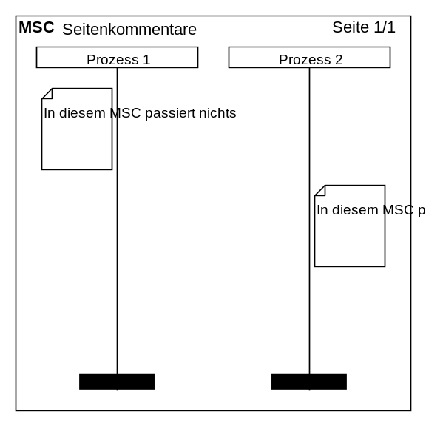 | mscname: "Seitenkommentare"  process: process1, "Prozess 1"  process: process2, "Prozess 2"  sidecomment: "In diesem MSC passiert nichts";  sidecomment: "In diesem MSC passiert nichts",r;

Markierung
Markierungen bieten eine zusätzliche Möglichkeit Kommentare zu einem MSC hinzuzufügen. Sie werden aber im Gegensatz zu den regulären Kommentaren nicht auf die Instanzlinie gezeichnet, sondern am Rand des MSC positioniert. Eine Markierung wird wie folgt definiert:

mark: instanceID, markName, [placement]

Mit dem Parameter instanceID wird die Instanz definiert, für die eine Markierung hinzugefügt werden soll. Der Parameter markName beinhaltet die Beschriftung der Markierung. Optional kann noch die Ausrichtung der Markierung über den Parameter placement angegeben werden. Der Parameter placement kann eine beliebige Kombination der folgenden Buchstaben besitzen: „l“ für Linksausrichtung, „r“ für Rechtsausrichtung, „t“ für eine Ausrichtung nach Oben und „b“ für eine Ausrichtung nach Unten. Standardmäßig wird eine Links-Oben-Ausrichtung verwendet.

Das folgende Beispiel soll es ein wenig verdeutlichen.

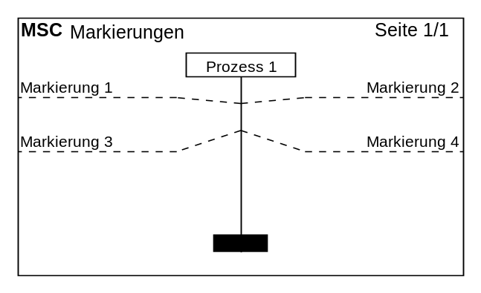 | mscname: "Markierungen"  dummyprocess: p1  process: process1, "Prozess 1"  dummyprocess: p2  mark: process1, "Markierung 1"  mark: process1, "Markierung 2", r;  mark: process1, "Markierung 3", b  mark: process1, "Markierung 4", br;

Timer

Verbundene Timerelemente
Verbundene Timerelemente sind Timer, die zwischen ihrem Anfang und ihrem Ende mit einer sichtbaren Linie verbunden sind. Sie müssen mit einem Befehl angelegt und durch einen Befehl beendet werden. Der Befehl für das Anlegen eines verbundenen Timers sieht wie folgt aus:

timeoutbegin: instanceID, [timerName], [placement]

Der Parameter instanceID definiert die Instanz, für die der Timer angelegt werden soll. Mit dem ersten optionalen Parameter timerName kann die Beschriftung des Timers angegeben werden. Der zweite optionale Parameter placement dient der Ausrichtung des Timers. Der Parameter placement kann die Werte „r“ für eine Rechtsausrichtung und „l“ für eine Linksausrichtung haben. Standardmäßig wird eine Linksausrichtung verwendet. Soll der Timer beendet werden, so stehen zu diesem Zweck zwei Befehle zur Verfügung, die auf unterschiedliche Weise den Timer beenden. Zum einfachen beenden dient der Befehl timeoutend.

timeoutend: instanceID, [timerName]

Zum abbrechen des Timers gibt es den Befehl timeoutstop.

timeoutstop: instanceID, [timerName]

Die Bedeutung der Parameter der beiden Befehle ist die gleiche. Der Parameter instanceID identifiziert die Instanz, für die der Timer beendet bzw. abgebrochen werden soll. Über dem optionalen Parameter timerName ist es möglich eine Beschriftung hinzuzufügen.

Das folgende Beispiel zeigt diese Befehle in einem MSC.

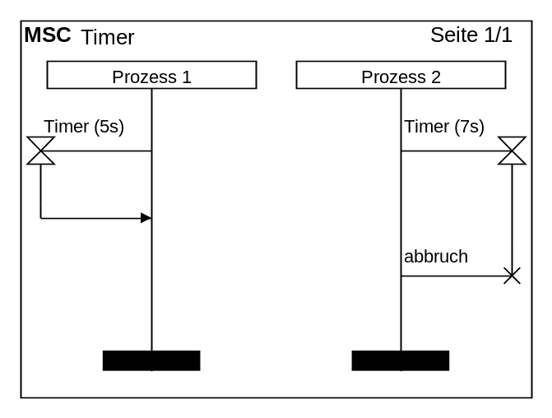 | mscname: "Timer"  process: process1, "Prozess 1"  process: process2, "Prozess 2"  timeoutbegin: process1, "Timer (5s)"  timeoutbegin: process2, "Timer (7s)", r;  timeoutend: process1;  timeoutstop: process2, "abbruch";

Die Darstellung der Timer unterscheidet sich stark zwischen SDL und UML. Die UML - Darstellung des gleichen MSCs sieht wie folgt aus.

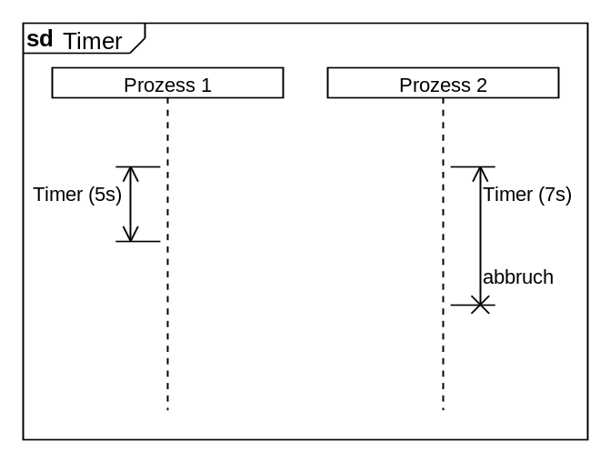 | mscname: "Timer"  mscstyle: UML  process: process1, "Prozess 1"  process: process2, "Prozess 2"  timeoutbegin: process1, "Timer (5s)"  timeoutbegin: process2, "Timer (7s)", r;  timeoutend: process1;  timeoutstop: process2, "abbruch";

Verbundene Timerelemente können nicht verschachtelt werden. Werden dennoch verschachtelte Timer im MSC benötigt, so müssen nichtverbundene Timer verwendet werden.

Nichtverbundene Timerelemente
Nichtverbundene Timerelemente sind Timer, deren Anfang und Ende nicht durch eine Linie miteinander verbunden sind. Sie eignen sich deshalb auch zum Darstellen von verschachtelten Timern. Der Befehl für den nichtverbundenen Timeranfang lautet wie folgt:

settimer: instanceID, [timerName], [placement]

Mit dem Parameter instanceID wird die Instanz bestimmt, für die der Timeranfang gezeichnet werden soll. Der erste optionale Parameter timerName beinhaltet die Beschriftung des Timers. Der zweite optionale Parameter placement ist für die Links-, Rechtsausrichtung des Timers zuständig. Der Parameter placement kann die Werte „r“ für eine Rechtsausrichtung und „l“ für eine Linksausrichtung annehmen.
Das Ende eines Timers kann auch hier wieder auf zwei unterschiedliche Arten dargestellt werden. Für das reguläre Beenden ist der folgende Befehl zuständig:

timeout: instanceID, [timerName], [placement]

Für das Beenden durch Abbruch muss dieser Befehl verwendet werden:

stoptimer: instanceID, [timerName], [placement]

Die Parameter dieser beiden Befehle sind äquivalent. Die instanceID definiert die Instanz, für die der Timer beendet werden soll. Mit dem Parameter timerName kann optional eine Beschriftung hinzugefügt werden. Der zweite optionale Parameter placement ist wie bei dem Befehl settimer für die Ausrichtung verantwortlich und kann ebenso die Werte „r“ für eine Rechtsausrichtung und „l“ für eine Linksausrichtung annehmen.

Das folgende Beispiel zeigt diese Befehle in einem generierten MSC.

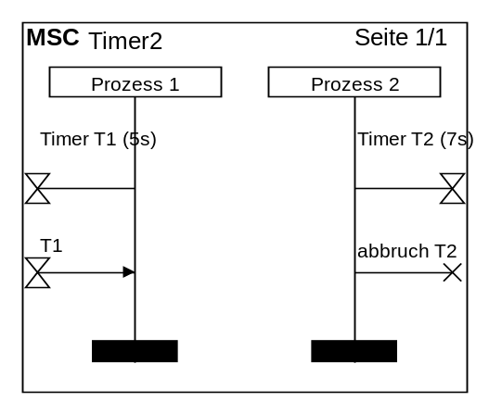 | mscname: "Timer2"  process: process1, "Prozess 1"  process: process2, "Prozess 2"  settimer: process1, "Timer T1 (5s)"  settimer: process2, "Timer T2 (7s)", r;  timeout: process1, "T1"  stoptimer: process2, "abbruch T2", r;

Abmessung

Verbundenes Abmessungselement
Das verbundene Abmessungselement ist eine Abmessung, die zwischen ihrem Anfang und ihrem Ende mit einer sichtbaren Linie verbunden ist. Das verbundene Abmessungselement muss durch einen Befehl angelegt und durch einen weiteren Befehl beendet werden. Der Befehl zum anlegen eines verbundenen Abmessungselementes sieht wie folgt aus:

measurebegin: instanceID, [measureName], [placement], [style]

Der Parameter instanceID gibt die Instanz an, für die das Zeichnen des Abmessungselements gestartet werden soll. Mit dem ersten optionalen Parameter measureName kann eine Beschriftung hinzugefügt werden. Der zweite optionale Parameter placement bestimmt die Ausrichtung des Abmessungselements. Hat der Parameter den Wert „r“ so wird das Element rechtsseitig gezeichnet, ist der Wert ein „l“ wird das Element linksseitig gezeichnet. Standardeinstellung ist die Linksausrichtung. Der letzte optionale Parameter style bestimmt die Darstellungsform. Das Abmessungselement kann in zwei unterschiedlichen Formen gezeichnet werden. Wird der Parameter style nicht angegeben, so werden die Messpfeile innerhalb der Messlinie gezeichnet. Wird als style ein „*“ angegeben, so werden die Messpfeile außerhalb der Messlinie gezeichnet.
Das verbundene Abmessungselement muss mit folgendem Befehl geschlossen werden:

measureend: instanceID, [measureName]

Mit dem Parameter instanceID wird angegeben, für welche Instanz das Abmessungselement beendet werden soll. Mit dem optionalen Parameter measureName kann eine Beschriftung angegeben werden.

Das folgende Beispiel zeigt zwei verbundene Abmessungselemente in unterschiedlicher Darstellung.

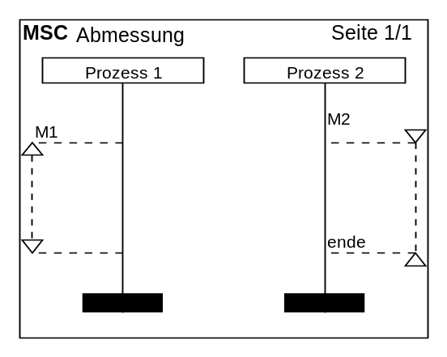 | mscname: "Abmessung"  process: process1, "Prozess 1"  process: process2, "Prozess 2"  measurebegin: process1, M1  measurebegin: process2, M2, r, *;  ;  ;  measureend: process1  measureend: process2, ende;

Die verbundenen Abmessungselemente können nicht geschachtelt werden. Wird dennoch eine Verschachtelung in einem MSC gewünscht, so müssen die nichtverbundenen Abmessungselemente verwendet werden.

Nichtverbundenes Abmessungselemet
Nichtverbundene Abmessungselemente sind Abmessungen, deren Anfang und Ende nicht durch eine Linie miteinander verbunden sind. Der Beginn eines nichtverbundenen Abmessungselementes wird durch den folgenden Befehl definiert:

measurestart: instanceID, [gate], [measureName], [placement], [style]

Der Parameter instanceID definiert die Instanz, für die der Beginn des nichtverbundenen Abmessungselementes gezeichnet werden soll. Der erste optionale Parameter gate beinhaltet die Beschriftung des Gates. Mit dem Parameter measureName kann eine Beschriftung des Abmessungselementes angegeben werden. Der Parameter placement ist für die Ausrichtung des Elementes verantwortlich. Hat der Parameter placement den Wert „l“ so wird das Element linksseitig von der Instanz gezeichnet. Ist der Wert des Parameters ein „r“, so wird das Abmessungselement auf der rechten Site der Instanz gezeichnet. Standardmäßig wird das Element linksseitig dargestellt. Der letzte Parameter style ist für die Darstellung der Messpfeile verantwortlich. Wird der Parameter style nicht angegeben, so werden die Messpfeile innerhalb der Messlinie gezeichnet. Wird als style ein „*“ angegeben, so werden die Messpfeile außerhalb der Messlinie gezeichnet.
Das Ende eines nichtverbundenen Abmessungselementes wird mit dem folgenden Befehl definiert.

measurestop: instanceID, [gate], [measureName], [placement], [style]

Mit dem Parameter instanceID wird die Instanz angegeben, für die das Ende einer Abmessung gezeichnet werden soll. Der optionale Parameter gate ist für die Beschriftung des Gates zuständig. Mit dem Parameter measureName kann eine Beschriftung des Elementes angegeben werden. Der Parameter placement ist auch hier wieder für die Ausrichtung des Elementes verantwortlich. Der Parameter placement kann ein „r“ für die rechtsseitige Ausrichtung bzw. ein „l“ für die linksseitige Ausrichtung haben. Der letzte Parameter style ist für die Darstellung der Messpfeile zuständig. Wird der Parameter style nicht angegeben, so werden die Messpfeile innerhalb der Messlinie gezeichnet. Wird als style ein „*“ angegeben, so werden die Messpfeile außerhalb der Messlinie gezeichnet.

Das folgende Beispiel zeigt ein generiertes MSC unter der Verwendung der Befehle.

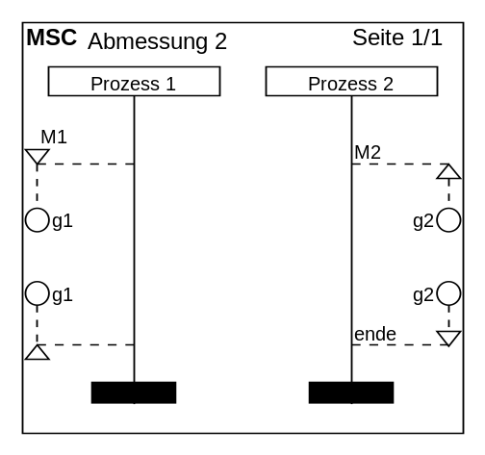 | mscname: "Abmessung 2"  process: process1, "Prozess 1"  process: process2, "Prozess 2"  measurestart: process1, g1, M1,,*  measurestart: process2, g2, M2, r;  ;  ;  ;  measurestop: process1, g1,,,*  measurestop: process2, g2, ende, r;

Bereiche

Inlines
Bereiche, auch Inlines genannt, spielen in MSCs eine vielseitige Rolle. Mit ihrer Hilfe können Schleifen, alternative oder parallele Abläufe dargestellt werden. Die jeweilige Bedeutung eines Bereichs wird aus dessen Beschriftung ersichtlich. Im MSC-Generator wird der Beginn eines Bereichs mit dem folgenden Befehl definiert:

inlinebegin: inlineID, instanceIDBegin, instanceIDEnd, inlineName

Der Parameter inlineID identifizier den Bereich innerhalb des gesamten MSCs und muss eindeutig vergeben werden. Es kann ein beliebiger alphanumerischer Wert sein. Die Parameter instanceIDBegin und instanceIDEnd definieren die erste und die letzte Instanz, über die sich der Bereich erstrecken soll. Mit dem letzten Parameter inlineName wird die Beschriftung des Bereichs angegeben. Der Bereich wird mit dem folgenden Befehl wieder geschlossen:

inlineend: inlineID

Der Parameter inlineID identifiziert den Bereich, der mit dem Befehl inlinebegin angelegt wurde und muss deshalb den gleichen Wert haben.
Weiterhin besteht die Möglichkeit einen oder mehrere Trennstriche in dem Bereich zu definieren. Dies geschieht mit dem folgenden Befehl:

inlineseperator: inlineID

Auch hier ist der Parameter inlineID dafür verantwortlich, den Bereich, in dem ein Trennstrich gezeichnet werden soll, zu identifizieren.

Das folgende Beispiel zeigt die Anwendung der Bereiche in einem MSC.

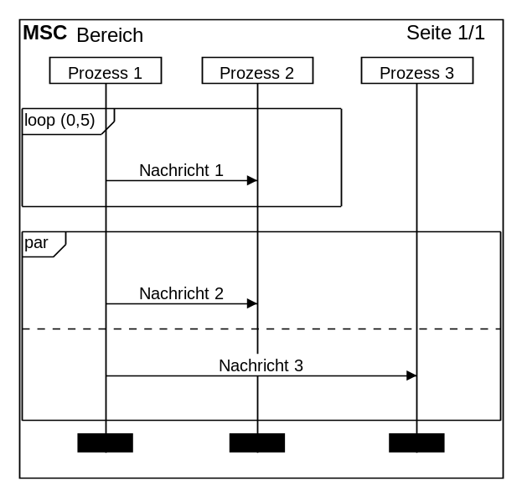 | mscname: "Bereich"  process: process1, "Prozess 1"  process: process2, "Prozess 2"  process: process3, "Prozess 3"  inlinebegin: inline1, process1, process2, "loop (0,5)";  msg: process1, process2, "Nachricht 1";  inlineend: inline1;  inlinebegin: inline2, process1, process3, "par";  msg: process1, process2, "Nachricht 2";  inlineseperator: inline2;  msg: process1, process3, "Nachricht 3";  inlineend: inline2
Bereiche können auch verschachtelt eingesetzt werden. Das folgende Beispiel zeigt eine solche Verschachtelung:

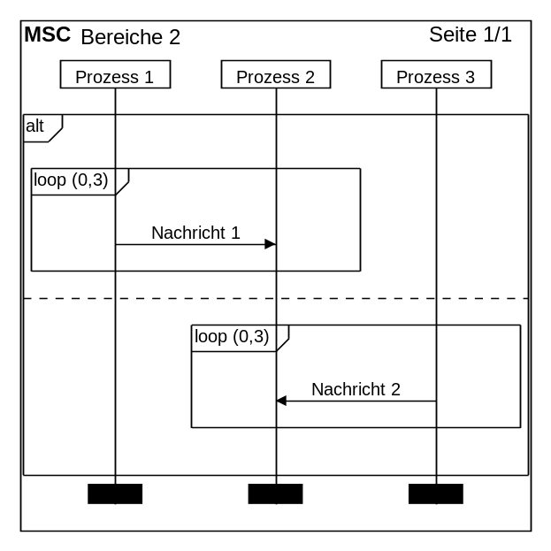 | mscname: "Bereiche 2"  process: process1, "Prozess 1"  process: process2, "Prozess 2"  process: process3, "Prozess 3"  inlinebegin: inline1, process1, process3, "alt";  inlinebegin: inline2, process1, process2, "loop (0,3)";  msg: process1, process2, "Nachricht 1";  inlineend: inline2;  inlineseperator: inline1;  inlinebegin: inline3, process2, process3, "loop (0,3)";  msg: process3, process2, "Nachricht 2";  inlineend: inline3;  inlineend: inline1

Referenzen
Um in einem MSC auf andere MSCs zu verweisen, werden Referenzen verwendet. Die Darstellung der Referenzen ist der Darstellung der InLines sehr ähnlich, mit dem einem Unterschied, dass sie die Instanzlinien überdecken. Referenzen können mit dem folgenden Befehl erzeugt werden.

ref: instanceIDBegin, instanceIDEnd, referenceName

Die Parameter instanceIDBegin und instanceIDEnd definieren die erste und die letzte Instanz, über die sich die Referenz erstrecken soll. Mit dem letzten Parameter referenceName wird der Name der Referenz angegeben.

Das folgende Beispiel zeigt eine Referenz in einem MSC.

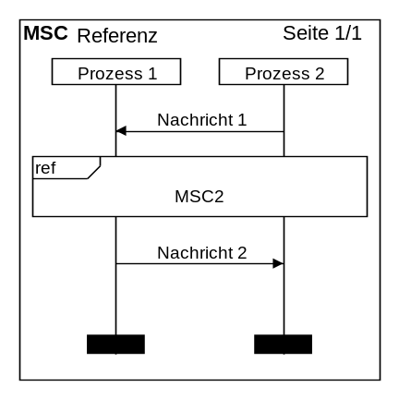 | mscname: "Referenz"  process: process1, "Prozess 1"  process: process2, "Prozess 2"  msg: process2, process1, "Nachricht 1";  ref: process1, process2, "MSC2";  msg: process1, process2, "Nachricht 2";

Kommandozeilenparameter

Automatisches öffnen eines MSC beim Start

Soll beim Start des MSC – Generators sofort eine MSC-Datei geöffnet werden, so kann diese in der Kommandozeile als Parameter mit angegeben werden.

mscGenerator.exe File

Soll beispielsweise beim Start die Datei „Beispiel.sc“ aus dem Ordner „MSCs“ auf Laufwerk „C:“ beim Programmstart geöffnet werden, so sieht der Programmaufruf folgender maßen aus:

mscGenerator.exe C:\MSCs\Beispiel.sc

Automatische MSC – Erzeugung aus Textdateien

Über die Kommandozeilenangabe können automatisch mehrere .sc – Dateien automatisch in grafische MSC – Dateien umgewandelt werden.

mscGenerator.exe File [Destination] Format

Über den Parameter File können die .sc – Dateien angegeben werden, die in MSCs umgewandelt werden sollen. Im File – Parameter kann auch das „*“ – Schreibweise verwendet werden, um mehrere Dateien gleichzeitig anzusprechen. Durch den Parameter Destination Kann der Ordner angegeben werden, in den die erstellten MSCs gespeichert werden sollen. Wird das Ziel nicht angegeben, so werden die MSCs in dem Verzeichnis erstellt, in dem sich auch die .sc – Dateien befinden. Über den letzten Parameter Format muss das Format der zu erstellenden MSC – Datei angegeben werden. Der Parameter Format kann einen der folgenden Werte annehmen:
„BMP“, „GIF“, „JPG“, „PNG“, „WMF“ und „EMF“.

Das folgende Beispiel erstellt MSCs im Windows Meta File – Format aus allen .sc – Dateien in dem Verzeichnis „C:\MSCs\“ und speichert diese in das Verzeichnis „C:\FertigeMSCs\“

mscGenerator.exe C:\MSCs\*.sc C:\FertigeMSCs\ WMF
Befehlsliste

actor: instanceID, instanceName, [instanceDescription]
comment: instanceID, commentName
commentoverall: commentName
create: instanceIDSource, instanceIDDestination, msgName, instanceName, [instanceDescription]
dummyprocess: instanceID
found: instanceID, msgName, [gate], [placement]
inlinebegin: inlineID, instanceIDBegin, instanceIDEnd, inlineName
inlineend: inlineID
inlineseperator: inlineID
linecomment: instanceID, commentName, [placement], [style]
lost: instanceID, msgName, [gate], [placement]
mark: instanceID, markName, [placement]
measurebegin: instanceID, [measureName], [placement], [style]
measureend: instanceID, [measureName]
measurestart: instanceID, [gate], [measureName], [placement], [style]
measurestop: instanceID, [gate], [measureName], [placement], [style]
msclinespace: mscLinespace
mscname: mscName
msg: instanceIDSource, instanceIDDestination, msgName, [style]
msgbegin: msgID, instanceIDSource, instanceIDDestination, msgName, [style]
msgend: msgID
mscheight: height, [unit]
mscmarginbottom: size, [unit]
mscmarginleft: size, [unit]
mscmarginright: size, [unit]
mscmargintop: size, [unit]
mscwidth: width, [unit]
process: instanceID, instanceName, [instanceDescription]
ref: instanceIDSource, instanceIDDestination, referenceName
regionend: instanceID
regionstart: instanceID, type
settimer: instanceID, [timerName], [placement]
sidecomment: commentName, [placement]
state: instanceID*, stateName, [style]
stateoverall: stateName
stop: instanceID
stoptimer: instanceID, [timerName], [placement]
task: instanceID taskName
timeout: instanceID, [timerName], [placement]
timeoutbegin: instanceID, [timerName], [placement]
timeoutend: instanceID, [timerName]
timeoutstop: instanceID, [timerName]

