# WCAG QA Request - Test Screens and Scenarios

**Important Notes:**

**Before requesting QA audit, ensure that:**

* All pages pass the automated accessibility tools [Axe](https://www.deque.com/axe/axe-for-web/) plugin for WCAG 2.1 AA
* [WAI-ARIA Patterns](https://www.w3.org/TR/wai-aria-practices-1.1/)  or [WET 4 components](https://wet-boew.github.io/v4.0-ci/demos/index-en.html) are implemented for all complex widgets or modules used e.g. tab interface, expand & collapse, tree, upload process et
* [Focus management](https://youtu.be/EFv9ubbZLKw) is respected; visibility of focus, logical focus order
* Keyboard interaction is tested & verified by a screen reader e.g. [NVDA free screen reader](https://youtu.be/Vx1vSd5uYS8)
* Both English and French pages are ready for testing

Completing the above steps will help reducing the number of rounds to achieve recommendation for publishing and speed up the time of each round.

**Application Information**

* Provide the screens for **ALL new pages AND/OR ALL pages** with new features and include instruction on how to interact with interactive elements on the page. In addition, include data/input to use in order to navigate from screen to the other.

|  |  |
| --- | --- |
| End Product Name (DINA-AAFC) and common abbreviations | DINA –BIOMOB (sequence module) |
| Published External OR Internal? | Our system is externally facing but required authentication/authorization to use. |
| Expected number of users? | 200-500 |
| Release version number | Release 1.0 |
| Business owner | Unit name: STB – Biodiversity and Collections  Contact name and email: Anissa Lybaert [**anissa.lybaert@canada.ca**](mailto:anissa.lybaert@canada.ca) |
| Technical Project manager/ lead | Name and email Christian Gendreau [Christian.Gendreau@canada.ca](mailto:Christian.Gendreau@canada.ca) |
| Developer to contact for this test | Name and email Gan, (Shemy) Xuemei (AAFC/AAC) [xuemei.gan@canada.ca](mailto:xuemei.gan@canada.ca) |
| Who should receive a copy from the WCAG results | Name and email Christian Gendreau [Christian.Gendreau@canada.ca](mailto:Christian.Gendreau@canada.ca) / Satpal Bilkhu Satpal.Bilkhu@canada.ca |
| QA stable/environment  (code freeze expected during assessment) | Login Info  URL User name & Password |
| Planned Go live/Scheduled production date | Dec 15th 2020 |
| Priority (in case of sending multiple requests/apps) |  |
| We confirm that the French as well as the English are both ready for WCAG testing  (The two languages has to be ready for testing. We don’t test English only or French only) | Majority of text is available in both languages. (80%) |

# 

Contents

WCAG QA Request - Test Screens and Scenarios 1

List of Screens (new pages AND/OR pages with new features) 3

Screens Details (URL, steps & transitions to next screens, screenshots) 4

**1.** Sequence Module – Log in 4

**2.** Sequence Module - Home 4

**3.** Sequence Module – NGS workflows- List page 5

**4.** Sequence Module – NGS Workflows – Add Workflow page 5

**5.** Sequence Module – NGS Workflows – Workflow page 6

**6.** Sequence Module – NGS Workflows – Edit Workflow page 6

**7.** Sequence Module – NGS Workflows – Workflow Step 1 - Select Sample page 7

**8.** Sequence Module – NGS Workflows – workflow - Step 2 – Pre library Prep 7

**9.** Sequence Module – NGS Workflows – Workflow - Step 3 – Library Prep 8

**10.** Sequence Module – NGS Workflows – Workflow - Step 3 – Library Prep - Saved 9

**11.** Sequence Module – NGS Workflows – Workflow - Step 3 – Library Prep – Saved- SubStep 2 10

**12.** Sequence Module – NGS Workflows – Workflow - Step 3 – Library Prep – Saved- SubStep 3 11

**13.** Sequence Module – Index Sets – List page 12

**14.** Sequence Module – Index Sets – Details page 13

**15.** Sequence Module – PCR Primers – List page 14

**16.** Sequence Module – PCR Primers – Add PCR Primer page 14

**17.** Sequence Module – PCR Primers – Details page 15

**18.** Sequence Module – Regions – List page 16

**19.** Sequence Module – Regions – Add Region page 16

**20.** Sequence Module – Regions – Details page 17

**21.** Sequence Module – Thermocycler Profiles – List page 17

**22.** Sequence Module – Thermocycler Profiles – Add Thermocycler Profile page 18

**23.** Sequence Module – Thermocycler Profiles – Details page 19

**24.** Sequence Module – Products – List page 20

**25.** Sequence Module – Products – Add Product page 20

**26.** Sequence Module – Products – Details page 21

**27.** Sequence Module – Protocols – List page 21

**28.** Sequence Module – Protocols – Add Protocol page 22

**29.** Sequence Module – Protocols – Details page 23

# List of Screens (new pages AND/OR pages with new features)

1. Sequence Module – Log in 4

2. Sequence Module - Home 4

3. Sequence Module – NGS workflows- List page 5

4. Sequence Module – NGS Workflows – Add Workflow page 5

5. Sequence Module – NGS Workflows – Workflow page 6

6. Sequence Module – NGS Workflows – Edit Workflow page 6

7. Sequence Module – NGS Workflows – Workflow Step 1 - Select Sample page 7

8. Sequence Module – NGS Workflows – workflow - Step 2 – Pre library Prep 7

9. Sequence Module – NGS Workflows – Workflow - Step 3 – Library Prep 8

10. Sequence Module – NGS Workflows – Workflow - Step 3 – Library Prep - Saved 9

11. Sequence Module – NGS Workflows – Workflow - Step 3 – Library Prep – Saved- SubStep 2 10

12. Sequence Module – NGS Workflows – Workflow - Step 3 – Library Prep – Saved- SubStep 3 11

13. Sequence Module – Index Sets – List page 12

14. Sequence Module – Index Sets – Details page 13

15. Sequence Module – PCR Primers – List page 14

16. Sequence Module – PCR Primers – Add PCR Primer page 14

17. Sequence Module – PCR Primers – Details page 15

18. Sequence Module – Regions – List page 16

19. Sequence Module – Regions – Add Region page 16

20. Sequence Module – Regions – Details page 17

21. Sequence Module – Thermocycler Profiles – List page 17

22. Sequence Module – Thermocycler Profiles – Add Thermocycler Profile page 18

23. Sequence Module – Thermocycler Profiles – Details page 19

24. Sequence Module – Products – List page 20

25. Sequence Module – Products – Add Product page 20

26. Sequence Module – Products – Details page 21

27. Sequence Module – Protocols – List page 21

28. Sequence Module – Protocols – Add Protocol page 22

29. Sequence Module – Protocols – Details page 23

# Screens Details (URL, steps & transitions to next screens, screenshots)

## Sequence Module – Log in

URL:

[http://dina-keycloak-dinaui.apps.biodiversity.agr.gc.ca/auth/realms/dina/protocol/openid-connect/auth?client_id=objectstore&redirect_uri=http%3A%2F%2FSequence Module-template-dinaui.apps.biodiversity.agr.gc.ca%2F&state=2f245a53-ee09-4c9a-88d1-90a536b88e15&response_mode=fragment&response_type=code&scope=openid&nonce=78029b5e-4467-4aae-8981-90cd84f32835](http://dina-keycloak-dinaui.apps.biodiversity.agr.gc.ca/auth/realms/dina/protocol/openid-connect/auth?client_id=objectstore&redirect_uri=http%3A%2F%2Fdina-ui-template-dinaui.apps.biodiversity.agr.gc.ca%2F&state=2f245a53-ee09-4c9a-88d1-90a536b88e15&response_mode=fragment&response_type=code&scope=openid&nonce=78029b5e-4467-4aae-8981-90cd84f32835)

Steps:

* Only accessible through the link

Screenshots

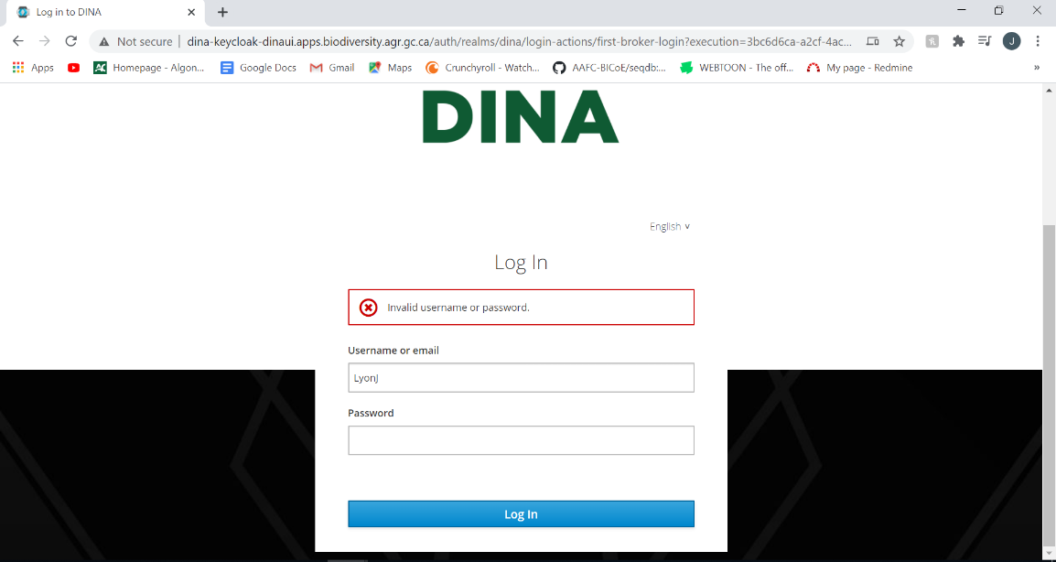

## Sequence Module - Home

URL:

<http://seqdb.traefik.me/>

Steps:

* From Login page, enter Dina-Authenticated username and password. (for testing enter *user* for both username and password.)
* Click the login button or press enter.

Screenshots

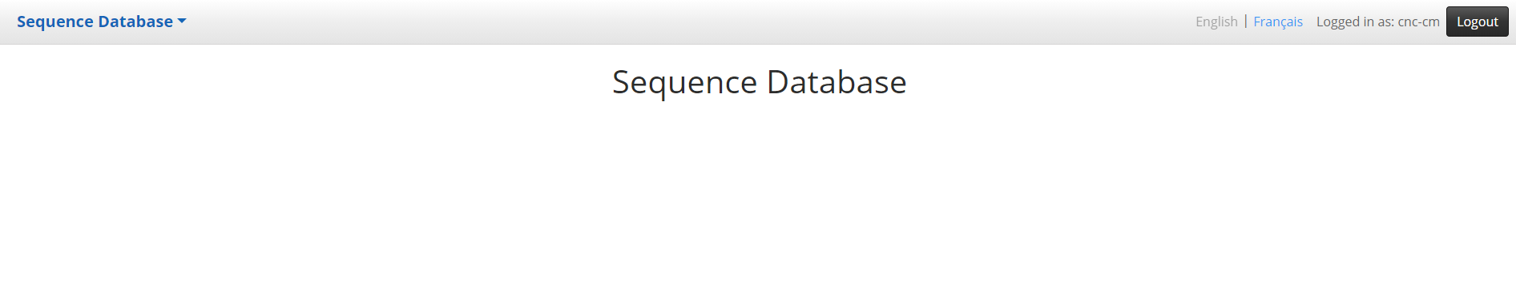

## Sequence Module – NGS workflows- List page

URL:

http://seqdb.traefik.me/workflow/list

Steps:

* Click on the NGS workflows link on Sequence Home page Sequence Database dropdown list
* A list of available workflows will be shown on this page

Screenshots:

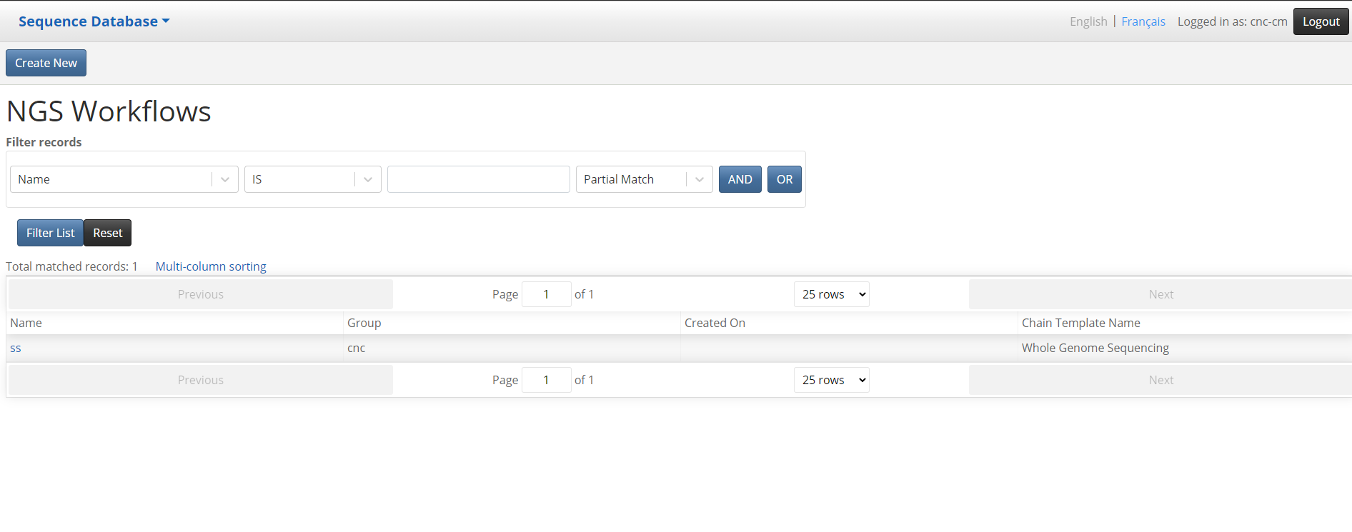

## Sequence Module – NGS Workflows – Add Workflow page

URL:

<http://seqdb.traefik.me/workflow/edit>

Steps:

* Click on the Create New button on the NGS Workflow list page
* User can create a new NGS workflow with a name and select a workflow template from dropdown list, currently only Whole Genome Sequencing templet should be selected.

Screenshots

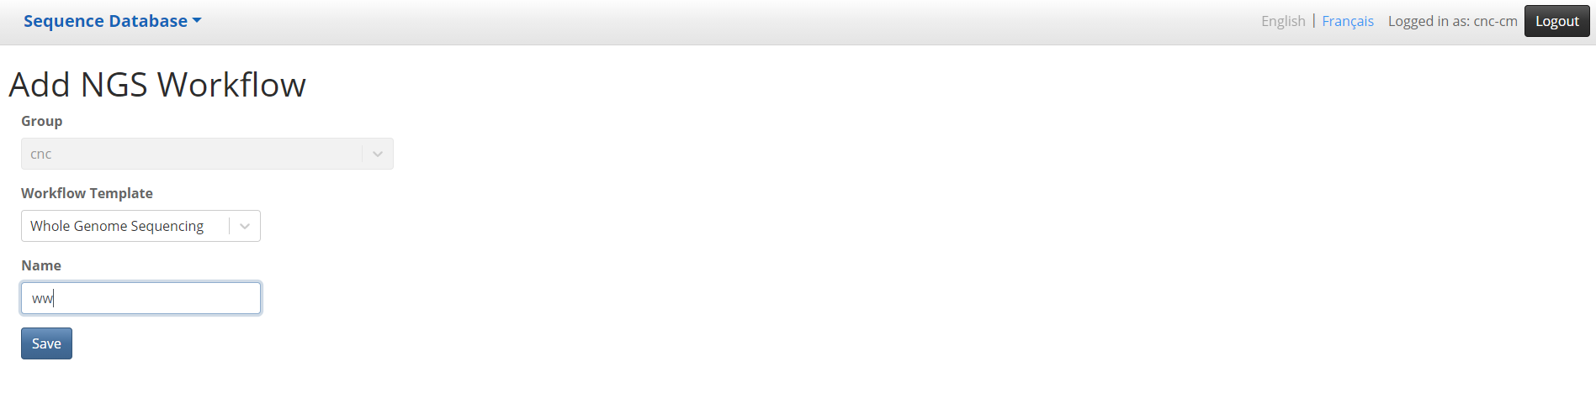

## Sequence Module – NGS Workflows – Workflow page

URL:

<http://seqdb.traefik.me/workflow/view?id=eb1ea755-c86d-4427-b0eb-c4b57c431baa>

Steps:

* Click on the Save button on the Add NGS Workflow page
* The page display the workflow created and an Edit button if need to edit the NGS workflow info.
* The page provides 3 tabs for editing the workflow details for individual step
* The Next Step button will lead user to the correspondent next step based on their current step in the workflow chain
* The Back to List button will navigate back to the NGS Workflow List page

Screenshots

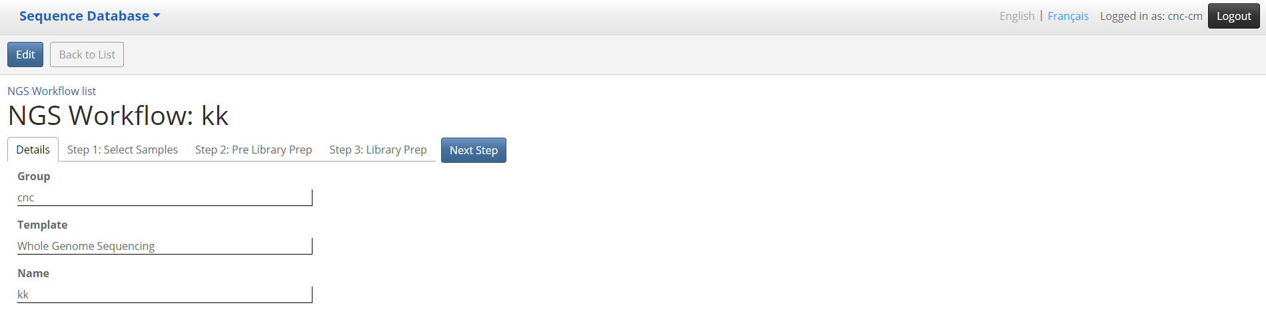

## Sequence Module – NGS Workflows – Edit Workflow page

URL:

http://seqdb.traefik.me/workflow/edit?id=c34037dc-7ed3-41bb-af15-f41ff1f7b577

Steps:

* Click on the Edit button on the NGS Workflow age
* User can edit the workflow information and save it.

Screenshots

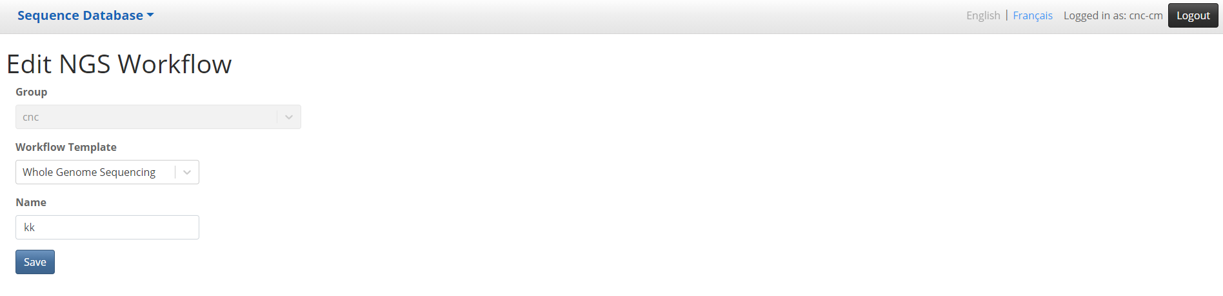

## Sequence Module – NGS Workflows – Workflow Step 1 - Select Sample page

URL:

http://seqdb.traefik.me/workflow/view?id=c34037dc-7ed3-41bb-af15-f41ff1f7b577&step=1

Steps:

* Click on the “Step 1 : Select Sample” tab on the NGS Workflows- Workflow page
* From Available Samples table, check the sample’s checkbox and press “Select all checked Samples -> “ button
* Selected samples are moved to the Selected Samples table and removed from Available Samples table

Screenshots

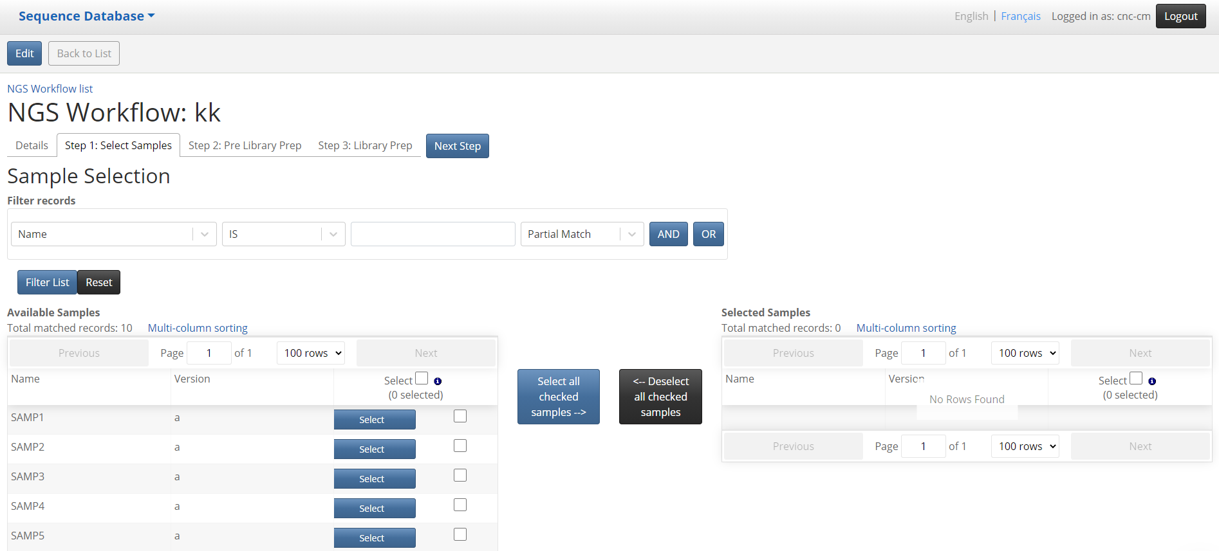

## Sequence Module – NGS Workflows – workflow - Step 2 – Pre library Prep

URL:

[http://seqdb.traefik.me/workflow/view?id=c34037dc-7ed3-41bb-af15-f41ff1f7b577&step=](http://seqdb.traefik.me/workflow/view?id=c34037dc-7ed3-41bb-af15-f41ff1f7b577&step=1)2

Steps:

* Click on the “Next Step” on Workflow - Step 1 - Select Sample page
* Or click “Step 2- Pre library Prep” tab on the NGS Workflows- Workflow page if already gone through the sample selection on Workflow - Step 1 - Select Sample page
* User can specify the values for Quality,Input Amount etc in the “Shearing Details” tab for each sample selected
* User can specify the values in “Size Selection Details” tab for each sample selected
* Click Save button to save all above changes

Screenshots:

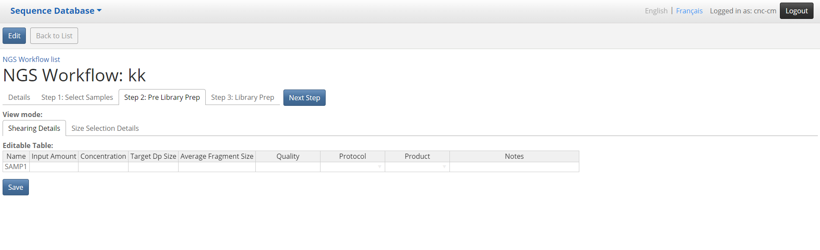

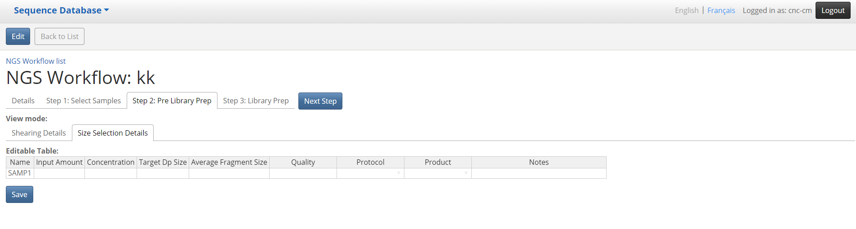

## Sequence Module – NGS Workflows – Workflow - Step 3 – Library Prep

URL:

[http://seqdb.traefik.me/workflow/view?id=c34037dc-7ed3-41bb-af15-f41ff1f7b577&step=](http://seqdb.traefik.me/workflow/view?id=c34037dc-7ed3-41bb-af15-f41ff1f7b577&step=1)3

Steps

* Click on the “Next Step” button on Workflow - Step 2 – Pre Library Prep page
* Or click “Step 3- Library Prep” tab on the NGS Workflows- Workflow page if already gone through the Workflow - Step 2 – Pre Library Prep page
* User can enter values for Batch name, Date, select product, protocol , Container Type etc from dropdown list and click Save button, this will save a new Library Preparation Batch

Required fields:

1. Library Prep Batch Name
2. Container Type
3. Index Set Name

Screenshots:

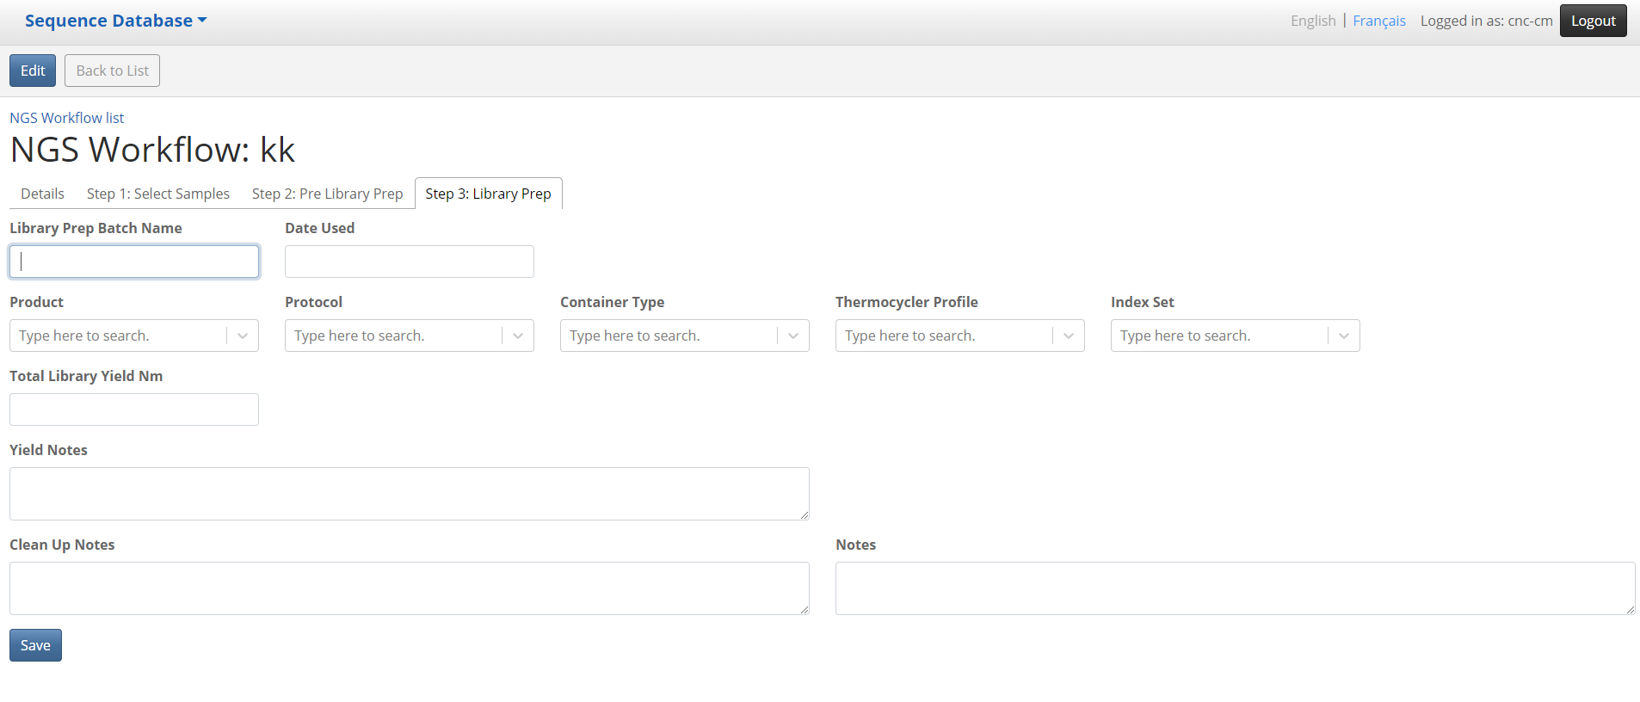

## Sequence Module – NGS Workflows – Workflow - Step 3 – Library Prep - Saved

URL:

[http://seqdb.traefik.me/workflow/view?id=c34037dc-7ed3-41bb-af15-f41ff1f7b577&step=](http://seqdb.traefik.me/workflow/view?id=c34037dc-7ed3-41bb-af15-f41ff1f7b577&step=1)3

Steps

* Click on the Save button on Workflow - Step 3 – Library Prep page
* On this page, user can enter details in 3 tabs :

1. Substep 1 : Library Prep Details page
2. SubStep 2 : Container Grid
3. Substep 3: Index Assignment

* On the Substep 1 : Library Prep Details page, this is an editable table, user can enter values for Input, Quality and Size on the excel like spreadsheet directly and press Save button

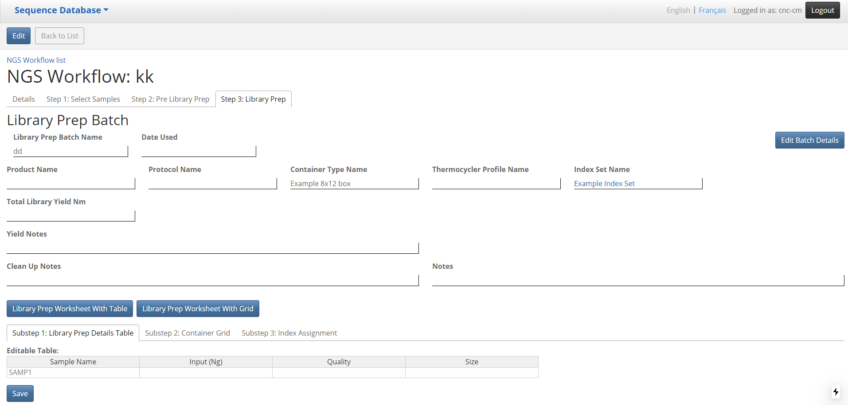

## Sequence Module – NGS Workflows – Workflow - Step 3 – Library Prep – Saved- SubStep 2

URL:

[http://seqdb.traefik.me/workflow/view?id=c34037dc-7ed3-41bb-af15-f41ff1f7b577&step=](http://seqdb.traefik.me/workflow/view?id=c34037dc-7ed3-41bb-af15-f41ff1f7b577&step=1)3

Steps

* Click on the Save button on Workflow - Step 3 – Library Prep page
* On this page, user can enter details in 3 tabs :

1. Substep 1 : Library Prep Details page
2. Substep 2 : Container Grid
3. Substep 3: Index Assignment

* On the Substep 2 : Container Grid page, User can select samples to put into container grid
* Select from the left side samples and click the Move all button to move the select samples to the grid,
* Drag/move/drop the sample to the place in container where it is intended to be placed
* Click the Save changed well coordinates button to save the change
* Click the Clear Grid to reset the Samples from the Container grid back to left side Selected Samples stack.

Screenshots:

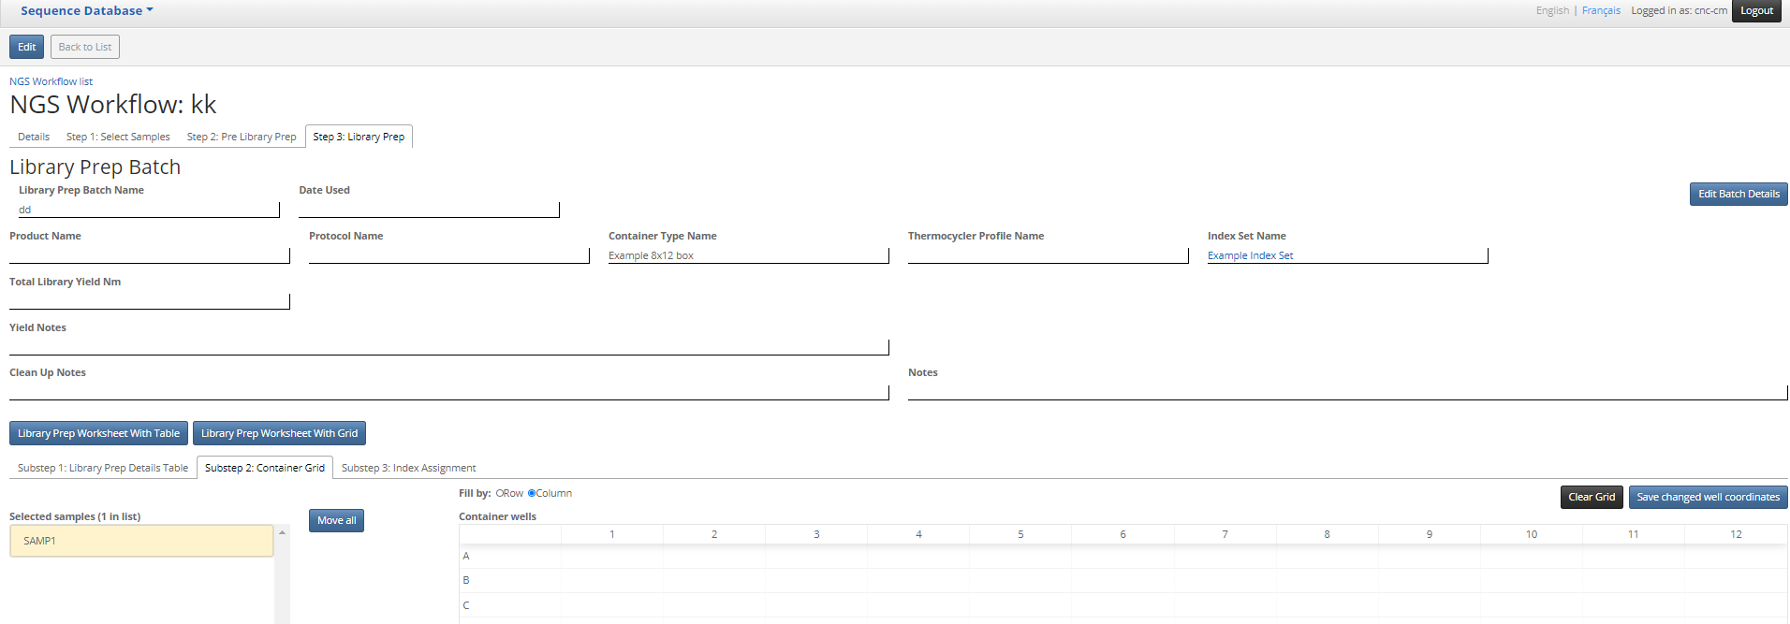

## Sequence Module – NGS Workflows – Workflow - Step 3 – Library Prep – Saved- SubStep 3

URL:

[http://seqdb.traefik.me/workflow/view?id=c34037dc-7ed3-41bb-af15-f41ff1f7b577&step=](http://seqdb.traefik.me/workflow/view?id=c34037dc-7ed3-41bb-af15-f41ff1f7b577&step=1)3

Steps

* Click on the Save button on Workflow - Step 3 – Library Prep page
* On this page, user can enter details in 3 tabs :

1. Substep 1 : Library Prep Details page
2. Substep 2 : Container Grid
3. Substep 3: Index Assignment

* On the Substep 3 : Index Assignment page, User can assign forward and reverse indexes to the selected samples

there are 2 ways to assign index

1. Assign by grid
2. Assign by table

* To assign by grid, select from the index dropdown list from the column head and row head for indexes
* Click Save button will save the index assignment for all the samples that index has been applied via assign by grid method
* To assign by table, select from the index dropdown list for the indexi5 and indexi7 individually
* Click Save button will save the index assignment for all the samples that index has been applied via assign by table method

Screenshots:

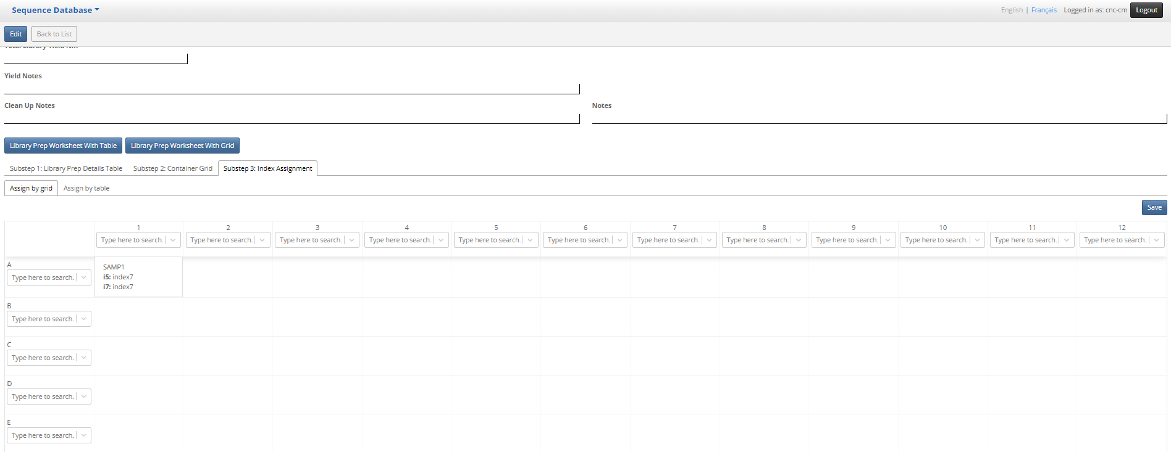

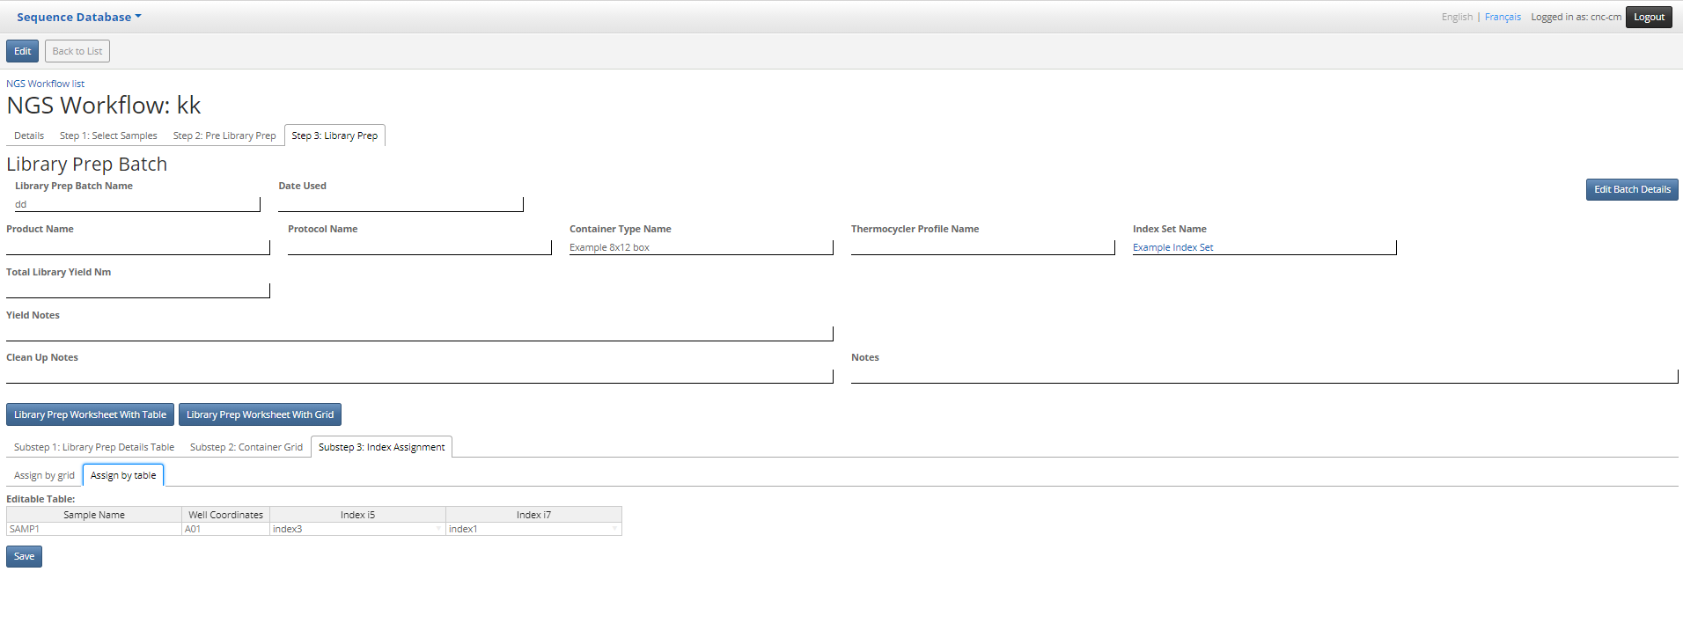

## Sequence Module – Index Sets – List page

URL:

<http://seqdb.traefik.me/index-set/list>

Steps

* Click on the “Index Sets” menu item on Home page Sequence Database dropdown menu
* The list page show all the index sets

Screenshots

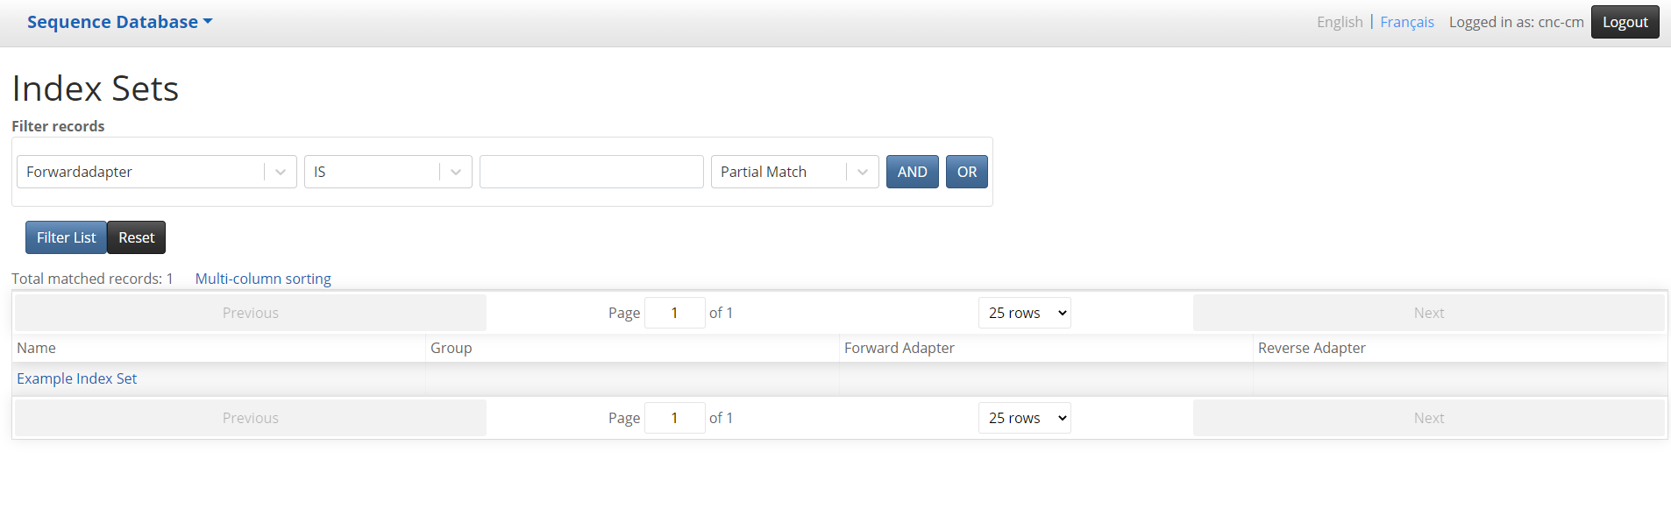

## Sequence Module – Index Sets – Details page

URL:

<http://seqdb.traefik.me/index-set/view?id=a3223c80-1654-460f-8f9a-e537075487eb>

Steps

* Click on the individual link under name column on Index Sets List page
* The Index Sets detail page show all the index sets details information
* Click Back to List button will go back to Index Sets List page

Screenshots

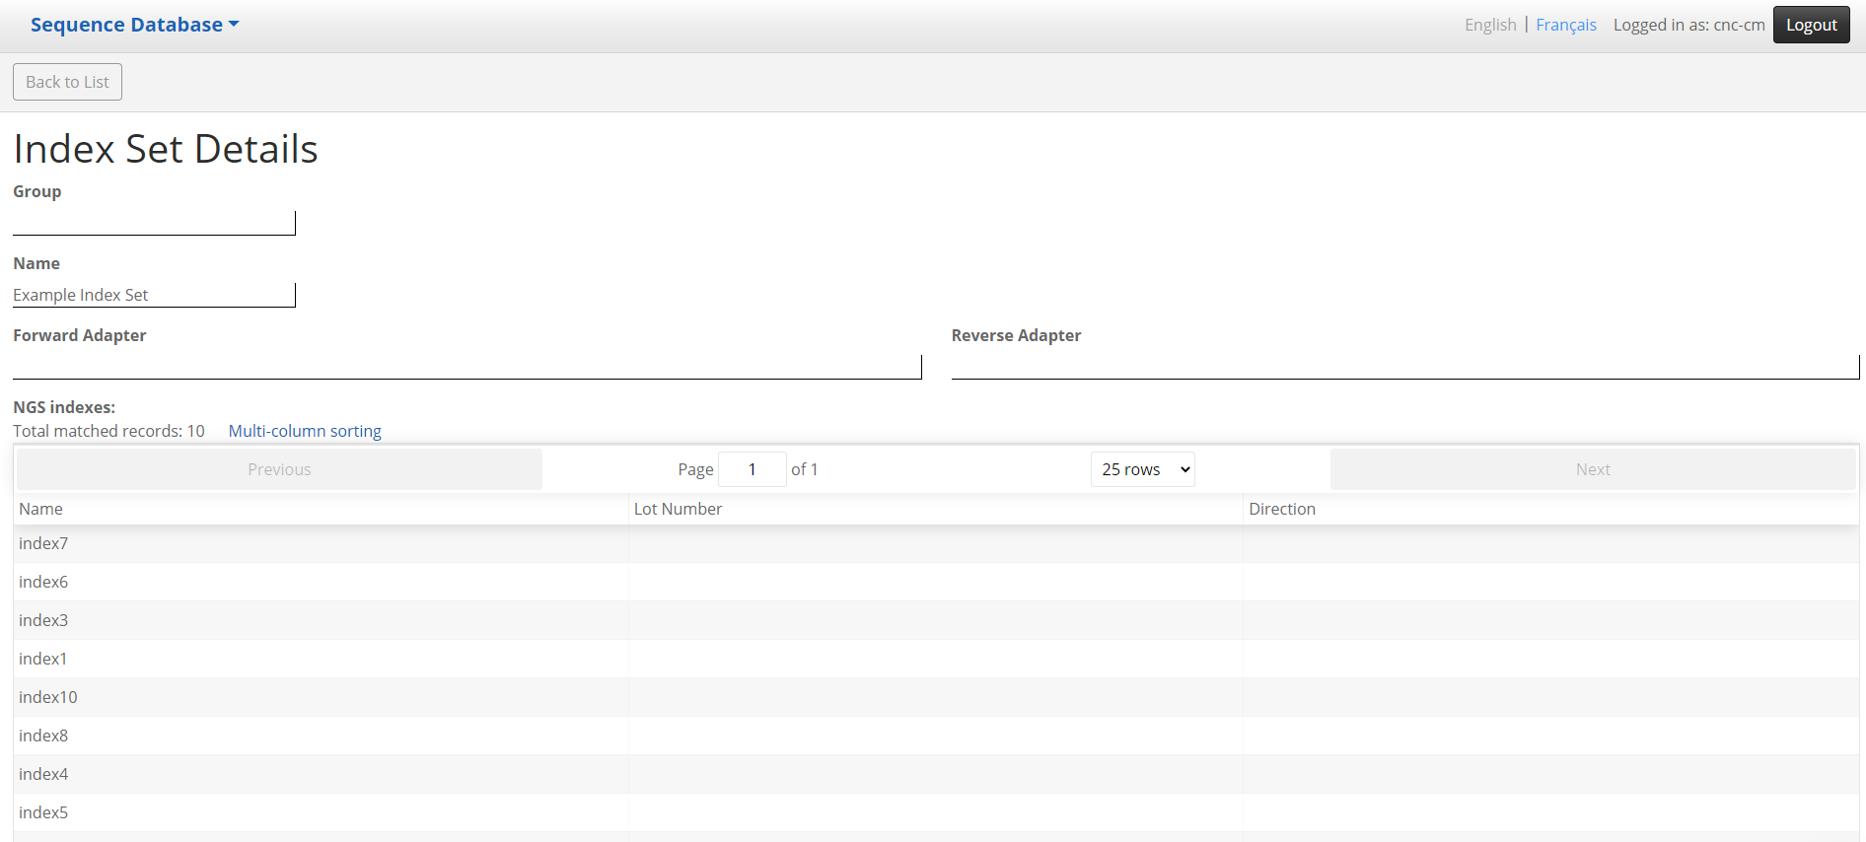

## Sequence Module – PCR Primers – List page

URL:

http://seqdb.traefik.me/pcr-primer/list

Steps

* Click on the “PCR Primers” menu item on Home page Sequence Database dropdown menu
* The list page show all the PCR Primers

Screenshots

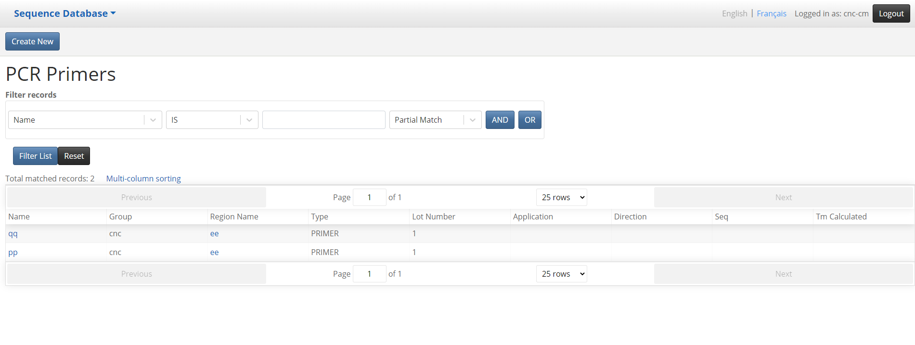

## Sequence Module – PCR Primers – Add PCR Primer page

URL:

http://seqdb.traefik.me/pcr-primer/edit

Steps

* Click on the Create New button on PCR Primers List page
* The PCR Primers edit page show all the PCR Primers fields

Required fields:

1. Name

* Click Back to List button will go back to PCR Primers List page
* Click Save button will save the info to the new PCR Primer and go back to PCR Primers List page

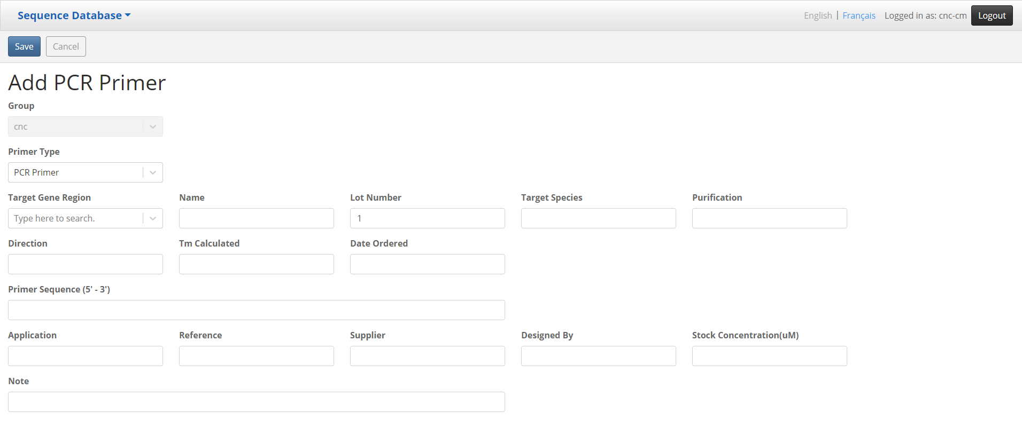

## Sequence Module – PCR Primers – Details page

URL:

<http://seqdb.traefik.me/pcr-primer/view?id=cb60556c-d35c-43b7-bb2a-5a1800098a71>

Steps

* Click on the individual link under name column on PCR Primers List page
* The PCR Primers detail page show all the PCR Primers details information
* Click Back to List button will go back to PCR Primers List page
* Click Save button will save the info to the PCR Primer and go back to PCR Primers List page

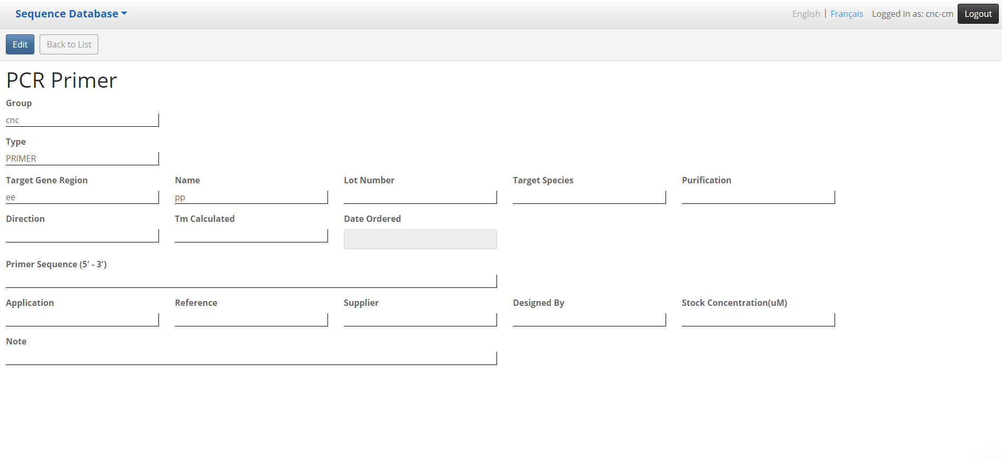

## Sequence Module – Regions – List page

URL:

<http://seqdb.traefik.me/region/list>

Steps

* Click on the “Regions” menu item on Home page Sequence Database dropdown menu
* The list page show all the Regions

Screenshots

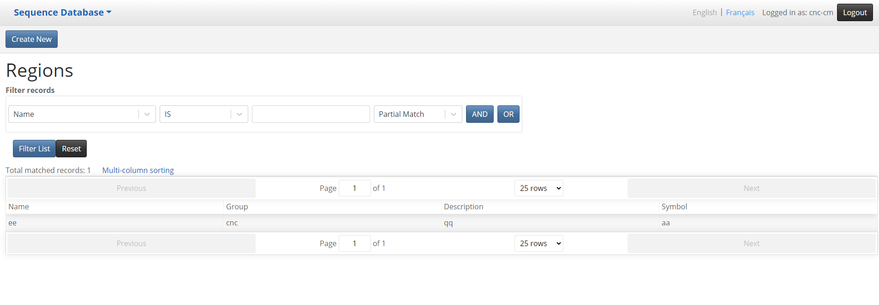

## Sequence Module – Regions – Add Region page

URL:

<http://seqdb.traefik.me/region/edit>

Steps

* Click on the Create New button on Regions List page
* The Regions edit page show all the Regions fields

Required fields:

1. Symbol

* Click Back to List button will go back to Regions List page
* Click Save button will save the info to the new PCR Primer and go back to Regions List page

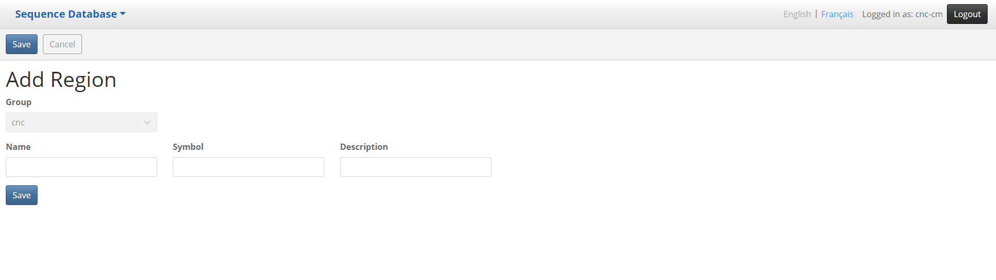

## Sequence Module – Regions – Details page

URL:

<http://seqdb.traefik.me/region/view?id=1e9b694f-1337-416d-bebe-eb0ec694f582>

Steps

* Click on the individual link under name column on Regions List page
* The Regions detail page show all the Regions details information
* Click Back to List button will go back to Regions List page
* Click Save button will save the info to the Region and go back to Regions List page

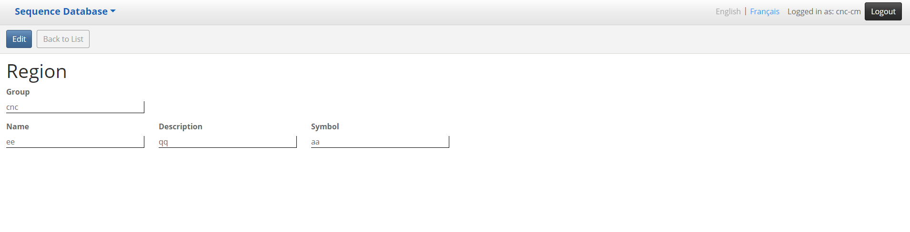

## Sequence Module – Thermocycler Profiles – List page

URL:

http://seqdb.traefik.me/pcr-profile/list

Steps

* Click on the “Thermocycler Profiles” menu item on Home page Sequence Database dropdown menu
* The list page show all the Thermocycler Profiles

Screenshots

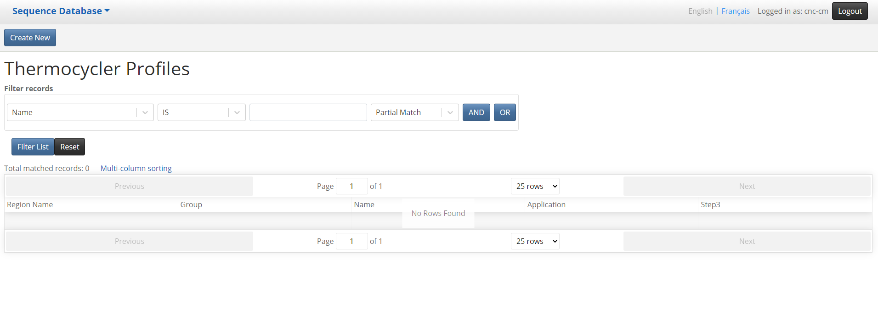

## Sequence Module – Thermocycler Profiles – Add Thermocycler Profile page

URL:

<http://seqdb.traefik.me/pcr-profile/edit>

Steps

* Click on the Create New button on  Thermocycler Profiles List page
* The Thermocycler Profiles edit page show all the Thermocycler Profile fields

Required fields:

1. Name

* Click Back to List button will go back to  Thermocycler Profiles List page
* Click Save button will save the info to the new Thermocycler and go back to Thermocycler Detail page

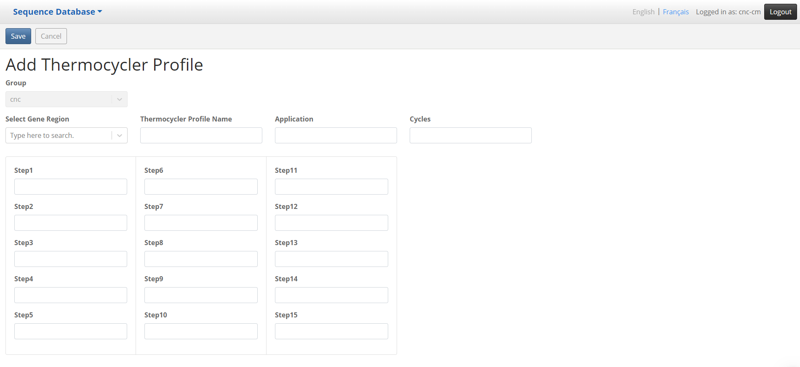

## Sequence Module – Thermocycler Profiles – Details page

URL:

http://seqdb.traefik.me/pcr-profile/view?id=5166eed9-12ac-47f3-a37c-31088614849d

Steps

* Click on the individual link under name column on  Thermocycler Profiles List page
* The Thermocycler Profiles detail page show all the Thermocycler Profile details information
* Click Back to List button will go back to  Thermocycler Profiles List page
* Click Save button will save the info to the Thermocycler Profile and go back to  Thermocycler Profiles List page

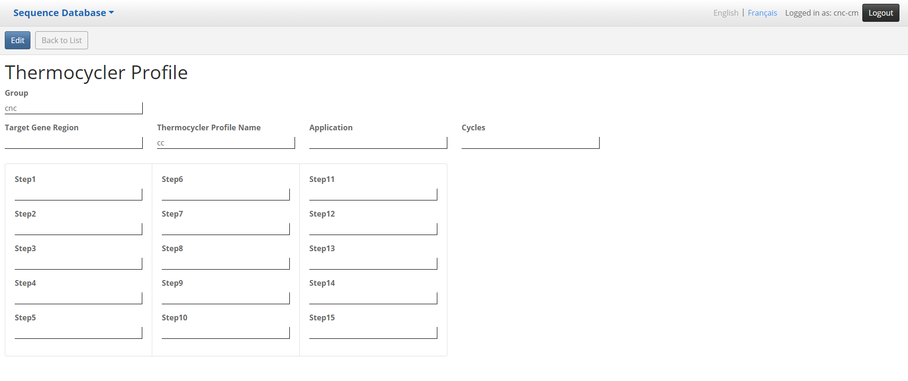

## Sequence Module – Products – List page

URL:

http://seqdb.traefik.me/product/list

Steps

* Click on the “Products” menu item on Home page Sequence Database dropdown menu
* The list page show all the Products

Screenshots

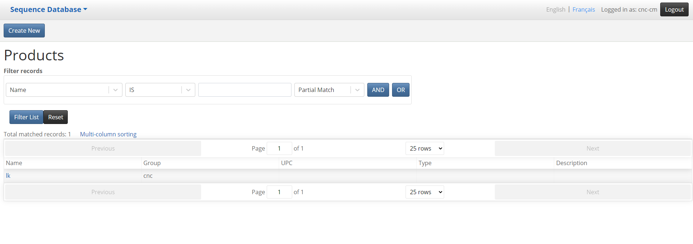

## Sequence Module – Products – Add Product page

URL:

<http://seqdb.traefik.me/product/edit>

Steps

* Click on the Create New button on Products List page
* The Products edit page show all the Product fields

Required fields:

1. Name

* Click Back to List button will go back to Products List page
* Click Save button will save the info to the new Product and go back to Products Detail page

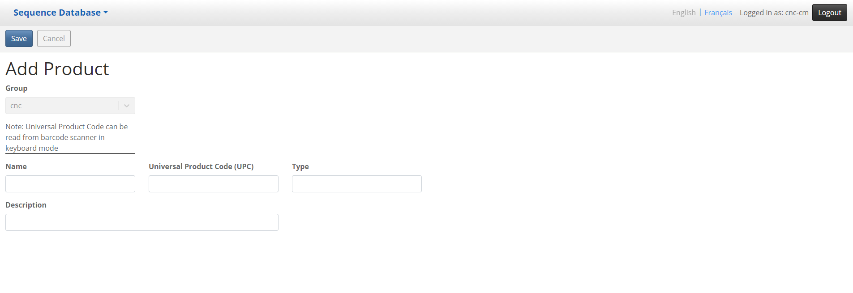

## Sequence Module – Products – Details page

URL:

<http://seqdb.traefik.me/product/view?id=95dd4758-9c21-4c83-9372-668cdd1dc78d>

Steps

* Click on the individual link under name column on Products List page will land on this page
* The Products detail page show all the Product details information
* Click Back to List button will go back to Products List page

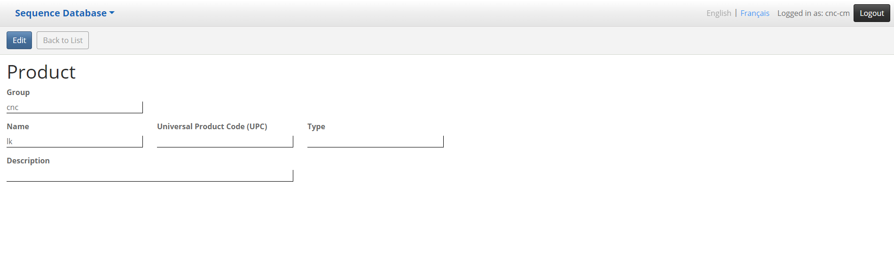

## Sequence Module – Protocols – List page

URL:

<http://seqdb.traefik.me/protocol/list>

Steps

* Click on the “Protocols” menu item on Home page Sequence Database dropdown menu
* The list page show all the Protocols

Screenshots

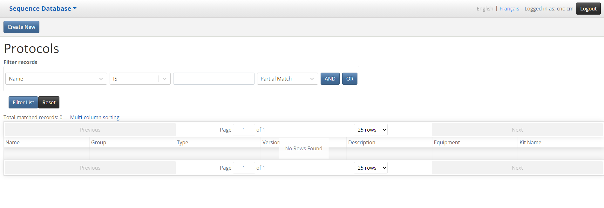

## Sequence Module – Protocols – Add Protocol page

URL:

<http://seqdb.traefik.me/protocol/edit>

Steps

* Click on the Create New button on Protocol List age
* The Protocols edit page show all the Protocol fields

Required fields:

1. Name
2. Type

* Click Back to List button will go back to Protocol List page
* Click Save button will save the info to the new Protocol and go back to Protocol Detail page

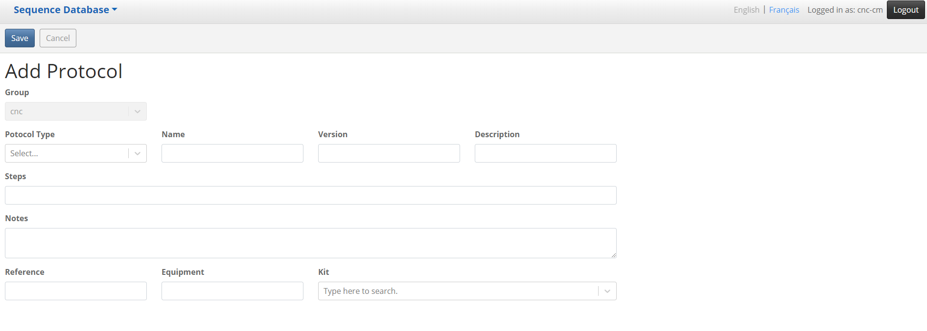

## Sequence Module – Protocols – Details page

URL:

<http://seqdb.traefik.me/protocol/view?id=4ed85102-4901-441a-b6b4-c06e22cb01d2>

Steps

* Click on the individual link under name column on Protocol List page will land on this page
* The Protocol detail page show all the Protocol details information
* Click Back to List button will go back to Protocol List page

