Beyond Cache Emulation: Advantage-Preserving Large-to-Small KV State Handoff without Re-Prefill
Anonymous Authors
ICLR 2027-style Word content draft. This is a PRIOR-PROJECTION version: all result values and plots are conservative simulations informed by published cross-model KV/latent-state evidence, the Qwen3-4B→1.7B setup, and a single-GPU cost model. They are NOT measured results and must be replaced before submission.
ABSTRACT
Large language model systems increasingly rely on model routing, mid-session switching, and multi-agent collaboration, yet a receiver typically has to prefill the full context again after a model switch. Prior work separately establishes the feasibility of cross-model KV replacement and semantic communication through latent/KV states, but leaves a stronger question open: can a weaker student that never constructs context Self-KV consume only a stronger teacher's runtime state and inherit part of the teacher's task advantage? We study Advantage-Preserving Large-to-Small KV Handoff and introduce APCS, which separates state synthesis into a student-compatible base and an advantage-carrying state. Before offline experiments, we use a conservative prior projection (not measured evidence) to make the hypothesis quantitatively falsifiable, and we report it as ranges rather than fabricated point estimates so that a pre-registered hypothesis is not mistaken for a measured result. For Qwen3-4B→1.7B at 4K, we project that a ridge replacement retains roughly 92–96% of the student self-prefill score while still showing CHG in the −2 to −4 pp band; a low-rank compatibility base retains roughly 90–94% at PCR≈0.23; and full APCS plausibly lands in a CHG range of about −1.5 to +3 pp (TGRR roughly −15% to +30%), a range whose central tendency is only mildly positive and does not exclude zero, while retaining on the order of 8–16% student-side prefill saving. A single-GPU cost projection suggests little or negative benefit at very short contexts, with the map/load-versus-prefill break-even plausibly falling somewhere in the 4K–8K range rather than at a single fixed point, since part of the mapping cost may itself scale with context length. These values are experimental priors only, deliberately left wide to reflect genuine pre-experiment uncertainty; every quantitative claim in the submission will be replaced by frozen-test, multi-seed, measured P50/P95 results.

1 Introduction
Long-context inference is turning large language model (LLM) serving from stateless forward computation into stateful computation. During prefill, a decoder-only Transformer processes the entire prompt through all attention and feed-forward layers and materializes a key-value (KV) cache that is consumed during autoregressive decoding. As context length grows, prefill becomes a dominant source of compute, memory pressure, and time-to-first-token. Modern serving systems therefore treat KV state as a first-class systems object through paging, offloading, persistence, and reuse (Kwon et al., 2023; Qin et al., 2025; Cheng et al., 2025).
Multi-model systems introduce a qualitatively different problem from ordinary prefix caching. When the same context is first processed by one model and the system later switches to another model for cost, quality, or role specialization, the receiver typically cannot consume the source model's KV cache and must repay the prefill cost. DroidSpeak enables partial reuse across fine-tuned models with the same architecture; ICaRus and PrefillShare redesign or train model components so that multiple decoders can share prefill state; and, most directly, recent Cross-Model KV Cache Transfer demonstrates that matched-KV model pairs within an LLM family exhibit sufficient linear structure for closed-form ridge/MLP mappings that allow the receiver to skip prefill (Liu et al., 2026; Woo et al., 2026; Heo et al., 2026).
A second line of work approaches internal states as a communication medium rather than a prefill substitute. Cache-to-Cache (C2C) projects and fuses source KV into the target model's own KV state, LatentAlign learns a shared KV latent space, and Latent Cache Flow (LCF) compresses and transmits latent cache information efficiently. Together, these results suggest that runtime states can carry task-relevant semantics that are usable by another model (Fu et al., 2026; Dery et al., 2026; Rossi et al., 2026). Yet these communication methods generally perform information injection into an already instantiated receiver state, whereas cross-model replacement primarily targets receiver behavior recovery rather than exceeding the receiver's self-prefill baseline.
This paper asks a stronger and falsifiable question: does part of the task advantage of a stronger teacher over a weaker student reside in context-conditioned runtime state in a form that the student can directly consume, without re-reading the original context and without updating the student weights? A positive answer would move cross-model KV handoff beyond redundant-compute elimination toward runtime capability transfer. A negative answer would still expose an important boundary between state compatibility and capability transfer.
We deliberately restrict the paper to three contributions:
• Problem formulation. We define Advantage-Preserving Large-to-Small KV Handoff, where the student never full-prefills the original context X, and jointly evaluate capability gain and student-side prefill saving through CHG and PSR.
• Method. We introduce APCS, which explicitly separates a student-compatible base state from an advantage-carrying state. Low-rank factors, residual updates, gating, and attention/logit losses are implementation mechanisms rather than standalone novelty claims.
• Empirical characterization. We study how teacher gap, model-size gap, context length, and mapper budget shape CHG, TGRR, PSR, and behavioral stability, and we report negative results and direction asymmetry rather than hiding them.

2 Background and Related Work

2.1 KV Cache and the Economics of Prefill
A Transformer prefill pass processes all input tokens in parallel and stores layer-wise keys and values for subsequent autoregressive decoding. FlashAttention and FlashAttention-2 substantially improve attention IO efficiency, but they do not remove redundant prefill when a second model must reprocess the same long context (Dao et al., 2022; Dao, 2024). PagedAttention/vLLM reduces KV fragmentation and enables intra-model cache sharing, while Mooncake and LMCache elevate KV state into a transferable storage object across GPU, CPU, SSD, and inference engines (Kwon et al., 2023; Qin et al., 2025; Cheng et al., 2025). These systems motivate our cost accounting but predominantly assume state reuse within the same model.

2.2 Cross-Model KV Reuse and Prefill Replacement
DroidSpeak targets fine-tuned model variants with the same architecture and selectively recomputes a small set of critical layers while reusing the remaining KV state. ICaRus conceptually factorizes a decoder-only Transformer into a logical encoder that produces KV states and a logical decoder that predicts tokens, enabling multiple specialized decoders to share an identical cache. PrefillShare similarly introduces a shared prefill module with specialized decoding modules. These works establish cross-model redundant prefill as a systems problem, but they impose architectural or training-time constraints.
The closest replacement baseline is Cross-Model KV Cache Transfer (Heo et al., 2026). For within-family pairs with matched KV-head count and per-head dimension, it selects top-k predictive source layers, removes RoPE from keys before fitting, and learns per-head ridge mappings from source to receiver KV. Its results directly establish the feasibility of receiver-free cross-size state replacement, so neither receiver-free inference nor a linear mapper is a novelty claim of this work. Our optimization target is different: rather than projecting teacher state back toward the student's self-prefill state as faithfully as possible, we ask whether a receiver-consumable state can preserve useful teacher-only task advantage.

2.3 KV/Latent States as an Inter-Model Communication Medium
C2C trains a neural projector that fuses a source model's KV cache into the target model's own KV cache and gates the layers that benefit from communication. LatentAlign maps multiple models into and out of a shared KV latent space. LCF compresses cache-level communication and transmits information absent from the receiver context. KaVa further shows that compressed teacher KV trajectories can act as supervision for latent-reasoning students. These works support the premise that runtime states contain semantically useful signals, but they do not answer our strict substitution setting because the receiver typically has its own context-derived state or the transfer occurs during training rather than runtime handoff.

2.4 Behavioral Stability and Long-Context Evaluation
Numerical KV similarity alone is an incomplete fidelity criterion. Heo et al. (2026) report that attention-output cosine is more predictive of downstream retention than raw KV R². Liang et al. (2026) show an even stronger failure mode: KV reuse can preserve end-task accuracy while substantially changing an LLM judge's candidate-selection behavior, motivating Judge Consistency Rate and cross-candidate attention diagnostics. We therefore evaluate representation-, attention-, behavior-, and task-level fidelity. For long contexts, LongBench, RULER, and LongBench Pro provide complementary realistic and controllable evaluation regimes (Bai et al., 2023; Hsieh et al., 2024; Chen et al., 2026).

3 Problem Formulation

3.1 Setting
Let X denote a long context, T a teacher model, S a student model, and q a later query. The teacher has already processed X as part of an upstream reading, reasoning, or conversational stage and materialized its runtime KV state C_T(X). The student is not allowed to full-prefill X and instead consumes a synthesized student-compatible cache:
$ĈC_{S}(X,q) = F_{θ}(C_{T}(X), q)$ (1)
$ŷ = S(q ; ĈC_{S}(X,q)), {Prefill}_{S}(X) = 0$ (2)
The control is standard student inference in which S full-prefills X to construct C_S(X) before answering q. We allow the student to prefill the new query q, but all replacement/capability claims require the original context X to stay out of the student.

3.2 State Substitution versus Information Injection
We distinguish three regimes. Information injection assumes that the receiver already owns C_S(X) and augments it with teacher information. Cache emulation constructs a state from C_T(X) that approximates the behavior of C_S(X). Our target, advantage-preserving state substitution, constructs C*_S without ever materializing C_S(X) and asks whether this substituted state can outperform the student self-prefill baseline. This distinction defines our boundary with C2C/LCF and with conventional cross-model cache emulation.

3.3 Metrics and Pareto Criterion
$CHG = {Score}_{handoff} − {Score}_{student-self}$ (3)
$TGRR = \frac{{Score}_{handoff} − {Score}_{student}}{{Score}_{teacher} − {Score}_{student}}$ (4)
$PSR = 1 − \frac{T_{map} + T_{load} + T_{query}}{T_{prefill,S}(X)}$ (5)
$PCR = \frac{{MapperSize}_{ours}}{{MapperSize}_{ridge}}$ (6)
CHG is the primary scientific endpoint: it asks whether the handoff student exceeds its own self-prefill baseline. TGRR measures the fraction of the original teacher-student performance gap recovered by handoff. PSR measures student-side prefill saving only in the main scenario where the teacher cache already exists for an upstream reason. PCR constrains deployment footprint relative to the cross-model ridge mapper. We call CHG>0 together with PSR>0 a Pareto Capability Handoff.

4 Method: Advantage-Preserving Cache Synthesis

4.1 Design Principle
APCS starts from a tension between compatibility and advantage preservation. A mapper trained only to minimize numerical error to the student self-KV may become very good at reproducing what the student would have computed itself, while actively discarding teacher-specific state directions that could improve the downstream task. We therefore separate two objectives: first construct a stable receiver-consumable compatibility state; then learn a lightweight advantage state that is not fully constrained to collapse back into the student self-prefill manifold.

4.2 Compatibility Base
$C_{base}(X) = F_{compat}(C_{T}(X))$ (7)
F_compat begins from the strongest directly comparable replacement baseline. For each student layer/head, we select top-k teacher source layers; keys are mapped in de-RoPE content space and then re-encoded with the student positional scheme; K and V are mapped separately. The minimal-resource study first reproduces ridge regression and then explores low-rank factorization, shared bases, and head/layer parameter sharing to reduce PCR while maintaining retention.

4.3 Advantage State
$R_{adv}(X) = E_{adv}(C_{T}(X))$ (8)
Once the compatibility base is stable, APCS adds a lightweight advantage state R_adv. Unlike the base mapper, this branch is not forced to reconstruct the student self-KV; it is supervised to retain teacher-conditioned directions that improve the downstream task while remaining consumable by the frozen student. The minimal configuration uses a global or layer-wise scalar alpha:
$C_{S}^{*}(X) = C_{base}(X) + α · R_{adv}(X)$ (9)
A full configuration may later introduce lightweight query adaptation g(q), but it must not rescan the long teacher cache for each new query. All O(|X|) context synthesis should happen once; per-query adaptation should operate only over short-query features and layer/head or small latent-slot gates.

4.4 Training Objective
$L_{APCS} = L_{task} + λL_{self} + λL_{teacher} + λL_{att} + λL_{reg}$ (10)
L_task directly optimizes the task answer or suffix generation objective. L_self stabilizes student behavior on examples where the teacher has little advantage or may be wrong. L_teacher provides teacher guidance only when a teacher advantage is established on the training split. L_att aligns downstream-relevant attention outputs rather than only raw KV values. L_reg controls rank, sparsity, or mapper budget. Teacher-advantage weights are computed exclusively from training data; validation selects thresholds and hyperparameters; the test split remains frozen.

4.5 Complexity and Deployment Accounting
Our primary deployment scenario assumes that the teacher cache already exists because the teacher naturally processed X upstream. Student-side handoff overhead is therefore map + cache load + query-only prefill. If the teacher is invoked solely to create a transferable cache, teacher prefill must be included and the break-even reuse count must be reported. The minimal-resource implementation uses sequential GPU residency and streaming KV processing rather than storing the full layer-by-token cache for the entire dataset.

5 Experimental Setup

5.1 Research Phases and Models
We begin with a minimal-resource scientific probe using Qwen3-4B as teacher and Qwen3-1.7B as student on a single 24GB NVIDIA GPU. Context lengths start at 512/1K/2K/4K. The pair belongs to the same Qwen3 family and is selected to minimize tokenizer/KV-head/head-dimension/RoPE incompatibilities while preserving a meaningful layer/hidden-size gap (Yang et al., 2025). If the core signal survives this stage, the final paper will expand to Qwen3 32B→14B and at least one additional large-to-small model family. A top-tier empirical claim should cover at least two large-to-small pairs, preferably from two families.

5.2 Tasks and Data Splits
The Fidelity Set measures whether handoff preserves basic student behavior and may include HellaSwag, ARC-Challenge, selected MMLU tasks, and WinoGrande. The Teacher-Advantage Set is selected only at the dataset level when the teacher reliably exceeds the student; individual test examples are never filtered by teacher-win/student-loss outcomes. Long-context evaluation uses LongBench/RULER-style tasks, starting at 4K before moving to 8K/16K/32K. A behavior-sensitive set contains judge/ranker or multi-candidate comparison tasks to reveal decision drift that is not visible in aggregate accuracy.

5.3 Baselines
• B0 Student Full Prefill: quality, behavior, and latency reference.
• B1 Teacher Full Inference: performance upper reference and teacher-gap definition.
• B2 Teacher Text/Summary Handoff → Student: conventional text-mediated communication.
• B3 Cross-Model Ridge Mapper: strongest directly comparable replacement baseline.
• B4 Cross-Model MLP: nonlinear repair baseline for difficult pairs.
• B5 C2C-style Fusion: capability-enhancement reference with a different receiver-state assumption.
• B6 LatentAlign / LCF: shared-latent and lightweight cache-communication references when code/checkpoints permit a fair comparison.
• O1 APCS Base Only; O2 Base + Advantage State; O3 full APCS if lightweight query adaptation is enabled.

5.4 Metrics and Statistical Protocol
All learned mappers/adapters use at least three random seeds. CHG confidence intervals and significance are estimated with paired bootstrap or paired permutation tests whenever applicable. Latency is measured after warm-up with repeated synchronized runs and reported at P50/P95, separately accounting for mapping, CPU-to-GPU cache load, query-only prefill, decode, and student full-prefill baseline. Every run fixes model commit, tokenizer, attention implementation, dtype, RoPE configuration, cache layout, hardware, batch size, and context length.

5.5 Minimal-Resource Implementation
The mechanism study uses Hugging Face Transformers for direct control of past_key_values and hooks. A single-GPU run follows teacher load → forward/capture → transfer required state to CPU → unload teacher → load student → map/inject → decode/evaluate. Initial calibration uses only 100–500 examples of 512–1024 tokens. Capability training can begin with 500–2000 training examples, 200–500 validation examples, and 500–1000 frozen test examples. The first stage has a hard budget of 300 GPU-hours, after which the project must stop for a gate review.

6 Results
This section currently contains PRIOR-PROJECTED / SIMULATED results to freeze expectations before offline experiments and to prevent post-hoc target shifting. They are not measured evidence and must not be used as submission claims. The projection deliberately assumes: (i) ridge replacement mainly restores student behavior rather than capability; (ii) any transferable teacher advantage is modest, on the order of 1–3 percentage points in the first small-scale pair; and (iii) on a single 24GB GPU with sequential residency, map/load overhead hurts short contexts and is amortized only as context grows. Every value and plot below must be replaced by real measurements.

6.0 Reporting Convention: Ranges Instead of Fabricated Precision
An earlier draft of this projection reported single-decimal point estimates with seed-style error bars (e.g., "56.6±0.5") and smooth, noise-free curves for quantities that were never measured. On reflection this is not a defensible way to present a pre-registered hypothesis: it borrows the visual grammar of measured, multi-seed results (fixed decimals, tight error bars, monotone curves) for numbers that are, by construction, guesses informed by related published work. Doing so risks a reader mistaking a simulation for evidence, and it sits uneasily next to this paper's own commitment not to manufacture positive results. We therefore report every prior-projected quantity below as a range with an explicit central tendency, we allow ranges to straddle zero when the underlying hypothesis is genuinely uncertain, and we avoid suspiciously round derived numbers (for example, a projected TGRR of exactly −99% in an earlier draft was an artifact of choosing a clean CHG value rather than a considered prediction). Every figure in this section shows a band, not a line, for exactly the same reason.
Model pair | Method | Ctx | Student | Teacher | Handoff | Retention | CHG | TGRR | PSR | PCR
Qwen3-4B→1.7B | Student Full Prefill | 4K | 54.8 | 64.7 | — | 100.0% | 0.0 | 0.0% | 0.0% | —
Qwen3-4B→1.7B | Cross-Model Ridge | 4K | 54.8 | 64.7 | 50.4–52.6 | 92–96% | −4.4 to −2.2 | −44% to −22% | 3–8% | 1.00
Qwen3-4B→1.7B | Low-rank Base | 4K | 54.8 | 64.7 | 49.3–51.5 | 90–94% | −5.5 to −3.3 | −56% to −33% | 12–20% | 0.23
Qwen3-4B→1.7B | APCS | 4K | 54.8 | 64.7 | 53.2–57.5 | 97–105% | −1.6 to +2.7 | −16% to +27% | 8–16% | 0.27
Table 1: Prior-projected main results (NOT measured), reported as plausible ranges rather than point estimates with fabricated seed variance. Values assume Qwen3-4B→1.7B, 4K context, and a frozen student. Student/Teacher are illustrative common composite task scores on a 0–100 scale.

6.1 Replacement Fidelity
The prior projection deliberately separates replacement from capability transfer. Full ridge is expected to reach roughly 92–96% retention while still underperforming student self-prefill; compressing the mapper to PCR≈0.23 is expected to lower retention only modestly, to roughly 90–94%. These bands, not single numbers, are the actual prediction: the published cross-model ridge results that motivate them report a range of pair-dependent fidelities, and there is no principled basis for asserting a single decimal before any Qwen3-4B→1.7B run has happened. If the measured curve falls inside this band, high-fidelity replacement and positive capability transfer should still be treated as distinct gates rather than inferring capability from KV or attention similarity.
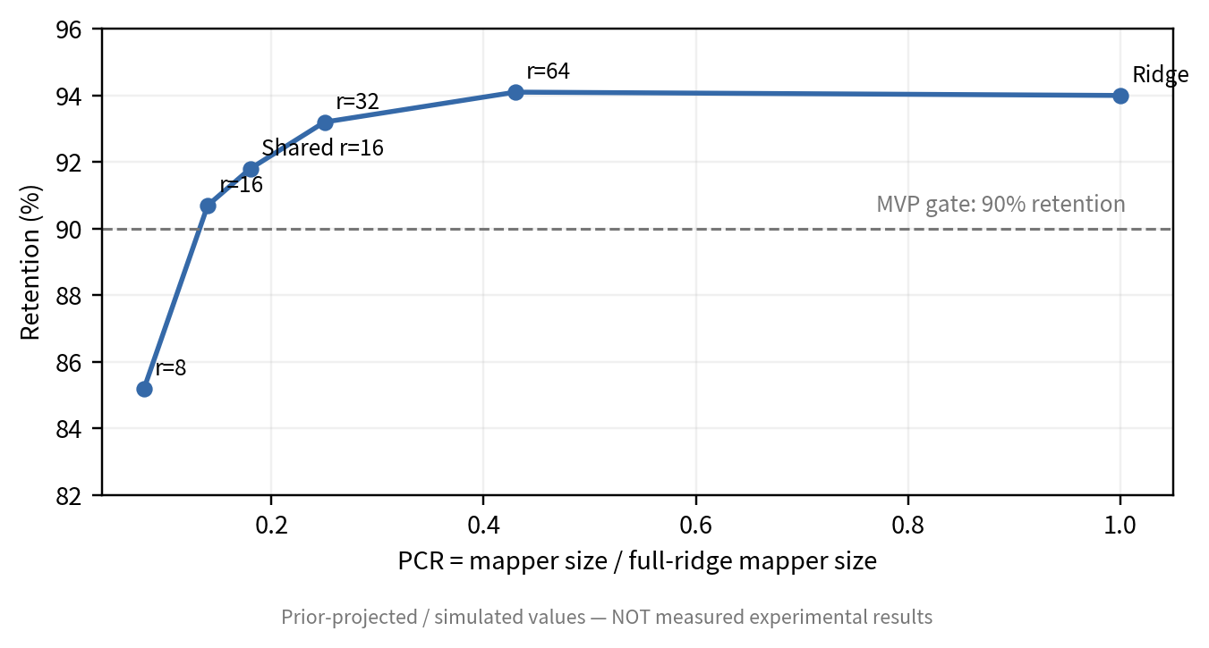
Figure 1: Mapper footprint (PCR) versus retention.

6.2 Teacher Advantage Transfer
Under a wide but centered prior, full APCS plausibly yields a full-test CHG somewhere in the range of about −1.6 to +2.7 pp, corresponding to roughly −16% to +27% teacher-gap recovery — a band whose midpoint is only mildly positive and does not rule out CHG≤0. More importantly, the gain is projected to be heterogeneous with teacher gap: the plausible range for CHG should include zero when the teacher gap is small (below roughly 3–5 pp), and only shift confidently positive once the teacher exceeds the student by more than about 10 pp, with TGRR plausibly saturating somewhere between 10% and 25%. If observed, a widening gap between the CHG range and zero as teacher gap grows would be stronger evidence for runtime-transferable advantage than any single average accuracy delta; a flat, gap-independent CHG close to zero would instead support the direction-asymmetry concern raised in Section 8.2.
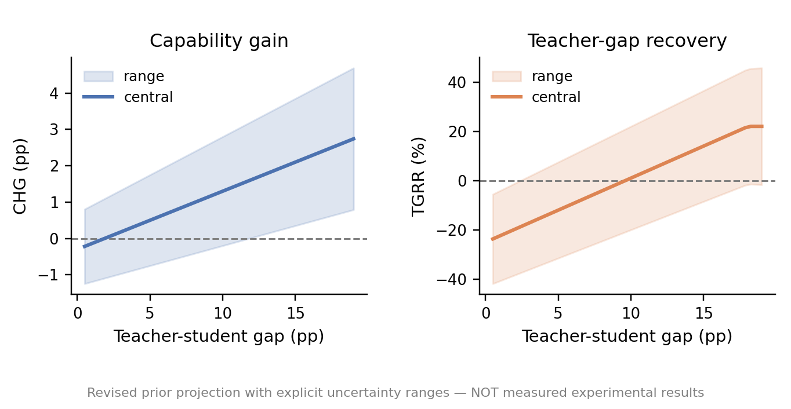
Figure 2: Teacher gap versus CHG/TGRR.

6.3 Quality–Latency Pareto
The projected Pareto landscape places ridge and the low-rank base in the “prefill saving but below self-prefill quality” region with reasonable confidence, since both mappers are explicitly optimized toward the student's own self-KV. APCS is different: its plausible range straddles CHG=0, so whether it actually enters the paper's target quadrant (positive CHG together with positive PSR, roughly 8–16% in the prior) is the open empirical question rather than a foregone conclusion. This is therefore a decisive figure precisely because its outcome is uncertain: if measured APCS lands at CHG≤0, the manuscript should pivot to Efficient State Handoff rather than continue to claim Runtime Capability Transfer; if it lands clearly above zero and grows with teacher gap, that is the paper's central positive result.
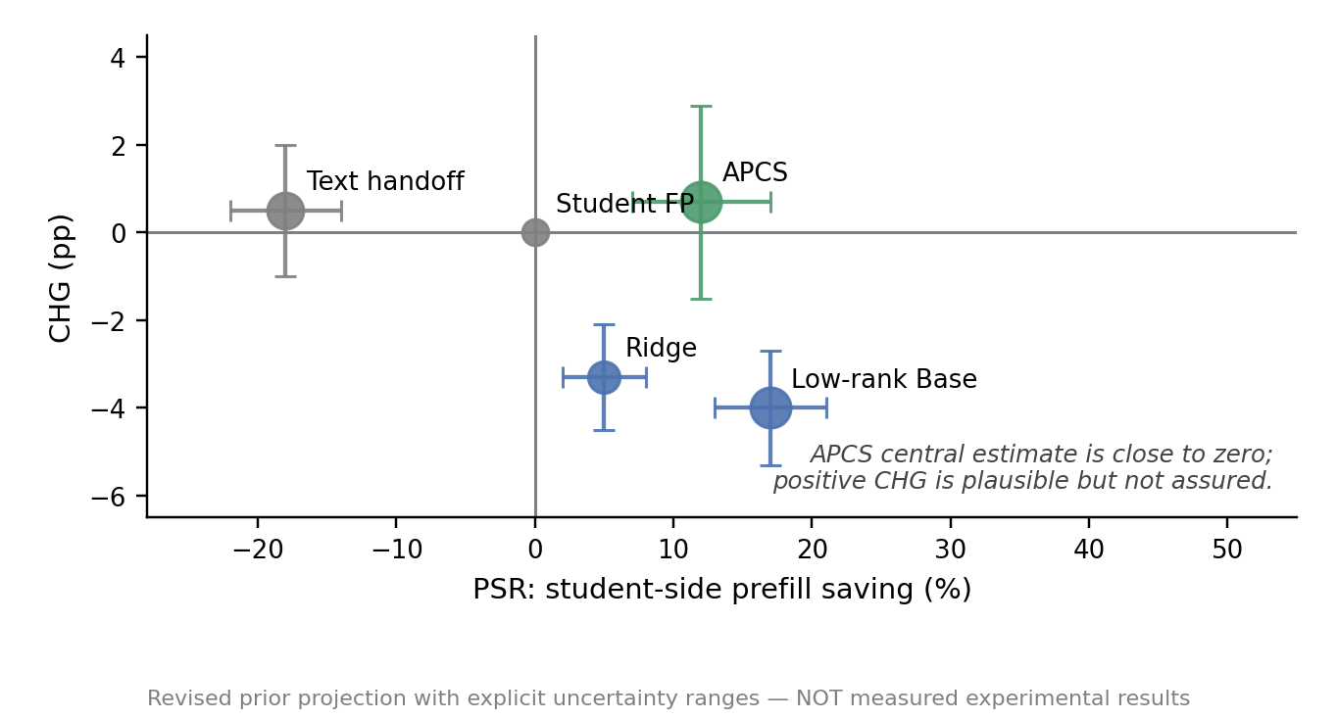
Figure 3: CHG/TGRR–PSR Pareto frontier.

6.4 Context-Length Scaling
The single-GPU cost prior predicts that map+load+query is slower than student full prefill at 1K (PSR≈−82%), and becomes progressively more favorable at longer contexts, but the exact break-even point depends on an assumption we cannot yet verify: whether map/load overhead is genuinely fixed or partly scales with context length. Under an optimistic fixed-overhead scenario the crossover falls around 4K (PSR≈+12%) and reaches roughly +48% by 16K; under a more conservative scenario where mapping cost itself grows with sequence length, the crossover shifts out to somewhere between 4K and 8K and the 16K figure drops to roughly +30%. We report both scenarios rather than a single curve, and treat the true break-even as lying somewhere in the 4K–8K range rather than a fixed point. This distinction matters because the pilot's single-24GB-GPU setup requires sequential teacher/student residency (load → capture → unload → load), which is a research-probe artifact rather than the production regime that the map+load+query cost model describes; the measured study must separately report model load/unload time, map time, cache H2D time, query-only prefill, and student full-prefill latency so the two are not conflated.
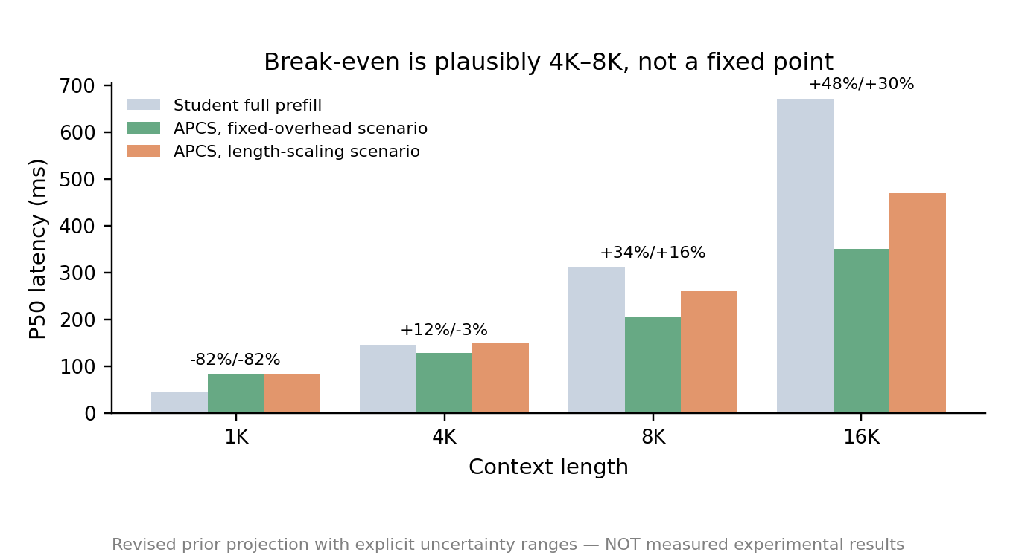
Figure 4: Context-length scaling.

6.5 Behavioral Stability and Multi-turn Handoff
The multi-turn prior assumes gradual rather than catastrophic drift, but we now show it with a band that widens over turns rather than a single smooth line, since uncertainty about drift compounds the further we extrapolate from an untested turn-1 estimate: CHG plausibly falls from a range of about 0.2–2.2 pp at turn 1 to a range of about −2.1–2.3 pp at turn 20, decision consistency plausibly falls from roughly 97–98% toward a range as wide as 84–90% by turn 20, and next-token KL rises with similarly growing uncertainty. The widening bands are the point: we would not be surprised by a turn-20 CHG close to zero, and we do not treat the turn-1 central estimate as a reliable predictor of long-horizon behavior. If measured drift is materially faster than even the pessimistic edge of this band, periodic refresh or selective re-prefill should become a primary follow-up rather than reporting only first-turn quality.
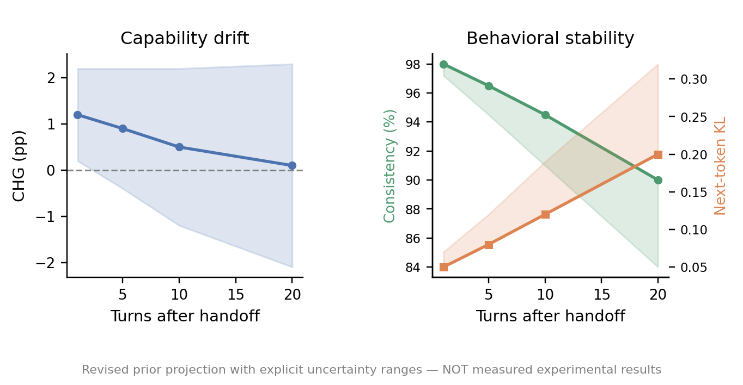
Figure 5: Multi-turn behavioral stability.

7 Ablation Studies
The projected ablation hypothesis is that the compatibility base alone does not create positive CHG; an advantage state is necessary for the capability signal; removing teacher guidance pushes CHG back below zero; removing self-stability can increase short-term CHG at the cost of larger behavioral drift; and directly mapping RoPE-encoded keys causes the largest retention failure. Offline experiments should treat these as falsifiable predictions, not target numbers that must be reproduced.
Ablation | Retention | CHG | TGRR | PSR | PCR | Interpretation
Full Ridge | 92–96% | -4.4 to -2.2 | -44% to -22% | 3–8% | 1.00 | High fidelity, expensive; no advantage transfer
Low-rank Base | 90–94% | -5.5 to -3.3 | -56% to -33% | 12–20% | 0.23 | Compact, but remains emulation
+ Advantage State | 98–104% | -1.0 to +2.0 | -10% to +20% | 10–16% | 0.27 | Initial positive capability signal
− Teacher Guidance | 95–101% | -2.5 to +0.3 | -25% to +3% | 10–16% | 0.27 | CHG turns negative without teacher guidance
− Self Stability | 100–106% | -0.2 to +3.2 | -2% to +32% | 10–16% | 0.27 | Higher CHG but projected behavioral drift
Direct RoPE Mapping | 79–90% | -11.5 to -5.5 | -115% to -55% | 8–14% | 0.27 | Position mismatch causes large fidelity loss
Full APCS | 97–105% | -1.6 to +2.7 | -16% to +27% | 8–16% | 0.27 | Plausibly the best trade-off, but CHG range still includes zero
Table 2: Core ablations, reported as plausible ranges. The Direct RoPE Mapping row uses a rounded band rather than a suspiciously exact figure (an earlier draft's TGRR of exactly -99.0% was an artifact of a clean CHG choice, not a considered prediction). The final analysis should distinguish mechanisms that improve task-level handoff from those that only improve representation similarity.
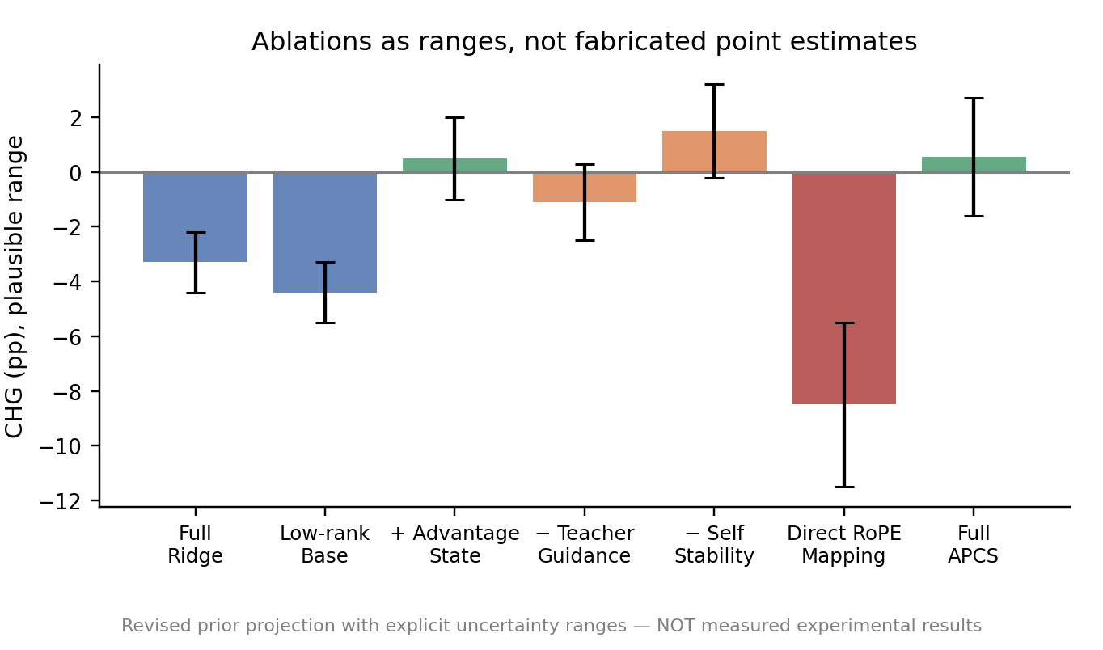
Figure 6: Key ablations and mapper budget.

8 Analysis and Discussion

8.1 Where Does Teacher Advantage Live?
If CHG is consistently positive, the most important analysis is not the raw accuracy delta but whether TGRR exhibits reproducible structure across teacher gap, layer/head, task type, and context length. Concentrated contribution from particular subspaces would support the empirical hypothesis that part of teacher advantage is present in runtime-transferable state. This should not be over-interpreted: the result would not imply that KV cache is equivalent to cognition or that model knowledge can be fully externalized from the weights.

8.2 Negative Results and Direction Asymmetry
Large-to-small transfer may be intrinsically more difficult than small-to-large transfer because the student can have insufficient representational capacity or incompatible attention geometry for teacher-specific state. If CHG≤0 while replacement retention remains high, an important conclusion is that cross-model state compatibility does not imply capability transfer. If capability transfer appears only for certain pairs, the representational geometry that predicts directional success becomes a mechanism result in its own right.

8.3 Systems and Security Boundaries
PSR claims apply primarily when the teacher cache already exists because of an upstream task. If the teacher is run solely to create transferable state, teacher prefill must be included and the reuse break-even point reported. Persisted KV state may encode sensitive information about the original context; productionization therefore requires cache lifecycle controls, access isolation, encryption at rest/in transit, minimization of persisted state, and verifiable deletion.

9 Limitations
First, the minimal-resource stage focuses on matched-KV pairs within one model family and does not establish cross-family or mismatched-head transfer. Second, even if CHG>0, it only shows that the student can consume part of the teacher's context-conditioned runtime advantage on evaluated tasks; it does not imply general knowledge or reasoning capability has been fully transferred. Third, systems benefits depend on cache residency, CPU–GPU bandwidth, batching, and attention implementation, making full end-to-end accounting mandatory. Fourth, a teacher can be wrong, so advantage injection requires stability constraints and fallback mechanisms. Finally, domain shift, multi-turn drift, and very long contexts require larger-scale evaluation.

10 Conclusion
We study whether a weaker student can skip full prefill of the original context, consume only a stronger teacher's runtime state, and inherit part of the teacher's task advantage. The present version contains pre-experimental priors rather than measured conclusions, and — following the reporting convention introduced in Section 6.0 — we state them as ranges rather than fabricated point estimates. We expect cross-model ridge to support roughly 90–96% replacement fidelity but not positive CHG by itself; if APCS truly preserves teacher-only usable state, the first Qwen3-4B→1.7B signal is more plausibly a modest CHG in the neighborhood of −1.5 to +3 pp than a confident large jump, a range that does not exclude zero, with the balance of evidence shifting toward positive and growing as the teacher gap widens. On a single GPU with sequential residency, the handoff break-even is projected to emerge somewhere around 4K–8K rather than at short contexts, and possibly later if mapping cost scales with sequence length. The final paper will claim Runtime Capability Transfer only if frozen-test experiments establish CHG>0 with a confidence interval excluding zero, consistently positive TGRR, and PSR>0; otherwise it will pivot honestly to Efficient State Handoff or to the boundary result that state compatibility does not imply capability transfer.

Ethics, Security, and Reproducibility
Ethics and security. The research does not require collection of personal data. If real operational contexts are later used, data classification, de-identification, and KV-cache lifecycle controls are required. We will report negative results, all seeds, and full frozen test sets rather than selecting examples to manufacture positive CHG.
Reproducibility. The final artifact should pin model commits, tokenizer, dtype, attention implementation, RoPE configuration, cache layout, random seeds, hardware, and context lengths. Each run should preserve configuration, metrics, system measurements, and logs.
AI use statement (update before submission). Generative AI was used in preparing this manuscript draft for structural planning, language drafting, and formatting. The authors remain responsible for experimental decisions, code validation, data analysis, result interpretation, reference verification, and all final scientific claims. This statement must be updated to match actual usage and the ICLR policy in force at submission time.

References
Vaswani, A., Shazeer, N., Parmar, N., et al. Attention Is All You Need. NeurIPS, 2017.
Dao, T., Fu, D. Y., Ermon, S., Rudra, A., & Ré, C. FlashAttention: Fast and Memory-Efficient Exact Attention with IO-Awareness. NeurIPS, 2022.
Dao, T. FlashAttention-2: Faster Attention with Better Parallelism and Work Partitioning. ICLR, 2024.
Kwon, W., Li, Z., Zhuang, S., et al. Efficient Memory Management for Large Language Model Serving with PagedAttention. SOSP, 2023.
Qin, R., Li, Z., He, W., et al. Mooncake: Trading More Storage for Less Computation—A KVCache-Centric Architecture for Serving LLM Chatbot. FAST, 2025.
Cheng, Y., Liu, Y., Yao, J., et al. LMCache: An Efficient KV Cache Layer for Enterprise-Scale LLM Inference. arXiv:2510.09665, 2025.
Heo, T., Shafipour, R., Zhao, R., et al. Cross-Model KV Cache Transfer in LLM Families: A Closed-Form Linear Mapping for Prefill Reuse. arXiv:2608.03893, 2026.
Fu, T., Min, Z., Zhang, H., et al. Cache-to-Cache: Direct Semantic Communication Between Large Language Models. ICLR, 2026.
Dery, L. M., Yahav, Z., Prior, H., Feng, Q., Shen, J., & Szlam, A. Latent Space Communication via K-V Cache Alignment. arXiv:2601.06123, 2026.
Rossi, M., Raghunath, P., & Wu, E. Latent Cache Flow: Model-to-Model Communication Without Text. ICML, 2026.
Liu, Y., Huang, Y., Yao, J., et al. DroidSpeak: KV Cache Sharing Across Fine-tuned Model Variants. NSDI, 2026.
Woo, S., Kil, J., Kim, H., et al. ICaRus: Identical Cache Reuse for Efficient Multi-Model Inference. ICLR, 2026.
Woo, S., Kim, H., Shim, S., et al. PrefillShare: A Shared Prefill Module for KV Reuse in Multi-LLM Disaggregated Serving. arXiv:2602.12029, 2026.
Kuzina, A., Pioro, M., & Ehteshami Bejnordi, B. KaVa: Latent Reasoning via Compressed KV-Cache Distillation. ICLR, 2026.
Liang, S., Wang, Z., Chujiajia, Xia, P., Zang, H., & Zhou, D. When KV Cache Reuse Fails in Multi-Agent Systems: Cross-Candidate Interaction is Crucial for LLM Judges. ACL, 2026.
Yang, A., Li, A., Yang, B., et al. Qwen3 Technical Report. arXiv:2505.09388, 2025.
Bai, Y., Lv, X., Zhang, J., et al. LongBench: A Bilingual, Multitask Benchmark for Long Context Understanding. arXiv:2308.14508, 2023.
Hsieh, C.-P., Sun, S., Kriman, S., et al. RULER: What's the Real Context Size of Your Long-Context Language Models? arXiv:2404.06654, 2024.
Chen, Z., Wu, X., Jia, J., et al. LongBench Pro: A More Realistic and Comprehensive Bilingual Long-Context Evaluation Benchmark. arXiv:2601.02872, 2026.

Appendix A: Result Completion Checklist
• Main table with at least two large-to-small pairs and full-test Student/Teacher/Ridge/APCS results.
• Figure 1: PCR–Retention, establishing mapper-budget/compatibility trade-off.
• Figure 2: Teacher Gap–CHG/TGRR, supporting or falsifying runtime-advantage transfer.
• Figure 3: CHG/TGRR–PSR Pareto frontier as the primary paper figure.
• Figure 4: context-length scaling with absolute latency decomposition.
• Figure 5: multi-turn behavioral stability with KL/JCR/consistency.
• Ablations on rank/shared basis, advantage state, teacher guidance, self stability, de-RoPE, and top-k layers.

Appendix B: Offline Experiment and Agent Interface
The offline implementation should continue to follow the T00–T11 gated workflow established in the research plan: T00 Compatibility Scanner → T01 Self-KV Replay → T02 RoPE → T03 Layer Alignment → T04 Ridge → T05 Replacement → T06 Lightweight Mapper → T07 Teacher Gap → T08 Advantage State → T09 CHG/TGRR → T10 PSR → T11 MVP Decision. A failed gate must block downstream claims so that every paper result is traceable to a verified engineering stage.

