Valuation Project 2: Stochastic Volatility
Due Monday, 6 October, 2025
(This is a group assignment. Groups may have up to 3 members.)

The assignment is to: (a) calibrate a Heston stochastic model to market options data on SPX instrument (b) use your model to price a straightforward exotic product and (c) prepare a short written report documenting your calibration procedure, implementation of the valuation model how and your result compares to a standard method of valuation such as seen in FIN 512. Your valuation model and documentation must be completed by the deadline.

Grading will be based on both the calibration procedure, and how well you carry out the implementation of the valuation model.

Data Collection

Thus far we have only developed a semi-analytic formula for pricing European style options with the Heston model. So, for ease of calibration we are limited to underlying assets with market prices of European options. We will select our underlying asset to be the S&P 500 index (SPX) and we will also price an SPX product:

https://www.sec.gov/Archives/edgar/data/1682472/000191870425014438/form424b2.htm

Bloomberg have detailed option prices via the OMON command where (if you ask nicely) you can observe the prices of options with ALL strikes and all maturities. Annoyingly, Bloomberg limit us to only current option prices (the historical prices provided are very limited – especially if we want to do a calibration).

So, we will have to use this current data for our calibration:

- Go to Bloomberg, preferably at some point after 12pm, download ATM SPX option prices at all maturities. Alternatively, get the ATM implied volatilities from OVDV. This is Data Set 1.
Also you will want Forward Prices at all of these maturities (OVDV has these) as this will save bother later.
From this data, remove all quotes with low volume, I would say below 10 and definitely all options with 0 bid.
- At a very similar time (within a 10 minute window preferably), download ALL option prices on SPX with maturity, 19 December, 2025 and 20 March 2026. You will want to change the strikes to ‘ALL’ and set the maturity at the top left of the OMON page. This is Data set 2.
From this data, remove all quotes with low volume, I would say below 10 and definitely all options with 0 bid.
- Additionally download a more limited data set (25 strikes perhaps?) at ALL quarterly maturities until Dec 2029: i.e. Mar 2026, Jun 2026, Sep 2026, Dec 2026,…, Dec 2029. This is Data Set 3.

Calibration

- Starting with data set 1, we are going to come up with a first guess of v₀, κ and θ. Set v₀ to be the shortest ATM variance (do not change this), θ (initially only) to be the longest dated one (Dec 2029), then we can fit κ and θ to the known expectation of future variance:

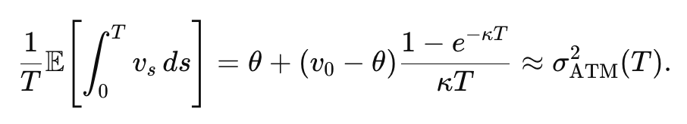
You have the ATM vols and so you can find the κ and θ values that fits these ATM vols the best.
- For Data Set 2. Record the midpoint of the bid and ask as your price (last price can be stale especially for reasonably low volumes. Actually, if you use the implied vols that’s probably easiest.
- You can decide what to do with put options, you can either have your calibration work just on call prices (you can convert via put call parity) or use both call and put prices (and have Heston price puts via put-call parity). Again, using the implied vols is probably easiest.
- Short dated options are best to set ρ. First, Using your κ, θ, and v₀ from data set 1 we need a first guess for the η value that comes from some ATM options (choose the same as those from Data Set 1) with ρ initially set to 0.
Additionally, there is a requirement on the link between η, k and theta – The Feller condition – that states 2κθ > η² that you may also have to deal with when getting η. (I have applied a soft penalty here, where λ_{F} is 10)

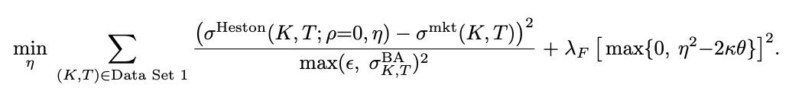

You can choose to do this by just minimizing the squared errors of prices (or better – vols) but usually you would scale these by dividing the squared errors by the bid ask spreads (as I have done) and (maybe even the vega of the option) squared. The epsilon is just to avoid dividing by really small amounts, so set ε = 0.0005)
- For ρ itself we are going to work with Data Set 2 for the first guess for ρ. Here we only have ρ to set and so we use (with $\hat{η}$ as the estimate from step 7 above):

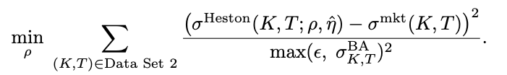

- Then go to the entire surface until December 2029 (Data Set 3). To begin with let’s just work with ρ and η. So keep the whole data set but keep κ, θ, and v₀ fixed to the levels in Step 4. Again still weight by the bid ask spread of implied vols. So that we are performing

- Finally with our best guesses now recorded perform another calibration to the whole of data set 3 by allowing all of your parameters to vary. You probably want to at least limit them to the range suggested in class but this would be the calibration:

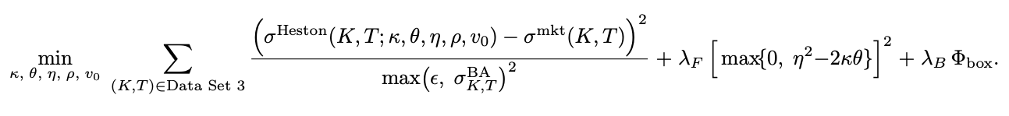
where

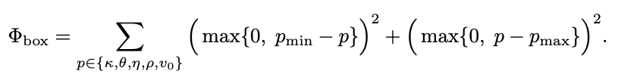
Stops parameters moving out of the range that you set (I’ll let you choose this).

Valuation

Now with your calibrated model let’s try to price something. Let’s take a contingent coupon, autocallable product:

https://www.sec.gov/Archives/edgar/data/1682472/000191870425014438/form424b2.htm

- In Project 2 in FIN 512 you valued something similar. Now you should retrieve that code (or use mine from canvas) and adapt to value the product above (using a binomial tree is probably easiest).
Annoyingly, we are now interested in its value at the time which you obtained your data(!) and so determine the value using your binomial tree at the exact time when you calibrated your Heston model.
- Finally, using Monte Carlo (or finite differences if you are amazingly brave) use your calibrated Heston model to value the same product (at the same date).
- Comment on how different your valuation is, it might be interesting to see how sensitive your valuation is to the different parameters in the Heston set up.

