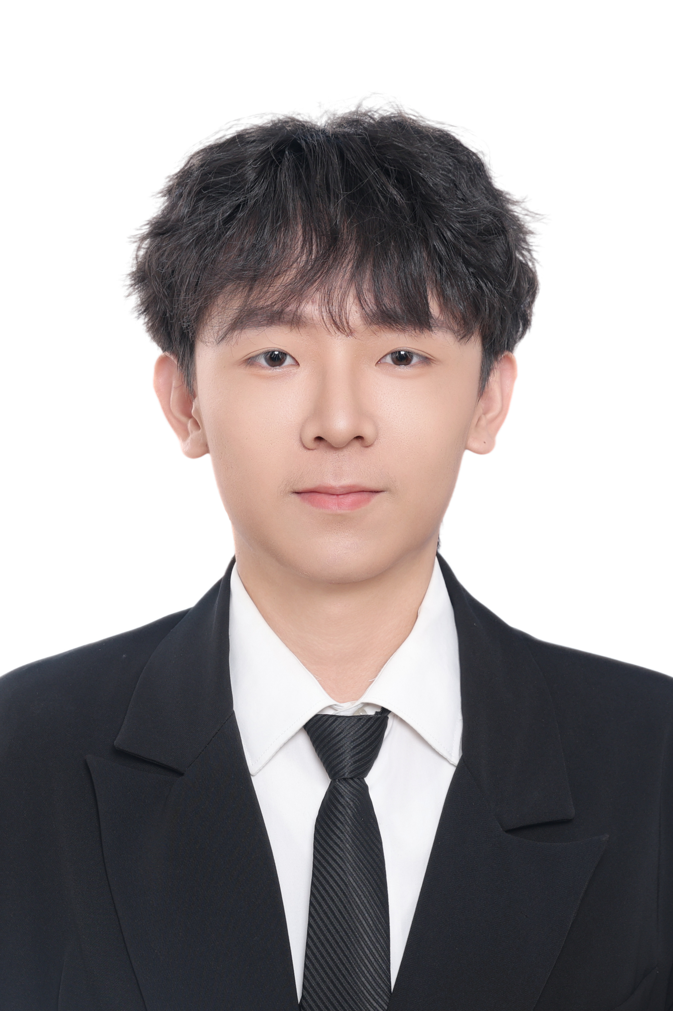
Su Zirui
Electronic Information Engineering Undergraduate
+86 15131997955 | 3073028s@student.gla.ac.uk
Electronic Information Engineering undergraduate seeking research internships and early-career engineering opportunities. Hands-on experience with Arduino-based laboratory automation and collaborative web development, with interests in embedded systems and applied AI.

Education
University of Electronic Science and Technology of China 2024 - Present
BEng in Electronic Information Engineering
Relevant study: programming, embedded systems, circuit analysis and electronic system design.

Research Experience
University of Glasgow Jul - Aug 2026
Summer Research Programme | Biomedical Laboratory Automation
Supervisor: Huabing Yin
- Programmed an Arduino to control a peristaltic pump for automated liquid transfer in a biomedical laboratory workflow.
- Connected the control hardware and carried out preliminary hardware testing; gained familiarity with the laboratory’s research directions and experimental workflows.
- Presented preliminary work in a final programme presentation; the full automation project remained incomplete at the end of the placement.

Industry Experience
UCloud Dec 2025 - Feb 2026
Intern | Innovation Product Department
- Supported front-end and back-end development for web-based projects within a collaborative product team.
- Assisted with webpage design, implementation and testing, gaining practical experience in product development and team delivery.

Technical Skills and Research Interests
Programming and hardware: C for basic embedded applications; Python fundamentals; Arduino programming, microcontroller experimentation and basic circuit knowledge.
Research interests: Applied AI, medical image analysis, computer vision, embodied intelligence and biomedical automation.
Tools and languages: Word, PowerPoint and Excel; native Mandarin Chinese; English for academic and working contexts, CET-4 and CET-6.

Leadership and Activities
- Class Monitor, UESTC (2024 - Present): coordinate class affairs, facilitate communication between teachers and students, and support group organisation.
- Student Society Lead: led the college’s UK-affiliated student society and organised events including Halloween and Christmas celebrations, evening parties and a ceilidh.
- Core Member, Youth Volunteer Association: helped plan and support student volunteer and community service activities.
- Blue Heart Social Practice Team (2025): contributed to activity planning and on-site organisation; the team received provincial-level outstanding social practice recognition.

Honours
Leadership Scholarship | All-round Development Scholarship

