**B. 理組情侶的密碼**

(Time Limit: 1 sec, Memory Limit: 512 MB)

**Description**

這題要您定義念數字串的方式。把它分成數組，使每組都是連續一樣的數字。接著對於每一組，先說字組的數量，再說是甚麼字符。要將這句話轉換為數字串，請先從1開始。

(1). count-and-say(1) = 1

(2). count-and-say(n)是count-and-say(n-1)念的方式

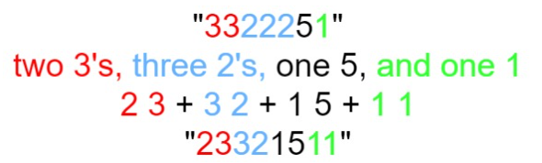

**Sample Input/Output**

輸入一整數n (1 ≤ n ≤ 30)，輸出其密碼。

|  |  |
| --- | --- |
| **Sample Input #1** | **Sample output #1** |
| 1 | 1 |
| **Sample Input #2** | **Sample output #2** |
| 4 | 1211 |

#1說明 : n=1 => count-and-say(1) = "1"

#2說明 : n=4 => count-and-say(1) = "1"

count-and-say(2) = say "1" = "11"

count-and-say(3) = say "11" = "21"

count-and-say(4) = say "21" = "1211"