100001-700001
- http://www.360buy.com/product/34.html
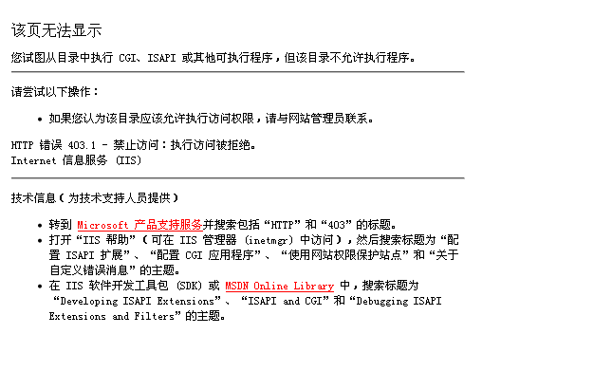
<TITLE>该页无法显示</TITLE>

