CMPT 383
professor: Greg Baker
Assignment 2
Name: Xuetian Wu

Introduction
Scala is one of the most popular multi-purpose programming languages. The name “Scala” means “scalable language”. The reason why the language is named this way is because Scala is a concise, high level language that combines properptis of both object-oriented and funtional programming languages. It was designed to grow with the demands of its users and achieve a variety of programming tasks that inludes writing short scripts to building large systems. Scala is purely object-oriented bebause of the property that every value is an object and every operation is a method call. Furthermore, Scala’s traits - like interfaces in Java, but they can also have method implementations and even fields makes scala more advanced when it comes to composing objects.

Scala is easy to get hands on and most collection problems can be solved in a couple of operations within 20 to 50 methods, with complex looping structure or recursions barely used. Its source code is compiled to Java bytecode, therefore, It can run on the Java virtual machine and is compatible with Java applications, achieves seamless interaction with Java. So that the programs written in Scala are able to utilize Java Virtual machine.
It’s quite a good language for writing scripts that pull together Java components. But it can apply its strengths even more when used for building large systems and frameworks
of reusable components.

Scala is also a “safe” language. For programmers who has some experience, it is obvious that because Scala is statically typed and functional, most of errors programmers make are caught at compile time. Besides, because collection operations are tuned and optimized in the libraries Scala is considered fast and efficient. Programmer can write faster code with carefully hand-tuned data structures and operations.

Type System

Built-in types:
Scala’s basic types and operators is similar to Java. According to figure 1 below, we found out that Any is the top class. Any is the supertype of all other types, it is also called top type. It includes certain universal methods including toString, equals, hashCode. AnyVal amd AmyRef are the only two direct subclasses of Any. AnyVal is the group of value types. There are nine predefined value types and they are non-nullable: Double, Float, Long, Int, Short, Unit, StringOps, Char, Boolean, Byte. There is only one value of type Unit, (), and it is not represented by any object in the underlying runtime system. A method with return type Unit is analogous to void method in Java.
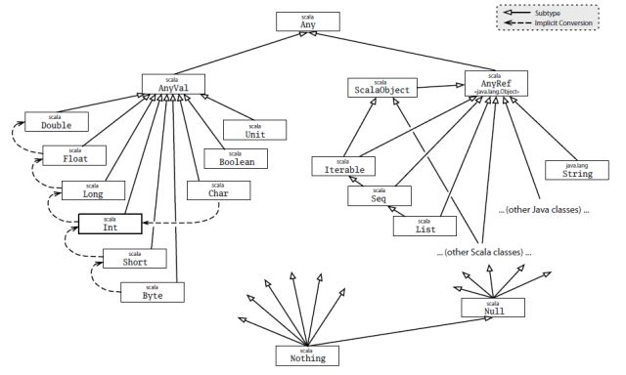
AnyRef is reference type. All non-values are defined under reference type. Every user-defined class type in Scala is a subtype of AnyRef. Anyref is analogous to java.lang.Object type in Java used under Java runtime environment.

figure 1: Basic Types in Scala:
Objects:
As I mentioned in the introduction section, Scala is object-oriented like Python, Java, C++ which mean that the language is based on Class and object, and we can define fields and methods. According to the example below, In this class, contents is declared as a method that has no implementation. In other words, the method is an abstract member of class Element . The height method returns the number of lines in contents . The width method returns the length of the first line. “new Element ” cannot be used for this because class Element is abstract. Class ArrayElement is defined to extend class Element. Class ArrayElement is called a subclass of class Element. Conversely, Element is a superclass of ArrayElement

abstract class Element {
def contents: Array[String]
def height: Int = contents.length
def width: Int = if (height == 0) 0 else contents(0).length
}
class ArrayElement(conts: Array[String]) extends Element {
def contents: Array[String] = conts
}

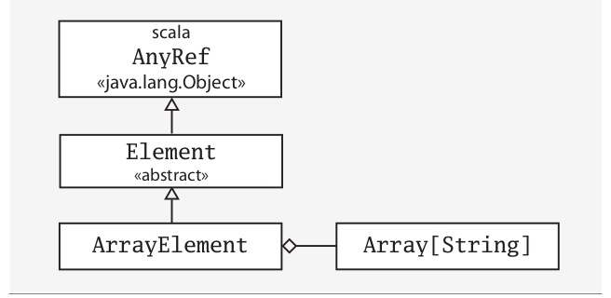

In Scala, fields and methods belong to the same namespace. This makes it possible for a field to override a parameterless method. I could change the implementation of contents in class ArrayElement from a method to a field without having to modify the abstract method definition of contents in class Element , as shown. Also, the The ArrayElement class uses the override keyword to override the methods and fields from base class Element. Note that Scala supports single inheritance, not multiple inheritance.
class ArrayElement(conts: Array[String]) extends Element {
val contents: Array[String] = conts
override def height: Int = contents.length
}
Apart from that, static members do not exist in classes of Scala. Instead, we could define singleton objects. When a singleton object shares the same name with a class, it is called that class’s companion object. They can access each other's private members and Scala is more than Java.
Type system features:
Scala is strong typing because values are explicitly statically typed. The type in every variable and expression within Scala program is already known at compile time. The possible values to which a variable can refer, or an expression can produce at run time is constraint by type. A variable or expression’s type can also be referred to as a static type if necessary to differentiate it from an object’s runtime type. In other words, “type” by itself means static type. When programmer pass a value as a parameter to a method that needs parameter of another type, compiler will generate error and will not compile the programm. There is no possibility of an unchecked runtime type error. Therfore, The statically typed and functional nature of Scala’s collections means that the overwhelming majority of errors you might make are caught at compile-time, which made Scala a safe language. C and Java are also mostly strongly typed because values are explicitly statically typed, but pointer/reference casting allows the programmer to do weakly-typed things.

Memory Management
The memroy management in Scala is very similar to Java because Scala is also compiled to Java bytecode and and runs on Java virtual machine. In Java or Scala, the programmer need not to worry about all the objects which are no longer in use becuase Garbage collector exisits on both languages and it destroys the objects for the programmer. In C,C++, programmer is responsible for both creating and destroying objects. If a program fails to free a memory occupied by objects that have become unreachable, it will cause memory leaks. The compilation process for a JVM application is not the same as that of a statically compiled language. On most modern JVMs, once the program bytecode is run, it is converted into machine code for the computer architecture on which it is being run. This is called the just-in-time compilation. The JVM loads the code, verifies the code, executes the code, manages memory (this includes allocating memory from the Operating System (OS), managing Java allocation including heap compaction and removal of garbage objects) and finally provides the runtime environment.
Java memory is divided into three parts: Heap Memory, Non-Heap Memory, and Other
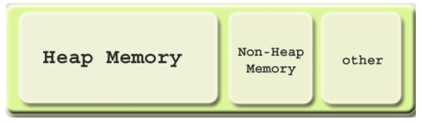
Heap has dynamically allocated objects and at any given time, some parts of the heap are in use, while some are "free" (unused) and thus available for future allocations. Non-Heap memory stores runtime constant pools, field and method data. Others has JVM code itself.
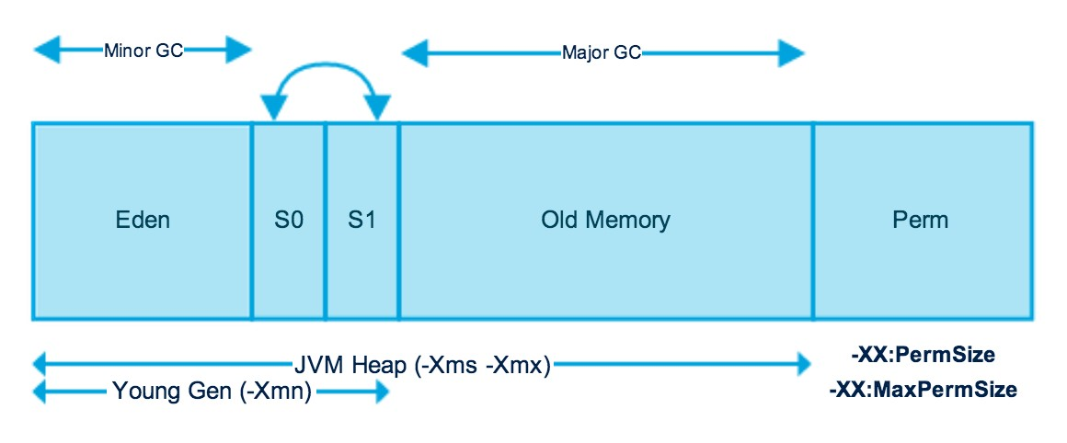
JVM heap is also devided into two parts : nursery(young) space and old space. Newly allocated objects are located in the Eden Memory space. A young collection is designed to be swift at finding newly allocated objects that are still alive and moving them away from the nursery. Perm region has metadata that JVM needs. It contains classes and method used in the application.

Other Interesting Features
Scala is a powerful language that have diferent features: Immutability, Lazy computation,Type inference, Singleton object, Pattern matching, Concurrency control, String interpolation, Higher order function, Traits, Rich collection set etc.
Type Inference: Scala automaticly detects types of expression.
val message = "hello"
In this case, the compiler looks at the right hand side and finds out it is string. Therefore the type of message must also be String. The compiler will write a complete value defination for us.
val x = 2 val y = x + "item"
In this example above, we have two values x and y for which we have not specified any type and the compiler is able to progressively determine the type for programmer.
def succ(x: Int) = x + 1
The compiler is also able to figure out the return type of functions by looking at their implementations in this case, the return type of function scc is int

Singleton object: In scala, there are no static variables or methods. Instead, it uses singleton onject. Note that singleton object is decleared by using object.
object Person extends App { // type + its only instance }
val person1 = Person
val person2 = Person
In the example aove, Person is the only object. “person1” and “person2” are both refering to the same instance which is Person.

Concurrency control is an interesting feature for Scala. Scala has standard library and one more platfrom and tool to deal with concurrency. Specifically, it’s simpler to implement concurrency in Scala over C++/C/Java and also the code is very efficient, safe and simple. Along with the property of immutability, Scala helps achieving safety and efficiency in concurrency by providing a integrated concurrency libraries and frameworks.

Traits is another feature in Scala
In Scala, trait is a collection of abstract and non-abstract methods. You can create trait that can have all abstract methods or some abstract and some non-abstract methods.
trait Equal {
def isEqual(x: Any): Boolean
def isNotEqual(x: Any): Boolean = !isEqual(x)
}
class Point(xc: Int, yc: Int) extends Equal {
var x: Int = xc
var y: Int = yc
def isEqual(obj: Any) = obj.isInstanceOf[Point] && obj.asInstanceOf[Point].x == y
}
object Demo {
def main(args: Array[String]) {
val p1 = new Point(2, 3)
val p2 = new Point(2, 4)
val p3 = new Point(3, 3)
println(p1.isNotEqual(p2))
println(p1.isNotEqual(p3))
println(p1.isNotEqual(2))
}
}
This trait has two methods isEqual and isNotEqual. Here, we have not implementated isEqual whereas another method isNotEqual has its implementation. Child classes Point extends a trait, and it implemente for the un-implemented methods which isisEqual in this case. So a trait is very similar to what we have abstract classes in Java. Other than the a couple of features mentioned, there are also interesting features including Set of Collection, Lazy Computation, Case classes, Pattern matching.

Comparison with Other Languages
Compared with Java, Scala has several advantages and they have many differences. First of all, the structure consists of one method called main which takes the command line arguments, an array of strings as parameter. The “main” method is in the declaration of object, which introduces singleton object, that is a class with a single instance. To compile code written in Scala, we use the Scala compiler-scala. scala works like other compilers, which takes a source file and produces one Java class files which can ben be directly excuted using scala command. Its usage is very similar to running Java program.
Besides, Scala is a pure object-oriented language in the sense that everything is an object, including values and variables and functions. On the other hand, Java, however, has primitive types that includes boolean, byte, char, short, int, long, float anddouble. (such as boolean and int) from reference types, and does not enable one to manipulate functions as values. These types serve as the building blocks of data manipulation in Java. Such types are only used as values. Because these data types are defined into the Java type system by default, they come with a number of operations predefined. Perhaps more surprisingly, functions are also objects in Scala. Therefore we can pass functions as arguments, use them in variables and get returned from other functions. The ability to manipulate functions as value is one of the features of functional programming. The Classes in Scala are declared using a syntax which is close to Java. An obvious difference is that classes in Scala can have parameters.
Scala does not the only attempt to create a “better Java”. Scala is not the only attempt to create a “better Java”. But they made the fundamental decision to remain very close in syntax to the Java language itself, so as to minimize the learning curve.

Conclusion
It must be admitted that “Scala is hard”, but learning curve is well worth the investment. Tuples, Functions, Macros, chich are the more complicated feaatures of the language makes it easier for the developer to write better code and increase performance by programming in Scala. Scala is a type-safe JVM language that incorporates both object oriented and functional programming into an extremely concise, logical, and very powerful language. Scala is not the only attempt to create a “better Java”. Alternatives like Ceylon and Kotlin have also gone down that way, and they made the decision of keeping similar syntax with Java language itself in order to minimize the learning curve.
Scala was created specifically for the goal of creating a better language, taking away those aspects of Java which is considered tedious, frustrating or restrictive. As a result, there must be some distinctions and paradigm shifts that make it diffifult to learn Scala. But, Scala is a much cleaner and well-organzied language that is easier to use and increases productivity.

