CITI TECHNOLOGY HACKATHON 2018

Financial Planning of Real Estate

**Smart Evaluator Report**



**GROUP MEMBERS**

*Xu Hong G1518135X*

*Du Li G1530938K*

*Huang Xiangyuan G1516710L*

**[10/09/2018]**

1. Summary

Smart Evaluator is an online web application, which helps home buyers analyze their financial situation and eligibility to suggest suitable houses to them based on users’ savings, monthly expense, monthly income and age.

**Assumption:**

1. Our home property type is limited to condo.
2. We exclude CPF saving as the input for users but just savings as general.
3. We only collect house data from 99.co website.
4. We only consider age, saving, monthly income and monthly expense as factors to analyse users’ eligibility and affordability to buy the house.

**Solution:**

We use JSF web application, Java, Netbeans, Python and web scraping as framework and programming language to solve this task.

Our whole solution is divided into client-end part and server-end part. There are two data entities, house and home buyer. Here is the entity relation diagram.

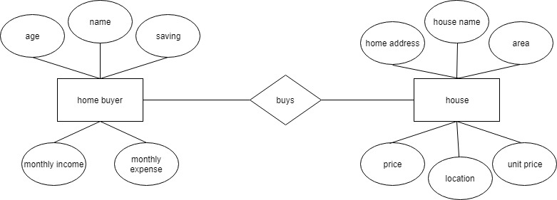

When the program is deployed, the server end will use the web scraping to get all condos information from the website and keep it inside the local storage.

A website about Singapore condo information is targeted for web scraping. Selenium driver on Google is used to conduct website traversal and redirection and classic BeautifulSoup is used to locate elements and get information about each condo. Eventually, information about 30k condos are scraped in order to provide user with sufficient source.

In the client end, we ask the user to enter in name, age, savings, monthly income and monthly expenses as their personal information.

Upon the user click on the “Explore” button, the server end will get the user info.

We have a formula to calculate how much loan the person can get based on his saving, age and monthly income. Also integrated on this person’s other information, we can analyze his financial situation and find them most suitable house from the house information keeped in local storage.

The algorithm used to estimate the condos that one person can afford is as follows.

The house must have a price below 0.8*(personal savings+ total amount of loan he/she can apply). Personal savings are collected directly from the user and the total amount of loan is calculated according to regression analysis.

Another web scraping session is conducted on a loan calculator. The total amount of housing loan that one person can apply for is determined by his/her age, personal savings, monthly income and monthly living expenses. Thousands of trial data is imported into the online loan calculator and the results, which are the amount of data each person can apply for are collected. Thus, a formula to calculate one’s loan that he/she can apply for is created based on regression analysis with an accuracy of 95.7%.

**Technology stack:**

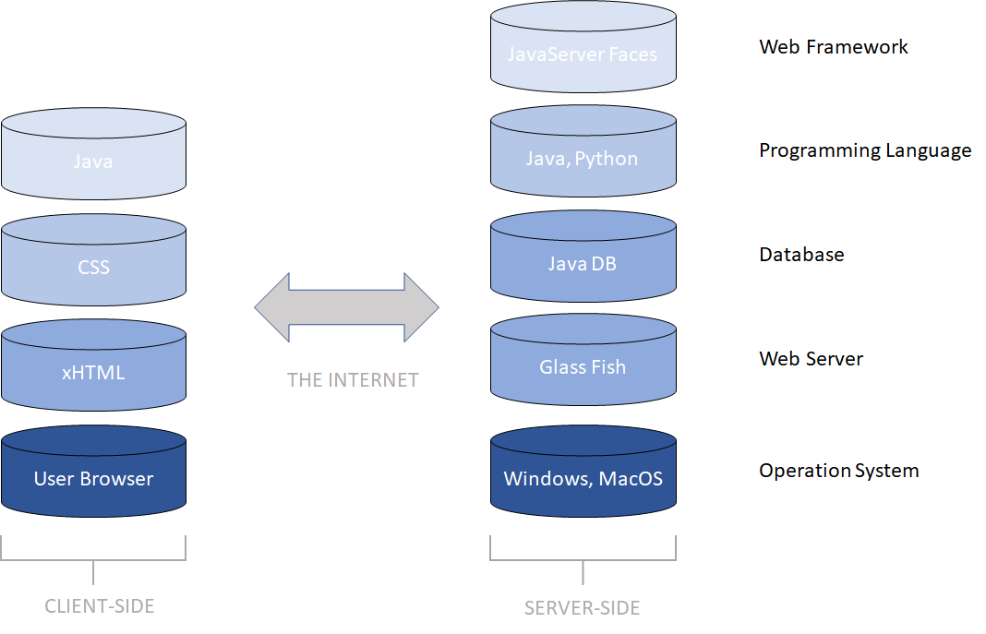

We have two main pages in this web application, which are home page and house suggestion page.

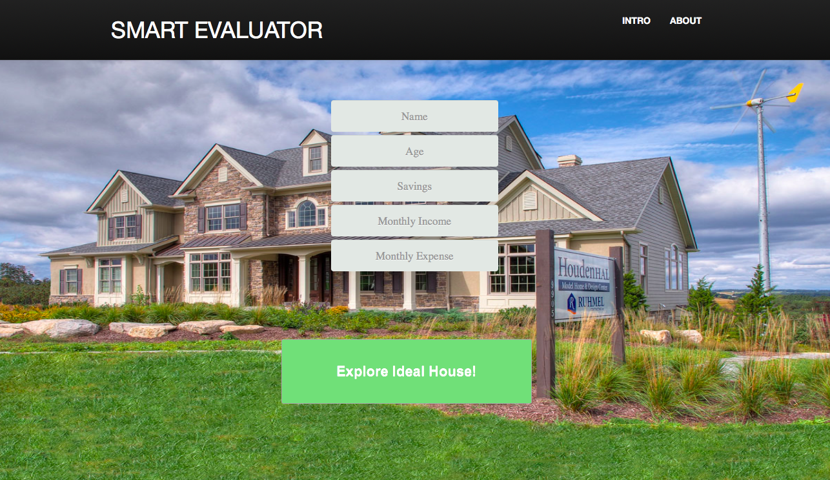

*Figure 1.1: Home Page Part 1*



*Figure 1.2: Home Page Part 2*



*Figure 1.3: Home Page Part 3*

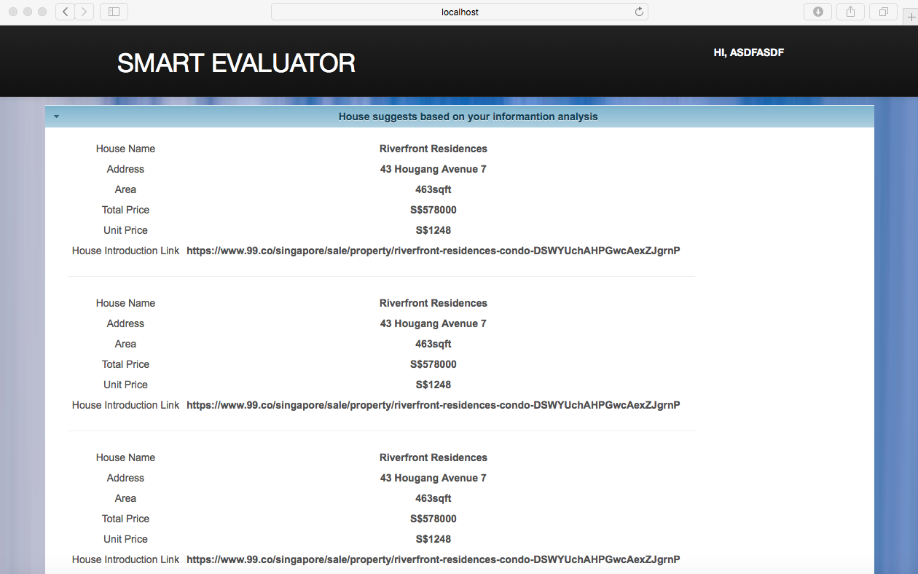

*Figure 1.4: House Suggestion Page*

2. Application architecture diagram

Smart Evaluator is a JSF web application, which follows the below architecture. However, due to time limitation, we have not yet finish setting the database and alternatively uses Microsoft Excel to store house data for the moment.

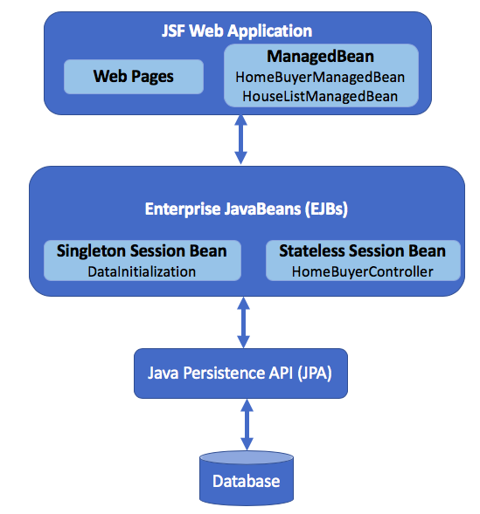

*Figure 2.1: High-level Architecture Diagram of SmartEvaluator*

3. Detailed instructions on how to set up your solution

* Open the source code in github using netbean IDE. (preferrably 8.2 version)
* Click on the two Java EE modules to open them (“Inside Netbeans project navigation bar, there is a folder named “Java EE modules”)
* Import Jar files

1) import jxl-2.6.12.jar into SmartEvaluator-ejb module.

2) import the rest of 5 jar packages (“redmond-1.0.10.jar”, “xmlbeans-2.6.0.jar”, “itext-2.1.7.jar”, “poi-3.7.jar”, “primefaces-6.1-jar”) into SmartEvaluator-war module.

* Open Service window, start GlassFish server
* Change Excel file absolute path in dataInitilizaiton.java line 57.
* Right click the project directory to build the project.
* Right click the project directory to deploy the project.
* Go to localhost:8080/SmartEvaluator-war and start inputting your information!

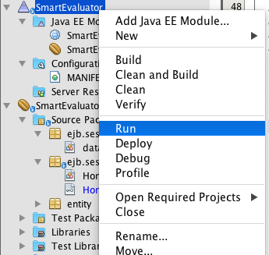

4. Git repository details

URL: https://github.com/hxy0229/SmartEvaluator

All summaries and diagrams are in projectDetails.docx.

webScraping.py is the web scraping code.

housingInfo.xls is the collected houses information.

SmartEvaluator-ejb contains server-end codes.

SmartEvaluator-war contains client-end codes.