SDA_in SCL_in
Connect to I2C Bus

addr_match/bit_send
(1) Receive from local comparator.
(2) Once the address match is complete, this input is ignored for the rest of the transmission.
(3) For slave is a transmitter, this input is called bit_send. This input is used to provide serial data bits to the controller.

byte_done
(1) Receive from local counter. Monitor SCL.
(2) Generate ‘1’ when receive 1 Byte at appropriate time.
(3) Asserted high just before the ACK symbol needs to transmit.

SDA_en/SDA_out
(1) When the slave drive the SDA bus.

data_out
(1) Slave is receiver.
(2) Output the data in I2C bus received.

addr_out
(1) Output address received from I2C bus.

Master control:
(1) ‘S’
(2) ‘P’
Slave Receiving: asserted after ACK from slave
Slave Transmitting: no ACK but P as the last byte
(3) 7-bit Address + R/W
(4) SCL

Slave control:
(1) ‘ACK’ for 7-bit Address

Transmitter control:
(1) Byte of data

Receiver control:
(1) ACK for data (ACK is low at entire next clock/Immediately after receive the 8th bit)

(d) Some of key points of our design
(1) Slave act as receiver

A diagram of time sequence table is attached with the documents.
(2) Slave act as sender

A diagram of time sequence table is attached with the documents.
slave receiver
(i)
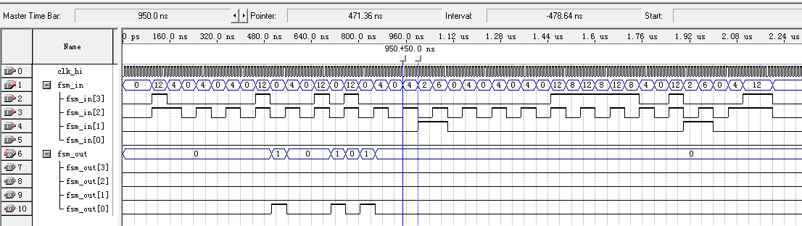

(ii)
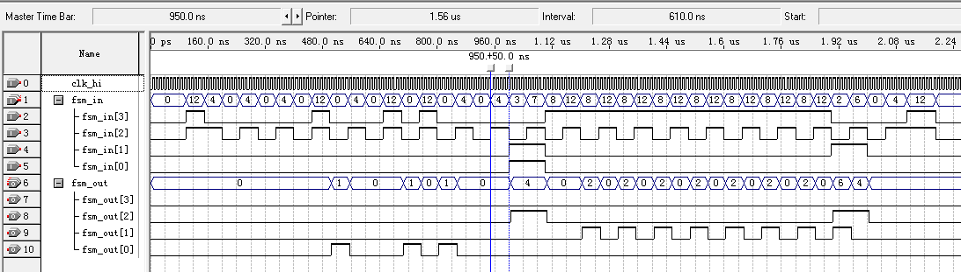

(iii)
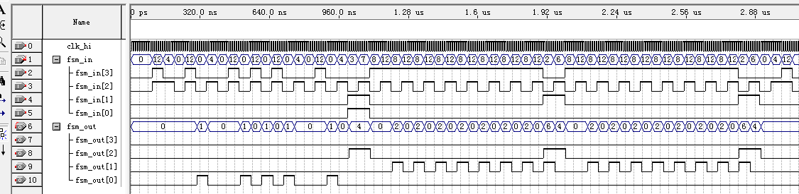

Slave as transmitter
(iv)
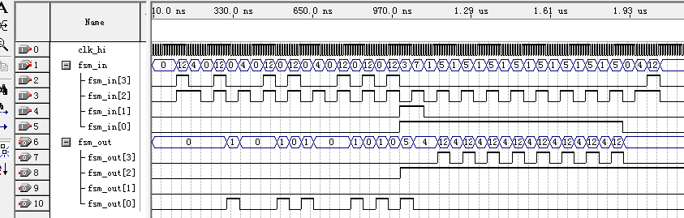

(v)
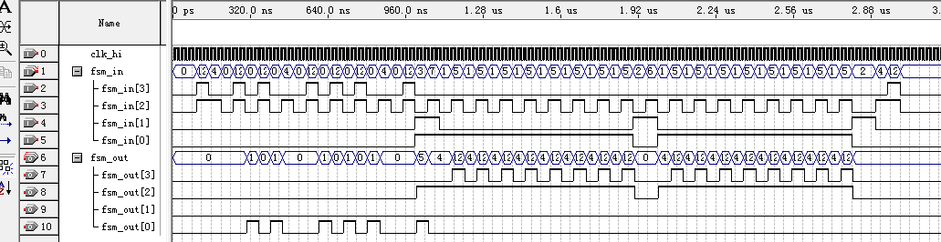

(vi) The signal diagram below shows our FSM can handle unexpected stop signal during data transmission. (Master to slave)
