# 一、数据描述

1 自变量：58（C1 – C58）；因变量：3（D1 – D3）

2 样本量：1656。无缺失值。

# 二、不限定个数的因素分析

## 1 KMO 和 Bartlett 的检验

|  |  |  |
| --- | --- | --- |
| KMO 和 Bartlett 的检验 | | |
| 取样足够度的 Kaiser-Meyer-Olkin 度量。 | | .978 |
| Bartlett 的球形度检验 | 近似卡方 | 36263.324 |
| df | 1653 |
| Sig. | 0.000 |

该问卷适合做因素分析。

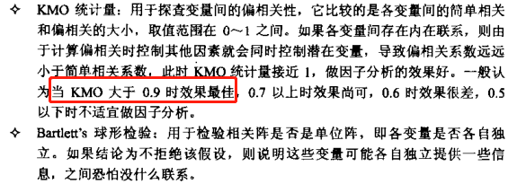

## 2 解释的总方差

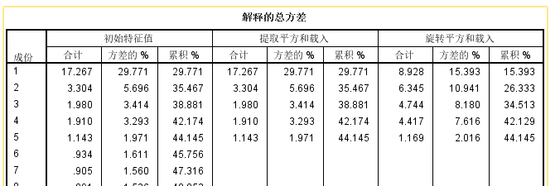

## 3 旋转后成分矩阵

**放到Excel里面看**

|  |  |  |  |  |  |
| --- | --- | --- | --- | --- | --- |
|  | 成份 | | | | |
| 1 | 2 | 3 | 4 | 5 |
| C26 | .687 | -.016 | .131 | .106 | .038 |
| C37 | .646 | .066 | .101 | .183 | .083 |
| C27 | .644 | .021 | .147 | .197 | .111 |
| C14 | .637 | .034 | .155 | .155 | -.037 |
| C28 | .629 | .068 | .075 | .179 | -.062 |
| C42 | .624 | .046 | .159 | .199 | .096 |
| C31 | .611 | .093 | .108 | .186 | .044 |
| C45 | .604 | .107 | .170 | .181 | -.130 |
| C40 | .580 | .216 | .148 | .109 | -.176 |
| C35 | .574 | .128 | .149 | .146 | -.180 |
| C30 | .572 | .117 | .205 | .174 | .115 |
| C29 | .562 | .176 | .157 | .152 | .013 |
| C41 | .550 | .258 | .113 | .138 | -.202 |
| C48 | .532 | .259 | .154 | .193 | .011 |
| C15 | .521 | .190 | .216 | .137 | .113 |
| C38 | .512 | .235 | .142 | .183 | .125 |
| C32 | .507 | .323 | .203 | .127 | .171 |
| C36 | .507 | .207 | .225 | .153 | -.088 |
| C13 | .473 | .321 | .170 | .165 | .053 |
| C43 | .458 | .326 | .193 | .206 | .009 |
| C33 | .447 | .348 | .163 | .193 | -.005 |
| C39 | .446 | .360 | .182 | .097 | -.280 |
| C18 | .440 | .316 | .163 | .139 | .167 |
| C44 | .403 | .325 | .165 | .189 | .044 |
| C19 | .056 | .698 | .155 | .112 | -.069 |
| C20 | .046 | .695 | .168 | .100 | -.115 |
| C25 | .166 | .642 | .159 | .099 | -.132 |
| C24 | .118 | .635 | .189 | .123 | -.178 |
| C23 | .122 | .627 | .121 | .154 | .227 |
| C46 | .137 | .600 | .165 | .146 | .318 |
| C21 | .221 | .596 | .184 | .141 | .096 |
| C16 | .246 | .572 | .236 | .125 | .000 |
| C22 | .222 | .567 | .194 | .166 | .063 |
| C47 | .199 | .525 | .173 | .137 | .017 |
| C4 | -.018 | .464 | .076 | .359 | -.175 |
| C34 | .383 | .455 | .140 | .141 | .104 |
| C17 | .381 | .390 | .121 | .136 | .338 |
| C56 | .151 | .228 | .629 | .143 | -.060 |
| C53 | .286 | .086 | .613 | .195 | .010 |
| C51 | .242 | .173 | .609 | .156 | -.226 |
| C58 | .193 | .192 | .600 | .164 | .207 |
| C55 | .278 | .170 | .599 | .134 | .184 |
| C49 | .245 | .166 | .599 | .181 | -.131 |
| C50 | .174 | .262 | .594 | .143 | -.027 |
| C52 | .148 | .271 | .588 | .118 | -.145 |
| C54 | .235 | .178 | .564 | .220 | .113 |
| C57 | .204 | .329 | .561 | .080 | .151 |
| C11 | .237 | .123 | .130 | .562 | -.096 |
| C2 | .217 | .119 | .196 | .561 | -.154 |
| C6 | .218 | .142 | .128 | .559 | .133 |
| C12 | .247 | .068 | .141 | .553 | .080 |
| C9 | .300 | .020 | .103 | .552 | .156 |
| C7 | .201 | .126 | .103 | .552 | .114 |
| C5 | .128 | .228 | .157 | .541 | -.097 |
| C10 | .121 | .205 | .174 | .527 | -.309 |
| C1 | .282 | .069 | .139 | .527 | .124 |
| C8 | .165 | .273 | .143 | .500 | -.098 |
| C3 | .169 | .256 | .061 | .465 | .040 |

成分与题项对应。

## 4 碎石图

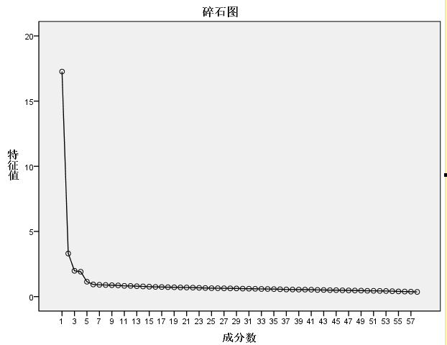

选择三个或四个成分。

# 三、限定三个因素的因素分析

## 1 KMO 和 Bartlett 的检验

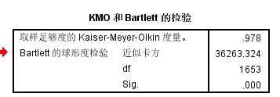

## 2 解释的总方差

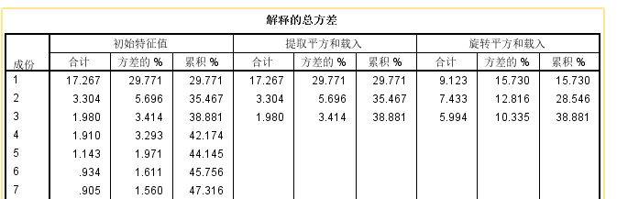

## 3 旋转后成分矩阵

**放到Excel里面看**

|  |  |  |  |
| --- | --- | --- | --- |
| **旋转成份矩阵a** | | | |
|  | 成份 | | |
| 1 | 2 | 3 |
| C26 | .690 | .010 | .149 |
| C27 | .655 | .044 | .226 |
| C37 | .654 | .074 | .191 |
| C14 | .635 | .059 | .207 |
| C42 | .634 | .071 | .233 |
| C28 | .623 | .067 | .188 |
| C31 | .615 | .102 | .199 |
| C45 | .593 | .130 | .242 |
| C30 | .585 | .155 | .227 |
| C29 | .565 | .197 | .190 |
| C40 | .563 | .233 | .166 |
| C35 | .558 | .146 | .205 |
| C48 | .535 | .273 | .219 |
| C15 | .534 | .231 | .196 |
| C41 | .531 | .261 | .174 |
| C32 | .526 | .357 | .165 |
| C38 | .525 | .249 | .195 |
| C36 | .501 | .245 | .233 |
| C13 | .480 | .340 | .194 |
| C43 | .461 | .347 | .245 |
| C18 | .458 | .337 | .157 |
| C33 | .449 | .361 | .219 |
| C39 | .421 | .380 | .174 |
| C17 | .415 | .400 | .111 |
| C44 | .409 | .341 | .213 |
| C20 | .038 | .701 | .129 |
| C19 | .052 | .700 | .129 |
| C25 | .156 | .646 | .129 |
| C24 | .105 | .646 | .170 |
| C23 | .146 | .624 | .122 |
| C46 | .170 | .614 | .129 |
| C21 | .233 | .610 | .157 |
| C16 | .249 | .602 | .181 |
| C22 | .232 | .583 | .189 |
| C47 | .203 | .539 | .161 |
| C57 | .229 | .470 | .304 |
| C34 | .394 | .463 | .144 |
| C4 | -.031 | .433 | .331 |
| C52 | .145 | .414 | .385 |
| C50 | .183 | .408 | .398 |
| C2 | .209 | .120 | .586 |
| C10 | .098 | .196 | .556 |
| C11 | .233 | .106 | .548 |
| C5 | .125 | .217 | .536 |
| C12 | .260 | .061 | .531 |
| C6 | .236 | .128 | .519 |
| C9 | .320 | .005 | .506 |
| C7 | .217 | .106 | .503 |
| C1 | .299 | .064 | .503 |
| C8 | .161 | .259 | .491 |
| C53 | .299 | .241 | .461 |
| C49 | .245 | .312 | .450 |
| C51 | .233 | .322 | .444 |
| C54 | .258 | .315 | .440 |
| C56 | .158 | .385 | .421 |
| C3 | .176 | .223 | .407 |
| C58 | .225 | .345 | .399 |
| C55 | .307 | .325 | .377 |

# 四、总结

1 从碎石图来看，该问卷应该选取三到四个成分

2 累计解释率比较低（44%、39%）。如果可以，应该对比题项，看在与该成分对应的所有题项中是否有明显差异的题项，然后删除该题项，重新做因素分析，以提高累计解释率。

3 KMO 和 Bartlett 的检验，发现该问卷结构适合做因素分析。