**Machine Translation**

Language Model:

Machine Translation:

**Beam Search**

Beam Search Algorithm:

: the input sentence

: the output sentence

Length Normalization:

: the beam width

* Large *B*: better result, slower
* Smaller *B*: worse result, faster

Error Analysis:

* Purpose:
  + To figure out what faction of errors are “due to” beam vs. RNN model
* Example:
  + French: “Jane visite l’Afrique en septembre.”
  + Human: “Jane visits Africa in September.”
  + Algorithm: “Jane visited Africa in September.”
* Case 1:
  + Beam search chose , but attains higher .
  + Conclusion: beam search algorithm is at fault.
* Case 2:
  + is a better translation than , but RNN predicts .
  + Conclusion: RNN model is at fault.

**Attention Model**

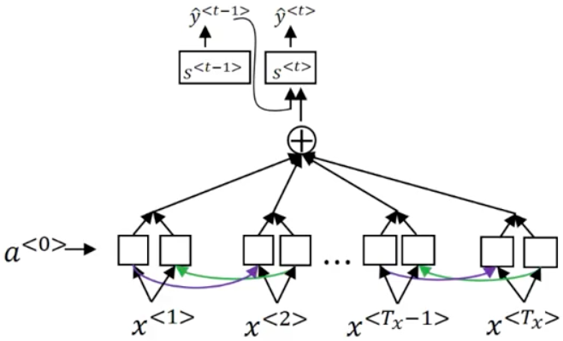

: the time step in the input French sentence

: the forward recurrent activation of time step

: the backward recurrent activation of time step

: the activation feature vector of time step

: the amount of attention that should pay to

:

**Speech Recognition**

**Trigger Word Detection**