Ernest (Jiachang) Xu

CSCI 360: Introduction to Artificial Intelligence

Project #3: Part 1 (Bayesian Networks)

1. *P* (*Rain*5 = *True* | *Umbrella*1 = *True*, *Umbrella*2 = *True*, *Umbrella*3 = *True*, *Umbrella*4 = *False*, *Umbrella*5 = *True*) = 0.73194  
   *P* (*Rain*5 = *False* | *Umbrella*1 = *True*, *Umbrella*2 = *True*, *Umbrella*3 = *True*, *Umbrella*4 = *False*, *Umbrella*5 = *True*) = 0.26806  
   *P* (*e* | *Umbrella*1 = *True*, *Umbrella*2 = *True*, *Umbrella*3 = *True*, *Umbrella*4 = *False*, *Umbrella*5 = *True*) = 0.04099  
   Real-world application: Given a series of economic events, and a sequence of DJIA index, we can predict the probability of whether the DJIA index is going to increase or decrease.  
   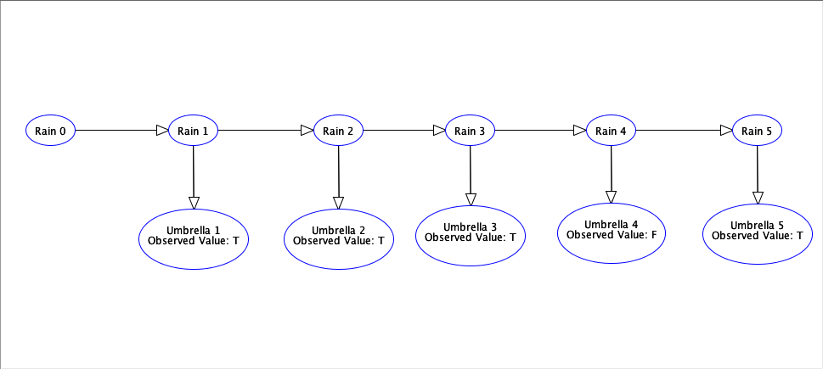
2. Because *Humidityt* and *Umbrellat* are not directly connected, but rather connected through *Raint*, *Humidityt* and *Umbrellat* are conditionally independent given *Raint*. Because *Humidityt* and *Raint* are not directly connected, *Humidityt* and *Raint* are independent of each other.  
   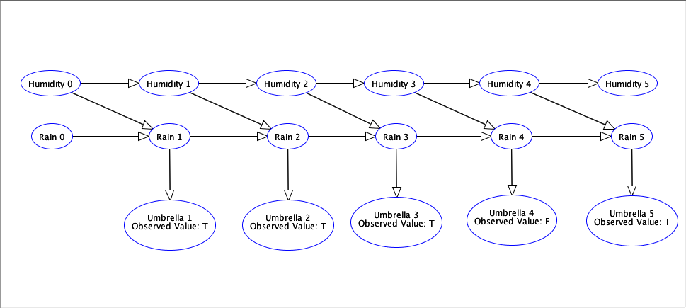
3. Chase Bank Loan Decision Bayesian Network  
   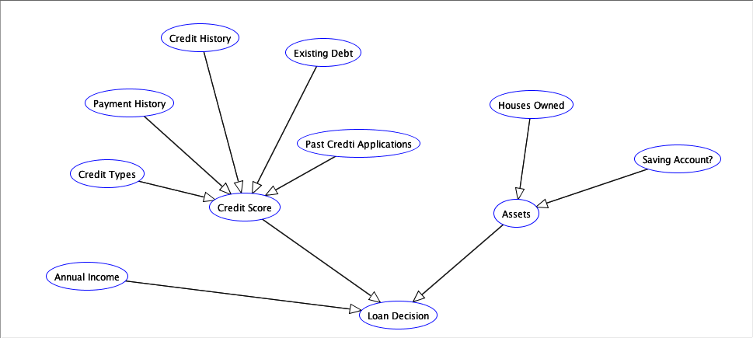
   1. Scenario 1: high annual income, good credit score, many assets  
      P (Loan Approved | high annual income, good credit score, many assets) = 0.95
   2. Scenario 2: low annual income, bad credit score, few assets  
      P (Loan Approved | low annual income, bad credit score, few assets) = 0.1