**This document helps you to use this tool. Please follow the instructions below:**

**Single Raster Clips:**

1. Add the Input Raster

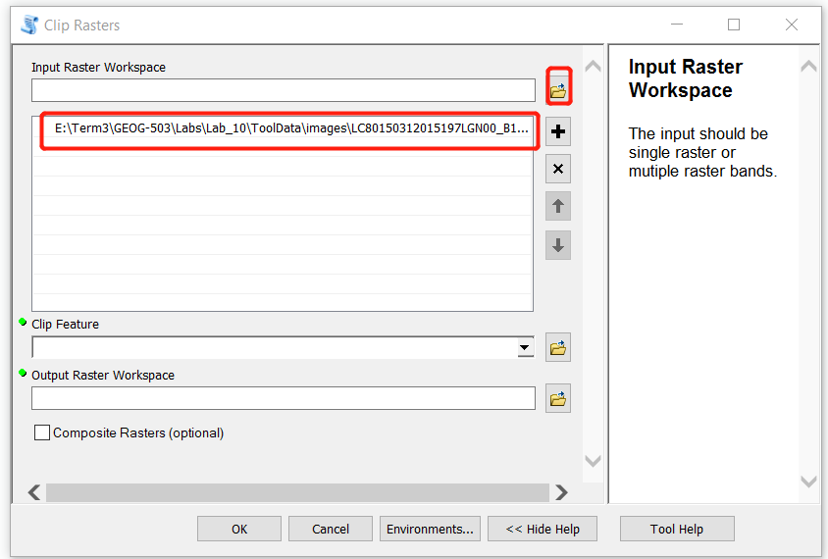

1. Add the Feature layer which is used to clip the raster

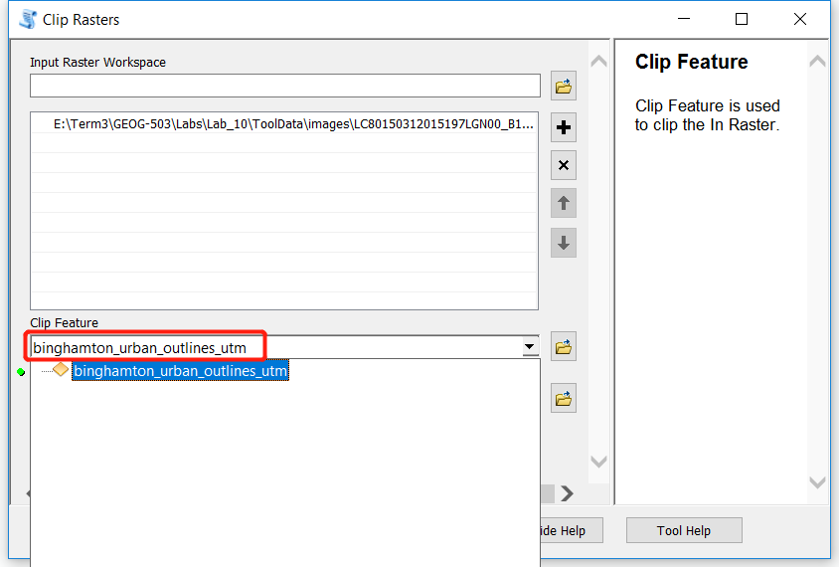

1. Set the output path

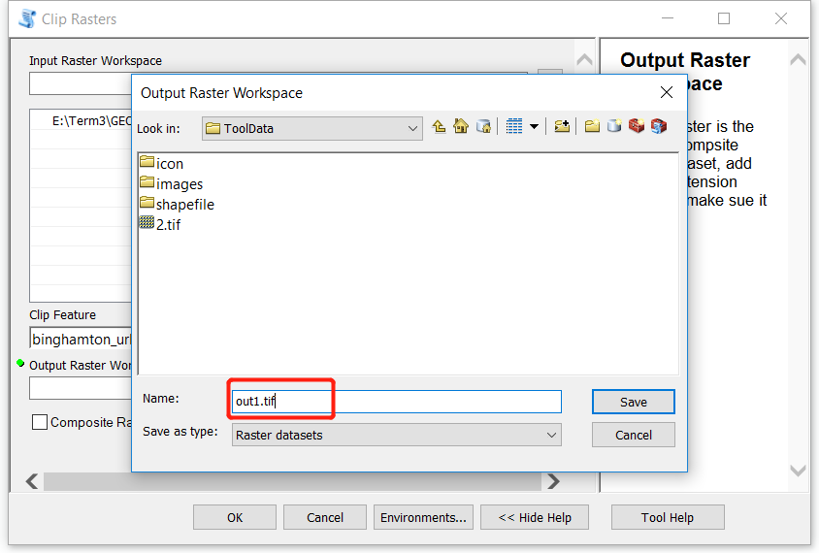

1. Uncheck the checkbox and Click ‘Ok’

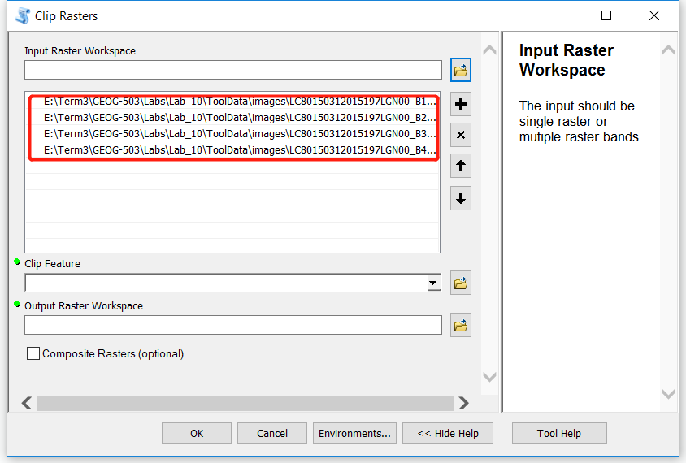

**Multiple Raster bands composite and clips**

1. Add multiple raster bands

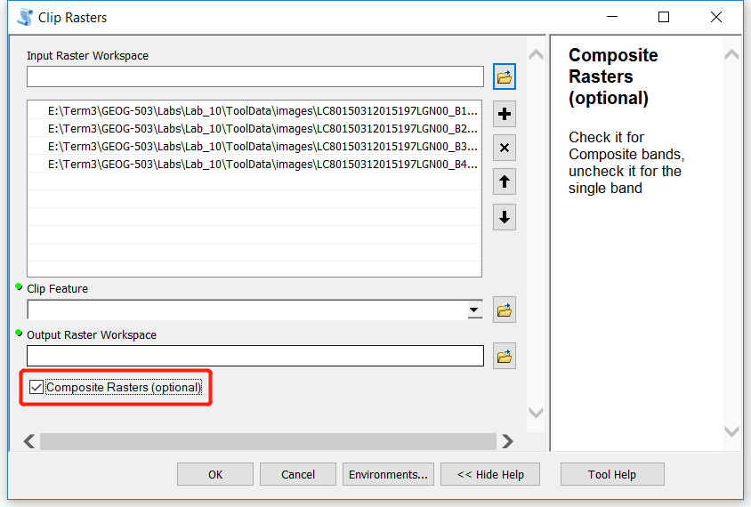

1. Add the Feature layer which is used to clip the raster
2. Set the output path, check the checkbox and click ‘ok’



