GEOG505

Jian Xu

Lab 4

1.

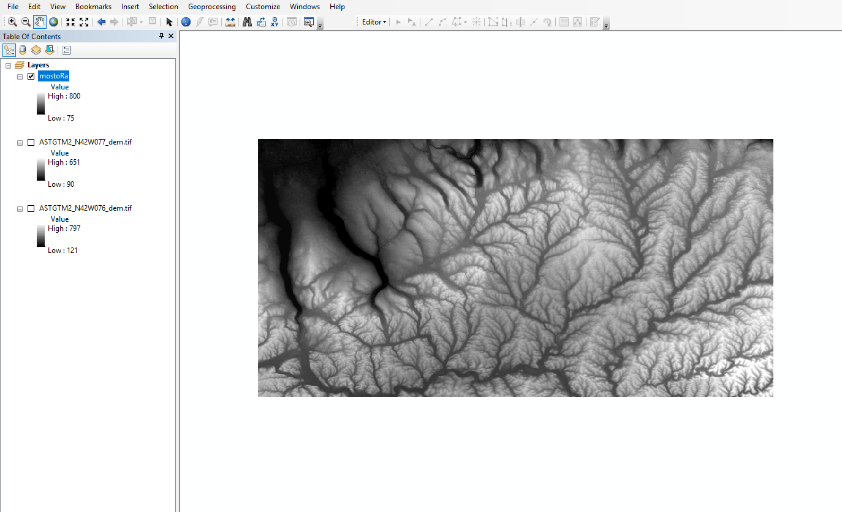

What are the new high and low elevation values?

High : 800 , low : 75.