GEOG505

Jian Xu

Lab 5

1. Overlaid with high elevation and low elevation rasters

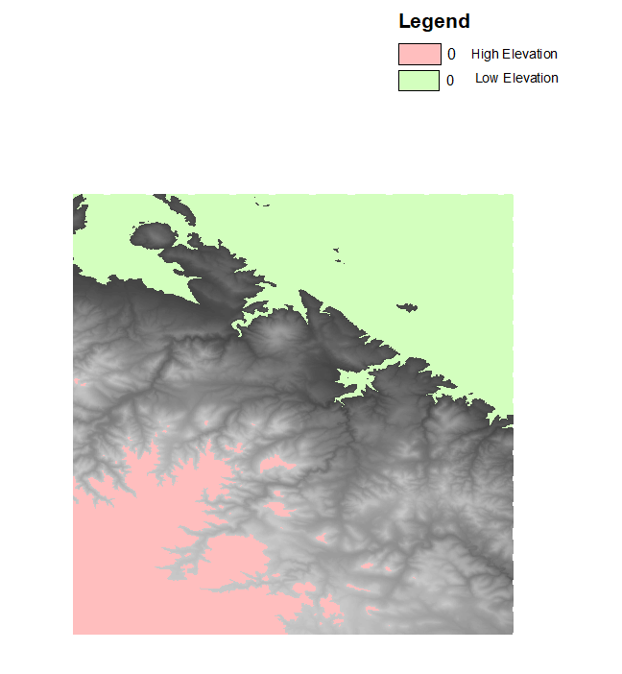

1. A. high and low Elevation

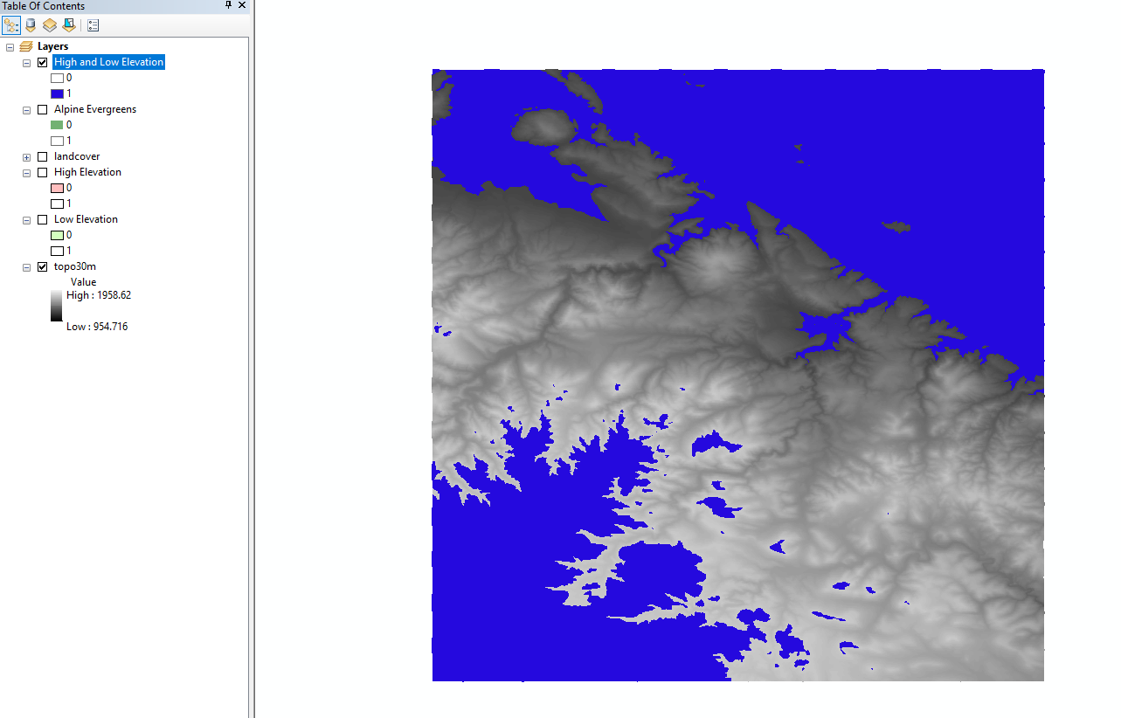

B. Alpine Evergreens

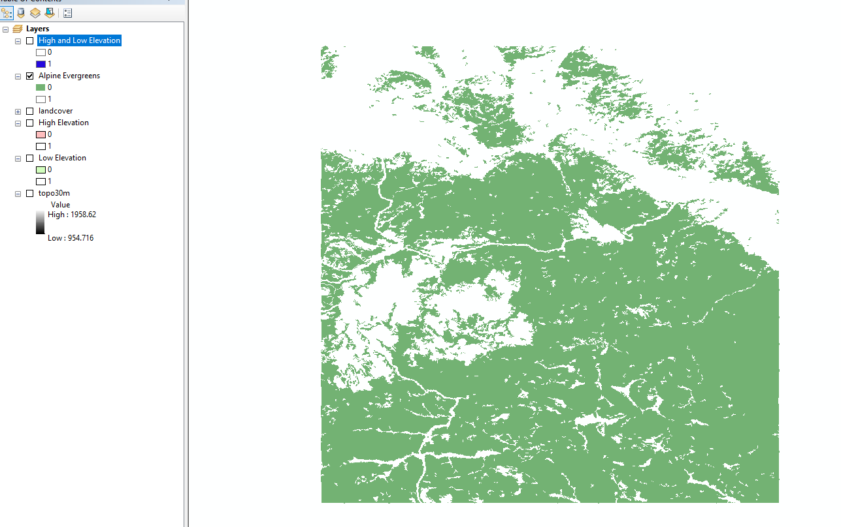

C. Middle Elevation

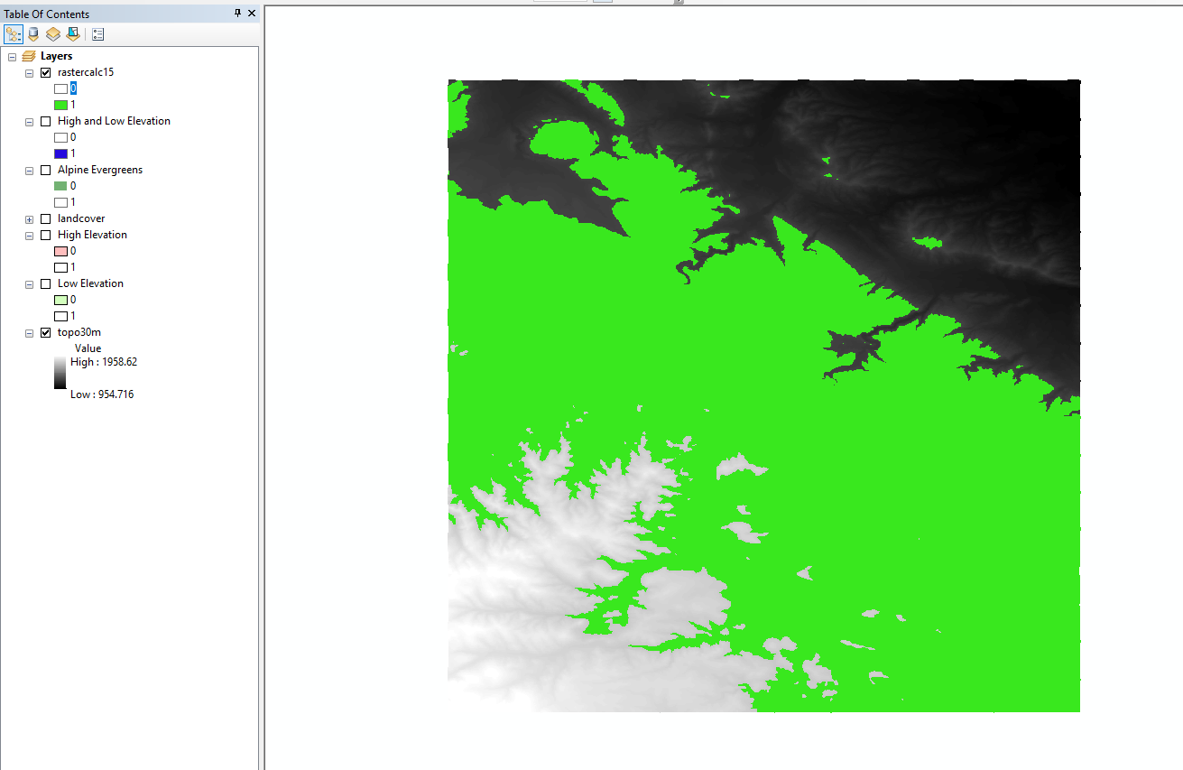

1. a. landcover = 42

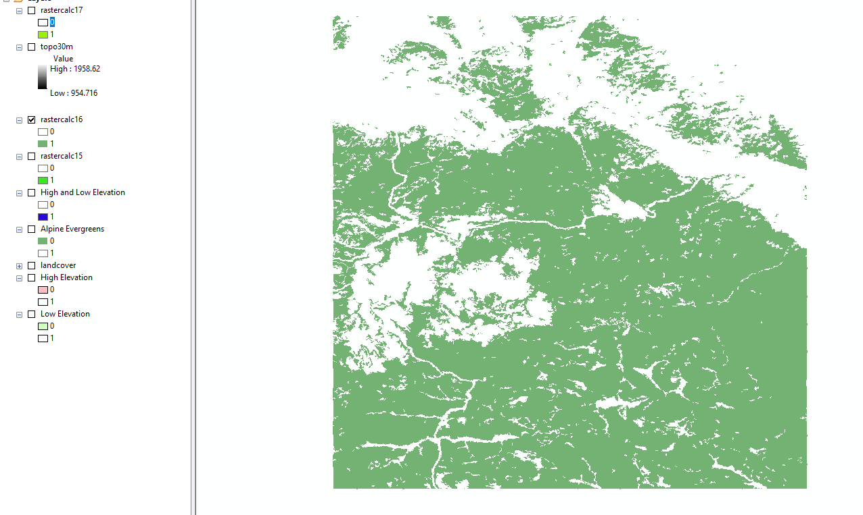

b. topo30m > 1800

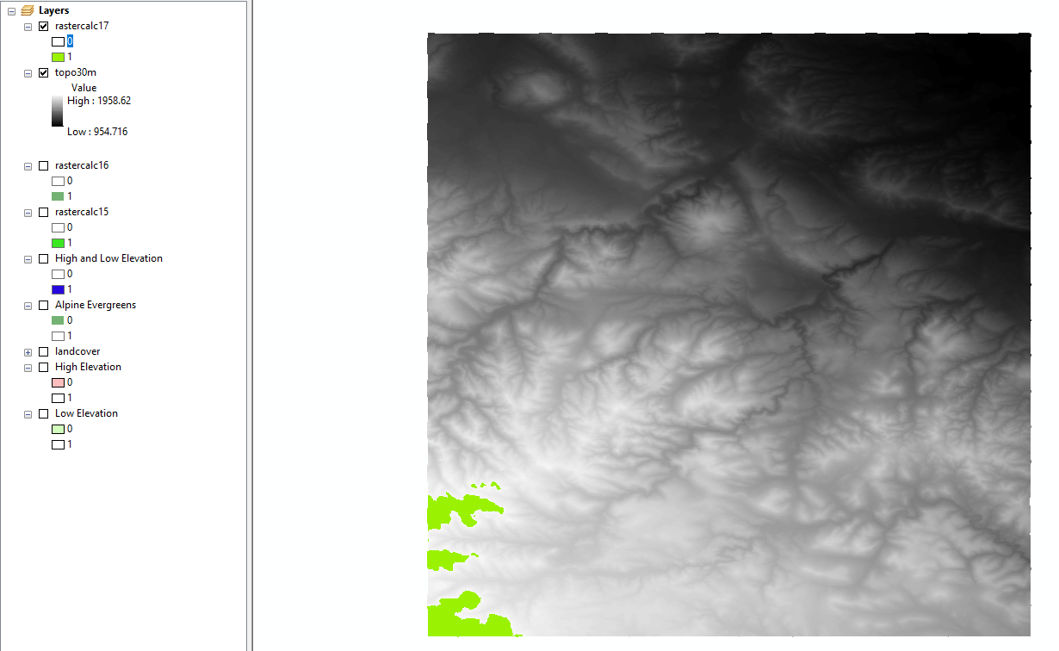

1. screenshot of Float raster

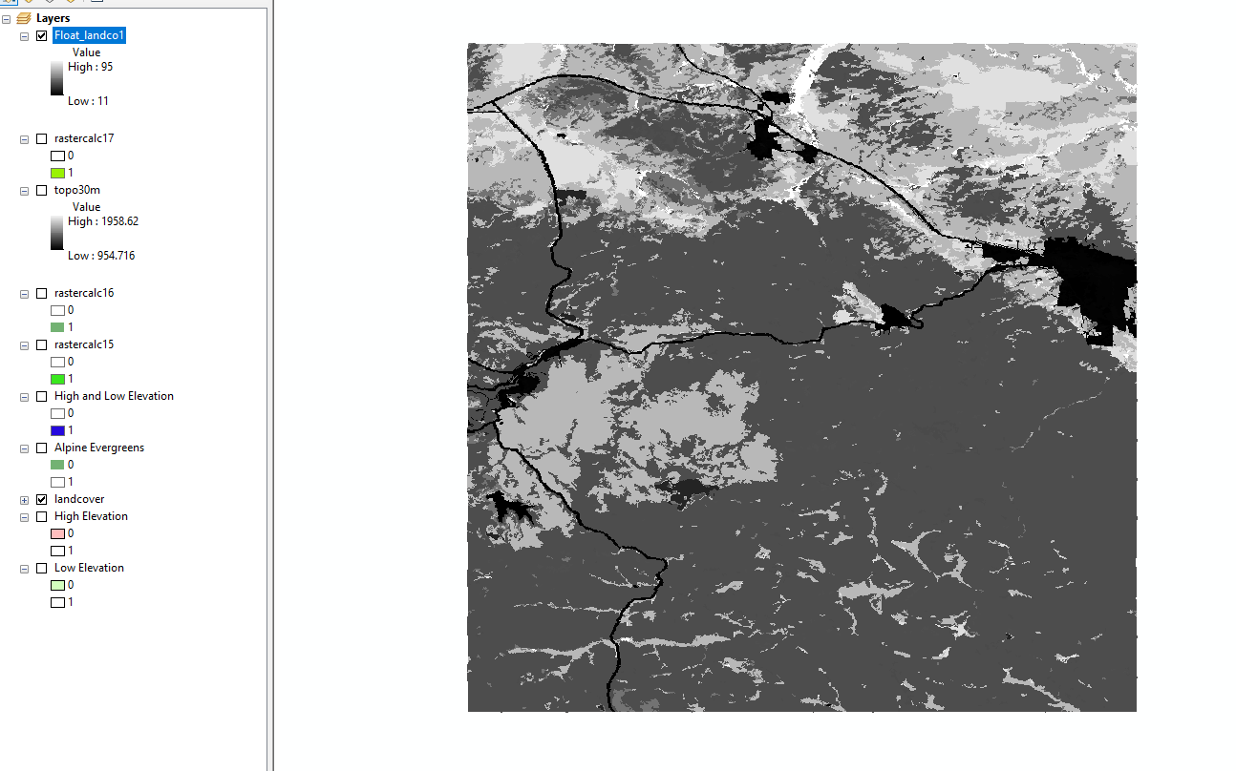

Why are roads easier to observe?

In the layer of Float raster, the features are stretched in the whole layer. But when it comes to the roads, they are usually distinguished with the features(like vegetation, water and barren land) around them. So, roads are easier to observe.

1. output raster’s stretched values

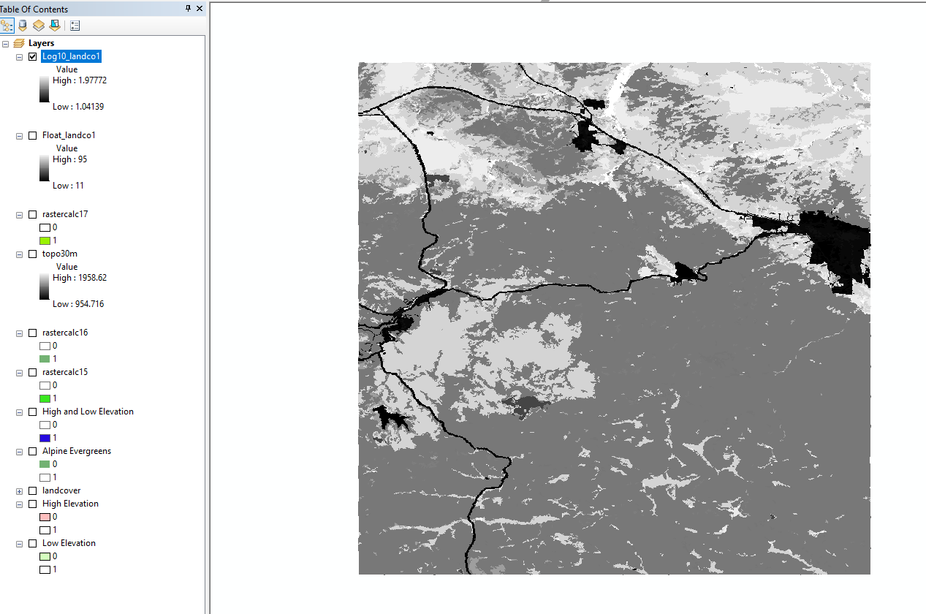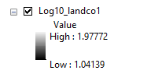

Interpret: Compared to the Landcover layer, the values in the SquareR_Floa1 are the results of the landcover’s values Logarithmic. So the difference in these two layers is much fewer. In addition, the changes are small after using logarithmic function. So the new layer seems to be close to the original one.

1. square

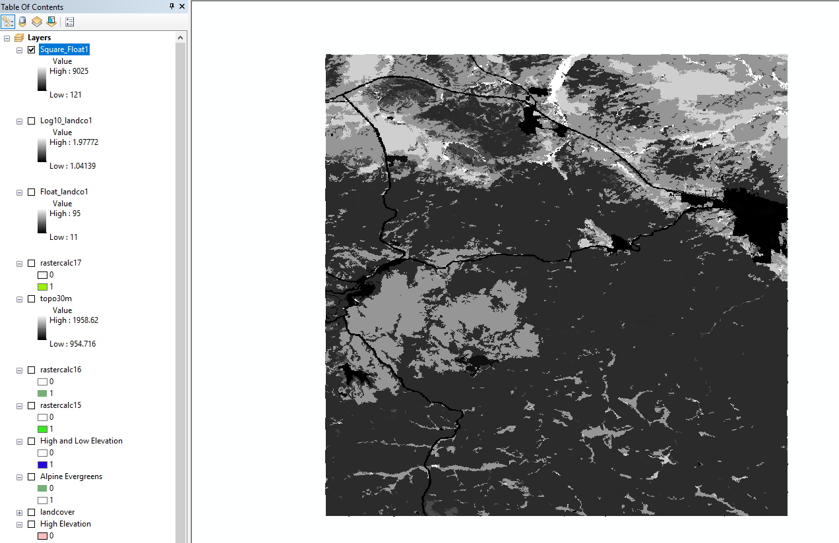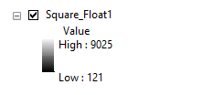

Interpret: Compared to the landcover layer, the values in the SquareR_Floa1 are the results of the landcover’s values squaring. So values become much greater. In addition, the changes are larger after squaring. So the new layer seems to be more different from the original one.

1. square root

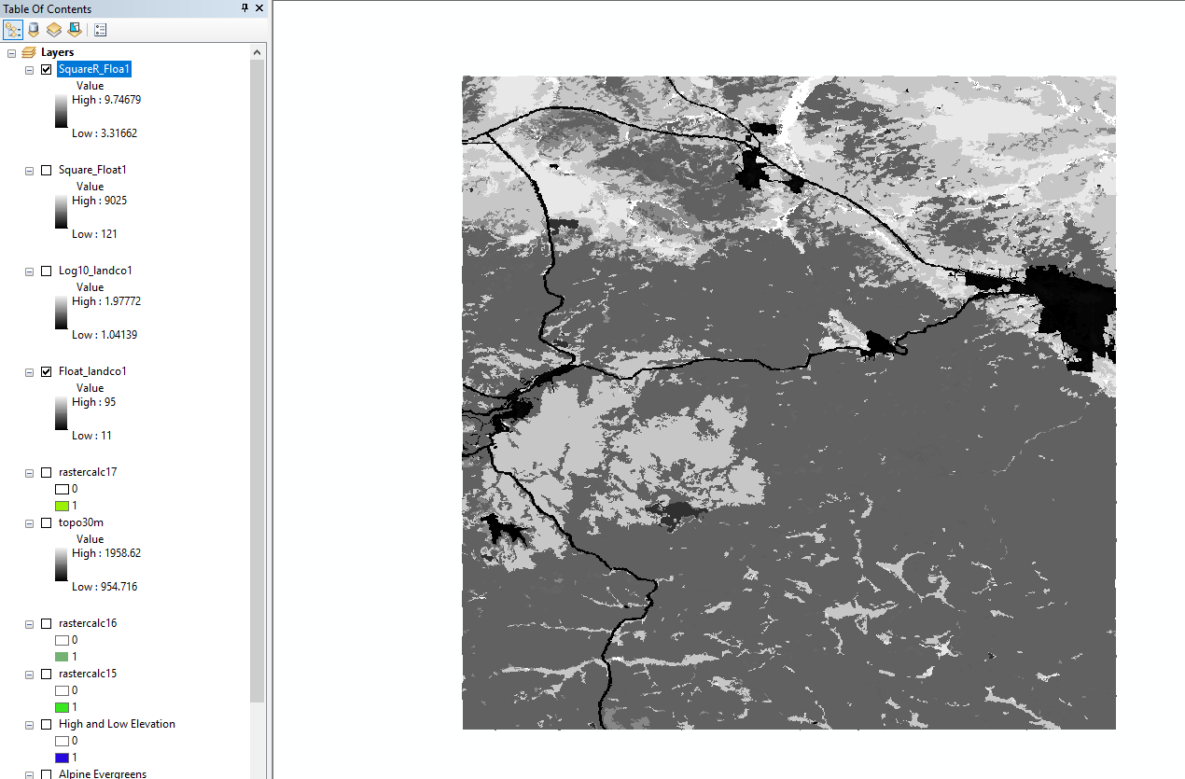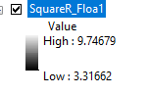

Interpret: Compared to the landcover layer, the values in the SquareR_Floa1 are the results of the landcover’s values square rooting. So the difference in these two layers is much fewer. In addition, the changes are small after square rooting. So the new layer seems to be same as the original one.