Object Recognition with Multi-source Images based on Kernel Dictionary Learning

XU Jun¹, LI Yuan-xiang¹, WEI Xian², PENG Xi-shuai¹, LU Yong-shuai¹
1 School of Aeronautics and Astronautics, Shanghai Jiao Tong University, Shanghai 200240, China
2 Technische Universitaet München, Munich D-80333, Germany
E-mail:xujun101820@sjtu.edu.cn, yuanxli@sjtu.edu.cn, xian.wei@tum.de, xishuai_peng@sjtu.edu.cn, lys__2008@sjtu.edu.cn

Abstract—With the development of widely-used unmanned aerial vehicles (UAV), automatic object recognition for UAV aerial images has important practical values. Since the background of objects is complex, there are limitations in object recognition using single-source visible or infrared data. Multi-source images contain much more information of objects, which improves the recognition rate. Meanwhile there exist the problems of high dimension and nonlinearly-separable between features. In order to solve these problems, a recognition algorithm based on kernel dictionary learning is proposed. First, the algorithm learns a kernel dictionary and then obtains the sparse representations of objects by the kernel dictionary. Then the linear discriminant analysis is used to discriminate the sparse representations. Finally, the support vector machine is employed to classify four kinds of objects. The experimental results on visible and infrared images show that our method based on kernel dictionary learning has superior recognition performance in comparison with the methods based on traditional feature extraction and dictionary learning.
Keywords—Automatic object recognition; multi-source images; kernel dictionary learning; linear discriminant analysis; support vector machine

Introduction
Image data can be obtained by various types of sensors, but different image sensors have different imaging mechanisms, which means that the basic features of object are difficult to be described by a single sensor. Thus, there exist certain limitations when only using single-source images [1]. In order to apply multiple image sensors to the technology of recognition, we use multiple UAV airborne sensors to acquire multi-source images (visible light image and long-wave infrared images), which can improve object recognition performance.
Feature extraction is the most critical step in object recognition tasks. There are many classic methods of feature extraction, such as Principal Component Analysis (PCA), Linear Discriminant Analysis (LDA), Independent Component Algorithm (ICA), Histogram of Oriented Gradients (HOG), and Speeded up Robust Feature (SURF). PCA first solves the eigenvalues of the samples’ covariance matrix, then take the corresponding feature vectors of the top n eigenvalues as the subspace directions, so that dimensionality reduction can be used in the basis of maintaining the original data’s energy to the maximum extent. The goal of LDA is to maximize the ratio of the between-class scatter to the within class scatter, and then find out the projection of samples so that samples can be separated. It is a linear dimension reduction method of supervision. ICA linearly decomposes the observed data into statistically independent components, it assumes that the signal sources must be independent and do not interfere with each other [2]. HOG describes the distribution of gradient strength and gradient direction of the object region in image, which can well represent the appearance and the shape of objects. SURF has good adaptability for the scale and rotation changes of objects.
PCA, LDA, ICA are all based on the structure of global dimensionality reduction, and these they are all linear methods, while the useful features of the data are often not the linear combination of features [2]. Because of the background of UAV aerial data is complex and changeable, and also lack of prior knowledge, HOG and SURF methods do not always have good results.
There is another classical algorithm of object classification, called Sparse Representation based Classifier (SRC). The basic idea of SRC is introduced as follows: First let an over-complete dictionary be composed of all the training samples, assuming that any one of the test images can be represented by the linear combination of the training set, which belongs to the same classification as the test image. Then using the dictionary to represent an image data, the coefficients of the representations are large only in the corresponding parts of the dictionary, therefore the coefficients are usually sparse, namely, sparse representation. Through solving the sparse representation of the test image by the over-complete dictionary, we can obtain the classification of test image by sparse representation coefficients. If the over-complete dictionary is obtained by a learning method, the method is called dictionary learning.
On the basis of SRC and dictionary learning, a recognition algorithm based on kernel learning dictionary is proposed in this paper. On one hand, through mapping the data from low-dimensional feature space to high-dimensional space using kernel method [3], the features can be linearly separable. On the other hand, using the sparse representations of kernel dictionary learning as the features can reduce its dimension of features without the need of prior knowledge. The features can be obtained automatically by the training set. Experimental results show that our proposed algorithm has superior recognition performance in comparison with the methods based on feature extraction and linear dimension reduction.

principle of kernel dictionary learning
As described above, we use the sparse representations as object features. And the sparse representations are obtained by over-complete dictionary, thus it is crucial to construct the a good? over-complete dictionary. Usually there are two ways of dictionary construction：the method based on prior knowledge and the dictionary learning. It has been observed that learning a dictionary directly from the training data rather than using a predetermined dictionary usually leads to a more compact representation [4]. Therefore, the method of kernel dictionary learning is proposed to learn over-complete dictionary from the training data set. Studies show that the sparse representations obtained by nonlinear dictionary learning method are more separable, thus they are used in this paper.

Dictionary Learning and sparse representation
We first find some basic elements for the image data, then use the linear combination of these basic elements to represent the image data approximately. This representation is called sparse representation or sparse coding when the most coefficients of the representation are zero.
Given a data matrix ,represents the dimension of sample,represents the number of sample.So that can be written as: 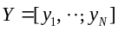. Our goal is to find an over-complete dictionary,so that any one sample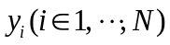 can be represented by the linear combination of the elements of dictionary, and the coefficients of the linear combinations are sparsity. According to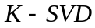, the cost function is given as Eq. (1). The problem of solving dictionary and sparse matrix 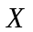can be transformed into the problem of minimizing the cost function [5][6].
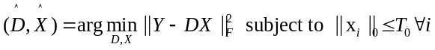 (1)
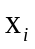is a column of sparse matrix.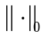describes the number of non-zero elements of sparse representation.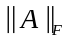 denotes the Frobenius norm. As shown in Eq. (1),the dictionary and sparse matrix need to be solved. is a iterative method and it alternates between sparse coding when dictionary is fixed and dictionary update steps when sparse matrix is fixed .

Kernel methods
Kernel methods are first used in SVM. With the success of support vector machine, more and more people begin to study kernel methods. Map the data from the space of 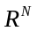 into a high dimensional feature space by a nonlinear transformation 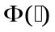 to make the data become linearly separable [7]. Thus we can apply the linear learning algorithm in high dimensional feature space. Since the feature space can be very high dimensionally, it will bring the problem called "dimension disaster" [8]. If the operations of these linear learning algorithms are only some dot product, the specific form of non-linear transformation is not needed. We can use the linear learning algorithm in nonlinear space by replacing the dot product of linear algorithm with the Mercer kernel. Therefore the problem of "dimension disaster" can be solved by using kernel methods.
For a data set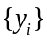, the kernel function 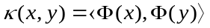 can produce a kernel matrix 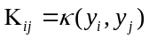. The kernel matrix contains all the dot products of data set in the high-dimensional space. Some commonly used Mercer kernels including polynomial kernels: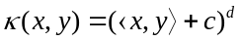 and Gaussian kernels 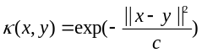，where c and d are the parameters [9].

Solving dictionary learning models based on kernel methods
As we mentioned in Section II-A, the alternately iterative algorithm is mainly used to solve cost function of dictionary learning, which includes two steps:1) fix the dictionary, then solve the sparse matrix. 2) fix the sparse matrix, then solve the dictionary . Alternate iterate step 1) and step 2) until the termination condition is satisfied, then we can obtain the dictionary that we needed.
Step 1) is a process of sparse coding and is an NP-hard problem, it can be solved by greedy algorithms such as OMP(Orthogonal Matching Pursuit) [10]. And the step 2) is a regression problem, 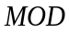 (Method Of Directions) and 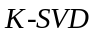 are two common algorithms to solve the problem. algorithm is very effective and usually converges in a few iterations, it suffers from the high complexity of the matrix inversion. In the case of , the dictionary update is performed atom-by-atom in an efficient way rather than using a matrix inversion. It has been observed that 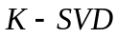 requires fewer iterations to converge than MOD [11]. Thus and based on kernel methods are mainly introduced as follows.
The optimization of compared to is that the dictionary update is atom-by-atom. Suppose we want to update column of dictionary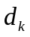and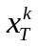 is the 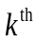 row of sparse matrix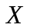. The cost function Eq. (1) can be rewritten as
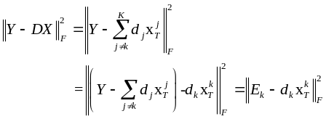 (2)
Decompose 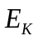 by 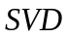，then we can find the rank-1 matrix 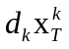best approximates? .So that we can update and .But the problem is that does not guarantee the updated to be sparse, and the corresponding is not what we wanted. The ssolution of this problem is to remove the zero value of and retain the non-zero values, and retain the corresponding values at the same time. An index set 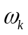 is defined to record the index of nonzero values of .
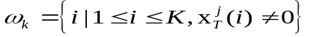 (3)
Define a matrix 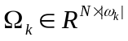，and values of the matrix are 1 only in the positions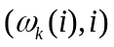, the rest values are 0. Let 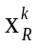 be a vector composed of the non-zero values of? and 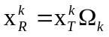.Similarly, 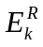represents the columns of 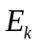 related to ，and 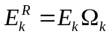.(2) can be rewritten as
(4)
Then decompose 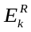by and 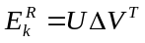,is a diagonal matrix .Let 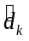 be the first column of 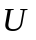and be the product of the first column of 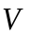and 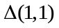 [9]. represents the maximum eigenvalue.
According to the above statement, we can derivate the algorithm based on the kernel methods. For the input data 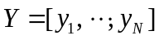, define a projection for mapping the data into the high-dimensional feature space, so that the mapped data can be represented as 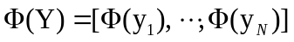.Let 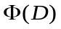 be the dictionary of high-dimensional feature space and it is proved that the dictionary can be a linear combination of all samples，that is 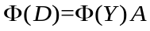,whereis the coefficient matrix of this linear combination. Then Eq. (1) can be rewritten as [12][15].
(5)
Similarly, according to the derivation quote? of Eq. (2), 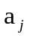and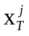 represent the column of and respectively, the penalty term of Eq. (5) can be rewritten as
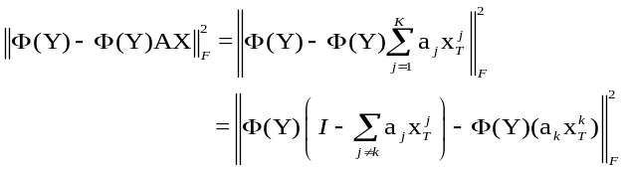 (6)
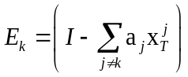,and according to the definition of Eq.(3) ,we can know that ，，Eq. (6) can be rewritten as
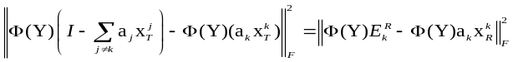 (7)
As we know? Thus? that 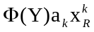is a rank-1 matrix，then decompose 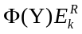 by
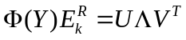 (8)
and are unit orthogonal matrix, is a diagonal matrix. Let 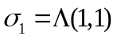 be the largest singular value.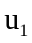 and 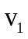represent a column of and respectively corresponding to 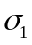.
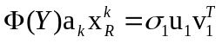 (9)
It is considered that
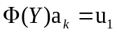 (10)
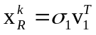 (11)
If we want to use Eq. (9) and Eq. (10) to solve the problem ,we need to use the projectionwill be needed .According to the kernel methods, we can decompose 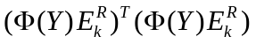by instead of solving the problem.
(12)
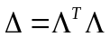，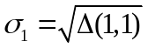, multiply by 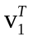 on both sides of Eq. (8) at the same time.
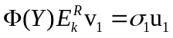 (13)
Combining Eq. (10) and Eq. (13)
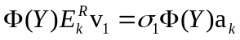 (14)
Then 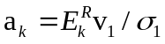，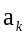and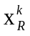 are the updated values.

Object classification based on kernel dictionary learning

Input of Kernel Dictionary Learning
In this paper, the multi-source images are taken by UAV, which consist of visible light image and longwave infrared image. The method based on kernel dictionary learning(KDL) proposed in this paper has better results for large-scale image ,especially for the data of high dimension and nonlinear separability between features (dimension of features is greater than the number of samples). our proposed method can not only reduce the data dimension , but also make the features of nonlinear separability become linear separability by projecting the data into a high-dimensional space. Thus pixel value of the image data is taken as the input of the method based on kernel dictionary learning. In order to conduct the comparative experiments for multi-source data, we take a single source of visible (visible light image), a single source of infrared (infrared image), multi-source (visible and infrared images) respectively as the input of kernel learning dictionary, as shown in Fig.1.
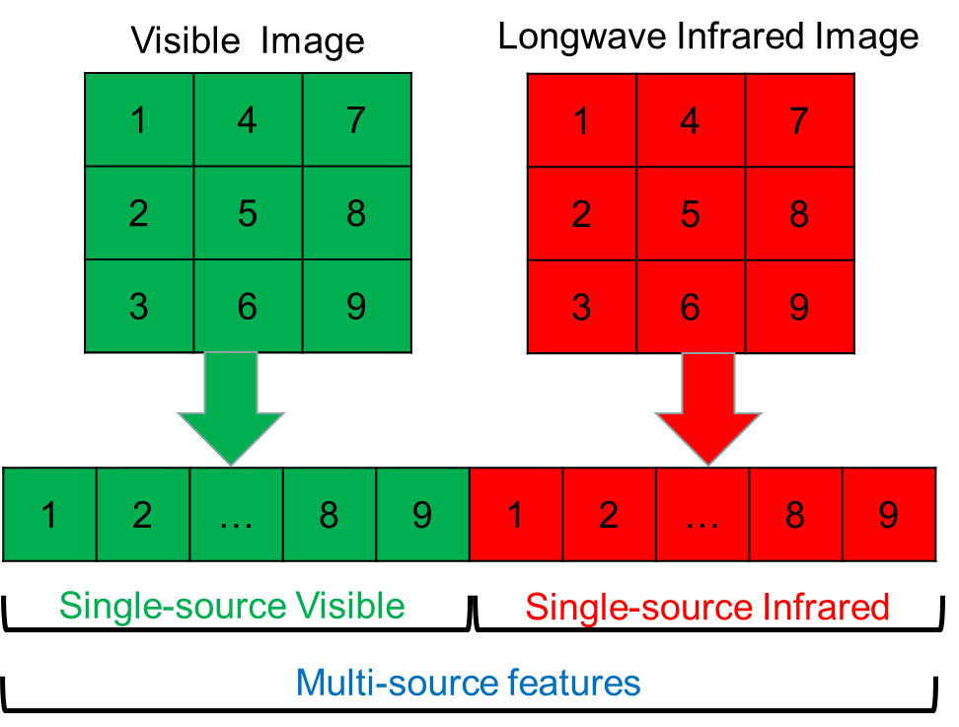
Fig.1 Schematic diagram of the input data for kernel dictionary learning

The image of 3 * 3 is just used as an example to illustrate how to extract pixel features, by which we can deduce to the image of 100 * 100. However the dimension of the features will become too high, generally there are two solutions: feature selection and dimensionality reduction methods. Therefore, this paper uses both the feature extraction methods such as HOG, SURF and dimensionality reduction method such as LDA to deal with the data. SVM is employed to classify objects. Finally compare our method with traditional methods using HOG, SURF and LDA in this paper.

Process of Object Classification
According to the above description, we can know that the KDL-based object classification can be divided into two parts: kernel dictionary learning and the process of classification.
KDL steps include: firstly, determine the input of kernel dictionary learning, the input is a data matrix, each column is a sample of the data from a single source (visible light image or infrared images) or multiple sources (visible and infrared image). then fix the sparse representation to solve the kernel dictionary, finally fix the kernel dictionary to solve the sparse representation. Through the steps above, we can obtain the kernel dictionary which satisfies the requirements, as shown in the flowchart in Fig 2.
Classification steps are depicted as follows: firstly, solve the sparse representations of training set and testing set respectively by the kernel dictionary. Secondly, use the sparse representations processed by LDA to train classifier. Finally, use the classification model for testing set to obtain experimental results, as shown in Fig 3.

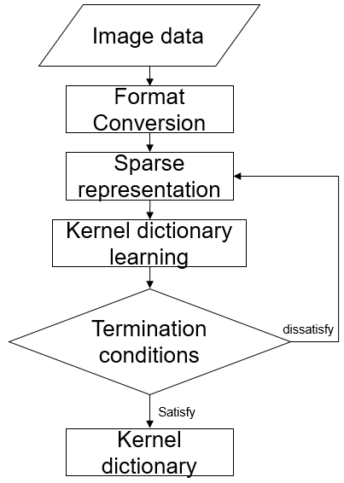

Fig.2 Flow chart of kernel dictionary learning

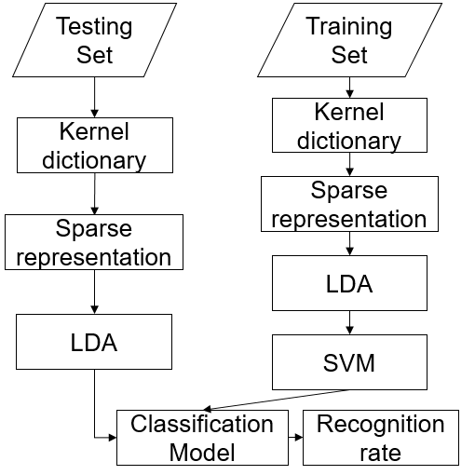

Fig.3 Flow chart of object classification

ExperimentAL Results And Analysises

Experimental Data
The experimental data set is composed of four types of objectives, namely camouflage tanks, artillery camouflage, non-camouflage tanks and vehicles. The samples’ numbers of each class are 390, 314, 500, 1088 respectively. The total number of samples is 2292. The ranges of images’ original size for each object are: width [33, 164], height [54, 167],which are all normalized to multi-source image (visible light, LWIR) of [100,100]. As shown in Section II-A, convert the data into the input of kernel dictionary learning, then the feature dimensions of single-source and multi-source data are 10000 and 20000 respectively. It is far greater than the number of samples. And the sizes of single-source and multi-source data set are 10000 * 2292 and 2292*20000.

Experimental parameters
Some important parameters need to be determined in advance when the algorithm of kernel dictionary learning is used, such as sparsity degree, size of kernel dictionary and the iterations of kernel dictionary learning. These parameters have great impact on recognition results. Figure 4 shows the influence of different sparsity, and Fig. 5 shows the influence of different dictionary sizes.
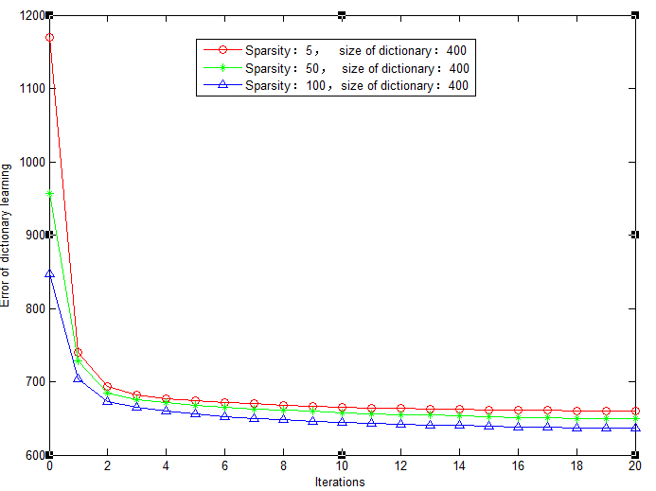
Fig.4 Influence of different sparsity
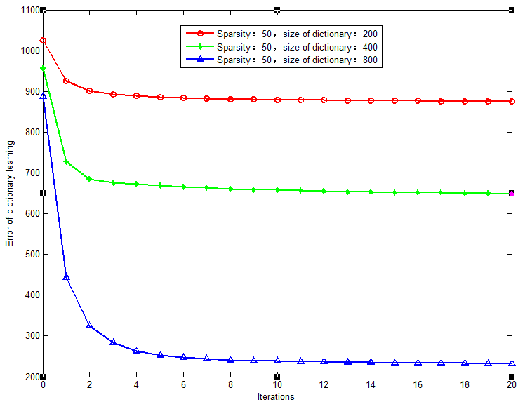
Fig.5 Influence of different dictionary sizes

From Fig. 4 and Fig. 5，we can know that：
- As is shown in Fig. 4 and Fig. 5 ,with the iterations increasing, the error of dictionary learning decreases. But, when the number of iterations is greater than 5, the rapidly decreasing of error stops, and tends to stable with slight decline. Thus we choose 5 as the number of iterations.
- As is shown in Fig. 4,when the size of dictionary is fixed, the sparsity degree has little impact on the error of dictionary learning. But increasing the sparsity will increase the time consumption of algorithm. According to the experience of experiment, we select 5 as the sparsity degree.
- As is shown in Fig. 5, when the sparsity degree is fixed, the larger the size of the dictionary is, the smaller the error of the dictionary is. But increasing the dictionary size will increase the time consuming of algorithm as well, Thus we choose 800 as the dictionary size .

Classification Results
For comparative tests, the methods of LDA + SVM, HOG+ SVM and SURF + SVM are used to compare with the algorithm proposed in this paper (namely KDL+LDA+SVM). For the purpose of highlighting the kernel, three dictionary- learning-based (Dictionary Learning, DL) algorithm are added to the comparative tests: DL + KNN (K-Nearest Neighbor), DL + SVM and DL + LDA + SVM. The kernel function of SVM is RBF and the parameter K (number of nearest neighbors) of KNN is 4. In order to simplify the expression of results, the writing of SVM is omitted in Table 1 and Table 2.

Tab.1 The classification results with 100 samples per class as the training set (ACC means average recognition accuracy)
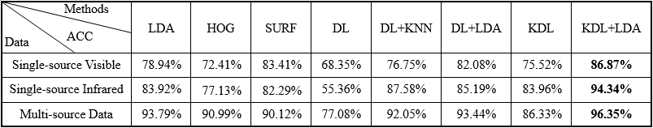
Tab.2 The classification results with 200 samples per class as the training set (ACC means average recognition accuracy)
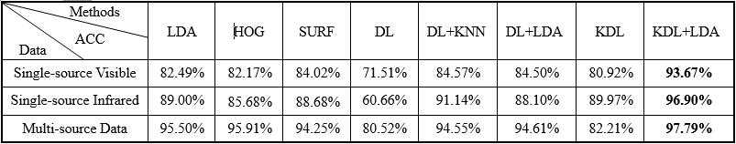

As is shown in section III-A, There are four classes in the data set of 2292 samples. Since SVM is mainly used in this experiment and each class includes different amount of samples, two sets of experiments are carried out to balance the training set: 1) Select 100 samples of each class as the training set randomly and the rest as testing set, then repeat the experiment 10 times, and the average recognition rates are listed in Table 1. 2) Select 200 samples of each class as the training set randomly and the rest as testing set, then repeat the experiment 10 times as well, and the average recognition rates are listed in Table 2.
From Table 1 and Table 2, we can know:
1）For all object recognition algorithms, using multi-source data can significantly improve the recognition rate comparing with the single-source data of visible light or infrared. Take LDA in Table 2 for example, using multi-source data increase the recognition rate by about 13% and 6% when compared to single-source data visible light or infrared respectively.
2）For both single-source dataset and multi-source dataset, KDL + LDA based on kernel dictionary learning has better recognition result than the other methods mentioned. Take the multi-source data for example, KDL + LDA improved recognition rate by about 2% at least when compared to other methods.
3）KDL-based algorithm is more effective than DL-based algorithm. Take KDL+LDA and DL +LDA in multi-source data for example, KDL+LDA can improve the recognition rate by nearly 3% when compared to DL+LDA.
4）We use LDA to deal with sparse representation and then perform SVM, because the most elements of sparse representations are 0, it means that the most elements of features are useless element for solving SVM classifier, which will cause the inseparability of data. Thus LDA is used before solving SVM, it can improve the recognition rate. Take KDL and KDL + LDA in multi-source data for example, KDL + LDA can improve the recognition rate by about 15% when compared to KDL.

Conclusion
An object recognition method based on kernel dictionary learning is proposed in this paper, it is more suitable for the situations when the feature dimensions are much larger than the size of samples. On one hand, the method maps the data into a high dimensional feature space to make the data become linearly separable. So that we can apply the linear learning algorithm in high dimensional feature space. On the other hand, when the feature dimensions are greater than the number of samples, it will also be larger than the size of the dictionary, then taking the sparse representation as features can be regarded as a process of dimensionality reduction. Experiments show that for both single-source image and multi-source images, object recognition based on kernel dictionary learning is feasible.

References
- ZHENG Shuang. Study on object tracking method based on multi-source image fusion in complex background [D]. Shanghai Jiao Tong University, 2014.
- ZHU Jie, YANG Wan-Kou, TANG Zhen-Min.A Dictionary Learning Based Kernel Sparse Representation Method For Face Recognition [J]. Pattern Recognition and Artificial Intelligence, 2012, 25(5):859-864.
- Jayasumana S, Hartley R, Salzmann M, et al. Kernel Methods on Riemannian Manifolds with Gaussian RBF Kernels [J]. Pattern Analysis & Machine Intelligence IEEE Transactions on, 2014, 37(12):2464-2477.
- Rubinstein R, Bruckstein A M, Elad M. Dictionaries for Sparse Representation Modeling [J]. Proceedings of the IEEE, 2010, 98(6):1045-1057.
- Rubinstein R, Peleg T, Elad M. Analysis K-SVD: A Dictionary-Learning Algorithm for the Analysis Sparse Model [J]. IEEE Trans. on Signal Processing, 2013, 61(3):661-677.
- Chang K Y, Lin C F, Chen C S, et al. Single-Pass K-SVD for Efficient Dictionary Learning[J]. Circuits Systems & Signal Processing, 2014, 33(1):309-320.
- Bahrampour S, Nasrabadi N M, Ray A, et al. Kernel task-driven dictionary learning for hyperspectral image classification[C]. Acoustics, Speech and Signal Processing (ICASSP), 2015 IEEE International Conference on. IEEE, 2015: 1324-1328.
- ZHENG Si-Long, LI Yuan-Xiang, WEI Xian, PENG Xi-Shuai. Nonlinear Dimensionality Reduction Based On Dictionary Learning [J]. Acta Automatica Sinica, 2016, 42(6).
- Nguyen H, Patel V M, Nasrabadi N M, et al. Kernel dictionary learning[C]. Acoustics, Speech and Signal Processing (ICASSP), 2012 IEEE International Conference on. IEEE, 2012: 2021-2024.
- Chen Y, Nasrabadi N M, Tran T D. Hyperspectral image classification via kernel sparse representation [J]. IEEE Trans. on Geoscience and Remote Sensing, 2013, 51(1): 217-231.
- Van Nguyen H, Patel V M, Nasrabadi N M, et al. Design of non-linear kernel dictionaries for object recognition [J]. IEEE Trans. on Image Processing A Publication of the IEEE Signal Processing Society, 2013, 22(12):5123-35.
- Aharon M, Elad M, Bruckstein A K. K-SVD: An Algorithm for Designing Overcomplete Dictionaries for Sparse Representation [J].IEEE Trans. on Signal Processing, 2006, 54(11):4311-4322.
- Kim M. Efficient kernel sparse coding via first-order smooth optimization [J]. IEEE Trans. on Neural Networks & Learning Systems, 2014, 25(8):1447-1459.
- Gao W, Chen J, Richard C, et al. Online Dictionary Learning for Kernel LMS [J]. IEEE Trans. on Signal Processing, 2014, 62(11):2765-2777.
- Yang S, Han Y, Zhang X R. A sparse kernel representation method for image classification[C]. Neural Networks (IJCNN), The 2012 International Joint Conference on. IEEE, 2012:1-7.

