一．DISCONF部署安装 2
部署REDIS 2
部署NGINX 2
新建数据库 3
DISCOF部署 4
二．部署ELK 4
部署ES集群 4
部署logstash 4
部署kibana 5

一．DISCONF部署安装

部署REDIS
启动

部署NGINX
启动配置
user nginx;
worker_processes 1;

error_log /var/log/nginx/error.log warn;
pid /var/run/nginx.pid;

events {
worker_connections 1024;
}

http {
include /etc/nginx/mime.types;
default_type application/octet-stream;

log_format main '$remote_addr - $remote_user [$time_local] "$request" '
'$status $body_bytes_sent "$http_referer" '
'"$http_user_agent" "$http_x_forwarded_for"';

access_log /var/log/nginx/access.log main;

sendfile on;
#tcp_nopush on;

keepalive_timeout 65;

#gzip on;

upstream disconf {
server 127.0.0.1:8015;
}

server {

listen 8090;
server_name disconf.com;

access_log /usr/local/tomcat8/disconf-web/access.log;
error_log /usr/local/tomcat8/disconf-web/error.log;

location / {
root /opt/app/disconf-web/html;
if ($query_string) {
expires max;
}
}

location ~ ^/(api|export) {
proxy_pass_header Server;
proxy_set_header Host $http_host;
proxy_redirect off;
proxy_set_header X-Real-IP $remote_addr;
proxy_set_header X-Scheme $scheme;
proxy_pass http://disconf;
}
}
}

新建数据库
克隆10.1.102.155:3306 数据disconf 到生产服务器

DISCOF部署
1.从架构部获WAR包或 https://github.com/knightliao/disconf从地址获取，mvn后达成WAR包。
2.解压WAR包，并修改WEB-INFO下面的配置文件。包括数据库地址和REIDS地址
3.tomcat8部署。指定path路径为 war包的跟目录。端口号设置为8090
4.启动TOMCAT
5.测试是否配置成功,浏览器访问 http://IP:8090

二．部署ELK

部署ES集群

下载版本 https://www.elastic.co/downloads/past-releases
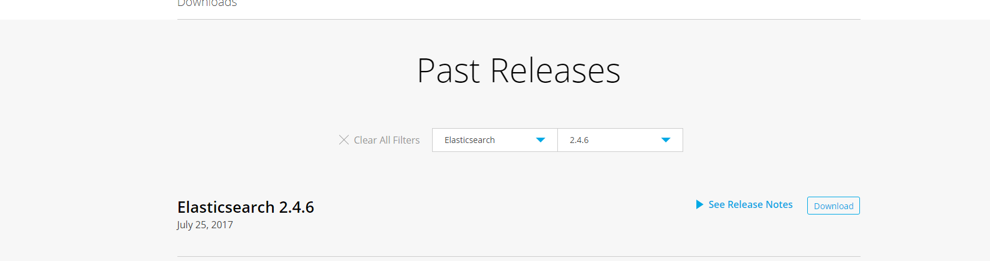
用2.4.6版本的ES
解压后，按照此文档流程部署
http://blog.csdn.net/dingzfang/article/details/42776299
其中设置为 cluster.name: elasticsearch

部署logstash

1.使用版本-2.4.1
2.下载地址https://www.elastic.co/downloads/past-releases
3. 新建配置文件logstash-2.4.1/bin/logstash.conf
文件内容为
input {
tcp {
host => "本机IP"
port => 9250
mode => "server"
tags => ["tags"]
codec => json_lines
}
}
output {
stdout { codec => rubydebug }
elasticsearch { hosts => "127.0.0.1:9200"
index => "log"
}
}

- 指定配置文件logstash.conf启动

部署kibana
1.使用版本-4.5.1
2.下载地址https://www.elastic.co/downloads/past-releases
3.解压
4.在文件中kibana-4.5.1-linux-x64/config/kibana.yml 追加
server.port: 5601
server.host: "0.0.0.0"
elasticsearch.url: "http://127.0.0.1:9200"
kibana.index: ".kibana"

- 启动
- 测试安装结果
http://IP:5601

